Intelligent Job Role & Skill Matching Reasoning System
A rule-based KR system that models candidates, skills, qualifications, experience, certifications and job requirements using Frames and Semantic Networks, formalizes eligibility and skill-matching constraints through First-Order Logic and Description Logic, and applies Horn clause reasoning with Forward and Backward Chaining to determine suitable job roles and give explainable decisions.
Complex Computing Problem (CCP) Report
Field | Value
Course | CT-351 Knowledge Representation & Reasoning
Department | Department of Computer Science and IT, NED University of Engineering & Technology
CLO / PLO | CLO 3 (Taxonomy Level C6, Design/Analysis); PLO-10 (Lifelong Learning)
Group | Group 9
Members | [PLACEHOLDER: Student 1 name, roll number]
 | [PLACEHOLDER: Student 2 name, roll number]
 | [PLACEHOLDER: Student 3 name, roll number]
 | [PLACEHOLDER: Student 4 name, roll number]
Instructor | [PLACEHOLDER: instructor name]
Submission date | [PLACEHOLDER: date]

Grading Rubric Sheet
Course Code: CT-351 | Course Title: Knowledge Representation & Reasoning Complex Computing Problem (CCP) - Grading Rubric
Student No. | Name | Roll No.
S1 | [PLACEHOLDER] | [PLACEHOLDER]
S2 | [PLACEHOLDER] | [PLACEHOLDER]
S3 | [PLACEHOLDER] | [PLACEHOLDER]
S4 | [PLACEHOLDER] | [PLACEHOLDER]

Criteria and scales | 0 (Unsatisfactory) | 1 (Developing) | 2 (Proficient) | S1 | S2 | S3 | S4
Criterion 1: Problem Statement & Motivation | Objective of the project and domain requirements are not clear or described. | Some lack of clarity in objectives/purpose or domain justification. | The project’s objectives and domain motivation are clearly stated and justified.
Criterion 2: Structural KR (Frames & Semantic Networks) | Model fails to represent necessary concepts, frames, slots, or semantic relationships. | Model includes frames and semantic networks but lacks complete slots, facets, or default values. | Model meets Proficient criteria with comprehensive, accurate frame structures and semantic networks.
Criterion 3: Formal Logic (FOL & Description Logic) | Logical representations contain major syntax/semantic errors or are missing. | FOL and DL formulas are present but contain minor syntax/quantifier errors. | Model represents domain constraints perfectly using correct FOL formulas and Description Logic axioms.
Criterion 4: Inference Engine (Horn Clauses & Chaining) | Rules are not converted to Horn clauses; failure to execute chaining. | Rules are in Horn clauses, but Forward/Backward chaining traces have minor logical gaps. | Horn clauses are correctly formulated with flawless, detailed Forward and Backward chaining traces.
Criterion 5: Team Participation & Individual Viva | The individual did not contribute to the project and failed to answer viva questions. | The individual contributed partially and demonstrated basic understanding during viva. | The individual contributed significantly and demonstrated mastery of KR concepts during viva.
Total Marks (Out of 10):
Teacher’s Signature: ___________________________ Date: _______________

Contents
- Text Summary
  - 1.1 Problem statement and motivation
  - 1.2 Domain requirements
  - 1.3 Problem challenge
  - 1.4 Limitations of traditional databases
  - 1.5 Team participation statement
- Semantic Network and Frame Architecture
  - 2.1 Semantic networks (is-a, has-a, part-of)
  - 2.2 Frame architecture
  - 2.3 Frames: slots, facets and defaults
  - 2.4 Script
- Formal Logic Definitions
  - 3.1 Predicates
  - 3.2 First-Order Logic formulas
  - 3.3 Description Logic axioms
  - 3.4 Limitations analysis: propositional logic, FOL, expressivity and tractability
- Horn Clause Knowledge Base and Chaining Trace Sheets
  - 4.1 Facts
  - 4.2 Rules R1 to R15
  - 4.3 Why every rule is a Horn clause
  - 4.4 Closed World Assumption for “missing” and “partial match”
  - 4.5 Queries and answers
  - 4.6 Forward chaining: algorithm and trace sheet
  - 4.7 Backward chaining: algorithm and trace sheets
- Sample Execution Output and Code Snippets
  - 5.1 System architecture
  - 5.2 Results for all sample candidates
  - 5.3 Code snippets
  - 5.4 Testing
  - 5.5 User interface
- Limitations and Future Work
- Conclusion
- References

1. Text Summary

1.1 Problem statement and motivation
A candidate knows their own skills, degree, experience and certificates, but often does not know which job roles these qualify them for, or what exactly is missing. A keyword overlap count (“you match 3 of 5 words”) cannot tell a mandatory skill from an optional one, cannot handle a degree or experience threshold, and cannot explain its answer.
This project builds a knowledge-based system that:
- stores knowledge about skills (with a skill hierarchy), degrees, certifications and 6 job roles,
- takes one candidate’s profile as input,
- decides for each role whether the candidate is Fully eligible, a Partial match or Not matched,
- lists every met and missing requirement, and
- explains each decision with a forward chaining trace and a backward chaining proof.
The system is symbolic and rule-based. Nothing is trained. It runs as a Python rule engine with a Streamlit interface.
Objectives. (1) Acquire and structure the domain knowledge. (2) Represent it with Frames, a Script and Semantic Networks. (3) Formalise it in FOL and Description Logic. (4) Encode the executable part as Horn clauses. (5) Implement forward and backward chaining with traces. (6) Use one eligibility policy everywhere. (7) Analyse expressivity versus tractability. (8) Test the engine against an independent check.

1.2 Domain requirements
Entities. Candidates, skills (18), skill categories (5), degree levels (4), certifications (3) and job roles (6).
Knowledge sources and honesty statement. The roles, skills and thresholds were chosen by the group from common entry-level technology job titles. They are illustrative and simplified for teaching. They were not validated against hiring data or an official standard. The system’s correctness claim is only this: given the stated knowledge base, every conclusion follows logically from the rules.
Job roles (from JOB_ROLE_FRAMES).
Role | Mandatory skills | Min degree | Min experience | Required certification | Optional (bonus only)
Data Analyst | python, sql, pandas | Bachelors | 0 | none | data_visualization, statistics; google_data_analytics
Machine Learning Engineer | python, machine_learning, data_structures | Bachelors | 1 | none | deep_learning, statistics; tensorflow_developer
Python Developer | python, data_structures | Bachelors | 0 | none | sql
Frontend Developer | html, css, javascript | No degree | 0 | none | react
Data Scientist | python, statistics, machine_learning, pandas | Masters | 1 | none | data_visualization, sql
Cloud Engineer | python, linux, cloud_computing | Bachelors | 2 | aws_solutions_architect | none
Skill hierarchy (from the is_a slot of SKILL_FRAMES). tensorflow is_a deep_learning; pytorch is_a deep_learning; deep_learning is_a machine_learning; scikit_learn is_a machine_learning; react is_a javascript; postgresql is_a sql. Knowing a child skill implies knowing its parent. The link only goes upward: knowing machine_learning does not imply tensorflow.
Degree ranks. none = 0, bachelors = 1, masters = 2, phd = 3. A higher degree satisfies a lower requirement.
Eligibility policy (one policy, used in the code, the interface and this report). A candidate x is Fully eligible for role r if and only if all of these hold:
- x has every mandatory skill of r, either directly or through the skill hierarchy;
- x meets the degree requirement: rank(degree of x) >= minimum rank of r, or x has 5 or more years of experience (the exception rule);
- years of experience of x >= minimum experience of r;
- x holds every required certification of r.
Partial match: not fully eligible, but x has at least one mandatory skill of r. Not matched: x has none of the mandatory skills of r. Optional skills and optional certifications are shown as a bonus and never change the label.
Displayed percentage. Requirements met = (met requirements) / (total requirements) x 100, rounded, where the requirements of a role are its mandatory skills, its degree requirement, its experience requirement and its required certifications. Example: Data Analyst has 3 skills + degree + experience = 5 requirements. The percentage is for display only. No threshold is used.

1.3 Problem challenge
- Many-to-many links. Python is mandatory for 5 of the 6 roles, and one candidate can satisfy several roles at once.
- Conjunctive conditions with mixed types. Eligibility combines symbolic facts (skills, certificates) with numeric comparisons (degree rank, years).
- Inheritance. A candidate who lists only TensorFlow must be recognised as knowing Machine Learning. This needs a recursive rule, and in goal-driven reasoning a badly ordered recursive rule loops forever (Section 4.3).
- Exceptions. Five years of experience replaces the degree requirement. This is a disjunction (“degree OR experience”), which Horn clauses cannot state in one rule (Section 4.3).
- Negative information. “Missing requirement” and “partial match” depend on what the candidate does not have. Horn rules cannot contain negation, so a stated assumption is needed (Section 4.4).
- Explanation. The user must see why, so every inference step is recorded.

1.4 Limitations of traditional databases
A relational database could store candidate_skill(candidate, skill) and role_skill(role, skill) and answer matching questions in SQL. Its limits for this problem:
- The policy is hidden in a query. Eligibility would live inside GROUP BY ... HAVING COUNT(...) and WHERE rank >= ... clauses, not as readable rules that can be inspected and explained.
- No inference. A database returns stored rows. It does not chain rules (skill hierarchy, then eligibility, then recommendation) or derive new facts with a record of why.
- Recursive knowledge is awkward. The skill hierarchy needs a recursive query (WITH RECURSIVE). A rule engine states it as one rule.
- No explanation. A query result is not a proof.
- No class semantics. “Candidate IS-A Person” and inheritance of slot defaults are not native to tables.
- Fixed closed world. A database always treats missing rows as false. In KRR we can state the assumption and compare it with the open-world view of Description Logic (Section 3.3.6).

1.5 Team participation statement
Group 9.
Member | Roll No. | Responsibilities
Abdul Aakhir Saifullah | AI-23041 | [PLACEHOLDER: responsibilities]
Mustufa Asad | AI-23042 | [PLACEHOLDER: responsibilities]
Munawwer Khan | AI-23035 | [PLACEHOLDER: responsibilities]
Muhammad Ashir Iqbal | AI-23039 | [PLACEHOLDER: responsibilities]

2. Semantic Network and Frame Architecture

2.1 Semantic networks
The network is split into four diagrams so that each one stays readable. All four are generated by make_diagrams.py from the frames in knowledge_base.py, and unit tests 39 and 40 check that the files match the knowledge base and that IS-A, HAS-A and PART-OF are all present.
Link types used
Link | Meaning | Where it lives in the code
IS-A (class) | subclass: every member of the lower class is a member of the upper class | DL axioms; rule R15 person(X) :- candidate(X)
IS-A (skill taxonomy) | knowing the lower skill implies knowing the upper skill | is_a slot of Skill frames; facts is_a(S, T); rule R1
HAS-A | an entity owns or holds another entity | Candidate frame slots skills, degree, total_experience_years, certifications; facts has_skill, has_degree, total_experience_years, has_cert
PART-OF | a component belongs to a whole | each requirement is part of a role’s requirement profile (Job Role frame slots); each skill is part of a skill category (belongs_to facts)
REQUIRES-SKILL / REQUIRES-CERT | role needs this skill or certificate | facts requires_skill, requires_cert
INSTANCE-OF | an individual belongs to a class | facts candidate(zara), skill(python), job_role(data_analyst)
dotted links | inferred by the rules, not stored | e.g. derived has_skill(zara, machine_learning), eligible(zara, ml_engineer)
Semantic network 1: concept level (IS-A, HAS-A, PART-OF)
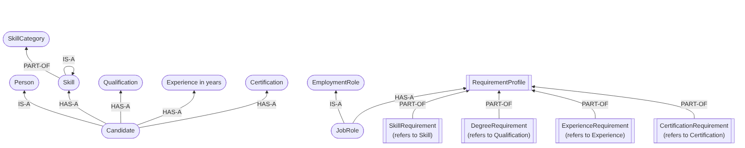
Semantic network 1
A Candidate IS-A Person and a JobRole IS-A EmploymentRole. A Candidate HAS-A Skill, Qualification, Experience and Certification. A JobRole HAS-A RequirementProfile, whose parts (skill, degree, experience and certification requirements) are PART-OF that profile; each requirement refers to the matching concept on the candidate side. A Skill is PART-OF a SkillCategory, and the IS-A loop on Skill stands for the skill taxonomy drawn in network 2.
Semantic network 2: skill taxonomy and categories
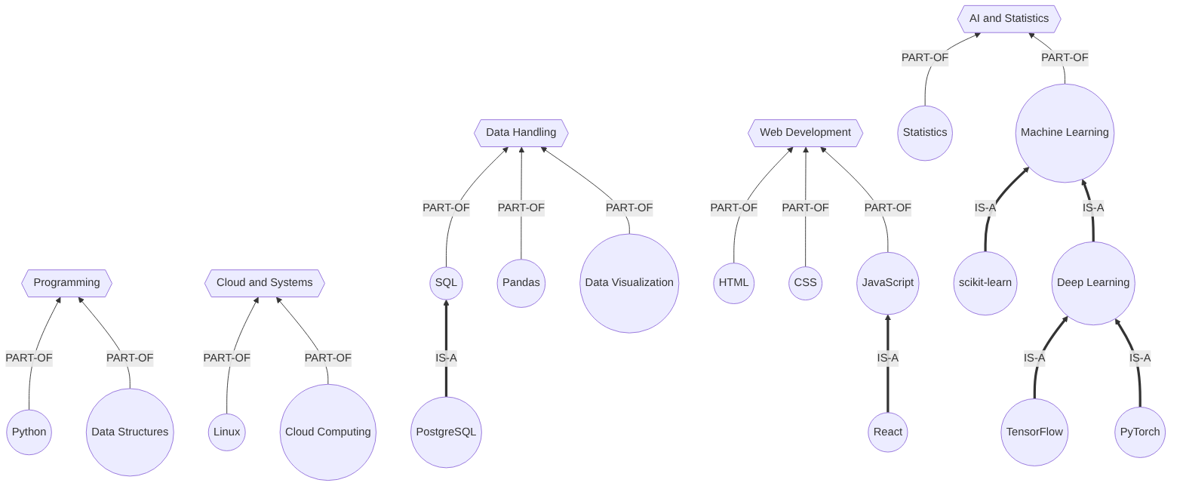
Semantic network 2
Thick arrows are IS-A links between skills. Top-level skills are PART-OF one of five categories; child skills reach their category through their parent.
Semantic network 3: job roles and their requirements
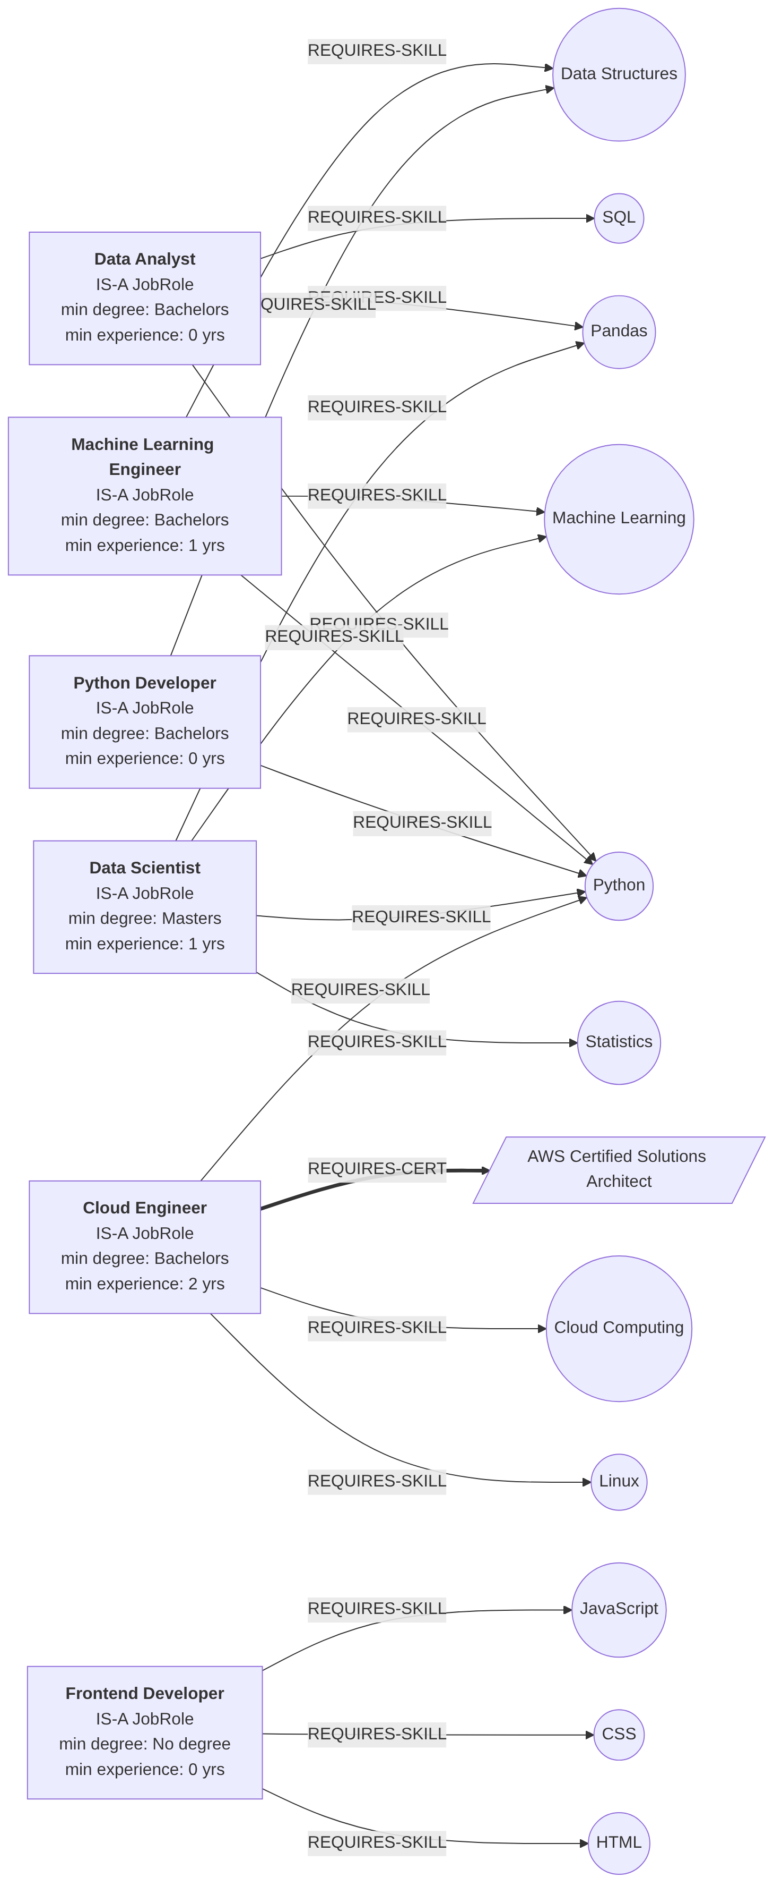
Semantic network 3
Each role box states IS-A JobRole and its minimum degree and experience. Arrows show the mandatory skills (REQUIRES-SKILL) and the one required certificate (REQUIRES-CERT, Cloud Engineer).
Semantic network 4: instance level (sample candidate Zara)
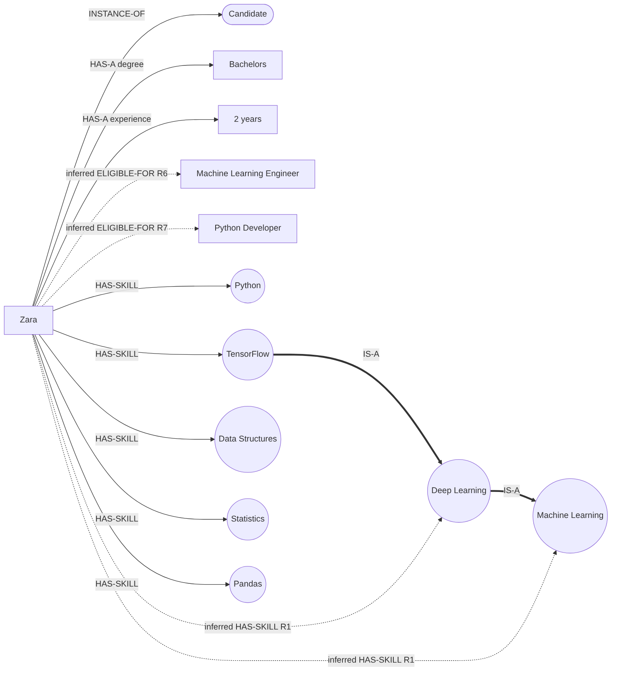
Semantic network 4
How the network supports reasoning (example). Is Zara eligible for Machine Learning Engineer? Network 3 shows the role REQUIRES-SKILL python, machine_learning and data_structures. Network 4 shows HAS-SKILL links from Zara to python and data_structures, but not to machine_learning. Following the IS-A path tensorflow → deep_learning → machine_learning from a skill Zara has fills the gap (two applications of rule R1). Her degree (Bachelors) and experience (2 years) meet the role’s minimums, so the dotted ELIGIBLE-FOR link is inferred (rule R6). The same reasoning appears as a machine trace in Sections 4.6 and 4.7.

2.2 Frame architecture
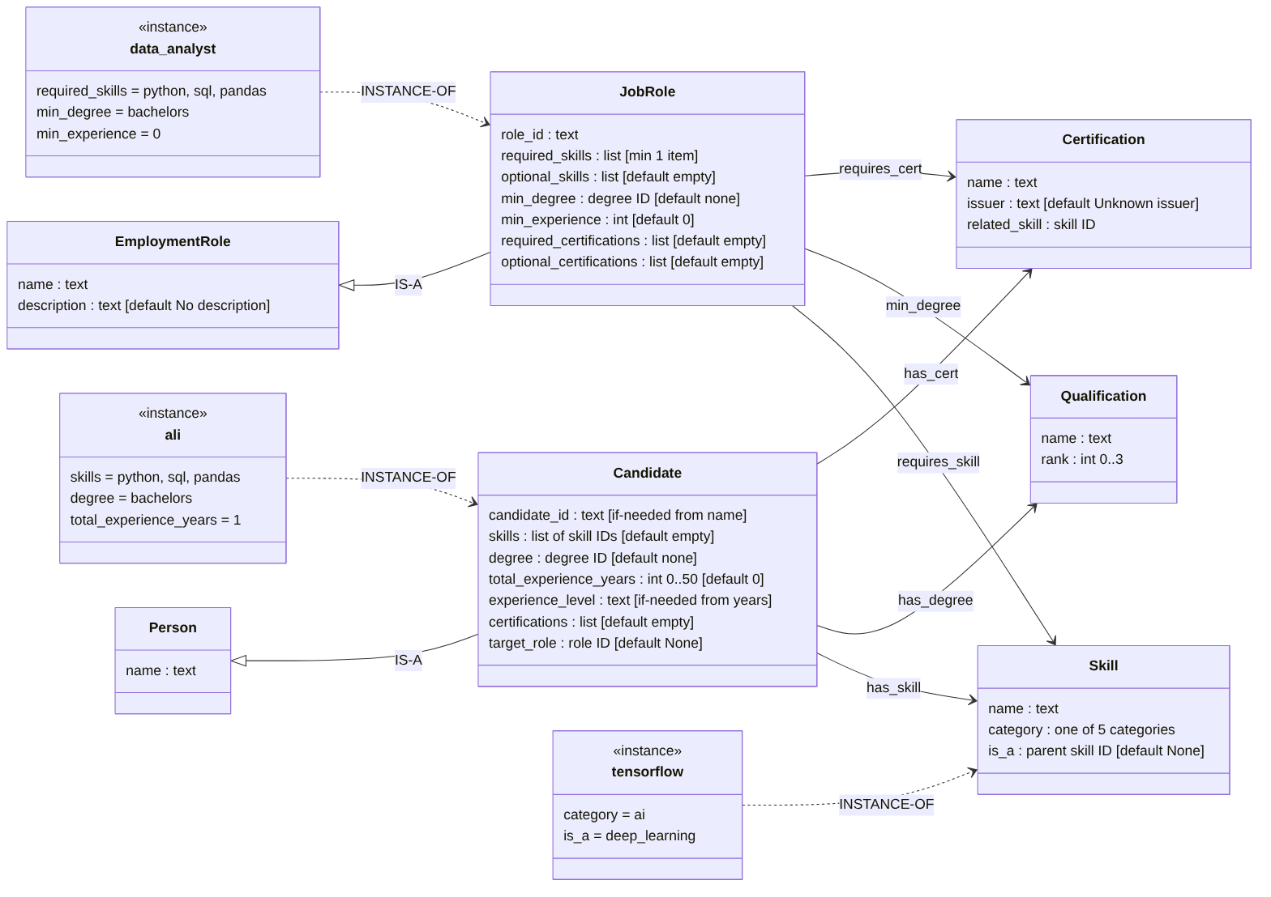
Frame architecture
Class frames are boxes with their slots and facets in brackets. Hollow-triangle arrows are IS-A (the lower frame inherits the slots of the upper frame: Candidate inherits name from Person; JobRole inherits name and description from EmploymentRole). Dotted arrows marked INSTANCE-OF link instance frames (ali, data_analyst, tensorflow) to their class frames. Plain arrows are the relations between frames (has_skill, requires_skill, …).

2.3 Frames: slots, facets and defaults
Frame concept | Python representation
Frame | a dictionary, e.g. JOB_ROLE_FRAMES["cloud_engineer"]
Slot | a key, e.g. "required_certifications"
Filler | the value, e.g. ["aws_solutions_architect"]
Facets | the *_FRAME_TEMPLATE dictionaries: type, required, default, allowed_values, range, min_items, if_needed
Default | copied into an empty slot by create_candidate()
If-needed procedure | a function that computes a slot when it is asked for: make_candidate_id(name), experience_level_if_needed(years)
Candidate frame
Slot | Facets | Default / if-needed
candidate_id | type text; required | if-needed: make_candidate_id(name), e.g. “Omar Ali” → omar_ali
name | type text; required | “Candidate”
skills | list of skill IDs; allowed_values: the 18 skills | []
degree | degree ID; allowed_values: none, bachelors, masters, phd | none
total_experience_years | integer; range 0..50 | 0
experience_level | text | if-needed from years: <2 Entry level, 2 to 4 Mid level, 5+ Senior
certifications | list of certification IDs; allowed_values: the 3 certificates | []
target_role | role ID or None; allowed_values: the 6 roles | None
Facets are enforced: an unknown skill, certificate or degree is removed and reported, a duplicate is kept once, and an experience value that is not a whole number from 0 to 50 is replaced by the default 0 with a warning (unit test 26).
Job Role frame (IS-A EmploymentRole)
Slot | Facets | Default
role_id | text; required | none
name | text; required | none
description | text | “No description.”
required_skills | list of skill IDs; required; min_items 1 | none
optional_skills | list of skill IDs | []
min_degree | degree ID; allowed_values: the 4 degrees | none
min_experience | integer (years) | 0
required_certifications | list of certification IDs | []
optional_certifications | list of certification IDs | []
Skill frame
Slot | Facets | Default
name | text; required | none
category | allowed_values: programming, data, ai, web, cloud | none
is_a | parent skill ID or None; allowed_values: the 18 skills | None (top-level skill)
Qualification frame
Slot | Facets | Values
name | text; required | No degree, Bachelors, Masters, PhD
rank | integer; allowed_values 0..3 | 0, 1, 2, 3
Certification frame
Slot | Facets | Default
name | text; required | none
issuer | text | “Unknown issuer”
related_skill | skill ID | None
Every frame slot now feeds the reasoning, except target_role (used only to pick the default backward chaining goal in the demo), description, issuer and related_skill (display only), and experience_level (a readable label computed from the years).

2.4 Script
RECOMMENDATION_SCRIPT describes the stereotyped sequence of events for one recommendation.
Script part | Content
Entry condition | A candidate wants to know which roles suit their profile
Roles | Candidate, Reasoning System
Props | Skill list, degree, experience, certifications, job role frames, rules
Scene 1 | Candidate enters a name, skills, degree, years of experience and certifications
Scene 2 | System fills the Candidate frame (defaults, if-needed slots, invalid values removed): create_candidate()
Scene 3 | System turns the frame into facts: build_candidate_facts()
Scene 4 | Forward chaining derives inherited skills, meets_degree, meets_experience, eligible and recommended facts: forward_chain()
Scene 5 | System labels each role: recommend_all_roles()
Scene 6 | System lists met and missing requirements (Closed World Assumption) and explains them: explain()
Scene 7 | Candidate asks a specific question; backward chaining tries to prove it: backward_chain()
Result | Candidate sees recommended roles, missing requirements and the reasoning trace

3. Formal Logic Definitions

3.1 Predicates
Variables: x candidate, r job role, s, t skills, c certification, d degree, n, m, y, w integers. Constants are lowercase (zara, tensorflow, data_analyst, 5).
Predicate | Meaning | Stored or derived
Candidate(x), Person(x) | x is a candidate / a person | stored / derived (R15)
Skill(s), JobRole(r), Certification(c) | type facts | stored
IsA(s, t) | skill s is a kind of skill t | stored (Skill frames)
HasSkill(x, s) | x has skill s | stored, and derived through IsA (R1)
HasDegree(x, d) | x’s highest degree is d | stored
DegreeRank(d, n) | degree d has rank n | stored
MinDegreeRank(r, m) | role r needs degree rank at least m | stored
TotalExperienceYears(x, y) | x has y years of experience | stored
MinExperience(r, m) | role r needs at least m years | stored
DegreeWaiverYears(w) | w years of experience waive the degree requirement (w = 5) | stored
HasCert(x, c) | x holds certification c | stored
RequiresSkill(r, s), RequiresCert(r, c) | mandatory skill / required certificate of r | stored
BelongsTo(s, k) | skill s is part of category k | stored
n ≥ m | integer comparison (built-in gte) | computed
MeetsDegree(x, r) | x meets the degree requirement of r | derived (R2, R3)
MeetsExperience(x, r) | x meets the experience requirement of r | derived (R4)
Eligible(x, r) | x is fully eligible for r | derived (R5 to R10)
Recommended(x, r) | r is recommended to x | derived (R11)
MatchedSkill(x, r, s) | r requires s and x has s | derived (R12)
RelevantTo(x, r) | x has at least one mandatory skill of r | derived (R13)
KnowsCategory(x, k) | x has a skill in category k | derived (R14)
PartialMatch(x, r), Missing(x, r, q) | not eligible but relevant / requirement q not met | computed after chaining (CWA)

3.2 First-Order Logic formulas
F1. Skill hierarchy (universal rule). ∀x ∀s ∀t ( IsA(s, t) ∧ HasSkill(x, s) → HasSkill(x, t) ) If s is a kind of t and x has s, x also has t. Rule R1. Applying F1 repeatedly gives the effect of transitivity: from IsA(tensorflow, deep_learning) and IsA(deep_learning, machine_learning), HasSkill(zara, tensorflow) yields HasSkill(zara, machine_learning) in two steps.
F2. Degree requirement. ∀x ∀r ∀d ∀n ∀m ( HasDegree(x, d) ∧ DegreeRank(d, n) ∧ MinDegreeRank(r, m) ∧ n ≥ m → MeetsDegree(x, r) ) x meets the degree requirement if the rank of x’s degree is at least the role’s minimum. Rule R2.
F3. Experience exception for the degree requirement. ∀x ∀r ∀y ∀w ( TotalExperienceYears(x, y) ∧ DegreeWaiverYears(w) ∧ y ≥ w ∧ JobRole(r) → MeetsDegree(x, r) ) Five or more years of experience counts as meeting the degree requirement of every role. Rule R3. F2 and F3 together say MeetsDegree(x, r) ← (degree condition ∨ experience condition), written as two Horn clauses with the same head (Section 4.3).
F4. Experience requirement. ∀x ∀r ∀y ∀m ( TotalExperienceYears(x, y) ∧ MinExperience(r, m) ∧ y ≥ m → MeetsExperience(x, r) ) Rule R4.
F5. General eligibility policy (not a Horn clause). ∀x ∀r ( Candidate(x) ∧ JobRole(r) ∧ ∀s ( RequiresSkill(r, s) → HasSkill(x, s) ) ∧ MeetsDegree(x, r) ∧ MeetsExperience(x, r) ∧ ∀c ( RequiresCert(r, c) → HasCert(x, c) ) → Eligible(x, r) ) x is eligible for r if x has every skill r requires, meets the degree and experience requirements, and holds every certificate r requires. The two inner universal quantifiers sit inside the condition of an implication. Moving them out turns them into existentials, so F5 is not a Horn clause and cannot be executed directly by our engine (Section 3.4).
F6. Compiled instance of F5 for Cloud Engineer (Horn). ∀x ( HasSkill(x, python) ∧ HasSkill(x, linux) ∧ HasSkill(x, cloud_computing) ∧ MeetsDegree(x, cloud_engineer) ∧ MeetsExperience(x, cloud_engineer) ∧ HasCert(x, aws_solutions_architect) → Eligible(x, cloud_engineer) ) Rule R10. Because each role’s required skills and certificates are a fixed, finite, known list, F5 is compiled into one Horn rule per role (R5 to R10). This is equivalent to F5 provided the requires_skill and requires_cert facts are complete, which holds by construction: rules and facts are both generated from the same Job Role frame (unit test 38).
F7. Recommendation. ∀x ∀r ( Eligible(x, r) → Recommended(x, r) ). Rule R11.
F8. Matched skill. ∀x ∀r ∀s ( RequiresSkill(r, s) ∧ HasSkill(x, s) → MatchedSkill(x, r, s) ). Rule R12.
F9. Relevance (existential in the condition). ∀x ∀r ( ∃s MatchedSkill(x, r, s) → RelevantTo(x, r) ), which is logically equivalent to ∀x ∀r ∀s ( MatchedSkill(x, r, s) → RelevantTo(x, r) ). The second form is Horn: rule R13.
F10. Partial match (uses negation, not Horn). ∀x ∀r ( PartialMatch(x, r) ↔ RelevantTo(x, r) ∧ ¬Eligible(x, r) ) Computed after chaining under the Closed World Assumption.
F11. Missing skill (uses negation, not Horn). ∀x ∀r ∀s ( MissingSkill(x, r, s) ↔ RequiresSkill(r, s) ∧ ¬HasSkill(x, s) ) Computed after chaining under the CWA, after the hierarchy rule has added inherited skills, so an inherited skill is never reported as missing. Missing degree, experience and certificate are defined the same way with ¬MeetsDegree, ¬MeetsExperience and ¬HasCert.
F12. Class hierarchy. ∀x ( Candidate(x) → Person(x) ). Rule R15.
F13. Category knowledge. ∀x ∀s ∀k ( HasSkill(x, s) ∧ BelongsTo(s, k) → KnowsCategory(x, k) ). Rule R14.
F14. Every role requires at least one skill (integrity constraint). ∀r ( JobRole(r) → ∃s RequiresSkill(r, s) ) Not run by the engine. Enforced by the min_items: 1 facet and unit test 27. It guarantees “Fully eligible” can never come from an empty requirement list.
F15. A candidate has exactly one recorded degree (integrity constraint, uses equality). ∀x ∀d1 ∀d2 ( HasDegree(x, d1) ∧ HasDegree(x, d2) → d1 = d2 ) Enforced by the Candidate frame, whose degree slot holds one value.
Concrete instances from the knowledge base
Formula | Instance | Conclusion
F1 | IsA(tensorflow, deep_learning) ∧ HasSkill(zara, tensorflow) | HasSkill(zara, deep_learning)
F1 | IsA(deep_learning, machine_learning) ∧ HasSkill(zara, deep_learning) | HasSkill(zara, machine_learning)
F2 | HasDegree(hamza, bachelors) ∧ DegreeRank(bachelors, 1) ∧ MinDegreeRank(data_scientist, 2) ∧ 1 ≥ 2 | premise 1 ≥ 2 is false: no conclusion
F3 | TotalExperienceYears(usman, 6) ∧ DegreeWaiverYears(5) ∧ 6 ≥ 5 ∧ JobRole(python_developer) | MeetsDegree(usman, python_developer)
F6 | ayesha meets all premises except HasCert(ayesha, aws_solutions_architect) | Eligible(ayesha, cloud_engineer) not derived
F10 | RelevantTo(ayesha, cloud_engineer) ∧ ¬Eligible(ayesha, cloud_engineer) | PartialMatch(ayesha, cloud_engineer)

3.3 Description Logic axioms
Notation: ⊑ subsumption, ≡ equivalence, ⊓ intersection, ⊔ union, ⊥ empty concept, ⊤ top, ∃R.C existential restriction, ∀R.C value restriction, ≤1 R number restriction, {a} nominal, a : C concept membership, R(a, b) role membership. Roles (DL properties): hasSkill, hasDegree, hasCert, requiresSkill, requiresCert, belongsTo. Concrete (data) property: experienceYears, with integer facets such as ≥5 (as in ALC(D) or OWL 2 datatype restrictions).
In the DL model, skills are concepts (PythonSkill, TensorFlowSkill, …), so the skill taxonomy becomes ordinary subsumption. The Python fact has_skill(zara, tensorflow) corresponds to the assertion zara : ∃hasSkill.TensorFlowSkill.

3.3.1 Subsumption (TBox)
Axiom | Meaning
Candidate ⊑ Person | every candidate is a person
JobRole ⊑ EmploymentRole | every job role is an employment role
DataAnalyst ⊑ JobRole, MLEngineer ⊑ JobRole, PythonDeveloper ⊑ JobRole, FrontendDeveloper ⊑ JobRole, DataScientist ⊑ JobRole, CloudEngineer ⊑ JobRole | the six role classes
TensorFlowSkill ⊑ DeepLearningSkill, PyTorchSkill ⊑ DeepLearningSkill | skill taxonomy
DeepLearningSkill ⊑ MachineLearningSkill, ScikitLearnSkill ⊑ MachineLearningSkill | skill taxonomy
ReactSkill ⊑ JavaScriptSkill, PostgreSQLSkill ⊑ SQLSkill | skill taxonomy
PythonSkill ⊑ Skill, …, CloudComputingSkill ⊑ Skill (all 18) | every skill class is a Skill
Bachelors ⊑ Degree, Masters ⊑ Degree, PhD ⊑ Degree, NoDegree ⊑ Degree | degree levels
BachelorsOrHigher ≡ Bachelors ⊔ Masters ⊔ PhD | defined concept used by role axioms
MastersOrHigher ≡ Masters ⊔ PhD | defined concept
Entailment that mirrors rule R1. From zara : ∃hasSkill.TensorFlowSkill and TensorFlowSkill ⊑ DeepLearningSkill ⊑ MachineLearningSkill, a DL reasoner concludes zara : ∃hasSkill.MachineLearningSkill, because ∃R.C ⊑ ∃R.D whenever C ⊑ D.

3.3.2 Disjointness
Axiom | Justification
Person ⊓ Skill ⊑ ⊥ | nothing is both a person and a skill
Person ⊓ JobRole ⊑ ⊥ | a person is not a job role
Skill ⊓ Certification ⊑ ⊥, Skill ⊓ Degree ⊑ ⊥, Degree ⊓ Certification ⊑ ⊥ | different kinds of thing
Bachelors ⊓ Masters ⊑ ⊥ (and every other pair of degree levels) | a degree record has exactly one level
DataAnalyst ⊓ PythonDeveloper ⊑ ⊥ (and every other pair of the six role classes) | the role classes contain job positions, and each position in our model has one role type. This does not stop a candidate from qualifying for two roles: eligibility is a relation between a candidate and a role, not class membership. Usman is eligible for both Data Analyst and Python Developer and the axiom still holds.
(no disjointness along the taxonomy) | TensorFlowSkill and DeepLearningSkill are deliberately not disjoint: one is a subclass of the other

3.3.3 Restrictions
Axiom | Meaning
JobRole ⊑ ∃requiresSkill.Skill | every role requires at least one skill (F14)
∃hasSkill.⊤ ⊑ Candidate | only candidates have skills (domain of hasSkill)
⊤ ⊑ ∀hasSkill.Skill | anything had as a skill is a Skill (range of hasSkill)
Candidate ⊑ ≤1 hasDegree | a candidate has at most one recorded degree (F15)
Skill ⊑ ∃belongsTo.SkillCategory | every skill belongs to a category
CloudEngineer ⊑ ∃requiresSkill.PythonSkill ⊓ ∃requiresSkill.LinuxSkill ⊓ ∃requiresSkill.CloudComputingSkill ⊓ ∃requiresCert.{aws_solutions_architect} | Cloud Engineer requirements (one axiom of this form per role)

3.3.4 Defined eligibility concepts
MeetsDegreeBachelorsRole ≡ Candidate ⊓ ( ∃hasDegree.BachelorsOrHigher ⊔ ∃experienceYears.≥5 ) A candidate meets a Bachelors-level requirement if they hold a Bachelors or higher, or have at least 5 years of experience. This is rules R2 and R3 in one DL axiom: DL allows ⊔ inside a definition, Horn clauses do not.
EligibleCloudEngineer ≡ Candidate ⊓ ∃hasSkill.PythonSkill ⊓ ∃hasSkill.LinuxSkill ⊓ ∃hasSkill.CloudComputingSkill ⊓ ( ∃hasDegree.BachelorsOrHigher ⊔ ∃experienceYears.≥5 ) ⊓ ∃experienceYears.≥2 ⊓ ∃hasCert.{aws_solutions_architect}
EligibleMLEngineer ≡ Candidate ⊓ ∃hasSkill.PythonSkill ⊓ ∃hasSkill.MachineLearningSkill ⊓ ∃hasSkill.DataStructuresSkill ⊓ ( ∃hasDegree.BachelorsOrHigher ⊔ ∃experienceYears.≥5 ) ⊓ ∃experienceYears.≥1

3.3.5 Membership (ABox)
Assertion | Meaning
zara : Candidate | Zara is a candidate
zara : ∃hasSkill.PythonSkill ⊓ ∃hasSkill.TensorFlowSkill ⊓ ∃hasSkill.DataStructuresSkill ⊓ ∃hasSkill.StatisticsSkill ⊓ ∃hasSkill.PandasSkill | Zara’s listed skills
hasDegree(zara, deg_zara), deg_zara : Bachelors | Zara holds a Bachelors
experienceYears(zara, 2) | 2 years of experience
usman : Candidate, hasDegree(usman, deg_usman), deg_usman : NoDegree, experienceYears(usman, 6) | Usman
aws_solutions_architect : Certification | an individual certificate
Expected entailments: zara : Person; zara : ∃hasSkill.MachineLearningSkill; zara : EligibleMLEngineer; usman : MeetsDegreeBachelorsRole (through the ⊔ branch ∃experienceYears.≥5). These match the engine’s results for scenarios D and F.
Consistency check (by hand). No individual is asserted into two disjoint concepts: each degree record has one level; candidates are only Persons; skills, degrees and certificates are separate. The taxonomy has no cycles (unit test 14).

3.3.6 Open world versus closed world
DL uses the Open World Assumption: if the ABox does not say Ayesha holds the AWS certificate, a DL reasoner concludes neither that she has it nor that she lacks it. So DL alone cannot conclude “Ayesha is missing the certificate” or “Ayesha is a partial match”. Our engine adds the Closed World Assumption on purpose, only for those outputs (Section 4.4).
Scope statement. These axioms formally describe the domain. The Python program does not contain a Description Logic reasoner. The parts of the model that are Horn-expressible are executed as rules: Candidate ⊑ Person (R15), the skill subsumptions (as is_a facts plus R1), the ⊔ in MeetsDegree (as R2 plus R3), and the eligibility definitions (R5 to R10).

3.4 Limitations analysis

Propositional logic versus FOL in this domain
Propositional logic has only true/false symbols with no structure. “Zara has TensorFlow” must be a symbol such as Zara_has_TensorFlow. With n candidates the model needs:
- 18n symbols for skills, 3n for certificates, 4n for degrees;
- the hierarchy rule written 6 times per candidate (one per is_a pair), so 6n rules, and repeated again for every new skill;
- for experience, one symbol per candidate per possible value (Zara_years_2), with no way to say “at least 2”. Each threshold must be spelled out, e.g. Zara_years_2 ∨ Zara_years_3 ∨ ... ∨ Zara_years_50 → Zara_meets_exp_Cloud, about 50 literals per candidate per role;
- one eligibility rule per role per candidate: 6n rules.
FOL replaces all of this with a fixed set of formulas (F1 to F15) that use variables, quantifiers and the comparison n ≥ m. A new candidate needs only new facts.

Why FOL is expressive but costly
Entailment in full FOL is semi-decidable. If a conclusion follows, a complete prover will eventually find a proof; if it does not follow, the prover may run forever, and no algorithm can always answer “no” in finite time. Even when answers exist, general resolution can be very slow.

Why a restricted Horn engine fits this project
Our executable rules are function-free Horn clauses over a finite set of constants (a Datalog-style fragment) plus one built-in comparison, gte, applied only to integers that are already in the facts. gte never creates new constants, so the set of possible facts is finite. Forward chaining therefore always reaches a fixed point after a finite number of passes, and each step is simple pattern matching a student can trace by hand.

Expressivity versus tractability
Logic | What it can express | Reasoning | Role in this project
Propositional logic | ground true/false statements only | decidable; SAT is NP-complete; Horn-SAT is linear time | used above only to show why it does not scale
First-Order Logic | variables, quantifiers, negation, disjunction, nested quantifiers (F5) | semi-decidable (undecidable in general) | formal specification (F1 to F15)
Description Logic (ALC with nominals, number restrictions, datatype facets) | classes, subsumption, ⊔ and ¬ in concepts, restrictions, disjointness | decidable but can be expensive (ALC concept satisfiability with a general TBox is EXPTIME-complete) | ontology of the domain (Section 3.3)
Horn clauses (function-free, finite constants, + gte) | “if all of these then that”; no negation, no disjunction in the head, no nested quantifier | decidable; forward chaining reaches a fixed point | the executable rules R1 to R15
What we gave up, and how each gap is handled:
Lost in Horn | Example in our domain | How the project handles it
Universal quantifier inside a condition | F5: “for every required skill s, x has s” | compiled into one Horn rule per role (R5 to R10), generated from the frames
Disjunction in a condition | MeetsDegree ← degree condition ∨ 5+ years | split into two Horn rules with the same head (R2, R3), since (A ∨ B) → C ≡ (A → C) ∧ (B → C)
Negation | PartialMatch, Missing (F10, F11) | computed after chaining with the CWA, outside the rules (Section 4.4)
Disjunction in a conclusion | “a candidate is junior or senior” | not needed in this domain
The design uses FOL and DL to describe the domain completely and precisely, including the parts with negation, disjunction and nested quantifiers, and uses Horn clauses to execute the positive, tractable part with a trace.

4. Horn Clause Knowledge Base and Chaining Trace Sheets
Notation: Prolog style, head :- body. Variables start with an uppercase letter. Constants are lowercase words or whole numbers. gte(A, B) means A ≥ B and is computed by the engine.

4.1 Facts
The program builds 87 domain facts from the frames (18 skill, 18 belongs_to, 18 requires_skill, 6 job_role, 6 min_experience, 6 min_degree_rank, 6 is_a, 4 degree_rank, 3 certification, 1 degree_waiver_years, 1 requires_cert), plus each candidate’s facts. Selected domain facts:
% skill taxonomy (all 6)
is_a(tensorflow, deep_learning). is_a(pytorch, deep_learning).
is_a(deep_learning, machine_learning). is_a(scikit_learn, machine_learning).
is_a(react, javascript). is_a(postgresql, sql).
% degree ranks (all 4) and the waiver threshold
degree_rank(none, 0). degree_rank(bachelors, 1). degree_rank(masters, 2). degree_rank(phd, 3).
degree_waiver_years(5).
% role requirements, two roles shown
requires_skill(ml_engineer, python). requires_skill(ml_engineer, machine_learning).
requires_skill(ml_engineer, data_structures).
min_degree_rank(ml_engineer, 1). min_experience(ml_engineer, 1).
requires_skill(cloud_engineer, python). requires_skill(cloud_engineer, linux).
requires_skill(cloud_engineer, cloud_computing).
min_degree_rank(cloud_engineer, 1). min_experience(cloud_engineer, 2).
requires_cert(cloud_engineer, aws_solutions_architect).
Candidate facts for Zara (scenario D), exactly as printed by the program:
candidate(zara).
has_degree(zara, bachelors).
has_skill(zara, data_structures).
has_skill(zara, pandas).
has_skill(zara, python).
has_skill(zara, statistics).
has_skill(zara, tensorflow).
total_experience_years(zara, 2).

4.2 Rules R1 to R15
ID | Horn clause | Meaning | FOL
R1 | has_skill(X, T) :- is_a(S, T), has_skill(X, S). | If S is a kind of T and X has S, then X also has T. | F1
R2 | meets_degree(X, R) :- has_degree(X, D), degree_rank(D, N), min_degree_rank(R, M), gte(N, M). | X meets the degree requirement of R if the rank of X’s degree is at least R’s minimum rank. | F2
R3 | meets_degree(X, R) :- total_experience_years(X, Y), degree_waiver_years(W), gte(Y, W), job_role(R). | EXCEPTION: 5 or more years of experience counts as meeting the degree requirement of every role. | F3
R4 | meets_experience(X, R) :- total_experience_years(X, Y), min_experience(R, M), gte(Y, M). | X meets the experience requirement of R if X’s years are at least R’s minimum. | F4
R5 | eligible(X, data_analyst) :- has_skill(X, python), has_skill(X, sql), has_skill(X, pandas), meets_degree(X, data_analyst), meets_experience(X, data_analyst). | X is eligible for Data Analyst if X has every mandatory skill, meets the degree and experience requirements. | F5 / F6
R6 | eligible(X, ml_engineer) :- has_skill(X, python), has_skill(X, machine_learning), has_skill(X, data_structures), meets_degree(X, ml_engineer), meets_experience(X, ml_engineer). | X is eligible for Machine Learning Engineer if X has every mandatory skill, meets the degree and experience requirements. | F5 / F6
R7 | eligible(X, python_developer) :- has_skill(X, python), has_skill(X, data_structures), meets_degree(X, python_developer), meets_experience(X, python_developer). | X is eligible for Python Developer if X has every mandatory skill, meets the degree and experience requirements. | F5 / F6
R8 | eligible(X, frontend_developer) :- has_skill(X, html), has_skill(X, css), has_skill(X, javascript), meets_degree(X, frontend_developer), meets_experience(X, frontend_developer). | X is eligible for Frontend Developer if X has every mandatory skill, meets the degree and experience requirements. | F5 / F6
R9 | eligible(X, data_scientist) :- has_skill(X, python), has_skill(X, statistics), has_skill(X, machine_learning), has_skill(X, pandas), meets_degree(X, data_scientist), meets_experience(X, data_scientist). | X is eligible for Data Scientist if X has every mandatory skill, meets the degree and experience requirements. | F5 / F6
R10 | eligible(X, cloud_engineer) :- has_skill(X, python), has_skill(X, linux), has_skill(X, cloud_computing), meets_degree(X, cloud_engineer), meets_experience(X, cloud_engineer), has_cert(X, aws_solutions_architect). | X is eligible for Cloud Engineer if X has every mandatory skill, meets the degree and experience requirements and every required certification. | F5 / F6
R11 | recommended(X, R) :- eligible(X, R). | If X is eligible for role R, then R is recommended to X. | F7
R12 | matched_skill(X, R, S) :- requires_skill(R, S), has_skill(X, S). | S is a matched skill of X for R if R requires S and X has S. | F8
R13 | relevant_to(X, R) :- matched_skill(X, R, S). | X is relevant to R if X has at least one skill that R requires. | F9
R14 | knows_category(X, C) :- has_skill(X, S), belongs_to(S, C). | X knows category C if X has some skill S that belongs to C. | F13
R15 | person(X) :- candidate(X). | Every candidate is a person. | F12
In Python each rule is a dictionary, for example R1:
{"id": "R1",
"head": ("has_skill", "X", "T"),
"body": [("is_a", "S", "T"), ("has_skill", "X", "S")]}
Rules R5 to R10 are generated by build_rules() from JOB_ROLE_FRAMES, so a change to a frame changes its rule automatically.

4.3 Why every rule is a Horn clause, and three design points
A Horn clause has at most one positive literal. The rule H :- B1, ..., Bn. is the clause ¬B1 ∨ … ∨ ¬Bn ∨ H: exactly one positive literal (H). All 15 rules have one head and only positive premises (unit test 36).
1. Built-in comparison. gte(N, M) is a premise with a fixed meaning (N ≥ M) that the engine computes instead of looking up. Both arguments must already have values when it is reached, so it is always placed after the premises that bind them. Unit test 37 checks this for every rule.
2. Disjunction split into two rules. R2 and R3 have the same head meets_degree(X, R). Together they mean “degree condition OR experience condition”, which a single Horn clause cannot say.
3. Left recursion in R1. R1 is recursive: has_skill appears in its head and its body. In backward chaining, the order of the body matters:
- Bad order: has_skill(X, T) :- has_skill(X, S), is_a(S, T). To prove has_skill(zara, machine_learning), the first sub-goal is has_skill(zara, S) with S unknown. That sub-goal matches the head of the same rule, whose first sub-goal is again has_skill(zara, S'), and so on forever, before is_a is ever checked. This is left recursion, the classic way depth-first SLD resolution (as in Prolog) fails to terminate.
- Our order: has_skill(X, T) :- is_a(S, T), has_skill(X, S). The first sub-goal is_a(S, machine_learning) is answered from facts only and binds S to a concrete child skill (deep_learning or scikit_learn). The recursive call is then about a skill that is one level lower in the taxonomy. The taxonomy is finite and has no cycles (unit test 14), so the recursion must stop. Unit test 13 runs goals with unbound skills and confirms they terminate.
Forward chaining does not have this problem with either order, because it works bottom-up from facts and stops at a fixed point.

4.4 Closed World Assumption for “missing” and “partial match”
Horn clauses cannot contain negation, so F10 (partial match) and F11 (missing requirement) are not rules. After forward chaining reaches its fixed point, recommend_all_roles() applies the Closed World Assumption: a fact that is not in working memory is false.
- A mandatory skill is missing if has_skill(x, s) is not in working memory. Inherited skills are already there (R1), so they are never reported as missing.
- The degree / experience requirement is missing if meets_degree(x, r) / meets_experience(x, r) is not there.
- A certificate is missing if has_cert(x, c) is not there.
- Partial match = relevant_to(x, r) is there and eligible(x, r) is not.
This is the same idea as Prolog’s negation as failure (\+). It is applied once, outside the rules, and clearly labelled in the interface.

4.5 Queries and answers
All answers below were produced by backward_chain().
Query | Answer | How
?- eligible(ali, data_analyst). | PROVED | R5; skills are facts; R2 and R4 succeed
?- eligible(sara, data_analyst). | NOT PROVED | R5 fails at has_skill(sara, sql); R1 tries postgresql and fails
?- has_skill(zara, machine_learning). | PROVED | R1 twice: deep_learning, then tensorflow
?- recommended(zara, R). | R = ml_engineer; R = python_developer | R11, then R6 and R7 succeed
?- meets_degree(hamza, data_scientist). | NOT PROVED | R2 fails at gte(1, 2); R3 fails at gte(3, 5)
?- meets_degree(usman, python_developer). | PROVED | R2 fails at gte(0, 1); R3 succeeds with gte(6, 5)
?- eligible(ayesha, cloud_engineer). | NOT PROVED | R10 fails at has_cert(ayesha, aws_solutions_architect)
?- has_skill(bilal, javascript). | PROVED | R1 with is_a(react, javascript)
?- person(omar). | PROVED | R15
?- knows_category(zara, C). | C = programming; C = data; C = ai | R14, using inherited skills too

4.6 Forward chaining: algorithm and trace sheet
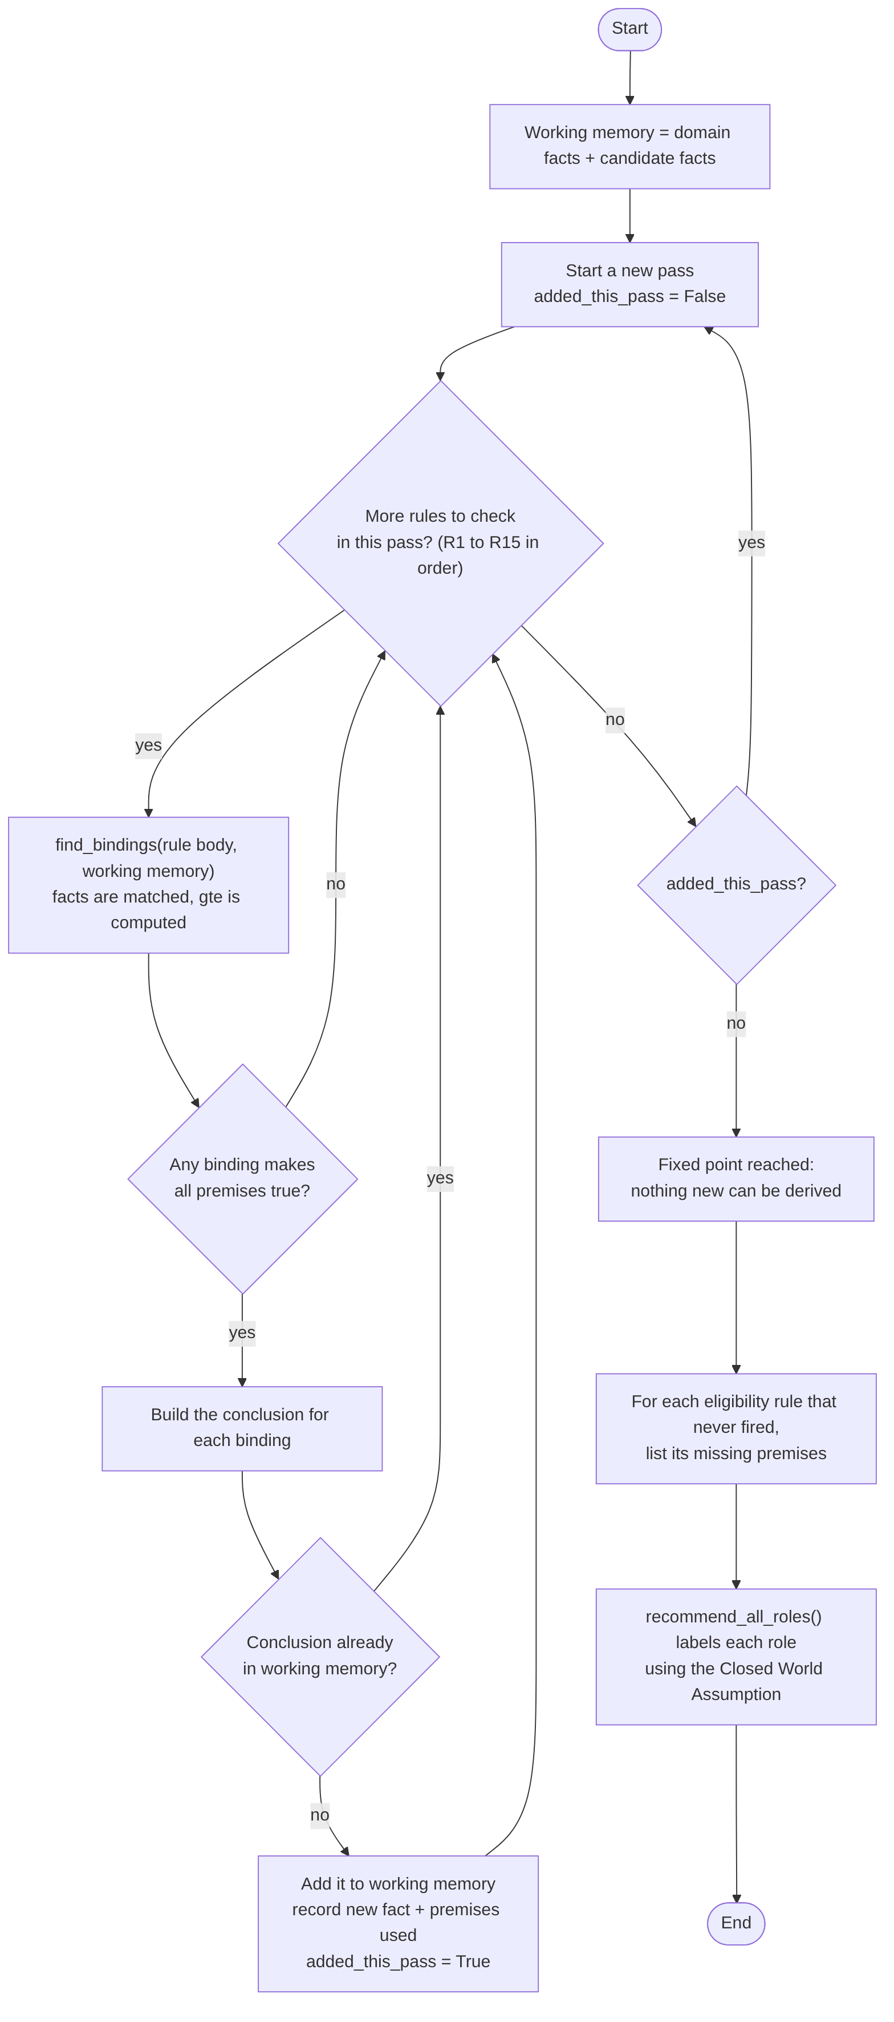
Forward chaining flowchart
Algorithm (forward_chain()):
working_memory ← domain facts ∪ candidate facts
repeat // one PASS
added ← false
for each rule R1 .. R15, in order:
bindings ← every binding that makes all premises true
(facts are matched with unify(); gte is computed)
for each binding:
conclusion ← head with variables replaced
if conclusion ∉ working_memory:
add it; record (rule, conclusion, premises used); added ← true
until added = false // FIXED POINT
for each eligibility rule that never fired: record its missing premises
Trace sheet: scenario D, Zara (skill hierarchy). Every line below is copied from sample_outputs.txt (the output of python demo.py).
Initial candidate facts:
candidate(zara).
has_degree(zara, bachelors).
has_skill(zara, data_structures).
has_skill(zara, pandas).
has_skill(zara, python).
has_skill(zara, statistics).
has_skill(zara, tensorflow).
total_experience_years(zara, 2).
Trace (only rules that produced new facts are listed):
[pass 1] R1 -> has_skill(zara, deep_learning) because is_a(tensorflow, deep_learning), has_skill(zara, tensorflow)
[pass 1] R2 -> meets_degree(zara, cloud_engineer) because has_degree(zara, bachelors), degree_rank(bachelors, 1), min_degree_rank(cloud_engineer, 1), gte(1, 1)
[pass 1] R2 -> meets_degree(zara, data_analyst) because has_degree(zara, bachelors), degree_rank(bachelors, 1), min_degree_rank(data_analyst, 1), gte(1, 1)
[pass 1] R2 -> meets_degree(zara, frontend_developer) because has_degree(zara, bachelors), degree_rank(bachelors, 1), min_degree_rank(frontend_developer, 0), gte(1, 0)
[pass 1] R2 -> meets_degree(zara, ml_engineer) because has_degree(zara, bachelors), degree_rank(bachelors, 1), min_degree_rank(ml_engineer, 1), gte(1, 1)
[pass 1] R2 -> meets_degree(zara, python_developer) because has_degree(zara, bachelors), degree_rank(bachelors, 1), min_degree_rank(python_developer, 1), gte(1, 1)
[pass 1] R4 -> meets_experience(zara, cloud_engineer) because total_experience_years(zara, 2), min_experience(cloud_engineer, 2), gte(2, 2)
[pass 1] R4 -> meets_experience(zara, data_analyst) because total_experience_years(zara, 2), min_experience(data_analyst, 0), gte(2, 0)
[pass 1] R4 -> meets_experience(zara, data_scientist) because total_experience_years(zara, 2), min_experience(data_scientist, 1), gte(2, 1)
[pass 1] R4 -> meets_experience(zara, frontend_developer) because total_experience_years(zara, 2), min_experience(frontend_developer, 0), gte(2, 0)
[pass 1] R4 -> meets_experience(zara, ml_engineer) because total_experience_years(zara, 2), min_experience(ml_engineer, 1), gte(2, 1)
[pass 1] R4 -> meets_experience(zara, python_developer) because total_experience_years(zara, 2), min_experience(python_developer, 0), gte(2, 0)
[pass 1] R7 -> eligible(zara, python_developer) because has_skill(zara, python), has_skill(zara, data_structures), meets_degree(zara, python_developer), meets_experience(zara, python_developer)
[pass 1] R11 -> recommended(zara, python_developer) because eligible(zara, python_developer)
[pass 1] R12 -> matched_skill(zara, cloud_engineer, python) because requires_skill(cloud_engineer, python), has_skill(zara, python)
[pass 1] R12 -> matched_skill(zara, data_analyst, pandas) because requires_skill(data_analyst, pandas), has_skill(zara, pandas)
[pass 1] R12 -> matched_skill(zara, data_analyst, python) because requires_skill(data_analyst, python), has_skill(zara, python)
[pass 1] R12 -> matched_skill(zara, data_scientist, pandas) because requires_skill(data_scientist, pandas), has_skill(zara, pandas)
[pass 1] R12 -> matched_skill(zara, data_scientist, python) because requires_skill(data_scientist, python), has_skill(zara, python)
[pass 1] R12 -> matched_skill(zara, data_scientist, statistics) because requires_skill(data_scientist, statistics), has_skill(zara, statistics)
[pass 1] R12 -> matched_skill(zara, ml_engineer, data_structures) because requires_skill(ml_engineer, data_structures), has_skill(zara, data_structures)
[pass 1] R12 -> matched_skill(zara, ml_engineer, python) because requires_skill(ml_engineer, python), has_skill(zara, python)
[pass 1] R12 -> matched_skill(zara, python_developer, data_structures) because requires_skill(python_developer, data_structures), has_skill(zara, data_structures)
[pass 1] R12 -> matched_skill(zara, python_developer, python) because requires_skill(python_developer, python), has_skill(zara, python)
[pass 1] R13 -> relevant_to(zara, cloud_engineer) because matched_skill(zara, cloud_engineer, python)
[pass 1] R13 -> relevant_to(zara, data_analyst) because matched_skill(zara, data_analyst, pandas)
[pass 1] R13 -> relevant_to(zara, data_scientist) because matched_skill(zara, data_scientist, pandas)
[pass 1] R13 -> relevant_to(zara, ml_engineer) because matched_skill(zara, ml_engineer, data_structures)
[pass 1] R13 -> relevant_to(zara, python_developer) because matched_skill(zara, python_developer, data_structures)
[pass 1] R14 -> knows_category(zara, programming) because has_skill(zara, data_structures), belongs_to(data_structures, programming)
[pass 1] R14 -> knows_category(zara, ai) because has_skill(zara, deep_learning), belongs_to(deep_learning, ai)
[pass 1] R14 -> knows_category(zara, data) because has_skill(zara, pandas), belongs_to(pandas, data)
[pass 1] R15 -> person(zara) because candidate(zara)
[pass 2] R1 -> has_skill(zara, machine_learning) because is_a(deep_learning, machine_learning), has_skill(zara, deep_learning)
[pass 2] R6 -> eligible(zara, ml_engineer) because has_skill(zara, python), has_skill(zara, machine_learning), has_skill(zara, data_structures), meets_degree(zara, ml_engineer), meets_experience(zara, ml_engineer)
[pass 2] R11 -> recommended(zara, ml_engineer) because eligible(zara, ml_engineer)
[pass 2] R12 -> matched_skill(zara, data_scientist, machine_learning) because requires_skill(data_scientist, machine_learning), has_skill(zara, machine_learning)
[pass 2] R12 -> matched_skill(zara, ml_engineer, machine_learning) because requires_skill(ml_engineer, machine_learning), has_skill(zara, machine_learning)
[pass 3] no new facts: fixed point reached
Total new facts derived: 38 in 3 passes
Eligibility rules still unsatisfied at the fixed point:
R5 eligible(zara, data_analyst) missing: has_skill(zara, sql)
R8 eligible(zara, frontend_developer) missing: has_skill(zara, html), has_skill(zara, css), has_skill(zara, javascript)
R9 eligible(zara, data_scientist) missing: meets_degree(zara, data_scientist)
R10 eligible(zara, cloud_engineer) missing: has_skill(zara, linux), has_skill(zara, cloud_computing), has_cert(zara, aws_solutions_architect)
Reading the trace. - Pass 1, R1 derives has_skill(zara, deep_learning) from the stored tensorflow fact. - In pass 1, R1 cannot also derive machine_learning, because each rule matches against the working memory as it was when that rule started. So has_skill(zara, machine_learning) appears in pass 2. The ML Engineer rule R6 fires in pass 2, followed by R11. - Pass 3 adds nothing, so chaining stops at the fixed point. - The Data Scientist rule stays unsatisfied only because of meets_degree(zara, data_scientist) (Masters needed). The Data Analyst rule stays unsatisfied only because of has_skill(zara, sql).
Shorter trace sheet: scenario F, Usman (experience exception). Lines selected from the full output:
[pass 1] R1 -> has_skill(usman, sql) because is_a(postgresql, sql), has_skill(usman, postgresql)
[pass 1] R3 -> meets_degree(usman, cloud_engineer) because total_experience_years(usman, 6), degree_waiver_years(5), gte(6, 5), job_role(cloud_engineer)
[pass 1] R3 -> meets_degree(usman, data_analyst) because total_experience_years(usman, 6), degree_waiver_years(5), gte(6, 5), job_role(data_analyst)
[pass 1] R3 -> meets_degree(usman, data_scientist) because total_experience_years(usman, 6), degree_waiver_years(5), gte(6, 5), job_role(data_scientist)
[pass 1] R3 -> meets_degree(usman, ml_engineer) because total_experience_years(usman, 6), degree_waiver_years(5), gte(6, 5), job_role(ml_engineer)
[pass 1] R3 -> meets_degree(usman, python_developer) because total_experience_years(usman, 6), degree_waiver_years(5), gte(6, 5), job_role(python_developer)
[pass 1] R5 -> eligible(usman, data_analyst) because has_skill(usman, python), has_skill(usman, sql), has_skill(usman, pandas), meets_degree(usman, data_analyst), meets_experience(usman, data_analyst)
[pass 1] R7 -> eligible(usman, python_developer) because has_skill(usman, python), has_skill(usman, data_structures), meets_degree(usman, python_developer), meets_experience(usman, python_developer)
[pass 1] R11 -> recommended(usman, data_analyst) because eligible(usman, data_analyst)
[pass 1] R11 -> recommended(usman, python_developer) because eligible(usman, python_developer)
[pass 2] no new facts: fixed point reached
Total new facts derived: 35 in 2 passes

4.7 Backward chaining: algorithm and trace sheets
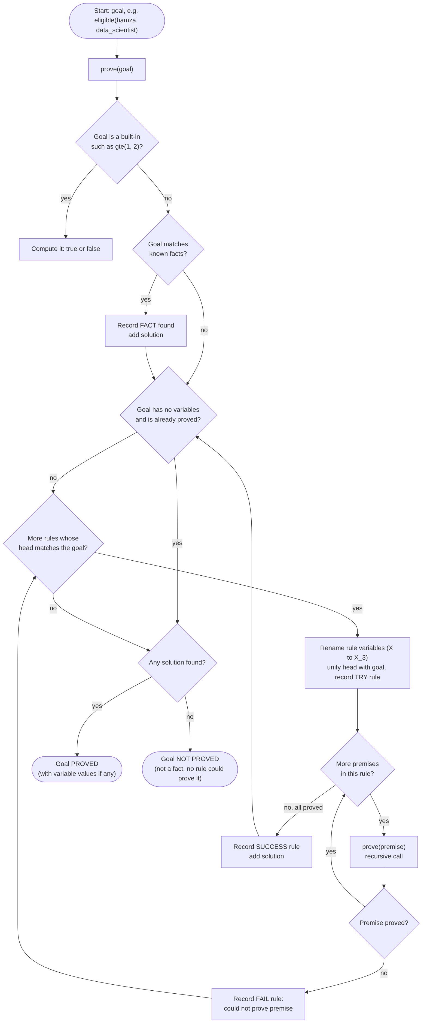
Backward chaining flowchart
Algorithm (backward_chain()):
prove(goal):
if goal is a built-in (gte): compute it, return true/false
for each fact that unifies with goal: record FACT found, add solution
(a goal with no variables stops after its first proof)
for each rule whose head unifies with goal:
rename the rule's variables (X → X_7) so separate uses do not clash
record TRY rule
prove each premise in order, keeping the bindings
if a premise cannot be proved: record FAIL rule, try the next rule
if all premises are proved: record SUCCESS rule, add solution
if no solution: record NOT PROVED
It is a small depth-first Horn-clause prover, not a full Prolog: no cut, no negation, no function symbols. A depth limit of 12 is a safety stop; the only recursive rule (R1) stops on its own as explained in Section 4.3. Renamed variables such as D_6 appear in the trace.
Trace sheet 1: success through the skill hierarchy. Goal eligible(zara, ml_engineer).
GOAL: eligible(zara, ml_engineer)
TRY rule R6: eligible(X, ml_engineer) :- has_skill(X, python), has_skill(X, machine_learning), has_skill(X, data_structures), meets_degree(X, ml_engineer), meets_experience(X, ml_engineer).
GOAL: has_skill(zara, python)
FACT found: has_skill(zara, python)
GOAL: has_skill(zara, machine_learning)
TRY rule R1: has_skill(X, T) :- is_a(S, T), has_skill(X, S).
GOAL: is_a(S_3, machine_learning)
FACT found: is_a(deep_learning, machine_learning)
FACT found: is_a(scikit_learn, machine_learning)
GOAL: has_skill(zara, deep_learning)
TRY rule R1: has_skill(X, T) :- is_a(S, T), has_skill(X, S).
GOAL: is_a(S_4, deep_learning)
FACT found: is_a(pytorch, deep_learning)
FACT found: is_a(tensorflow, deep_learning)
GOAL: has_skill(zara, pytorch)
TRY rule R1: has_skill(X, T) :- is_a(S, T), has_skill(X, S).
GOAL: is_a(S_5, pytorch)
NOT PROVED: is_a(S_5, pytorch) (not a known fact, and no rule could prove it)
FAIL rule R1: could not prove is_a(S_5, pytorch)
NOT PROVED: has_skill(zara, pytorch) (not a known fact, and no rule could prove it)
GOAL: has_skill(zara, tensorflow)
FACT found: has_skill(zara, tensorflow)
SUCCESS rule R1 proves has_skill(zara, deep_learning)
SUCCESS rule R1 proves has_skill(zara, machine_learning)
GOAL: has_skill(zara, data_structures)
FACT found: has_skill(zara, data_structures)
GOAL: meets_degree(zara, ml_engineer)
TRY rule R2: meets_degree(X, R) :- has_degree(X, D), degree_rank(D, N), min_degree_rank(R, M), gte(N, M).
GOAL: has_degree(zara, D_6)
FACT found: has_degree(zara, bachelors)
GOAL: degree_rank(bachelors, N_6)
FACT found: degree_rank(bachelors, 1)
GOAL: min_degree_rank(ml_engineer, M_6)
FACT found: min_degree_rank(ml_engineer, 1)
BUILT-IN: gte(1, 1) is true
SUCCESS rule R2 proves meets_degree(zara, ml_engineer)
GOAL: meets_experience(zara, ml_engineer)
TRY rule R4: meets_experience(X, R) :- total_experience_years(X, Y), min_experience(R, M), gte(Y, M).
GOAL: total_experience_years(zara, Y_7)
FACT found: total_experience_years(zara, 2)
GOAL: min_experience(ml_engineer, M_7)
FACT found: min_experience(ml_engineer, 1)
BUILT-IN: gte(2, 1) is true
SUCCESS rule R4 proves meets_experience(zara, ml_engineer)
SUCCESS rule R6 proves eligible(zara, ml_engineer)
RESULT: eligible(zara, ml_engineer) is PROVED
Trace sheet 2: failure because of the degree. Goal eligible(hamza, data_scientist).
GOAL: eligible(hamza, data_scientist)
TRY rule R9: eligible(X, data_scientist) :- has_skill(X, python), has_skill(X, statistics), has_skill(X, machine_learning), has_skill(X, pandas), meets_degree(X, data_scientist), meets_experience(X, data_scientist).
GOAL: has_skill(hamza, python)
FACT found: has_skill(hamza, python)
GOAL: has_skill(hamza, statistics)
FACT found: has_skill(hamza, statistics)
GOAL: has_skill(hamza, machine_learning)
FACT found: has_skill(hamza, machine_learning)
GOAL: has_skill(hamza, pandas)
FACT found: has_skill(hamza, pandas)
GOAL: meets_degree(hamza, data_scientist)
TRY rule R2: meets_degree(X, R) :- has_degree(X, D), degree_rank(D, N), min_degree_rank(R, M), gte(N, M).
GOAL: has_degree(hamza, D_6)
FACT found: has_degree(hamza, bachelors)
GOAL: degree_rank(bachelors, N_6)
FACT found: degree_rank(bachelors, 1)
GOAL: min_degree_rank(data_scientist, M_6)
FACT found: min_degree_rank(data_scientist, 2)
BUILT-IN: gte(1, 2) is false
FAIL rule R2: could not prove gte(1, 2)
TRY rule R3: meets_degree(X, R) :- total_experience_years(X, Y), degree_waiver_years(W), gte(Y, W), job_role(R).
GOAL: total_experience_years(hamza, Y_7)
FACT found: total_experience_years(hamza, 3)
GOAL: degree_waiver_years(W_7)
FACT found: degree_waiver_years(5)
BUILT-IN: gte(3, 5) is false
FAIL rule R3: could not prove gte(3, 5)
NOT PROVED: meets_degree(hamza, data_scientist) (not a known fact, and no rule could prove it)
FAIL rule R9: could not prove meets_degree(hamza, data_scientist)
NOT PROVED: eligible(hamza, data_scientist) (not a known fact, and no rule could prove it)
RESULT: eligible(hamza, data_scientist) is NOT PROVED
Both ways of proving meets_degree fail: R2 at gte(1, 2) (Bachelors is rank 1, Masters is rank 2), and R3 at gte(3, 5) (3 years is below the waiver).
Trace sheet 3: success through the exception rule. Goal eligible(usman, python_developer).
GOAL: eligible(usman, python_developer)
TRY rule R7: eligible(X, python_developer) :- has_skill(X, python), has_skill(X, data_structures), meets_degree(X, python_developer), meets_experience(X, python_developer).
GOAL: has_skill(usman, python)
FACT found: has_skill(usman, python)
GOAL: has_skill(usman, data_structures)
FACT found: has_skill(usman, data_structures)
GOAL: meets_degree(usman, python_developer)
TRY rule R2: meets_degree(X, R) :- has_degree(X, D), degree_rank(D, N), min_degree_rank(R, M), gte(N, M).
GOAL: has_degree(usman, D_4)
FACT found: has_degree(usman, none)
GOAL: degree_rank(none, N_4)
FACT found: degree_rank(none, 0)
GOAL: min_degree_rank(python_developer, M_4)
FACT found: min_degree_rank(python_developer, 1)
BUILT-IN: gte(0, 1) is false
FAIL rule R2: could not prove gte(0, 1)
TRY rule R3: meets_degree(X, R) :- total_experience_years(X, Y), degree_waiver_years(W), gte(Y, W), job_role(R).
GOAL: total_experience_years(usman, Y_5)
FACT found: total_experience_years(usman, 6)
GOAL: degree_waiver_years(W_5)
FACT found: degree_waiver_years(5)
BUILT-IN: gte(6, 5) is true
GOAL: job_role(python_developer)
FACT found: job_role(python_developer)
SUCCESS rule R3 proves meets_degree(usman, python_developer)
GOAL: meets_experience(usman, python_developer)
TRY rule R4: meets_experience(X, R) :- total_experience_years(X, Y), min_experience(R, M), gte(Y, M).
GOAL: total_experience_years(usman, Y_6)
FACT found: total_experience_years(usman, 6)
GOAL: min_experience(python_developer, M_6)
FACT found: min_experience(python_developer, 0)
BUILT-IN: gte(6, 0) is true
SUCCESS rule R4 proves meets_experience(usman, python_developer)
SUCCESS rule R7 proves eligible(usman, python_developer)
RESULT: eligible(usman, python_developer) is PROVED
Trace sheet 4: failure because of a missing certificate. Goal eligible(ayesha, cloud_engineer).
GOAL: eligible(ayesha, cloud_engineer)
TRY rule R10: eligible(X, cloud_engineer) :- has_skill(X, python), has_skill(X, linux), has_skill(X, cloud_computing), meets_degree(X, cloud_engineer), meets_experience(X, cloud_engineer), has_cert(X, aws_solutions_architect).
GOAL: has_skill(ayesha, python)
FACT found: has_skill(ayesha, python)
GOAL: has_skill(ayesha, linux)
FACT found: has_skill(ayesha, linux)
GOAL: has_skill(ayesha, cloud_computing)
FACT found: has_skill(ayesha, cloud_computing)
GOAL: meets_degree(ayesha, cloud_engineer)
TRY rule R2: meets_degree(X, R) :- has_degree(X, D), degree_rank(D, N), min_degree_rank(R, M), gte(N, M).
GOAL: has_degree(ayesha, D_7)
FACT found: has_degree(ayesha, bachelors)
GOAL: degree_rank(bachelors, N_7)
FACT found: degree_rank(bachelors, 1)
GOAL: min_degree_rank(cloud_engineer, M_7)
FACT found: min_degree_rank(cloud_engineer, 1)
BUILT-IN: gte(1, 1) is true
SUCCESS rule R2 proves meets_degree(ayesha, cloud_engineer)
GOAL: meets_experience(ayesha, cloud_engineer)
TRY rule R4: meets_experience(X, R) :- total_experience_years(X, Y), min_experience(R, M), gte(Y, M).
GOAL: total_experience_years(ayesha, Y_8)
FACT found: total_experience_years(ayesha, 3)
GOAL: min_experience(cloud_engineer, M_8)
FACT found: min_experience(cloud_engineer, 2)
BUILT-IN: gte(3, 2) is true
SUCCESS rule R4 proves meets_experience(ayesha, cloud_engineer)
GOAL: has_cert(ayesha, aws_solutions_architect)
NOT PROVED: has_cert(ayesha, aws_solutions_architect) (not a known fact, and no rule could prove it)
FAIL rule R10: could not prove has_cert(ayesha, aws_solutions_architect)
NOT PROVED: eligible(ayesha, cloud_engineer) (not a known fact, and no rule could prove it)
RESULT: eligible(ayesha, cloud_engineer) is NOT PROVED
Forward versus backward
 | Forward chaining | Backward chaining
Direction | facts → conclusions | goal → sub-goals → facts
Answers | “what follows about this candidate?” | “is this specific goal true?”
Work for Zara | derives all 38 new facts | proves only the sub-goals the goal needs
Used in the system for | role labels, full trace | the Backward Chaining tab (proof tree)

5. Sample Execution Output and Code Snippets

5.1 System architecture
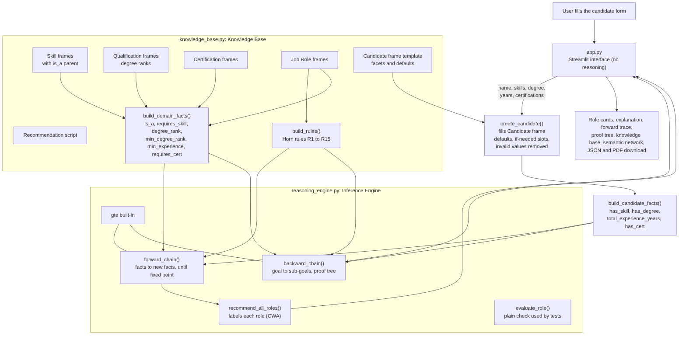
System architecture
File | Contents
knowledge_base.py | frames, facet templates, create_candidate(), sample candidates, script, build_domain_facts(), build_candidate_facts(), build_rules()
reasoning_engine.py | unify(), find_bindings(), run_builtin(), forward_chain(), backward_chain(), recommend_all_roles(), explain(), evaluate_role()
app.py | Streamlit interface; calls the engine, does no reasoning itself
ui_helpers.py | HTML for role cards, proof tree and graph; JSON and PDF export
demo.py | runs all sample candidates in the terminal; output saved as sample_outputs.txt
make_diagrams.py | writes the semantic network and frame diagrams from the frames
tests/test_reasoning.py | 42 unit tests

5.2 Results for all sample candidates
“Req. met” is the percentage of requirements met (Section 1.2). “Skills” is matched / mandatory skills. Copied from sample_outputs.txt.
Scenario A: Ali, data analyst (all requirements met)
Role Status Req. met Skills Missing
Data Analyst Fully eligible 100% 3/3 nothing
Python Developer Partial match 75% 1/2 Data Structures
Machine Learning Engineer Partial match 60% 1/3 Machine Learning, Data Structures
Data Scientist Partial match 50% 2/4 Statistics, Machine Learning, Degree: Masters or higher
Cloud Engineer Partial match 33% 1/3 Linux, Cloud Computing, Experience: 2+ years, Certification: AWS Certified Solutions Architect
Frontend Developer Not matched 40% 0/3 HTML, CSS, JavaScript
Explanation (Data Analyst): Recommended. Every requirement for Data Analyst is met.
FINAL RECOMMENDATION: Data Analyst
Scenario B: Sara, missing one skill (SQL)
Role Status Req. met Skills Missing
Data Analyst Partial match 80% 2/3 SQL
Python Developer Partial match 75% 1/2 Data Structures
Machine Learning Engineer Partial match 40% 1/3 Machine Learning, Data Structures, Experience: 1+ years
Data Scientist Partial match 33% 2/4 Statistics, Machine Learning, Degree: Masters or higher, Experience: 1+ years
Cloud Engineer Partial match 33% 1/3 Linux, Cloud Computing, Experience: 2+ years, Certification: AWS Certified Solutions Architect
Frontend Developer Not matched 40% 0/3 HTML, CSS, JavaScript
Explanation (Data Analyst): Not yet eligible for Data Analyst. Missing: SQL.
FINAL RECOMMENDATION: No role fully eligible yet
Scenario C: Bilal, frontend without a degree
Role Status Req. met Skills Missing
Frontend Developer Fully eligible 100% 3/3 nothing
Python Developer Not matched 25% 0/2 Python, Data Structures, Degree: Bachelors or higher
Data Analyst Not matched 20% 0/3 Python, SQL, Pandas, Degree: Bachelors or higher
Machine Learning Engineer Not matched 20% 0/3 Python, Machine Learning, Data Structures, Degree: Bachelors or higher
Data Scientist Not matched 17% 0/4 Python, Statistics, Machine Learning, Pandas, Degree: Masters or higher
Cloud Engineer Not matched 0% 0/3 Python, Linux, Cloud Computing, Degree: Bachelors or higher, Experience: 2+ years, Certification: AWS Certified Solutions Architect
Explanation (Frontend Developer): Recommended. Every requirement for Frontend Developer is met. Note: JavaScript was inferred from React (skill hierarchy).
FINAL RECOMMENDATION: Frontend Developer
Scenario D: Zara, skill hierarchy (TensorFlow gives ML)
Role Status Req. met Skills Missing
Machine Learning Engineer Fully eligible 100% 3/3 nothing
Python Developer Fully eligible 100% 2/2 nothing
Data Scientist Partial match 83% 4/4 Degree: Masters or higher
Data Analyst Partial match 80% 2/3 SQL
Cloud Engineer Partial match 50% 1/3 Linux, Cloud Computing, Certification: AWS Certified Solutions Architect
Frontend Developer Not matched 40% 0/3 HTML, CSS, JavaScript
Explanation (Machine Learning Engineer): Recommended. Every requirement for Machine Learning Engineer is met. Note: Machine Learning was inferred from TensorFlow (skill hierarchy).
FINAL RECOMMENDATION: Machine Learning Engineer, Python Developer
Scenario E: Hamza, degree failure (needs Masters)
Role Status Req. met Skills Missing
Data Scientist Partial match 83% 4/4 Degree: Masters or higher
Data Analyst Partial match 80% 2/3 SQL
Machine Learning Engineer Partial match 80% 2/3 Data Structures
Python Developer Partial match 75% 1/2 Data Structures
Cloud Engineer Partial match 50% 1/3 Linux, Cloud Computing, Certification: AWS Certified Solutions Architect
Frontend Developer Not matched 40% 0/3 HTML, CSS, JavaScript
Explanation (Data Scientist): Not yet eligible for Data Scientist. Missing: Degree: Masters or higher.
FINAL RECOMMENDATION: No role fully eligible yet
Scenario F: Usman, experience exception (6 years, no degree)
Role Status Req. met Skills Missing
Data Analyst Fully eligible 100% 3/3 nothing
Python Developer Fully eligible 100% 2/2 nothing
Machine Learning Engineer Partial match 80% 2/3 Machine Learning
Data Scientist Partial match 67% 2/4 Statistics, Machine Learning
Cloud Engineer Partial match 50% 1/3 Linux, Cloud Computing, Certification: AWS Certified Solutions Architect
Frontend Developer Not matched 40% 0/3 HTML, CSS, JavaScript
Explanation (Python Developer): Recommended. Every requirement for Python Developer is met. Note: the degree requirement is met through the experience exception (5+ years).
FINAL RECOMMENDATION: Data Analyst, Python Developer
Scenario G: Ayesha, missing certification
Role Status Req. met Skills Missing
Cloud Engineer Partial match 83% 3/3 Certification: AWS Certified Solutions Architect
Python Developer Partial match 75% 1/2 Data Structures
Data Analyst Partial match 60% 1/3 SQL, Pandas
Machine Learning Engineer Partial match 60% 1/3 Machine Learning, Data Structures
Data Scientist Partial match 33% 1/4 Statistics, Machine Learning, Pandas, Degree: Masters or higher
Frontend Developer Not matched 40% 0/3 HTML, CSS, JavaScript
Explanation (Cloud Engineer): Not yet eligible for Cloud Engineer. Missing: Certification: AWS Certified Solutions Architect.
FINAL RECOMMENDATION: No role fully eligible yet
Scenario H: Omar, no skills selected
Role Status Req. met Skills Missing
Frontend Developer Not matched 40% 0/3 HTML, CSS, JavaScript
Python Developer Not matched 25% 0/2 Python, Data Structures, Degree: Bachelors or higher
Data Analyst Not matched 20% 0/3 Python, SQL, Pandas, Degree: Bachelors or higher
Machine Learning Engineer Not matched 0% 0/3 Python, Machine Learning, Data Structures, Degree: Bachelors or higher, Experience: 1+ years
Data Scientist Not matched 0% 0/4 Python, Statistics, Machine Learning, Pandas, Degree: Masters or higher, Experience: 1+ years
Cloud Engineer Not matched 0% 0/3 Python, Linux, Cloud Computing, Degree: Bachelors or higher, Experience: 2+ years, Certification: AWS Certified Solutions Architect
Explanation (Data Analyst): Not matched. The candidate has none of the mandatory skills for Data Analyst.
FINAL RECOMMENDATION: No role fully eligible yet

5.3 Code snippets
Unification (matches one atom with one fact):
def unify(pattern, fact, binding):
"""
Try to match a pattern atom (may contain variables) with a fact.
Returns a NEW binding dictionary if they match, otherwise None.
unify(("has_skill","X","python"), ("has_skill","ali","python"), {}) -> {"X": "ali"}
"""
if len(pattern) != len(fact):
return None
new_binding = dict(binding)
for p_term, f_term in zip(pattern, fact):
if is_variable(p_term):
if p_term in new_binding:
if new_binding[p_term] != f_term:
return None
else:
new_binding[p_term] = f_term
elif is_variable(f_term):
# Only in backward chaining, when a goal still contains a variable.
if f_term in new_binding and new_binding[f_term] != p_term:
return None
new_binding[f_term] = p_term
elif p_term != f_term:
return None
return new_binding
Finding all bindings for a rule body, with the built-in:
def find_bindings(premises, facts, binding=None):
"""
Find every binding that makes ALL premises true.
Works left to right, like a nested loop. Built-ins are computed, not looked up.
"""
if binding is None:
binding = {}
if not premises:
return [binding]
first, rest = premises[0], premises[1:]
if is_builtin(first):
return find_bindings(rest, facts, binding) if run_builtin(first, binding) else []
results = []
for fact in facts:
if fact[0] != first[0]:
continue
new_binding = unify(first, fact, binding)
if new_binding is not None:
results.extend(find_bindings(rest, facts, new_binding))
return results
Inner loop of forward chaining (from forward_chain()):
for pass_number in range(1, max_passes + 1):
added_this_pass = False
for rule in rules:
bindings = find_bindings(rule["body"], sorted(working_memory, key=sort_key))
new_facts = []
for binding in bindings:
conclusion = substitute(rule["head"], binding)
if conclusion not in working_memory:
working_memory.add(conclusion)
...
if not added_this_pass:
break

5.4 Testing
Method. Python’s built-in unittest. Each test states its expected result in a comment. Test 35 is a consistency check: for 1,500 random candidates (fixed seed 351, random skills, degree, 0 to 7 years, random certificates) and all 6 roles, the label and missing skills from forward chaining must equal a plain-Python check that uses no rules (evaluate_role()). On every 25th candidate, backward chaining must prove eligible(...) exactly when the label is Fully eligible. In that sample, 231 role results are Fully eligible, 11 of them through the experience exception.
As a check that the tests can fail, the gte(Y, W) premise was deleted from rule R3 in a copy of the project: 5 tests failed.
Command: python -m unittest discover -s tests -v
Result of the run on 2026-11-02 (Python 3.13.17): 42 tests ran, 42 passed, 0 failed, 0 errors.
# | Test | Expected | Result
1 | all requirements met gives fully eligible | Ali (python, sql, pandas, bachelors, 1 year) is Fully eligible for Data Analyst. | ok
2 | some skills gives partial match | Sara misses SQL -> Partial match; 4 of 5 requirements met = 80%. | ok
3 | no mandatory skill gives not matched | Bilal (web skills only) is Not matched for Data Scientist. | ok
4 | eligible for more than one role | Usman is Fully eligible for Data Analyst and Python Developer. | ok
5 | empty skill set | no crash; every role Not matched; every mandatory skill missing. | ok
6 | missing skills are correct | Sara misses [‘sql’] for DA and [‘statistics’, ‘machine_learning’] for DS. | ok
7 | optional skills and certs do not change status | optional data_visualization and optional google_data_analytics are shown as bonus, but Sara stays a Partial match. | ok
8 | tensorflow gives deep learning then machine learning | pass 1 derives has_skill(zara, deep_learning), pass 2 derives has_skill(zara, machine_learning). | ok
9 | hierarchy makes zara eligible for ml engineer | Zara never listed machine_learning but is Fully eligible, and the explanation names the inherited skill. | ok
10 | hierarchy only goes upward | machine_learning does NOT imply tensorflow or deep_learning. | ok
11 | react gives javascript and postgresql gives sql | react implies javascript; postgresql implies sql. | ok
12 | backward chaining uses hierarchy | has_skill(zara, machine_learning) PROVED through R1 twice. | ok
13 | hierarchy rule cannot loop | R1 puts is_a before has_skill, and goals with unbound skills finish. | ok
14 | taxonomy has no cycles | following is_a from any skill ends at a top-level skill. | ok
15 | meets degree positive and negative | bachelors meets Data Analyst (rank 1) but not Data Scientist (rank 2). | ok
16 | degree failure blocks eligibility | Hamza has all 4 Data Scientist skills but only a bachelors -> Partial. | ok
17 | higher degree satisfies lower requirement | a PhD meets the Masters requirement, so Hamza with a PhD is eligible. | ok
18 | meets experience positive and negative | 0 years meets Data Analyst (min 0) but not ML Engineer (min 1). | ok
19 | experience exception relaxes degree | Usman (no degree, 6 years) meets the bachelors requirement via R3. | ok
20 | exception boundary at five years | 4 years without a degree fails, exactly 5 years passes. | ok
21 | exception does not replace experience or skills | 6 years waives the degree only; missing skills still block eligibility. | ok
22 | missing certification blocks eligibility | Ayesha meets everything for Cloud Engineer except the AWS certificate. | ok
23 | with certification becomes eligible | Ayesha with the AWS certificate is Fully eligible for Cloud Engineer. | ok
24 | gte builtin | gte(5, 5) and gte(6, 5) are true; gte(4, 5) is false. | ok
25 | defaults and if needed slots | empty slots get defaults; candidate_id and experience_level are computed. | ok
26 | unknown values are rejected safely | unknown skill, certificate and degree produce warnings; duplicates removed; invalid experience becomes 0. | ok
27 | frames reference only known ids | every role has at least 1 skill and uses only known skill, degree and certificate IDs. | ok
28 | forward chaining derives new facts | from Ali’s facts: meets_degree, meets_experience, eligible, recommended. | ok
29 | forward chaining stops at fixed point | running forward chaining again on its own output derives nothing new. | ok
30 | forward reports missing premises | the Data Analyst rule for Sara is missing has_skill(sara, sql) only. | ok
31 | backward chaining success | eligible(ali, data_analyst) is PROVED and the proof tree root is ok. | ok
32 | backward chaining failure | eligible(sara, data_analyst) is NOT PROVED at has_skill(sara, sql). | ok
33 | backward chaining with variable goal | recommended(zara, R) -> R = ml_engineer and R = python_developer. | ok
34 | unify basic cases | X binds to ali; different constants fail; an already-bound X cannot change. | ok
35 | rules agree with plain python check | for 1500 random candidates (fixed seed) the label and missing skills from forward chaining equal a direct Python check that uses no rules, and backward chaining proves eligible(…) exactly when the label is Fully eligible (checked on every 25th candidate). | ok
36 | all rules are horn clauses | one head atom, at least one premise, no negated premise. | ok
37 | builtins come after their variables are bound | every variable inside gte(…) appears in an earlier premise. | ok
38 | eligibility rules generated from frames | each eligible rule body = skills + meets_degree + meets_experience + certs. | ok
39 | diagram files match knowledge base | every .mmd written by make_diagrams.py equals what the current knowledge base would generate (run “python make_diagrams.py” after edits). | ok
40 | semantic networks show is a has a part of | the CCP’s three relation types all appear, and every role requirement and skill-taxonomy link is drawn. | ok
41 | json export is valid | the JSON download parses and lists all 6 roles with their status. | ok
42 | pdf export and html helpers | the PDF download is a real PDF; card and proof tree HTML escape text. | ok

5.5 User interface
The Streamlit interface (app.py) has a candidate form (name, skills grouped by category, degree, years of experience, certifications), role cards with an eligibility badge, a progress bar, green chips for met requirements and red chips for missing ones, and tabs for Recommendations, Explanation, Forward Chaining, Backward Chaining (proof tree), Knowledge Base, Semantic Network (interactive graph), Compare Candidates and About. Results can be downloaded as JSON or PDF.
During development the interface code was executed against a stand-in for the Streamlit library, because Streamlit could not be installed in the build environment. The group must run the real interface and complete this checklist:
Check | Pass / Fail
streamlit run app.py opens without errors | [ ]
Loading each sample candidate updates every tab | [ ]
Zara: ML Engineer card is Eligible and mentions TensorFlow | [ ]
Backward Chaining tab: Hamza / Data Scientist shows NOT PROVED at gte(1, 2) | [ ]
Semantic Network tab shows a draggable graph | [ ]
JSON and PDF downloads open correctly | [ ]
No skills selected: no error, friendly message shown | [ ]
Deployed link opens on a phone | [ ]

6. Limitations and Future Work
Limitations
- Illustrative knowledge. Role requirements, thresholds and the 5-year waiver are simplified and not validated against hiring data.
- Small domain. 6 roles, 18 skills, 4 degree levels, 3 certificates.
- Binary skills. A skill is held or not; there is no proficiency level.
- Experience is one number. Total years only, not years per skill or per field.
- Hierarchy goes one way. A child skill implies its parent, never the reverse, and there is no partial credit for a sibling skill (PyTorch does not count as TensorFlow).
- No negation inside rules. Missing requirements and partial match use the CWA outside the rules.
- FOL and DL are not executed in full. There is no FOL prover and no DL reasoner; only the Horn-expressible part runs.
- Naive forward chaining. Every pass re-checks every rule. Fine at this size, slow for thousands of rules.
Future work
- Skill levels, e.g. has_skill_level(X, python, L), gte(L, 3).
- Use related_skill of certificates to suggest what to learn next.
- Move frames to a JSON file so non-programmers can edit them.
- Export the DL axioms to OWL and check them with a standard reasoner such as HermiT.
- Semi-naive evaluation or the Rete algorithm for faster forward chaining.

7. Conclusion
The project builds an expert system that matches candidates to job roles from explicit knowledge. Five kinds of frames with facets, defaults and if-needed slots structure the domain, a script describes the recommendation process, and four semantic networks show IS-A, HAS-A and PART-OF links. FOL formulas and DL axioms describe the domain precisely, including the parts that need negation, disjunction and nested quantifiers. Fifteen Horn clauses, including a recursive skill-hierarchy rule, numeric comparisons and an exception rule, form the executable knowledge base. Forward chaining derives every conclusion with a pass-by-pass trace, and backward chaining proves or refutes a specific goal and shows which premise failed. One eligibility policy is used in the code, the interface and this report. 42 automated tests, including a 1,500-candidate comparison against an independent check, confirm the rule-based results. The main limitation is that the role requirements are illustrative: the reasoning is correct for the stated knowledge, not a verified model of real hiring.

8. References
- R. J. Brachman and H. J. Levesque, Knowledge Representation and Reasoning. Morgan Kaufmann, 2004.
- S. Russell and P. Norvig, Artificial Intelligence: A Modern Approach, 4th ed. Pearson, 2020.
- F. Baader, D. Calvanese, D. McGuinness, D. Nardi and P. Patel-Schneider (eds.), The Description Logic Handbook, 2nd ed. Cambridge University Press, 2007.
- M. Minsky, “A Framework for Representing Knowledge,” MIT AI Laboratory Memo 306, 1974.
- R. C. Schank and R. P. Abelson, Scripts, Plans, Goals and Understanding. Lawrence Erlbaum, 1977.
- S. Ceri, G. Gottlob and L. Tanca, “What you always wanted to know about Datalog (and never dared to ask),” IEEE Transactions on Knowledge and Data Engineering, 1(1), 1989.
- Streamlit documentation, https://docs.streamlit.io
- [PLACEHOLDER: CT-351 course lecture notes, NED UET]

