Hari prasanna.M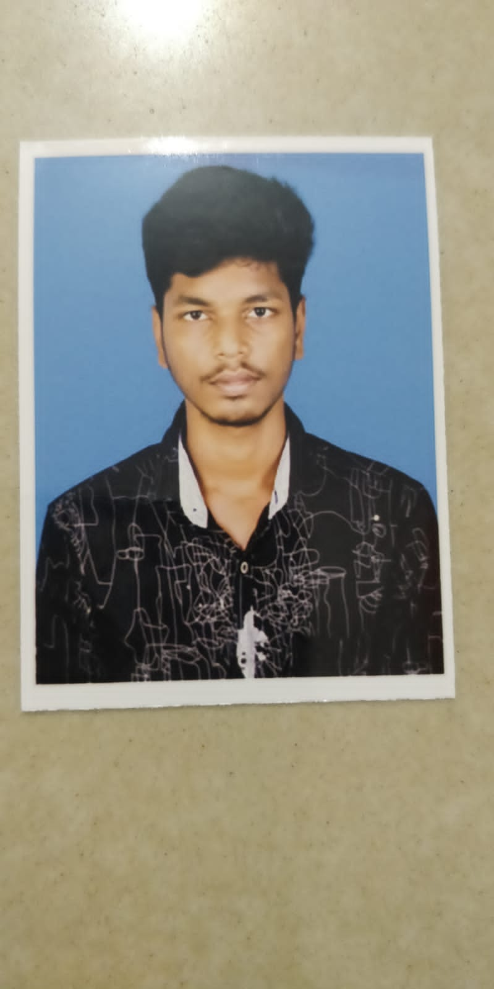

Address:10/4 ellangovan strret,

vellanathan patty,

Melur,

Madurai.

# CARREER OBJECTIVE :

My goal is to become associated with a company where I can utilize my skills and gain further experience while enhancing the company’s productivity and reputation.

# EDUCATIONAL QUALIFICATION :

* Alagappa govt.arts college,karaikudi.
* 2021
* Pursuing B.sc.Computer Science.
* Jazz public matric hr sec school,melur,madurai
* 2020
* HSLC – 90.82%
* Subramaniya bharathi matric hr sec school,melue
* 2018
* SSLC – 96.66%

# PROGRAMMING LANGUAGES KNOWN :

* C
* C++
* JAVA
* SQL

# STRENGTH/AREA OF EXPERIENCE :

* Positive thinking and active quick learner.
* Planning and scheduling.
* Good leadership and supervision quality.
* Presence of mind.

# LANGUAGES KNOWN :

* Tamil
* English

# PERSONAL DETAILS :

|  |  |
| --- | --- |
| NAME | Hari prasanna.M |
| DAUGHTER OF/SON OF | Manikandan .k |
| GENDER (M/F) | Male |
| DATE OF BIRTH | 03.10.2003 |
| NATIONALITY | INDIAN |
| EMAIL ID | Prasannahari571@gmail.com |
| MOBILE NUMBER | 8438531176 |

HOBBIES :

* Reading Books
* Listening Music

# DECLARATION

I hereby declare that the above mentioned statement is correct and true to the best of my knowledge and belief.

DATE : 18.10.2023 Hari prasanna.M