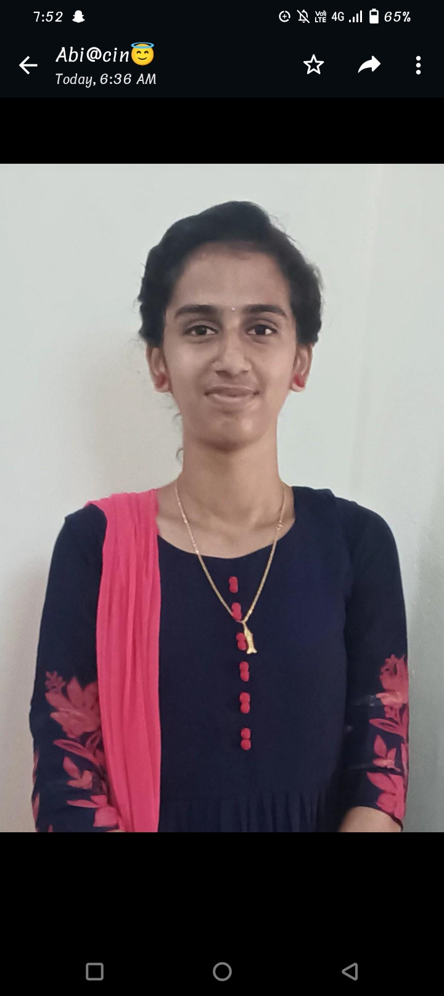

***Abirami P,***

***No.4/15 A,Pudhunilaipatti, kilanilaikottai,***

***Pudukottai.***

***CARRER OBJECTIVE***

***\*My goal is to become associated with a company where I can utilize my skills and gain further experience while enhancing the company’s productivity and reputation.***

***EDUCATIONAL QUALIFICATION***

***• Alagappa govt.arts college,Karaikudi.***

***2021***

***Pursuing B.sc.,Computer Science.***

***• Ayyakannu govt Higher Secandory School***

***Karaikudi***

***2020***

***HSLC – 89.74%***

***• Ayyakannu govt Higher Secandory School***

***Karaikudi***

***2018***

***SSLC – 90.84%***

***PROGRAMMING LANGUAGES KNOWN***

***• C***

***• C++***

***• JAVA***

***• HTML***

***STRENGTH/AREA OF EXPERIENCE***

***• Positive thinking and active quick learner.***

***• Planning and scheduling.***

***• Skilled problem solver.***

***• Good leadership and supervision quality.***

***• Good coordination power.***

***• Ability to built up relationship rapidly and set up trust.***

***LANGUAGES KNOWN***

***• Tamil***

***• English***

***PERSONAL DETAILS***

|  |  |
| --- | --- |
| ***NAME*** | ***Abirami P*** |
| ***DAUGHTER OF/SON OF*** | ***Periyasamy*** |
| ***GENDER (M/F)*** | ***FEMALE*** |
| ***DATE OF BIRTH*** | ***16.07.2004*** |
| ***NATIONALITY*** | ***INDIAN*** |
| ***EMAIL ID*** | ***abiperiyasamy33@gmail.com*** |
| ***MOBILE NUMBER*** | ***8940685157*** |

***HOBBIES AND INTEREST***

***• Listening Novels.***

***• Drawing and Portrait art.***

***DECLARATION***

***I hereby declare that the above mentioned statement is correct and true to the best of my knowledge and belief.***

***KARAIKUDI,***

***DATE : 18.10.2023 ABIRAMI P***