**Week_4_resources**

**Deep Learning**

Please do only Week 3 and Week 4 of this course.

Link to the Coursera course: <https://www.coursera.org/learn/neural-networks-deep-learning?&utm_medium=sem&utm_source=gg&utm_campaign=b2c_india_neural-networks-deep-learning_deeplearning.ai_ftcof_learn_arte_may-24_dr_sem_rsa_gads_lg-all&campaignid=21254051965&adgroupid=160484001823&device=c&keyword=neural%20networks%20and%20deep%20learning%20coursera&matchtype=b&network=g&devicemodel=&adposition=&creativeid=698134896937&hide_mobile_promo&gad_source=1&gclid=CjwKCAjwrvyxBhAbEiwAEg_KgskaJJSweYGV4Z5HBC4LXg4F6XC0bBYRJUEkHRDOKwEBWpjG7sPsRxoCYGoQAvD_BwE>

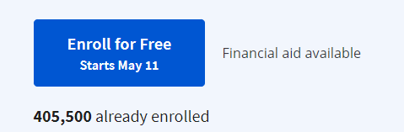

**Click on Audit course**

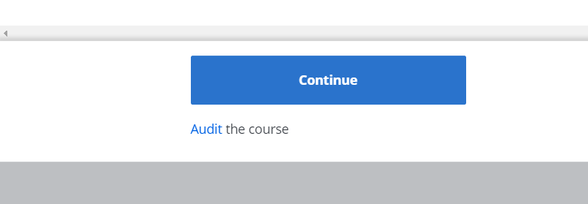

Click on Skip



Git hub repository: <https://github.com/amanchadha/coursera-deep-learning-specialization/tree/master/C1%20-%20Neural%20Networks%20and%20Deep%20Learning>

In the above GitHub repo there are programming assignments and labs which you won’t be able to access because you have audited the course. Please go through all the assignments/quizzes carefully.

Assignment: Write a report/summary (not more than 150 words) of what you learnt in this week. Please submit the PDF file of the same on Teams before the deadline.