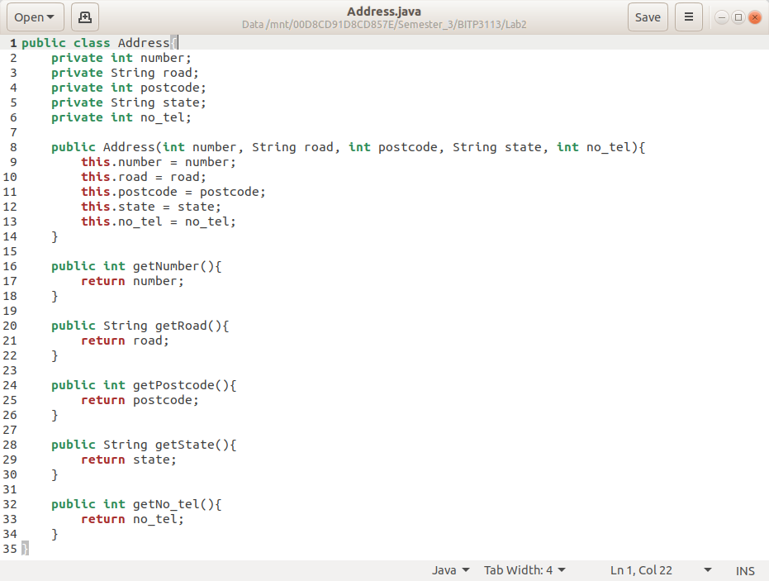

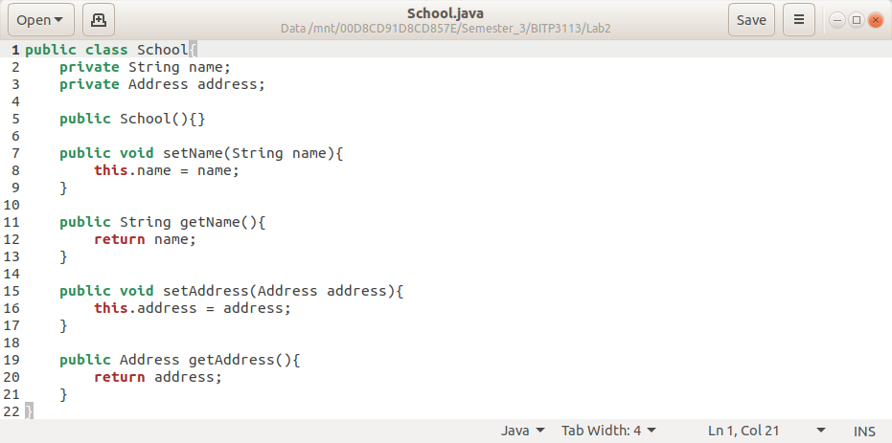

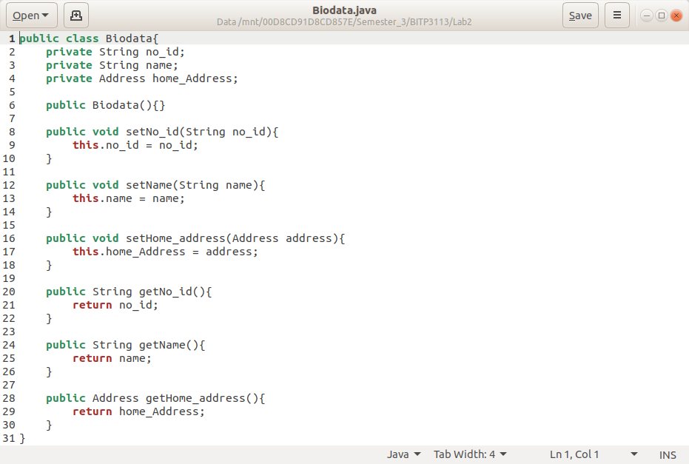

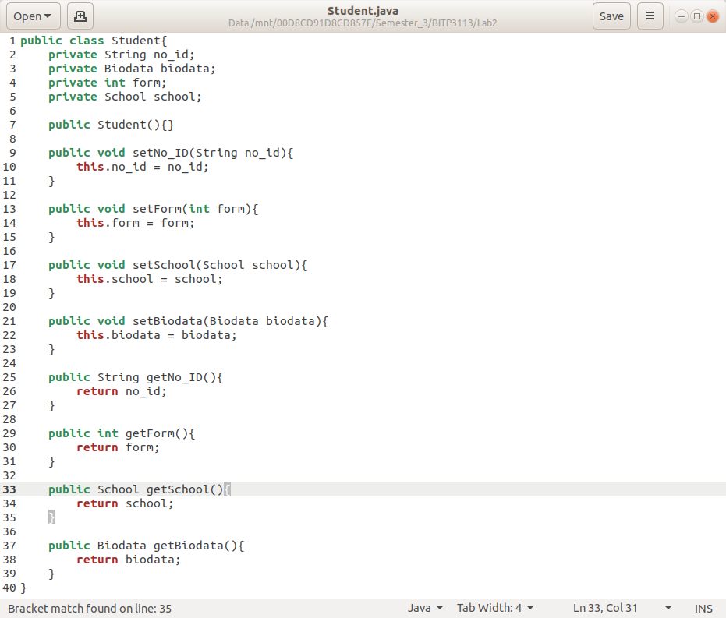

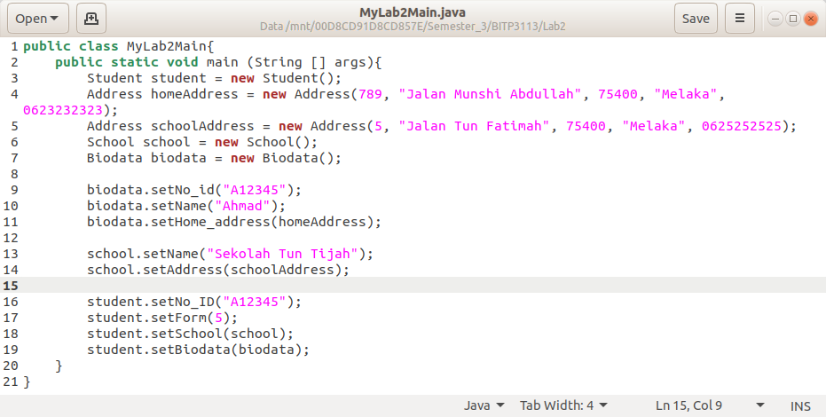

|  |
| --- |
| Rectangle |
| -height:float  -width:float |
| +Rectangle()  +Rectangle(height:float, width:float)  +getArea():float  +getPerimeter():float |

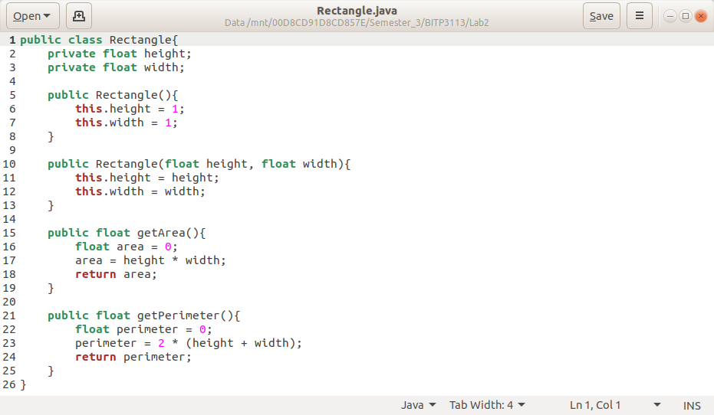

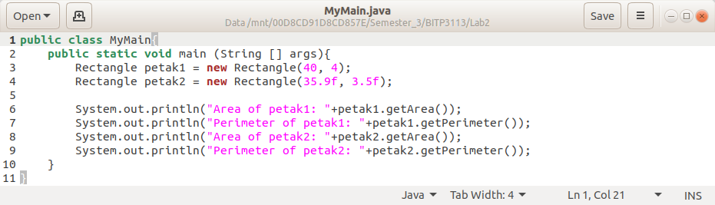

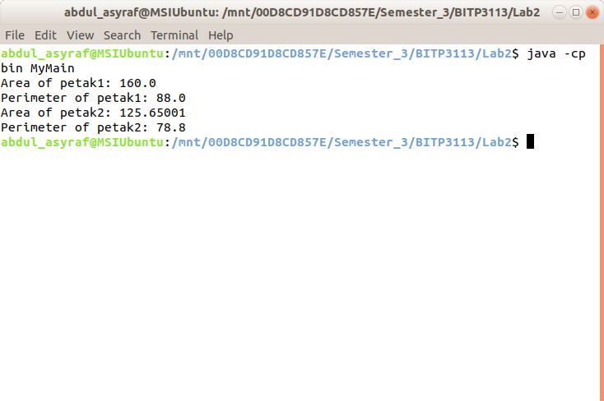

|  |
| --- |
| RegularPolygon |
| -n:int  -side:double  -x:double  -y:double |
| +RegularPolygon()  +RegularPolygon(n:int, side:double)  +RegularPolygon(n:int, side:double, x:double, y:double)  +getArea():double  +getN():int  +getPerimeter():double  +getSide():double  +getX():double  +getY():double  +setN(n:int)  +setSide(side:double)  +setX(x:double)  +setY(y:double) |

