Name: Abdul Azeem
Roll Number: 24i-2013
Department/Section: AI/A

Entities:

UserAccount:

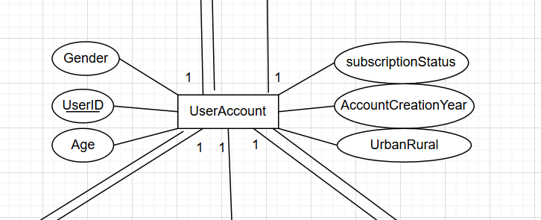

UserDemographics:

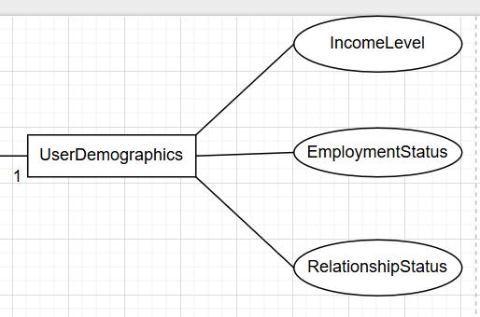

SocialEngagement:

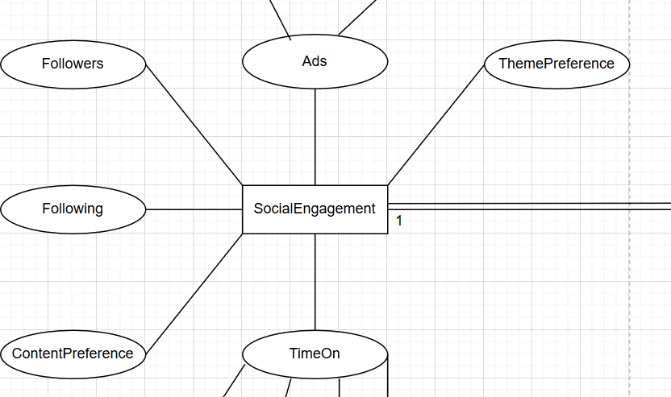

SecuritySettings:

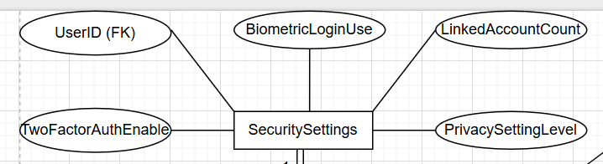

AppUsage:

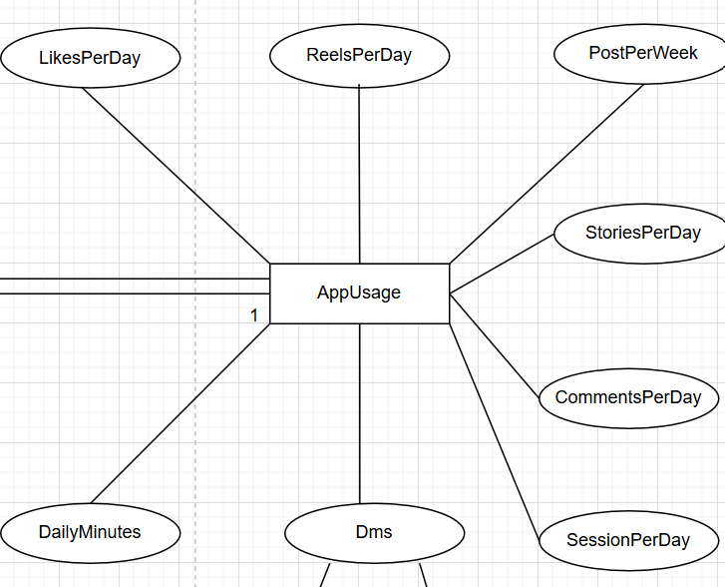

Composite Attributes:

Dms (Attribute of AppUsage):

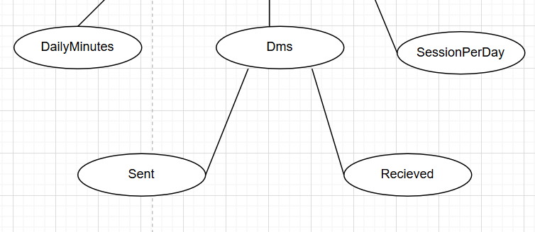

TimeOn (Attribute of SocialEngagement):

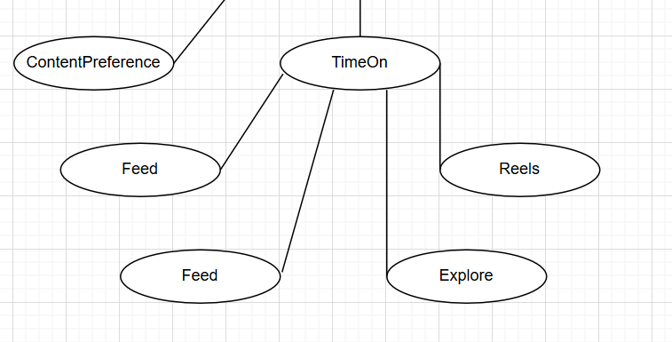

Ads (Attribute of SocialEngagement):

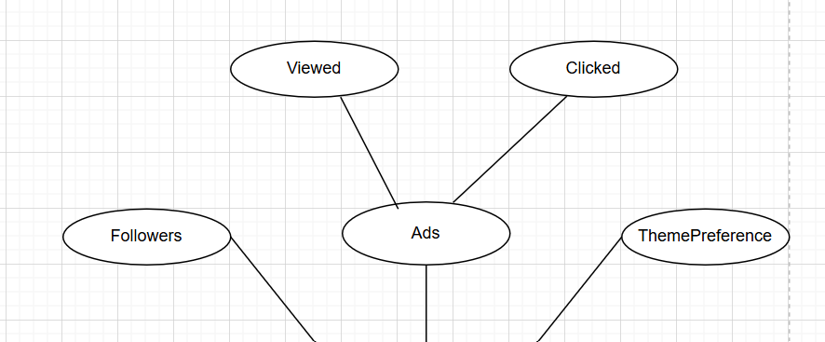

Relationships:

UserAccount with SecuritySettings (1:1):

Total Participation

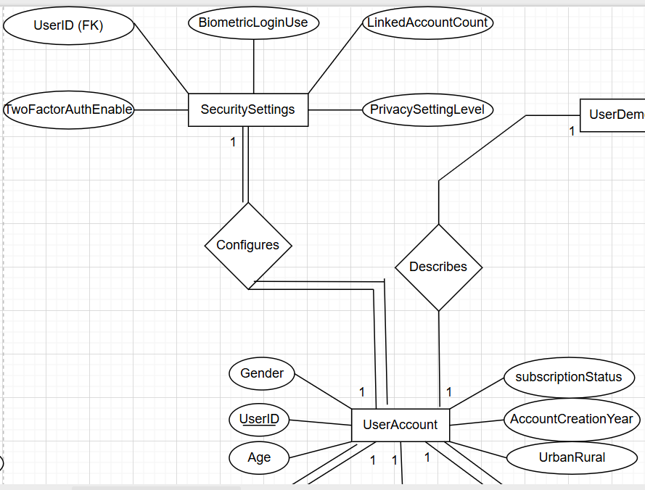

UserAccount with UserDemographics(1:1):

Partial Participation

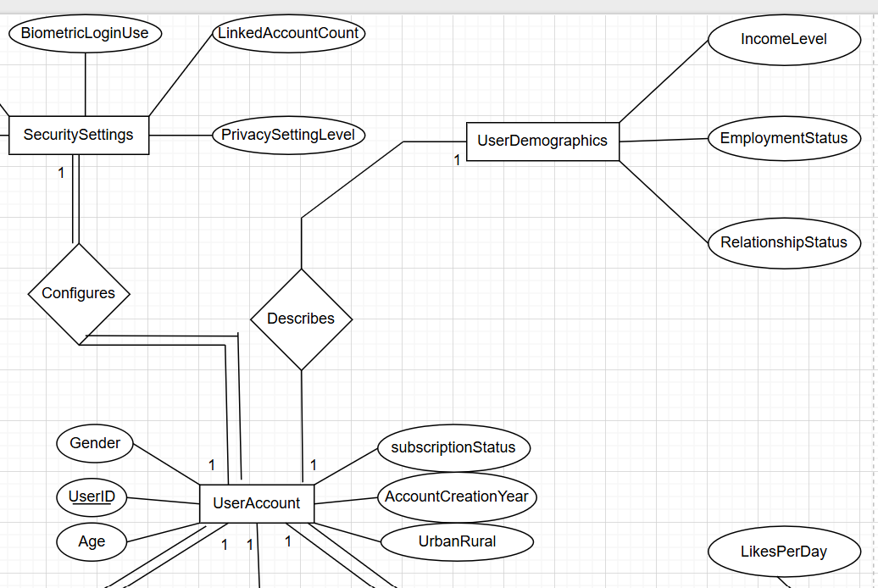

UserAccount with AppUsage (1:1):

Total Participation

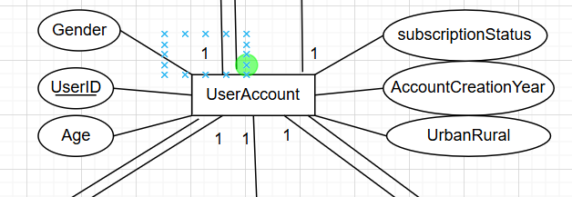

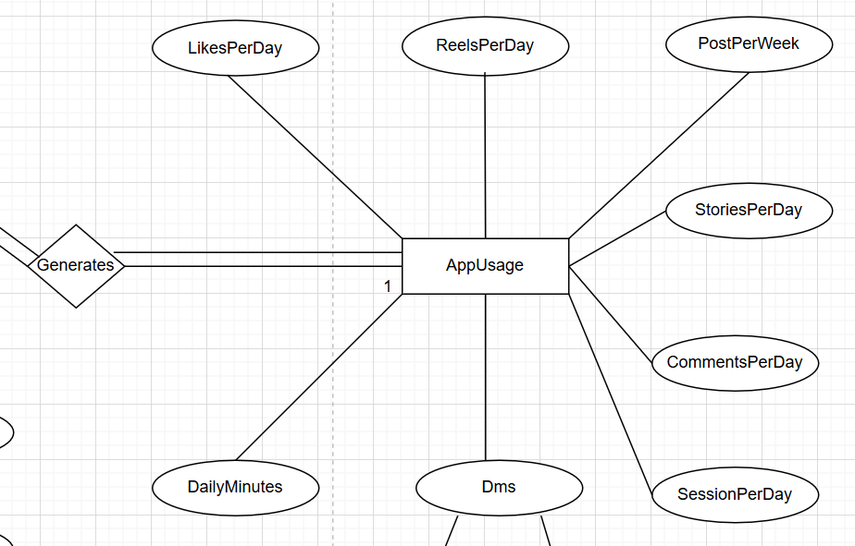

UserAccount with HealthLifestyle (1:1):

Partial Participation

Weak Relationship

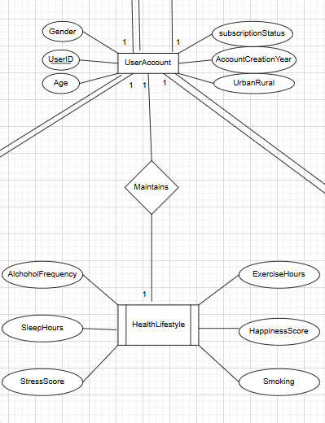

UserAccount with SocialEngagement(1:1):

Total Participation

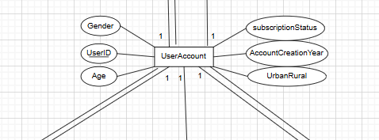

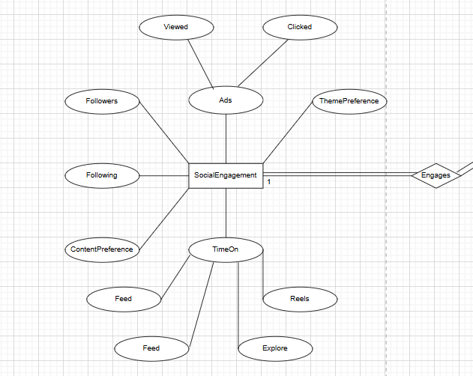

Attributes Removed:

I have removed many attributes, like country in order to minimize the data.
I have removed many attributes, like bodymassindex because they were irrelevant.

