Assignment # 02 - Database Management System (CS2005)

Name: Abdul Azeem

Roll Number: 24i-2013

Section: BAI-4A

1. Introduction

In this assignment, I have implemented the database schema designed in Assignment #01. The dataset used is the "Instagram Usage & Lifestyle" dataset. I have used MySQL for the database management and Python (Pandas & MySQL Connector) for data preprocessing and insertion. The goal was to perform analytical queries to understand user behavior, engagement, and health-related factors.

2. Database Connection (Python)

I used the mysql-connector-python library to establish a connection between Python and the MySQL server. 1,200 random records were selected from the CSV file, cleaned (removing duplicates and handling null values), and then inserted into the respective tables.

Python Connection Code Output:

3. Schema Design & ERD
The database consists of 6 tables: UserAccount, UserDemographics, SecuritySettings, SocialEngagement, AppUsage, and HealthLifestyle. These tables are connected via 1:1 relationships using user_id as the Primary and Foreign Key.
Reverse Engineered ERD:

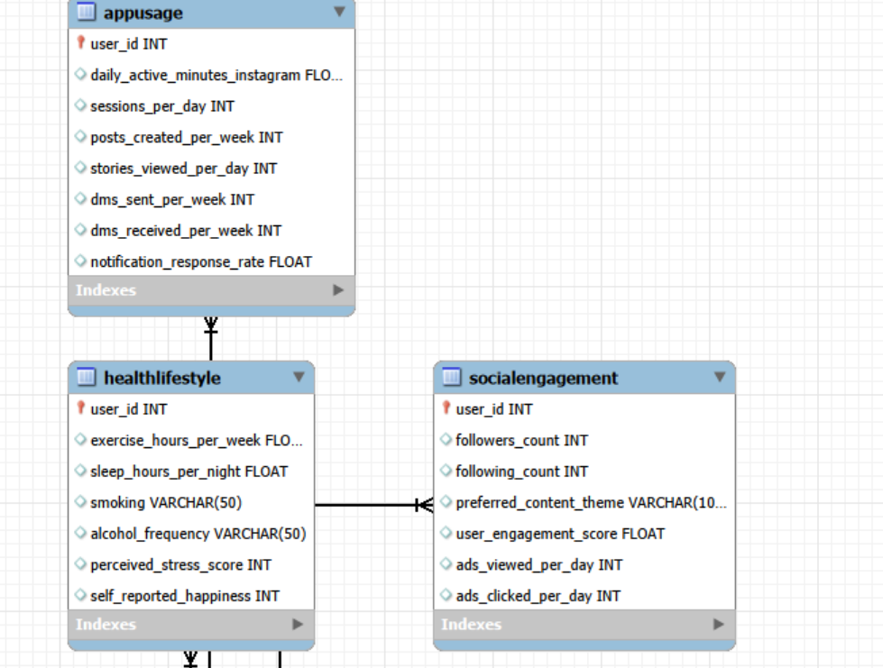
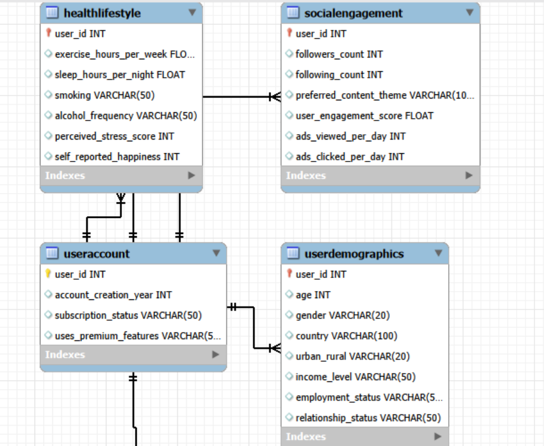
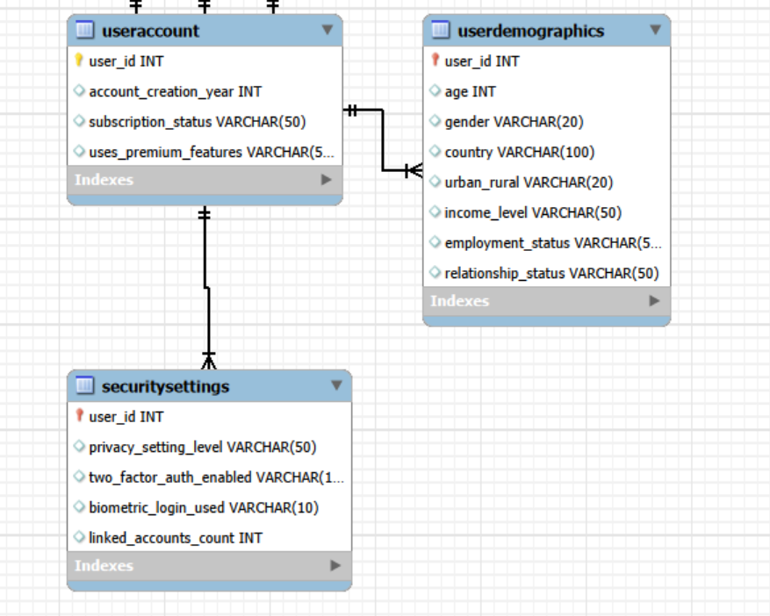

4. Database Tables (Sample Data)

Below are the snapshots showing that the data has been successfully inserted into the MySQL tables.

UserAccount Table: SELECT * FROM UserAccount LIMIT 5;

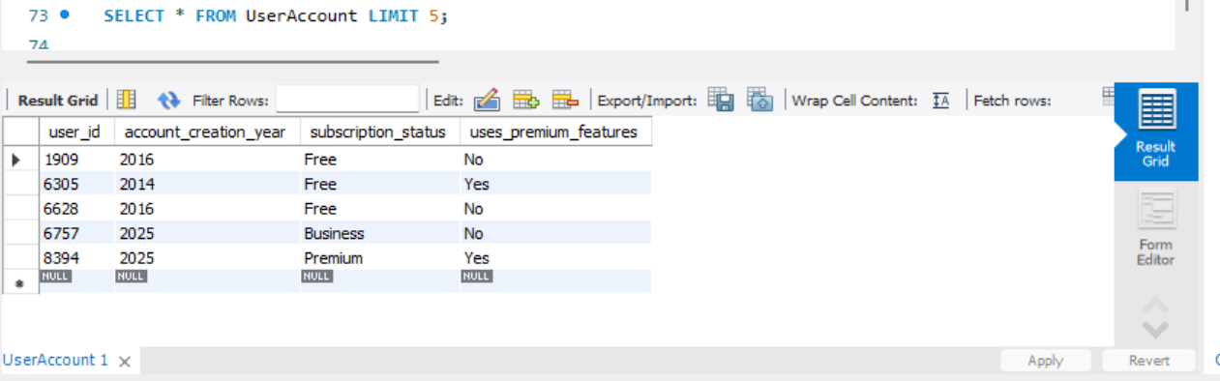

UserDemographics Table: SELECT * FROM UserDemographics LIMIT 5;

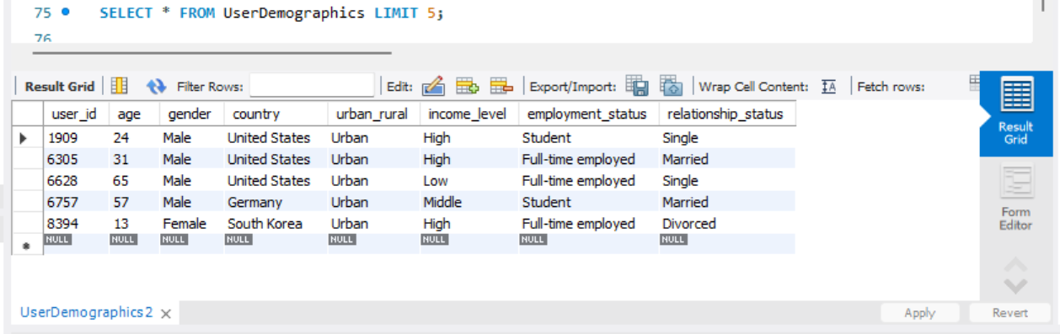

HealthLifestyle Table: SELECT * FROM HealthLifestyle LIMIT 5;

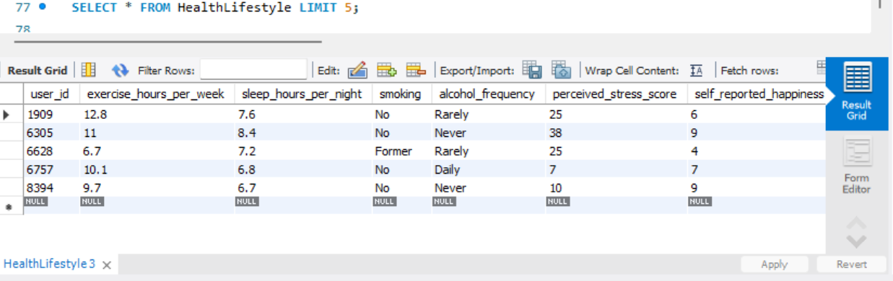

AppUsage Table: SELECT * FROM AppUsage LIMIT 5;
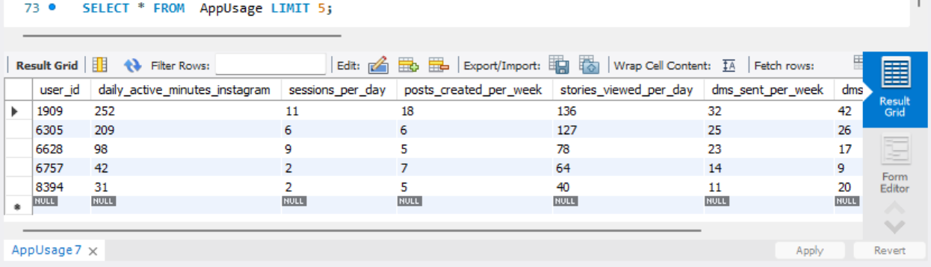

SocialEngagement Table: SELECT * FROM SocialEngagement LIMIT 5;

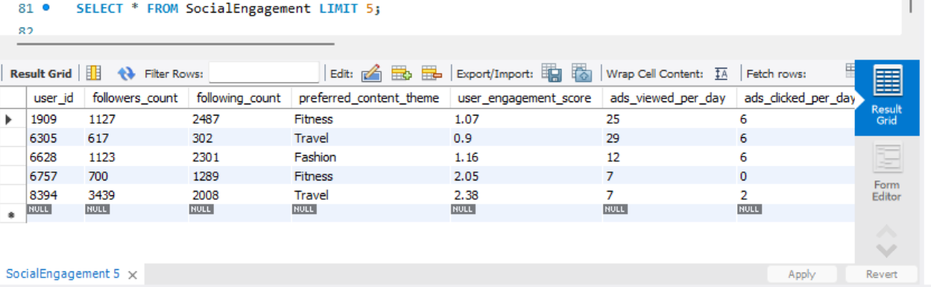

SecuritySettings Table: SELECT * FROM SecuritySettings LIMIT 5;

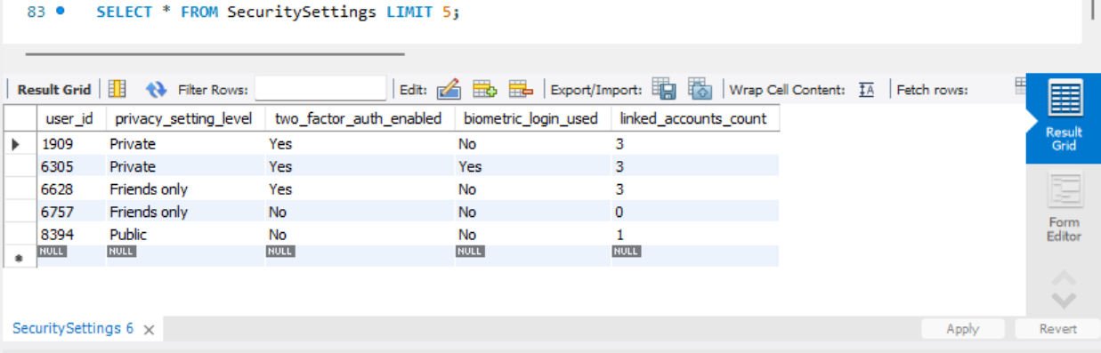

5. Query-Based Analysis
I have performed the following 10 analytical queries as per the assignment requirements:
Query 1: Top 10 High Engagement Users (>2 hours/day)

SQL: SELECT u.user_id, s.user_engagement_score FROM AppUsage u JOIN SocialEngagement s ON u.user_id = s.user_id WHERE u.daily_active_minutes_instagram > 120 ORDER BY s.user_engagement_score DESC LIMIT 10;
Result:

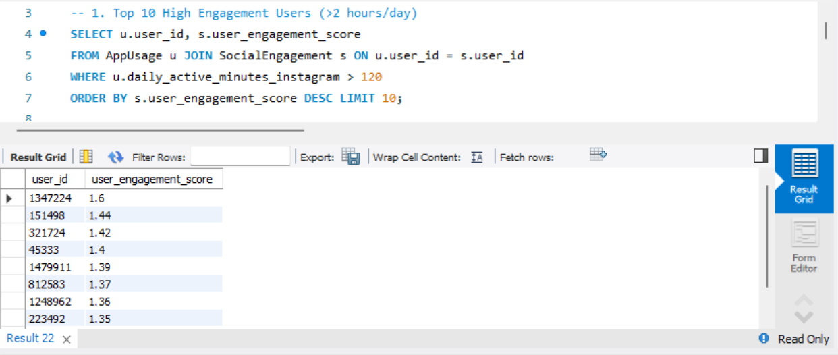

Query 2: Average time spent: Urban vs Rural
SQL: SELECT d.urban_rural, AVG(a.daily_active_minutes_instagram) FROM UserDemographics d JOIN AppUsage a ON d.user_id = a.user_id GROUP BY d.urban_rural;

Result:

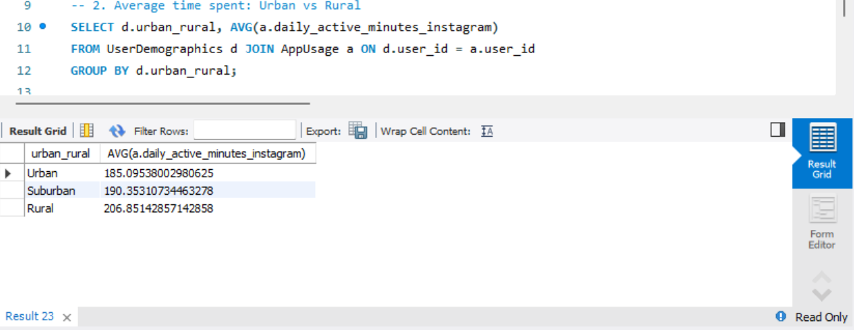

Query 3: Users with High Stress (>7) and High Activity (>100 mins)

SQL: SELECT h.user_id FROM HealthLifestyle h JOIN AppUsage a ON h.user_id = a.user_id WHERE h.perceived_stress_score > 7 AND a.daily_active_minutes_instagram > 100;

Result:

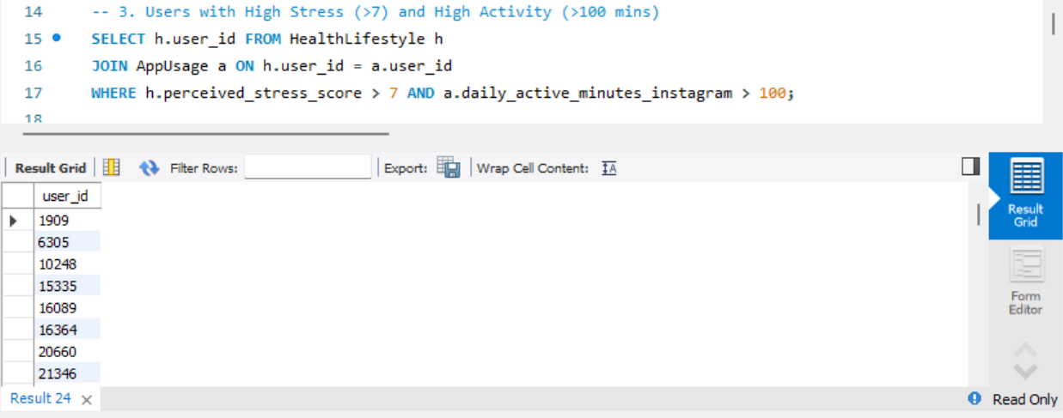

Query 4: Avg minutes by Age Group and Gender

SQL: SELECT CASE WHEN age < 25 THEN '<25' ... GROUP BY age_group, gender;

Result:
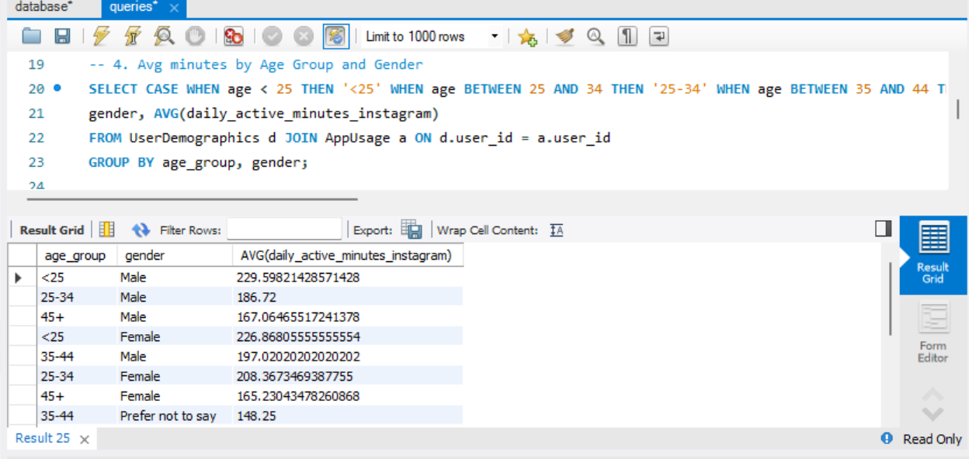

Query 5: Country with the highest average followers

SQL: SELECT d.country, AVG(s.followers_count) FROM UserDemographics d JOIN SocialEngagement s ON d.user_id = s.user_id GROUP BY d.country ORDER BY AVG(s.followers_count) DESC LIMIT 1;

Result:

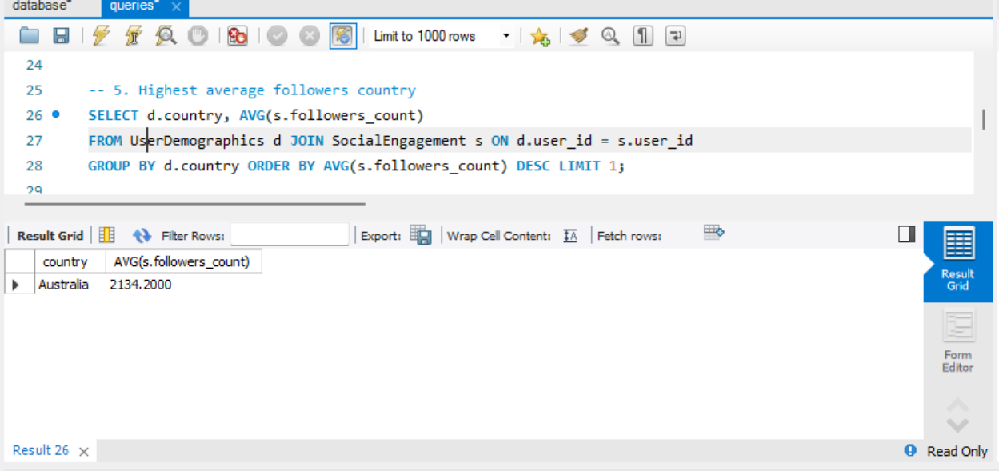

Query 6: Happiness Level: Smokers vs Non-smokers (Exercise > 5 hrs)

SQL: SELECT smoking, (exercise_hours_per_week > 5), AVG(self_reported_happiness) FROM HealthLifestyle GROUP BY smoking, (exercise_hours_per_week > 5);

Result:

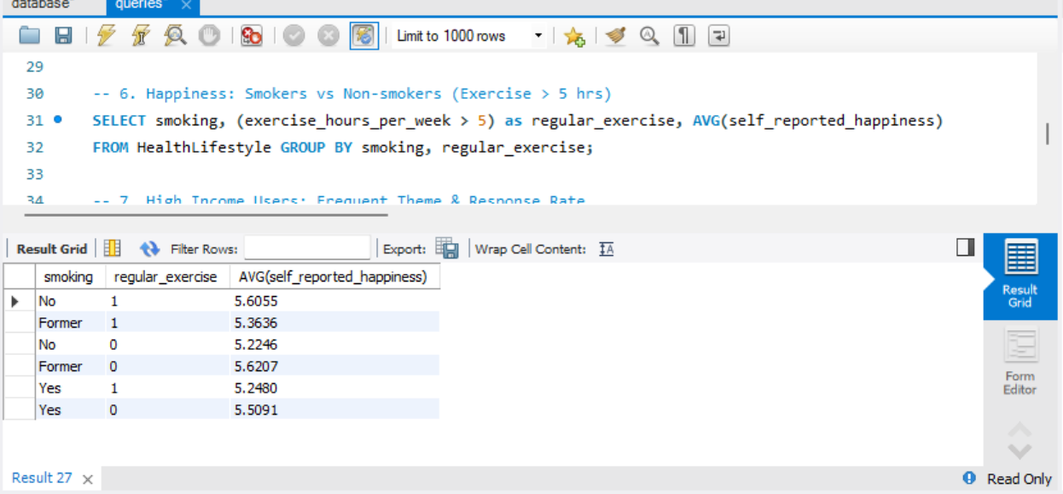

Query 7: High Income Users - Preferred Theme & Response Rate

SQL: SELECT s.preferred_content_theme, AVG(a.notification_response_rate) FROM UserDemographics d ... WHERE d.income_level = 'High' GROUP BY s.preferred_content_theme ORDER BY COUNT(*) DESC LIMIT 1;

Result:

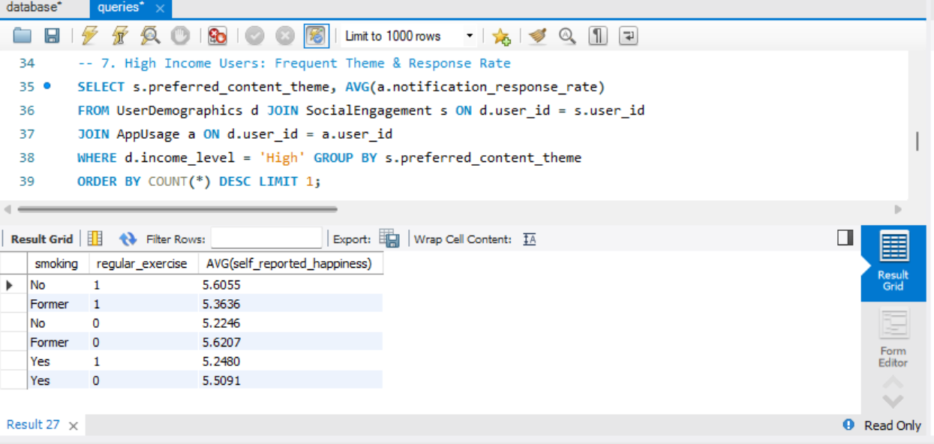

Query 8: Theme with the highest average engagement score

SQL: SELECT preferred_content_theme, AVG(user_engagement_score) FROM SocialEngagement GROUP BY preferred_content_theme ORDER BY AVG(user_engagement_score) DESC LIMIT 1;

Result:

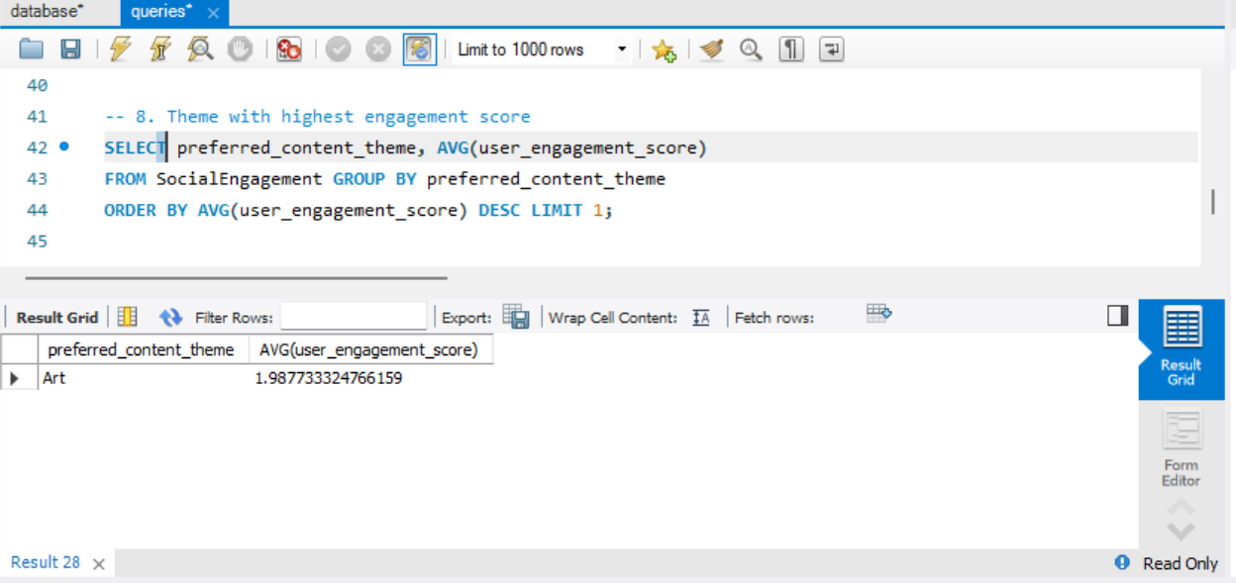

Query 9: Alcohol Frequency vs Instagram Usage

SQL: SELECT h.alcohol_frequency, AVG(a.daily_active_minutes_instagram) FROM HealthLifestyle h JOIN AppUsage a ON h.user_id = a.user_id GROUP BY h.alcohol_frequency;

Result:

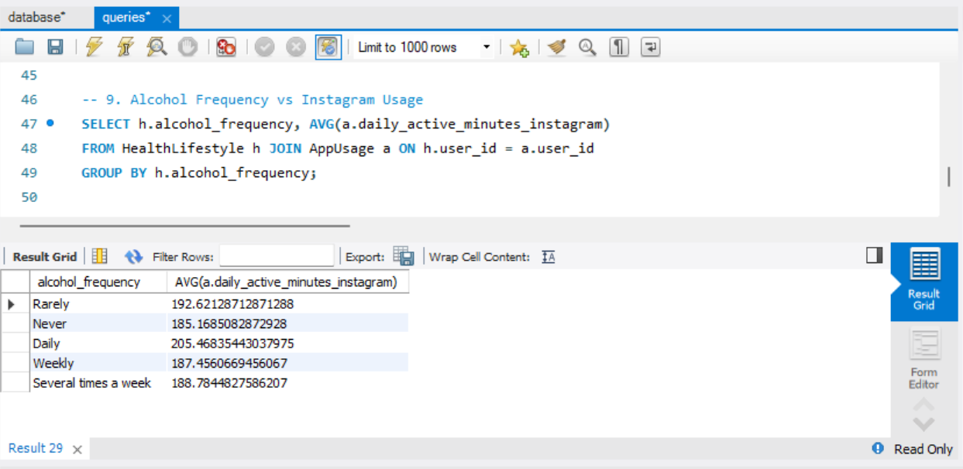

Query 10: Ads Clicked (High Stories vs Low Stories for >500 followers)
SQL: SELECT (a.stories_viewed_per_day > 20) as heavy_viewer, AVG(s.ads_clicked_per_day) FROM AppUsage a ... GROUP BY heavy_viewer;

Result:

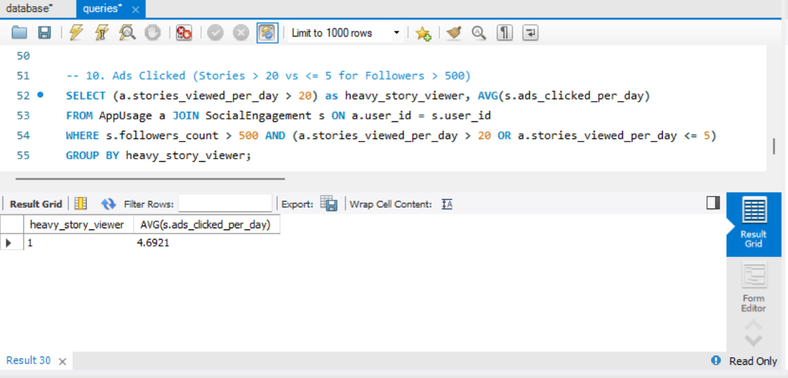

6. Documentation of Assumptions
- Data Cleaning: All duplicate records were removed to ensure data integrity.
- Missing Values: Missing values in numerical columns were replaced with 0.
- Relationships: Each table is related via a 1:1 relationship as the dataset is user-centric.
- Sampling: A random sample of 1,200 records was used to fulfill the requirement of 1,000-1,500 records.

