UAV DEPENDABILITY RESEARCH LAB
Project Report and Technical Documentation
Agentic UAV Mission Planning
and Safety Compliance Assistant
An AI Driven Mission Planning System for Unmanned Aerial Vehicles
Author: Abdul Azeem Hashmi
Organization: UAV Dependability Research Lab
Role: AI Intern
Duration: 8 Weeks, July to August 2026
Date: August 2026
Version: 1.0
Repository: github.com/AbdulAzeemHashmi/agentic-uav-mission-planner
Software simulation only. No physical UAV hardware was used in the development or testing of this project.

Table of Contents
3. Executive Summary — 4
4. Introduction — 4
4.1 Background and Motivation — 4
4.2 Problem Statement — 5
4.3 Project Objectives — 5
5. System Architecture — 6
5.1 Overall Architecture Diagram — 6
5.2 Technology Stack — 7
5.3 Agentic Workflow — 7
5.4 System Flow Diagram — 9
6. Implementation Details — 10
6.1 User Interface and Pages — 10
6.2 Dual Display Mode System — 11
6.3 Key Algorithms and Technical Innovations — 11
6.4 Database Design — 12
6.5 Export Capabilities — 13
6.6 Docker Containerization — 13
7. Safety Compliance Rules — 14
8. Testing and Validation — 16
8.1 Unit Tests — 16
8.2 Manual Testing — 16
8.3 Validation Results — 16
9. Project Challenges and Solutions — 17
10. Features Implemented — 19
11. Screenshots — 20
12. Future Work — 27
13. Conclusion — 27
14. References — 29
15. Appendix — 30
Appendix A. Complete Project Folder Structure — 30
Appendix B. Sample Mission JSON Output — 30
Appendix C. Sample Waypoint CSV Output — 31
Appendix D. Sample PDF Report Page — 31
Appendix E. Installation and Setup Instructions — 31
Appendix F. Docker Deployment Instructions — 31
Appendix G. Sample Natural Language Prompts and Extracted Parameters — 31

3. Executive Summary
The Agentic UAV Mission Planning and Safety Compliance Assistant is a software application developed during an eight week internship at the UAV Dependability Research Lab. The system allows an operator to describe a drone mission in plain English and converts that description into a complete, safety audited flight plan. The application is built in Python using the Streamlit web framework, with Google Gemini AI powering natural language understanding, SQLite handling persistent mission storage, and Folium rendering an interactive ground control style map.
At the core of the system are five specialized agents that operate in a single pipeline. The Mission Understanding Agent extracts structured mission parameters from natural language or manual form input. The Waypoint Planner Agent then builds three dimensional flight paths for Square, Grid, Circle, and Perimeter route patterns. The Safety Compliance Agent audits every generated mission against seven airspace safety rules covering altitude, geofencing, leg distance, mission duration, and battery reserve. Where violations are found, the Correction Agent proposes precise, geometry based fixes, and the Report Generation Agent produces a complete mission summary suitable for archival or handoff.
Beyond the core pipeline, the application delivers a full mission management experience: a searchable mission history stored in SQLite, an interactive radar style map with live no fly zone overlays, dark and light display modes, and export to six industry relevant formats including QGroundControl, ArduPilot, Google Earth, JSON, CSV, and PDF. The result is a working, end to end demonstration of how agentic AI systems can reduce human error, enforce regulatory discipline, and accelerate mission preparation for UAV operators, all without requiring physical flight hardware. This report documents the system architecture, implementation, safety logic, testing process, and outcomes achieved over the internship period.

4. Introduction

4.1 Background and Motivation
Unmanned aerial vehicles have become central to a widening range of industries, including precision agriculture, infrastructure inspection, security surveillance, environmental monitoring, and last mile delivery. As adoption grows, the process of planning individual flights has remained largely manual in many small and mid sized operations, requiring an operator to hand calculate waypoints, altitude limits, and mission duration while separately checking local airspace restrictions.
Manual mission planning is time consuming and prone to error. A single overlooked no fly zone, an altitude that exceeds the regulatory ceiling, or a battery estimate that does not account for wind and payload can turn a routine flight into a safety incident. Regulatory frameworks such as FAA Part 107 in the United States and equivalent CAAC rules elsewhere place firm boundaries on altitude, operational distance, and restricted airspace, and these boundaries must be verified before every flight, not just at the planning stage but again whenever a route changes.
These pressures motivate an automated, AI driven approach to mission planning. By combining a large language model for intent understanding with a deterministic, rule based safety engine, it becomes possible to reduce the manual burden on operators while simultaneously raising the consistency and rigor of safety checks. This project was undertaken to explore that combination directly, building a working prototype rather than a purely theoretical design.

4.2 Problem Statement
UAV mission planning involves several interconnected challenges that compound one another. Waypoint definition requires converting a general mission intent, such as surveying a field or patrolling a perimeter, into a precise sequence of coordinates. Altitude limits must be respected throughout the flight, not only at the highest point. Mission duration has to be estimated accurately enough that the aircraft can return before its battery is depleted. Geofence restrictions, which mark out airspace that is off limits for reasons of safety, privacy, or regulation, must be checked against every segment of the planned route, not just the waypoints themselves.
Common mistakes in manual planning include underestimating leg distances between waypoints, forgetting to include an explicit return to launch command, and treating battery consumption as a simple linear function of time rather than the multi stage physical process that it actually is. These mistakes are difficult to catch by eye, particularly when a mission is adjusted repeatedly during the planning session.
An automated safety check removes the burden of manual verification and applies the same rule set consistently to every mission. No fly zone detection in particular benefits from geometric computation rather than visual inspection of a map, since a route segment can clip the edge of a restricted polygon in ways that are easy to miss on screen. Finally, allowing mission requirements to be expressed in natural language lowers the barrier to entry for operators who are not specialists in flight planning software, letting them describe intent directly rather than learning a dedicated mission planning interface from scratch.

4.3 Project Objectives
- Develop a user friendly UAV mission planning application.
- Allow users to enter mission requirements in natural language.
- Convert mission instructions into structured mission data.
- Generate UAV waypoints automatically for multiple flight patterns.
- Visualize UAV mission routes on an interactive map.
- Define and check no fly zones and geofence areas.
- Verify mission safety using rule based compliance checks.
- Suggest corrections for unsafe or incomplete missions.
- Generate a comprehensive mission summary report.
- Export mission data in multiple formats, including QGroundControl, ArduPilot, KML, JSON, CSV, and PDF.

5. System Architecture

5.1 Overall Architecture Diagram
The application follows a linear, agent based pipeline in which each stage consumes the output of the previous stage and passes forward a progressively more complete mission object. The diagram below summarizes the flow from raw user input through to the final export, database, and map visualization stage.
User Input
↓
Streamlit Interface
↓
Mission Understanding Agent
↓
Waypoint Planner Agent
↓
Safety Compliance Agent
↓
Correction Agent
↓
Report Generation Agent
↓
Mission Export / Database / Map

The Streamlit interface serves as the single entry point for all user interaction, including natural language prompts and manual parameter overrides. The Mission Understanding Agent converts that input into structured parameters. The Waypoint Planner Agent turns those parameters into a concrete three dimensional route. The Safety Compliance Agent then audits the route against seven airspace rules, and the Correction Agent proposes geometry based fixes for anything that fails. The Report Generation Agent assembles a complete mission summary, after which the application persists the mission to SQLite, renders it on the live Folium map, and makes it available for export in six formats.

5.2 Technology Stack
Component | Technology | Purpose
Programming Language | Python 3.12 | Application logic
Web Framework | Streamlit 1.32.0 | User interface
AI Integration | Google Gemini AI, google-genai 1.0.0 | Natural language understanding
Data Processing | Pandas 2.2.1 | Data manipulation
Map Visualization | Folium 0.16.0, Streamlit Folium 0.18.0 | Interactive maps
Database | SQLite3 | Local storage
Geometry Engine | Shapely 2.0.3 | Geofence calculations
PDF Generation | ReportLab 4.1.0 | Report generation
Data Visualization | Matplotlib 3.8.3, Plotly 5.19.0 | Charts and graphs
Containerization | Docker | Application deployment
Version Control | Git, GitHub | Code management
IDE | VS Code with Antigravity IDE | Development environment
Operating System | Windows 11 | Development platform

5.3 Agentic Workflow
Five specialized agents cooperate in a fixed sequence. Each agent has a narrow, well defined responsibility, which keeps the pipeline easy to test, debug, and extend.

1. Mission Understanding Agent
agents/mission_understanding_agent.py
Purpose: Parses natural language using Google Gemini AI, with a regex based fallback when the AI service is unavailable.
- Extracts mission type, altitude, duration, route pattern, safety constraints, and home coordinates
- Falls back to a regex based parser when Gemini is unreachable
- Models attempted in order: gemini-2.0-flash, then gemini-1.5-flash

2. Waypoint Planner Agent
agents/waypoint_planner_agent.py
Purpose: Generates three dimensional waypoint lists for the supported flight patterns.
- Supports Square, Grid, Circle, and Perimeter patterns
- Automatically inserts a takeoff point, an RTL point, altitude assignment, and sequence numbering
- Configurable dimensions for side length, grid step, perimeter offset, and circle radius

3. Safety Compliance Agent
agents/safety_compliance_agent.py
Purpose: Enforces the seven airspace safety rules described in Section 7.
- Uses Shapely LineString segment checks for geofence intersections
- Applies a physics based, multi stage battery energy model
- Loads configurable no fly zones from a JSON configuration file

4. Correction Agent
agents/correction_agent.py
Purpose: Adjusts non compliant waypoints so that a failed mission can be brought back into compliance automatically.
- Uses Shapely boundary normal vector projection
- Applies an exact 15 meter clearance outside geofence boundaries
- Returns both a list of suggestions and the corrected mission data

5. Report Generation Agent
agents/report_agent.py
Purpose: Builds the final mission summary for review, archival, or export.
- Outputs an HTML report with dynamic theming
- Includes mission details, the waypoint table, the safety checklist, and the overall approval status

5.4 System Flow Diagram
- The user enters a mission request through natural language or a manual form.
- The Mission Understanding Agent extracts structured mission parameters.
- The Waypoint Planner Agent generates the flight path waypoints.
- The Safety Compliance Agent audits the mission against all seven safety rules.
- The Correction Agent proposes fixes for any rule violations that were found.
- The Report Generation Agent creates the mission summary report.
- The mission is saved to the SQLite database and displayed on the live map.
- The user exports the finished mission package in one or more supported formats.

6. Implementation Details

6.1 User Interface and Pages
The application is organized into eight dedicated pages, each responsible for one stage of the mission lifecycle. Screenshots of every page are provided in Section 11.

1. Home Page
- Dashboard overview with active safety regulations on display
- Quick action cards for Mission Input, Mission Plan, and Map and Safety
- Telemetry HUD metrics covering altitude, duration, compliance status, and flight profile

2. Mission Input Page
- Option A, Natural Language Request, with Gemini AI integration, example prompts with quick use buttons, an extracted parameters feedback card, and a clear extraction button
- Option B, Manual Parameter Override, covering mission name, mission type, route pattern selection, altitude and duration sliders, and home latitude and longitude input with validation
- Import Mission Package through JSON file upload, and a Reset to Defaults button

3. Mission Plan Page
- Active mission setup display and route pattern dimension configuration, covering square side length, grid scan step spacing, perimeter boundary offset, and circle orbit radius
- Generate Waypoint Trajectory button with status tracking
- Interactive waypoint editor as an editable dataframe, with an Apply Edits and Re Audit Safety button, and mission summary report generation

4. Map View Page
- Flight telemetry summary card and waypoint sequence list display
- Interactive Folium map with automatic zoom to the generated waypoints

5. Safety Check Page
- Mission status indicator showing Safe or Rejected
- Rule by rule compliance checklist with pass and fail icons
- Save Mission to Database button

6. Suggestions Page
- Correction recommendations display
- Actionable fixes for any failed safety checks

7. Export Page
- Mission package status display
- Download buttons for QGroundControl, ArduPilot, Google Earth, JSON, CSV, and PDF formats

8. Mission History Page
- Search by mission name, filter by status, and filter by mission type
- Pagination at ten missions per page, with batch export of all missions as JSON
- Interactive history map preview, the ability to load a mission back into the planner, and delete with a confirmation popover

6.2 Dual Display Mode System
The interface supports both a dark mode and a light mode, implemented through dynamic CSS injection driven by a color scheme mapping. The active theme is persisted across sessions using a URL query parameter, and the layout is responsive across desktop, tablet, and mobile screen widths.
Element | Dark Mode | Light Mode
Page Background | #0D0D14 | #F8FAFC
Page Text | #E8EAF0 | #1A1A2E
Card Background | #1C1C2E | #FFFFFF
Card Text | #E8EAF0 | #1A1A2E
Map Tile Provider | CARTO Dark Matter | CARTO Positron

6.3 Key Algorithms and Technical Innovations

Haversine Distance and Metric Projection
Great circle distances between coordinates are calculated with the Haversine formula, which accounts for the curvature of the earth. A companion function, latlon_to_meters, projects latitude and longitude into a local Cartesian plane so that geometric operations such as offsets and boundary checks are not distorted by the narrowing of longitude lines at higher latitudes. Both routines are implemented in utils/distance_utils.py.

Shapely Boundary Normal Vector Correction
When the Correction Agent identifies a waypoint that falls inside or too close to a restricted zone, it projects the offending point onto the boundary of that zone using the boundary.project and boundary.interpolate methods from Shapely, then computes the outward facing normal vector at that boundary point. The corrected waypoint is placed exactly 15 meters outside the boundary along that normal, and the technique supports both circular and polygon shaped no fly zones.

Physics Based Battery Estimation
Rather than treating power draw as constant, the battery model separates a flight into climb, cruise, descent, and hover phases, each with its own power draw. Climb consumes 215 watts at 4 meters per second, cruise consumes 120 watts at 10 meters per second, descent consumes 115 watts at 2 meters per second, and hover consumes 130 watts. These figures are combined against a 90 watt hour battery capacity and a 1.5 kilogram aircraft mass to estimate total consumption for Safety Rule R7.

No Fly Zone Management
Restricted airspace is defined in a JSON configuration file at config/no_fly_zones.json, supporting both circular and polygon zone shapes. The Safety Compliance Agent checks both individual waypoints and the line segments connecting them, so that a route which merely clips the edge of a restricted zone between two otherwise safe waypoints is still detected and flagged in real time.

6.4 Database Design
Mission data is persisted in a local SQLite database using three related tables.

Missions Table
Column | Type | Notes
mission_id | INTEGER | Primary key
mission_name | TEXT
mission_type | TEXT
altitude | REAL
duration | REAL
status | TEXT
created_at | TEXT

Waypoints Table
Column | Type | Notes
waypoint_id | INTEGER | Primary key
mission_id | INTEGER | Foreign key to Missions
sequence_no | INTEGER
latitude | REAL
longitude | REAL
altitude | REAL
action | TEXT

Safety Checks Table
Column | Type | Notes
check_id | INTEGER | Primary key
mission_id | INTEGER | Foreign key to Missions
check_name | TEXT
result | TEXT
message | TEXT

6.5 Export Capabilities
Format | Description
QGroundControl (.plan) | Standard JSON format compatible with QGroundControl. Uses MAVLink commands such as MAV_CMD_NAV_TAKEOFF, MAV_CMD_NAV_WAYPOINT, and MAV_CMD_NAV_RETURN_TO_LAUNCH, and imports directly into PX4 and ArduPilot ground control stations.
ArduPilot (.waypoints) | Standard ArduPilot waypoint file format, compatible with Mission Planner software.
Google Earth (.kml) | Keyhole Markup Language format for visualizing flight paths in Google Earth.
JSON | Complete mission data including metadata, waypoints, and safety checks, both human readable and machine parseable.
CSV | Waypoint table formatted for spreadsheet analysis, compatible with Excel and Google Sheets.
PDF | Professional report generated with ReportLab, including mission details, the waypoint table, the safety checklist, and the approval status.

6.6 Docker Containerization
A Dockerfile and an accompanying docker-compose.yml allow the application to be built and run as a container, with environment variable configuration for the Gemini API key, volume mounting for data persistence across container restarts, and port 8501 mapped for browser access. This provides an easy, cross platform deployment path that does not require installing Python dependencies directly on the host machine.

7. Safety Compliance Rules
Every generated mission is audited against seven independent safety rules before it can be marked as approved. Each rule below lists its purpose, how it is implemented in code, and the underlying safety reasoning.

R1 Maximum Altitude Ceiling
Rule: Altitude must not exceed 80 meters.
Implementation: Direct comparison against the user specified altitude value.
Reason: Prevents airspace intrusion and reduces the risk of collision with manned aircraft.

R2 Takeoff Verification
Rule: Mission must include a takeoff command.
Implementation: Checks that the action of the first waypoint is takeoff.
Reason: Ensures the mission begins at a clearly defined origin point.

R3 Landing or RTL Verification
Rule: Mission must include a return to launch or landing point.
Implementation: Checks that the action of the last waypoint is rtl or land.
Reason: Guarantees a safe, defined terminal return command.

R4 Geofence Clearance
Rule: No waypoint or path segment may enter a no fly zone.
Implementation: Shapely point in polygon and line segment intersection tests.
Reason: Prevents restricted airspace violations.

R5 Maximum Leg Distance
Rule: Distance between consecutive waypoints must not exceed 500 meters.
Implementation: Haversine distance calculation between waypoint pairs.
Reason: Limits single segment distance to preserve signal reliability.

R6 Mission Duration Ceiling
Rule: Mission duration must not exceed 30 minutes.
Implementation: Direct comparison against the user specified duration value.
Reason: Caps the total operational flight window.

R7 Battery Consumption Reserve
Rule: Estimated battery usage must stay below 80 percent of capacity.
Implementation: Physics based, multi stage energy model, see Section 6.3.
Reason: Ensures the aircraft can return to launch with a safe battery reserve remaining.

8. Testing and Validation

8.1 Unit Tests
Automated unit tests in tests/test_planner.py cover the core planning and safety logic of the application.
- test_haversine_distance, verifies the geographic distance calculation
- test_square_route_generation, verifies waypoint generation for the square pattern
- test_geofence_check, verifies no fly zone violation detection
- test_battery_model, verifies battery estimation accuracy
- test_waypoint_generation_all_patterns, verifies all four route patterns
All tests in the suite are passing as of the current build.

8.2 Manual Testing
- Testing with safe missions, confirming that all seven rules pass as expected
- Testing with unsafe missions, confirming that rule violations are correctly detected
- Edge case testing, covering boundary values and empty waypoint lists
- UI testing, confirming that every page is functional and theme switching works correctly
- Database testing, covering save, load, search, and delete operations
- Export testing, confirming that all six formats generate correctly

8.3 Validation Results
- Mission history, multiple missions were saved successfully across repeated sessions
- Safety checks, all seven rules were validated per mission as intended
- Export formats, all six formats were confirmed functional
- Map behavior, automatic zoom, no fly zone rendering, and waypoint markers all worked correctly
- Theme switching, dark and light modes toggled correctly without visual artifacts
- Interactive history map preview, confirmed working without overwriting the active session

9. Project Challenges and Solutions

9.1 Gemini API Key Availability
Challenge: Users may not have a Gemini API key, which would cause the natural language parser to fail.
Solution: A regex based fallback parser was implemented to extract mission parameters through pattern matching, and the system automatically switches to this fallback whenever the API key is unavailable.

9.2 Map Theme Consistency
Challenge: The map background did not match the page theme, creating a visual disconnect between the map and the surrounding interface.
Solution: Automatic tile switching was implemented between CARTO Dark Matter and CARTO Positron based on the current display mode, along with injected CSS to hide the Leaflet attribution and scale bar.

9.3 Native Streamlit Sidebar Buttons
Challenge: The native Streamlit sidebar toggle buttons remained visible alongside the application's custom toggle controls.
Solution: Strong CSS selectors using the important flag were used to fully hide all native sidebar controls, including the close button and the toggle navigation panel button.

9.4 gRPC Import Errors
Challenge: The deprecated google.generativeai library caused import errors on some systems.
Solution: The project was migrated to the newer google-genai library, with graceful fallback through try and except blocks, and the regex parser serving as the ultimate fallback.

9.5 White Gap Below Map
Challenge: A white gap appeared below the Folium map component in the browser.
Solution: Iframe and container CSS were adjusted to remove all margins and padding, so that the map fills its container completely.

9.6 Correction Agent Not Applying Fixes
Challenge: The Correction Agent generated suggestions but did not apply the corresponding fixes to the active mission.
Solution: The Correction Agent was modified to return both the suggestions and the corrected mission data, and this corrected data was then integrated into the session state.

9.7 Waypoint Editing
Challenge: Users had no way to edit waypoints after they were generated.
Solution: An interactive data editor was implemented, allowing inline editing of every waypoint field with a re audit function to recheck safety compliance.

9.8 Route Dimension Customization
Challenge: Route pattern dimensions were originally hardcoded, limiting flexibility.
Solution: Configurable sliders were added for square side length, grid step, perimeter offset, and circle radius, and these values were integrated into the waypoint generation pipeline.

9.9 Multi Format Export
Challenge: Users needed exports compatible with different ground control software packages.
Solution: QGroundControl, ArduPilot, and Google Earth export formats were implemented alongside JSON, CSV, and PDF.

10. Features Implemented
- Natural Language Request Processing: Google Gemini AI integration with automatic regex fallback.
- Manual Parameter Control: Precise manual inputs for every mission parameter.
- Four Waypoint Route Profiles: Square, Grid, Circle, and Perimeter, each with configurable dimensions.
- Dual Display Modes: Dark mode and light mode with dynamic color inversion.
- Live Interactive Map: Folium map with automatic tile switching, no fly zones, waypoint markers, and automatic zoom.
- Seven Rule Airspace Safety Auditor: Comprehensive compliance checks with detailed pass and fail messages.
- Actionable Correction Suggestions: Automated recommendations for any failed safety checks.
- Telemetry HUD Metrics: Real time status overview for altitude, duration, status, and route pattern.
- SQLite Persistence: Complete mission history with search, filter, and pagination.
- Multi Format Export: QGroundControl, ArduPilot, Google Earth, JSON, CSV, and PDF.
- Interactive Waypoint Editor: Inline editing with re audit capability.
- Mission Import: Upload and load previously exported mission packages.
- Batch Export: Export all missions as a single JSON file.
- Interactive History Map Preview: View saved mission routes without overwriting the active session.
- Docker Containerization: Easy deployment with Docker and Docker Compose.
- Responsive Design: Mobile and tablet support through media queries.
- Keyboard Accessibility: Focus states for keyboard navigation.
- Confirmation Dialogs: Safe deletion behavior with confirmation popovers.
- Loading Status: Detailed status updates for long running operations.
- Two Query Batch Export Optimization: Efficient database queries for export operations.

11. Screenshots
The following screenshots, captured directly from the running application, illustrate the interface and workflow described in Section 6.
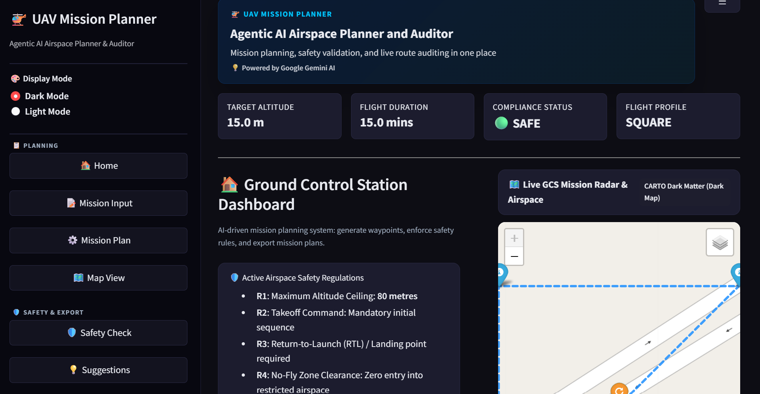
Figure 1. Ground Control Station dashboard, showing the home page overview with the mission workflow and quick action cards.
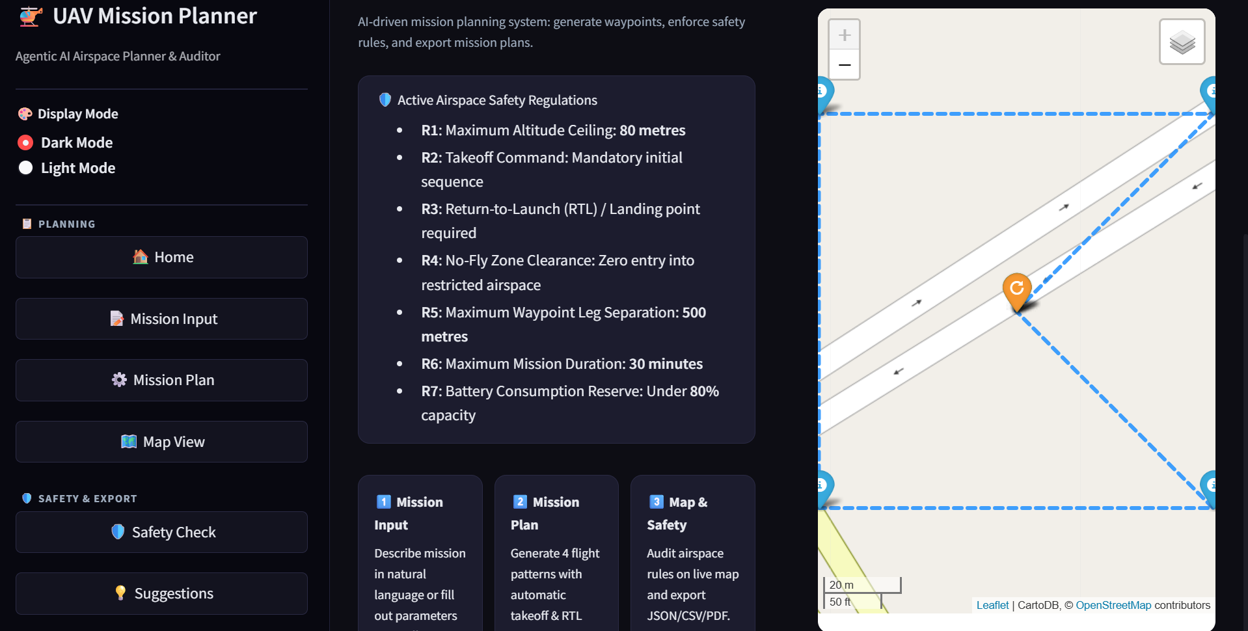
Figure 2. Active safety regulations panel on the home page dashboard.
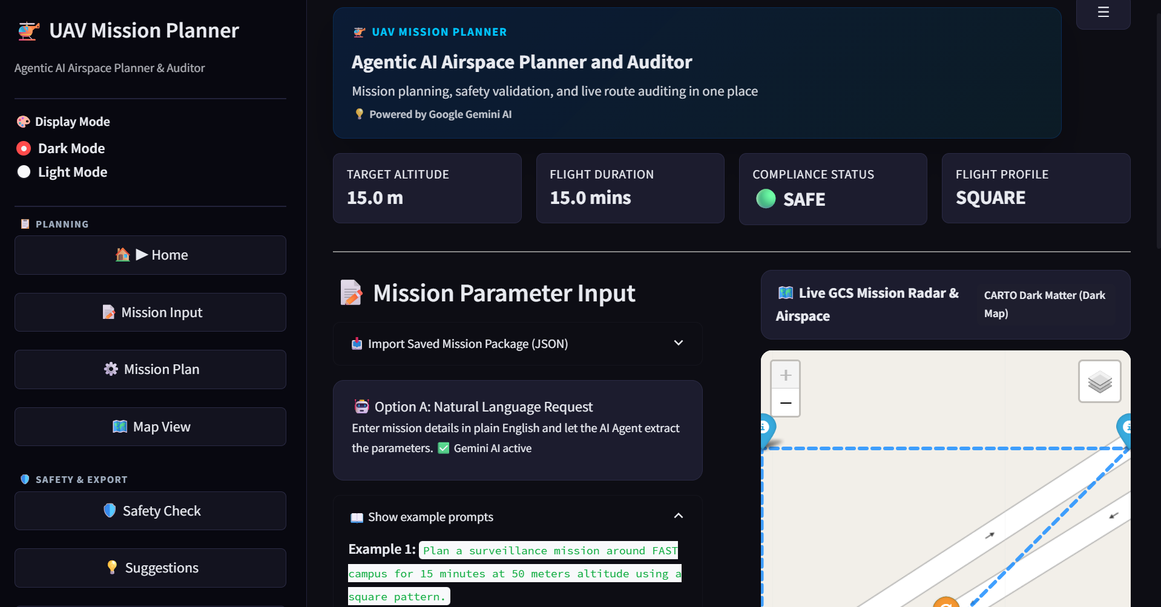
Figure 3. Mission Input page, showing the natural language request panel with example prompts.
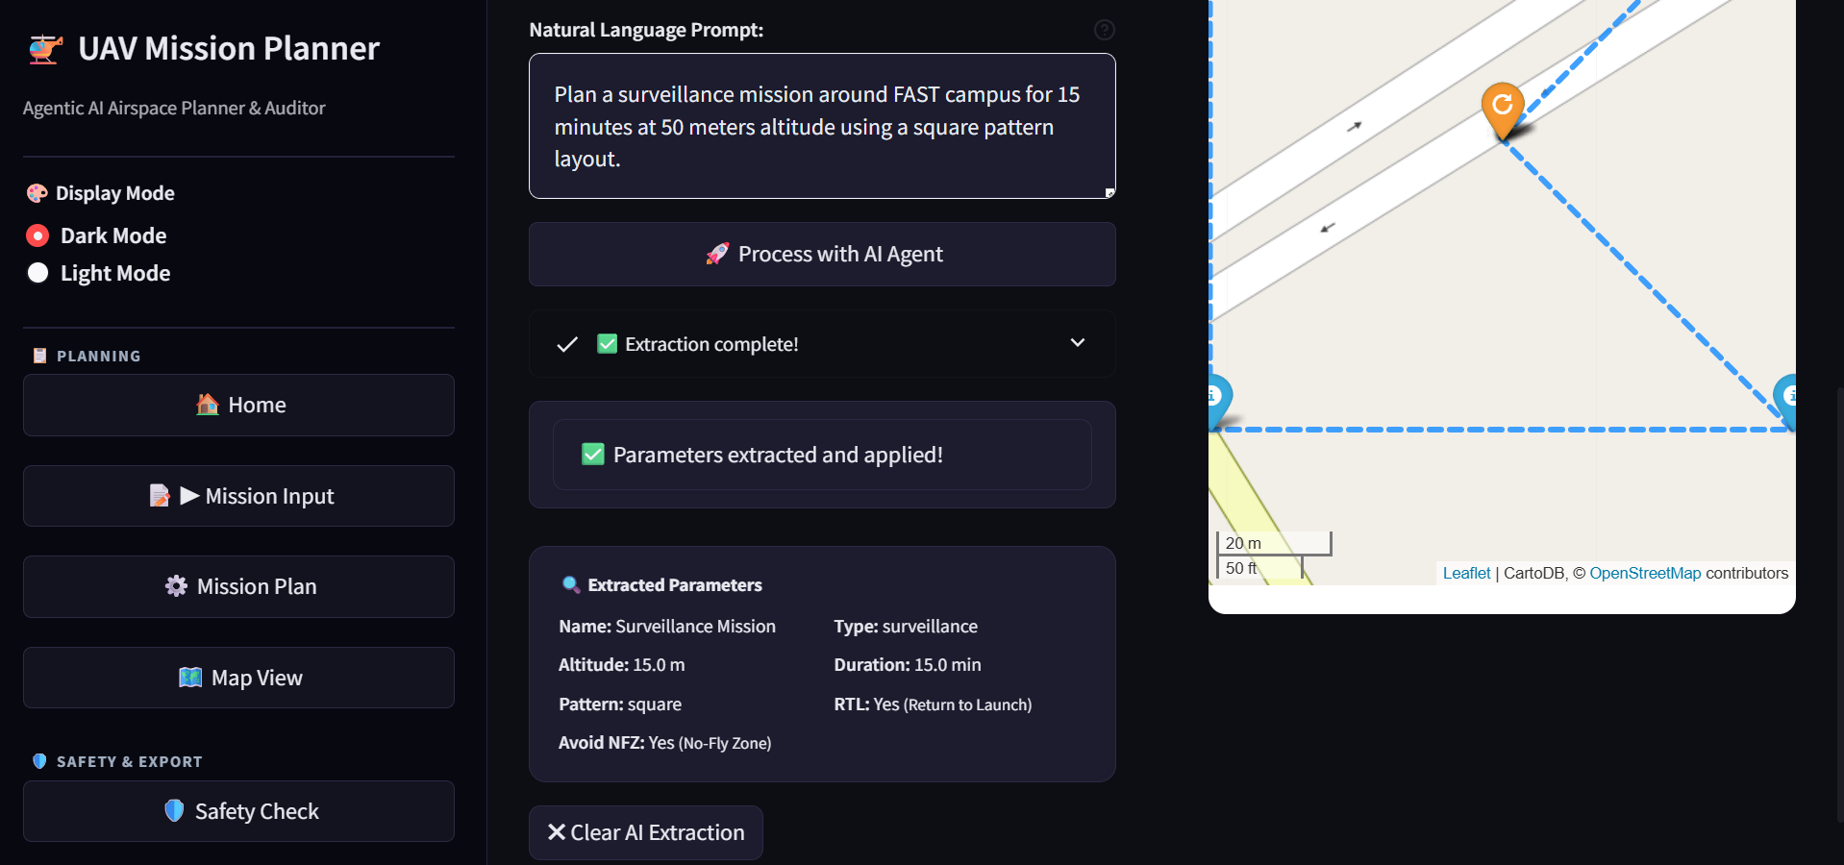
Figure 4. Natural language extraction results, showing mission parameters extracted by the Gemini AI agent.
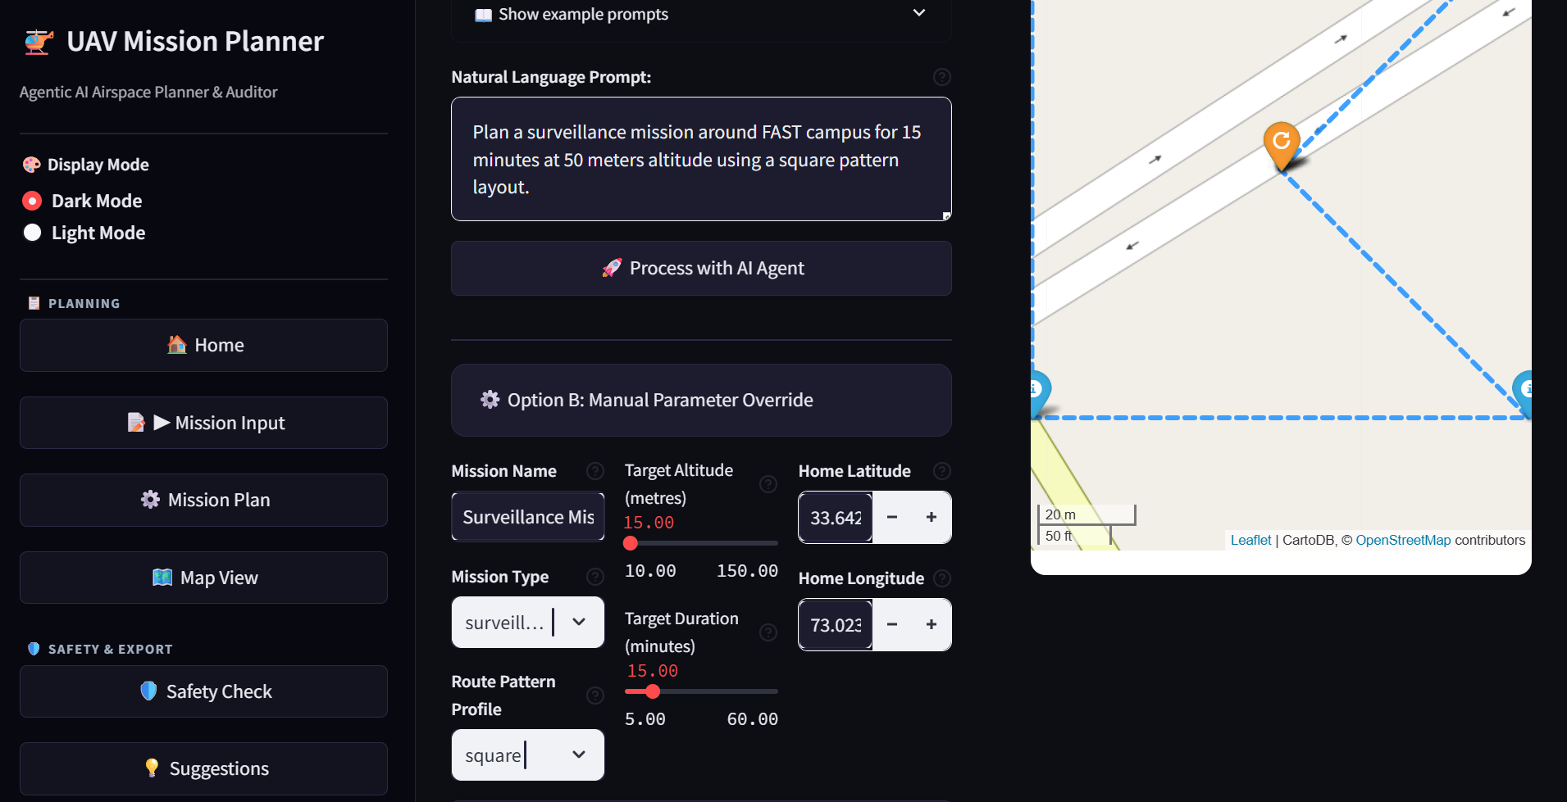
Figure 5. Manual parameter override panel for direct mission configuration.
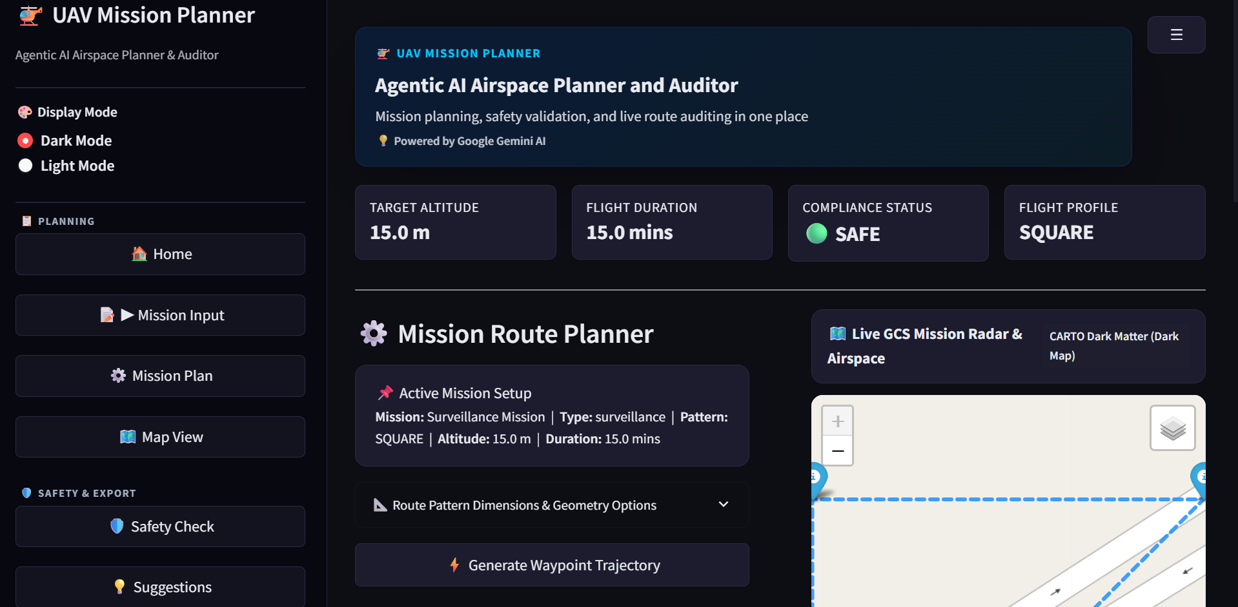
Figure 6. Mission Plan page, showing route pattern configuration and the Generate Waypoint Trajectory control.
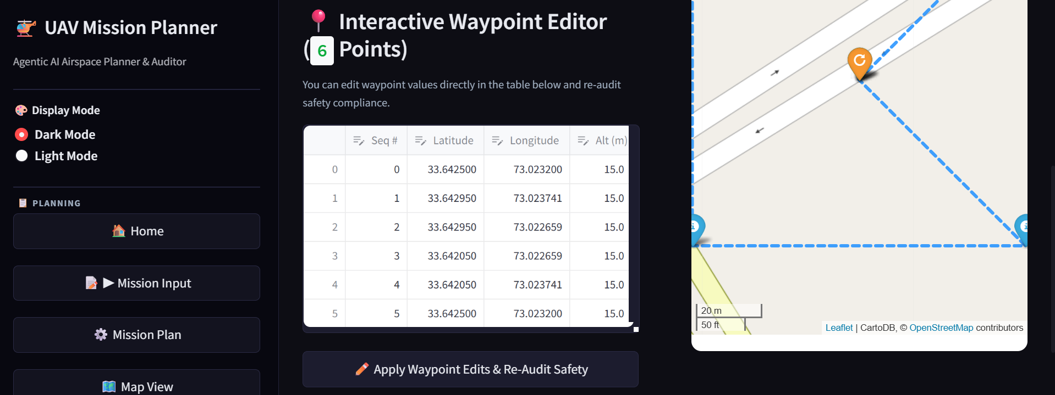
Figure 7. Interactive waypoint editor, showing the editable waypoint table.
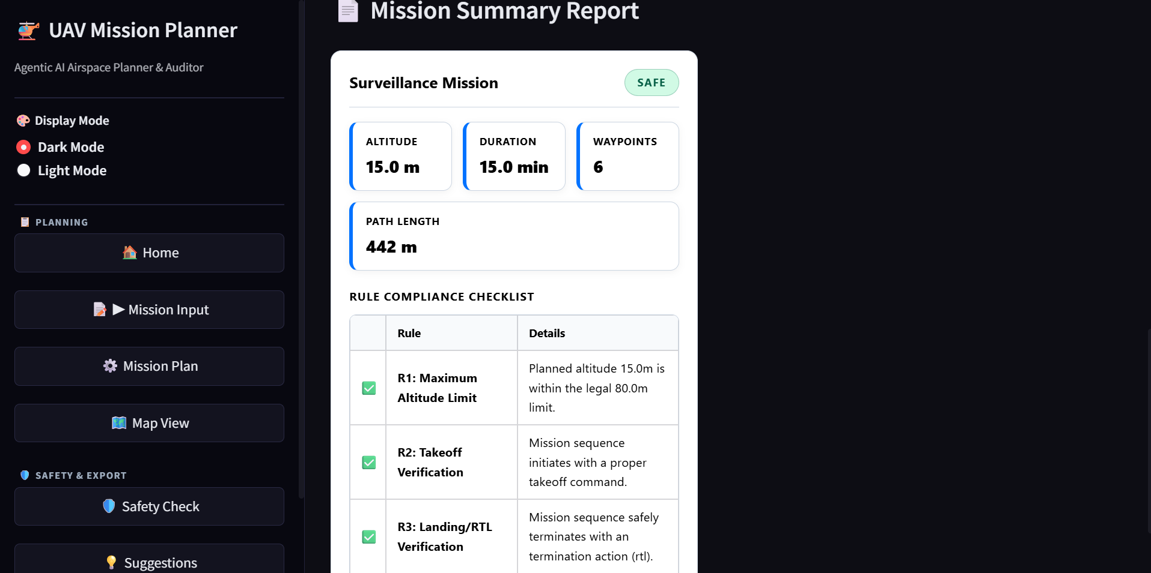
Figure 8. Mission summary report generated from the Mission Plan page.
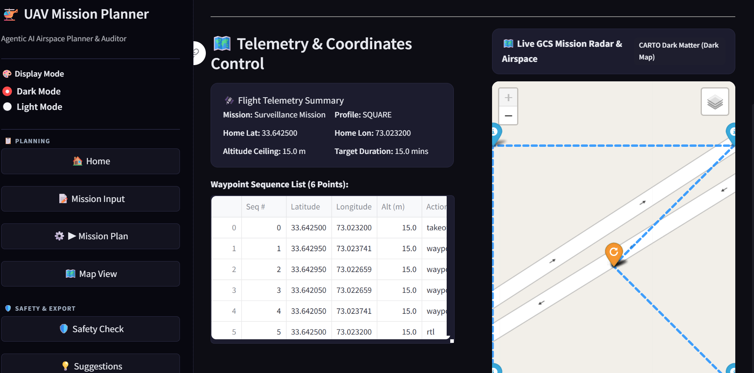
Figure 9. Map View page, showing flight telemetry, the waypoint sequence list, and the live radar map.
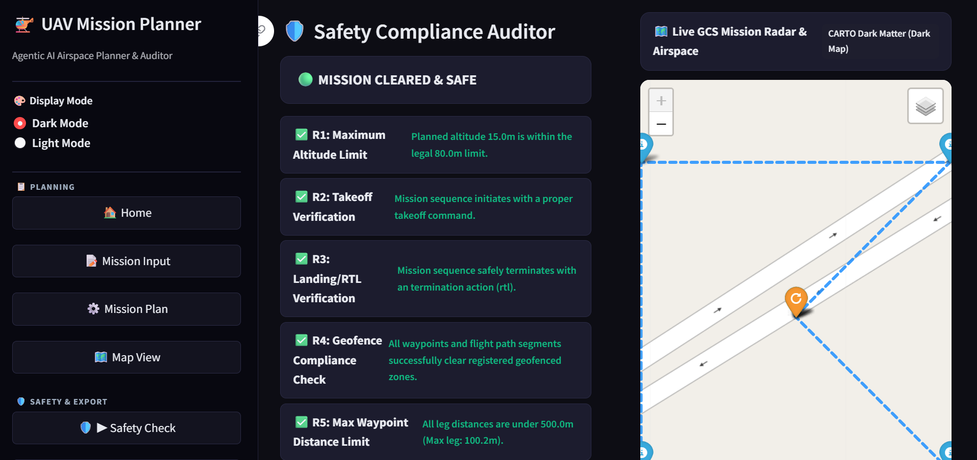
Figure 10. Safety Check page, showing the seven rule airspace safety compliance results.
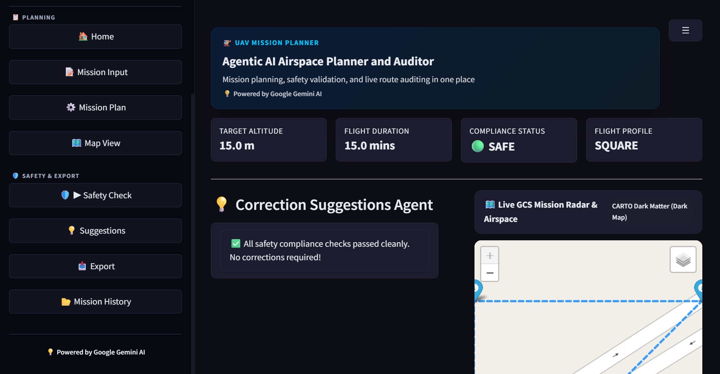
Figure 11. Suggestions page, showing AI generated correction recommendations.
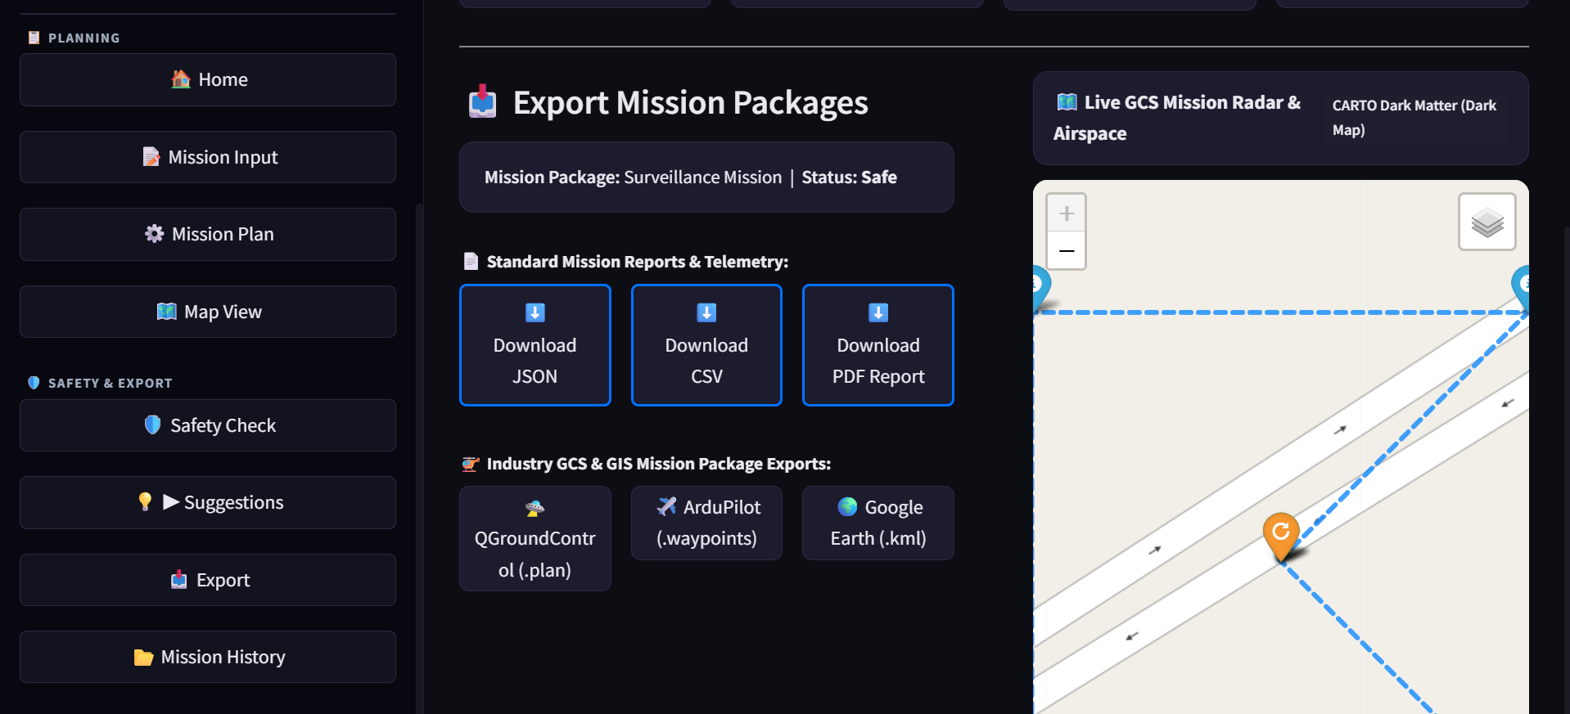
Figure 12. Export page, showing multi format mission export options.
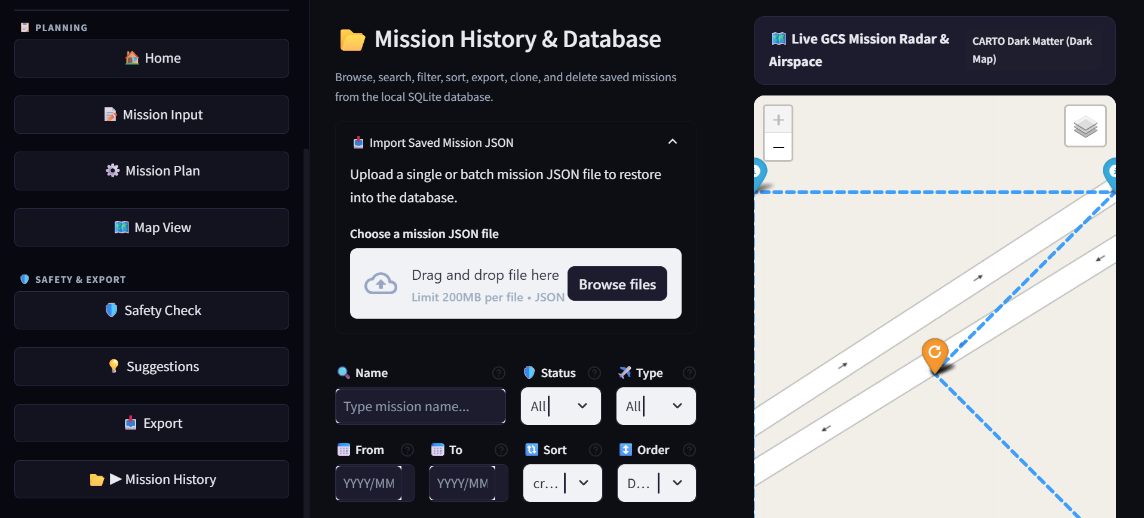
Figure 13. Mission History page, showing database import and management controls.
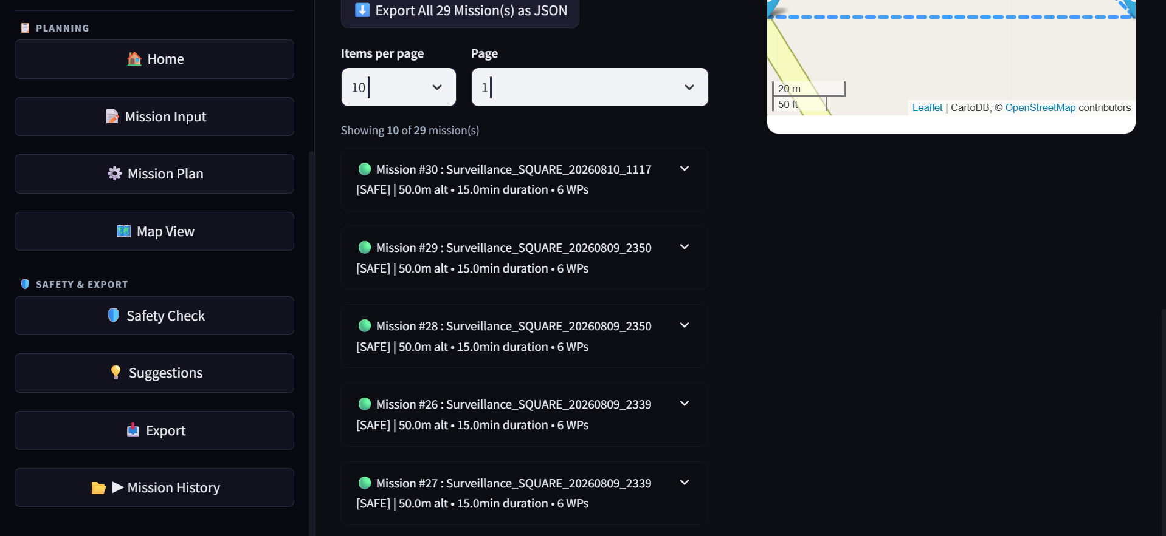
Figure 14. Mission history search results with pagination and status filters.

12. Future Work
- QGroundControl Export Enhancement: Direct .plan format export with full MAVLink command support.
- PX4 SITL Integration: Software in the loop flight simulation testing.
- Multi UAV Swarm Support: Synchronized mission planning for multiple drones.
- Advanced Battery Physics: Modeling drag, wind velocity, and payload mass.
- Real Time Weather Audit: Live METAR data and wind vector safety checking.
- Voice Command Inputs: Speech to text mission prompt processing.
- Terrain Following Altitude Profiles: Integration of SRTM elevation data.
- REST API Mode: Integration with third party ground control station software.
- User Authentication: Multi user support with role based access.
- Cloud Deployment: Deployment to cloud platforms with scalable infrastructure.
- Real Time Telemetry: Live drone telemetry data streaming during missions.
- Mission Replay: Replay of saved missions with animation on the map.

13. Conclusion
The Agentic UAV Mission Planning and Safety Compliance Assistant successfully demonstrates how a multi agent AI pipeline can turn a plain language mission description into a fully audited, exportable flight plan. Over the course of the internship, all ten project objectives set out in Section 4.3 were achieved: the application accepts natural language and manual input, generates waypoints across four distinct route patterns, visualizes missions on a live interactive map, enforces seven independent safety rules, proposes automated corrections, and exports finished missions into six industry relevant formats.
The project underscores the practical value of pairing a large language model with a deterministic, rule based safety layer. The language model lowers the barrier to entry for describing mission intent, while the rule based engine guarantees that every mission, regardless of how it was specified, is held to the same consistent safety standard. This separation of concerns proved central to building a system that is both approachable for a non expert operator and rigorous enough to catch the kinds of errors that manual planning tends to miss.
Automated safety compliance of this kind carries direct significance for UAV research and education. It provides a low cost, hardware free environment in which students and researchers can experiment with mission planning logic, safety rule design, and agentic AI architectures without the overhead or risk of operating a physical aircraft. During the internship, the work involved designing agent boundaries, building geometry based safety logic with Shapely, constructing a physics informed battery model, and developing a full stack Streamlit application with persistent storage and multi format export.
Looking ahead, the roadmap outlined in Section 12 points toward deeper integration with real world ground control ecosystems, more advanced physical modeling, and multi UAV coordination. The current prototype provides a solid, tested foundation for that expansion, and it stands as a complete, working example of how agentic AI systems can support safer, faster, and more accessible UAV mission planning.

14. References
- MAVLink Protocol. Available at mavlink.io.
- QGroundControl Documentation. Available at docs.qgroundcontrol.com.
- ArduPilot Mission Planner. Available at ardupilot.org/planner.
- Shapely Documentation. Available at shapely.readthedocs.io.
- Google Generative AI. Available at ai.google.dev.
- ReportLab PDF Library. Available at reportlab.com.
- Streamlit Documentation. Available at docs.streamlit.io.
- Folium Documentation. Available at python-visualization.github.io/folium.
- Sinnott, R. W. (1984). Virtues of the Haversine. Sky and Telescope.
- CAAC and FAA Part 107 UAV Regulations.
- Docker Documentation. Available at docs.docker.com.

15. Appendix

Appendix A. Complete Project Folder Structure
agentic-uav-mission-planner/
app.py
requirements.txt
README.md
Dockerfile
docker-compose.yml
.env
agents/
mission_understanding_agent.py
waypoint_planner_agent.py
safety_compliance_agent.py
correction_agent.py
report_agent.py
utils/
database_utils.py
map_utils.py
export_utils.py
distance_utils.py
screenshots/
data/
database/
docs/
reports/
tests/
test_planner.py
test_history.py

Appendix B. Sample Mission JSON Output
{
"mission_name": "Campus Perimeter Survey",
"mission_type": "surveillance",
"route_pattern": "square",
"altitude_m": 45,
"duration_min": 18,
"home": { "lat": 33.6844, "lon": 73.0479 },
"waypoints": [
{ "seq": 0, "lat": 33.6844, "lon": 73.0479, "alt": 0, "action": "takeoff" },
{ "seq": 1, "lat": 33.6851, "lon": 73.0479, "alt": 45, "action": "waypoint" },
{ "seq": 2, "lat": 33.6851, "lon": 73.0487, "alt": 45, "action": "waypoint" },
{ "seq": 3, "lat": 33.6844, "lon": 73.0487, "alt": 45, "action": "waypoint" },
{ "seq": 4, "lat": 33.6844, "lon": 73.0479, "alt": 0, "action": "rtl" }
],
"status": "safe"
}

Appendix C. Sample Waypoint CSV Output
seq,lat,lon,alt,action
0,33.6844,73.0479,0,takeoff
1,33.6851,73.0479,45,waypoint
2,33.6851,73.0487,45,waypoint
3,33.6844,73.0487,45,waypoint
4,33.6844,73.0479,0,rtl

Appendix D. Sample PDF Report Page
The PDF export generated by the Report Generation Agent contains a mission summary section, listing mission name, type, altitude, and duration, followed by a waypoint table with sequence number, coordinates, altitude, and action, then a safety checklist listing all seven rules with pass or fail status, and finally an overall approval statement at the bottom of the page.

Appendix E. Installation and Setup Instructions
- Clone the repository: git clone followed by the repository URL, then move into the project folder.
- Create a virtual environment with python -m venv .venv, then activate it.
- Install dependencies with pip install -r requirements.txt.
- Create a .env file in the project root and add the GEMINI_API_KEY value obtained from Google AI Studio.
- Launch the app with streamlit run app.py and open the browser at localhost, port 8501.

Appendix F. Docker Deployment Instructions
- Option A, Docker Compose: ensure Docker Desktop is running and the .env file contains GEMINI_API_KEY, then run docker compose up with the build flag.
- Option B, Docker CLI: build the image with docker build, then run the container with docker run, mapping port 8501 and passing the .env file.
- Open localhost, port 8501, in the browser once the container is running.

Appendix G. Sample Natural Language Prompts and Extracted Parameters
"Plan a surveillance mission around the campus for 20 minutes. Keep altitude below 80 meters, avoid restricted airspace, and return to launch after completion."
Parameter | Extracted Value
mission_type | surveillance
route_pattern | square
duration_min | 20
altitude_m | 80 (ceiling constraint applied)
safety_constraints | avoid restricted airspace
return_to_launch | true

