Articles – Property in Pakistan

# #001 – **Top Properties of 2019 in Karachi**

Karachi, the biggest metropolitan city of Pakistan with an increasing population of approximately 23 million ([*http://worldpopulationreview.com*](http://worldpopulationreview.com/)), is expanding at a gradual but swift pace regarding residential and commercial properties in numerous areas. Karachi is offering multiple options to invest in properties for the people who are interested in buying properties in Karachi for sale or rent. As of 2019, the economic conditions seem like to give good ROI (return on investment) with a stability in prices of properties in Karachi.

Looking at the early past, there was an abrupt change in the prices of properties in Karachi at mid-2018 due to numerous cases of scam, forgery and corruption. Trust and credibility fell down, declining Karachi’s property market for a short period of time. People became doubtful before investing in properties of Karachi.

With the passage of time and change in Pakistan’s political and economic condition, 2019 proved to be an opening once again for property market of Karachi with ever growing business and splendid profit in investments. Following properties of Karachi are trending in 2019:

## **Residential Properties in Karachi**

With an ever growing real estate business in Karachi, there exists an immense number of residential properties in different areas including North Nazimabad, DHA, Gulshan-e-Maymar and Gulshan-e-Iqbal. At the very prime locations, the properties are of high value with amenities like gymnasium, family park, car-parking, 24/7 CCTV secured environment and smooth elevators.

The year 2019 is giving a lot of opportunities to invest in residential properties in Karachi. People from all around the world are availing them looking at the property forecast of Karachi, Pakistan. Moreover, the higher return on investment is on the verge of growing in 2020 and so on because of investments from overseas Pakistani people is boosting like never before.

Therefore it is not too late now to invest in residential properties in Karachi.

## **Commercial Properties in Karachi**

The fast pace of expansion of Karachi is allowing people to look and invest in commercial properties. According to [*https://www.fincyte.com/*](https://www.fincyte.com/), businesses like eateries, real estate, cafes/dhabas, event management hubs, software houses and utility/general stores are also getting established at a very great pace. People are entering into these businesses more frequently in 2019 because of increasing rate of literacy, technology, awareness about standard of living and unique business and marketing strategies.

Moderately populated areas are offering investment options to buy or sell commercial properties in Nazimabad, Gulshan-e-Maymar and Gulshan-e-Iqbal. These properties provide spacious shops in malls and ground-floors of apartments. These shops are attractive towards audience and provide great value to customers as well as residents.

These properties are of great values and some of them are also providing an option of payment on installments and discount. The residential and commercial properties in Karachi are of high demand right now because of tough competition between real estate businesses. The real estate business is ever growing from year 2019 and will allow international trade in Pakistan with more opportunities for future investment.

# #002 – **Best Chance to Invest in Properties of Karachi**

According to a report by SBP (State Bank of Pakistan), an increment of about 128% has been observed in the real estate sector of Pakistan in last 5-6 years, giving the best chance of investment to investors. The economic conditions of the country are allowing the real estate to grow more rapidly as not only Pakistanis living abroad are investing, but other businessmen and industrialists are also looking for properties in Pakistan, especially in Karachi with more interest.

Residential as well as commercial properties are of high demand in 2019, and according to the sales forecast and analysis of real estate market of Karachi, the demand will increase more than ever before. This scenario is bringing a fruitful opportunity for the investors as it will give a handsome profit from each individual property if registered and bought legally. Consider an example, “if a person buys a property in Karachi for 1 million PKR at the end of year 2013, that person would attain approximately 2.3 million PKR in year 2018; a significant gain of about 129% in just 5 years”.

~ [*http://www.sbp.org.pk/reports/quarterly/fy19/First/Special-Section-1.pdf*](http://www.sbp.org.pk/reports/quarterly/fy19/First/Special-Section-1.pdf)

Therefore, Karachi is giving best chance to invest in properties of Karachi as it’s almost the beginning of 4th quarter of 2019. Real Estate market in Karachi is spreading its wings to grow more property business and allow investments from different resources.

With a huge benefit in investments in properties of Karachi, strict amendments have been made in the rules and regulations that must be followed to avoid any kind of mishap or miscommunication. More focused areas are of taxation and transparency in transactions. These new reforms in the real estate market are now officially enforced and can be found online visiting authentic resources like [*http://www.sbp.org.pk/*](http://www.sbp.org.pk/)*.*

These reforms highlight the importance of legal proceedings in the process of property dealing in Karachi and provide proper guidance for the investors. As mentioned above, the tax-filing is a major topic in Pakistan nowadays because of black market, corruption and tax avoidance. It is as important as buying any property and paying its price. Majority of the property taxes are paid annually. And if not done within due date, the transactions made in the current year would be considered as non-filer transactions. This will cause to pay extra taxes, giving an additional amount to go as tax-filing.

Properties in Karachi are one of the best options for a long term investment for overseas Pakistanis as people living abroad can’t go in the hassle of visiting their properties more frequently in Pakistan because of high cost of transport. At least visiting properties in Pakistan once in a year will suffice. With this, Pakistanis living abroad do not have much knowledge about the real estate market and the probability of them falling into traps of false marketing is higher than the Pakistanis living here. If unfortunately any fraud happens regarding properties in Pakistan, the investor suffers badly and the whole real estate market loses its credibility in no time.

Therefore it is highly recommended that one must follow authentic source of marketing about properties in Pakistan and research before taking any step that is costly or unaffordable. It is true that higher risks bring higher reward in terms of return but in the market of real estate, every step related to investment must be taken with full responsibility.

# #003 – **Property Market in Karachi**

Being the largest city of Pakistan, Karachi is also one of the most valuable cities in the world in a sense of providing living (small as well as large scale businesses) to its citizen as well as people living nearby to it. Looking at its importance and the value Karachi is providing to the people, it is considered as one of the best places for investment in real estate business. People living in Karachi have multiple options for investing in commercial as well as residential properties in Karachi.

Since the property market in Karachi is expanding, more investments have been predicted in the real estate business of Karachi because of newly reformed regulations and prices. More authentic sources are emerging in the favor of property buyers and sellers. People are showing more interest in investing in properties in Karachi. No doubt it is essential for any economy to remain competent but in a legal way. Otherwise the whole economy could collapse.

Property market is booming in Karachi, Pakistan because of internal as well as external investments in commercial & residential properties. The political and economic conditions are allowing people to go for sound yet strict proceedings for the buying and selling of properties in Karachi. The overall property market in Karachi has been marvelous since 2018. Putting aside the pricing schemes with respect to the outside suggestions, the general growth in the real estate business of Karachi has been proved to be highly beneficial and productive for the economy of Pakistan.

As there is nothing as perfectly existing, the property market in Karachi also suffered from downfall multiple times due to forgery, corruption, black money and tax evasion. The whole real estate business got affected in that period. Investments nearly ceased to proceed. Negative reviews began to erupt, labelling the whole real estate businesses of not only Karachi, but of whole Pakistan. That time, no tax-filing was done as an option. Lack of awareness of property market in Karachi led many investors and agents into loss. Observing all this situation, finance secretary of Federal Board of Revenue (FBR) of that time said, “The spirit of the reforms is to improve documentation and plug loopholes in the framework that is being used to evade taxes.” ~ [*https://www.dawn.com/news/1440441*](https://www.dawn.com/news/1440441)

The residential as well as commercial properties in Karachi are getting searched online more frequently because of massive growth in real estate market since 2018. Investors from multiple domains are ready to invest because of tough competition in property markets of Karachi. The greater return from the investments in properties in Karachi is not the only single factor that is alluring the investors but the prime locations of Karachi’s properties with promising amenities are also increasing the value on a higher scale of these properties.

As of 2019, the era dominant by technology, the online property markets of Karachi have been doing outstanding in advertising and reaching maximum audience. The clients are regaining their trust. Online portals are working with full responsibility and accountability. Majority of the queries are getting solved online. The client’s satisfaction is given the maximum priority. And eventually, it is all coming in the mutual benefit of Karachi’s property market and its stakeholders.

# #004 – Most Demanding Real Estate of Karachi in 2019

There are 3 most basic human needs that have been discovered so far. According to Abraham Maslow, an American psychologist renowned for his famous “Maslow’s hierarchy of needs”, those 3 human needs are:

* **Basic Needs**

These need include physiological & safety needs.

* **Psychological needs**

These include needs of love and esteem.

* **Self-fulfillment needs**

Here comes self-actualization.

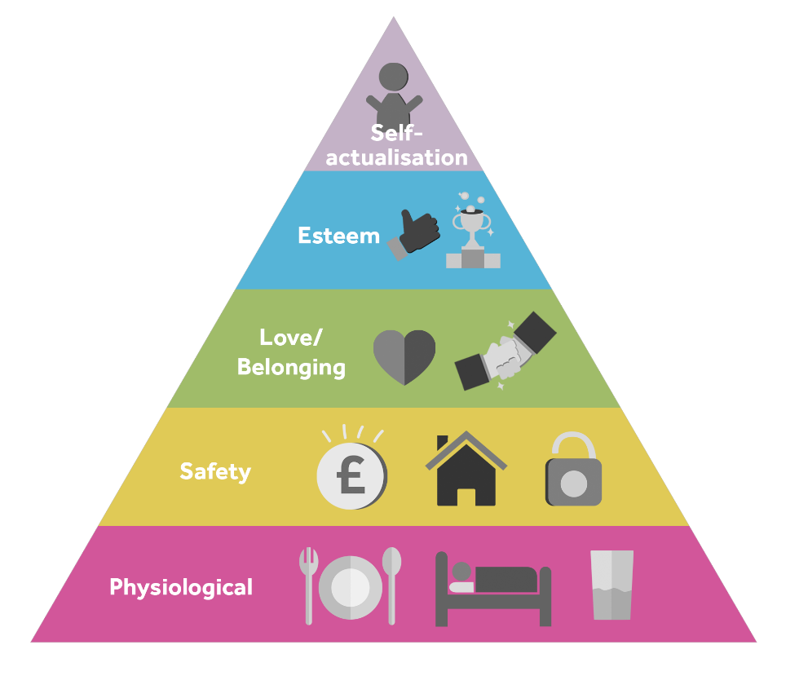

Looking at the first and foremost physiological & safety needs, people’s instincts demand a suitable place to live where they can begin their lives with harmony. Since the world is not so kind these days to common people, a collective practice has been observed in which people tend to invest most of their savings in livelihood. There is nothing wrong, in fact their step towards these kind of huge investments is allowing the real estate business to grow and let the higher economy benefit the country’s overall standard with respect to the modern world.

Finding a commercial or residential property is not easy these days, especially in hugely crowded cities like Karachi, Pakistan. Accepting a highly diverse lifestyle, Karachi’s real estate business is also tasting a beginning of success from the perspective of 3 parties i.e. property buyers, dealers and sellers in Karachi. Not only for the population residing in Karachi right now, but also investments from overseas like U.K and GULF countries are also rising in 2019, and it is predicted that year 2020 will provide more investments and higher returns in Karachi’s property market.

Reason behind this future success of real estate business in Karachi is the newly reformed rules & regulations regarding property buying and selling. Whether the property is commercial or residential, a strict protocol has been enforced that must be abide by all the stakeholders. Tax, transparency, transactions, possessions and licensing etc. are now taken more seriously to avoid any kind of corruption and future hassle. It must be acknowledged that cases of property fraud and illegal documentation will surely lead to heavy fines (5-7 lakhs PKR, varies from property to property) and may be imprisonment for 3-4 years. People are recommended to follow authentic resource and real estate agency in Karachi to avoid any kind of mishap. With this, follow-ups are required, especially for the Pakistanis living overseas because these days are not of trust anymore.

The real estate business in Karachi is booming and offering multiple investment options in highly demanded properties. These properties are from the big names of Karachi like Saima Builders & Developers and Maliha Towers. These names have been dominating the real estate market of Karachi since years and they never compensate in the name of quality and trust. Their properties include luxury and executive apartments, houses and excellent shops with excellent facilities like fully secured environment, family parks, gymnasium and easy & open car parking. These **properties in Karachi for sale** are of high value with reasonable prices. The builders are taking big steps in response of most demanding real estate of Karachi in 2019. Awareness about these properties in Karachi have now become more popular because of use of technology is now getting more common.

# #005 – Properties in Karachi - Most Profitable Investment of 2019

“Money loses its value over time”.

This phenomenon happens due to several reasons, especially when the economy of a country grows. The growing economy brings in more employments and jobs and the employers must raise wages of their employees to generate more revenue. Now the stuff that was of 100 PKR suppose, has now become of 120 PKR. Vendors charge higher prices to compete and to survive as well. Sometimes it’s when the government decides to print more money, eventually decreasing the value of money. That is why it is said that “Money of today is better than money of tomorrow”.

Same goes with the investment in properties, whether they are commercial or residential. If you rationally invest in something demanding or trending, there is high probability of you getting higher returns at the end of your contract. People run behind money to earn it maximum in least amount of time. The ever increasing demand of property investments is a golden opportunity for the economy to grow, especially in cities like Karachi, having area of approximate 3,780 km2 (1,460 sq. mi) by Wikipedia. This huge piece of land is still vacant enough to establish great number of properties to bring Karachi in the world’s top-notch hubs of residential & commercial properties. More opportunities to invest in this real estate business will flow throughout the developed countries where earning money is the only reason left to live a happy life.

The growing diversity of people in Karachi is another reason in exponential growth of real estate business. Massive amount of investments have been recorded in the **real estate sales** and analytics till year 2018. Not only this, the investment in properties in Karachi is getting considered as the most profitable investment of 2019. People are in dire need of these opportunities. Taking note of this situation, a huge applause for the property builders because of their continuous efforts in making Karachi a residential as well as commercial property hub.

Property market of Karachi is now experiencing a bang from the customers because of the big names like Euro Builders and Developers and China Group. These renowned names bring value to people by opening investment opportunities in real estate sector of Karachi. Not only this, their residential and commercial projects are of high demand right now and it is expected that by the end of 2019, these properties of Karachi will give big return on investment.

China Group’s luxury livings in the prime location of DHA, Karachi with exceptional technological enhancements will gives customers the best living experience like never before. Facilities include 24/7 CCTV secured environment, Air-conditioned malls, safe and spacious car parking and family parks. The surroundings of this project are close to nature and brings-in good healthy life style for the inhabitants.

Therefore it is the time to invest in these mega fruitful properties in Karachi because these properties are of high demand and are ready to invest in, doesn’t matter whether it’s for sale or rent, because as stated above “money of today is better than money of tomorrow”.

# #006 – Find out the Top demanding Properties in Karachi

Property market in the world is experiencing a rapid change in the market dynamics. Technological enhancements, increasing literacy rate, better lifestyle and fast overall development are leading the world’s property market to a next level. The trend of exploring different parts of the world is now becoming more common to have a personal insight in the real estate business. And also to own properties legally in other countries for future perks. Property analyzers are keeping a good record of property sales and forecast throughout the continents. Due to this awareness, people are now investing more than before in real estates.

Talking about the property market analysis of continents, Asia’s property market is now trending because of massively crowded cities like Karachi. A study shows that there occurred an abrupt fluctuation in Karachi’s property market because of currency’s value.

“In Karachi, house prices averaged PKR 13,158 (US$ 93) per sq. ft. in Q1 2019, up 4.25% from the previous year, but down 4.62% when adjusted for inflation”. ~ [*https://www.globalpropertyguide.com/Asia/Pakistan*](https://www.globalpropertyguide.com/Asia/Pakistan)

Due to this neutralization in prices of Karachi’s property market, the residential and commercial properties are now of high demand. 2019 is the year of dominancy for the real estate business in Karachi to fulfill the ever increasing demands of the people in Pakistan and also overseas Pakistanis. The higher demands in 2019 are more competing too because of the competition in Karachi’s real estate business. Decision making for the investors is getting more challenging because of increasing fraud and scam in property market of Karachi but there is nothing to worry about because the newly constituted rules & regulations are strict enough to tight the noose for corrupt property businesses in Karachi. Tax evasion and false documentation aka forgery is getting eradicated. Proper licensing, possessing and buying & selling of properties in different places of Karachi is becoming a common practice for the property investors in Karachi.

With this, numerous properties are top demanding in Karachi and some of them are on the verge of getting completed. Property builders in Karachi like Wasi Builders and Developers & Al-Amna Builders and Developers are doing exquisite job in making Karachi one of the biggest centers of residential as well as commercial properties in the world. There projects are of high caliber with extra ordinary facilities and surrounding. Bungalows, cottages, 4 & 5 rooms luxury apartments and sizeable shops are available. Not only this, there is prayer area, children play-ground, extensive parking and armed guards surveillance too to fulfill all additional demands from their clinets. These top demanding properties in Karachi are located at Gulshan-e-Maymar, near Diamond City, Karachi and Scheme 33, close to Rim Jhim Towers, Karachi.

Investing in these Karachi’s top demanding properties will be a smart move because of returns more than expected in 2019 and forthcoming years. Moreover, some these projects are offering pre-launch discounts so that the clients may avail maximum benefit for themselves. And also the awareness about these projects is increasing day by day to guide maximum people who are ready to invest in these properties in Karachi.

# #007 – 3 Places of Properties in Karachi Where You Should Invest

In the past few years, the real estate business was not quite booming because of bad economic conditions and also the worst management of **property market in Karachi, Pakistan**. Fraudulent documentation was very common and got accepted on a huge bribe. Law and order situations were not up to the mark. Real estate agents were struggling to earn the best from illegal sources. No sign of proper tax-filing and transaction record and verification was there. **Karachi’s property market** was in a chaotic distress.

With the passage of time, when the economic and political conditions got stable, IMF’s approval of $6 billion to assist “return of sustainable growth” to the economy of Pakistan played a vital role. [[*https://thediplomat.com/2019/07/the-imf-takeover-of-pakistan/*](https://thediplomat.com/2019/07/the-imf-takeover-of-pakistan/)] Through the harsh sufferings in **real estate market, Karachi** is now offering multiple investment options in the real estate business. **Properties of residential as well as commercial** **kind** **for sale** are available by multiple projects and people are investing with legal proceedings. The elevated prices are now even because of inflation. Real estate sector is rising, encompassing majority of the **areas of Karachi**.

The investment options are no doubt full of risk because of past experience of **Karachi’s property market** but steps have been taken and newly reformed rules and regulations have now been enforced to mitigate all possible types of risk.

2019 has brought more splendid investment opportunities to Karachi which are **commercial and residential properties for sale**. The huge area of Karachi is positive for its real estate business. Investments are in total favor of country’s overall economy. Overseas Pakistanis are getting more interested in these projects and are investing with full legality. Not only this, but the real estate sector is now flourishing like never before.

Getting more insights about the builders and properties, following 3 places of **properties in Karachi for sale** where you should invest are:

1. **Scheme 33**

This area is getting awareness because of Al-Amna Builders and Developers’ project known as Amna Towers, located in Scheme 33 near Rim Jhim Towers. This area is hassle free and brings value to the clients. This place is getting filled with multiple other projects. The real estate business is getting real benefit from these projects. Karachi is expanding its wings and reviving from the dearth of investments. Since the properties of Pakistan for sale were more of fraud cases in the past, this time every stakeholder of that specific **property for sale** will be responsible and accountable in case of any illegal activity recorded.

1. **Tariq Road**

One of the most famous places in Karachi. Renowned for the boutique hub, Tariq Road is well established area with **commercial and residential properties for sale**. At main Tariq Road, Evergreen Residency is open to invest in 5 & 7 rooms luxury apartments. These apartments are up to the standard with fully secured surrounding. The area of main Tariq Road is of greater value because of availability of all human necessities. From hospitals, schools to restaurants, markets and masjids, Tariq Road is considered one of the best places to invest in **properties in Karachi for sale**.

1. **North Karachi**

With the high rate of increasing population, the worthy area of North Karachi is a good option as a residential point where people are able to get everything in neighboring streets. This area is offering investment option in Maliha Towers, located at posh area of 4K circuitous (chowrangi). This project is providing 2, 3, 4 & 5 rooms luxury apartments with amenities including covered car parking area, high-speed elevator, gymnasium, swimming pool, park and jogging track.

In a nutshell, these 3 places are providing best options to **invest in properties in Karachi for sale** because these places are of great value and bring life closer to nature.

# #008 – Top Searched Properties of Karachi

[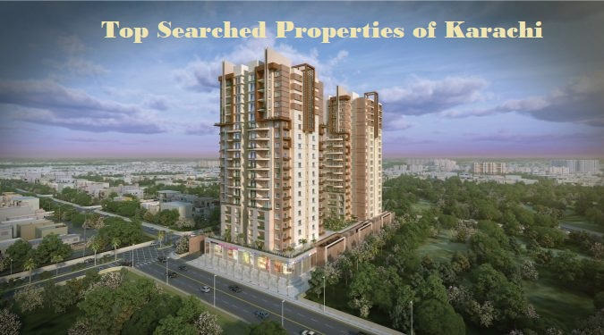](http://www.frontline.com.pk)

[*Saima Excellency*](http://www.frontline.com.pk)

Every real estate **property for sale in Karachi** is of high value until the set of taxes are being paid on time. Not only taxes, other license renewing process in case of **commercial property for sale** also matters in one’s property. Before 2016, Karachi’s real estate market was in abyss of corruption. This declined the economic graph badly because taxes were not getting paid, transactions were getting done in black money and estate agents were not sincere with obligations i.e. to document the files of properties in Karachi officially.

As we all are aware of how things are changing, every business in Karachi is getting positively affected due to new yet strict rules and regulation regarding selling and buying properties in Karachi. People with black money are getting choked because all the record related to property transaction is required when it comes to reporting at FBR. Nowadays people have begun to follow these rules and regulation more precisely so that they can avoid any kind of risk.

The **properties in Karachi for sale** are one of best ways for long term investment. These investments bring high return and will be bringing even higher returns in next 3-4 years. These investment opportunities do bring prosperity, but it must be remembered that everything comes with a price. Not the actual price of properties, but the price to pay for proper and authentic guidance. One can never be so naïve to **invest in big properties for sale** without doing enough research. There are multiple resources available in Karachi so that interested people can gather as much information about specific **property for sale** as they require.

Karachi being on the verge of getting acknowledged as one of the biggest spot to invest in Pakistan, is now offering multiple investment options including **residential as well as commercial properties for sale**. With the big names of property pioneers, there are some **top searched properties of Karachi for sale** namely Saima Jinnah Icon, Maliha Tower, China Gold Park and Euro Hi-Tech Residency. These property builders and developers are well known for their projects. Millions of clientele, these builders always go beyond the satisfaction of their clients i.e. the clients’ delight. All of these projects are located at the most valuable locations with extra ordinary surroundings. The projects include luxury & executive apartments, spacious & attractive shops, extensive car parking, gymnasium, swimming pool, 24/7 CCTV secured environment and high capacity back-up generators.

Moreover, some of these **properties in Karachi for sale** are offering pre-launch discounts and payment on installments as well. Therefore, above are the reasons why these **properties for sale in Karachi** are top searched in **Karachi’s property market for sale**. All of these projects are open for investment and with people in Pakistan, overseas Pakistanis are heavily investing in these properties of Karachi.

# #009 – Long-term Investments in Karachi

Knowing the fact that long-term investments are safer than short-term investments, still it requires to do maximum study and research prior to investing in something big for an extra ordinary outcome. The long-term investments let you wait for 8 – 10 years to see the greater good.

The market is cyclic and always recovers from the downfalls, although it may require time to make it done. However, if you back off when prices go low, there is a big chance that you would lose some portion of the money you invested in the beginning. ~ [[*https://www.thebalance.com/are-long-term-or-short-term-investments-better-2385918*](https://www.thebalance.com/are-long-term-or-short-term-investments-better-2385918)]

Problem occurs only when human’s instinct of hastiness in knowing the result rises. Being a human, it’s common that every person want to know the result as quickest as possible in which he or she invests in. In academics, we want to know the result of our exams because we invest our time and money in it. We desperately wait for our brand-new car when we invest a huge amount and they tell us that your car will be available in 3-4 months. We struggle avoiding that feeling because it’s in our nature.

Majority of people living in Karachi, Pakistan let go golden opportunities of long-term investments because of this long waiting period to see their return on investment. Some of them lose these chances because of their risk averse nature. Investment includes risks no doubt but these risks can be mitigated by research and consultation from authentic resources. Still the risk can’t be zero but being optimistic, everything come for a cost. The cost resides in investment conceals in the name of risks. One can minimize them, but can’t avoid them totally.

Since the awareness of technology, better lifestyle and online world in Karachi has grown rapidly, the chances to avail long-term investment opportunities has also risen. Most of these opportunities include property investment in Karachi. And these long-term investments in Karachi are expected to produce a handsome share of return in the coming years. It is true that the real estate business is facing tough competition throughout the heavily crowded city of Karachi. The whole property market of Karachi is experiencing massive response for the **investment in properties for sale**. People are exploring more insights regarding **properties in Karachi for sale** for long-term investments. It’s no more anecdotal to say that **property for sale in Karachi** will shoot to touch the peak of maximum investments in the history of **Karachi’s property** market in the next few years.

These properties are available for both residential as well as commercial purposes. The real estate market is serving the clients with full potential. Clients with queries are getting clarification and also satisfaction from the Karachi property market’s services. The marketing agencies of these **properties in Karachi for sale** are also performing excellent job in promoting the real estate business. The real state sector is playing a mega role in providing multiple investment opportunities for the people around the world interested in **buying properties in Karachi for sale**. With effort and interest in respected domains, whole benefit is doing better for the economy of Pakistan.

Therefore people have acknowledged the myth of risk and accepted the fact that “the higher the risk, the higher the potential return”.

# #010 – 3 Best Areas of Residential Properties in Karachi

Before investing in properties of Pakistan, whether they are residential or commercial, gathering insights about the area is as essential as making research for the Karachi’s property for sale. This is because the environment affecting the properties for sale plays an important role in the value of that specific property. The environment may increase or decrease the property’s value by huge margin.

Let’s consider an apartment located at a very posh area. The apartment is providing amenities like extensive car parking, swimming pool and gymnasium. Shops of eatery, boutique, medical and general store are available on walking distance. Everything is good about that apartment. But, there is a sewage line passing at the back of apartment, spreading a stinky smell within a radius twice that of the apartment’s premises. Due to this only factor, you would get residence in that apartment in less than reasonable price because the builder want’s to complete its job and agents want to give residential possession to the clients as quickly as possible so that both of them may suffer from least possible loss. The process of compelling clients to buy property there would become more difficult because no one in this world will want to invest in Karachi’s property for sale that would give nothing in return but a stinky place to live. This happened not from the project’s own features, but the surrounding affecting the environment, eventually decreasing the value of the project.

Karachi, being the biggest residential as well as commercial property hub of Pakistan, is providing best properties for sale in the most demanding areas. These areas are moderately crowded with everything available in shops nearby. Moreover, the surrounding is also natural, not allowing any kind of negative impact to affect the property for sale in any way. This enhances the value of the project in clients’ view and the clients become more reliable regarding investing in these properties for sale. For long-term investments, the price is not the only key factor. Above mentioned example proves this that the apartment’s price is lower than reasonable amount, still people are not willing to invest in that property just because of bad surrounding.

Looking at these circumstances, [Karachi’s property market](http://www.frontline.com.pk) takes good care of these aspects. The project builders and developers are curious about the surrounding to satisfy clients’ needs with responsibility. There are multiple areas in which properties of Karachi for sale are under construction, and some of them are very close to completion. These projects are of higher value with multiple set of amenities. The builders & developers are offering great long-term investment opportunities. Some of the areas in Karachi to find these golden opportunities are:

* **DHA**

Defence Housing Authority (DHA), Karachi is an area providing lovely residential properties for sale of standard living with luxury apartments and houses. This area is close to seaside that gives fresh air to breathe, soothing environment and a healthy lifestyle. Not only this, there are malls available for shopping, restaurants to dine-in delicious food, health care places and entertainment spots. The properties of Karachi for sale in DHA are of high value and people have started looking there for investment.

* **Nazimabad No.1**

Area of great characteristics including schools, colleges, universities, masjids, eateries and amusement spots. Nazimabad No.1 offers options for [long term investment in Karachi’s property for sale](http://www.frontline.com.pk). Luxury apartments, beautiful houses and elegant shops are available with attractive surroundings.

* **Muhammad Ali Society**

The posh area is recognized as one of the most beautiful residential spots of Karachi. This area is offering executive apartments and also spacious shops to fulfill clients’ commercial needs. Moreover, this area is also renowned for schools & colleges, National Stadium Karachi and nearby Pakistan Air-Force (PAF) museum. Surroundings like these are hard to find in Karachi.

# #011 – Karachi Real Estate Market of October 2019

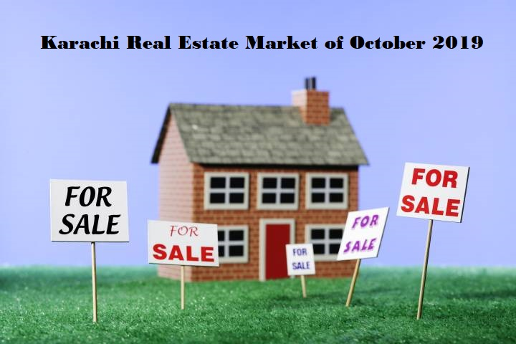

*Real Estate Market*

The economic and political situations act as major influencers in shaping the property market of any city or country. With the superiority in decision making, government enforces set of rules and regulations on the real estate stakeholders to control the autonomy in property dealings throughout the country. As rules and regulations are made for the betterment of humanity, still people feel proud in not abiding by these enforced rules. Due to their lack of compliance, government begins to take strict actions because the real estate business is one of the major sources of long-term investments and also a golden channel for country’s economic growth.

Cities having large areas like Karachi are suffering more from corruption than the cities having small areas. Properties for sale couldn’t find stability in Karachi due to running of black money, non-filing and making illegal documentation. This causes loss in overall property market and also loss in credibility, eventually decreasing real estate market’s revenue. Stakeholders including property buyers, sellers and agents go in trouble whenever the rules and regulations become stricter. Heavy fines are imposed with years of imprisonment if involved in these illegal property dealing.

Talking about the real estate market of Karachi in 2019, a slight change has been observed in the statistics of Karachi’s properties sales and forecast. This slight change is expected to become the game changer for Pakistan’s real estate market. The reason behind this change is the newly reformed rules and regulations regarding the real estate business. Multiple factors that were negatively affecting the [property market of Karachi](http://www.frontline.com.pk) are now getting eradicated. For example; property buying from non-filers, fraud and scam in property for sale in Pakistan, limitless dealing of property by non-filers and assisting false property documentation. These mentioned factors were on peak between years 2014-2018. Multiple cases of forgery, corruption and black money are still in court, pending to be solved. The whole real estate market of Karachi was on the verge of getting collapsed. Due to these reforms, people are now trusting more in real estate business and considering the Karachi property sector as a good long-term investment option.

The overall economy of Pakistan is regaining its strength once again due to emerging transparency of real estate business. As of October 2019, multiple projects are under construction in Karachi’s renowned areas where residency is of increasing demand. People are investing in these [Karachi’s residential properties for sale](http://www.frontline.com.pk) to get a key to future because the real estate analytics predicted that Karachi’s properties for sale will give better than expected returns in the coming years. Both, property buyers & sellers are looking for multiple opportunities to invest after looking into the growing Karachi’s real estate market.

According to experts, right now the final quarter of 2019 is the best chance to invest in residential as well as commercial properties for sale in Pakistan. Providing some perks to increasing number of clients, builders are providing pre-launch discounts and option of payment in installments too. The tough competition do occurs in Karachi’s real estate market but after all, it’s bringing back the power in Pakistan’s economy as heavy investments have started to enter in Pakistan’s property sector from overseas Pakistanis.

# #012 –Most Expensive Houses in Karachi

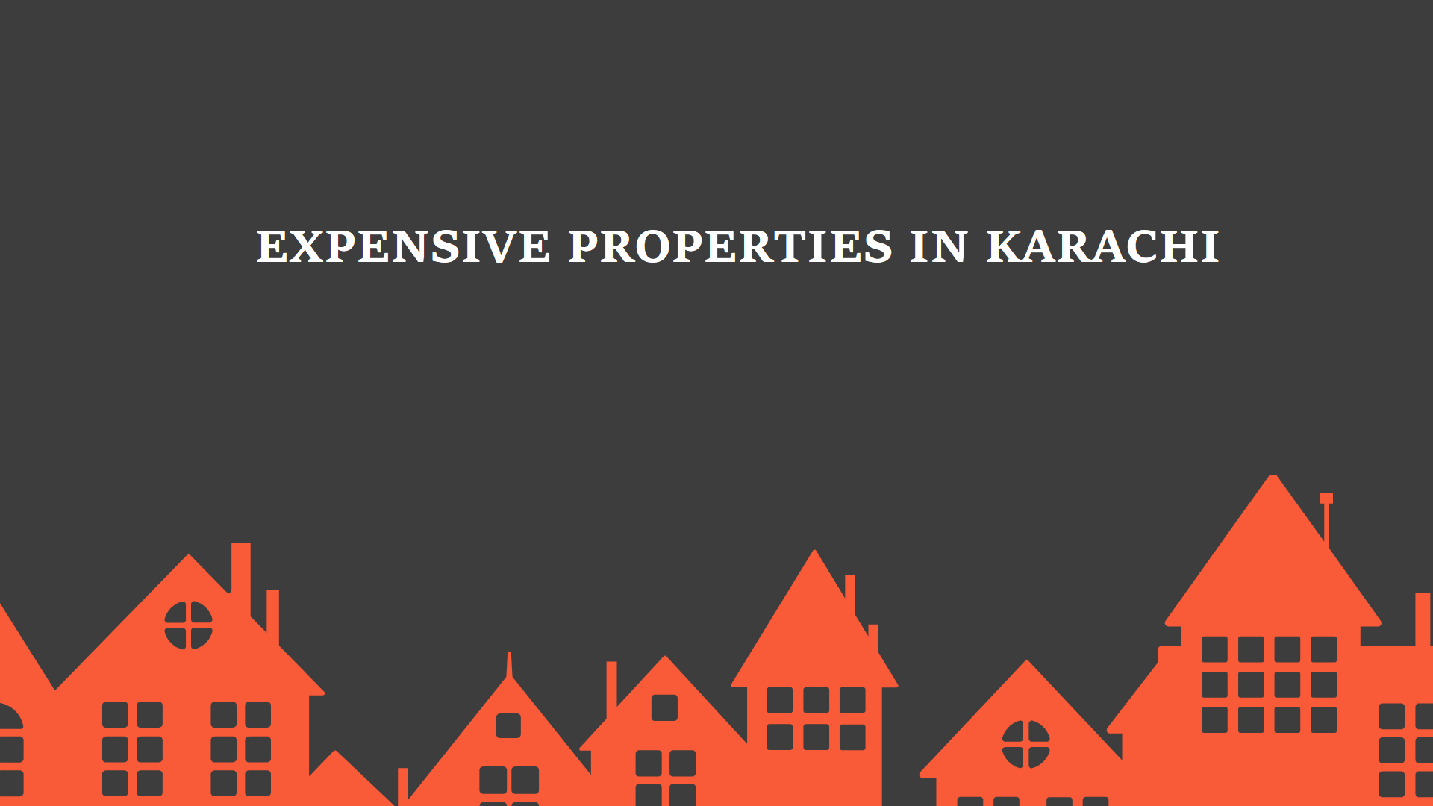

*Expensive Properties*

Karachi, being the financial capital of Pakistan, is one of the top-3 most populous cities in the world. Despite having several political issues, the city of lights is experiencing a rising demand of residential properties. People have begun to invest in property market of Karachi in 2019 more frequently. The real estate business is now taking new heights. With all these demands, builders and developers are growing their businesses too.

Karachi’s geolocation is considered to be among the best because one can easily enjoy all 4 seasons here. This gives advantage as the agricultural originated city is successful in growing and farming all kind of fruits and vegetables since the independence. The residents of Karachi do complain about the rising temperature every year in summer but deep down there is a strong bond between their hearts and this beautiful city. The historic places that are known as must-visit include Mohatta Palace, Frere Hall, Quaid’s Mausoleum and Empress Market.

With the valuable infrastructure of the city Karachi, it is considered as the best commercial hub of Pakistan too. Multiple businesses of every domain are available here. Wealthy businessmen also love to own [properties in Karachi, residential as well as commercial](http://www.frontline.com.pk). Being good in wealth, properties of great worth are also available in Karachi for sale.

* **Bilawal House, D-30 Block, Clifton, Karachi**

Worth of Rs. 3 million, Bilawal House in Karachi is Bilawal Bhutto’s (son of former president of Pakistan, Asif Ali Zardari) one of many other properties located in posh area of Clifton. It covers approximately 1027 sq. yards of the area with multiple amenities.

* **VIP Bungalows, Bahria Town, Karachi**

The newly established town with even higher residential value offers bungalows of greater wealth, starting from Rs. 120million. Bahria town in Karachi is a place to visit if your instincts are against the beauty of Karachi.

Not only this, the property builders are doing great in providing luxurious [residential properties for sale](http://www.frontline.com.pk). The area of P.E.C.H.S, main Tariq Road is offering lavish bungalows and luxurious apartments with 5 & 7 apartments by the renowned builders Evergreen Residency. These apartments bring beautiful lifestyle to the clients due to its prime location with everything available at walking distance. Moreover, P.E.C.H.S is an area of affluent residency with VIP villas, fancy shops, delicious cuisine, family parks and clubs.

Moreover, Evergreen Residency accomplishes their projects by fulfilling their clients’ trust and value. Their projects are like heaven to earth because of their amazing infrastructure, standardized interior and magnificent finishing. The residents are more than happy because their long-term investment in properties for sale in Karachi will never go in vain as Evergreen Residency always looks at the delight of their clientele.

# #013 – 2019 Pakistan’s Real Estate Forecast

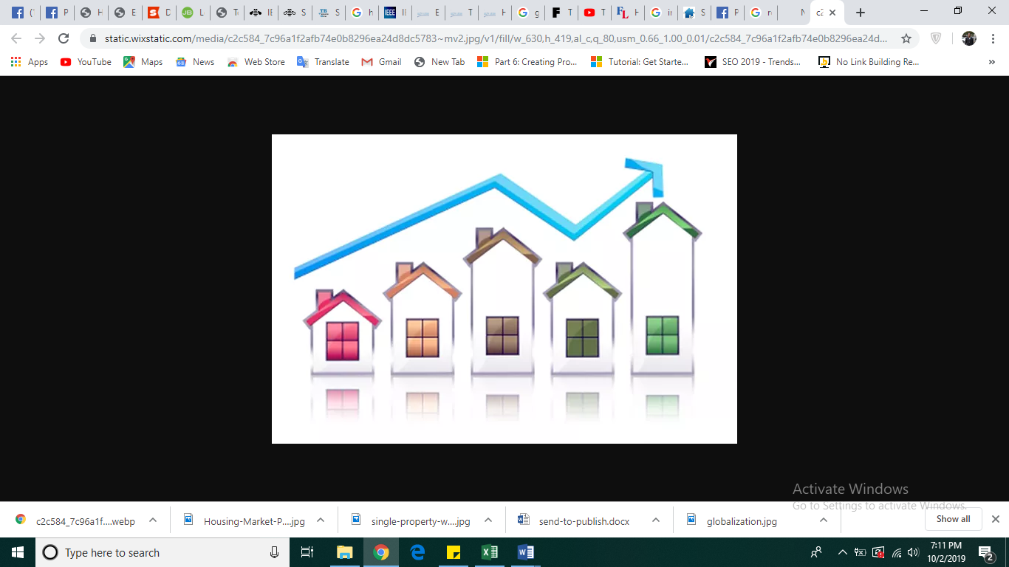

*Real Estate Forecast*

Looking at the economic conditions of Pakistan, the real estate sales forecast seems like a good omen for Pakistan’s property sector. Properties for sale in Karachi are rising due to multiple reasons that will be discussed later. For now, it is important to accept the truth that the final quarter of 2019 is a bit challenging for property buyers and sellers but, meanwhile the advantage is very fruitful too.

The economy of Pakistan depends on multiple factors and no doubt the real estate sector plays a vital role in the growth of overall economy. More [advanced residential properties for sale](http://www.frontline.com.pk), better surroundings, high-class interior and 24/7 secure environment, all the requirements a person expects to be fulfilled from a renowned builder while investing in property for sale in Karachi. Not only this, the new residential schemes in Karachi that are providing extra-ordinary lifestyle are getting credit for introducing better future for the people who are looking for a peaceful future for their family.

Now, reasons behind this exponential rise in Pakistan’s real estate market are general yet vague. Let’s see some them:

## Awareness

All hail the best marketer of properties for sale in Karachi. The awareness of residential as well as commercial properties in Karachi has increased in these 6 years. People are more inclined now towards investing in Karachi’s properties as they know that higher return on investment is guaranteed. Due to this awareness, people are looking for properties for sale in low price and easy installment plan. Also, overseas Pakistanis are investing in residential and commercial properties so that they can enjoy a hassle-free life after retirement.

## Lifestyle

Due to state-of-the-art residential projects being developed in Karachi for sale, people of Pakistan are moving towards easier yet sophisticated lifestyle. Deluxe apartments and luxury houses with 3, 4, 5 & 6 rooms are easily available in the best prices. Pakistani citizens are trying to adapt modern lifestyle as they know that if something is viable then it requires change. They are ready to invest in properties for sale in Karachi as the competition is tough and more people are availing opportunities in these residential properties.

## Better Projects

Property builders are providing niche specific residential as well as commercial properties for sale that are of high value located in the best areas of Karachi in 2019. Modern projects with exquisite amenities are being developed for the ever increasing population of Karachi. This also increases the chance of foreign investments and in particular, the overall economy of Pakistan. This affects the whole property market of Karachi positively and attracts more investors towards properties for sale in Karachi.

It is never too late to buy properties in Karachi as multiple options are available. The most renowned builders are serving the nation with full honor and trust. Huge set of clientele is more than satisfied. More investments are on the way with queries regarding [properties for sale in Karachi](http://www.frontline.com.pk).

Therefore, the real estate forecast of Pakistan in 2019 concludes that right now it is the best time to invest in Karachi’s properties for sale to have a profitable outcome and a happy life. The economy of Pakistan will rise again and the property market is playing an important role in achieving this success.

# #014 – Properties and Internet

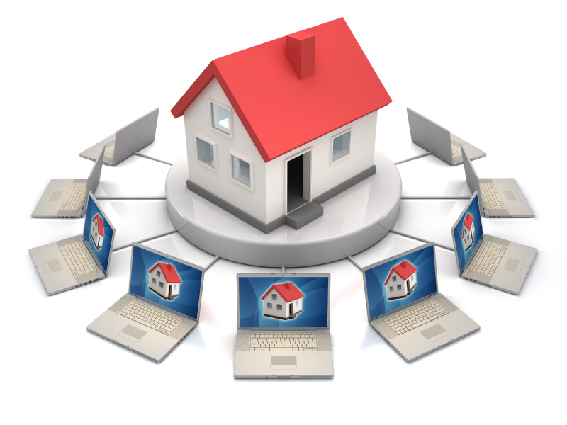

[*Property and Internet*](https://www.realestatemarketingblog.org/single-property-real-estate-websites/)

The advent of internet is the biggest breakthrough of the 19th century no doubt as it transformed major networking activities of the world into single global communication. People from any part of the world can connect with each other without any problem. This major invention in technology has converted many ideas into reality. No matter what’s the nature of the idea is, whether it’s business, educational, health, real estate, travel or military, internet is the backbone of these domains for communication.

As internet is considered as a major breakthrough, the life of today’s world has become more online. People tend to connect with the world more often. Time saving opportunities can be seen everywhere. Whether you are an entrepreneur or an employee, without internet you could’ve never been to able to achieve anything fruitful.

As internet is widely used as the core component of any organization, real estate market is also transferring itself towards online world. Properties for sale are available in numbers but to follow their proper marketing strategy is must. Property buyers are usually interested in knowing every tiniest detail because they want their long-term investments to generate good ROI (return on investment) in every condition. The [properties for sale](http://www.frontline.com.pk) require great research before signing any kind of contract. Online property guides are available. Consultation from authentic sources is necessary too to avoid any kind of fraud. Trustworthy online platforms available for property guidance are rare and *frontline.com.pk* is on top of the list and is serving the Pakistani commercial and residential properties with complete honor and value.

As internet is found everywhere, one can never succeed if his/her firm has no online activities. It’s not an easy task to transfer a business completely on internet. Suggestions say that only mobile components are feasible if transferred on internet. But the advancement in internet is in control that people are beginning their ventures totally based online. They don’t even need any physical office. Yes that’s true and that’s how start-ups are getting success because internet offers you to begin your venture with no or very less capital/resource if it’s online based.

Since majority of the businesses follow their marketing strategies online, real estate businesses are also doing the same to compete in the modern era. [Properties for sale in 2019](http://www.frontline.com.pk) are of high demand but their proper advertising is one of the issues. Marketing agencies lack in having a proper set of protocols and strategies to advertise their properties and that leads to unsatisfactory results.

In Karachi, properties for sale are boosting up to serve the residents as they are demanding residential as well commercial properties for sale. Top builders are developing modern schemes that include luxury apartments, elite houses and spacious shops. Moreover, the agencies are doing excellent job by utilizing online platforms like blogsites, social media and digital marketing as advertising channels. This does not end here. Maintenance of these online platforms is necessary because of high real estate competition in Karachi’s properties for sale in 2019.

Therefore it is highly recommended to make an impeccable online marketing strategy to advertise your properties for sale so that maximum audience can convert themselves into your loyal clients.

# #015 – Real Estate and the Modern Era



[*Globalization*](https://fee.org/articles/the-losers-of-globalization-didnt-lose-from-globalization/)

It’s the final Quarter of 2019 and the world is diving in to more enhance technological realm. Making money online is the new trend and people are fond of getting immersed in this modern era. For the majority, technology is inevitable for them. All the businesses, institutions, public and private organizations are planning to adapt this change. Technology has no doubt reduced the overall cost of organizational structure.

Since every business is trying to jump into the modern era, real estate business has also joined the queue. There is nothing perfect in this world but if one ever gets a chance to improve itself, it must improve. The modern era refers to the automation and digitalization of manual tasks via respective technology. Computations, data storage, communication, marketing and all other essential components of a successful organization are now computerized.

The real estate business is one of the most dominating businesses in the world where properties for sale are the only thing that attract the people living anywhere. Talking about the fact, people need a house to live, doesn’t matter whether it is apartment for sale, houses for sale, or commercial shops for sale. People pay for their abode. They need shelter for their selves and families. Therefore the real estate business is long-term planning and investors also require more time before investing in [properties for sale](http://www.frontline.com.pk).

This is the era where globalization can be observed easily. When a firm goes into online business, it becomes available globally. All the products and services can be viewed from any part of the world. This is one of the hundreds of benefits of adapting technology. The real estate business allows its clients to get every inch of detail about the residential as well as commercial properties for sale. The team of marketing and sales at real estate agencies must know what their clients think and what they may ask regarding specific property. If those clients find every answer to their question online from the real estate marketing agency’s website, the probability increases of conversion rate that the chance of person getting converted into a customer is getting increased.

In highly populated cities like Karachi, the competition in real estate business is high these days because of rising demands of [residential properties for sale in Karachi](http://www.frontline.com.pk). It is also predicted that there will be greater ROI in the coming 3-4 years because when the demand of any product or service increases, its core value automatically increases, giving benefit to every stakeholder involved in that product or service.

# #016 – Take a Tour of Karachi

Karachi, capital of Sindh province and the biggest city of Pakistan with respect to population, has one of the most diverse set of people living in. Considering this fact, there reside multiple cultures in Karachi due to which the value of Karachi’s residential sector has been increasing year by year. If there is a massive diversity in any city like Karachi, the residential sector is fortunate due to development of different residential as well as commercial projects in different areas of that city.

Additionally to that diverse culture, Karachi has multiple spots that enhance the significance of its real estate market at both national and international level. Those spots have a hidden attraction that allure not only the citizens of Karachi, but also the people living abroad. This makes tourists to make a tour to Karachi and to witness why Karachi is known as the “*City That Never Sleeps*”.

It is highly recommended that before coming to Karachi, do make a To-do-list and mark the must-visit spots of Karachi. Some of the best areas to visit are the following:

* **Clifton**

The posh area of Karachi attached with the shore of Arabian Sea. Upscale residential area where the standard of living is higher. You can find the luxurious wind blowing soothing your mind here. Hotels, restaurants, family parks and beautiful site of beach that no doubt attract the people to enjoy the time here and witness the beauty of Karachi.

* **DHA (Defence Housing Authority)**

A peaceful area with lush green environment that gives a person beautiful experience of nature while roaming around the streets of DHA. An area of great worth with [residential properties for sale](http://www.frontline.com.pk) of modern architecture and style.

* **Sadar**

The classical area of Karachi that has historical places, astonishing locales and beautiful sites. Sadar is known as the heart of Karachi because it provides the true essence of Pakistan in it. Markets, restaurants, cafes and historical buildings depict the history of Karachi.

In Sadar, if you want to make an unforgettable Tour de Karachi, do visit Frere Hall, National Museum of Pakistan, Empress Market and Karachi’s true taste at Burns Road.

* **Mohatta Palace**

Existed since 1925, this palace was established by a hindu prince and now it is still there as an icon of history. Mohatta Palace has been transformed into an art gallery and museum with breathtaking surrounding and appealing historical architecture. This Palace is truly an eye-catching picture with real memories residing in it.

* **Mazar-e-Quaid**

Touring Karachi gives you an opportunity to visit Jinnah Mausoleum that is the tomb of Quad-e-Azam Muhammad Ali Jinnah. The attractive and bold structure of this tomb is famous in the world and there is no doubt that people never miss the sight of Mazar-e-Quaid, no matter who they are. The area where this sign of heroism exists, is of great value from the perspective of people of Karachi who own properties there and also the realtors, who are earning good money from the [properties for sale in Karachi](http://www.frontline.com.pk) near Mazar-e-Quaid.

The above areas and spots are from a long must-visit list of Karachi and if you want to make a successful visit, ignoring any of the above places would make you feel guilty in future.

# #017 – Risk and Reward

There are times when you begin to think of doing wonders. Your power of imagination compels you to achieve things that are impossible for others. Yes that's true. *“Everything is possible. Impossible is something that your mind can't imagine of”.* All you need to do is **realize your honest focus** and **make proper steps towards your goal**.

The hindrances you'll going to face are more psychological rather than physical. The fear of consequence, failure and rejection are inevitable. Talking real, they complete our lives. They let us grow and experience in the highly competitive world where survival is getting tougher year by year. People are losing the true sight of what exactly risks hold in the form of rewards. And taking risks is the only option for passing through the difficult stages of life.

There are 3 types of people with respect to this terrible reality i.e. Risk:

1. ***Crazy Risk Takers***

These are the people who love to take risks because they believe in “*The greater the risk, the greater the reward*”.

1. ***Calculated Risk Takers***

These are the people who research like a maniac before taking any risk to make sure that they won’t be losing much in the longer run.

1. ***Risk Averse***

These are the people who avoid taking risks. Simple but awful. Being reluctant to take risks is not smart but a sign of having a trait of cowardliness.

Risks are attached with every single aspect of our development; physical, emotional, educational, financial, marital and mental development. You have to prepare yourself about the risks that are associated with every phase of life. Being a student, sometimes a moment comes in which people are stuck between attending class or going to get a motivational session from a renowned speaker which is happening at the same time of class. You can miss any important discussion with the teacher or even a quiz if you go for the session. And if you take the class, this could make you feel guilty for missing the motivational session by the best speaker and trainer of 2019.

In the world of business, once you take your first step, whether it’s a start-up or any other kind of business, you get surrounded by infinite number of risks, especially financial risk. Consider the real estate business where [residential properties are bought, sold](http://www.frontline.com.pk) and put on rent, all the transactional activities come with heavy investments and for the majority of the middle and working class, its’ their life-time saving. The risk associated while investing in real estate market is “what is the probability of getting the announced ROI (return on investment) after the completion of this project?” or “whether this residential project will be completed in the said period or the whole money will be drowned?”

On the verge of beginning a professional life, you must know how important taking risk is. Risk comes with reward. A reward that's intangible most of the time. Risk opens windows for light to enlighten your phase of development. Risk teaches you the mysteries of the real world. By taking risks, you can create a difference where ever you are, whether it’s your work place, a voluntarily work or a football game.

Suppose you want to switch your job because at the current work, you are not satisfied with the pay you are getting. You have looked another opportunity where the organization is paying you better but the organizational culture and behavior is not up to the mark. Now here the risk is associated with your professional development. You have to utilize your skill of decision making at this situation and choose the best option that fits the most suitable for not only you, but anyone who is depending upon you. So for these professional risks, you have to explore yourself more. Know yourself more. Find the answers of questions that point directly towards your spiritual satisfaction, your future and your physical, mental and emotional health.

Risk aversion is a quite failure in the long run. You can easily live for the present few years, but in future, the same risks will show up, haunting your anecdotal better times in life. And that time, your experience in making decisions would be none. You would start cursing risks even though you knew that risk is inevitable. There are people who look at risk like it is a piece of gold, covered in a pile of coal. And that’s true, risk are never futile. They either bring a better reward or they teach you what truly taking risks mean.

Therefore, learn to take risks whenever you think of converting an idea into practical, investing in [properties for sale](http://www.frontline.com.pk), buying accessories or taking any move forward in life. Because at any stage, taking risks is the best chance in your life to become an ultimate opportunist and to embrace the opportunities and make the best out of them. Once you realize what the associated risk with any move is, you can easily take the best option for yourself.

# #018 – SEO Tips & Tricks for Bloggers

* SEO emerging technology
* Marketing
* Blogging
* Tips and Tricks
* Keywords
* Competitors
* Audience’s thinking
* Branding
* Guest Posting
* Infographics

Talking about the top emerging technologies in the world right now, Search Engine Optimization (SEO) ranks in top 5 when it comes to covering the whole internet and competing by other websites. SEO is all about optimizing your webpage for the users so that they can find your website on top of the search engine result page (SERP). It is true that SEO is now changing its shape, but for the beginners, following an impeccable strategy of SEO can bring you success sooner than you expect. SEO has emerged as key to success for the businesses that are run online or those businesses that rely on online activities more than before.

As SEO is a trendy domain for IT geeks, the world of marketing has also adapted this technological enhancement and all the web-based businesses especially e-commerce business has embraced multiple SEO strategies to dominate the online market. No matter you are manufacturing some product and struggling to sell it or providing some service, SEO plays a major role in your marketing when you plan to go online to gather maximum audience.

Since the world is transforming and majority of the businesses are adapting this change, it is necessary to have a firm stability online so that you can stand against your competitors. Following SEO to promote your business, there exist some tips and tricks through which you can adjust your online marketing strategy, build connections and be on top of SERP.

1. ***Keywords***

First of all, you have to be fully aware of the business or organization for which you are putting your efforts in SEO. No doubt doing SEO is not an easy job, one must always prepare to create unique content and post it to update online content. Keywords are the set of words that are freshly being used by your competitors or similar websites. This set of keywords shows what users are searching in search engine (e.g. Google) regarding any specific subject. For example, if it’s a season of Christmas, concerned people might be searching “lightning for Christmas”, “Christmas gifts”, “Santa Claus in Christmas” or “Christmas decoration”. You can use keyword planner or similar webpage analyzer and fetch that people in, say Canada, are searching about Christmas. Therefore, you can modify your strategy and put Christmas as your keyword in your web content (whether it’s about your product or service) and observe the difference in your webpage rankings.

1. ***Guest Posting***

Guest Posting is a unique strategy to transform your business into a renowned brand online. This posting works in this way:

When you write an article or a blog, you search for a website having good domain authority (DA) and post your article or blog there. Your piece of content contains specific keywords and hyperlinks that link the user with your website indirectly. Not only this, posting your content on website that possess good DA gives your website link juice that ultimately increases your website’s DA.

So, if you know about blogging and love to write, SEO is a treasure to grab now because there are a number of opportunities regarding SEO content creation and organizations are offering heavy packages for SEO content strategists and writers. All you need to have is creativity in writing with related graphical work in order to make your website aesthetically beautiful and captivating.

Therefore, if you are looking to earn money by writing, SEO can help you to pursue your dream with technological knowledge of online world and by following these tips and trick, SEO can give you an identity to dominate the online market. And it’s naïve to spend money on online advertising when you can have an impeccable SEO strategy to grab attention of immense number of people from any part of the world.