Indhold
Sandsynlighed 1
Stokastiske Processer 5
Stokastiske Variabler 11
Statistik 16

Sandsynlighed
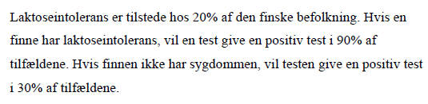
Figur 1 EXAM FALL 2015
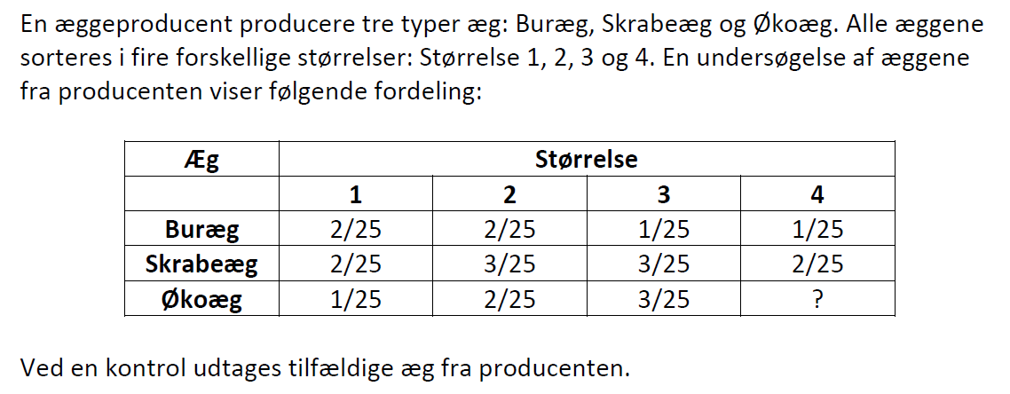
Figur 2EXAM FALL 2017

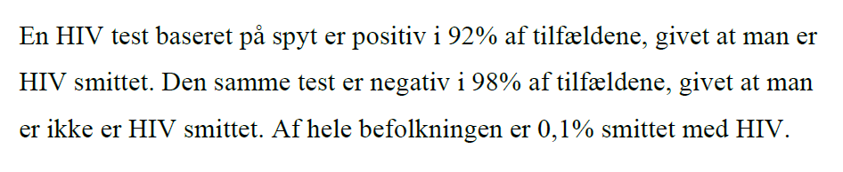
Figur 3 Exam FALL 2016

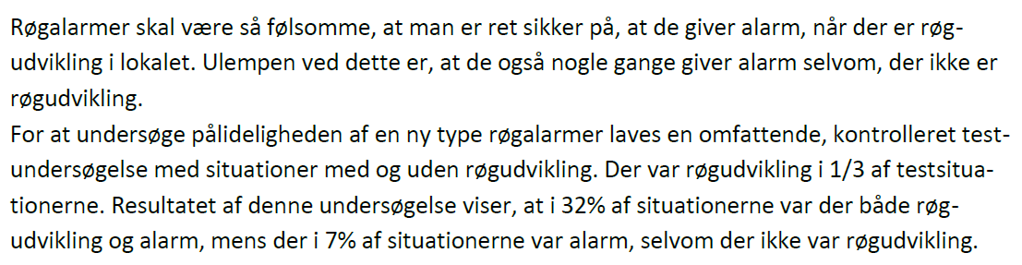
Figur 4 EXAM FALL 2018

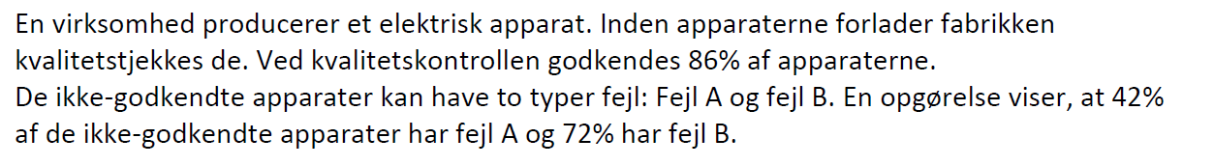
Figur 5 Exam Fall 2019

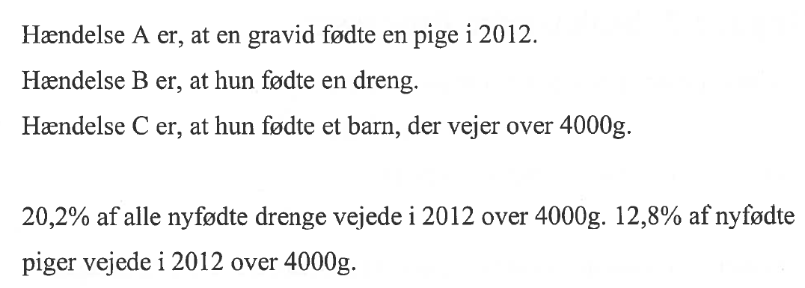
Figur 6EXAM SPRING 2016
Figur 7 Exam Spring 2017

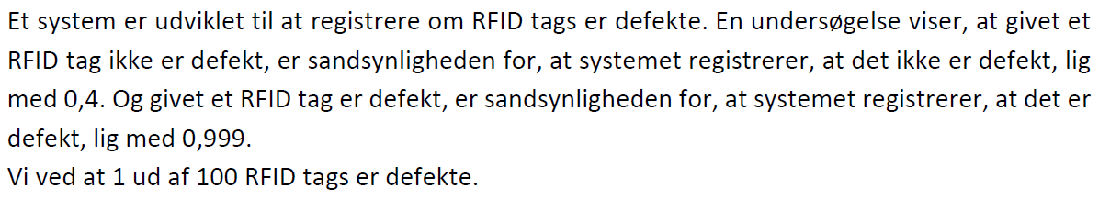
Figur 8 EXAM SPRING 18

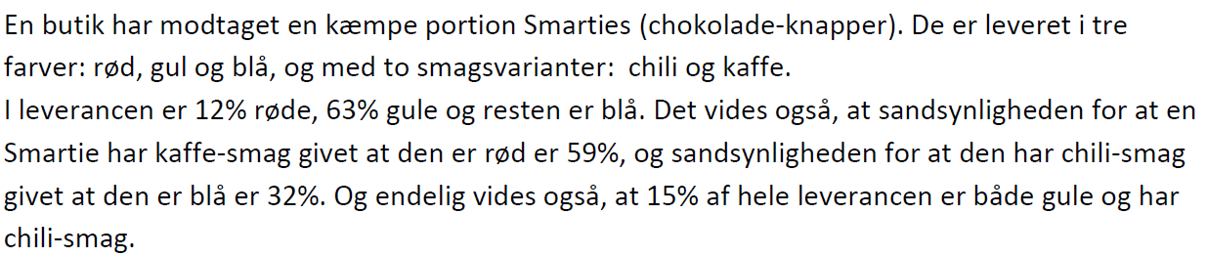
Figur 9 EXAM SPRING 2019
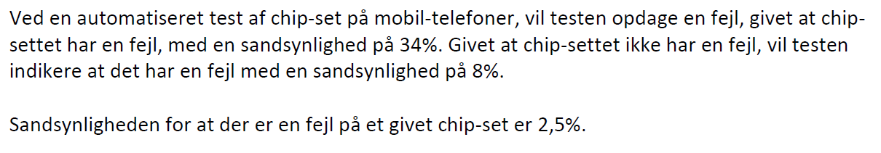
Figur 10 Exam Spring 2020
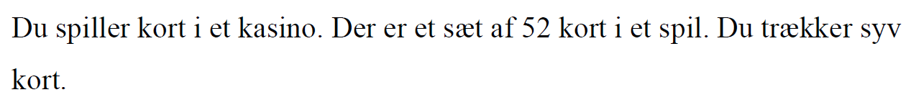
Figur 11Reexam Fall 2015
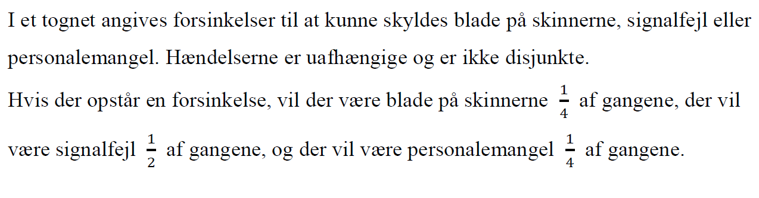
Figur 12 ReexamFall2016
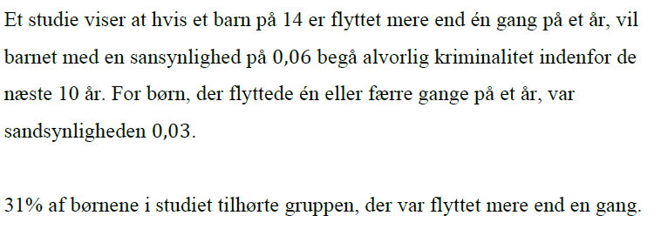
Figur 13 Reexam spring 2016
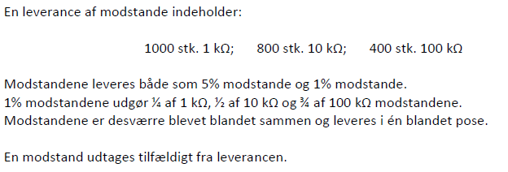
Figur 14 Rexam spring 2017

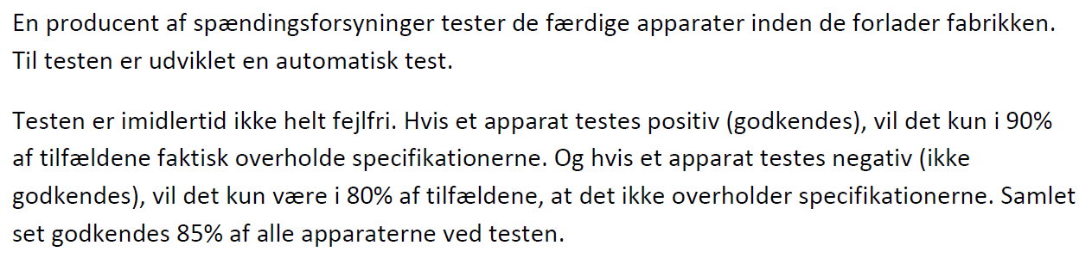
Figur 15 Reexam spring 2018
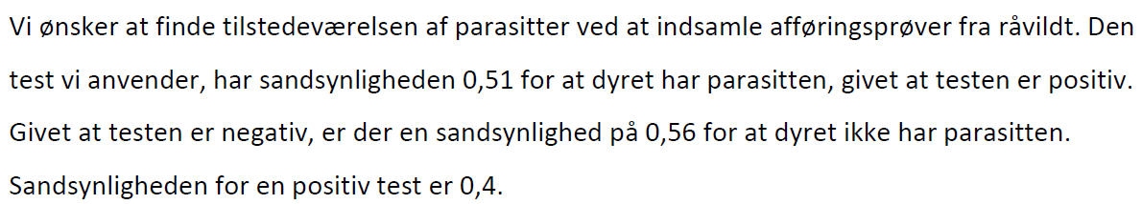
Figur 16 Reexam spring 2019

Stokastiske Processer
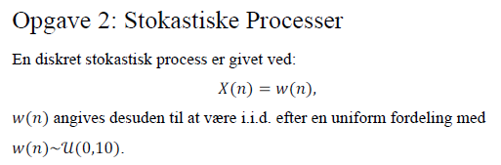
Figur 17 EXAM FALL 2015
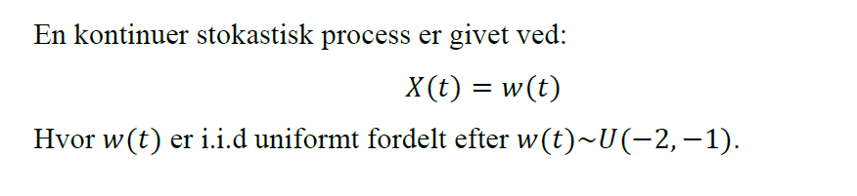
Figur 18 Exam FALL 2016
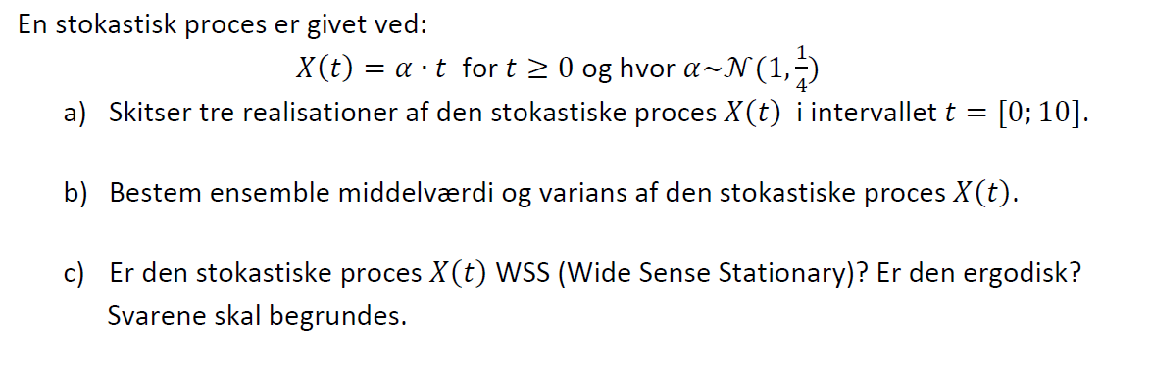
Figur 19EXAM FALL 2017

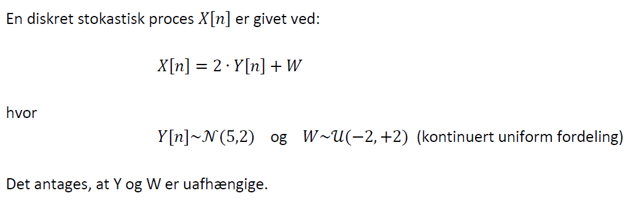
Figur 20 EXAM FALL 2018
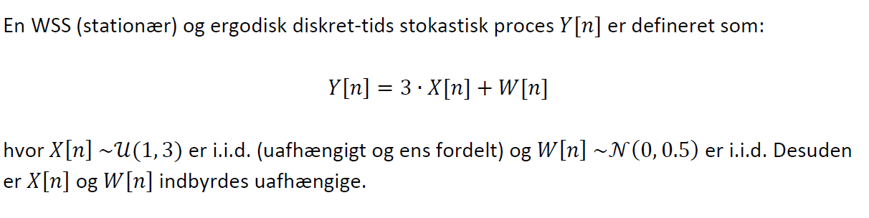
Figur 21 Exam Fall 2019
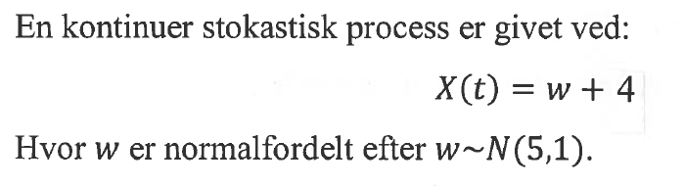
Figur 22EXAM SPRING 2016
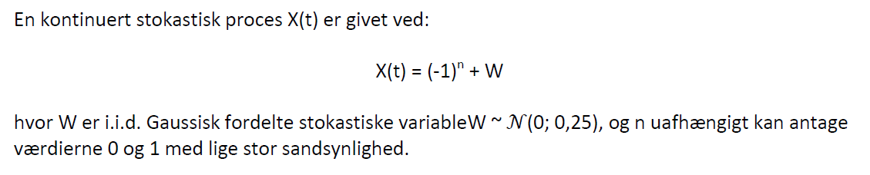
Figur 23 Exam Spring 2017

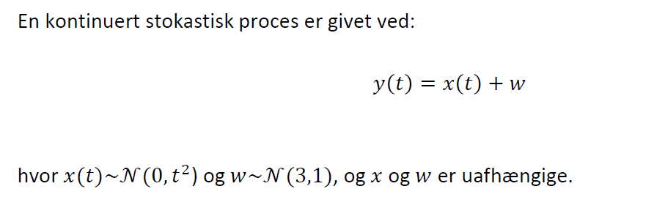
Figur 24 EXAM SPRING 18
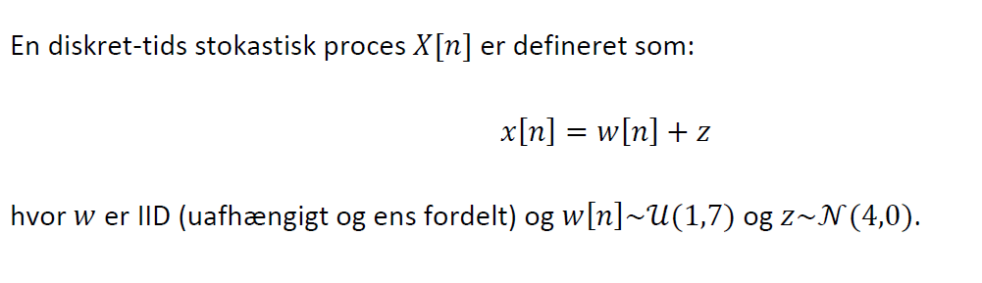
Figur 25 EXAM SPRING 2019
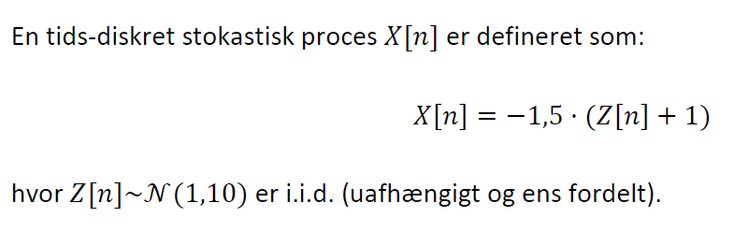
Figur 26 Exam Spring 2020

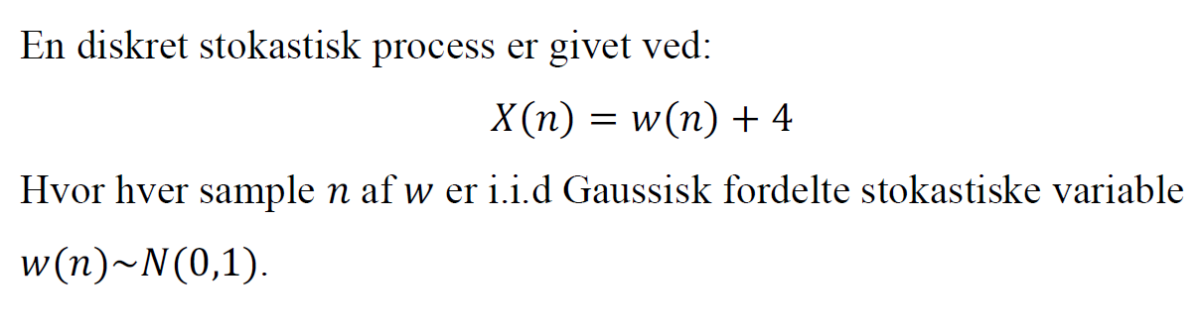
Figur 27Reexam Fall 2015
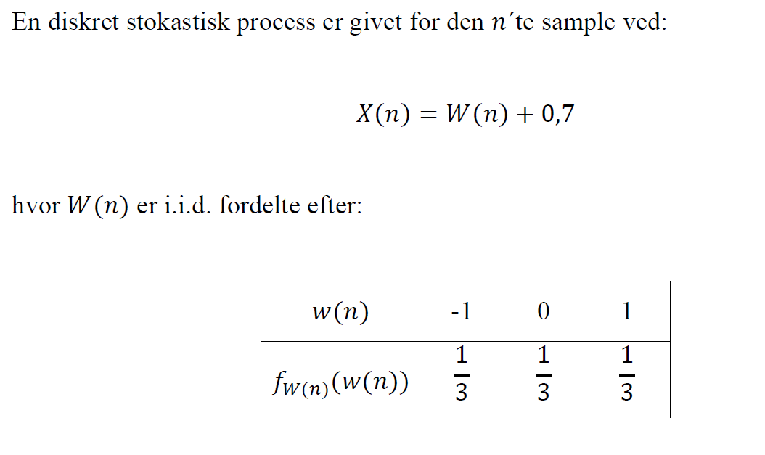
Figur 28 ReexamFall2016
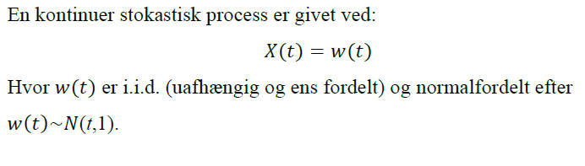
Figur 29 Reexam spring 2016
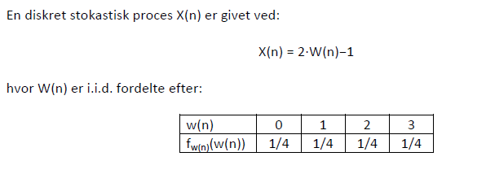
Figur 30 Rexam spring 2017
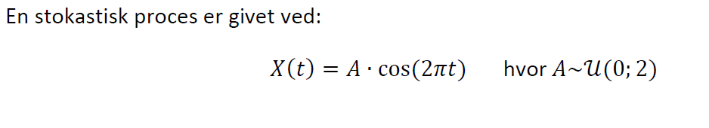
Figur 31 Reexam spring 2018

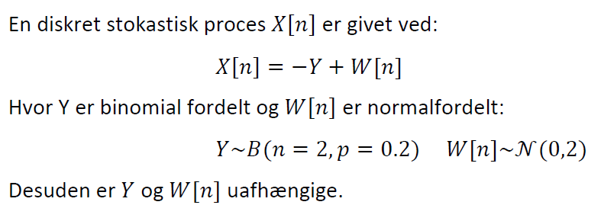
Figur 32 Reexam spring 2019

Stokastiske Variabler
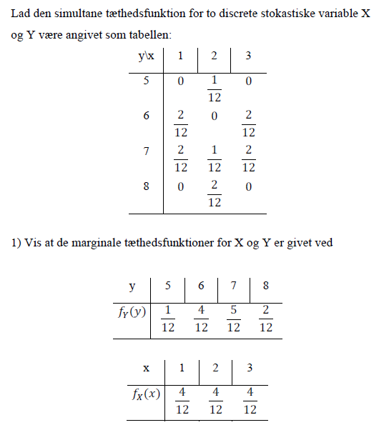
Figur 33 EXAM FALL 2015

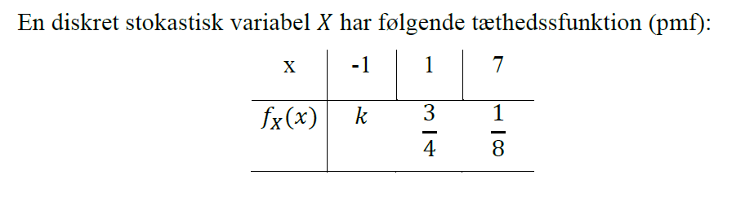
Figur 34 Exam FALL 2016

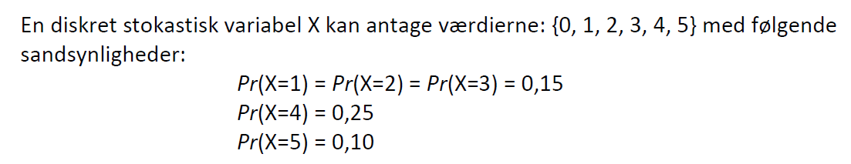
Figur 35EXAM FALL 2017

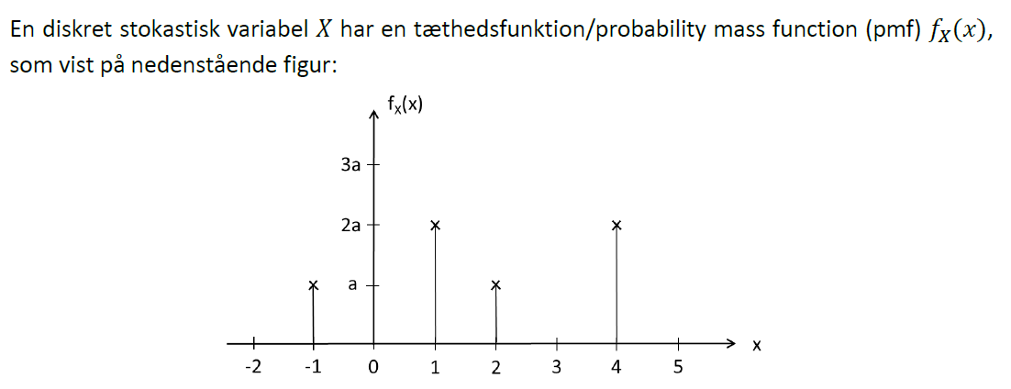
Figur 36 EXAM FALL 2018
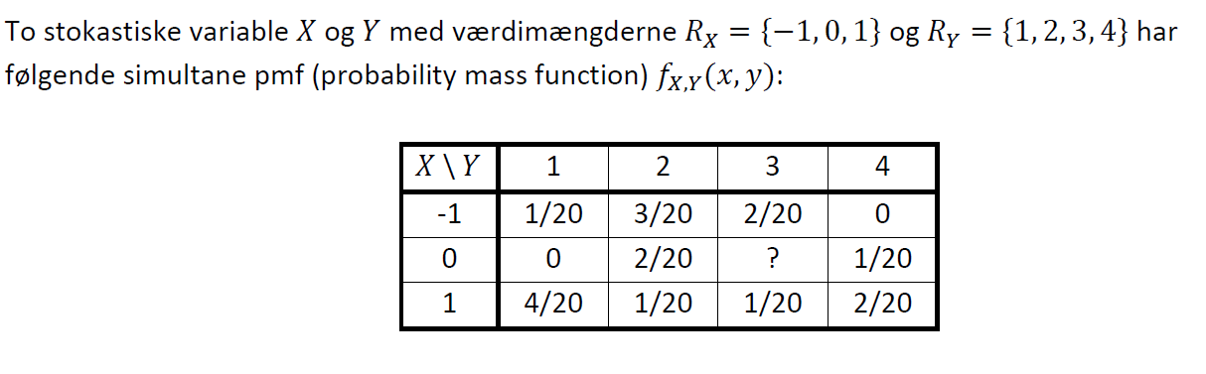
Figur 37 Exam Fall 2019
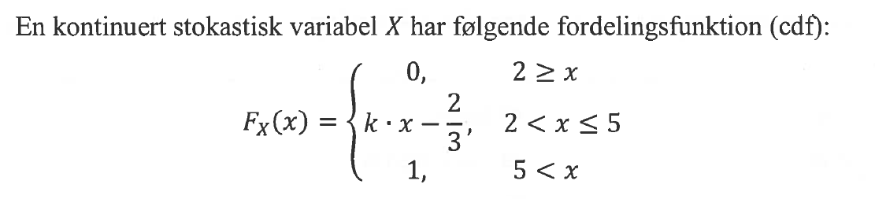
Figur 38EXAM SPRING 2016
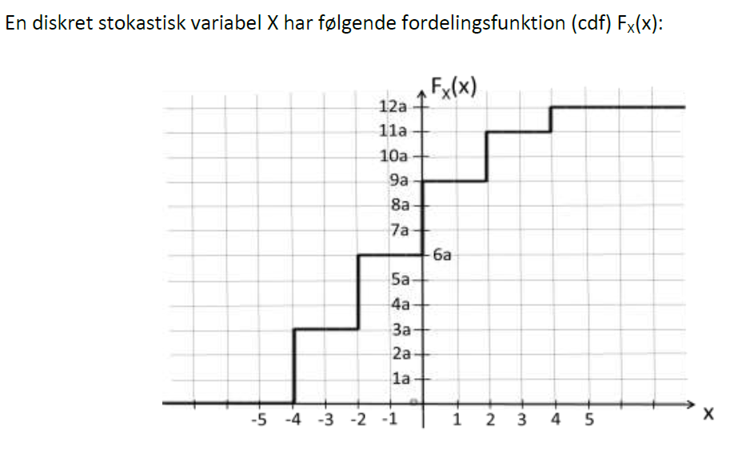
Figur 39 Exam Spring 2017
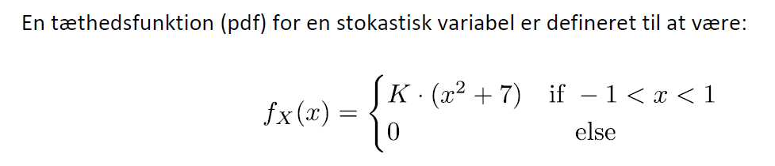
Figur 40 EXAM SPRING 18

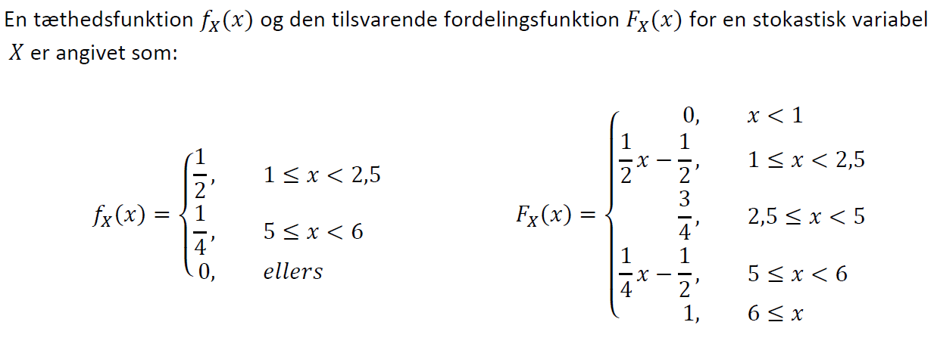
Figur 41 EXAM SPRING 2019

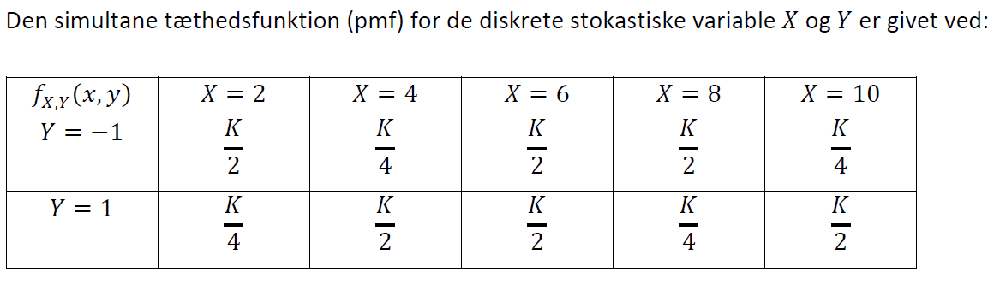
Figur 42 Exam Spring 2020

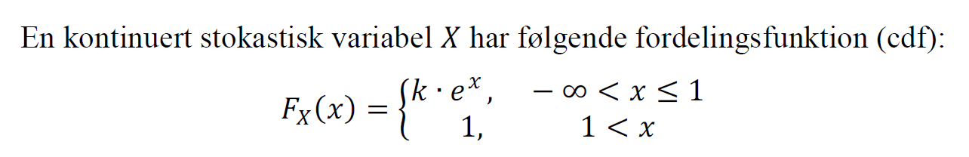
Figur 43Reexam Fall 2015
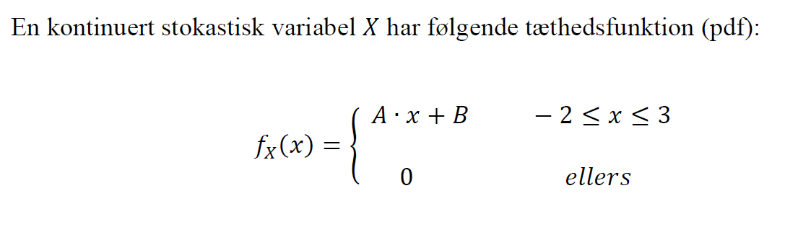
Figur 44 ReexamFall2016
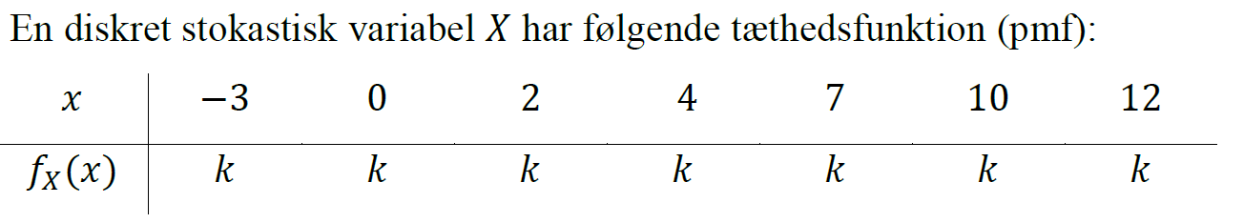
Figur 45 Reexam spring 2016
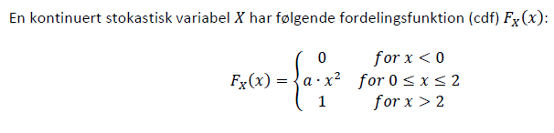
Figur 46 Rexam spring 2017
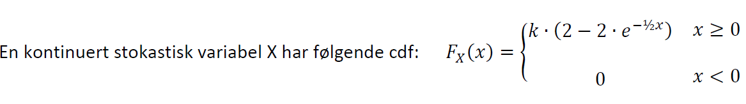
Figur 47 Reexam spring 2018

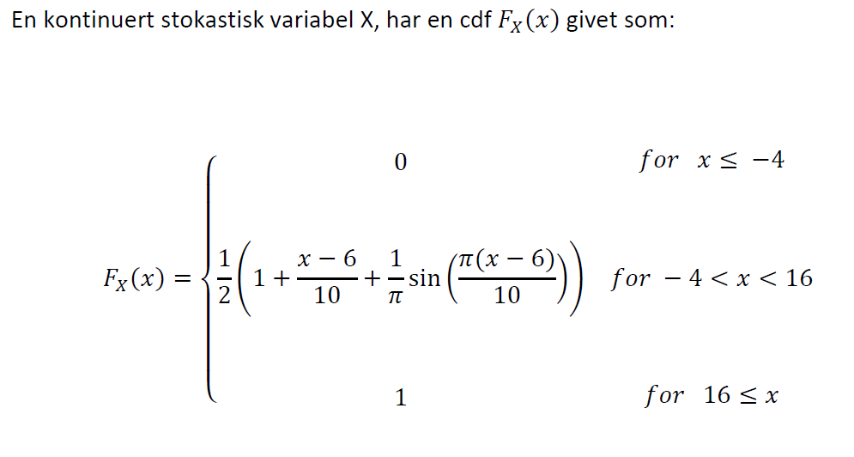
Figur 48 Reexam spring 2019

Statistik
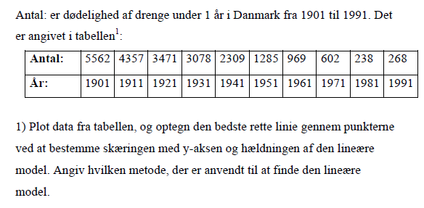
Figur 49 EXAM FALL 2015

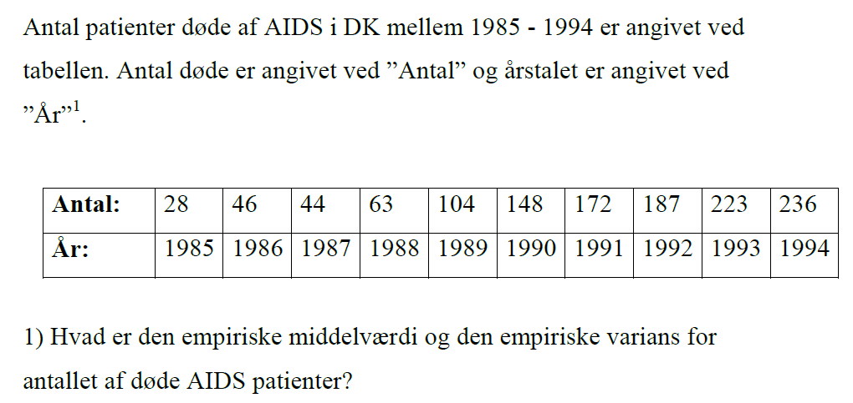
Figur 50 Exam FALL 2016
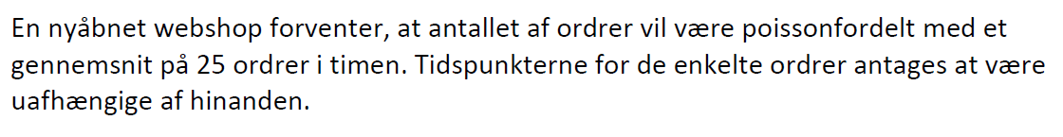
Figur 51EXAM FALL 2017
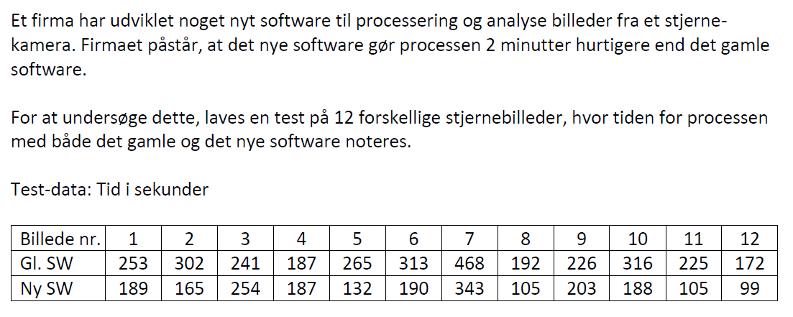
Figur 52 EXAM FALL 2018
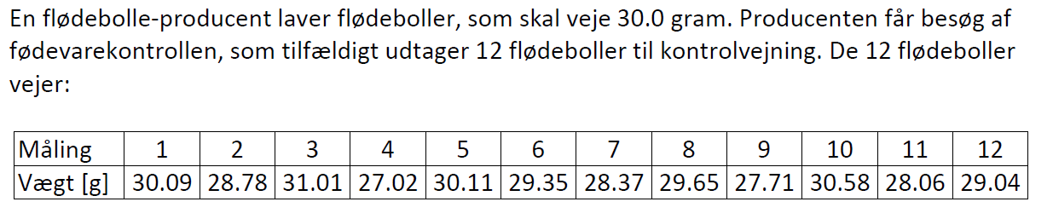
Figur 53 Exam Fall 2019
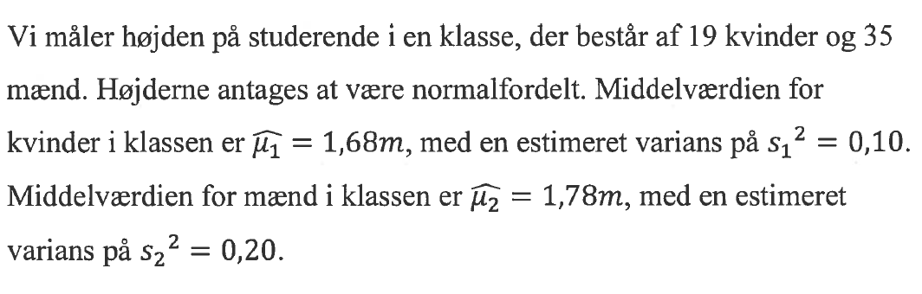
Figur 54EXAM SPRING 2016
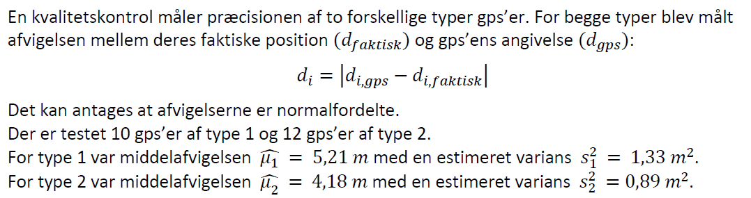
Figur 55 Exam Spring 2017
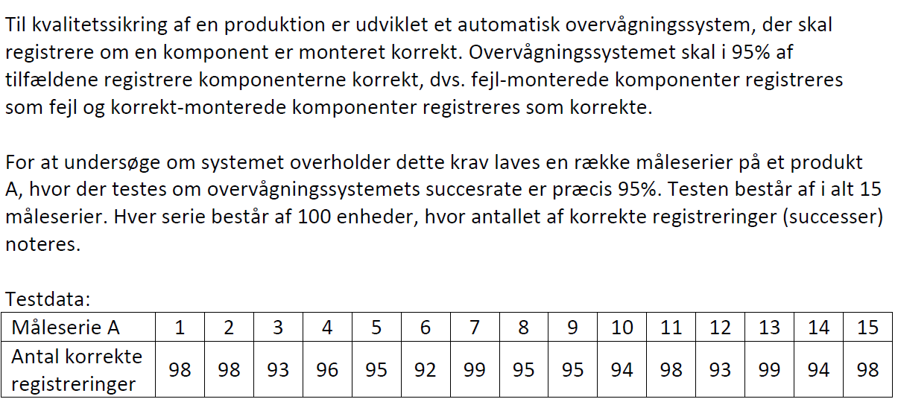
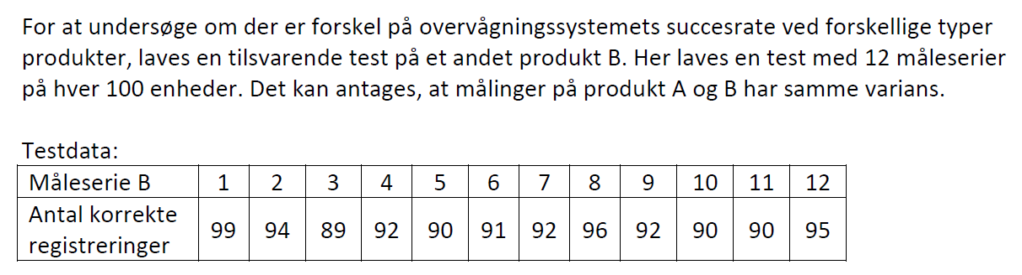
Figur 56 EXAM SPRING 18
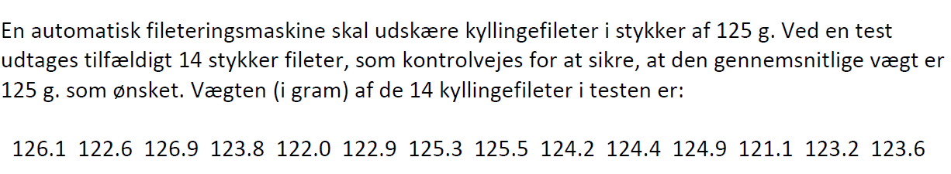
Figur 57 EXAM SPRING 2019
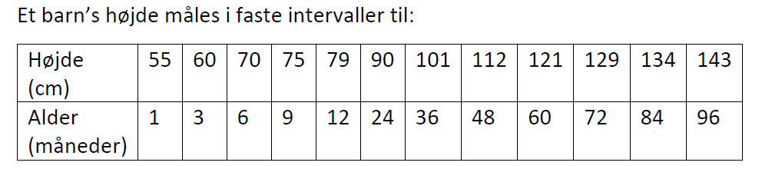
Figur 58 Exam Spring 2020

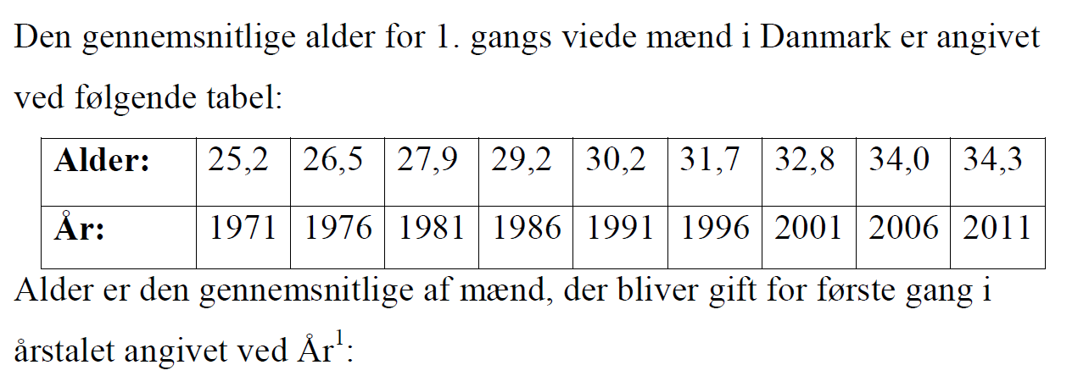
Figur 59Reexam Fall 2015
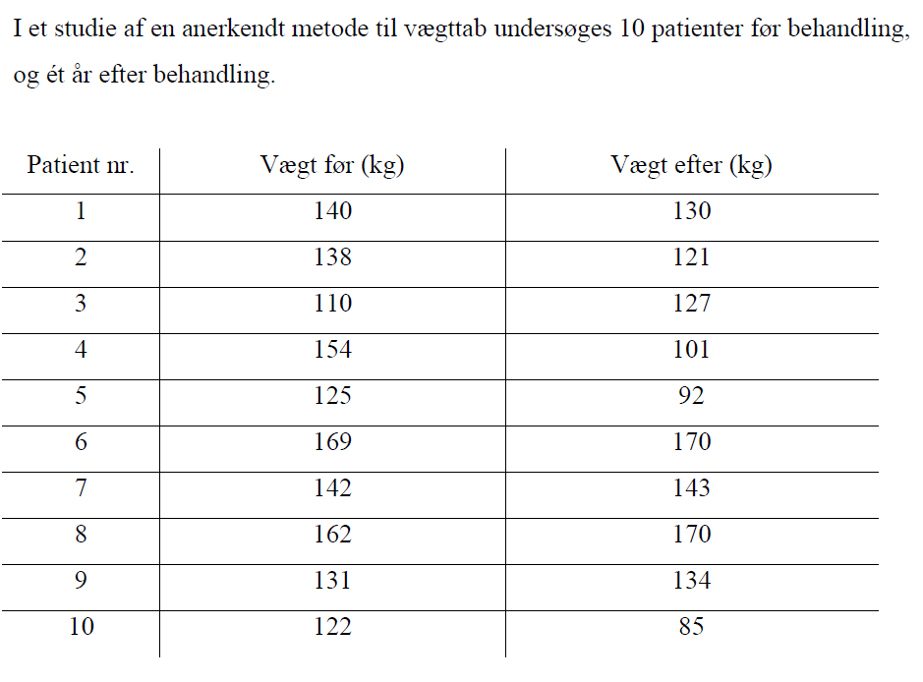
Figur 60 ReexamFall2016
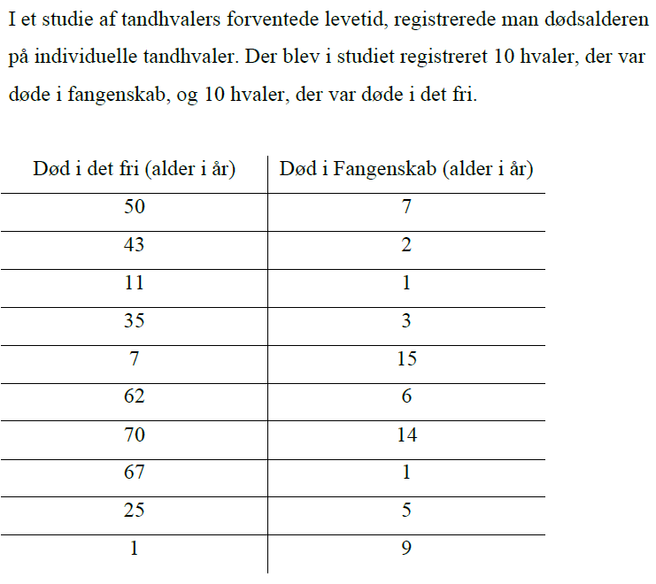
Figur 61 Reexam spring 2016
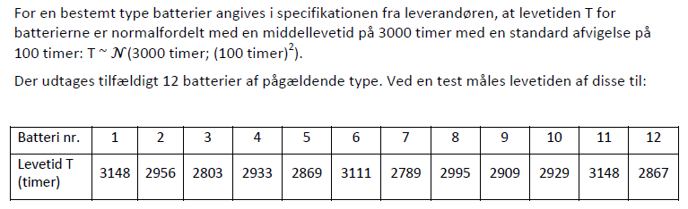
Figur 62 Rexam spring 2017
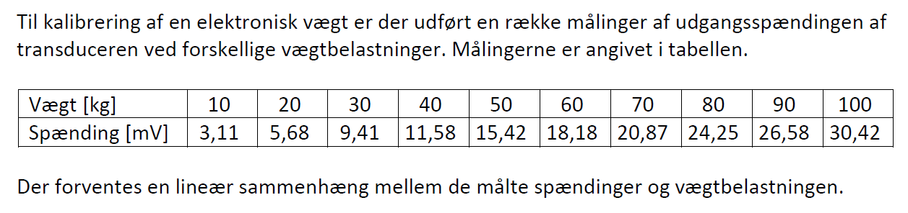
Figur 63 Reexam spring 2018
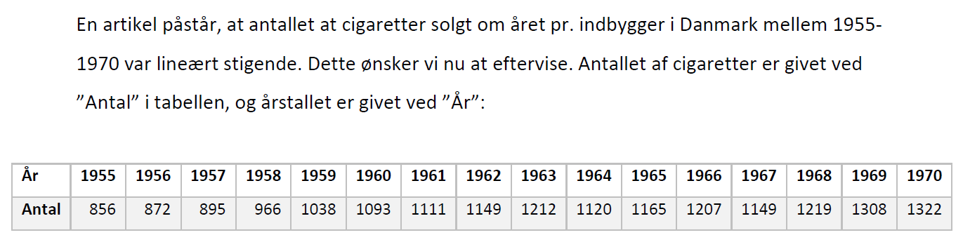
Figur 64 Reexam spring 2019

