Geethanjali College of Engineering and Technology
AUTONOMOUS
(Accredited by NBA, NAAC ‘A⁺’ Grade)
Cheeryal (V), Keesara (M), Medchal ( D), Telangana-501 301



ADVANCED ENGINEERING PHYSICS LABORATORY
WORKBOOK
B. Tech. I Year- I Semester
EEE, CSE (AI&ML), CSE (Cyber Security) and CSE (Data Science)
2025-2026

DEPARTMENT OF FRESHMAN ENGINEERING

Geethanjali College of Engineering and Technology
AUTONOMOUS
(Accredited by NBA, NAAC ‘A⁺’ Grade)
Cheeryal (V), Keesara (M), Medchal (D), Telangana- 501 301


CERTIFICATE

This is to certify that Mr./ Miss. _______________________________has satisfactorily completed _____number of experiments in the Semiconductor Devices laboratory.
Roll No: ____________ Branch: _____________
Year: _______________ Academic Year: 2025-26

Faculty In-charge Course Coordinator

Internal Examiner External Examiner

Geethanjali College of Engineering and Technology
(AUTONOMOUS)
25PH11L01 / 25PH12L01 - ADVANCED ENGINEERING PHYSICS LABORATORY
Common to all Engineering branches

B.Tech. I Year, I/II Sem. Prerequisite(s): None
L | T | P | C
0 | - | 2 | 1

Course Objectives:
- To provide practical exposure to advanced concepts in solid-state and modern physics.
- To study the physical properties of materials like semiconductors, ferromagnetic, and ferroelectric substances.
- To perform semiconductor characterization using Hall effect and band gap experiments.
- To explore the working principles of lasers and optical fibers through hands-on experiments.
- To develop skills in data analysis, interpretation, and scientific reporting.
Course Outcomes:
- CO1: Analyze the characteristics of Solar cell and LED
- CO2: Determine key electrical, magnetic, and optical properties of semiconductors and other functional materials.
- CO3: Characterize semiconductors using Hall effect and energy gap measurement techniques.
- CO4: Demonstrate working knowledge of laser systems and optical fiber parameters through experimental study.
- CO5: Apply scientific methods for accurate data collection, analysis, and technical report writing.

- Determination of energy gap of a semiconductor.
- Determination of Hall coefficient and carrier concentration of a given semiconductor.
- Plot the V-I characteristics of a Solar cell.
- Determination of Planck’s constant using the V-I characteristics of the LED.
- a. Determination of wavelength of a laser using a diffraction grating.
b. Study of V-I & L-I characteristics of a given laser diode.
- Determination of the magnetic moment of a bar magnet and the horizontal Earth's magnetic field.
- Study of the B-H curve of a ferromagnetic material.
- Study of the P-E loop of a given ferroelectric crystal.
- Determination of the dielectric constant of a given material.
- a. Determination of the numerical aperture of a given optical fibre.
b. Determination of bending losses of a given optical fibre.
Note: Any 8 experiments are to be performed.

To produce globally competent and socially responsible Computer Science engineers contributing to the advancement of engineering and technology which involves creativity and innovation by providing an excellent learning environment with world-class facilities.
Mission of the Department:
CSE and CSE (EA)
- To be a center of excellence in instruction, innovation in research and scholarship, and service to the stakeholders, the profession, and the public.
- To prepare graduates to enter a rapidly changing field as competent computer science engineer.
- To prepare graduate capable in all phases of software development, possess a firm understanding of hardware technologies, have the strong mathematical background necessary for scientific computing, and be sufficiently well versed in general theory to allow growth within the discipline as it advances.
- To prepare graduates to assume leadership roles by possessing good communication skills, the ability to work effectively as team members, and an appreciation for their social and ethical responsibility in a global setting.
Program Educational Objectives (PEOs):
CSE and CSE (EA)
Program Educational Objectives (PEOs) are broad statements that describe what graduates are expected to attain within a few years of graduation. The PEOs for Computer Science and Engineering graduates are:
PEO-I: To provide graduates with a good foundation in mathematics, sciences, and engineering fundamentals required to solve engineering problems that will facilitate them to find employment in industry and/or to pursue postgraduate studies with an appreciation for lifelong learning.
PEO-II: To provide graduates with analytical and problem-solving skills to design algorithms, other hardware/ software systems, and inculcate professional ethics, inter-personal skills to work in a multi-cultural team.
PEO-III: To facilitate graduates get familiarized with state-of-the-art software/hardware tools, imbibing creativity and innovation that would enable them to develop cutting-edge technologies of multi-disciplinary nature for societal development.
Program Outcomes (POs):
Program Outcomes (POs) describe what students are expected to know and be able to do by the time of graduation to accomplish Program Educational Objectives (PEOs). The Program Outcomes for Computer Science and Engineering students are:
Engineering Graduates will be able to:
PO 1: Engineering knowledge: Apply the knowledge of mathematics, science, engineering fundamentals, and an engineering specialization to the solution of complex engineering problems.
PO 2: Problem analysis: Identify, formulate, review research literature, and analyze complex engineering problems reaching substantiated conclusions using first principles of mathematics, natural sciences, and engineering sciences.
PO 3: Design/development of solutions: Design solutions for complex engineering problems and design system components or processes that meet the specified needs with appropriate consideration for the public health and safety, and the cultural, societal, and environmental considerations.
PO 4: Conduct investigations of complex problems: Use research-based knowledge and research methods including design of experiments, analysis and interpretation of data, and synthesis of the information to provide valid conclusions.
PO 5: Modern tool usage: Create, select, and apply appropriate techniques, resources, and modern engineering and IT tools including prediction and modeling to complex engineering activities with an understanding of the limitations.
PO 6: The engineer and society: Apply reasoning informed by the contextual knowledge to assess societal, health, safety, legal and cultural issues and the consequent responsibilities relevant to the professional engineering practice.
PO 7: Environment and sustainability: Understand the impact of the professional engineering solutions in societal and environmental contexts, and demonstrate the knowledge of, and need for sustainable development.
PO 8: Ethics: Apply ethical principles and commit to professional ethics and responsibilities and norms of the engineering practice.
PO 9: Individual and team work: Function effectively as an individual, and as a member or leader in diverse teams, and in multidisciplinary settings.
PO 10: Communication: Communicate effectively on complex engineering activities with the engineering community and with society at large, such as, being able to comprehend and write effective reports and design documentation, make effective presentations, and give and receive clear instructions.
PO 11: Project management and finance: Demonstrate knowledge and understanding of the engineering and management principles and apply these to one’s own work, as a member and leader in a team, to manage projects and in multidisciplinary environments.
PO 12: Life-long learning: Recognize the need for, and have the preparation and ability to engage in independent and life-long learning in the broadest context of technological change.
Mapping of Lab Course Outcomes with Program Outcomes:
POs | 1 | 2 | 3 | 4 | 5 | 6 | 7 | 8 | 9 | 10 | 11 | 12
Students would be able to
- Plot and analyze the characteristics of various p-n junction diodes, BJT, FET, and identify type of semiconductor | 3 | 2 | - | - | - | - | - | - | 2 | - | - | 2
- Measure the time constant of a given capacitor using RC circuit. | 3 | 2 | - | - | - | - | - | - | 2 | - | - | 2
- Demonstrate the conversion of ac to dc with and without filters. | 3 | 2 | - | - | - | - | - | - | 2 | - | - | 2
- Demonstrate dual nature of light. | 3 | 2 | - | - | - | - | - | - | 2 | - | - | 2
- Explain the variation of magnetic field with distance. | 3 | 2 | - | - | - | - | - | - | 2 | - | - | 2

Program Specific Outcomes (PSOs):

CSE
PSO1: To identify and define the computing requirements for its solution under given constraints.
PSO2: To follow the best practices namely SEI-CMM levels and six sigma which vary from time to time for software development project using open ended programming environment to produce software deliverables as per customer needs.

CSE (AIML)
PSO1: Demonstrate competency in Programming and problem solving skills and apply those skills in solving computing problems.
PSO2: Select appropriate programming languages, Data structures and algorithms in combination with modern technologies and apply them in developing innovative solutions.
PSO3: Demonstrate adequate knowledge in the concepts and techniques of artificial intelligence and machine learning, apply them in developing intelligent systems to solve real world problems.

CSE (DS)
PSO1: Demonstrate competency in Programming and problem solving skills and apply those skills in solving computing problems.
PSO2: Select appropriate programming languages, Data structures and algorithms in combination with modern technologies and apply them in developing innovative solutions.
PSO3: Apply techniques of data modeling, analysis and visualization which include statistical techniques to solve real world problems delivering actionable insights for decision making.
CSE (CS)
PSO1: Demonstrate competency in Programming and problem-solving skills and apply those skills in solving computing problems.
PSO2: Select appropriate programming languages, Data structures and algorithms in combination with modern technologies and apply them in developing innovative solutions.
PSO3: Apply cryptographic algorithms for ensuring cyber security as per cyber laws, demonstrate awareness of all the security related issues and employ state of the art technologies to protect the digital assets of an organization.

Mapping of Course with Programme Specific Outcomes:
S.No | Course component | Code | Course | Semester | PSO 1 | PSO 2
1 | Basic science course | 20PH12L01 | Semiconductor Devices Laboratory | II | - | -

Prerequisites:
Student should possess basic knowledge of measurements and handling of instruments like vernier calipers and screw gauge. Students should also be familiar with the operation of stop clock and temperature measurement with the thermometer. The diffraction phenomena and the fundamentals of a LASER form a prerequisite for optics experiments. The basic principles of electricity, magnetism and semiconductors are useful for electricity, magnetism and electronics experiments

Evaluation Pattern:
Total Marks - 100
- Continuous Internal evaluation (CIE) during the semester - 40 marks.
- Semester end Examination (SEE) - 60 marks.
- A detailed break up of 40 marks for CIE is given below:
  - A write-up on day-to-day experiment in the laboratory (in terms of aim, components / procedure, expected outcome) - 10 marks.
  - Viva-voce or tutorial or case study or application or poster presentation - 10 marks
  - Internal practical examination - 10 marks.
  - For Laboratory Project - 10 marks.
    - Software / Hardware Model Presentation
    - App. Development or Prototype Presentation submission
- A detailed break up of 60 marks for SEE is given below:
- Write-up – 10 marks
- Experiment / program – 15 marks
- Evaluation of result – 15 marks
- Presentation on another experiment in the same laboratory course – 10 marks
- Viva-voce on concerned laboratory course – 10 marks

INDEX
S No. | Name of the experiment | CO | Page No.
 | Determination of Planck’s constant using the V-I characteristics of the LED. | CO1
 | Determination of energy gap of a semiconductor. | CO3
 | Plot the V-I characteristics of a Solar cell. | CO1
 | Determination of Hall coefficient and carrier concentration of a given semiconductor. | CO3
5. | a. Determination of the numerical aperture of a given optical fibre.  b. Determination of bending losses of a given optical fibre. | CO4

Experiment No: Date:
1. V-I CHARACTERISTICS OF LIGHT EMITTING DIODE (LED) (CO1)
Aim: To draw the V-I characteristics and to measure the Plank’s constant using Light Emitting Diode (LED)
Apparatus: LED (680nm), voltmeter (0-5V), ammeter (0-10 mA) and DC regulated power supply (0-5V).
Formula: $E_{g}=hϑ=\frac{hc}{λ}=eV_{0}$
$h=\frac{eV_{0}λ}{C} J-S$
Where $ϑ$- frequency of the emitted photons,
$c$- velocity of light, $e$-charge of electron,
$λ$- wavelength of light,
$V_{0}$-turn on voltage and
$h$-Plank’s constant.
Circuit diagram:
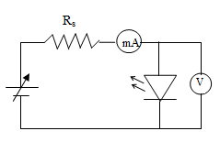

Fig.1(a): Circuit diagram to draw V-I Characteristics of LED
Procedure:-
- Connect the LED in the forward bias as shown in circuit diagram.
- Apply the forward bias voltage by using fine knob of regulated power supply.
- Note the corresponding voltage and current values from the voltmeter and ammeter respectively.
- See that initially the current drawn is negligible but it increases with the applied voltage. The LED starts glowing when it starts drawing the current.
- Draw the V-I curve as shown in the model graph and find V_{o} (turn on voltage).
Theory:
In this experiment we will use light emitting diodes (LED’s) to measure Planck’s constant. LED’s are semiconductors that emit electromagnetic radiation in optical and near optical frequencies when a voltage is applied to them. LED’s emit light only when the voltage is forward biased and above a minimum threshold value. This combination of conditions creates an electron hole pair in a diode. Electron hole pairs are charge carriers and move when placed in an electrical potential. Thus, many electron hole pairs produce a current when placed in an electric field. Above the threshold value the current increases exponentially with voltage.
A quantum of energy is required to create an electron hole pair and this energy is released when an electron and a hole recombine. In most diodes this energy is absorbed by the semiconductor as heat, but in LED’s this quantum of energy produces a photon of discreet energy E_{g} = hν. With increasing voltage, photons of increasing energies will be emitted. Thus, the light emitted by an LED may span a range of discrete wavelengths that decrease with increasing voltage above the threshold voltage (shorter wavelength = higher energy). We are interested in the maximum wavelength that is determined by the minimum energy needed to just to create an electron hole pair. It is numerically equal to the turn on voltage of the LED. The relation between the maximum wavelengths and the turn on voltage V_{o} is
$E_{g}=hϑ=\frac{hc}{λ}=eV_{0}$
Observations:
Wavelength = _________nm
S.No | Voltage (Volts) | Current(mA)

Model graph:
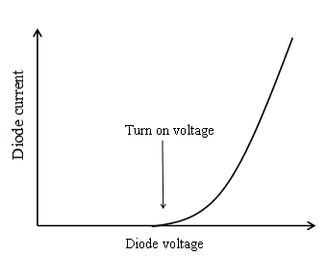

Fig.1(b): V-I characteristics of LED
Results:
- Turn on voltage V_{o} = __________Volt.
- The value of plank’s constant determined from the experiment is ___________
- The standard value of plank’s constant is ___________
- Percentage of error in the result obtained.

- If any deviation observed in the result obtained vis-à-vis the standard result, specify the reason and justify it.

- What are the final inferences and conclusions?

WORKSHEET

VIVA VOCE

- What are direct band gap semiconductors.

- Mention any two applications of direct band gap semiconductors.

- What are indirect band gap semiconductors?

- Give an example for direct and indirect band gap semiconductors.

- What is the principal of LED?

- What is Turn on voltage?

- Mention any two applications of LED.

Experiment No: Date:
2. ENERGY GAP OF A SEMICONDUCTOR (CO3)
Aim: To determine the energy gap of a given semiconductor.
Apparatus: Semiconductor diode, micro ammeter, thermometer, copper vessel, regulated DC power supply, heater and Bakelite lid.
Formula: $E_{g}=\frac{2x 2.303 x Slope x k}{1.6 x {10}^{-19}} eV$__________ (1)
Where $E_{g}=$ energy gap of semiconductor,
$k=$ Boltzmann’s constant= 1.38 x 10⁻²³J/K
Slope $=\frac{dy}{dx}$ from graph between $\frac{1}{T}$ and$\log_{10}I_{s}$, and
1 Joule = 1.6 x 10⁻¹⁹eV.
Theory:
In a reverse biased pn junction diode, the reverse saturation current in the diode is independent of the applied voltage and is temperature dependent. Under appropriate experimental conditions the current flowing through a reverse bias pn junction diode is given by the equation,
$$I=A\left[e^{\left(-\frac{E_{g}}{kT}+\frac{eV}{kT}\right)}\right]$$
Where $A$ - constant for a particular semiconductor taken,
$E_{g}$- energy gap of semiconductor,
$k$- Boltzmann constant,
$T$- Absolute temperature,
$e$- charge of the electron,
$V$- voltage across the p-n junction diode.
A graph can be drawn by taking $\frac{1}{T}$ on X-axis and the current passing through the semiconductor log₁₀$I_{s}$ on Y-axis and by using the value of the slope; energy gap $E_{g}$ can be computed using equation 1.
Description:
The apparatus consists of a diode, attached to a Bakelite lid with terminals. The diode can be immersed in oil, taken in the copper vessel. The Bakelite lid is provided with a hole to insert a thermometer. With the help of a heater, the oil can be heated to a desired temperature.
Procedure:
Make the required connections as shown in the circuit diagram. Pour some oil in the copper vessel, and fix the Bakelite lid on the copper vessel. Insert thermometer into the vessel and apply a constant voltage (1.5V) to the given semiconductor. Increase the temperature of the oil to 80℃ by switching on the heater. Switch off the heater then the oil starts cooling. Current is measured for every 5℃ fall of temperature from 80℃ to 50℃, and the readings are tabulated

Circuit diagram:
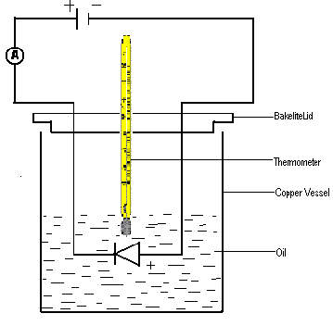
Fig.4(a): Circuit diagram to find E_{g} of semiconductor Fig.4(b): Graph between $\frac{1}{T}$ and $\log{I_{s}}$

Graph:
A graph is plotted by taking $\log_{10}I_{s}$ on Y-axis and $\frac{1}{T}$ on X-axis.
A straight line is obtained as shown, whose slope is determined.
Observations:
Applied constant voltage (V) = 1.5 V.

S.No | Temperature |  | Current (I) µA | Log₁₀ I_{S} | 1/T K⁻¹
 | ℃ | K
1 | 80
2 | 75
3 | 70
4 | 65
5 | 60
6 | 55
7 | 50
8 | 45
9 | 40
10 | 35
Calculations:
$E_{g}=\frac{2x 2.303 x Slope x k}{1.6 x {10}^{-19}} eV$ (1 Joule = 1.6 x 10⁻¹⁹ eV)
=

Substituting the value of slope in the formula, the energy gap is calculated.
Precautions:
- The oil should not be heated above the stipulated temperature i.e. around 80℃.
- The micro ammeter reading should not go beyond the scale limits.
Results:
- Expected value of Energy gap of the given semiconductor diode is ____________ eV.

- Energy gap of the given semiconductor diode is obtained through experiment (graph) is ____________ eV.

- Percentage of error in the result obtained.

- If any deviation observed in the result obtained vis-à-vis the standard result, specify the reason and justify it.

WORK SHEET

VIVA VOCE

1. What is valence band energy?

2. Define conduction band energy.

3. What is energy band gap?

4. Explain intrinsic and extrinsic semiconductors.

5. Compare p-type and n-type semiconductors.

6. What is the importance of energy gap in a semiconductor?

7. Explain why resistance decreases with increase in temperature in a semiconductor.

Experiment No: Date:
3. V-I CHARECTERISTICS OF SOLAR CELL (CO1)
Aim: To study the V-I characteristics of Solar Cell.
Apparatus: Voltmeter, ammeter, variable load, solar cell and mercury coated variable intensity source.
Formula:
Fill Factor $\left(FF\right)= \frac{P_{max}}{V_{OC}I_{SC}}$
Where $P_{max}$Is the maximum power from graph,
$V_{OC}$ is the open circuit voltage,
$I_{SC}$ is the short circuit current.
Description: It is a p-n junction device with a large surface area based on the principle of Photovoltaic effect. It directly converts light energy into electrical energy and hence is also known as Photovoltaic cell. In solar cell almost the total radiation (light) incident is absorbed and electron-hole pairs are generated giving raise to electrical energy. It has high efficiency. The materials used for solar cells are Si, CdS, GaAs etc. The solar cells are broadly classified into a) p-n homojunction type, b) p-n hetero junction type, c) Metal-Insulator-Semiconductor (MIS), and d) Semiconductor-Insulator-Semiconductor (SIS).
Efficiency of solar cell is defined as the ratio of the total power converted by the solar cell to the total power available for energy conversion.
Procedure:
  - Connect the circuit as shown in the circuit diagram.
  - Place Solar Cell directly in front of variable light intensity source and connect output of Solar Cell to voltmeter.
  - For various intensities of light (bulb) note down voltmeter and ammeter readings.
  - The experiment is repeated with a variable load in the circuit as shown.
  - Plot a graph, between voltage and current at different intensities with & without load.

Circuit diagram:
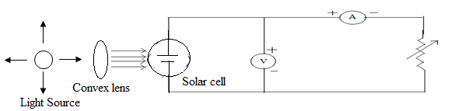

Fig. 9(a): circuit diagram to plot V-I characteristics of solar cell

Observations:

S.No. | Without load |  |  | S.No. | With load
 | Voltage (V) | Current (I) ( mA) |  |  | Voltage (V) | Current (I) (mA) | Power(P)(Watt)
1 |  |  |  | 1
2 |  |  |  | 2
3 |  |  |  | 3
4 |  |  |  | 4
5 |  |  |  | 5
6 |  |  |  | 6
7 |  |  |  | 7
8 |  |  |  | 8
9 |  |  |  | 9
10 |  |  |  | 10

Model graph:

V-I Characteristic curve without load | V-I Characteristic curve with load
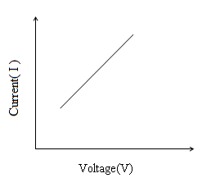 | Voltage (V)  Current (I)  P_{max}  V_{OC}  I_{SC}
Fig.9(b) : V-I Characteristics of solar cell without load Fig.9(c) : V-I Characteristics of solar cell with load
Results:
- V- I characteristic curve of a given solar cell obtained through experiment (Graph).

- Is there any deviation in V-I characteristic curve of a given solar cell?

- If any deviation observed in the result obtained vis-à-vis the expected/standard result, specify the reason and justify it.

- What are the final inferences and conclusions?

WORK SHEET

VIVA VOCE
- What is solar cell?

- Which type of materials are used in solar cells?

- What is the requirement of a solar cell material?

- What is short circuit current?

- What is open circuit voltage?

- What is efficiency of a solar cell?

- What is the principle of solar cell?

- What is the difference between photodiode and solar cell?

- Write any two applications of solar cell.

Experiment No: Date:

4. HALL EFFECT (CO1)
Aim: To determine the
- Hall coefficient of a semiconductor
- type of the semiconductor
- concentration of the majority carriers and
- mobility of the majority carriers in the material.
Apparatus: An extrinsic semiconductor wafer, a constant current source, an electromagnet anda voltmeter having high input impedance.
Formulae:
i) The sign of the majority carriers is found from the polarity of Hall voltage V_{H}
ii) The Hall coefficient R_{H} is calculated from,
R_{H} =
iii) The concentration of the majority charge carriers is
p = or n =
iv) The mobility of the charge carriers is
Circuit diagram:
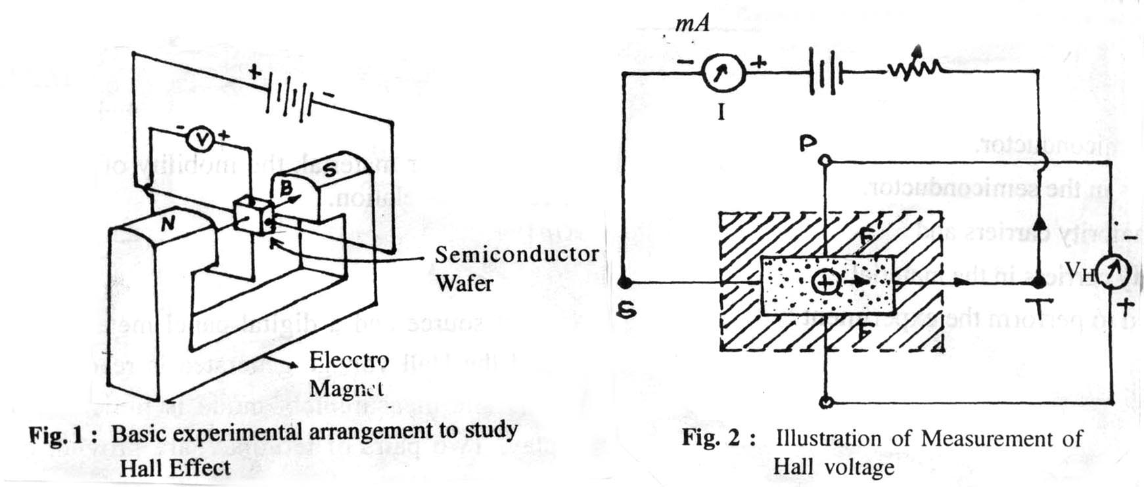
Fig.10(a) : Basic experimental arrangement to study Hall effect Fig.10(b) : Illustration of Measurement of Hall voltage

Procedure:
1. The semiconductor crystal is carefully mounted on the probe strip and electrical contacts are provided. The assembly known as a Hall probe is available in readymade form. The Hall probe is connected into the circuit as shown in fig. 10(b).
2. The widthwise contacts of the Hall probe are connected to the voltage terminals of the Hall Effect set up. Without connecting the current terminals, the setup is switched on and zero adjustment is made. The unit is then switched off.
3. The lengthwise contacts of the probe are connected to the current terminals of the set up.
4. The probe is held in a central position in the air gap of the electromagnet. The power supply is switched on and the magnetic field is adjusted to a suitable value (say 3 kilogauss). Hall Effect set up is switched on and the Hall probe is rotated in a vertical plane till the Hall voltage generated is a maximum.
5. The current through the semiconductor is adjusted to a suitable value. The Hall voltage and its polarity are noted down.
6. The current is varied and at different settings of current, the corresponding Hall voltage is noted down. The observations are recorded in observation table.
7. The current is kept at a constant value, say 3mA. The magnetic field is varied in steps of 500 gauss. At each settings of the magnetic field, the corresponding Hall voltage is noted. The observations are recorded in observation table.
8. Using the above observations, graphs are plotted. In one graph, the Hall voltage is plotted as a function of current at a constant magnetic field. In a second, the Hall voltage is plotted as a function of magnetic field at constant current. In both the graphs straight line plots are obtained, as shown in fig.10(c) and fig.10(d). The slope of straight line is determined in each case.
9. Using the values of slopes into equation the value of R_{H} in each case is calculated. The mean of two values is taken as the value of R_{H}.
10. Substituting the value of R_{H} into equation the concentration of charge carriers is determined.
11. From the manufacturer's data, the resistivity of the semiconductor sample is noted and using the value in equation, the carrier mobility is evaluated.

Observations:
Thickness of the semiconductor wafer (t): ________________ mm. = ___________________ m.
Resistivity (): _________________________ ohm. m.
Magnetic field, B = ____________k gauss = _____________Wb/m² (1 wb/m² = 10⁴ gauss)
S. No. | Current I (mA) | Hall voltage V_{H} (mV)
1
2
3
4
5
6
7
8
9
10

Current (I):_____________mA =_____________ x 10⁻³ A

S. No. | Magnetic field |  | Hall voltage V_{H} (mV)
 | K gauss | Wb/m²
1
2
3
4
5
6
7
8
9
10

Calculations:
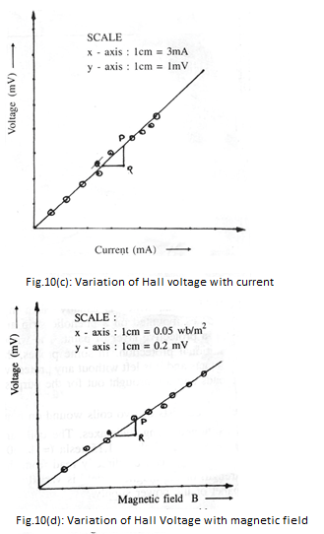
Slope
Slope
i) R_{H1} (Slope ) x = _____________ = ___________ m³/C
R_{H2} (Slope) x = _____________ = ___________ m³/C
Mean R_{H} = = _______________________ m³/C
ii) Majority carrier concentration
n ( or p) = =
= ___________________ / m³
iii) Mobility of the charge carriers
= ___________ S/m x____________m³/C
= __________________ m²/V.s
Results:
The polarity of the Hall voltage is _________________.
Therefore the given semiconductor is of _______ type.
The value of Hall coefficient is _______________ m³/C.
The concentration of the majority carriers is found to be ______________ /m³.
The mobility of the charge carriers is found to be __________________m²/V.s.
Precautions:
1. Care is taken to limit the current through the probe to a value less than mentioned by the manufacturer.
2. The probe is properly centered and oriented in the magnetic field such that maximum Hall voltage is generated.
3. Magnetic field is varied gradually in steps to avoid damage to the electromagnet coils.

WORKSHEET

VIVA VOCE
1. What parameters can you determine with this experiment?

2. State and explain Hall Effect.

3. How do you determine mobility of a charge carrier using Hall effect?

- What is Hall coefficient?

- How mobility does depend on electrical conductivity?

  - What are the applications of Hall effect?

Experiment No: Date:

5. NUMERICAL APERTURE (N.A) & BENDING LOSSES OF A GIVEN OPTICAL FIBER

Aim: To determine the numerical aperture, acceptance angle and bending losses of a given optical fiber.
Apparatus: Optical fiber cable (1,3,5 meter), Digital Multimeter (DMM), fiber optic trainer module kit.

Formula: Numerical Aperture (N. A. ) = W
(4L2+W2)1⁄2
- (1)

Here, W is the Diameter of the light spot falling on the screen.

L is the distance between fiber end and screen. Acceptance angle (θa) = sin⁻¹(N A) (2)
Loss of optical power = -10log (Pout/Pin)dB (3)

Most fiber manufactures characterize attenuation loss by the number of decibels loss per kilometer of fiber. This value can be calculated by

Loss/km = -(10/L) log (Pout/Pin)dB/km (4)

Description: The fiber optic trainer module consists of three important parts namely,
- Electrical to optical (E/O) converter
- Optical to electrical (O/E) converter
- Optical power meter

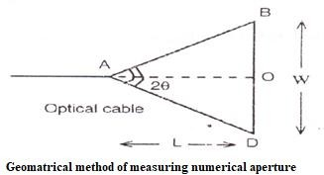
Theory: The numerical aperture of an optical fiber is a measure of the light gathering capacity of the optical fiber. It is given by
Numerical aperture (N.A) = nSin θ_{a} Where n is the refractive index of the
medium.
For air n =1
∴ N. A. = sin θ_{a}
For step-index fiber, the N.A. is given by:

N. A. = (n² − n²
x
1⁄2

core
cladding)
Light from the fiber end “A” is incident on the screen BD. Let the diameter of the light spot falling on the screen=BD
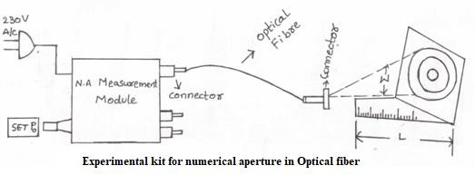

Let the distance between the fiber end and the screen=AO=L.

2 1⁄2 (4L2+W2)1⁄2
∴ From the fig.(a), AB = (L² + W ) =
4 2

∴ N. A = sin θ
= OB = W
Knowing W and L, the N.A can be calculated by using

a AB (4L2+W2)1⁄2
equation (1). Substituting this value of N.A. in equation (2), the acceptance angle θa can be calculated.

- Procedure to determine the numerical aperture:

  - Connect one end of the fiber optic cable to P₀and the other end to N.A.jig as shown in figure.
  - The AC main is switched ON. Light should appear at the end of the fiber on the N.A. jig to ensure proper coupling is made or not. Turn the SET P₀ knob in clockwise direction to get maximum intensity light through fiber.
  - A screen with concentric circles of known diameter is kept vertically at a distance of (L) from the fiber end and view red spot on the screen.
  - The diameter (W) of the red spot is made exactly equal to the first concentric circle and the corresponding distances (L) from the fiber end to the screen are noted in table 1.
  - The experiment is repeated for the subsequent diameters of the circles by adjusting the length L.

Table 1:

S.No. | W (mm) | L (mm) | N.A | θ_{a} = Sin⁻¹(N. A)
1 | 10
2 | 20
3 | 30
4 | 40
5 | 50

- Procedure to determine bending losses in Optical Fiber:

In this part of the experiment a transmitter and receiver along with mandrel are used.

  - One end of the optical fiber is connected to transmitter and other end is connected the receiver.
  - The knob P₀ of the transmitter kit is adjusted to get the maximum intensity.
  - The receiver reading is noted with the help of a digital multimeter when there are no bends in the fiber, the reading is recorded as Pin.
  - The optical fiber is wound on the mandrel say b2xy 5 turns and the receiver reading is noted as Pout in digital multimeter and recorded in the table 2.
  - The bending loss is calculated the above formula.
  - The experiment is repeated for more no. of turn’s say 10, 15….turns and the corresponding readings are tabulated.
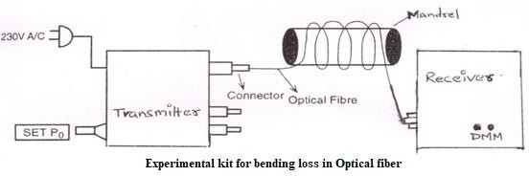

Table 2:

Digital multimeter reading without bending of the optical fiber Pin= mW

S.No | Length of optical fiber-L(m) | No. of  turns on the  mandrel | Pout µW | Bending loss dB/Km  [ -(10/L) log (Pout/Pin)dB/km]
1 | 1
2
3
4 | 3
5
6
7 | 5
8
9
Precautions:

- The knob P₀ should be adjusted for the maximum optical output.
- There should not be any bends in optical fiber while noting down P₀₁.

Result:

  - The Numerical aperture of the optical fiber = .
  - The acceptance angle of the optical fiber = .
  - The bending losses in optical fiber for various turns are determined.

Applications:
Optical fibers find applications in
- Sensors
- In the field of medicine (Endoscopy).
- Military applications (In submarines, missiles and air craft’s)
- In the field of Communication systems.

WORK SHEET

VIVA VOCE:
  - What is the Principle of Optical Fiber?

  - What is Numerical Aperture?

  - What is acceptance angle?

  - What is meant by mono mode and multimode fibers?

  - What is attenuation in Optical fiber?

  - What are the various types of attenuation in Optical fiber?

  - What is the source of light used in this experiment?

  - Intermodel dispersion is negligible in what type of Optical fiber?

  - What are the advantages of optical fiber?

  - What are the applications of optical fiber?

