Activity 1.

1. Display all of the process in current shell :

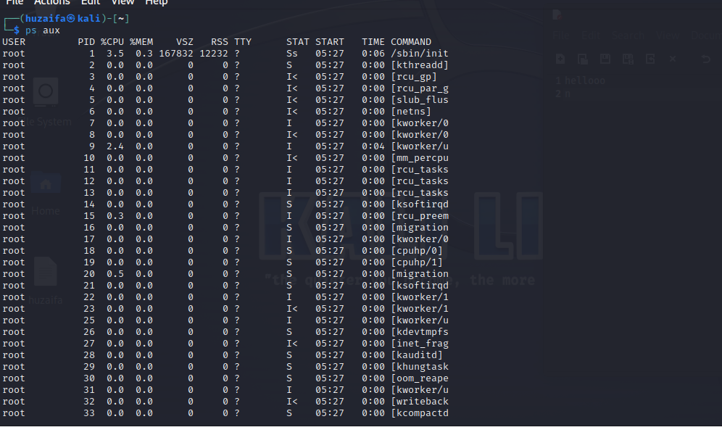

1. Display every active process in the system :

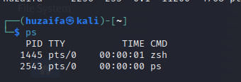

1. Display a full-format listing of processes owned by user ubuntu :

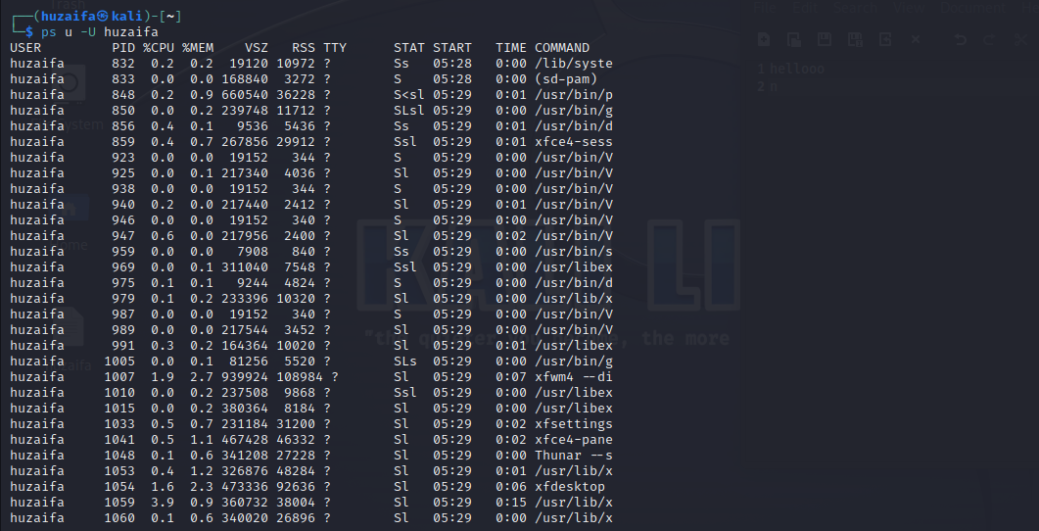

1. Display a process with id 1 :

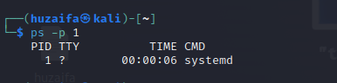

1. Display the dynamic view of the current processes in the system and set the refresh interval 0.5 second :

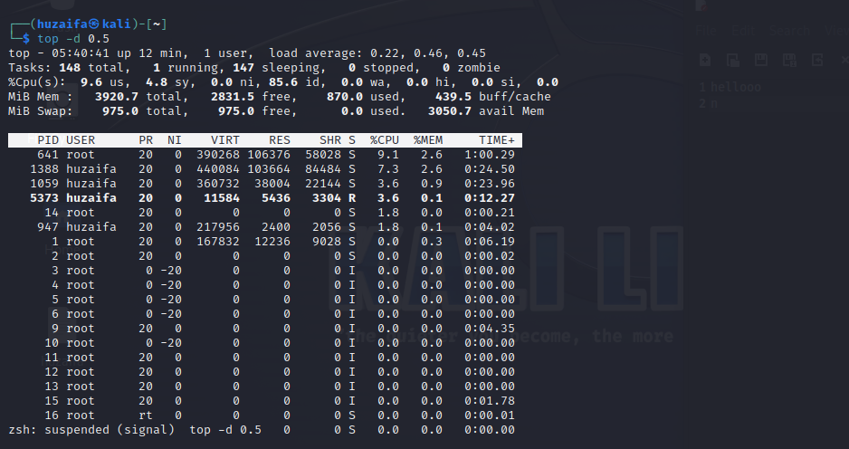

1. Display the dynamic view of the processes owned by user with id (or name ubuntu) :

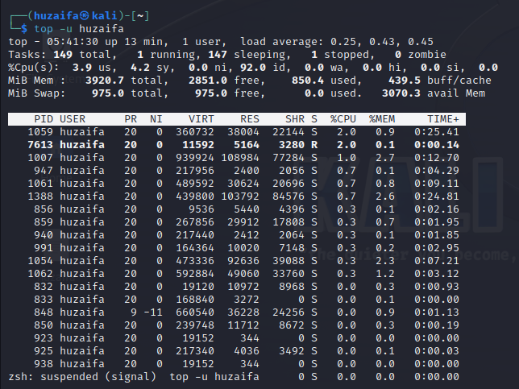

1. Start the gedit program in background and then bring it foreground:

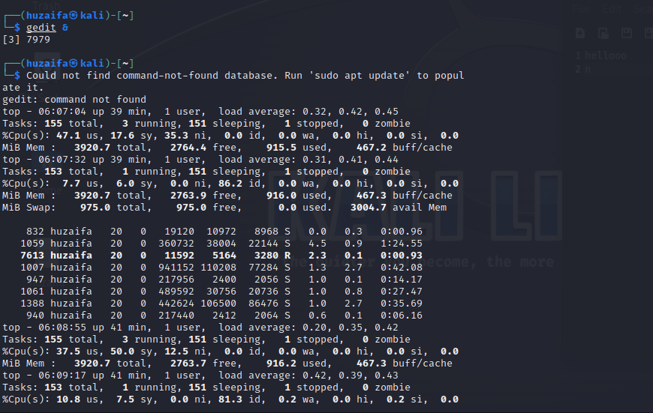

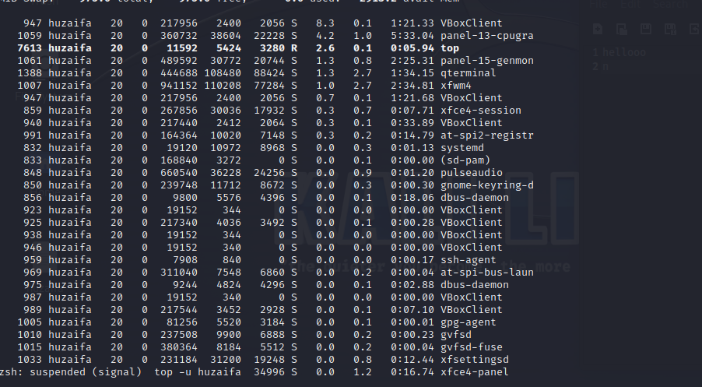

1. Suspend the gedit program:

To suspend the "gedit" program, you can use the Ctrl+Z keyboard shortcut **.**



Activity 2:

1. Start the gedit program with priority 10:

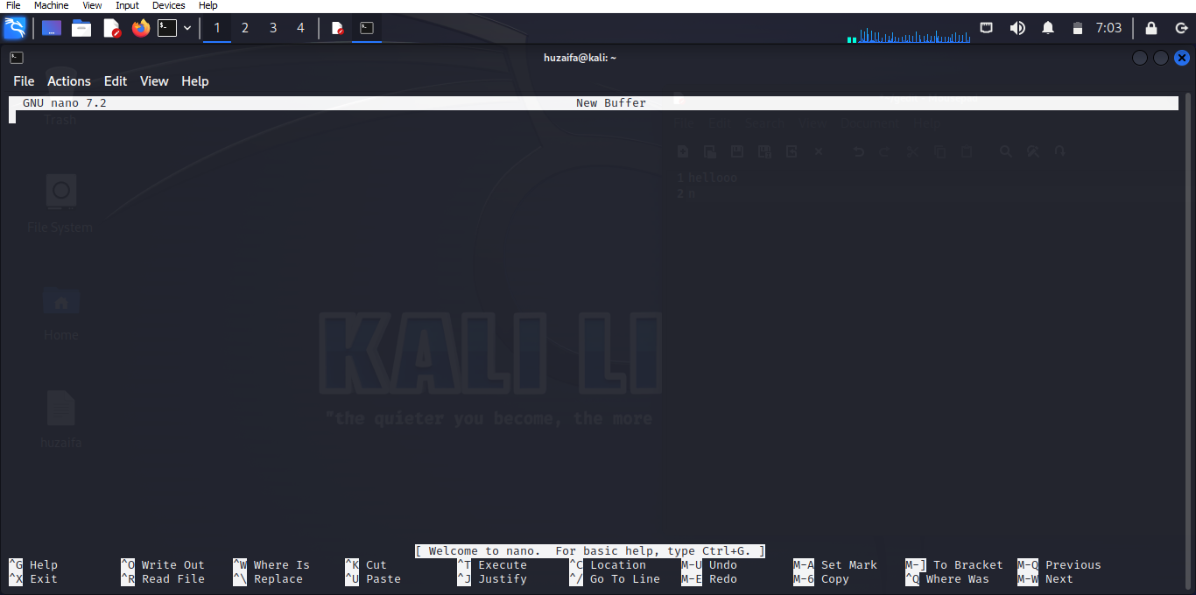

1. Reset the priority of gedit :

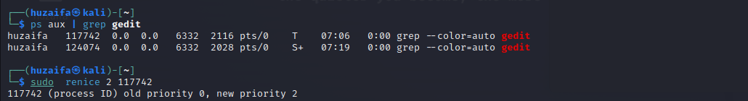

Activity 3:

Evaluate the following expressions on command line (both through expr and bc ):

1. 5+(10-5)/5 Ans. 6

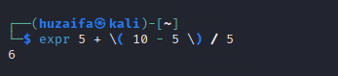

1. 2 (10*5-(15*10)) /10 Ans. -10

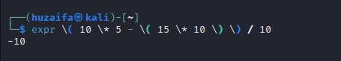

1. (31.5 - 12)/4.1 Ans. 4.756





1. (104.5-(15.3*10.4)) /10.5 Ans. -5.2019



