WEEK 4 PROJECT DOCUMENTATION
Unsupervised Learning &
Customer Segmentation
K-Means and Agglomerative Hierarchical Clustering

Internship Task — ITSimplera
Author: Abdul Basit
BS Artificial Intelligence, University of Agriculture Peshawar

Project focus: Discovering meaningful customer segments from credit-card usage behavior

1. Executive Summary
This project applies unsupervised machine learning to segment approximately 9,000 credit-card customers into behaviorally meaningful groups. Because the dataset has no target variable, the objective is not prediction; instead, the analysis discovers natural patterns in customers’ spending, cash-advance usage, payment behavior, credit limits, and account activity.
Two clustering approaches were investigated: K-Means clustering and agglomerative hierarchical clustering. The analysis selected four clusters (k = 4) as the practical segmentation solution. The resulting groups are interpretable in business terms: cash-advance users, high-value spenders, low-engagement/dormant customers, and responsible installment shoppers.
K-Means is recommended as the primary production method because it scales efficiently to the full customer base. Hierarchical clustering is valuable as an exploratory and validation technique, especially for understanding cluster relationships through a dendrogram.

2. Project Objective
The central objective is to identify customer segments that can support data-driven business decisions such as targeted marketing, customer re-engagement, personalized financial services, credit-risk monitoring, and customer-value management.
- Prepare and clean the credit-card customer dataset.
- Transform features to a comparable scale before distance-based clustering.
- Evaluate candidate K-Means solutions for k = 2 through k = 10.
- Select a practical number of clusters using the elbow method and silhouette analysis.
- Profile the final clusters using feature-level means and relative patterns.
- Compare K-Means with agglomerative hierarchical clustering.
- Translate the discovered clusters into actionable business interpretations.

3. Dataset and Data Preparation
The project uses the Credit Card Dataset for Clustering, containing customer-level behavioral information for approximately 9,000 credit-card holders. The customer identifier is not a useful behavioral feature, so CUST_ID is removed before clustering.
The analysis works with 17 behavioral variables covering account balance, purchase activity, cash advances, transaction frequencies, credit limits, payments, minimum payments, full-payment behavior, and tenure.

3.1 Missing-value treatment
Missing values in MINIMUM_PAYMENTS and CREDIT_LIMIT are handled using median imputation. The median is robust to extreme values and is appropriate for financial variables that may be highly skewed.

3.2 Feature scaling
All clustering features are standardized using StandardScaler. This step is important because distance-based algorithms can otherwise be dominated by high-magnitude variables such as balances, payments, and credit limits.
After standardization, each feature contributes on a more comparable scale to the distance calculations used by K-Means and Ward-linkage hierarchical clustering.

4. Methodology and Implementation

4.1 K-Means clustering
K-Means partitions observations into k groups by assigning each customer to the nearest centroid and iteratively updating centroids to minimize within-cluster variation. The analysis evaluates multiple values of k before fitting the final model.
- Load the dataset and inspect its structure, shape, data types, and missing values.
- Drop the customer identifier and impute missing values using feature medians.
- Standardize the behavioral features.
- Fit K-Means models for k = 2, 3, ..., 10 and record inertia.
- Plot the elbow curve to identify the point where additional clusters provide diminishing returns.
- Calculate silhouette scores for candidate values of k.
- Fit the final K-Means model using the selected k = 4.
- Compute cluster-level feature means and visualize the profiles in a heatmap.

4.2 Hierarchical clustering
Agglomerative hierarchical clustering begins with individual observations and progressively merges the most similar groups. Ward linkage is used to favor merges that minimize the increase in within-cluster variance.
- Select a random 300-row sample for dendrogram visualization, keeping the plot readable.
- Compute hierarchical structure using Ward linkage.
- Use the dendrogram to visualize merge distances and a cut threshold that yields four groups.
- Fit AgglomerativeClustering with the same k = 4.
- Compare K-Means and hierarchical assignments using a cross-tabulation.

5. Model Selection Results

5.1 Elbow method
The elbow curve shows a strong reduction in inertia as the number of clusters increases from k = 2 to k = 4. After this point, the improvement becomes more gradual. This indicates that k = 4 provides a useful balance between reducing within-cluster variation and avoiding unnecessary fragmentation.
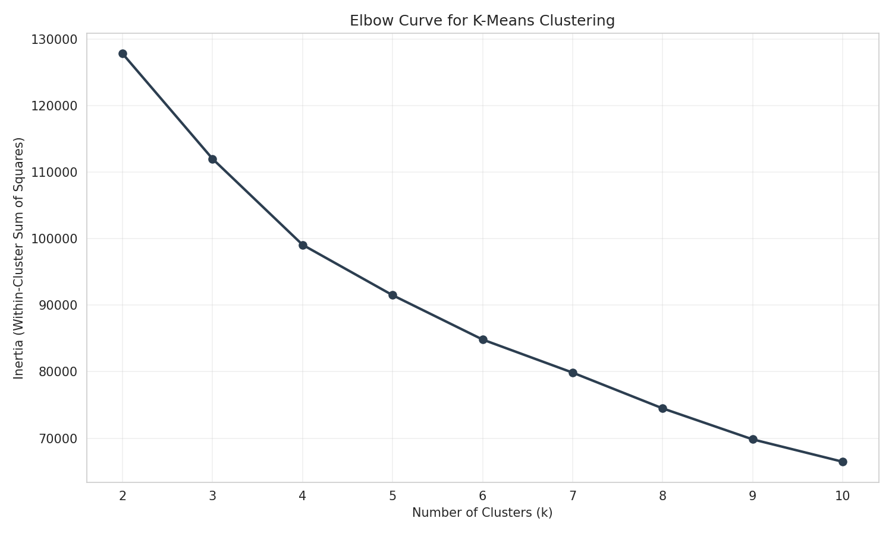
Figure 1. K-Means elbow curve: inertia decreases sharply before the improvement becomes more gradual.

5.2 Silhouette analysis
The silhouette score measures how well-separated and internally cohesive the clusters are. The highest score in the tested range occurs at k = 3 (approximately 0.251), while k = 4 produces a lower score of approximately 0.198. Although the pure silhouette optimum favors k = 3, the broader analysis selects k = 4 because it provides a more useful and interpretable business segmentation and is supported by the elbow analysis and the subsequent cluster profiles.
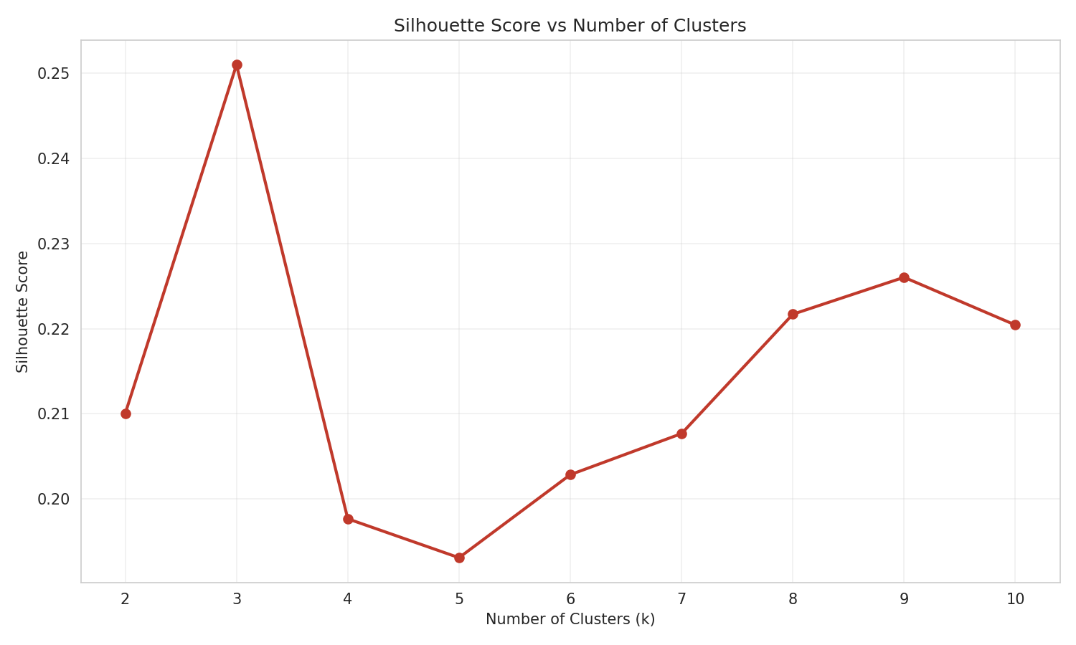
Figure 2. Silhouette scores for candidate numbers of clusters.
This is an important modeling observation: cluster-count selection should not rely on one metric alone. The final choice balances compactness, separation, interpretability, and the business purpose of the segmentation.

6. Final K-Means Cluster Profiles (k = 4)
The cluster-profile heatmap presents actual mean feature values as annotations and uses color to show relative feature levels. The profiles reveal four distinct behavioral patterns.
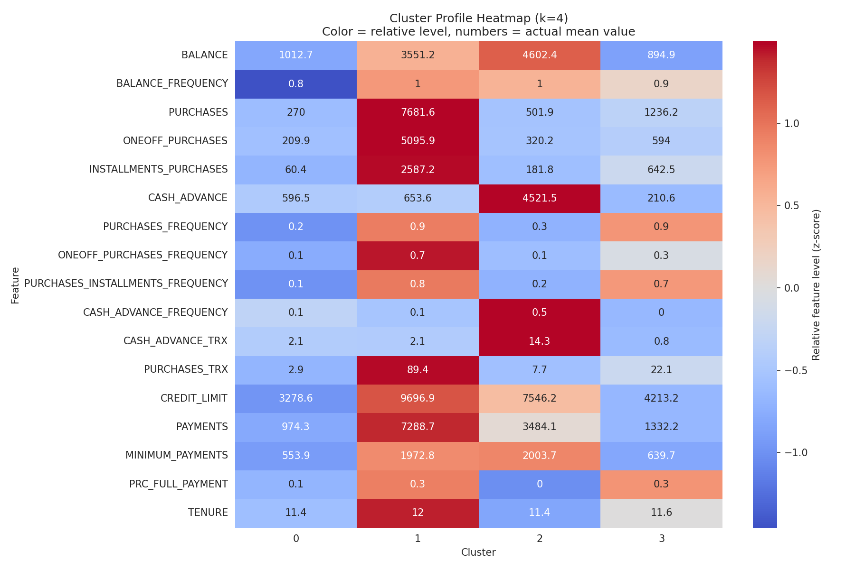
Figure 3. Cluster profile heatmap for the four K-Means segments.
Cluster | Behavioral profile | Business interpretation
Cluster 0 | Lower balance and credit limit; low purchase and cash-advance activity; relatively low engagement. | Low-engagement / dormant customers; suitable for re-engagement campaigns.
Cluster 1 | Very high purchases, payments, credit limit, and purchase transactions; strong installment and one-off purchase activity. | High-value spenders; potentially the most valuable segment for premium services and retention.
Cluster 2 | Very high cash advance and cash-advance transaction activity; comparatively weak purchase activity. | Cash-advance users; a higher-risk behavior pattern requiring monitoring and tailored financial support.
Cluster 3 | Moderate balances with strong purchase frequency and installment behavior; relatively low cash-advance activity. | Responsible installment shoppers; steady revenue with comparatively lower cash-advance dependence.
The strongest differentiators are purchase intensity, cash-advance behavior, transaction frequency, payment levels, and credit capacity. In particular, Cluster 1 is separated by exceptionally high purchase and payment activity, while Cluster 2 is dominated by cash-advance usage.

7. Hierarchical Clustering Results

7.1 Dendrogram
The dendrogram was created on a random 300-customer sample to keep the visualization interpretable. The horizontal cut threshold is selected to produce four clusters. The tree illustrates how customer groups merge at increasing Ward distances and provides a visual explanation of the hierarchical structure.
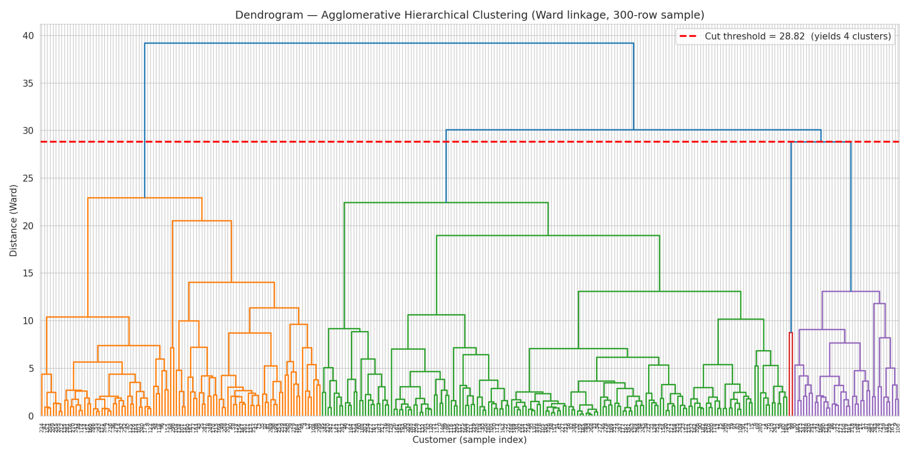
Figure 4. Ward-linkage dendrogram with a cut threshold yielding four clusters.

7.2 Comparison with K-Means
The cross-tabulation compares the K-Means and hierarchical assignments on a 300-row sample. The table shows that the two methods identify substantial correspondence between several groups, although cluster labels are algorithm-specific and do not inherently have the same numeric meaning.
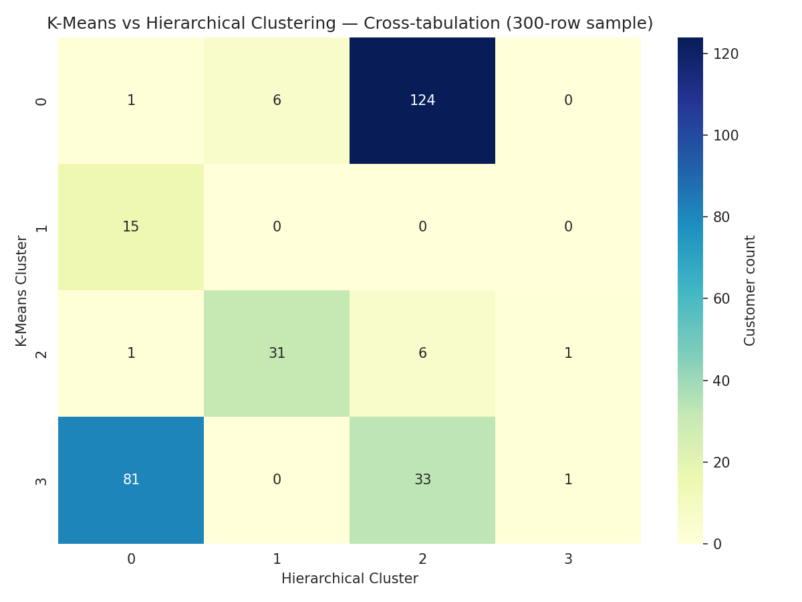
Figure 5. Cross-tabulation of K-Means and hierarchical cluster assignments.
The comparison supports the stability of the broad segmentation structure. However, the methods are not expected to produce a perfect one-to-one match because they optimize different clustering objectives.

8. Key Observations
- The customer base is heterogeneous: customers differ substantially in spending, cash advances, payments, and credit capacity.
- Cash-advance behavior is a major segmentation dimension and creates a distinct behavioral group.
- High purchase and payment activity identifies a high-value segment with strong commercial potential.
- A low-activity group represents an opportunity for re-engagement and retention campaigns.
- Installment-oriented purchasing creates a distinct group with steady usage and comparatively limited cash-advance dependence.
- Scaling is essential because raw financial variables have very different magnitudes.
- The elbow and silhouette methods provide complementary evidence; the final k should also reflect interpretability and business use.
- K-Means is more practical for repeatedly assigning new customers at scale, while hierarchical clustering is particularly useful for exploration and validation.

9. Business Applications
The segmentation can support differentiated customer strategies rather than treating all cardholders identically.
Segment | Potential action
High-value spenders | Premium rewards, retention programs, higher-value offers, and personalized services.
Cash-advance users | Risk monitoring, responsible borrowing communication, repayment support, and targeted financial products.
Low-engagement / dormant customers | Reactivation campaigns, onboarding reminders, incentives, and personalized offers.
Responsible installment shoppers | Installment product recommendations, loyalty benefits, and cross-selling of relevant services.

10. Limitations and Considerations
- The dataset is observational, so clusters describe behavioral patterns rather than proving causal relationships.
- K-Means assumes a centroid-based structure and can be affected by outliers and initialization.
- The hierarchical dendrogram is visualized on a 300-row sample for readability rather than the entire customer population.
- Cluster labels are arbitrary; Cluster 0, Cluster 1, and so on are identifiers, not rankings.
- The silhouette score alone favors k = 3, so the choice of k = 4 should be understood as a combined statistical and business decision.
- For production deployment, the chosen preprocessing pipeline and K-Means model should be versioned and monitored for customer behavior drift.

11. Final Recommendation
Use the four-segment K-Means solution as the primary production segmentation framework. It provides a practical balance between scalability and behavioral interpretability. The hierarchical approach should be retained as a periodic validation and exploratory tool to check whether the broad customer structure remains stable.
Before deployment, the segmentation should be refreshed periodically and evaluated against business outcomes such as campaign response, customer retention, credit-risk indicators, and customer lifetime value. This would turn the unsupervised analysis into a monitored, business-oriented segmentation system.

12. Reproducibility and Technical Stack
The analysis is implemented in Python and documented in the Week 4 clustering notebook. The primary libraries are pandas, NumPy, scikit-learn, SciPy, Matplotlib, and Seaborn.
Suggested execution workflow:
- Install dependencies from requirements.txt.
- Open the clustering notebook.
- Run the data preparation and preprocessing cells.
- Run the K-Means model-selection and evaluation cells.
- Run the final cluster profiling and visualization cells.
- Run the hierarchical clustering and comparison cells.

Appendix A — Main Outputs
The project produces five principal visual outputs: the elbow curve, silhouette-score curve, cluster profile heatmap, hierarchical dendrogram, and K-Means-versus-hierarchical cross-tabulation heatmap. Together, these visualizations provide model-selection evidence, cluster interpretation, and method comparison.

