10Pearls Shine Internship Project Report:
Pearls AQI Predictor (Karachi)
Prepared by: Abdul Basit Khatri
Role: Data Sciences Intern
Organization: 10Pearls
Date: May 31, 2026

Table of Contents
1. Executive Summary 2
2. Project Context & Objectives 2
2.1 Project Scope 2
3. Script Architecture Matrix 3
4. Data Storage & Managed Feature Store 3
4.1 Data Source Integration 3
4.2 Hopsworks Feature Store Configuration 3
4.3 Dual Ingestion Strategy 4
5. Exploratory Data Analysis (EDA) & Insights 4
6. Feature Engineering & Preprocessing 4
6.1 Preprocessing and Timeline Alignment 5
7. Model Evaluation & Lifecycle Management 5
8. Explainable AI (XAI) Integration 6
9. Serving & Deployment Architecture 6
10. MLOps Automation & CI/CD Pipelines 6
11. Technical Challenges, Solutions, & Resolutions 7
12. Conclusion and Acknowledgments 7

1. Executive Summary
This technical report presents the design, implementation, and deployment of a production-oriented Air Quality Index (AQI) prediction platform for Karachi, developed during my internship at 10Pearls. The system addresses the critical problem of forecasting short-term air quality trends by combining robust data ingestion, machine learning, model explainability, centralized feature storage, and automated MLOps pipelines.
The end-to-end architecture leverages Hopsworks for feature storage and model management, OpenWeather APIs for data ingestion, and Streamlit for the user-facing inference dashboard. Operational automation is achieved through scheduled GitHub Actions.
Deployment Link: The production dashboard is actively hosted on the cloud at:
https://aqipredictor-a-basit-khatri-10pearls.streamlit.app/

2. Project Context & Objectives
The core objective of this 10Pearls internship project was to transition from an experimental, notebook-based machine learning model to an enterprise-grade MLOps system. The specific goals included:
- Building a robust, predictive model for one-hour-ahead AQI forecasts.
- Centralizing features within a managed Feature Store to avoid training-serving skew.
- Automating data ingestion and model retraining workflows.
- Designing an interactive inference dashboard with built-in Explainable AI (XAI) capabilities.

2.1 Project Scope
The technical boundaries of the project encompass:
- Target Horizon: Next-hour AQI prediction with a recursive 72-hour forecast horizon for UI visualization.
- Data Frequency: Strict hourly temporal granularity.
- Geographic Focus: Karachi, Pakistan.
- Infrastructure: Serverless orchestration utilizing GitHub Actions and cloud serving via Streamlit.

3. Script Architecture Matrix
The system code ecosystem is structured into distinct, decoupled functional modules mapped below:
Script Name | Purpose | Operational Layer
current_feature_pipeline.py | Fetches live AQI/Weather data; computes real-time features. | Ingestion (Hourly)
backfill_feature.py | Downloads and engineers historical data for cold-start training. | Ingestion of Historical Data
training_pipeline.py | Preprecesses data, benchmarks algorithms, exports SHAP/LIME, registers best model. | Training & Registry (Daily)
eda.py | Performs data schema validation, profiling, and quality analysis. | Analysis & Diagnostics
app.py | Serving layer web application displaying forecasts and explainability artifacts. | Inference / Presentation

4. Data Storage & Managed Feature Store

4.1 Data Source Integration
The application consumes data from three main production endpoints provided by the OpenWeather API ecosystem:
- /air_pollution: Returns current pollutant concentrations (PM2.5, PM10, NO2, SO2, O3, CO) and the target AQI level.
- /weather: Provides real-time meteorological observations such as temperature, relative humidity, and wind speed.
- /air_pollution/history: Provides retroactive historical hourly atmospheric data streams.

4.2 Hopsworks Feature Store Configuration
To ensure feature reproducibility and eliminate severe training-serving data skew, features are stored centrally in a Hopsworks Feature Group configured with the following platform properties:
- Feature Group Name: karachi_aqi_fg
- Version: 1
- Primary Key: ["city", "timestamp"] (Composite structural layout to enforce uniqueness)
- Event Time: timestamp (Enables point-in-time correct joins and time-travel querying assets)
- Online Serving Layer: Enabled

4.3 Dual Ingestion Strategy
- Historical Backfill: Executed via backfill_feature.py to seed the operational database with observation baselines spanning January 1, 2026, to May 15, 2026.
- Streaming Ingestion: Executed via current_feature_pipeline.py driven by a cron-scheduled automated workflow to continuously append data.

5. Exploratory Data Analysis (EDA) & Insights
Before developing the predictive models, a complete analysis of the historic dataset was performed using eda.py to identify data quality anomalies and correlation dynamics.
- Extracted the baseline dataset by consuming rows directly from the Hopsworks feature group.
- Plotted target variable distributions (AQI) using frequency histograms.
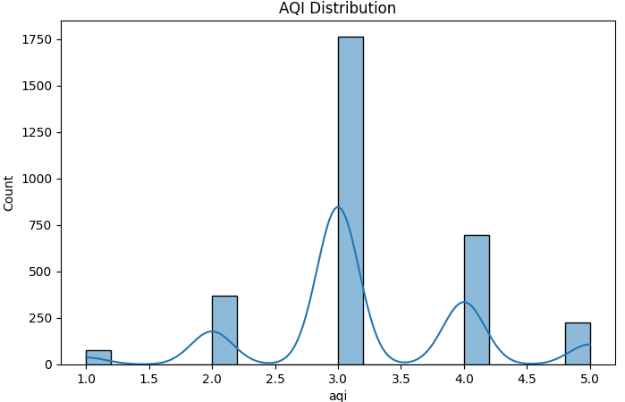

- Computed Pearson correlation coefficients across all numerical columns.
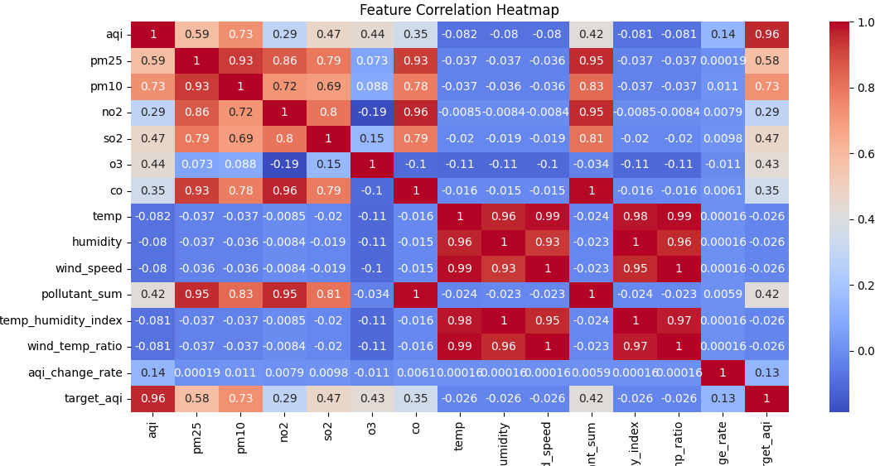
- Evaluated macro temporal trends, specifically checking variations between weekdays and weekends.
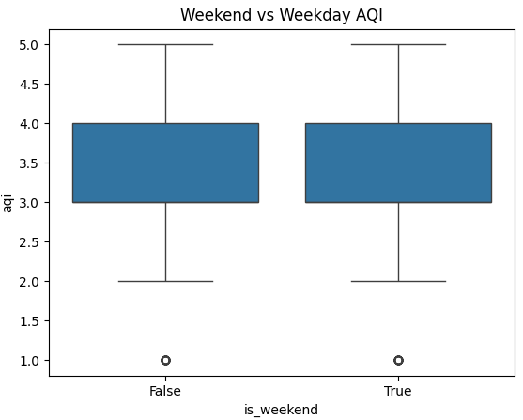
Key Findings & Structural Realizations: The raw historical feed contained irregular gaps, requiring a robust interpolation layer during preprocessing. The target AQI value distribution was highly right-skewed; while the standard state of air quality remains 'moderate', the environment experiences sharp, episodic pollution spikes. Strong positive relationships were observed between the target AQI and the concentrations of fine particulate matter (PM2.5, PM10), Nitrogen Dioxide (NO2), and Sulfur Dioxide (SO2). Furthermore, cyclical temporal markers (hour, day_of_week) showed notable variance, reflecting urban traffic rushes and reduced industrial cycles during weekends.

6. Feature Engineering & Preprocessing
To capture the complex temporal dynamics of air pollution, the raw API metrics were expanded into a multi-dimensional feature space:
- Baseline Pollutant Profiles: PM2.5, PM10, NO2, SO2, O3, CO.
- Meteorological Space: Temperature, relative humidity, wind speed.
- Calendar Vectors: Hour of day, day of month, month of year, day of week, and a binary is_weekend indicator flag.
- Domain-Specific Interactivity Features:
pollutant_sum = Sum of all six pollutant metrics
temp_humidity_index = Temperature * Humidity
wind_temp_ratio = Wind Speed / Temperature
aqi_change_rate = Delta AQI between sequential hours.
- Time-Series Lag & Volatility Operations: Autoregressive lags (AQI_t-1, AQI_t-3, AQI_t-6, AQI_t-24) alongside 6-hour moving averages, 6-hour moving standard deviations, and 24-hour moving averages.

6.1 Preprocessing and Timeline Alignment
To guarantee structural integrity prior to model training, the raw feature matrix undergoes strict sequential cleanup transformations:
- Coerces timestamps to native datetimes and sorts rows sequentially.
- Enforces a rigid 1-hour temporal grid across the timeline.
- Collapses duplicate records using mean values and fills missing intervals via linear interpolation.
- Drops initial index boundary rows containing NaN artifacts resulting from the rolling window definitions.
The target label target_aqi is established by applying an inverse shift on the index: target_aqi_t = AQI_t+1. Data splitting is handled chronologically (rather than randomly) to maintain time-series integrity and prevent data leakage: a Training Partition comprising the first 80% of chronological observations, and a Testing Partition comprising the final 20% of chronological observations.

7. Model Evaluation & Lifecycle Management
The model development pipeline systematically evaluates a diverse group of regression algorithms including Linear Estimators (Linear Regression, Ridge, Lasso, ElasticNet), Ensemble Tree Regressors (Decision Trees, Random Forest, Extra Trees, Gradient Boosting, AdaBoost), Instance/Kernel Learners (SVR, KNN), and advanced gradient boosting frameworks (XGBoost, LightGBM, CatBoost).
Each model is trained inside a Scikit-learn Pipeline encapsulating a StandardScaler transformations layer followed by the specific estimator. The selection logic optimizes for the highest test-set Coefficient of Determination (R2), while tracking MAE and RMSE. The champion model is compiled as a serialized artifact (best_aqi_model.pkl) alongside its validation performance metrics and pushed directly into the Hopsworks Model Registry under the entity name karachi_aqi_predictor. This approach allows for versioned rollout management and reproducible deployment tracking.

8. Explainable AI (XAI) Integration
To avoid relying on a 'black-box' model, the training workflow automatically generates global and local interpretability visualizations.
- Global Interpretability (SHAP): The pipeline leverages SHAP (SHapley Additive exPlanations) to provide game-theoretic evaluations of feature importances. SHAP summary plots visualize whether higher pollutant levels or specific moving averages shift the forecast up or down, quantifying the relative predictive power of engineered time-series lags versus raw meteorological variables.
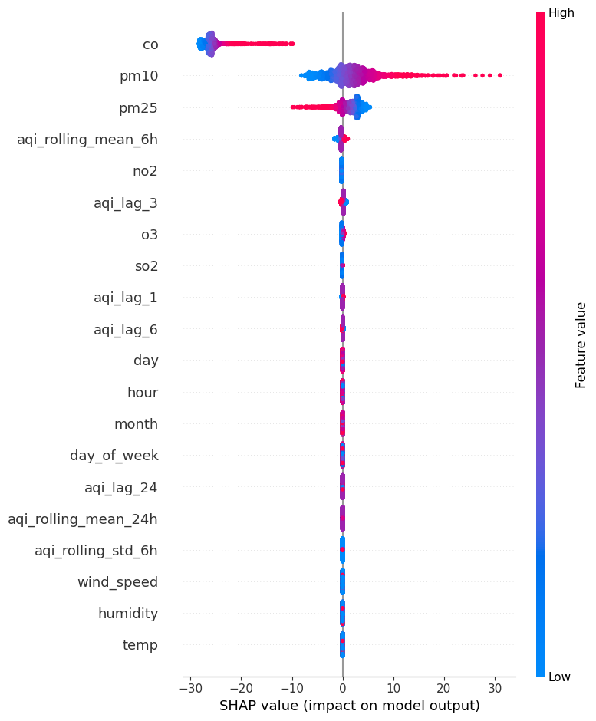
- Local Interpretability (LIME): For point-in-time runtime debugging, a LIME (Local Interpretable Model-agnostic Explanations) pipeline compiles an interactive lime_explanation.html file. This highlights the exact feature contributions driving any specific individual forecast window.
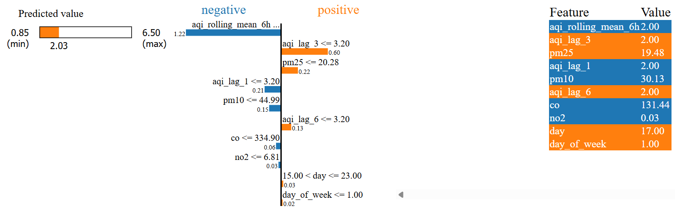

9. Serving & Deployment Architecture
The user-facing deployment environment (app.py) serves predictions through a lightweight Streamlit dashboard interface. It establishes an active session with Hopsworks using secure environment API keys, pulls the latest metadata and active binary models from the registry, and queries the online feature store to retrieve the latest real-time hourly telemetry state.
Since the model is structured as a one-hour-ahead forecaster, generating an extended 72-hour forecast horizon requires a recursive prediction loop: it starts from the latest available observation, uses predicted AQI values as inputs for subsequent future steps, updates lag and rolling features dynamically, applies a simple decay on pollutant concentrations for future hours, and uses calendar features derived from future timestamps.
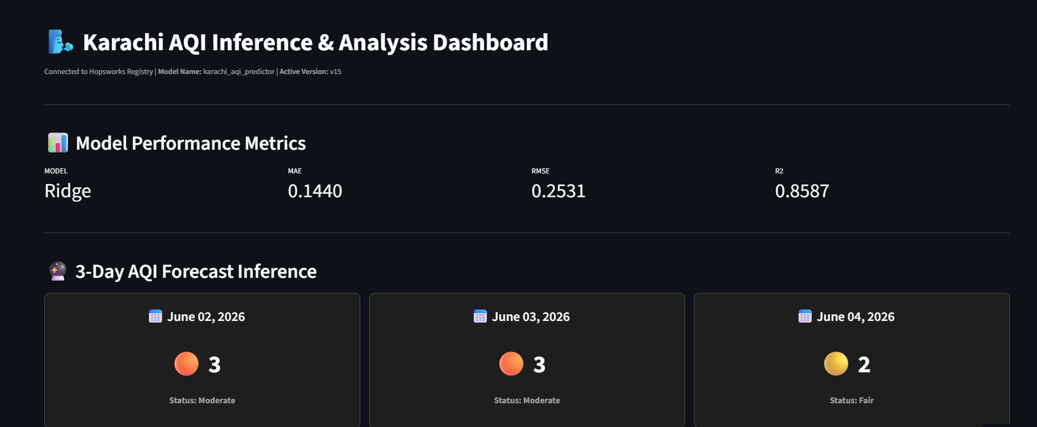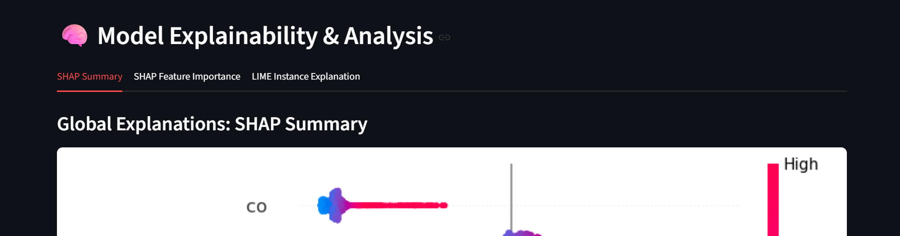

10. MLOps Automation & CI/CD Pipelines
The infrastructure operates entirely through serverless automation powered by GitHub Actions workflows located in .github/workflows/:
- feature_insert.yml (Hourly Ingestion): Automatically executes current_feature_pipeline.py on an hourly cron schedule to fetch live OpenWeather observations and stream updates into the feature store.
- model_training.yml (Daily Retraining): Automatically runs training_pipeline.py every 24 hours to re-evaluate the candidate models on the expanded historical data, generate updated SHAP/LIME assets, and version control the best model.
Operational Guardrails: All credentials and access provisions (such as HOPSWORKS_API_KEY and OPENWEATHER_API_KEY) are managed through encrypted GitHub Repository Secrets, preventing token exposure in the codebase.

11. Technical Challenges, Solutions, & Resolutions
- Structural Data Gaps: OpenWeather historical records contained non-standard timestamp gaps, disrupting downstream calculations. This was resolved by implementing a resampling and linear interpolation layer to construct a uniform time-series grid.
- Production Pipeline Automation: Manual execution of retraining cycles and ingestion tasks introduces human error. This challenge was eliminated by orchestrating the entire workflow using scheduled GitHub Actions pipelines.

12. Conclusion and Acknowledgments
The successful design, execution, and deployment of this production-oriented Air Quality Index (AQI) prediction platform represents a significant step forward in transitioning experimental machine learning models into enterprise-grade MLOps pipelines. By treating the feature store as a canonical data layer, implementing robust time-series feature engineering, and eliminating the training-serving data skew, this project establishes a sustainable framework for real-time environmental forecasting in Karachi.
A project of this scale could not have reached production readiness without the structured ecosystem, technical guidance, and collaborative community provided throughout this journey.
First and foremost, I would like to extend my deepest gratitude to the 10Pearls Shine Internship Program. This experience provided an exceptional environment to bridge the gap between academic theory and cloud infrastructure, offering hands-on exposure to enterprise machine learning workflows and automated software delivery systems.
Special recognition and heartfelt thanks go to my technical mentor, Muhammad Mobeen. His dedication was evident in every weekly milestone, as he joined and actively guided each and every intern during our technical sync-ups held every Friday. His consistent code reviews, architectural advice, and feedback during these sync-ups were instrumental. This mentorship not only ensured the success of this platform but also contributed significantly to my growth as a Data Scientist.

