**RESULTS**

* Modular Approach

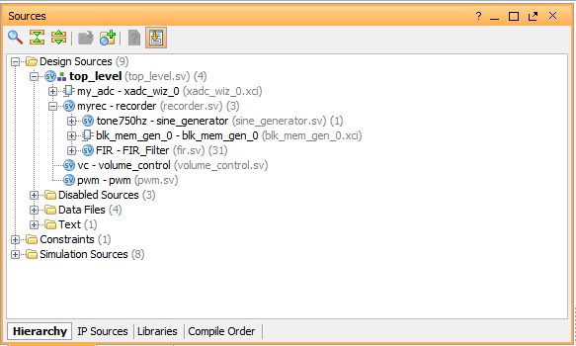

* 3rd order Filter Simulation

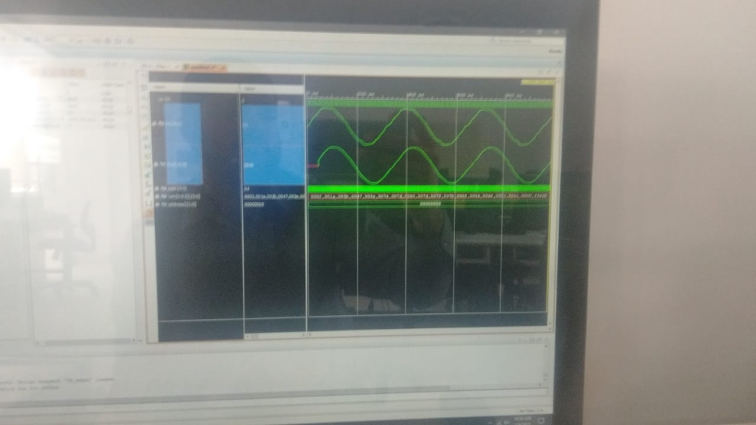

* Scaled Filter Simulation

Due to an unknown error the results are not desired one.

