E-Store-Ria: Istoria Coffee Shop Data Management System

Euwayne Paulette Brofar1, Andrea Charisse Celino2, Abdul Aziz De Borja3, Khylle Jefferson Dinero4, and Zyrha Alliah Rausa5

12345School of Computer Studies - Bachelor of Science in Information Technology

12345NU Laguna

2San Pablo City, Laguna, Philippines, 3Bay, Laguna, Philippines, 135Calamba City, Laguna, Philippines

1brofareb@students.nu-laguna.edu.ph, 2celinoaa@students.nu-laguna.edu.ph, 3deborjaaa@students.nu-laguna.edu.ph, 4dinerokg@students.nu-laguna.edu.ph, 5rausaz@students.nu-laguna.edu.ph

*Abstract*— The adoption of the E-Store-Ria Data Management System by Istoria Coffee Shop signifies a strategic endeavor aimed at optimizing operational efficiency, order accuracy, customer satisfaction, and staff productivity. This initiative prioritizes the creation of a seamless and user-friendly experience for both customers and employees. Key features, including customizable orders, streamlined online shopping, and real-time staff communication, are integral components of this effort. Employing the prototype methodology for software development, the project focuses on constructing a functional prototype to showcase the system's capabilities to stakeholders. It underscores the importance of rigorous testing, systematic deployment, and comprehensive review phases to ensure accessibility, functionality, and alignment with project objectives. Looking forward, future enhancements to the website will further elevate employee operations, empower administrators with comprehensive analytics, and fortify security measures. Attention to component formatting, style, and styling will be crucial to ensuring a cohesive and visually appealing user experience.

Keywords—MySQL, DBMS, database, system

# Introduction

# As the need for internet accessibility and more efficient operations grows, Istoria Coffee, a coffee store founded on a mutual interest among friends is taking a revolutionary step forward. We obtain permission to utilize Istoria Coffee for our primary project, which is to create a website for its business, with a strong dedication to boosting its visibility, solidifying its brand identity, and fostering enduring relationships with its clients.

# This digital platform serves as more than a mere virtual storefront; it encapsulates the essence of Istoria's captivating ambiance, ensuring a seamless transition between physical and digital realms. By harnessing the power of search engine optimization and incorporating interactive elements such as blog posts and client testimonials, the website promises to captivate a wide online audience while fostering enduring relationships with patrons. Furthermore, alongside elevating the café's digital footprint, the project endeavors to optimize café operations through the implementation of an inventory and point-of-sale system. This strategic initiative not only addresses existing operational gaps but also sets the stage for future growth and innovation.

# However, it's imperative to note that while the project ambitiously aims to bolster Istoria Coffee's online presence and operational efficiency, certain constraints necessitate a focused approach. The project's scope also includes point-of-sale and inventory management features; however, delivery and sales data are not included because of logistical and privacy concerns. As Istoria Coffee welcomes this significant turning point in its development, the website project is evidence of its persistent commitment to quality and client pleasure.

# Methodology

## Project Design

In considering the projects’ scope and limitations, the researchers adapted the Prototype Methodology. The Prototype Methodology is a software development process that allows developers to create only the prototype of the solution to demonstrate its functionality to the clients.[1] The project aims to create a prototype to demonstrate how the E-Store-Ria Data Management System will help to improve the services of the Istoria Coffee Shop.

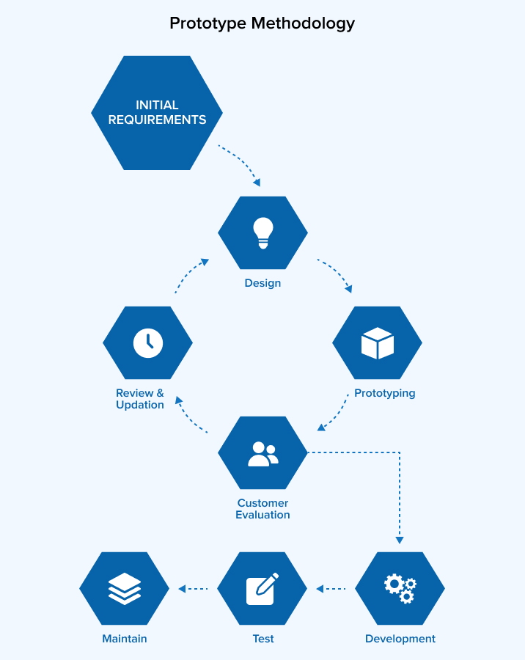

1. Flow of the Prototype Methodology

## Project Development

* Requirements

Details of the Istoria Coffee Shop is required for the system to operate, like the products, sales, address, publicity materials, and contact details. MySQL will be used for database management as this is the required database software.

* 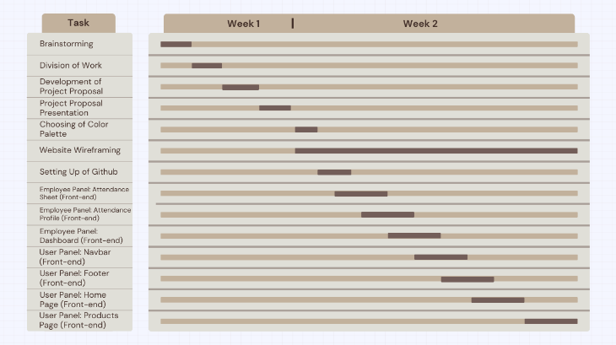Development

1. 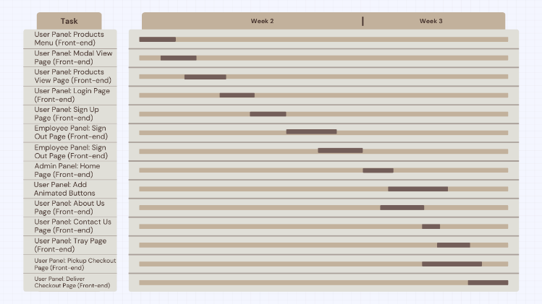Gantt Chart 1
2. 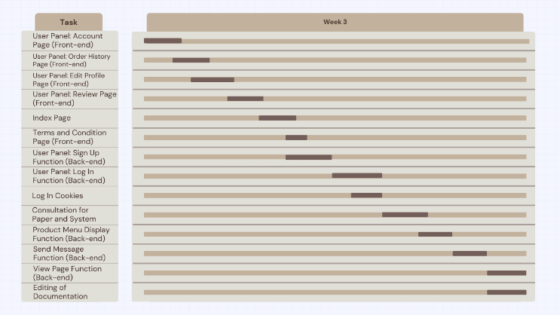Gantt Chart 2
3. Gantt Chart 3

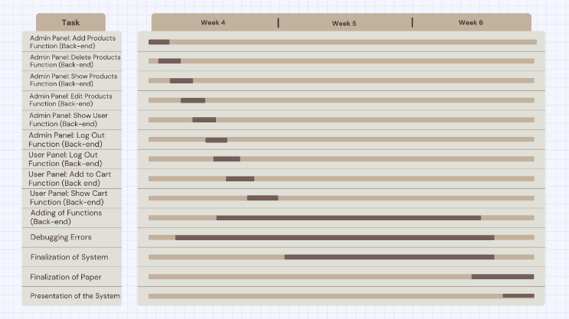

1. Gantt Chart 4

* Testing

While testing the system, it is normal to encounter bugs and errors. Developers takes note of the errors and bugs during testing then fix it later in the continuous development and improvement process of the system. Gather feedback from the client on usability and functionality.

* Deployment

In preparation for the deployment of the system, is the time to make sure that the website is accessible, functional, and connected to the database before releasing to the client. Provide a user-friendly tutorial of using the system.

* Review

Track system performance to ensure that it is aligned on the project plan. Monitor system pages and database requirements for data security and management.

# Results

With the implementation of E-Store-Ria system has resulted to significant improvements of Istoria Coffee Shop in:

* **Improved Efficiency and Productivity**. Simplifying work in the coffee shop to have more time to focus on faster service and reduce wait times for customers, whether it is online or offline. This improvement will result in potentially higher sales and increased customer satisfaction.
* **Accuracy in Order**. With the use of the system, the customer can now customize their orders which shall be received by the staff in the system. This will result in customer satisfaction and fewer remakes of orders.
* **Enhanced Customer Experience**. With a user-friendly system, efficient ordering process will contribute to overall positive experience. With a user-friendly system, an efficient ordering process will contribute to the overall positive experience. Customers will appreciate the effectiveness and convenience the system will offer and will be more likely to return to the coffee shop regularly. Istoria Coffee Shop can also receive feedback of the customer of their drinks.
* **Competitive Advantage**. A coffee shop with an efficient system can be differentiated from the other coffee shops within the area of service. This will increase the possible number of orders and will attract possible customers in the future.
* **Staff Productivity.** As their attendance will be monitored in the system, they will be motivated to go to work. They can also check their work hours in the system to monitor their performance.
* **Manageable Data.** The system can collect valuable data such as popular items, peak hours, sales, and more. Analyzing these data can inform the owners or managers of the coffee shop in making business decisions such as menu adjustments, marketing strategies, and staff requirements to optimize profit and customer satisfaction.

In summary, the system improves the quality-of-service that will help the business to grow and expand in the future. The system should be

# Discussion

Users of the website for Istoria Coffee Shop can expect an enhanced and more customized experience in the future. User-centric features will be incorporated into the design of an enhanced user interface, ensuring easy navigation and a user-friendly layout. User engagement will increase with the addition of interactive features like better mobile responsiveness and personalized suggestions based on past preferences. Customers will have an easier time navigating the menu, customizing their orders, and enjoying an easy online shopping experience due to the improved ordering process. In addition, a system of rewards and special offers will be implemented to express gratitude to customers for their ongoing assistance and to promote an atmosphere of community around the brand.

Future improvements to the Istoria Coffee Shop website will probably result in greater efficiency in operation for the employees. An easy-to-use employee panel will be created to help with order processing, inventory control, and team member communication. Improved materials for training will be included, ensuring that employees have the knowledge to deliver first-rate customer care. Software for scheduling and timekeeping will enhance labor management and improve output. In addition, the website will have features that allow managers and staff to communicate in real-time, promoting a helpful and cooperative work environment.

The advanced admin panel aims to make managing Istoria Coffee Shop's online presence easier for administrators. Comprehensive analytics features that offer insights into popular products, consumer behavior, and overall website performance will be integrated into the admin interface. The menu, promotions, and other website content can be easily updated with the help of an advanced content management system. To protect consumer information and maintain a safe online experience, security measures will be enhanced. In addition, the admin panel will make it easier to communicate with staff members and customers, which will keep the administrative team flexible and responsive to the shifting demands of the coffee shop's web presence.

# Conclusion

The E-Store-Ria Data Management System at Istoria Coffee Shop seeks to enhance consumer interactions, brand recognition, and visibility through the evolution of technology. With the use of interactive features and search engine optimization, the website hopes to draw in an engaged online audience and develop long-lasting connections with clients. Inventory and point-of-sale features are integrated to close operational gaps and create opportunities for future expansion and innovation. The prototype methodology was utilized to produce a physical prototype that ensured usability and accessibility, despite its restrictions. The website must be operational and reachable throughout the deployment phase for it to connect to the database without any issues. The process of post-implementation reviews ensures that data security is maintained, system performance is tracked, and the plan is followed. The coffee shop can now concentrate on providing smoother service, reducing wait times, and maybe increasing sales and customer happiness due to the E-Store-Ria system's increased productivity and efficiency.

# References

1. K. Sharma, “Top 12 Software Development Methodologies & its Advantages / Disadvantages | TatvaSoft,” Tatvasoft.com, Dec. 25, 2020. <https://www.tatvasoft.com/blog/top-12-software-development-methodologies-and-its-advantages-disadvantages/>

##### 