CodeCollab

# PROJECT SYNOPSIS

OF MAJOR PROJECT

# BACHELOR OF TECHNOLOGY

CSE-1(A)

SUBMITTED BY

ABDUL GANI (Enroll. No. 2000100185) MOHAMMAD RIZWAN (Enroll. No. 2000100413) MOHAMMAD ZAID (Enroll. No. 2000100158)

September 2024



**INTEGRAL UNIVERSITY LUCKNOW**

**CodeCollab**

1. Name of Student : Abdul Gani , Mohammad Rizwan , Mohammad Zaid

2. University Roll No. 2001012003 , 2001012073 , 2001012080

3. Branch : Btech CSE-1(A)

4. Proposed Topic : CodeCollab: A Collaborative Coding Platform with simple AI Integration.

5. Submitted by : Abdul Gani , Mohammad Rizwan , Mohammad Zaid

**Table of Contents**

|  |  |  |
| --- | --- | --- |
| **S.NO.** | **Content** | **Page No** |
| 1. | Table of Contents | ii |
| 2. | Introduction | 3-4 |
| 3. | Rationale | 5 |
| 4. | Objective | 6 |
| 5. | Feasibility Study | 6-7 |
| 6. | Methodology/ Planning Of Work | 7 |
| 7. | Facilities required for proposed work | 7-8 |
| 8. | Expected Outcome | 9 |
| 9 | Expected User Interface (UI) of CodeCollab | 10 |
| 10. | Supervisor’s Remarks | 11 |

# Introduction

## CodeCollab: A Collaborative Coding Platform with simple AI Integration.

This project, titled "CodeCollab," aims to create a web-based platform that not only facilitates real-time collaboration among developers but also employs simple AI to offer suggestions, detect bugs, and improve code quality in real time.

The second component of our project is a language learning platform powered by AI, known as "LangLearn." This platform is designed to provide personalized language learning experiences, utilizing AI to analyze pronunciation, deliver interactive lessons, and offer immediate feedback to users. By combining these two distinct yet complementary platforms, we aim to revolutionize the way students approach both coding and language acquisition.

Our project is built using accessible technologies and methodologies suitable for a college-level project, ensuring that the end product is both educational and practical. We believe that "CodeCollab" and "LangLearn" will serve as valuable tools for students and professionals alike, fostering a collaborative and intelligent learning environment.

## Project Overview:

CodeCollab" and "LangLearn" are two interconnected platforms designed to enhance the learning experience in computer science and language acquisition. The collaborative coding platform allows users to write, share, and debug code together in real-time, while the AI-powered language learning platform offers personalized lessons and instant feedback to help users master new languages. Both platforms are web-based, making them easily accessible and user-friendly, ideal for educational settings and professional development.

## The Vision:

Our vision is to create a seamless and intuitive learning ecosystem where students and professionals can grow their skills through collaborative efforts and AI-driven guidance. We envision a world where education is no longer confined to traditional classrooms but is accessible and transformative, empowering individuals to learn at their own pace and in their own style. Through "CodeCollab" and "LangLearn," we aim to bridge the gap between technology and education, fostering a culture of continuous learning and innovation.

## Technology used:

1. Front-End: HTML, CSS, and JavaScript.
2. Express.js and socket.io.

## Specialized Field:

The specialized field of this project lies in the intersection of computer science, education, and artificial intelligence. Specifically, it focuses on developing web-based platforms that leverage AI to support collaborative coding and language learning. These platforms are designed to address the challenges faced by students and professionals in acquiring new skills and knowledge, particularly in the rapidly changing landscape of technology.

# Rationale

The rationale behind this project is rooted in the need for effective and efficient learning tools that can adapt to individual learning styles and provide real-time assistance. Traditional teaching methods often fall short in providing personalized and timely feedback, which is crucial for effective learning. By integrating AI into the learning process, we can create platforms that not only teach but also learn from the user, tailoring the experience to meet their unique needs. This project seeks to address the limitations of current educational systems by offering a more dynamic and interactive approach to skill acquisition.

# Objective

1. Develop a Collaborative Coding Environment.
2. User-Friendly Interface.
3. Promote Accessible and Intuitive User Experience
4. Integrate simple AI for Code Assistance

# Feasibility Study

## Feasibility

Given the increasing demand for online learning solutions and the growing interest in AI-enhanced educational tools, the development of "CodeCollab" and "LangLearn" is feasible. The project aligns with current trends in technology and education, suggesting a strong market potential.

## Technical Feasibility

With modern web development frameworks and AI libraries available, the technical aspects of building these platforms are within reach. The use of cloud computing for hosting and processing data, along with machine learning algorithms for AI functionality, are well-documented and supported by extensive resources.

## Need

There is a recognized need for platforms that combine collaborative coding with AI assistance and personalized language learning. Such tools can significantly enhance the learning experience, making it more engaging and effective for users.

## Significance

The significance of this project lies in its potential to revolutionize the way people learn and work in the digital age. By providing a collaborative and AI-supported learning environment, "CodeCollab" and "LangLearn" can contribute to the advancement of education and professional development, ultimately benefiting society as a whole.

# Methodology/ Planning Of Work

## Define Project Scope

Begin by clearly defining the scope of the project, including the key features and functionalities of both "CodeCollab" and "LangLearn." Establish milestones and deliverables to ensure that all aspects of the project are accounted for.

## User Interface Development

Design intuitive and user-friendly interfaces for both platforms. Focus on creating a visually appealing and easy-to-navigate layout that encourages user interaction and engagement.

## API Integration

APIs for real-time collaboration, code analysis, language translation, and other necessary services. Ensure that these integrations are secure and reliable, providing a seamless experience for users.

## Display and Testing

Once the development phase is complete, conduct thorough testing of the platforms to identify and fix any bugs or issues. Display the final products to stakeholders and gather feedback for further refinement.

# Facilities required for proposed work

## HARDWARE REQUIREMENT

Processor: Intel Core i3 or higher.

Ram: Minimum 4 GB of RAM is recommended or Higher.

Storage: Minimum 250 MB to 900 MB available space on the disk.

## SOFTWARE REQUIREMENT

Front End: HTML, CSS , JavaScript

Language: JavaScript

## DEPLOYMENT

Front End: Vercel, Netlify or firebase

# Expected Outcome

Upon successful completion of the project, we anticipate the creation of two powerful educational platforms: "CodeCollab," a collaborative coding environment that leverages AI for real-time assistance, and "LangLearn," a personalized language learning tool that uses AI to enhance user engagement and learning outcomes. These platforms are expected to significantly improve the learning experience for students and professionals, fostering a culture of continuous growth and innovation in the digital world..

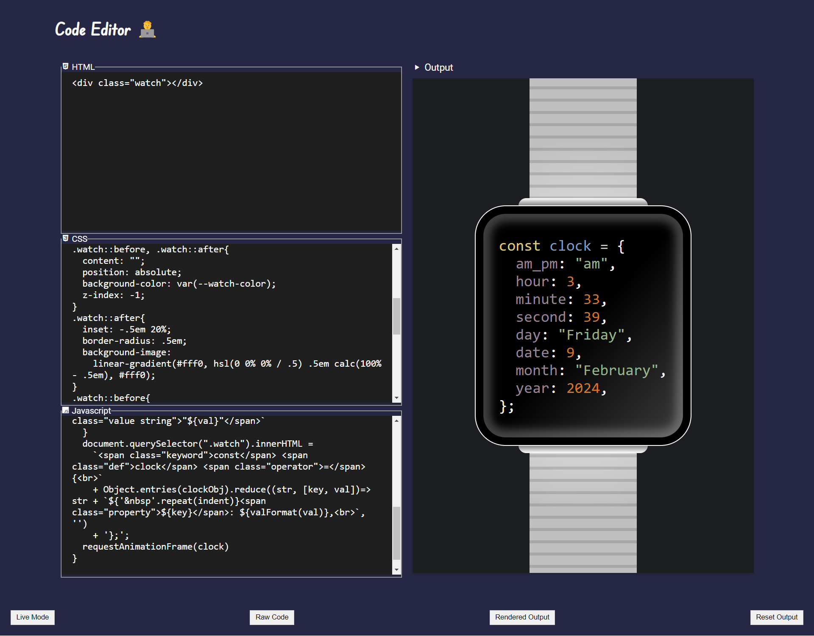

Expected User Interface (UI) of CodeCollab

## Supervisor’s Remarks:

**Approved Not Approved Remarks or Suggestions by Supervisor:**

……………………………………………………………………………………………………

……………………………………………………………………………………………………

……………………………………………………………………………………………………

……………………………………………………………………………………………………

………… **Signature Name: Date:**