

Digital Image Processing
Project Documentation

Submitted By:
Abdul Ghani 23l-0761
Muhammad Ali Shahzad 23l-0719
Zohaib tariq 23l-0979
Section:5H
Submitted to: Sir Asif Gillani

Table of Contents
- Introduction
- Literature Review
- Proposed System
- Methodology
- System Implementation
- Results & Evaluation
- Conclusion & Future Work
- References

1. Introduction
Pseudo-colorization is a digital image processing technique that converts grayscale images into color images by mapping intensity values to colors. This enhances visual perception, helps highlight hidden structures, and improves interpretation. Pseudo-coloring is commonly used in fields such as remote sensing, thermal imaging, industrial inspection, scientific visualization, and medical imaging.
The purpose of this project is to design a Pseudo-Colorization Studio, a desktop tool that allows users to apply multiple pseudo-color algorithms to any grayscale image using an interactive GUI.
Additionally, a deep learning–based colorization model is trained using the Oxford-IIIT Pet Dataset, where grayscale images act as inputs and the original RGB images serve as training targets.

2. Literature Review
Pseudo-colorization algorithms can be broadly categorized into three groups:
2.1 LUT-Based Pseudo-Colorization
Look-Up Table (LUT) methods convert grayscale intensity values to predefined colored gradients. Colormaps like viridis, plasma, inferno, and turbo are widely used in scientific visualization because they preserve perceptual uniformity.
2.2 Level Slicing
Level slicing divides the grayscale range into multiple intervals and assigns each interval a fixed color. This technique is effective for:
- Highlighting ranges in thermal imaging
- Emphasizing features in medical imaging (X-ray / MRI grayscale tones)
- Remote sensing band analysis
In this project, a 3-level slicing model is implemented with two user-adjustable thresholds.
2.3 Continuous Color Mapping (Triang Model)
Continuous pseudo-color algorithms use mathematical transformations such as sinusoidal or triangular waves to generate smooth color transitions. The project includes a Triang Model, inspired by triangular wave transformation and HSV-space adjustment, producing smooth pseudo-color effects.
2.4 Research Foundation
A major theoretical foundation comes from:
HU Jinlong, PENG Xianrong, XU Zhiyong
Study of Gray Image Pseudo-Color Processing Algorithms
Institute of Optics and Electronics, CAS This paper explains the mathematics behind pseudo-color techniques such as level slicing, LUT mapping, and continuous color models.

3. Proposed System
The Pseudo-Colorization Studio provides the following major features:
- Upload any grayscale image
- Apply three pseudo-coloring algorithms:
  - LUT Colorization
  - Level Slicing
  - Triang Model
- Real-time parameter control:
  - Thresholds for level slicing
  - Saturation and intensity for Triang Model
  - Gamma and blending for LUT
- Side-by-side display of:
  - Original image
  - LUT output
  - Level slice output
  - Triang Model output
- Save processed images
- Independent deep learning model training (offline)

4. Methodology
4.1 Dataset Used for CNN Training
Oxford-IIIT Pet Dataset:
- 7,000+ RGB images
- 37 classes of dogs and cats
- Labels are not used; only images are used for colorization training
Dataset Preparation
Each image is processed as follows:
- Input: grayscale version (1 channel)
- Target: original RGB image (3 channels)
Training pairs are therefore:
Input: Grayscale image (1 channel)
Output: Original RGB image (3 channels)
4.2 Pseudo-Color Algorithms in GUI
4.2.1 LUT Colorization
- Normalize grayscale intensities
- Apply selected colormap (default: viridis)
- Adjust gamma
- Blend with original grayscale image (optional)
4.2.2 Level Slicing
- User selects thresholds T1 and T2
- Define three intensity regions
- Assign each region a fixed RGB color
- Combine regions into final output
4.2.3 Triang Model
- Apply triangular wave transformation to intensity values
- Convert grayscale to HSV
- Adjust saturation and intensity
- Convert back to RGB
- Produces smooth continuous pseudo-color mapping
4.3 Deep Learning Colorization Model (CNN)
Model Architecture: SimpleColorCNN
A convolutional encoder-decoder model:
Encoder:
- 1-channel grayscale input
- Multiple Conv2D + ReLU layers to extract spatial features
Decoder:
- ConvTranspose2D layers to reconstruct 3-channel RGB output
Training Setup
Parameter | Value
Dataset | Oxford-IIIT Pet
Input | Grayscale image
Output | RGB image
Epochs | 10
Saved Model | triang_model.pth

5. System Implementation
5.1 Technologies Used
- Python
- Tkinter (GUI)
- OpenCV
- NumPy
- Matplotlib (colormaps)
- PyTorch (for CNN training)
5.2 GUI Components
Left Panel
- Upload button
- Process button
- Save button
- Checkboxes for selecting outputs
- Sliders for:
  - Slice thresholds
  - Saturation
  - Intensity
  - Gamma
  - Blending
Right Panel
- 2 × 2 grid display:
  - Original
  - LUT output
  - Level Slice output
  - Triang Model output
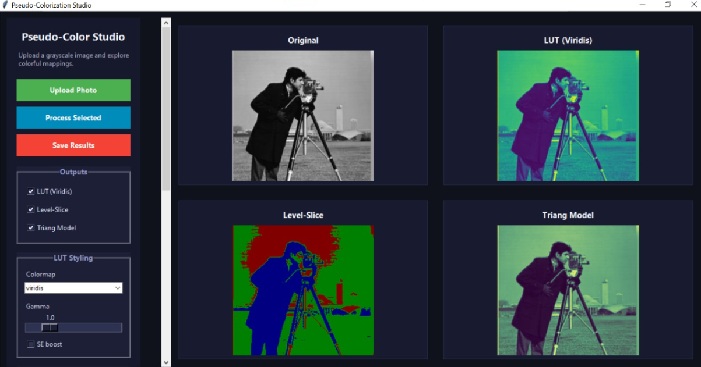

6. Results & Evaluation
- LUT Output: Smooth gradient mapping
- Level Slicing Output: Distinct intensity bands
- Triang Model Output: Continuous smooth color mapping
- CNN Output: Learned natural colors based on training data

7. Conclusion & Future Work
Conclusion
The Pseudo-Colorization Studio successfully demonstrates:
- Classical pseudo-color techniques
- Custom continuous color mapping
- Deep learning–based colorization
- Interactive GUI
Future Work
- Histogram visualization
- Custom user-defined colormaps
- Video pseudo-coloring
- CNN improvement (UNet / transformer models)
- Real-time GPU processing

8. References
- HU Jinlong, PENG Xianrong, XU Zhiyong.Study of Gray Image Pseudo-Color Processing Algorithms.Institute of Optics and Electronics, Chinese Academy of Sciences.
- Parkhi, O. M., Vedaldi, A., & Zisserman, A.The Oxford-IIIT Pet Dataset. Gonzalez, R. C., &Woods,R.E.Digital Image Processing.
- Matplotlib Colormap Reference.
- OpenCV Documentation.

