Over all the websites uses div as the main way of design. There is a div for the headers in the top of each page, and there a div for a “content” where most of the displays happens and the third div is the footer where there is links for the other pages as well. The website has a basic white color as the background which looks good with blue (inspired by DIT library website) the content and header\footer has blue color. All the website pages are connected to each other so the user cannot get lost or stuck in a page without getting out from it. A session is started at each page that is how we keep track of the logged in user and if he made any updates or changes

Note: it is highly recommended to open the code pages in a text editor

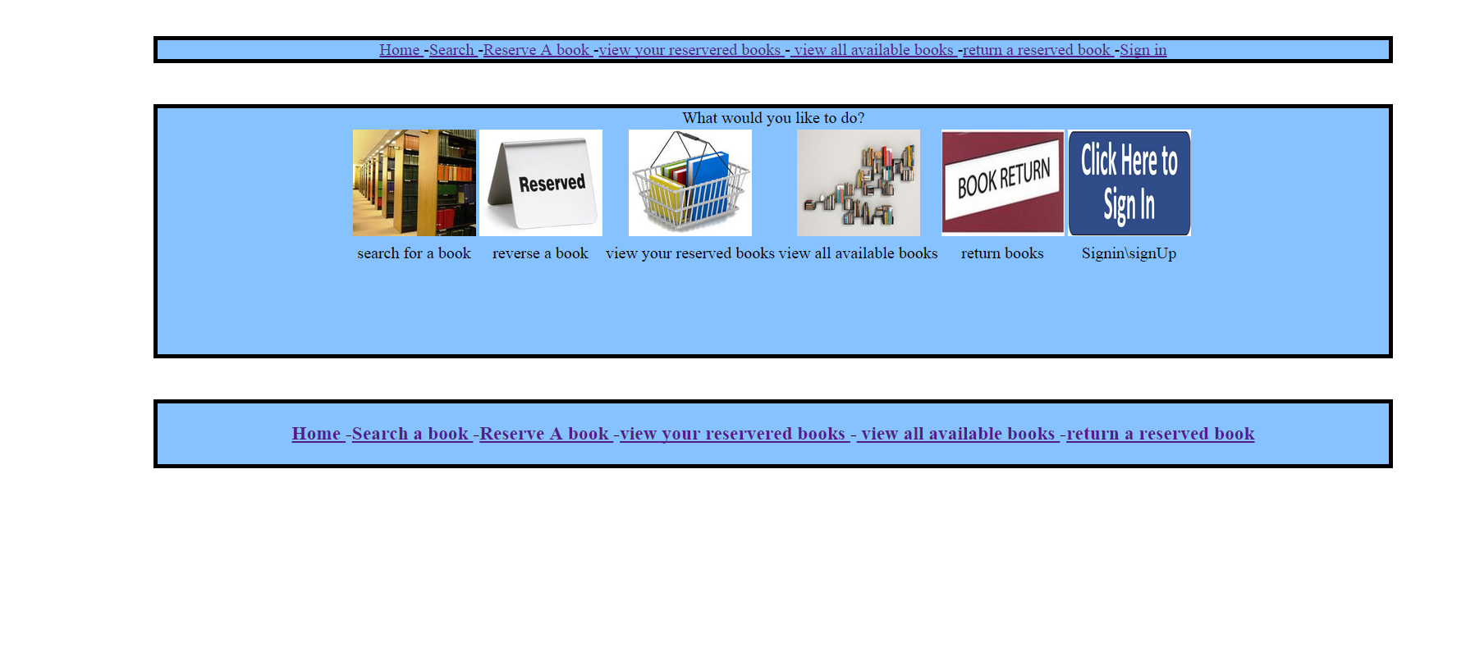This is page number 1, which is the home page for my website, this page has no special functions, most of it is links to the other pages\functions of the website ,all the website pages have the same header and footer and in them there is links to every page in the website

Once a user sign in the sign in would disappear from the headers and it will show sign out instead.

**Page1.php code:**

<?php

session_start();

//check for session

if ( isset($_SESSION["error"]) )

{

echo('<p>Error:'.$_SESSION["error"]."</p>\n");

unset($_SESSION["error"]);

}

if ( isset($_SESSION["success"]) )

{

echo('<p style="color:black">'.$_SESSION["success"]."</p>\n");

}

?>

<!DOCTYPE html>

<html lang="en">

<head>

<title>

Welcome

</title>

<meta charset="utf-8">

<link rel="stylesheet" type="text/css" href="style.css" />

</head>

<body>

<table align="center" valign="center">

<tr><td>

<img src="logo.jpg" alt="Smiley face" id="icon" align="center" height="200" Width="700">

</td></tr>

</table>

<div id="header">

<h3>

<a href="page1.php">Home </a>

-<a href="search.php">Search </a>

-<a href="reservebook.php">Reserve A book </a>

-<a href="userbooks.php">view your reservered books </a>

-<a href="availablebooks.php"> view all available books </a>

-<a href="returnbook.php">return a reserved book </a>

<?php

if(! isset($_SESSION["username"]) )

{ //if session not found

?>

-<a href="signIn.php">Sign in </a>

<?php

}

else

{ //if session was vaild

?>

-<a href="signOut.php">Sign out </a>

<?php

}

?>

</h3>

</div>

<div id="content">

<h3>

What would you like to do?

<table boarder="1">

<tr><td>

<a href="search.php"><img src="searchbook.jpg" alt="Smiley face" height="130" width="150"></a>

</td><td>

<a href="reservebook.php"><img src="reserve.jpg" alt="Smiley face" height="130" width="150"></a>

</td><td>

<a href="userbooks.php"><img src="basket.jpg" alt="Smiley face" height="130" width="150"></a>

</td><td>

<a href="availablebooks.php"><img src="availablebooks.jpg" alt="Smiley face"height="130" width="150"></a>

</td><td>

<a href="returnbook.php"><img src="returnbook.jpg" alt="Smiley face" height="130" width="150"></a>

</td><td>

<a href="signIn.php"><img src="signin.jpg" alt="Smiley face" height="130" width="150"></a>

</td></tr>

<tr><td>

search for a book

</td><td>

reverse a book

</td><td>

view your reserved books

</td><td>

view all available books

</td><td>

return books

</td><td>

Signin\signUp

</td><td>

</table>

</div>

</h3>

<div id="footer"><h3>

<a href="page1.php">Home </a>

-<a href="search.php">Search a book </a>

-<a href="reservebook.php">Reserve A book </a>

-<a href="userbooks.php">view your reservered books </a>

-<a href="availablebooks.php"> view all available books </a>

-<a href="returnbook.php">return a reserved book </a>

</h3>

</div>

</body>

</html>

this page contatins the search functions where there is a droplist with search by category or search by author name or search by the booktitle,or ISBN number after submitting the results from this page the user will be directed to another page which is Search 2, most of it is a PHP code to show the SQL Select statement results.

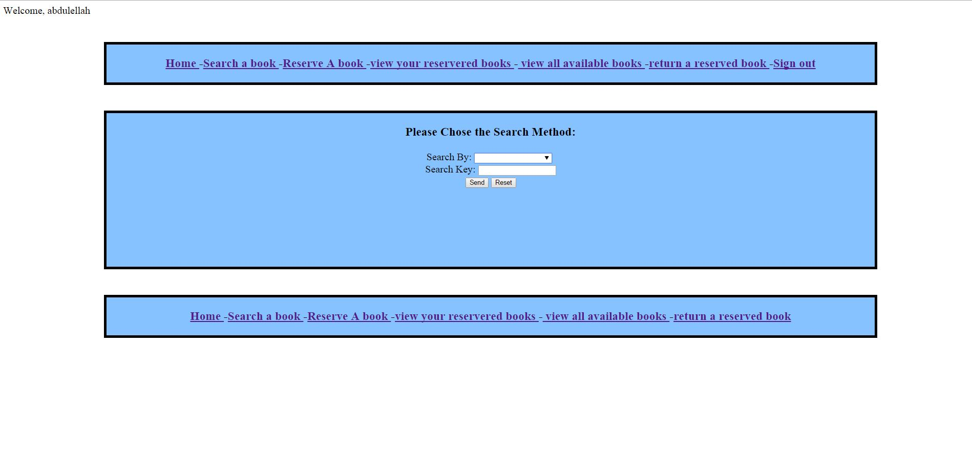

**Search.php code:**

<?php

//always start a session

session_start();

if ( isset($_SESSION["error"]) )

{

echo('<p>Error:'.$_SESSION["error"]."</p>\n");

unset($_SESSION["error"]);

}

if ( isset($_SESSION["success"]) )

{

echo('<p style="color:black" >'.$_SESSION["success"]."</p>\n");

}

?>

<html lang="en">

<head>

<title>

Search for a book

</title>

<meta charset="utf-8">

<link rel="stylesheet" type="text/css" href="style.css" />

</head>

<body>

<table align="center" valign="center">

<tr><td>

<img src="logo.jpg" alt="Smiley face" id="icon" align="center" height="200" Width="700">

</td></tr>

</table>

<div id="header"><h3>

<a href="page1.php">Home </a>

-<a href="search.php">Search for books </a>

-<a href="reservebook.php">Reserve books </a>

-<a href="userbooks.php">view your reservered books </a>

-<a href="availablebooks.php"> view all available books </a>

-<a href="returnbook.php">return reserved books </a>

<?php

//if there is no session

if(! isset($_SESSION["username"]) )

{

?>

-<a href="signIn.php">Sign in </a>

<?php

}

else

{// if no session

?>

-<a href="signIn.php">Sign out </a>

<?php

}

?>

</h3>

</div>

<div id="content">

Search for a book in our database

<h3>Please Chose the Search Method:</h3>

<form method="post" action="search2.php">

Search By:

<input list="browsers" name="searchmethod">

<datalist id="browsers">

<option value="ISBN">

<option value="BookTitle">

<option value="Author">

<option value="Categories">

</datalist>

<br>

Search Key:

<input type="text" name="searchkey"><br>

<input type="submit" value="Send">

<input type="reset" value="Reset">

</form>

</div>

<div id="footer"><h3>

<a href="page1.php">Home </a>

-<a href="search.php">Search a book </a>

-<a href="reservebook.php">Reserve A book </a>

-<a href="userbooks.php">view your reservered books </a>

-<a href="availablebooks.php"> view all available books </a>

-<a href="returnbook.php">return a reserved book </a>

</h3>

</body>

</html>

this page called Search2, here where the user search results appear if the book was found. If not the user will get a error massage says there is no such a book.

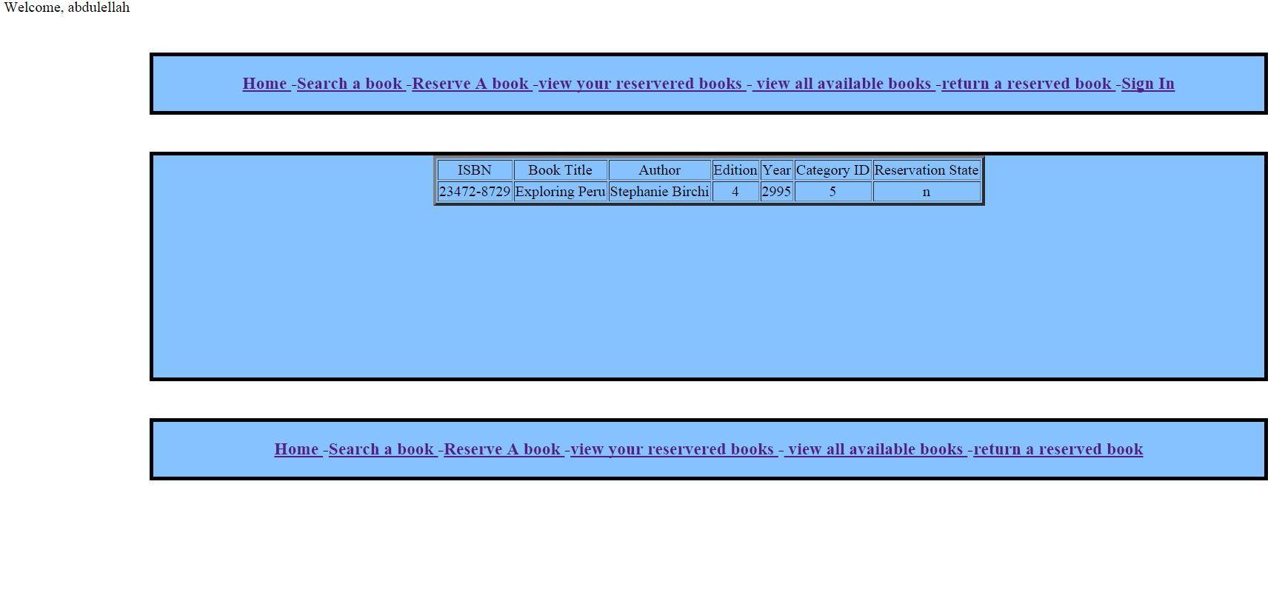

**Search2.php:**

<?php

//start session

session_start();

if ( isset($_SESSION["error"]) )

{

echo('<p>Error:'.$_SESSION["error"]."</p>\n");

unset($_SESSION["error"]);

}

if ( isset($_SESSION["success"]) )

{

echo('<p style="color:black">'.$_SESSION["success"]."</p>\n");

}

?>

<html lang="en">

<head>

<title>

Seach results

</title>

<meta charset="utf-8">

<link rel="stylesheet" type="text/css" href="style.css" />

</head>

<body>

<table align="center" valign="center">

<tr><td>

<img src="logo.jpg" alt="Smiley face" id="icon" align="center" height="200" Width="700">

</td></tr>

</table>

<div id="header"><h3>

<a href="page1.php">Home </a>

-<a href="search.php">Search for books </a>

-<a href="reservebook.php">Reserve books </a>

-<a href="userbooks.php">view your reservered books </a>

-<a href="availablebooks.php"> view all available books </a>

-<a href="returnbook.php">return reserved books </a>

<?php

//if there is no session

if(! isset($_SESSION["username"]) )

{

?>

-<a href="signIn.php">Sign in </a>

<?php

}

else

{// if no session

?>

-<a href="signIn.php">Sign out </a>

<?php

}

?>

</h3>

</div>

<div id="content">

<?php

echo '<table border="4">'."\n";

require_once"db.php";

//get the Search KEy and the Search method from pervious page.

$key = $_POST['searchkey'] ;

$method = $_POST['searchmethod'] ;

// To protect MySQL injection

$key= stripslashes($key);

$method= stripslashes($method);

$key= mysql_real_escape_string($key);

$method= mysql_real_escape_string($method);

$flag = 0 ;

//if the user chosed categories as method

if ( $method == "categories")

{

$result = mysql_query("SELECT * FROM books right outer join categories using(categoryID)");

echo ("<tr><td>");

echo ("Category ID");

echo("</td><td>");

echo("Category Name");

echo("</td><td>");

echo("ISBN");

echo("</td><td>");

echo("Book Title");

echo("</td><td>");

echo("Author");

echo("</td><td>");

echo("Edition");

echo("</td><td>");

echo("Year");

echo("</td><td>");

echo("Category ID");

echo("</td><td>");

echo("Reservation State");

echo("</td></tr>\n");

while ( $row = mysql_fetch_row($result))

{

echo ("<tr><td>");

echo($row[0]);

echo("</td><td>");

echo($row[1]);

echo("</td><td>");

echo($row[2]);

echo("</td><td>");

echo($row[3]);

echo("</td><td>");

echo($row[4]);

echo("</td><td>");

echo($row[5]);

echo("</td><td>");

echo($row[6]);

echo("</td></tr>\n");

$flag = 1 ;

}

}

else

{ // if user chosed another method

$result = mysql_query("SELECT * FROM books WHERE $method = '$key'");

echo ("<tr><td>");

echo("ISBN");

echo("</td><td>");

echo("Book Title");

echo("</td><td>");

echo("Author");

echo("</td><td>");

echo("Edition");

echo("</td><td>");

echo("Year");

echo("</td><td>");

echo("Category ID");

echo("</td><td>");

echo("Reservation State");

echo("</td></tr>\n");

while ( $row = mysql_fetch_row($result))

{

echo ("<tr><td>");

echo($row[0]);

echo("</td><td>");

echo($row[1]);

echo("</td><td>");

echo($row[2]);

echo("</td><td>");

echo($row[3]);

echo("</td><td>");

echo($row[4]);

echo("</td><td>");

echo($row[5]);

echo("</td><td>");

echo($row[6]);

echo("</td></tr>\n");

$flag = 1 ;

}

echo ("</table>\n");

}

if ( $flag == 0)

{

echo ("cant find the book in our database! please check the name or use other search feature!") ;

}

mysql_close($db);

?>

</div>

<div id="footer"><h3>

<a href="page1.php">Home </a>

-<a href="search.php">Search a book </a>

-<a href="reservebook.php">Reserve A book </a>

-<a href="userbooks.php">view your reservered books </a>

-<a href="availablebooks.php"> view all available books </a>

-<a href="returnbook.php">return a reserved book </a>

</h3>

</body>

</html>

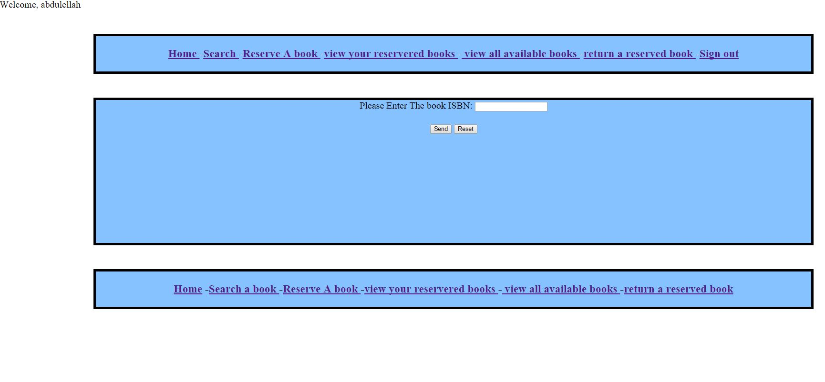

ONLY LOGED IN USERS ARE ABLE TO VIEW THIS PAGE. If you are not loged in you wont be able to view the page.

this page is the reservation page. In this page the user has to enter the ISBN for a book and then it will show that the book is on his basket(reserved) IF the book was available for reservation.

this page is Reservation2 it shows a confirmation with the book details and tells the user that the book is in his basket now. If the ISBN\book was reserved it will give him an error.

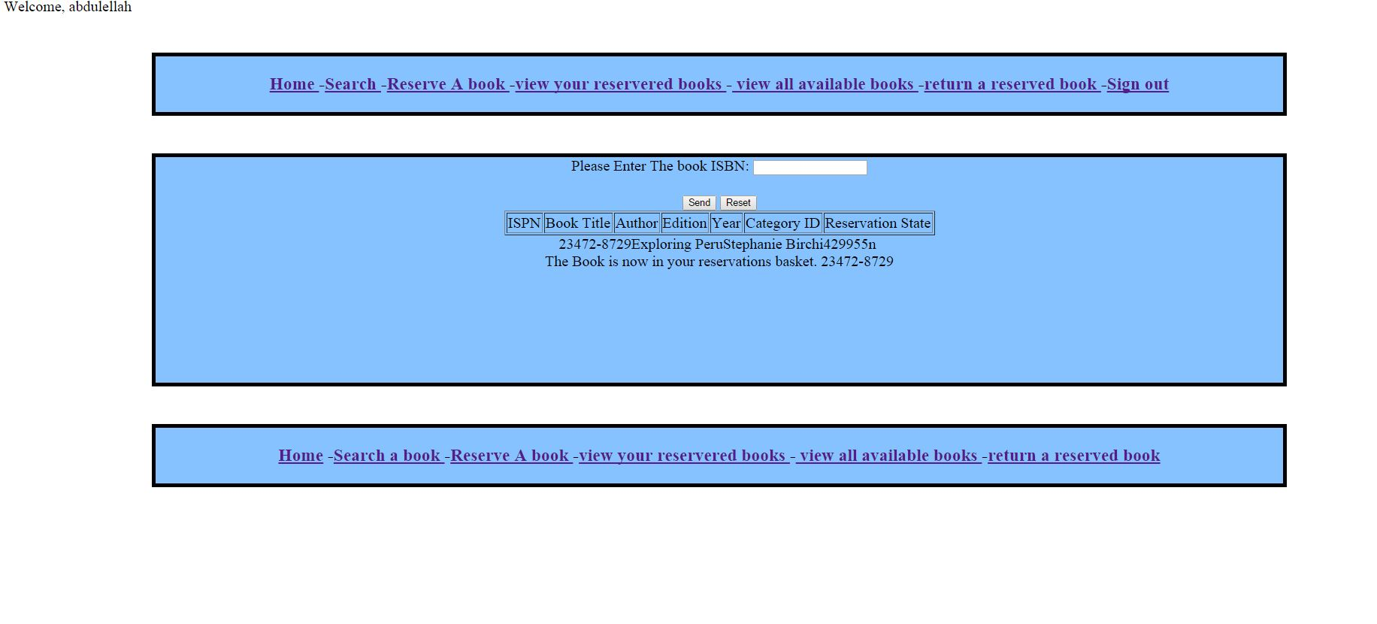

**Reservebook.php code:**

<?php

session_start();

if ( isset($_SESSION["error"]) )

{

echo('<p style="color:red">Error:'.$_SESSION["error"]."</p>\n");

unset($_SESSION["error"]);

}

if ( isset($_SESSION["success"]) )

{

echo('<p style="color:black">'.$_SESSION["success"]."</p>\n");

}

?>

<html lang="en">

<head>

<meta charset="utf-8">

<link rel="stylesheet" type="text/css" href="style.css" />

</head>

<body>

<table align="center" valign="center">

<tr><td>

<img src="logo.jpg" alt="Smiley face" id="icon" align="center" height="200" Width="700">

</td></tr>

</table>

<div id="header"><h3>

<a href="page1.php">Home </a>

-<a href="search.php">Search for books</a>

-<a href="reservebook.php">Reserve book </a>

-<a href="userbooks.php">view your reservered books </a>

-<a href="availablebooks.php"> view all available books </a>

-<a href="returnbook.php">return reserved book </a>

<?php

if(! isset($_SESSION["username"]) )

{

?>

-<a href="signIn.php">Sign in </a>

<?php

}

else

{

?>

-<a href="signIn.php">Sign out </a>

</h3>

</div>

<div id="content">

<?php

}

//if there is no session stop page script

if(! isset($_SESSION["username"]) )

{

?>

<h4> You Need To Sign in before You Can Make a Reservation </h4>

<?php

}

else

{

?>

Welcome to the reservation page! all you have to do is enter the book ISBN in the field below and the book will be yours

<br>

<br>

<form method="post">

Please Enter The book ISBN:

<input type="text" name="ISBN"><br>

<br>

<input type="submit" value="Send">

<input type="reset" value="Reset">

<?php

require_once"db.php";

if ( isset($_POST['ISBN']))

{

$key = $_POST['ISBN'] ;

// To protect MySQL injection

$key= stripslashes($key);

$key= mysql_real_escape_string($key);

//search for the book using the ISBN and resversion is N

$result = mysql_query("SELECT * FROM books where ISBN = '$key' and reserved = 'n'");

$flag = 0 ;

echo '<table border="1">'."\n";

echo ("<tr><td>");

echo("ISBN");

echo("</td><td>");

echo("Book Title");

echo("</td><td>");

echo("Author");

echo("</td><td>");

echo("Edition");

echo("</td><td>");

echo("Year");

echo("</td><td>");

echo("Category ID");

echo("</td><td>");

echo("Reservation State");

echo("</td></tr>\n");

while ( $row = mysql_fetch_row($result))

{

echo ("<tr><td>");

echo($row[0]);

echo("</td><td>");

echo($row[1]);

echo("</td><td>");

echo($row[2]);

echo("</td><td>");

echo($row[3]);

echo("</td><td>");

echo($row[4]);

echo("</td><td>");

echo($row[5]);

echo("</td><td>");

echo($row[6]);

echo("</td></tr>\n");

$flag = 1 ;

}

echo '</table>';

// if the book statues is Y

if ( $flag == 0 )

{

echo '<br>';

echo ("Book is not available for reservation\n");

}

else

{

//if the book was found and the book stats were N

echo '<br>';

echo ("The Book is now in your reservations basket.\n");

$name = $_SESSION["username"] ;

$w = $_POST['ISBN'] ;

$date = date('Y-m-d H:i:s'); //get date

echo ($_POST['ISBN']);

//SQL statement to update the book statues

$sql = "UPDATE books SET reserved = 'Y' WHERE ISBN = '$w'";

//SQL statment to add ISBN,username,date into the reservation table

$sql2 = "INSERT INTO reservation (isbn, username, reserveddate)

VALUES ('$w', '$name', '$date')";

//run the queries

mysql_query($sql);

mysql_query($sql2);

}

}

}

mysql_close($db);

?>

</div>

<div id="footer"><h3>

<a href="page1.php">Home</a>

-<a href="search.php">Search a book </a>

-<a href="reservebook.php">Reserve A book </a>

-<a href="userbooks.php">view your reservered books </a>

-<a href="availablebooks.php"> view all available books </a>

-<a href="returnbook.php">return a reserved book </a>

</h3>

</div>

</body>

</html>

ONLY LOGED IN USERS ARE ABLE TO VIEW THIS PAGE. If you are not logged in you wont be able to view the page.

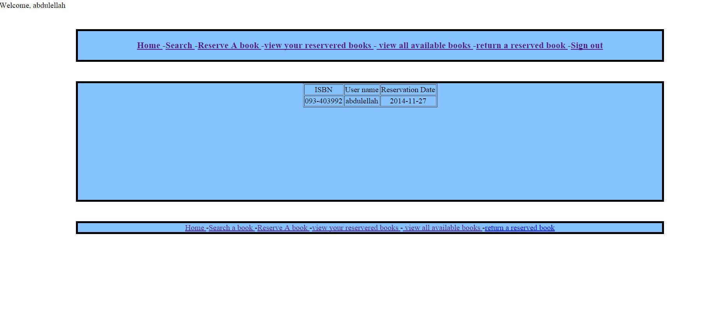

This page is called userbook it shows how many books the current loged in user have reserved any books- shows the username-ISBN- and reservation date which is taken from the computer using a PHP date function. Most of this page is a PHP code to fetch the details from the database and display it for the user.

**Userbooks.php code:**

<?php

//start session and check if theres a sucess one or no.

session_start();

if ( isset($_SESSION["error"]) )

{

echo('<p style="color:red">Error:'.$_SESSION["error"]."</p>\n");

unset($_SESSION["error"]);

}

if ( isset($_SESSION["success"]) )

{

echo('<p style="color:black">'.$_SESSION["success"]."</p>\n");

}

?>

<html lang="en">

<head>

<meta charset="utf-8">

<link rel="stylesheet" type="text/css" href="style.css" />

</head>

<body>

<table align="center" valign="center">

<tr><td>

<img src="logo.jpg" alt="Smiley face" id="icon" align="center" height="200" Width="700">

</td></tr>

</table>

<div id="header">

<h3>

<a href="page1.php">Home </a>

-<a href="search.php">Searh for books</a>

-<a href="reservebook.php">Reserve books </a>

-<a href="userbooks.php">view your reservered books </a>

-<a href="availablebooks.php"> view all available books </a>

-<a href="returnbook.php">return reserved books </a>

<?php

if(! isset($_SESSION["username"]) )

{//print sign in if no session

?>

-<a href="signIn.php">Sign in </a>

<?php

}

else

{//print sign out if there is session

?>

-<a href="signIn.php">Sign out </a>

</h3>

</div>

<?php

}

if(! isset($_SESSION["username"]) )

{

?>

<div id="content">

please sign in before you can make a reservation

</div>

<?php

}

else

{

require_once"db.php";

echo("in this page you will find all the books which are reserved under your name");

echo '<div id="content">';

$user = $_SESSION["username"] ;

//search in the reservation table for books with the same session username

$result = mysql_query("SELECT * FROM reservation where username = '$user' ");

echo '<table border="1"'."\n";

echo ("<tr><td>");

echo("ISBN");

echo("</td><td>");

echo("User name");

echo("</td><td>");

echo("Reservation Date" );

echo("</td></tr>\n");

while ( $row = mysql_fetch_row($result))

{

echo ("<tr><td>");

echo($row[0]);

echo("</td><td>");

echo($row[1]);

echo("</td><td>");

echo($row[2]);

echo("</td></tr>\n");

}

echo '</table>';

echo '</div>';

}

?>

<div id="footer">

<h3>

<a href="page1.php">Home </a>

-<a href="search.php">Search a book </a>

-<a href="reservebook.php">Reserve A book </a>

-<a href="userbooks.php">view your reservered books </a>

-<a href="availablebooks.php"> view all available books </a>

-<a href="returnbook.php">return a reserved book </a>

</h3>

</div>

</body>

</html>THIS IS AN EXTRA PAGE TO HELP IN FINDING A BOOK ONLY- IT SHOWS ALL THE BOOK IN THE TABLE WHERE THE reservation state is N.

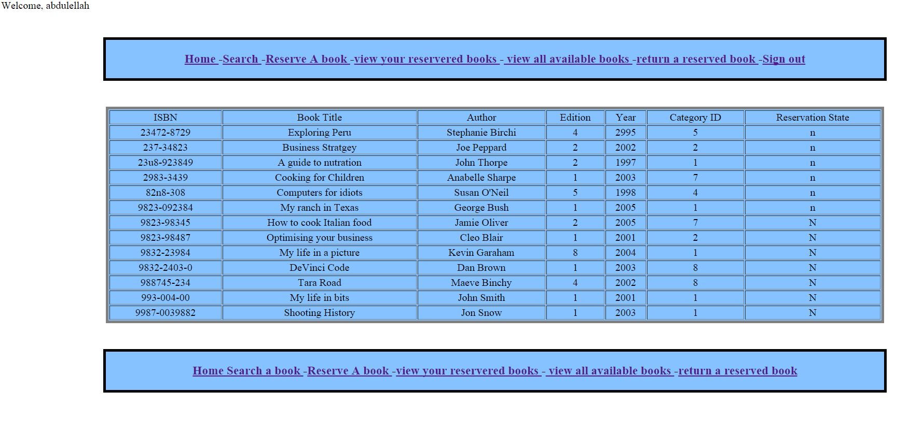

EDIT: increased the content height so everything is on the same size now and looks better

**Availablebooks.php code:**

<?php

//start session and check for existing one

session_start();

if ( isset($_SESSION["error"]) )

{

echo('<p style="color:red">Error:'.$_SESSION["error"]."</p>\n");

unset($_SESSION["error"]);

}

if ( isset($_SESSION["success"]) )

{

echo('<p style="color:black">'.$_SESSION["success"]."</p>\n");

}

?>

<html lang="en">

<head>

<meta charset="utf-8">

<link rel="stylesheet" type="text/css" href="style.css" />

</head>

<body>

<table align="center" valign="center">

<tr><td>

<img src="logo.jpg" alt="Smiley face" id="icon" align="center" height="200" Width="700">

</td></tr>

</table>

<div id="header"><h3>

<a href="page1.php">Home </a>

-<a href="search.php">Search for books </a>

-<a href="reservebook.php">Reserve books </a>

-<a href="userbooks.php">view your reservered books </a>

-<a href="availablebooks.php"> view all available books </a>

-<a href="returnbook.php">return reserved books </a>

<?php

//if there is no session

if(! isset($_SESSION["username"]) )

{

?>

-<a href="signIn.php">Sign in </a>

<?php

}

else

{// if no session

?>

-<a href="signIn.php">Sign out </a>

<?php

}

?>

</h3>

</div>

<?php

if(! isset($_SESSION["username"]) )

{ //if there is no session stop the page script and print this massage to user

?>

<div id="content">

<h4> You Need To Sign in before You Can Make a Reservation </h4>

<?php

}

else

{

//only print this if a valid session was started

require_once"db.php";

echo '<div id="content">';

$user = $_SESSION["username"] ;

//search in the table for book where reversion is N

$result = mysql_query("SELECT * FROM books where reserved = 'N'");

echo '<table border="1">'."\n";

echo ("<tr><td>");

echo("ISBN");

echo("</td><td>");

echo("Book Title");

echo("</td><td>");

echo("Author");

echo("</td><td>");

echo("Edition");

echo("</td><td>");

echo("Year");

echo("</td><td>");

echo("Category ID");

echo("</td><td>");

echo("Reservation State");

echo("</td></tr>\n");

while ( $row = mysql_fetch_row($result))

{

echo ("<tr><td>");

echo($row[0]);

echo("</td><td>");

echo($row[1]);

echo("</td><td>");

echo($row[2]);

echo("</td><td>");

echo($row[3]);

echo("</td><td>");

echo($row[4]);

echo("</td><td>");

echo($row[5]);

echo("</td><td>");

echo($row[6]);

echo("</td></tr>\n");

}

echo '</table>';

echo '</div>';

}

?>

</div>

<div id="footer">

<h3>

<a href="page1.php">Home </a>

<a href="search.php">Search a book </a>

-<a href="reservebook.php">Reserve A book </a>

-<a href="userbooks.php">view your reservered books </a>

-<a href="availablebooks.php"> view all available books </a>

-<a href="returnbook.php">return a reserved book </a>

</h3>

</div>

</body>

</html>

this is the login page. If the user loged in here it will start a session until the browser is closed. This page is the only one which have a Signup link and which takes the user to another page with a form in it to fill in his information.

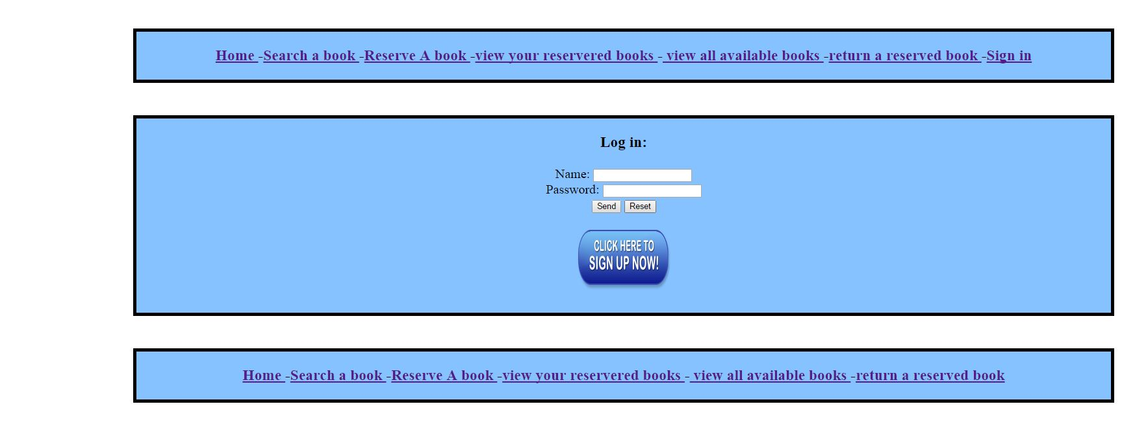

**Signin.php:**

<?php

//always start a session first thing in the page

session_start();

unset($_SESSION["username"]);

if ( isset($_SESSION["error"]) )

{

echo('<p style="color:red">Error:'.$_SESSION["error"]."</p>\n");

unset($_SESSION["error"]);

}

if ( isset($_SESSION["success"]) )

{

echo('<p style="color:black">'.$_SESSION["success"]."</p>\n");

}

?>

<?php

require_once"db.php";

if ( isset($_POST["username"]) && isset($_POST["password"]) )

{

$n1 = htmlentities($_POST['username']);

$p1 = htmlentities($_POST['password']);

// To protect MySQL injection

$n1= stripslashes($n1);

$p1= stripslashes($p1);

$n1= mysql_real_escape_string($n1);

$p1= mysql_real_escape_string($p1);

$flag = 0 ;

//search the database for the entered username and password

$result = mysql_query("SELECT Username, Password FROM users");

while ( $row = mysql_fetch_row($result))

{

//check username and password if both matches

if(strcmp($n1 , $row[0]) == 0 && $p1 == $row[1] )

{

$_SESSION["username"] = $_POST["username"] ;

$_SESSION["success"] = "Welcome, ".$_POST["username"];

header( 'Location: page1.php' ) ;

$flag = 1 ;

}

}

//if username does not match

if ( $flag == 0 )

{

$_SESSION["error"] = "Incorrect password OR username.";

header( 'Location: page1.php' ) ;

}

return;

}

if ( count($_POST) > 0 )

{

$_SESSION["error"] = "Missing Required Information";

header( 'Location: page1.php' ) ;

return;

}

?>

<html lang="en">

<head>

<meta charset="utf-8">

<link rel="stylesheet" type="text/css" href="style.css" />

</head>

<table align="center" valign="center">

<tr><td>

<img src="logo.jpg" alt="Smiley face" id="icon" align="center" height="200" Width="700">

</td></tr>

</table>

<div id="header"><h3>

<a href="page1.php">Home </a>

-<a href="search.php">Search for books </a>

-<a href="reservebook.php">Reserve books </a>

-<a href="userbooks.php">view your reservered books </a>

-<a href="availablebooks.php"> view all available books </a>

-<a href="returnbook.php">return reserved books </a>

<?php

//if there is no session

if(! isset($_SESSION["username"]) )

{

?>

-<a href="signIn.php">Sign in </a>

<?php

}

else

{// if no session

?>

-<a href="signIn.php">Sign out </a>

<?php

}

?>

</h3>

</div>

<?php

if(! isset($_SESSION["username"]) )

{

?>

<div id="content">

<h3>Log in:</h3>

<form method="post">

Name:

<input type="text" name="username"><br>

Password:

<input type="password" name="password"><br>

<input type="submit" value="Send">

<input type="reset" value="Reset">

</form>

<a href="register.php"><img src="signup.png" alt="Smiley face" height="100" width="150"></a>

</div>

<?php

}

else

{

?>

<table border="0">

<tr><td>

<h4> You are Logged in </h4>

</td></tr>

</table>

<?php

}

?>

<div id="footer"><h3>

<a href="page1.php">Home </a>

-<a href="search.php">Search a book </a>

-<a href="reservebook.php">Reserve A book </a>

-<a href="userbooks.php">view your reservered books </a>

-<a href="availablebooks.php"> view all available books </a>

-<a href="returnbook.php">return a reserved book </a>

</h3>

</html>

this page most of it is a HTML page. It sends the information to a page called add_user and that is only a PHP code to add the username and password into the users table.it the user name already exists it wont create it as the username is a primary key in the table

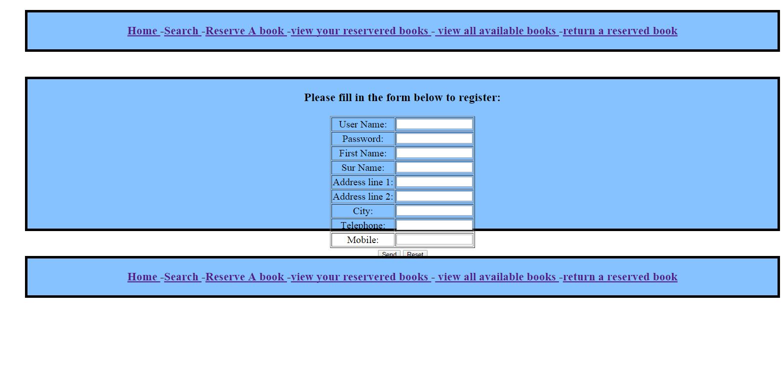

EDIT: increased the content height so everything is on the same size now and looks better

**Register.php:**

<?php

//start a session

//this page has a form and all the data is sent to add_user page later.

session_start();

?>

<html lang="en">

<head>

<meta charset="utf-8">

<link rel="stylesheet" type="text/css" href="style.css" />

</head>

<body>

<div id="header">

<h3>

<a href="page1.php">Home </a>

-<a href="search.php">Search </a>

-<a href="reservebook.php">Reserve A book </a>

-<a href="userbooks.php">view your reservered books </a>

-<a href="availablebooks.php"> view all available books </a>

-<a href="returnbook.php">return a reserved book </a>

</h3>

</div>

<div id="content">

<h3>Please fill in the form below to register:</h3>

<form method="post" action="add_user.php">

<table border="1" >

<tr><td>

User Name:

</td>

<td>

<input type="text" name="user"><br>

</td></tr>

<tr><td>

Password:

</td>

<td>

<input type="password" name="password"><br>

</td></tr>

<tr><td>

First Name:

</td>

<td>

<input type="text" name="firstname">

</td></tr>

<tr><td>

Sur Name:

</td>

<td>

<input type="text" name="surname">

</td></tr>

<tr><td>

Address line 1:

</td>

<td>

<input type="text" name="address1">

</td></tr>

<tr><td>

Address line 2:

</td>

<td>

<input type="text" name="address2">

</td></tr>

<tr><td>

City:

</td>

<td>

<input type="text" name="city">

</td></tr>

<tr><td>

Telephone:

</td>

<td>

<input type="text" name="phone">

</td></tr>

<tr><td>

Mobile:

</td>

<td>

<input type="text" name="mobile">

</td></tr>

</table>

<input type="submit" onclick="done()" value="Send">

<input type="reset" value="Reset">

</form>

</div>

<div id="footer"><h3>

<a href="page1.php">Home </a>

-<a href="search.php">Search </a>

-<a href="reservebook.php">Reserve A book </a>

-<a href="userbooks.php">view your reservered books </a>

-<a href="availablebooks.php"> view all available books </a>

-<a href="returnbook.php">return a reserved book </a>

</div>

</body>

</html>

The last page is the sign out page. It cannot be displayed in the browser so here is the code for it:

<?php

session_start();

unset($_SESSION["success"]);

session_destroy();

header("Location: signIn.php");

?>

And here is the db.php page which connents to my database:

**Db.php:**

<?php

//this page connects to the DB in mySQL folder

$db = mysql_connect('localhost', 'root', '');

if ( $db === FALSE ) die('Fail message');

if ( mysql_select_db("webdb") === FALSE ) die("Fail message");

?>

And finaly. This code is the CSS code:

**Style.css:**

body{ background-color: #FFFFF;}

p { color: black; }

h1{ color: black; }

h1.italic {font-style:italic;}

h2{ color: black; }

h2.italic {font-style:italic;}

h3{ color: black; }

h3

{

text-align: center;

}

#header

{

margin:50px auto;

width:1500px;

position:relative;

background-color:#85C2FF;

text-align:center;

border-style: solid;

border-width: 5px;

}

#footer

{

margin:50px auto;

width:1500px;

position:relative;

background-color:#85C2FF ;

text-align:center;

border-style: solid;

border-width: 5px;

}

#content

{

background-color:#85C2FF;

height:500px;

width:1500px;

text-align:center;

margin-left:auto;

margin-right:auto;

border-style: solid;

border-width: 5px;

}

table

{

text-align:center;

margin-left:auto;

margin-right:auto;

}

#icon

{

position: center;

}