FL-01: AI Workflow Audit
Name: ABDUL HADI | Date: 06 July 2026 | Course: AI Fluency

1. Recurring Task Classification
Ten to fifteen recurring tasks from a real week, classified using the four-bucket framework (just me / delegate with review / collaborate / fully automate).
Recurring Task | Classification | Rationale (why this bucket)
Reading assigned course chapters/articles before class | Just me | I need to actually build my own understanding; letting AI summarize would skip the learning.
Drafting first-pass summary notes from lecture recordings/slides | Delegate to AI with review | AI can compress content fast; I still need to check accuracy and add my own emphasis.
Brainstorming essay/project topic angles | Collaborate with AI | Back-and-forth idea generation works well here — AI surfaces angles I hadn't considered, I steer.
Writing final drafts of graded essays/reports | Delegate to AI with review | AI can produce a solid draft, but grading is on my voice/argument, so I rewrite and verify claims.
Proofreading/grammar pass on finished writing | Fully automate | Low-risk, mechanical task; AI catches typos/grammar reliably with minimal downside if it's wrong.
Studying for exams (active recall/practice problems) | Just me | Retention only happens if I do the retrieval practice myself; outsourcing defeats the purpose.
Debugging code for coursework/side projects | Collaborate with AI | I explain the error, AI suggests fixes, I test and iterate — genuine back-and-forth, not one-shot.
Writing boilerplate code (CRUD functions, config files) | Delegate to AI with review | AI is fast and usually correct on repetitive code; I still scan for logic errors before committing.
Scheduling/rescheduling meetings and deadlines | Fully automate | Low stakes, rule-based, and reversible — no judgment call needed.
Responding to routine work/team emails | Delegate to AI with review | AI drafts a reasonable reply; I review for tone and accuracy before sending since it's client/team-facing.
Deciding project priorities for the week | Just me | This depends on context (energy, deadlines, personal goals) that only I fully know.
Researching background info for a new topic/tool | Collaborate with AI | AI helps me explore faster, but I cross-check sources and keep asking follow-ups rather than accepting the first answer.
Formatting citations/reference lists | Fully automate | Purely mechanical formatting with a clear correct answer; easy to spot-check.
Reflecting on personal goals / journaling | Just me | The value is in doing the reflecting myself, not in AI generating the reflection for me.
Building slide decks for presentations | Delegate to AI with review | AI drafts structure and content fast; I still edit for accuracy, flow, and my own speaking style.

2. Toolkit Setup
Checklist — complete these outside this document, then check them off:
[✔ ] Claude account created (claude.ai)
[✔] ChatGPT account created (chatgpt.com)
[✔] Anthropic Academy account created
[✔] Enrolled in "AI Fluency: Framework & Foundations"
[✔ ] Completed Module 1 of the course

3. Claude Project Configuration
Project name: "My FL Coursework Assistant"
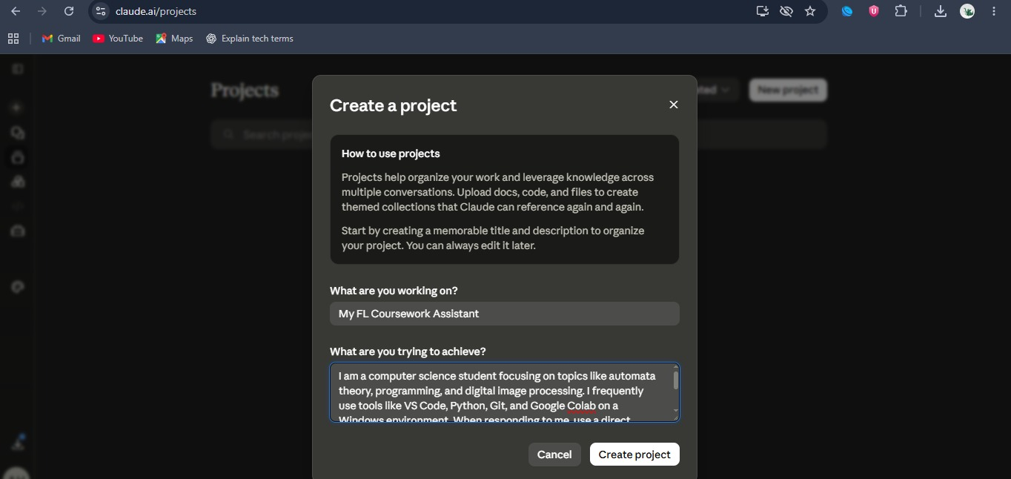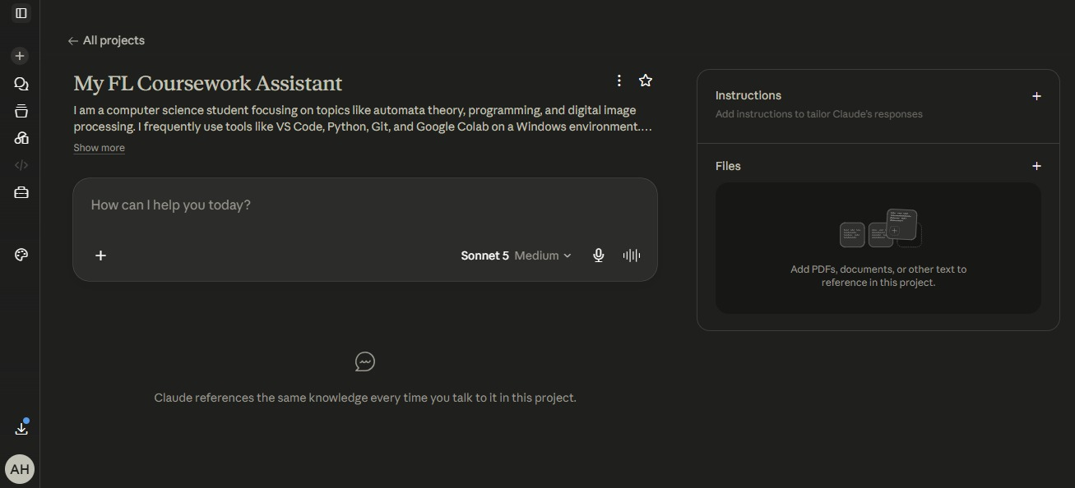

4. Three Target Tasks (for reuse in FL-02 – FL-04)
Selected because they are frequent, meaningfully different in nature (summarization, iterative technical problem-solving, and written communication), and each has a clear way to check whether AI's output was actually good.
Target Task | Why This One | "Done Well" Success Definition
Drafting first-pass summary notes from lecture/reading material | High frequency, clear stakes (feeds directly into exam prep), and easy to evaluate against the source. | Done well means: (1) every major concept from the source appears in the summary, (2) no fabricated facts or claims not present in the source, (3) under ~300 words per chapter/lecture, (4) organized under headings matching the source structure, and (5) I can verify each claim against the source in under 5 minutes.
Debugging code for coursework/side projects | Recurring across both study and side projects; good test of true collaboration (not just delegation) since it requires iteration. | Done well means: (1) the root cause is correctly identified (not just a symptom patched over), (2) the fix passes existing tests plus at least one new edge-case test, (3) I can explain in my own words why the bug happened, and (4) total time-to-fix is faster than solving it alone from scratch.
Responding to routine work/team emails | Frequent, low-to-medium stakes, and a good test of AI drafting + my own review/editing loop. | Done well means: (1) the reply accurately reflects facts I provided (no invented details), (2) tone matches the relationship (casual vs. formal) without me having to rewrite more than 20% of it, (3) it's sent within the same day, and (4) no factual or commitment errors slip through my review.

