Week 01: Sitemap + Claude Project Setup
Track: AI Engineering (early-career) | One person: Hiring manager at a mid-size AI-driven scaleup | Name: ABDUL HADI

1. Proof Statement (Claim, Person, Action)
Claim: I design and build AI agents that can independently evaluate real, messy input and produce structured judgment not just call an API and return text as shown by an agent I built that scores resumes and gives structured feedback on them.
Person: A hiring manager at a mid-size, AI-driven scaleup who is hiring an early-career AI engineer and needs proof I can actually build a working agent, not just talk about the theory.
Action: They reply to my application with an interview.
One-line why: A CV or LinkedIn can list "AI agents" as a skill tag, but it can't show that I've actually built one that makes real judgment calls on real input this project is the only thing that proves I can do it instead of just claiming it.
Everything below either states this claim, proves it, builds enough trust to believe it, or removes friction from the one action. Nothing else made the cut.

2. Sitemap
Four pages, in the order a hiring manager moves through them: land → believe → act.
Page | Why it earns its place | What's on it
Hero / Landing | States the claim plainly and points straight at the one project that proves it, so a skeptical reader knows immediately this isn't a theory-only claim. | Headline: "I build AI agents that evaluate real input and give structured judgment." One line naming the proof project (the resume-scoring agent). One CTA: something that nudges toward the application/interview, not a generic "contact me."
Work / Case Studies | Carries the actual burden of proof this early, it's one honest project done well, not a portfolio of case studies pretending to be more. | The resume analyzer, described in full: the problem it solves, how it evaluates and scores input, what makes it agentic (multi-step reasoning, not a single API call), and what's still rough/in progress honesty about scope builds more trust than overclaiming.
About | Only kept if it adds real evidence of trajectory that this is a genuine, serious transition into AI engineering, not a hobby project. | Short, honest note on the transition into AI engineering: what's been learned so far, why agents specifically, and what's being built next. No inflated experience claims.
Contact | The one action get a reply to the application, not a generic booking link. | Direct path to apply/respond: email or application link, plus one line pointing back at the resume-analyzer project as the reason to take the application seriously.
Flow reference:
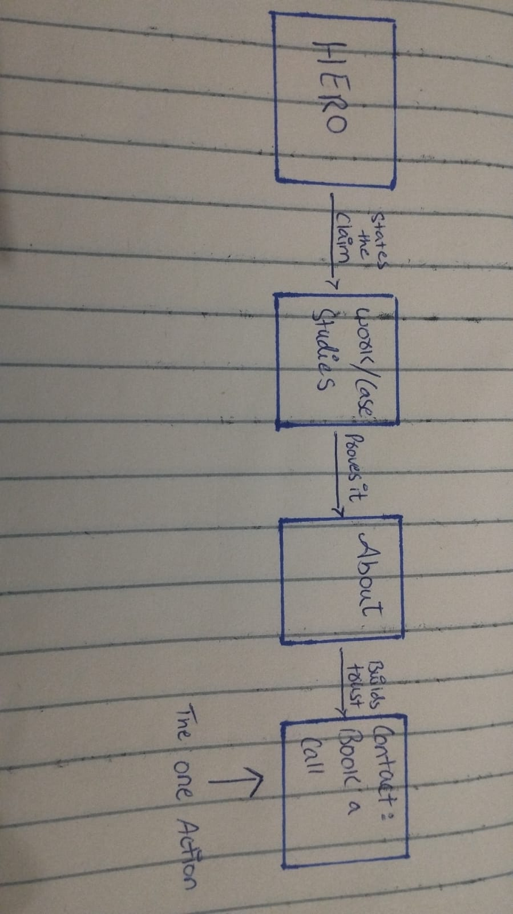

3. Toolkit Setup
[✔] Claude account created (claude.ai)
[✔] ChatGPT account created (chatgpt.com)
[✔] Gemini account created (gemini.google.com)
[✔] Perplexity account created (perplexity.ai)

4. Claude Project Configuration
Project name: "AI Eng Portfolio 8 Week Build"
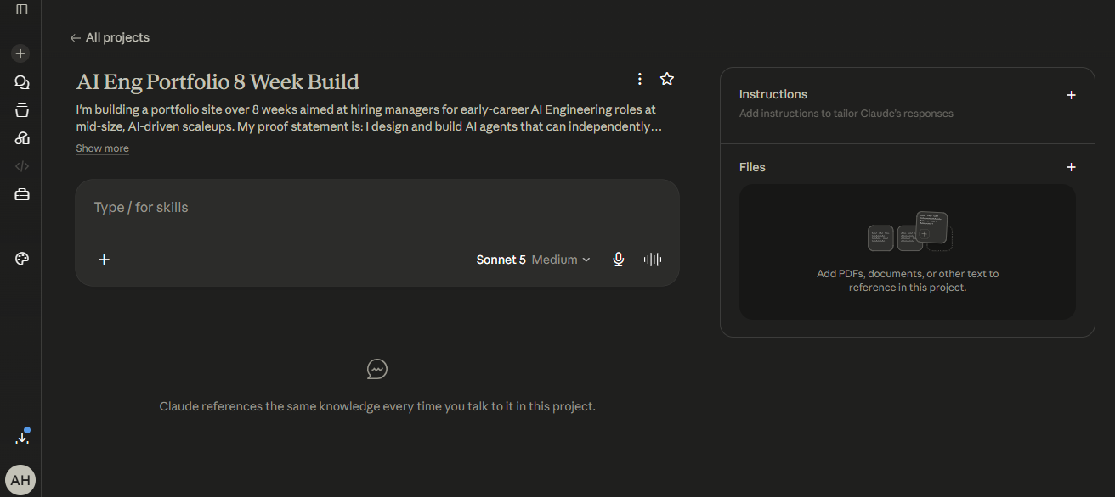

5. Pressure-Test Prompt
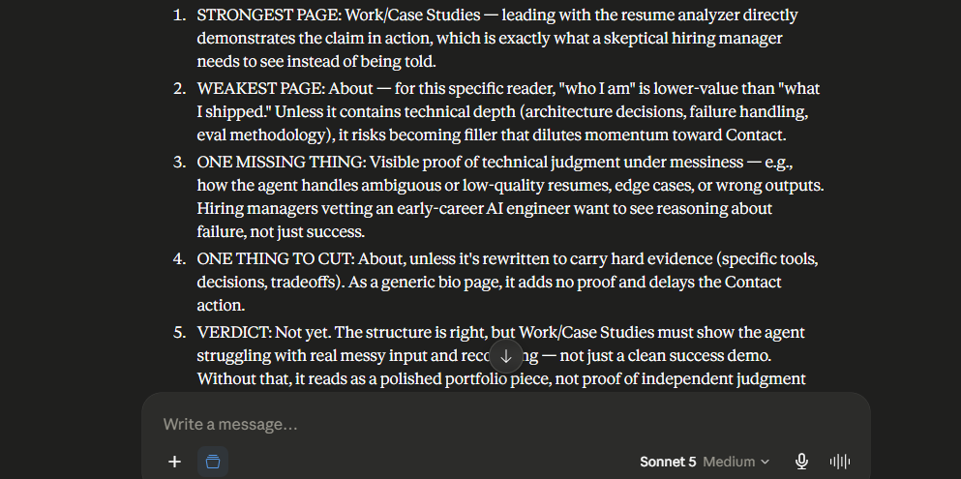
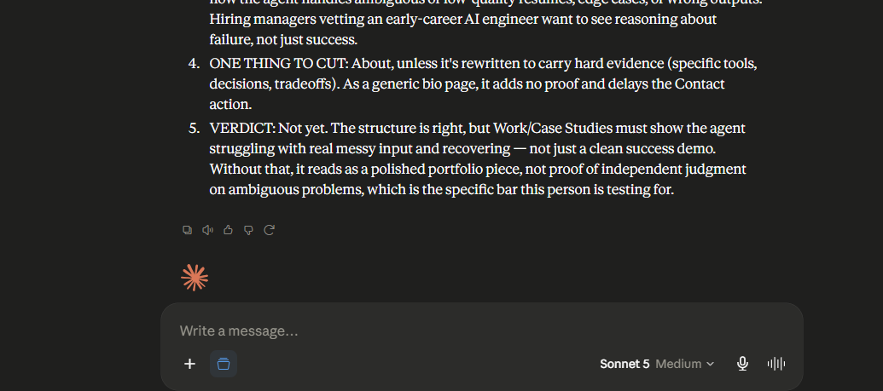

Output summary:

Claude said the Work/Case Studies page (led by the resume analyzer) is the strongest, since it shows the claim in action rather than asserting it. The About page was flagged as weakest, since for this reader "who I am" carries less weight than "what I shipped," and it risks becoming filler unless it's packed with technical specifics. The one missing thing: visible proof of the agent handling messy or ambiguous input edge cases, bad resumes, wrong outputs not just a clean success story. The one thing to cut: About, unless rewritten to carry hard technical evidence instead of generic bio content. Final verdict: No, not yet the sitemap doesn't currently earn the interview because the case study needs to show the agent struggling with real mess and recovering, not just working smoothly, since that's the specific bar this hiring manager is testing for.

What I'll change based on the pressure-test:
I'm adding a dedicated section within the resume analyzer case study called "Where it broke and what I did about it" covering at least one real edge case (e.g., a resume with inconsistent formatting, missing sections, or contradictory information) and walking through how the agent's judgment logic handled it, including any wrong output it initially produced and how I corrected the scoring/feedback pipeline in response. This replaces a purely "here's what it does" narrative with "here's how I made it reliable under real-world mess," which directly targets what the hiring manager is testing for.

