Agents, MCP, and My FL-04 Pipeline
Abdul Hadi · AI Fluency Track · Build (core)

Explainer
“Agent” is thrown around constantly in AI marketing right now, but Anthropic's own framing in Building Effective Agents draws a much simpler, more useful line than most of that marketing suggests: the difference between a workflow and an agent comes down to who decides what happens next.
A workflow follows a fixed, predefined sequence of steps every time. A human (or the code) has already decided the order in advance the LLM fills in each step, but it never gets to change the plan. My FL-04 project, the Weekly AI Brief Pipeline, is a clear example of this. It always runs the same four steps, in the same order: Gather, then Synthesize, then Draft, then Review. Regardless of what news it finds that week, regardless of whether a source turns out to be weak or strong, the pipeline never skips a step, adds a new one, or loops back on its own. I decided that structure ahead of time, and the model executes it faithfully every run but it isn't choosing the path. That makes it a workflow, not an agent.
An agent, by contrast, decides its own next steps dynamically, based on what it actually observes as it goes. It can choose whether to use a tool, which tool, when to stop, or when to try something different because the first attempt didn't work. The control flow lives inside the model's own reasoning at runtime, not in a script written beforehand. That's a real, meaningful distinction not just a branding difference because it changes what kind of failures and capabilities you should expect. A workflow is predictable and easy to reason about, but rigid. An agent is more flexible and can handle situations you didn't anticipate, but it's also less predictable and harder to fully verify in advance.
This is where MCP (Model Context Protocol) becomes relevant. Chat alone just me typing to an AI and it typing back has no way to actually reach outside that conversation. It can't check a real file, hit a real API, or see the current state of an external system unless I paste that information in myself. MCP changes this by giving an AI model a standardized way to actually connect to real external systems and interact with them directly, instead of relying on whatever I've manually copied in.
MCP organizes that connection around three primitives. Tools are actions the AI can actually perform calling an API, reading a file, running a search, sending a message. This is the primitive that turns “the AI told me what it thinks is true” into “the AI actually went and checked.” Resources are data the AI can read but not act on directly the raw material a tool call might return, or a file made available for context, without the AI being able to modify it. Prompts are pre-written instruction templates that an MCP server itself offers, so a common task on that server can be triggered in a structured, repeatable way, rather than the model or the user having to describe it from scratch every time.
I tested this directly by connecting Google Drive to Claude and running three tasks chat alone could never do: listing my actual, current Drive files; opening one specific file (a spreadsheet of intern data) and reading its exact live contents; and searching my Drive by keyword and getting real matching results back. Each of these produced a visible tool-call indicator in the response proof the AI was genuinely reaching into my real account, not generating a plausible-sounding guess.
So what would my FL-04 pipeline actually need to become an agent, rather than staying a workflow? Right now, it drafts a brief and stops the human (me) has to manually take that output and post it somewhere. To become an agent, it would need real tool access to actually publish or send the brief itself, not just produce a draft for me to copy elsewhere. But more importantly, giving it that single tool alone wouldn't make it an agent by Anthropic's definition it would just be a slightly longer fixed workflow with one more predetermined step tacked onto the end. The deeper agentic upgrade would be letting the model itself decide, in the moment, things like: how many sources are actually enough this week, whether a claim needs a second search before it's trustworthy, or whether an item is significant enough to include at all instead of always running exactly four fixed steps regardless of what it finds. That shift, from “always do these four things in this order” to “figure out what needs to happen based on what you're actually seeing,” is the real move from workflow to agent.

Evidence: Three Real Tasks via Google Drive MCP Connector
Connected: Google Drive (via claude.ai Connectors). All three tasks below required Claude to reach into my real, live Google Drive something chat alone cannot do — and each response shows a visible tool-call indicator (“Loaded tools, used Google Drive integration” or “Search files”), confirming genuine tool use rather than a plausible-sounding guess.

Task 1: List real files in my Drive
Prompt: "List the files in my Google Drive."
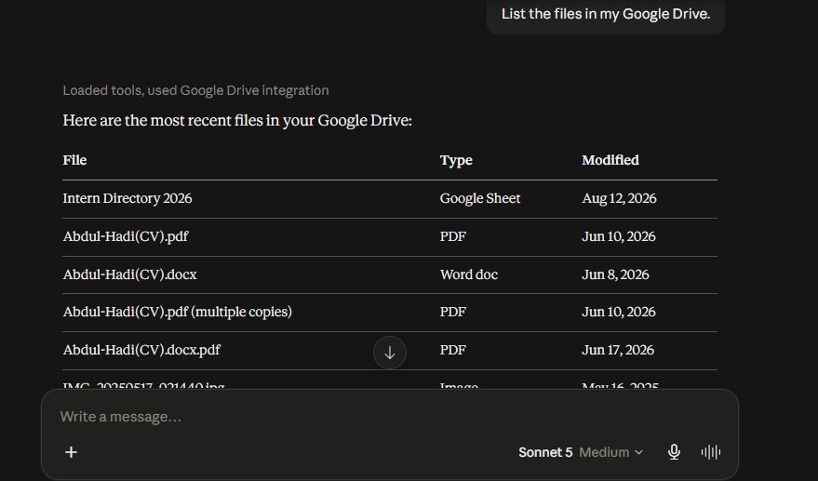
Tool call confirmed: “Loaded tools, used Google Drive integration” returns a live, current file listing.

Task 2: Open and read one specific file
Prompt: "Open the file “Intern Directory 2026” and tell me exactly what’s in it."
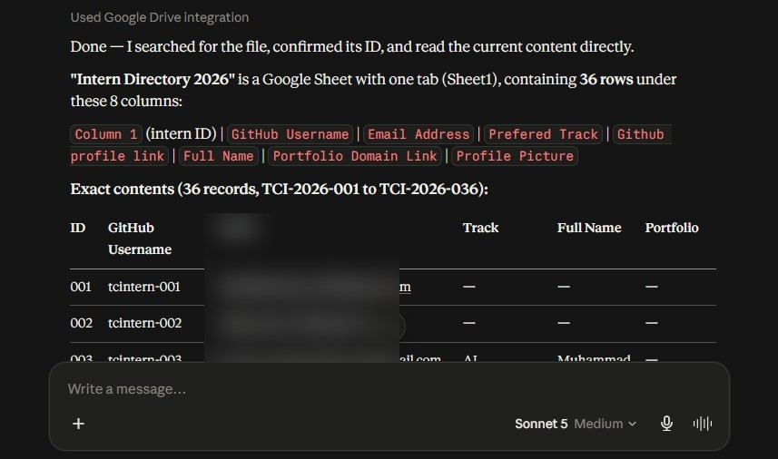
Tool call confirmed: “Used Google Drive integration” reads the real, current spreadsheet contents (36 rows). Email column blurred to protect other interns' personal data.

Task 3: Search Drive by keyword
Prompt: "Search my Google Drive for any document mentioning ‘resume’ and tell me what you find."
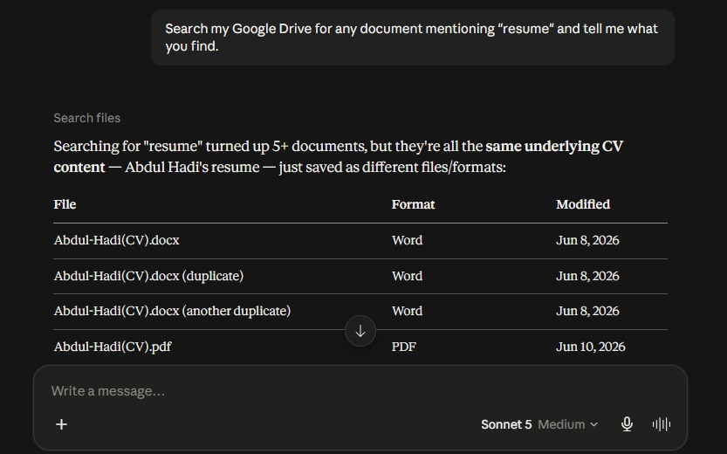
Tool call confirmed: “Search files” returns real, current search matches from my Drive, not a guess from conversation memory.

Summary
Workflow vs. agent: my FL-04 pipeline is a workflow fixed 4-step sequence, no runtime decision-making. MCP gives Claude real tool access to external systems (tools, resources, prompts). Concrete agent upgrade for FL-04: let the model decide in-the-moment how many sources are enough and whether a claim needs re-checking, instead of always running the same four steps regardless of what it finds.

