Portfolio Contact Form Explainer & Evidence
Abdul Hadi · AI Fluency Track · Build (core)

Live feature
URL: https://abdulhadi-81.github.io/contact.html a working contact form, added to my existing static portfolio site.

What a backend is
A backend is the part of an app that runs on a server, not in the visitor's browser. My portfolio's HTML/CSS is the "frontend" it's just what you see and click on, and it runs entirely on the visitor's own device. But something that stores data, sends emails, or talks to a database has to run somewhere else, on a server that's the backend. My portfolio itself has no backend of its own; it's a static site.

What my feature does
I added a real contact form to my Contact page. Instead of just giving people my email address to copy manually, someone can now type their name, email, and a message directly on my site and hit Send and it actually reaches my real inbox.

How the data flows
1. A visitor fills out the form on my live site and clicks Send.
2. The form doesn't go anywhere on my own site it sends that data directly to Formspree, a free service built exactly for this. My site doesn't need its own backend at all; Formspree is the backend for this one feature.
3. Formspree receives the submission, and then Formspree sends me that email the name, email, and message land in my real inbox (abdulhadi814981@gmail.com), formatted nicely.
4. I check my email like normal and can reply directly to whoever wrote in.
The reason this works without me writing any backend code myself is that Formspree already is a backend, running on their servers I just pointed my form at their address (action="https://formspree.io/f/xbgrzyok"), and the browser handles sending the data there on its own when the form is submitted.

Evidence real submission reaching my inbox
A real form submission from my live site (abdulhadi-81.github.io) arrived in my Gmail inbox via Formspree, with the submitted name, email, and message intact:
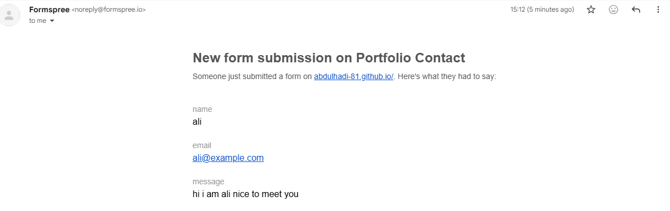
Real email received in Gmail, sent automatically by Formspree after a live submission on my portfolio's contact form.

