Portfolio Polish Pass Fix Log
Abdul Hadi · AI Fluency Track · Portfolio quality pass

Updated live URL
https://abdulhadi-81.github.io/

What was checked
- Opened the live site on a real phone (not a resized desktop browser) all 4 pages: Home, Work, About, Contact.
- Checked text size, line spacing, image scaling, button/link tap targets, and layout on mobile.
- Clicked every link on the site, including LinkedIn, GitHub, the contact form's Send button, and all nav links on all 4 pages.
- Compared work-sample screenshots for sharpness/legibility.

Problems found and fixed

1. Git merge conflict markers visible on the live homepage
What was broken: raw, unresolved Git conflict markers (<<<<<<< HEAD / ======= / >>>>>>> [commit hash]) were present at the very bottom of index.html and rendering on the live site, visible to any real visitor.
What I changed: removed the three conflict marker lines directly from index.html, confirmed the file now ends cleanly with the footer and closing </body> tag, committed and pushed.
Why it mattered: this is exactly the kind of thing that reads as "sloppy" even when the underlying work is solid a visible artifact of unfinished git hygiene on a page meant to represent finished, professional work.

2. Low-resolution, hard-to-read Resume Analyzer screenshots
What was broken: the 3 work-sample screenshots on the Work page were cropped from a summary document rather than the original app, making text inside them (scores, extracted fields, gap descriptions) blurry and difficult to read flagged earlier as a known "still ugly" issue.
What I changed: replaced all 3 images in /assets with sharper, original screenshots directly from the running app, keeping the same filenames so no HTML changes were needed. Also picked the 3 images that best demonstrate structured judgment (score + verdict, extracted details + improvements, gaps checklist) over two other available screenshots (a plain upload screen, and a keyword-suggestions feature) that didn't map as directly onto the existing case-study text.
Why it mattered: the assignment specifically requires work captures to be crisp a blurry proof point undermines the exact claim the site is making.

Mobile check real phone, not resized browser
Checked on an actual Android phone browser (screenshots below, taken directly on-device visible address bar and status bar confirm this, not a resized desktop window).
Result: no broken layout, no overflowing images, nav wraps cleanly onto two lines rather than overflowing the screen width, text is comfortably readable without zooming, and the sharper Resume Analyzer screenshots are now genuinely legible even at phone width.
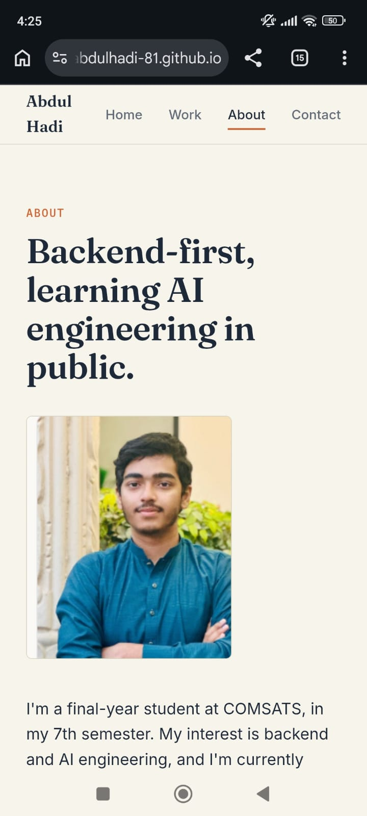
About page on real phone — photo scales correctly, text readable, nav visible.
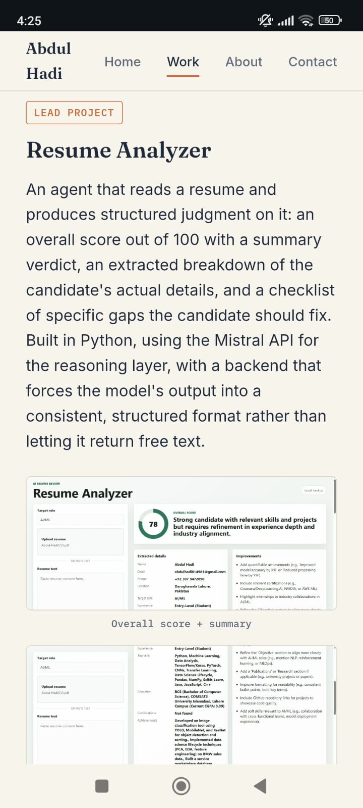
Work page on real phone — sharper Resume Analyzer screenshot now legible (score, extracted details readable).

Links checked
- Nav links (Home / Work / About / Contact) all 4 pages, working.
- LinkedIn link working, opens correct profile.
- GitHub link working, opens correct profile.
- Contact form Send button working, confirmed via a real Formspree submission reaching my inbox (separate assignment evidence).
- "See the case study" and "Get in touch" hero/footer CTAs working.

What I did not change
Contrast and text size were already within a comfortable range from the original build (dark navy text on a warm cream background, no low-contrast gray-on-white combinations) no changes were needed there. Layout breakpoints were already handled with flexbox from the original build, which is why mobile came back clean rather than needing new fixes this round.

