Portfolio Launch & Evidence Report
Custom Domain • Analytics • Launch Hygiene • Badge Status

1. Deliverable Summary
Live custom domain | https://haditci.site
HTTPS | Enabled and verified through the live site
Analytics | Realtime report captured with 1 active user
Launch hygiene | Favicon, page title, share preview, and mobile/phone checks verified
Badge | Pending documented honestly rather than claiming completion

2. Live Custom Domain
Live URL: https://haditci.site
The portfolio is deployed on the custom domain and is accessible over HTTPS. The supplied browser evidence shows the live haditci.site domain and the Contact page.
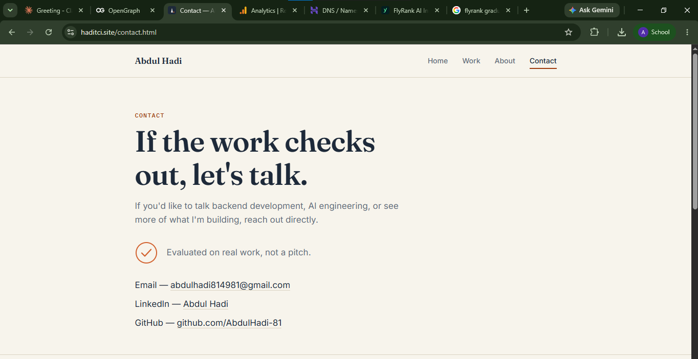
Evidence: Live custom domain and Contact page on haditci.site

3. Analytics Evidence
The Google Analytics Realtime report records 1 active user in the last 30 minutes and 1 active user in the last 5 minutes. The activity graph also shows recent activity, providing evidence of a real visit to the launched site.
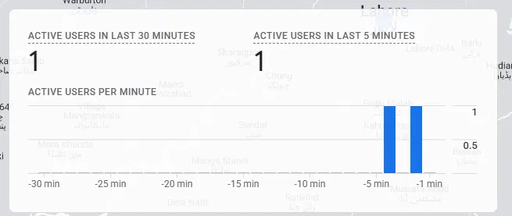
Evidence: Google Analytics Realtime report showing 1 active user

4. Launch Hygiene Confirmation
- Custom domain verified: haditci.site
- HTTPS access verified
- Browser/page presentation checked on the live domain
- Favicon verified as part of the launch check
- Page titles verified
- Social/share preview with image verified
- Mobile/phone presentation checked
The launch was checked on the new domain rather than relying only on the previous hosting URL.
Mobile Phone Evidence :
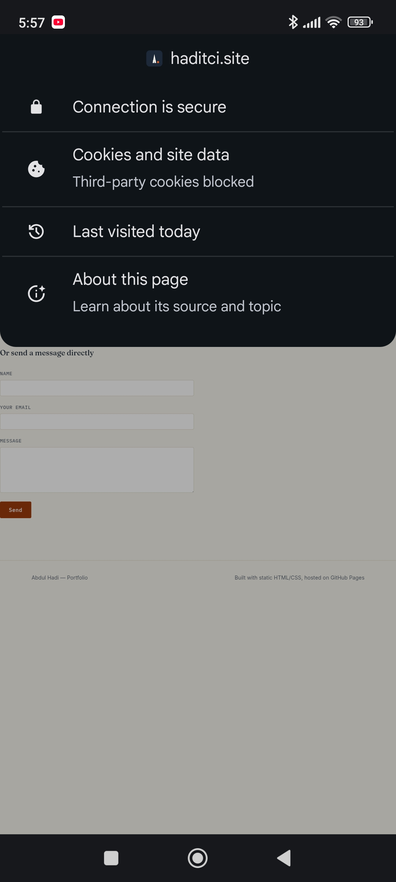

5. Badge Status
Status: Pending
The badge has not yet been issued, so it is intentionally not presented as completed. A placeholder/status note is retained until the issuing platform provides the badge.
Next step: replace the pending placeholder with the actual badge evidence immediately after it is issued.

6. Final Completion Status
The core launch evidence is ready: the portfolio is live on the custom domain, HTTPS is working, a real Analytics Realtime visit has been recorded, and launch-hygiene checks have been completed. The only outstanding item is the badge, which remains pending until it is officially issued.

