**Korean exclusive distributor request for year 2024-2027**

**1) Reason for work with Peter Persson**

* I found Peter Persson 3 years ago while web searching.
* At that time, I was contacting suppliers around the world to procure softshell crab supplies.
* I found out that Peter Persson had plans for a softshell crab production factory in Vietnam, so I went to Vungtau (in Vietnam) to meet him.
* We talked a lot about supplying softshell crab to Korea, and we are still in touch.
* I've met a lot of softshell crab suppliers around the world, but I've never seen anyone using robots and machines for softshell crab and so cost effective as Peter Persson.
* So I would like to continue working with Peter Persson about softshell crab.

**2) Our company history**

- 2017. 5. Established as PURPLE OCEAN co., ltd.

12. Achieve annual sales of 4 million dollar(USD)

- 2018.12. Achieve annual sales of 6 million dollar(USD)

- 2019. 3. Registered venture company in korea

12. Achieve annual sales of 10 million dollar(USD)

- 2020. 12. Achieve annual sales of 10 million dollar(USD)

- 2021. 12. Achieve annual sales of 10 million dollar(USD)

- 2022. 10. Established as “J-one international co., ltd.”

* Separation of import function and distribution function for work efficiency.

**3) Our softshell crab sales volume in Korea and where sourced from in tons (Before COVID 2020)**

|  |  |  |  |  |  |  |  |  |
| --- | --- | --- | --- | --- | --- | --- | --- | --- |
| Division | SUM | Myanmar | Thailand | Bangladesh | Malaysia | Indonesia | Vietnam | philipine |
| 2016 | 234.65 | 104.85 | 97.16 | 10.99 |  | 20.34 | 1.2 | 0.11 |
| 2017 | 213.24 | 125.35 | 75.67 | 12.22 |  |  |  |  |
| 2018 | 263.18 | 185.61 | 65.26 |  | 12.01 |  | 0.3 |  |
| 2019 | 174.99 | 122.80 | 46.36 | 5 | 0.83 |  |  |  |
| SUM | 886.06 | 538.61 | 284.45 | 28.21 | 12.84 | 20.34 | 1.5 | 0.11 |

**4) Reason of SSC shortage in korea**

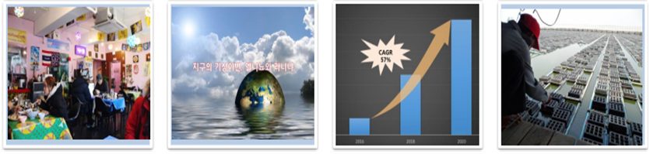

|  |  |  |  |
| --- | --- | --- | --- |
| THAl restaurant  increase | Unusual weather | Increase in SSC demand in developed countries | SSC supply limited |

**5) Our company SSC sales volumes**

- (**before 2020 / before COVID**) 20ton / per month

**- (After 2021 / COVID)** 5ton / per month

* Reason : Many THAI restaurant close due to COVID, market situation worse…. etc

**6) Our plan of SSC sales**

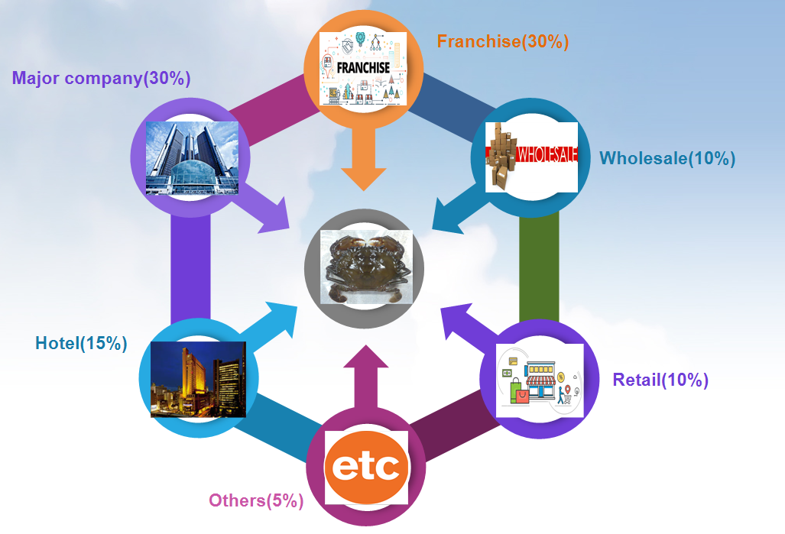

* We can sell SSC to various companies based on our many years of work know-how

* Plan to launch a new menu using SSC in 2024-2025 with SPC(Large Korean company)

**7) Advantage of Pete’s Claws and Fins’ soft-shelled carbs in Korean market**

- It is possible to constantly adjust the production volume throughout the year.

- It is possible to produce planned production for the specific size that buyer’s want.

- In terms of production cost of SSC, cost of producing it in a factory is much cheaper and better quality than using people.

- When the SSC molts, it can be accurately collected in time so shell does not get hard.

- Because the product production turnover is high, the cost-effectiveness is good compared to the traditional production method

**8) Quality problems i have had before from other SSC suppliers**

- The shell of SSC is too hard.

- Rotten smelly SSC.

- Product size is not uniform.

- Many undesirable sizes are produced, which puts a burden on the buyer's stock.

- We could not receive the quantity we wanted at the desired time, and we had no choice but to depend on local circumstances (availability, climate and environment, etc.).

**9) Conclusion**

- In Korea, the current COVID-19 is somewhat stabilizing.

- However, global economic downturn and COVID-19 are not yet over, so it will be a a slow development.

- So, I want to supply SSC to the Korean market in 2024-2027.

- I believe that if I use my SSC network and know-how, I will be able to achieve pre-COVID sales volume of 20ton / per month .

- And in 2024-2025, we plan to develop a new menu in cooperation with a large company and launch it in the Korean market with more volume.

- So, if all the plans go well as expected, it is expected that there will be a lot of SSC demand in 2024-2027.

- Therefore, I would like to get "Korean exclusive distributor" rights in 2024-2027.