MODULE-2

DESIGN AND SIMULATION

OF CIRCUITS AND EMBEDDED SYSTEMS

MINI PROJECT:

FENCE PROTECTOR

Submitted by:

Abdul Haq Indikar

# Table of Content

Table of Content 1

1.0 Abstract 1

2.0 Requirements 2

2.1 Description 3

Sensors: 3

Transducer: 3

2.2 High Level Requirements 3

2.3 Low Level Requirements 4

2.4 Block Diagram 5

2.5 Working 5

2.6 SWOT Analysis 6

2.7 Application 6

3.0 Architecture 7

3.1 Black Box of Fence Protector 7

3.2 Functional Diagram of Fence Protector 7

3.3 Flowchart of Fence Protector 8

3.4 Use case Diagram of Fence Protector 9

# Abstract

The purpose of this project is to provide an automated solution for Fence Protection. Guarding the area is generally done using manual workers which tends to be costly and not every one can afford to employ a watchman. That’s where our solution comes into picture, the device is fully automated and doesn’t require any assistance. The device work on various principles including piezoelectric effect, photoelectric effect and various other mechanical principles. The solution performs 2 basic operations, firstly it is responsible for detecting any disturbance in fence, as in if any one is trying to forcibly enter. It also comes an automatic Light system which turns itself on in darkness. The solution uses a vibration sensor which is used for sensing of the vibrations and hence sends the readings to controller which is preprogramed with a threshold value and as soon as the threshold value is breached the controller uses the speaker to make noise of desired frequency as preprogramed by the user. In same way it also uses LDR i.e., Light Dependent Resistor to sense the amount of light and sends those reading to the controller which compares it with the minimum light required as preprogramed by the user and turns the Lights ON and OFF accordingly.

# 2.0 Requirements

## 2.1 Description

This device consists of various Sensors, Transducer and a Microcontroller. It uses LDR for detecting the amount of light and turns the lights on accordingly, and in the same way Vibration sensor detects the vibrations and makes the required noise for protecting the Fence.

### **Sensors:**

* **Light Dependent Resistor (LDR):** Used to detect the amount of light in the surrounding.
* **Vibration Sensor:** Used to sense the vibrations of the fence.

### **Transducer:**

* **Speaker (piezoelectric):** Used to produce Sound as required.
* **Light-Emitting Diode (LED):** Used to produce Light.

## 2.2 High Level Requirements

|  |  |  |
| --- | --- | --- |
| **Sl. No** | **ID** | **Requirements** |
| 1. | HLR1 | The device should sound an alarm or make noise of different frequency in case someone is trying to enter the fence |
| 2. | HLR2 | The device should turn the lights ON automatically at night |
| 3. | HLR3 | The device should turn the lights OFF automatically at day break |

## 2.3 Low Level Requirements

|  |  |  |
| --- | --- | --- |
| **Sl. No** | **ID** | **Requirements** |
| 1. | LLR1.1 | It should have threshold vibration setting |
| 2. | LLR1.2 | It should sense the Vibrations |
| 3. | LLR1.3 | It should check whether the threshold value of vibration is breached |
| 4. | LLR1.4 | In case of a breach, it should sound alarm or producing noise of required frequency |
| 5. | LLR2.1 | It should have threshold light value setting |
| 6. | LLR2.2 | It should sense the amount of light |
| 7. | LLR2.3 | It should check whether the threshold value of light is breached |
| 8. | LLR2.4 | In case of a breach the device shall turning the lights ON |
| 9. | LLR3.1 | It should check whether the amount of light is above the threshold value of light |
| 10. | LLR3.2 | It should Turn the lights OFF |

|  |  |  |
| --- | --- | --- |
|  |  |  |
|  |  |  |
|  |  |  |

## 2.4 Block Diagram

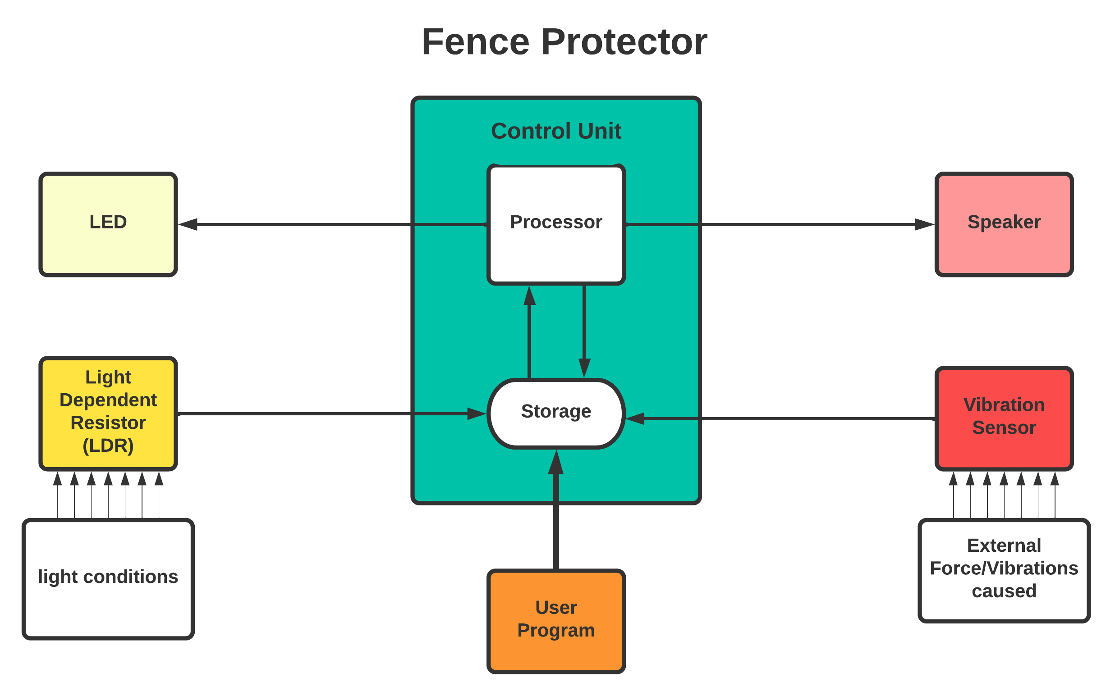

## 2.5 Working

This device has 2 independent features.

* **Automatic LED**: This feature is implemented using and **LDR** which is used for detecting the light conditions of the surrounding. when the amount of light moves below certain threshold value which is set by the user, it sends the signal to the **Controller** and the **LED** is turned on.
* **Anti-Theft System**: As mentioned above it can be used in various application with slight modification, Here we have use a **Vibration Sensor** which is mounted on fence, it detects any sort of vibration and sends the signal to the **controller** which produces different sounds with the help of **Speakers**.  
  The sound produced can vary as in if we are using it to protect and agriculture field then we can produce sound of the frequency which irritates the animal which generally destroys the field in that area.

## 2.6 SWOT Analysis

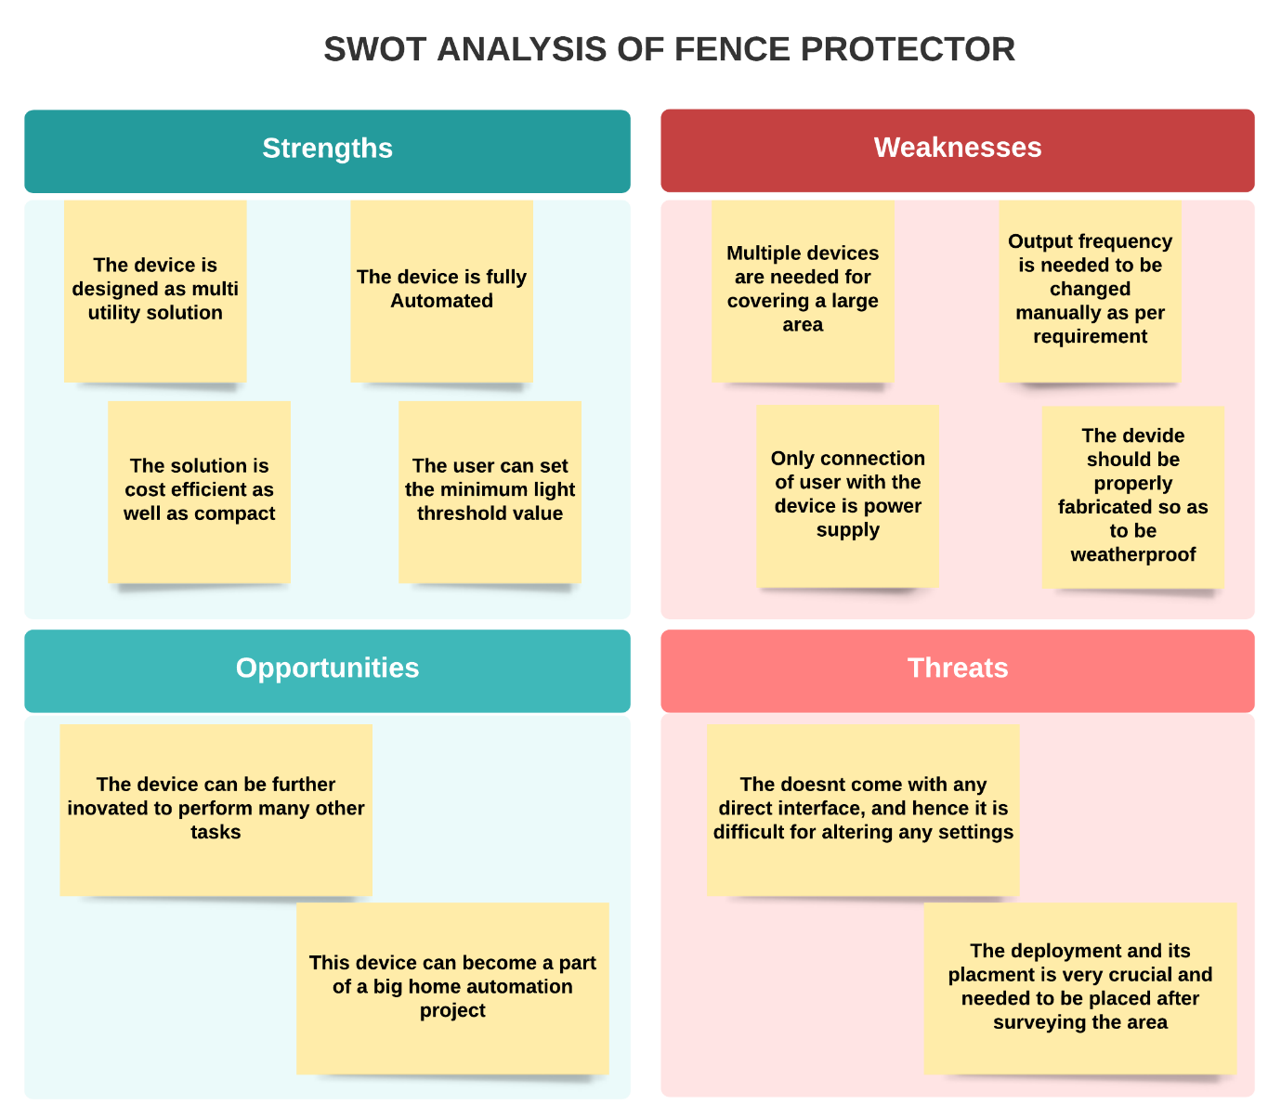

## 2.7 Application

This device can be easily modified to be implemented for various application.

* Protecting Agricultural Fields from animals.
* It can be used as an anti-theft device.

# 3.0 Architecture

## 3.1 Black Box of Fence Protector

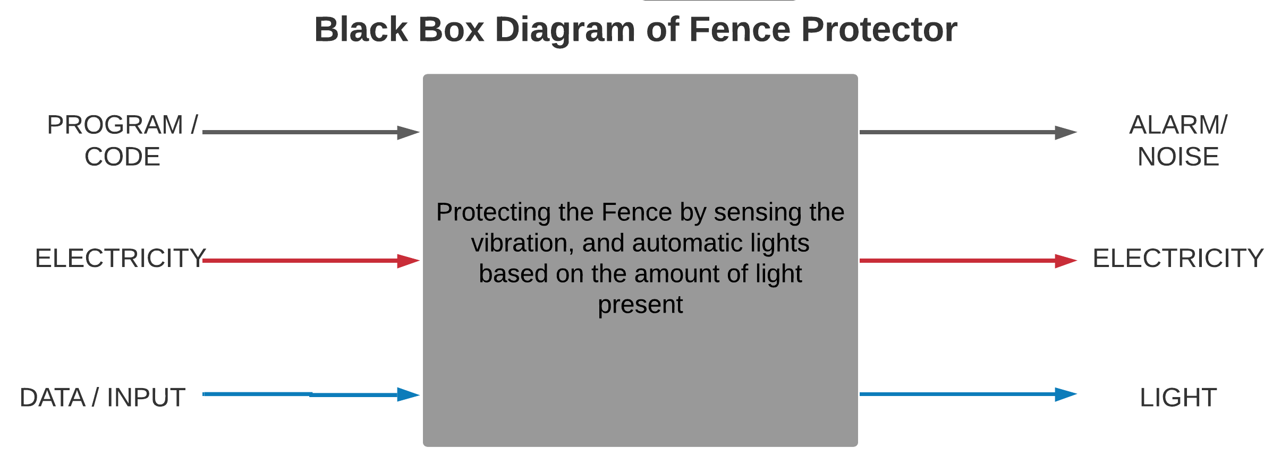

## 3.2 Functional Diagram of Fence Protector

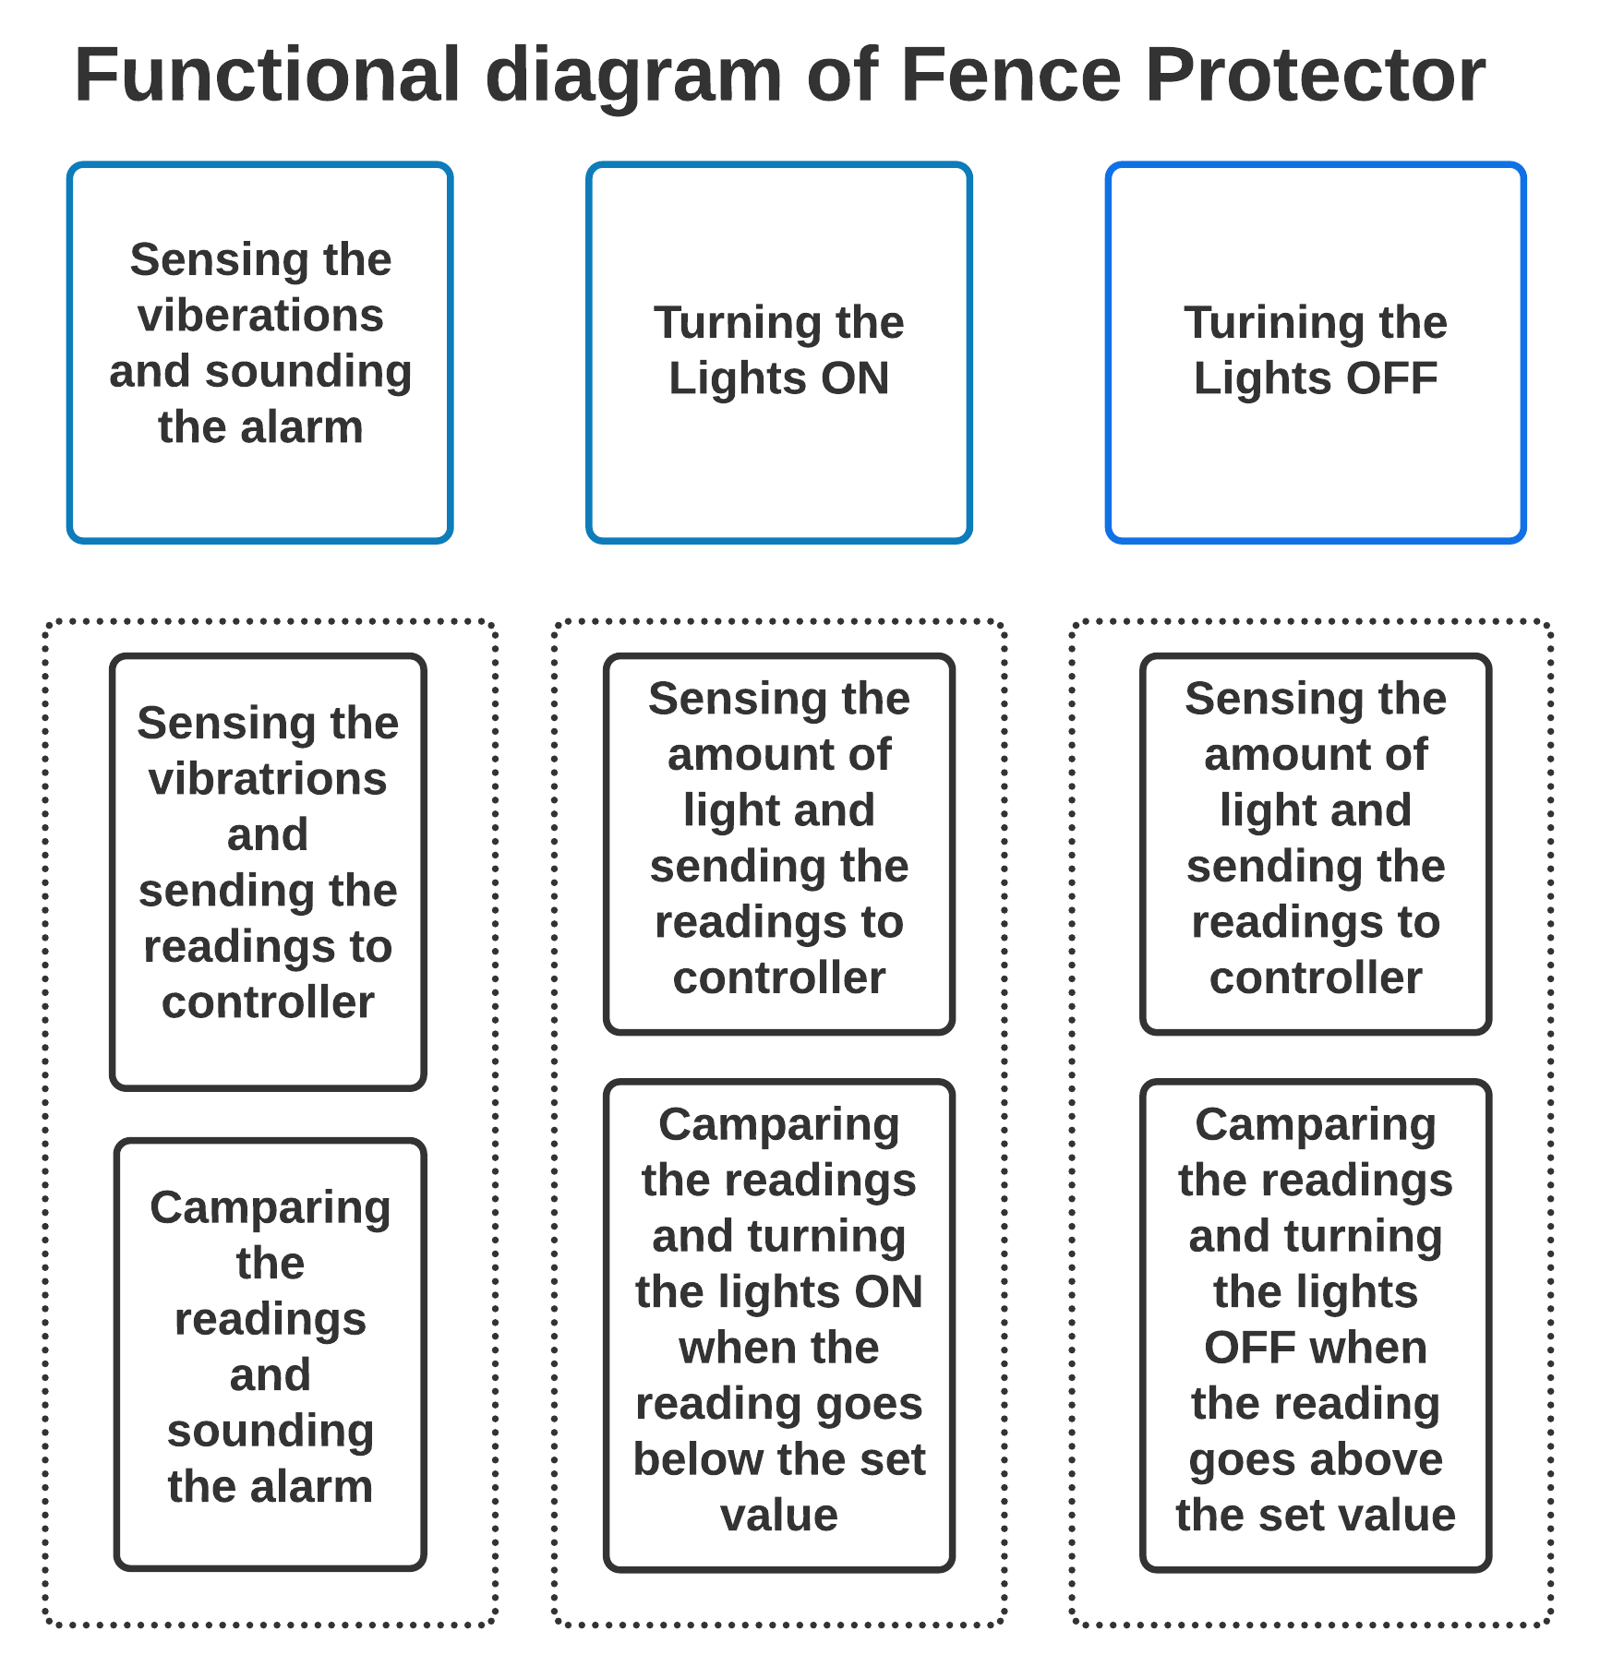

## 3.3 Flowchart of Fence Protector

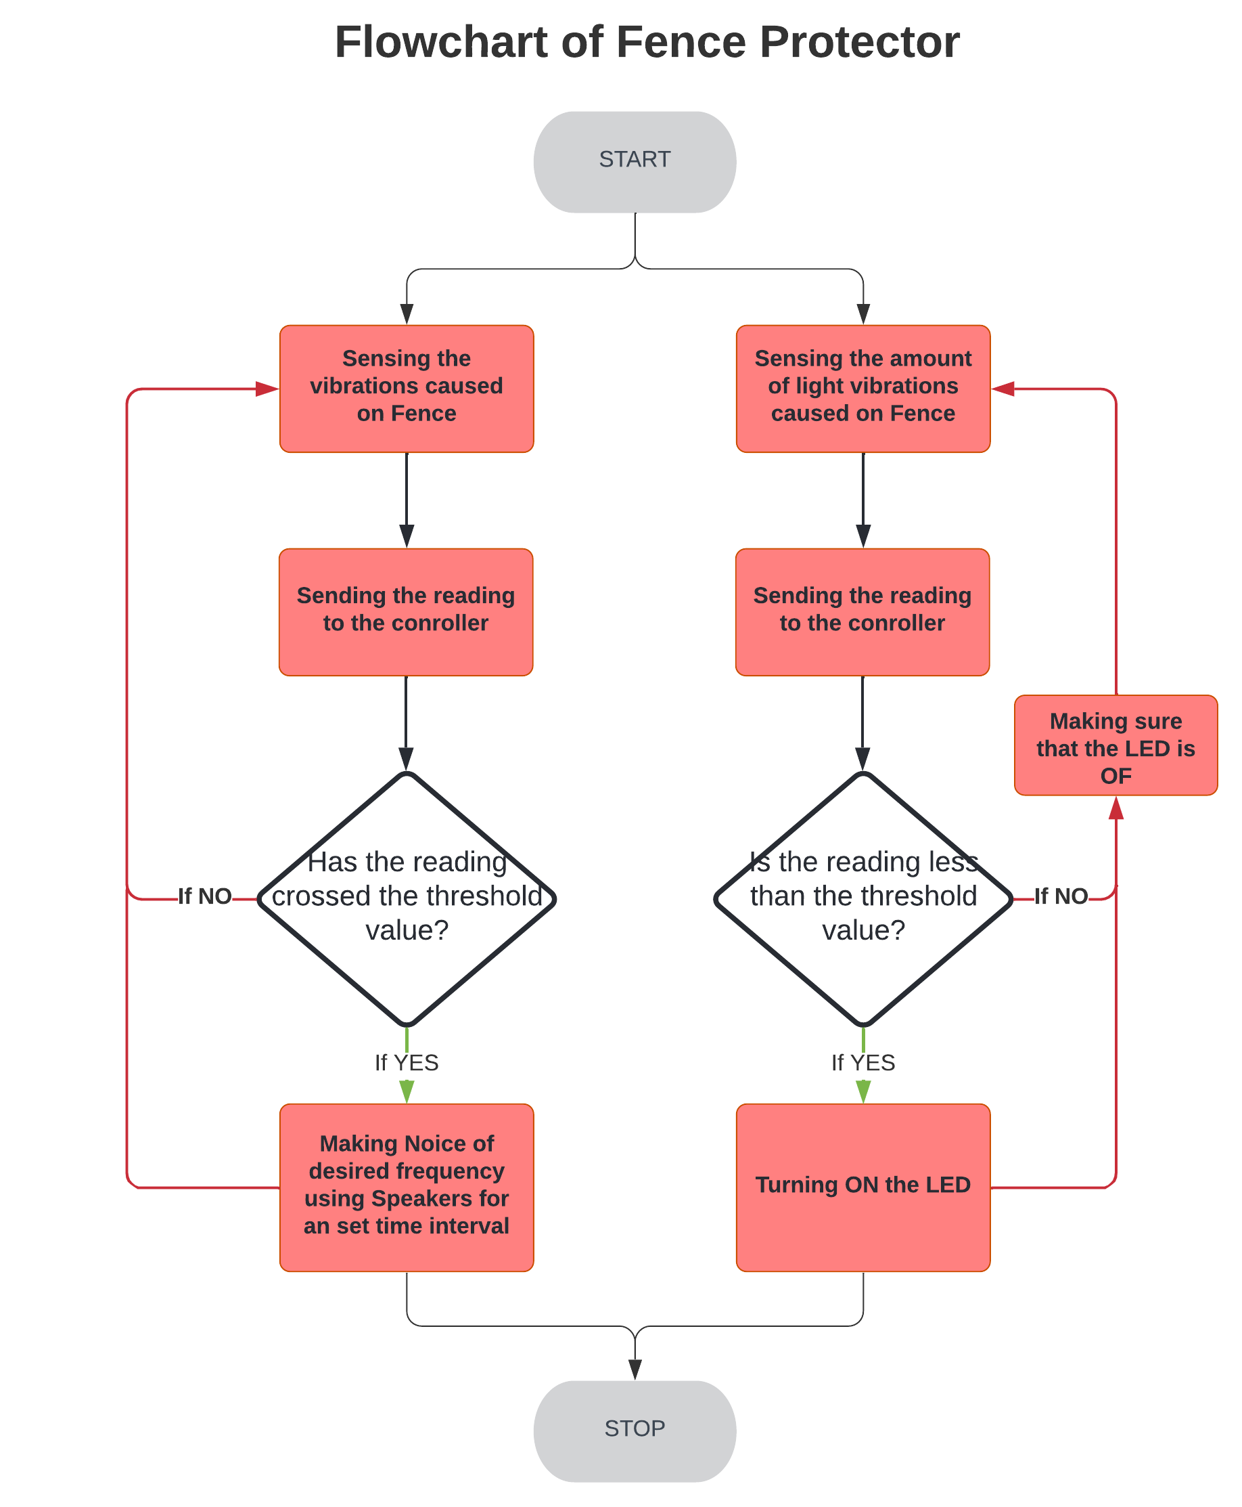

## 3.4 Use case Diagram of Fence Protector

