📘 Project Report – Election Management System (SQL Server)
Author: Abdul Hassan
Project Type: Database Design, Data Engineering, SQL Analytics
Tools Used: Microsoft SQL Server, SSMS, SQL Queries, ERD Modelling
Date: 2025

1. Introduction
This project presents the design and implementation of a complete Election Management System built using Microsoft SQL Server. The purpose of this project is to simulate real-world election operations, including administration, voter registration, candidate management, vote recording, result computation, and audit logging.
A robust relational database schema was created with strict Primary Key, Foreign Key, and Indexing strategies to ensure referential integrity and high-performance query execution. Randomized test data was seeded programmatically using SQL functions to populate the database with realistic election scenarios.
The project also includes 15 analytical SQL queries to uncover patterns in election outcomes, voter demographics, party performance, turnout behaviour, and variance across elections.

2. Project Objectives
The key objectives were:
- Design a normalized relational schema for election data
- Implement core tables including Admin, Voter, Election, Candidate, Vote, ElectionResult, and AuditLog
- Enforce data integrity via PKs, FKs, constraints, and relationships
- Programmatically seed the database with realistic sample data
- Perform comprehensive analytics on election behaviour
- Generate actionable insights from SQL queries

3. System Overview
The system replicates an election workflow:
- Admins create and manage elections
- Voters register and participate in elections
- Candidates contest in elections
- Votes are cast and stored
- Election results determine the winning candidates
- Audit logs capture all actions, supporting traceability
This architecture models how real-world election systems maintain transparency, security, and traceability.

4. Database Design
The database consists of seven core entities:
Table | Purpose
admin | Admin account details
voter | Voter personal information & demographics
election | Election metadata
candidate | Candidate details per election
vote | Votes cast by voters
electionresult | Final results per election
auditlog | System action logs
The schema follows normalization principles to reduce redundancy and improve efficiency.

5. ERD (Entity Relationship Diagram)
Key Relationships:
- Admin → Election (1:M)
- Election → Candidate (1:M)
- Election → Vote (1:M)
- Voter → Vote (1:M)
- Candidate → Vote (1:M)
- Election → ElectionResult (1:1)
- Voter/Admin → AuditLog (1:M)
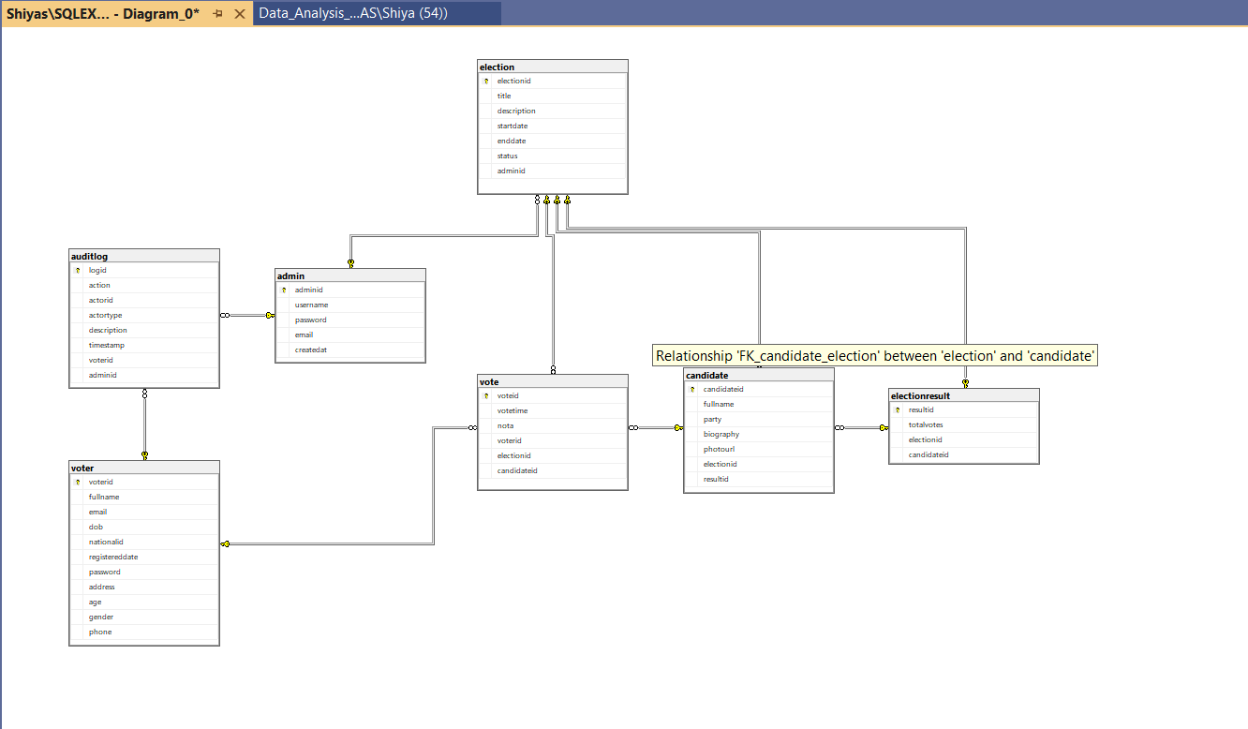

6. Database Implementation
6.1 Schema Creation
All tables were created using SQL Server’s DDL statements with explicit primary keys, foreign keys, data types, and constraints.
6.2 Data Integrity Constraints
- adminid, voterid, electionid, candidateid, resultid, voteid, logid configured as PKs
- Referential integrity enforced via FK constraints
- Indexes added to improve performance on frequently queried columns

7. Data Seeding
Randomized sample data was generated using SQL functions such as:
- ROW_NUMBER()
- NEWID()
- CHECKSUM()
- ABS()
- DATEADD()
- Derived numbers for demographic distribution.
The dataset includes:
Entity | Count
Admins | 5
Voters | 100
Elections | 3
Candidates | 30
Votes | 300
Audit Logs | 100

Election winners were assigned using deterministic logic based on the lowest candidate ID per election.

8. Analytical Queries (15 Total)
The following categories of analysis were performed:
8.1 Election Outcome Analysis
- Identify winners
- Compute winner margins
- Determine the most popular candidates
- Highest turnout elections
8.2 Voter Behaviour
- Gender distribution
- Age group segmentation
- Voting participation by gender
- Voting participation by age
8.3 Vote Pattern Analytics
- Total votes per election
- Votes per party
- NOTA voting behaviour
- Voter engagement levels
8.4 System Logging Insights
- Most common system actions through audit logs

9. Analytical Insights (Key Findings)
🟦 Election Insights
- Party 3 won 2 out of 3 elections
- Turnout remained high and consistent (96–107 votes)
🔥 Candidate/Party Insights
- Candidate 3 was the highest overall vote receiver
- Party 3 dominated in both votes and wins
👥 Demographic Insights
- Gender: 56% Female, 44% Male
- Age: Largest group = 26–35
- Voting activity was highest among ages 26–55
🗳️ Voter Engagement
- Voter 9 cast the highest number of votes (8)
- 94% of all registered voters participated
🚫 NOTA Insights
- NOTA usage was extremely high (46%), suggesting dissatisfaction or simulated randomness
⚔️ Competition Analysis
- Elections were competitive:
  - 1 tie
  - 1 election decided by a 1-vote margin

10. Strengths of the System
- Fully normalized relational schema
- High degree of referential integrity
- Randomized yet realistic dataset
- Comprehensive analysis covering political, demographic, and behavioural insights
- Robust update logic to handle winner assignment
- Scalable for real-world expansion (API, UI, dashboards)

11. Potential Extensions
The system can be expanded into a full application with:
- REST API (ASP.NET Core / Django)
- React or Angular frontend
- Admin dashboards with Power BI or Tableau
- Authentication and role management
- Detailed voting analytics visualization

12. Conclusion
This project successfully demonstrates the complete lifecycle of building a real-world-style Election Management System using SQL Server. It covers database design, schema creation, automated data generation, enforced integrity constraints, and deep analytical SQL queries.
The insights derived from the 15 analytical queries provide a meaningful understanding of voter behaviour, party performance, participation trends, and election competitiveness. The project showcases strong technical capabilities in SQL, data modelling, data engineering, and analytical thinking.

