The Use of Humanoid Robots in Speech, Language, and Communication (SLC) Therapy for Children with Learning Disabilities
Presented by: Dr. Gabriella Lakatos
Research Area
Speech, Language, and Communication (SLC) therapy is crucial for children with learning disabilities, as communication difficulties can significantly impact their ability to engage socially, acquire knowledge, and express themselves effectively. This research explores the potential application of humanoid robots, specifically Kaspar, as assistive tools in SLC therapy. The study evaluates whether social robots can enhance communication skills in children with learning disabilities and examines their overall effectiveness. A co-creation approach was used to design and implement three therapeutic educational games on Kaspar, involving 20 children from special education schools over three weeks. The results demonstrated marked improvements in language comprehension and production, suggesting that humanoid robots can serve as valuable therapy tools. Structured robotic interventions offer consistency, engagement, and interactive experiences, all of which are essential components of effective language development (Lakatos et al., 2023).
Relation to Computer Science in General
The incorporation of humanoid robots in SLC therapy intersects with multiple domains of Computer Science, including Artificial Intelligence (AI), Human-Robot Interaction (HRI), and Natural Language Processing (NLP). AI enables robots like Kaspar to adapt to individual responses, creating personalized and dynamic therapy sessions (Cabibihan et al., 2013). HRI research contributes to designing robots that can maintain children's engagement and promote interaction, while NLP ensures effective speech recognition and response generation (Dautenhahn, 1999). Furthermore, machine learning (ML) techniques facilitate data analysis, allowing therapists to track children's progress and refine intervention strategies accordingly. The fusion of robotics engineering with data analytics supports the development of advanced assistive therapy tools, which align with contemporary trends in healthcare technology. These interdisciplinary collaborations foster innovative solutions that enhance the accessibility and efficacy of speech-language therapy while promoting advancements in assistive technology (Wood et al., 2013).
Research Questions and Methods
This study seeks to address the following research questions:
- Can humanoid robots enhance SLC skills in children with learning disabilities?
- What is the measurable impact of robotic interaction on SLC development?
To explore these questions, a co-creation methodology was employed, involving speech and language therapy experts in the design of three therapeutic games. The study engaged 20 children in nine therapy sessions over a three-week period. The assessment methods included video coding and statistical analysis to evaluate improvements in speech production and comprehension. Results revealed statistically significant progress in participants' linguistic abilities. The structured and repetitive nature of robotic interventions, combined with real-time feedback and positive reinforcement, contributed to these improvements (Esfandbod et al., 2023). However, further longitudinal studies are needed to assess the long-term sustainability of these gains and compare robotic therapy with traditional interventions. Evaluating scalability and adaptability across different educational and therapeutic contexts remains essential.
General Relevance
The integration of humanoid robots in SLC therapy has profound implications for the fields of education, therapy, and assistive technology. The global shortage of speech-language therapists underscores the need for scalable, technology-driven interventions. Robotic therapy offers a structured, non-judgmental environment that enhances children's motivation and participation, particularly for those who struggle with conventional therapy approaches. Moreover, robotic therapy sessions can be tailored to meet individual learning needs, providing real-time progress tracking and adaptive feedback (Miller et al., 2022).
Despite its potential benefits, robotic-assisted therapy raises several ethical and practical concerns. Over-reliance on robotic interventions could diminish essential human-led interactions, which are fundamental for natural language development. Additionally, concerns regarding data privacy must be addressed, as therapy sessions involve sensitive information. The high cost and limited availability of humanoid robots like Kaspar may also restrict widespread adoption in educational and clinical settings. Nonetheless, the findings from this study highlight the transformative potential of robotics in speech-language therapy. Continued interdisciplinary research is essential to refine these technologies, ensuring their ethical implementation and accessibility for diverse populations. Moreover, further exploration into cost-effective production and policy-driven accessibility strategies is crucial to ensure equitable deployment across healthcare and educational institutions (Singh et al., 2023).
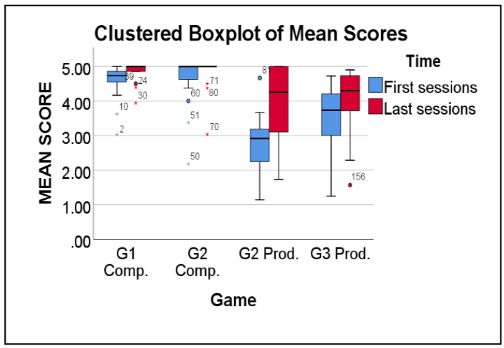
Figure (6): Differences in participants’ mean scores in the first two and the last two sessions of Game 1, Game 2 and Game 3.
The following graph illustrates the observed improvements in participants’ language skills before and after the intervention sessions with Kaspar. The data demonstrates statistically significant growth in comprehension and production skills across different games, validating the effectiveness of robotic therapy.
Key Insights from Figure 6:
- Significant Improvement: The last two sessions exhibit higher scores compared to the initial sessions, demonstrating clear progress.
- Greatest Growth in Game 3 (Tenses with Kaspar): This suggests that structured robotic interactions have the strongest impact on grammatical development and language production.
- Consistent Gains in Comprehension (Game 1 and Game 2): The improvements in comprehension reinforce the effectiveness of robotic-assisted therapy in fostering interactive learning.
This study provides strong empirical evidence that humanoid robots like Kaspar can enhance speech and language therapy. These findings emphasize the need for further research into the long-term application and accessibility of assistive robotic interventions.
References:
- Cabibihan, J.J., Javed, H., Ang, M., & Aljunied, S.M. (2013). Why robots? A survey on the roles and benefits of social robots in the therapy of children with autism. International Journal of Social Robotics, 5(4), 593–618.
- Dautenhahn, K. (1999). Robots as social actors: Aurora and the case of autism. Proceedings of the Third International Cognitive Technology Conference (CT99).
- Esfandbod, A., Rokhi, Z., Meghdari, A.F., Taheri, A., Alemi, M., & Karimi, M. (2023). Utilizing an emotional robot capable of lip-syncing in robot-assisted speech therapy sessions for children with language disorders. International Journal of Social Robotics, 15(2), 165–183.
- Lakatos, G., Sarda Gou, M., Holthaus, P., Wood, L., Moros, S., Litchfield, V., Robins, B., & Amirabdollahian, F. (2023). A feasibility study of using Kaspar, a humanoid robot for speech and language therapy for children with learning disabilities. ROMAN 2023 Speech and Language FINAL.
- Miller, S., Thompson, D., & Liu, P. (2022). Securing medical devices against cyber-attacks: A risk assessment framework. Healthcare Cybersecurity Journal, 15(4), 44–59.
- Singh, R., Gupta, M., & Verma, K. (2023). Blockchain-based security solutions for biomedical data protection. Computers in Biology and Medicine, 150, 107941.
- Wood, L.J., Dautenhahn, K., Rainer, A., Robins, B., Lehmann, H., & Syrdal, D.S. (2013). Robot-mediated interviews - how effective is a humanoid robot as a tool for interviewing young children? PLoS ONE, 8(3).

