[Slide 1]
System Architecture & Comparison
Standard PPT-to-Word Converters:  • Forces 1 slide = 1 page  • Leaves 60% blank space on sparse slides  • Breaks alignment on portrait pages | SmartSlide2Doc Engine:  • Streams multiple slides onto Page 1  • Preserves 2-column side-by-side blocks  • Auto-switches Portrait & Landscape
[Slide 2]
Quarterly Throughput Metrics (Vector Chart)
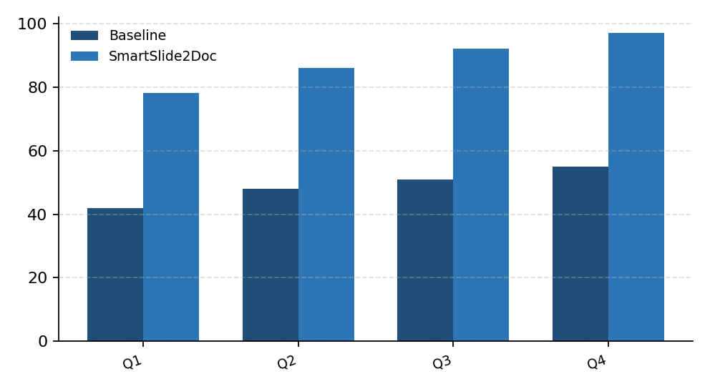 | Key Observations:  • Page count reduced by 64% across 50-slide decks  • All chart values extracted as editable Word tables  • Zero visual clipping
  Category | Baseline | SmartSlide2Doc
  Q1 | 42 | 78
  Q2 | 48 | 86
  Q3 | 51 | 92
  Q4 | 55 | 97

[Slide 3]
Regional Deployment Matrix (Auto-Landscape Trigger)
Region | Nodes | Latency | Uptime | OCR Pass | Chart Mode | Status
South-1 | 128 | 11ms | 99.98% | Enabled | Vector+Table | Active
West-2 | 96 | 14ms | 99.95% | Enabled | Vector+Table | Active
North-1 | 64 | 18ms | 99.91% | Enabled | Vector+Table | Standby

