POSTGRESQL

PostgreSQL is an open-source object-relational database system with 30+ years of active development in the industry. In this article on PostgreSQL Tutorial For Beginners, I will introduce you to the different concepts of databases and the commands used in PostgreSQL.
The topics covered in this article are mainly divided into 4 categories: DDL, DML, DCL & TCL.
- The DDL (Data Definition Language) commands are used to define the database. Example: CREATE, DROP, ALTER, TRUNCATE, COMMENT, RENAME.
- The DML (Data Manipulation Language) commands deal with the manipulation of data present in the database. Example: SELECT, INSERT, UPDATE, DELETE.
- The DCL (Data Control Language) commands deal with the permissions, rights and other controls of the database system. Example: GRANT, INVOKE.
- The TCL (Transaction Control Language) commands deal with the transaction of the database.Example: BEGIN, COMMIT, ROLLBACK.

What is PostgreSQL?
PostgreSQL is an object-relational database system which extends and uses the SQL language. It originates in the year 1986 and has been into active development for more than 30 years.
The features of PostgreSQL are as follows:
- Data Types: PostgreSQL supports various types of data types such as primitive, structured, document, geometry and customizations. This helps the user to store data in any format.
- Data Integrity: With the help of various constraints and keys in the database, PostgreSQL makes sure that data integrity is satisfied for simple to complex databases.
- Performance: PostgreSQL provides features such as indexing, multi-version concurrency control, JIT complication of expressions to make sure the concurrency and the performance are kept up to mark.
- Reliability: With the help of Write Ahead Logging(WAL) and Replication, PostgreSQL has proven itself to be one of the most reliable database systems over a period of time.
- Security: PostgreSQL provides powerful mechanisms such as authentication, a robust access-control system to ensure that only authorized users have access to the databases.
- Extensibility: PostgreSQL comes with various extensions to provide additional functionalities. It also has scaled its extensibility features with stored functions, procedural language, and foreign data wrappers.

Installing Postgres v12 on Ubuntu:
In order to install postgres on ubuntu, the following command can be executed in the terminal:
1. sudo apt-get update # to update the packages
2. sudo apt-get install postgresql-12 postgresql-contrib # to install postgresql v12

Inorder to get Postgres promt: sudo -u postgres psql
To check the version of Postgresql: select version();
To check the system status of Postgresql: service postgresql status

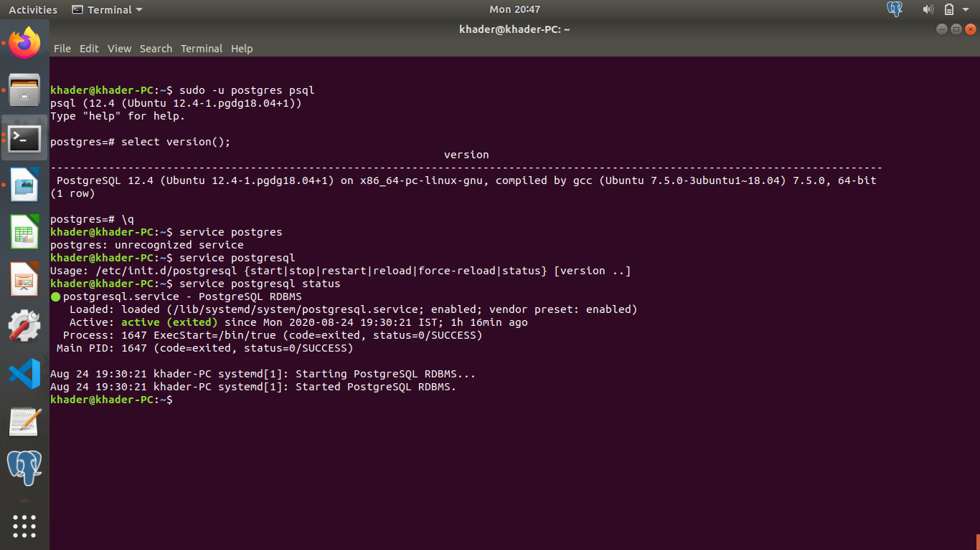

Data Definition (DDL) Commands :
This section of the article consists of those commands, which you can define your database. The commands are:
- CREATE
- ALTER
- DROP
- TRUNCATE
- RENAME

CREATE
This statement is used to either create a databases, schema, tables or an index.
The ‘CREATE SCHEMA’ Statement
The CREATE SCHEMA statement is used to create a database or most commonly known as a schema.
Syntax:
CREATE SCHEMA Schema_Name;
Example: CREATE SCHEMA teachers;
The ‘CREATE TABLE’ Statement
The CREATE TABLE statement is used to create a new table in a database.
Syntax:
CREATE TABLE table_name (
column1 datatype,
column2 datatype,
column3 datatype,
. . . .
) ;
Example:
CREATE TABLE TeachersInfo
(
TeacherID int,
TeacherName varchar(255),
Address varchar(255),
City varchar(255),
PostalCode int,
Country varchar(255),
Salary int
);

ALTER
This statement is used to add, modify or delete constraints or columns.
The ‘ALTER TABLE’ Statement
The ALTER TABLE statement is used to either add, modify or delete constraints and columns from a table.
Syntax:
ALTER TABLE table_name
ADD column_name datatype;
Example:
ALTER TABLE TeachersInfo
ADD DateOfBirth date;

DROP
This command is used to delete the database, tables or columns.
The ‘DROP SCHEMA’ Statement
The DROP SCHEMA statement is used to drop the complete schema.
Syntax:
DROP SCHEMA schema_name;
Example:
DROP SCHEMA teachers;
The ‘DROP TABLE’ Statement
The DROP TABLE statement is used to drop the entire table with all its values.
Syntax:
DROP TABLE table_name;
Example:
DROP TABLE TeachersInfo;

TRUNCATE
The TRUNCATE statement is used to delete the data which is present inside a table, but the table doesn’t get deleted.
Syntax:
TRUNCATE TABLE table_name;
Example:
TRUNCATE TABLE TeachersInfo;

RENAME
The RENAME statement is used to rename one or more tables or columns.
Syntax:
ALTER TABLE table_name RENAME TO new_table_name; --Rename Table name
ALTER TABLE table_name RENAME COLUMN column_name TO new_column_name; -- Rename Column name
Example:
ALTER TABLE TeachersInfo RENAME TO InfoTeachers;
ALTER TABLE InfoTeachers RENAME COLUMN dateofbirth TO dob;

Different Types Of Keys In Database
There are mainly 5 types of Keys, that can be mentioned in the database.
- Candidate Key – A Candidate Key is a combination of a minimal set of attributes which can uniquely identify a tuple. Any relation can have more than a single Candidate Key, with the key being a simple or a composite key.
- Super Key – A Super Key is the set of attributes which can uniquely identify a tuple. So, a Candidate Key is a Super Key, but vice-versa isn’t true.
- Primary Key – A Primary Key is a set of attributes that can be used to uniquely identify every tuple. So, if there are 3-4 candidate keys present in a relationship, then out those, one can be chosen as a Primary Key.
- Alternate Key – All the Candidate Keys other than the Primary Key is called as an Alternate Key.
- Foreign Key – An attribute that can only take the values present as the values of some other attribute, is the foreign key to the attribute to which it refers.

Constraints Used In Database
The constraints which you can use in databases are as follows:
- NOT NULL – The NOT NULL constraint ensures that a NULL value cannot be stored in a column
- UNIQUE – The UNIQUE constraint makes sure that all the values in a column are different
- CHECK -The CHECK constraint ensures that all the values in a column satisfy a specific condition.
- DEFAULT -The DEFAULT constraint consists of a set of default values for a column when no value is specified.
- INDEX – The INDEX constraint is used to create and retrieve data from the database very quickly

Data Manipulation (DML) Commands
This section of the article consists of the commands, by which you can manipulate your database. The commands are:
- SET SEARCH_PATH
- INSERT
- UPDATE
- DELETE
- SELECT
Apart from these commands, there are also other manipulative operators/functions such as:
- Arithmetic, Bitwise, Compound and Comparison Operators
- Logical Operators
- Aggregate Functions
- Special Operators
- Set Operations
- Limit, Offset and Fetch

SET SEARCH_PATH
This statement is used to mention which schema has to be used to perform all the operations.
Syntax:
SET search_path TO schema_name;
Example:
SET search_path TO teachers;

INSERT
The INSERT statement is used to insert new records in a table.
Syntax:
The INSERT INTO statement can be written in the following two ways:
INSERT INTO table_name (column1, column2, column3, ...) VALUES (value1, value2, value3, ...);
INSERT INTO table_name (column1, column2, column3, ...) VALUES (value1, value2, value3, ...);

Example:
INSERT INTO TeachersInfo(TeacherID, TeacherName, Address, City, PostalCode, Country, Salary) VALUES ('01', 'Saurav','Gangnam Street', 'Seoul', '06499', 'South Korea', '42000');

INSERT INTO TeachersInfo VALUES ('02', 'Preeti','Queens Quay', 'Rio Claro', '13500', 'Brazil', '45900');

UPDATE
The UPDATE statement is used to modify the existing records in a table.
Syntax:
UPDATE table_name
SET column1 = value1, column2 = value2, ...
WHERE condition;
Example:
UPDATE TeachersInfo
SET TeacherName = 'Alfred', City= 'Frankfurt'
WHERE TeacherID = '01';

DELETE
The DELETE statement is used to delete existing records in a table.
Syntax:
DELETE FROM table_name WHERE condition;
Example:
DELETE FROM TeachersInfo WHERE TeacherName='Vinod';

SELECT
The SELECT statement is used to select data from a database and the data returned is stored in a result table, called the result-set.
The following are the two ways of using this statement:
Syntax:
SELECT column1, column2, ...
FROM table_name;

--(*) is used to select all from the table

SELECT * FROM table_name;

Example:
SELECT Teachername, City FROM TeachersInfo; SELECT * FROM TeachersInfo;

Apart from the individual SELECT keyword, you can use the SELECT keyword with the following statements:
- DISTINCT
- ORDER BY
- GROUP BY
- HAVING Clause

The ‘SELECT DISTINCT’ Statement
The SELECT DISTINCT statement is used to return only distinct or different values. So, if you have a table with duplicate values, then you can use this statement to list distinct values.

Syntax:
SELECT DISTINCT column1, column2, ...
FROM table_name;

Example:
SELECT Country FROM TeachersInfo;

The ‘ORDER BY’ Statement
The ORDER BY statement is used to sort the desired results in ascending or descending order. By default, the results would be sorted in ascending order. If you want to sort the records in descending order, then you have to use the DESC keyword.

Syntax:
SELECT column1, column2, ...
FROM table_name
ORDER BY column1, column2, ...ASC|DESC;

Example:
SELECT * FROM TeachersInfo
ORDER BY Country;

SELECT * FROM TeachersInfo
ORDER BY Country DESC;

SELECT * FROM TeachersInfo
ORDER BY Country, TeachersName;

SELECT * FROM TeachersInfo
ORDER BY Country ASC, TeachersName DESC;

The ‘GROUP BY’ Statement
This statement is used with the aggregate functions to group the result-set by one or more columns.
Syntax:
SELECT column_name(s)
FROM table_name
WHERE condition
GROUP BY column_name(s)
ORDER BY column_name(s);
Example:
SELECT COUNT(TeacherID), Country
FROM TeachersInfo
GROUP BY Country
ORDER BY COUNT(TeacherID) DESC;
The ‘HAVING’ Clause Statement
Since the WHERE keyword cannot be used with aggregate functions, the HAVING clause was introduced.
Syntax:
SELECT column_name(s)
FROM table_name
WHERE condition
GROUP BY column_name(s)
HAVING condition
ORDER BY column_name(s);
Example:
SELECT COUNT(TeacherID), Country
FROM TeachersInfo
GROUP BY Country
HAVING COUNT(Salary) &amp;amp;amp;gt; 40000;

