**GTRACK testing**

**Below are findings upon testing**

**Identify button** // this will only works with admin user.

**1. GTIN button- not working**

**2. GLN- pop up required to update your profile**

**3. SSCC- error “something went wrong” –this working in my phone**

4. GRAI,GMN, GSRN, GSIN, GDTI,GINC— // This is not created yet

5.GIAI also

**Capture button**

**1.** Association // works as **Brand Owner User**

- Receiving - only **Vendors Returns**

-**Shipping**- ok **working Now** // this will only works as **Supplier User**

-**Handover, ownership transfer, Acceptance, Handoff, Consignment, Receipt, Allocation –**

**-Consignment- Shipper, receiver button-**

// this is because we did not create it yet

-**Transfer- all button working fine** // this will only works as **Supplier User**

- **Mapping-RFID mapping** - // will work after we connect the device with the mobile.

2.  **Transformation-inside all buttons -**

3. **Agregation**

4. **Serialization**

5. **Mapping barcode and RFId** // these are working fine

**Share Button** // this will only works with admin user.

**-Product information-(GTIN/GLN barcode) when scanning in 2d and view product information,**

**\*GTIN information – // Working now**

**\*Digital links- // Working now**

**\*Events- // Working Now**

Test Findings: perfectly scanning 1d and 2d barcode, and when scanning this below barcode, working fine displaying the GTIN info, digital link info and events display.sann

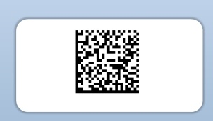

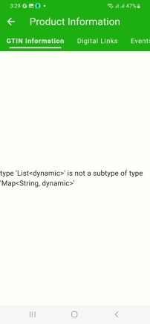

*Scanned this barcode also, showing this

And

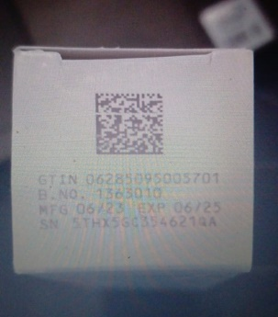

*scanned this sample with GTIN item, shows this, not showing info for digital link and events (maybe no data for this GTIN)

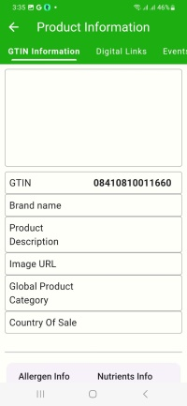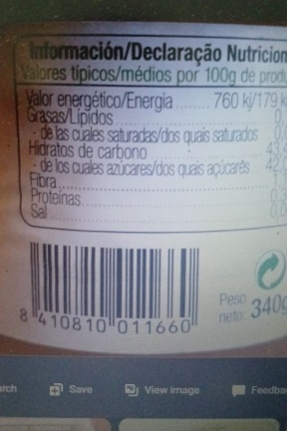

**-Digital links, Product catalogue, product certificate, EPCIS, CVB, Poduct origin, Traceability**

// this is because we did not create it yet

**Remarks:**

**Green Colour: All the green colour points is working fine.**

**Red Colour: All the red colour points are not yet created… it will be created soon.**

**Brand owner user**

55

1122

**Admin User**

[mitchlove1425@gmail.com](mailto:mitchlove1425@gmail.com)

097373

**Supplier**

abdulmajid1m1@gmail.com

123123