Brain Signal Processing: EEG + Graph Neural Networks for Psychiatric Disorder Classification
Results and architectures. Mini Project I, Department of CSE, IIIT Nagpur, July-December 2026. Rajat Malik, Yash Khedekar, Abdul Malik, Ashwin Rathore. Supervisor: Dr. Nileshchandra Pikle. Generated 2026-09-14 from repository commit ee7d14a.

1. Summary
- Base paper EEG-GCNN (Wagh & Varatharajah, ML4H 2020) reproduced exactly: all five held-out metrics match the published values, including standard deviations (AUC 0.871 +/- 0.001).
- One GNN per disorder was built for 5 disorders. On a held-out test split never used for tuning or training, every model separates its disorder from healthy controls: AUC 0.70-0.80, best anxiety 0.797; every 95% CI lies above chance.
- No model separates its disorder from the OTHER disorders (AUC 0.48-0.59, every CI includes 0.5). The models detect psychiatric illness, not which illness.
- The ensemble reaches balanced accuracy 0.235 [0.18, 0.29] over 6 classes (chance 0.167).
- As a screen for 'outside the healthy range', the pre-declared combined score (mean of the five) reaches AUC 0.738 [0.59, 0.85]: it catches 70% of patients and wrongly flags 42% of healthy controls. Combining did not beat the single models.
- Graph sparsification mattered: the selected GNN is GATv2 with mean+max pooling on a top-4 coherence graph, and the three best of eight configurations all use sparse graphs.
- On raw EEG from two independent hospitals, the same GNN (not re-tuned) detects schizophrenia within each hospital (AUC 0.77 ASEEG, 0.77 Warsaw; pooled 0.75), but a model trained at one hospital is at chance at the other (AUC 0.53 and 0.51). What is learned is largely hospital-specific: the disease signature, as captured by these features, does not transfer across sites.
- Depression within Mumtaz reaches AUC 0.95, but with no second open dataset it cannot be checked across hospitals, and the schizophrenia transfer result means a single-site score should not be read as a transferable disease signature.

2. Datasets
dataset | source | subjects | signal | role
TUH Abnormal + MPI LEMON | EEG-GCNN FigShare features | 1,593 (1,385 / 208) | 8-ch bipolar, precomputed | baseline reproduction
Park et al. 2021 | SMG-SNU Boramae, Seoul | 945 (OCD excluded -> 899) | 19-ch, precomputed PSD + coherence | per-disorder GNNs
ASEEG (Bagherzadeh 2026) | Zenodo 18029536, CC-BY | 51 SZ / 50 controls | 19-ch raw, 128 Hz | raw SZ track
Warsaw (Olejarczyk 2017) | RepOD 0107441 | 14 SZ / 14 controls | 19-ch raw EDF | raw SZ track
Mumtaz 2016 | figshare 4244171, CC-BY | 30 MDD / 28 controls | 19-ch raw EDF, 256 Hz | raw depression track
Mumtaz: 6 of 64 eyes-closed files are dead links on figshare. OCD dropped from Park (46 subjects; 9 in the test split, AUC CI roughly +/-0.22).

3. Graph construction
- Nodes are EEG electrodes. Edges are functional connectivity (spectral coherence), a statistic defined for every electrode pair - electrodes are not physically wired, so zeros exist only where a modelling choice puts them.
- EEG-GCNN baseline: 8 bipolar-montage nodes, complete graph with self-loops (64 edges), edge weight = normalised geodesic electrode distance + coherence, node features = 6-band PSD.
- Per-disorder GNNs (Park): 19 nodes (10-20 montage). Node features = 6 band powers + the channel's full coherence row (120 dims). Edge features = 6 per-band coherences. The selected graph keeps each node's top-4 most coherent neighbours (symmetrised, self-loops kept).
- Raw EEG: identical layout, with log relative band power (amplifier gain cancels) and magnitude-squared coherence computed per 10-second window.

4. Architectures

4.1 EEG-GCNN baseline (reproduced)
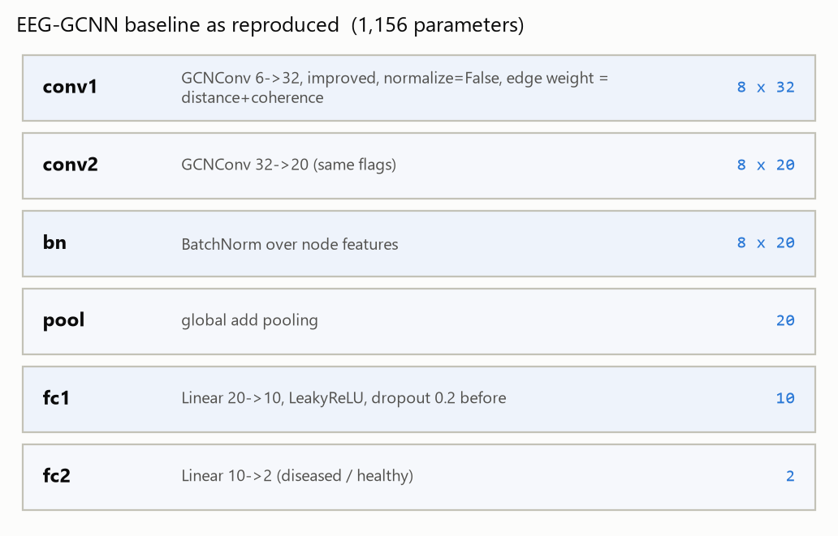
Figure 1. EEG-GCNN layer stack; output shapes per graph.
layer | operation | output | params
conv1 | GCNConv 6->32, improved, normalize=False, edge weight = distance+coherence | 8 x 32 | 224
conv2 | GCNConv 32->20 (same flags) | 8 x 20 | 660
bn | BatchNorm over node features | 8 x 20 | 40
pool | global add pooling | 20 | 0
fc1 | Linear 20->10, LeakyReLU, dropout 0.2 before | 10 | 210
fc2 | Linear 10->2 (diseased / healthy) | 2 | 22
total |  |  | 1,156

4.2 Selected per-disorder GNN
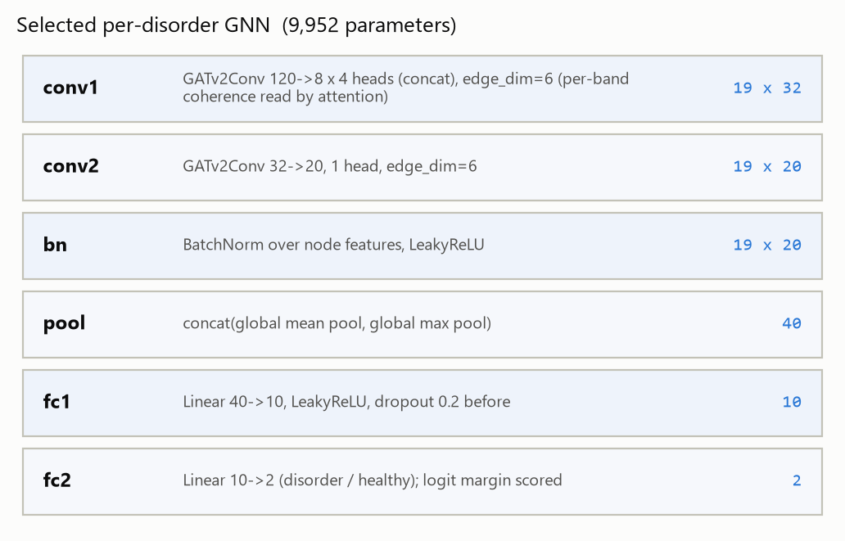
Figure 2. Selected GNN (identical for all five disorders).
layer | operation | output | params
conv1 | GATv2Conv 120->8 x 4 heads (concat), edge_dim=6 (per-band coherence read by attention) | 19 x 32 | 8,000
conv2 | GATv2Conv 32->20, 1 head, edge_dim=6 | 19 x 20 | 1,480
bn | BatchNorm over node features, LeakyReLU | 19 x 20 | 40
pool | concat(global mean pool, global max pool) | 40 | 0
fc1 | Linear 40->10, LeakyReLU, dropout 0.2 before | 10 | 410
fc2 | Linear 10->2 (disorder / healthy); logit margin scored | 2 | 22
total |  |  | 9,952
Training: Adam lr 0.001, weight decay 0.0005, batch 64, 150 epochs, class-weighted cross-entropy, GCN normalisation on. Graph-blind control (FCNN on the same 2280 inputs): 73,884 parameters.

4.3 Configurations searched
conv | pooling | graph | params
gcn | add | complete (361 edges) | 4,804
gcn | add | top-4 per node | 4,804
gcn | meanmax | complete (361 edges) | 5,004
gcn | meanmax | top-4 per node | 5,004
gatv2 | add | complete (361 edges) | 9,752
gatv2 | add | top-4 per node | 9,752
gatv2 | meanmax | complete (361 edges) | 9,952
gatv2 | meanmax | top-4 per node | 9,952

4.4 System and pipelines
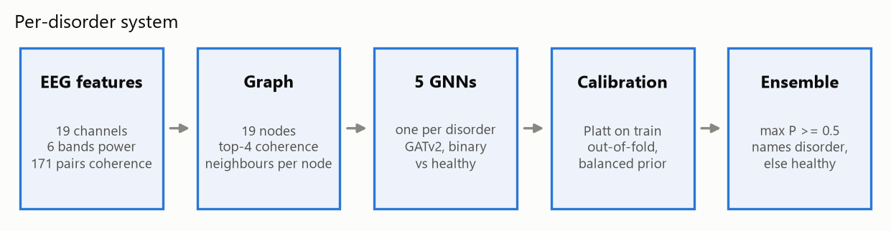
Figure 3. Per-disorder system: five binary GNNs, calibrated, then combined.
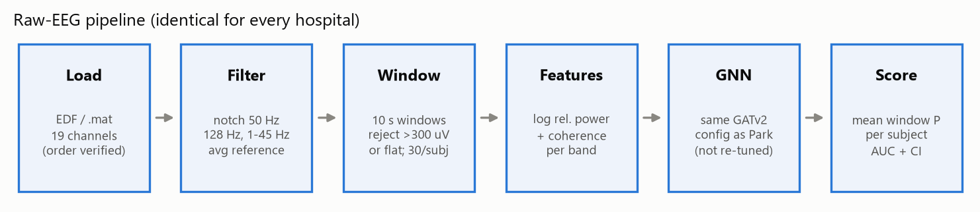
Figure 4. Raw-EEG preprocessing, identical for every hospital.

5. Results

5.1 Baseline reproduction: EEG-GCNN
metric | published | reproduced
AUC | 0.871 (0.001) | 0.871 (0.001)
precision | 0.989 (0.003) | 0.989 (0.003)
recall | 0.677 (0.018) | 0.677 (0.017)
F1 | 0.804 (0.011) | 0.804 (0.011)
balanced accuracy | 0.810 (0.003) | 0.810 (0.003)
478 held-out subjects, 10 released checkpoints. Run on the Blackwell node 2026-09-08 (train.py --eval-ckpt); values from the README table written at the time.

5.2 Graph formulation study on Park (all classes, 10-fold CV)
model | binary SZ vs HC | 4-way
logistic regression (all 1140 features) | 0.731 | 0.428
random forest | 0.721 | 0.449
majority class | - | 0.401
FCNN, profile node features | 0.703 | 0.321
GATv2, profile node features | 0.613 | 0.273
GCN, profile node features | 0.594 | 0.301
Park et al. 2021, published | 0.938 | not attempted
Accuracy. Run on Blackwell 2026-09-08; values from the README. Motivated the later design: node features must carry the coherence row, and the published 0.938 did not reproduce.

model | power only | + mean coherence | + coherence row
FCNN | 0.627 / 0.277 | 0.670 / 0.318 | 0.703 / 0.321
GCN | 0.566 / 0.260 | 0.538 / 0.252 | 0.594 / 0.301
GATv2 | 0.556 / 0.272 | 0.515 / 0.261 | 0.613 / 0.273
Node-feature ablation, accuracy binary / 4-way.

5.3 Per-disorder GNNs
Protocol: a stratified 80/20 subject split was fixed once. Eight GNN configurations were compared by 5-fold CV on the train split only; one configuration was chosen for all five models by mean out-of-fold AUC (choosing per disorder on 90-290 subjects would fit noise). Models were trained on the full train split, calibrated on train out-of-fold predictions, then evaluated once on the test split.
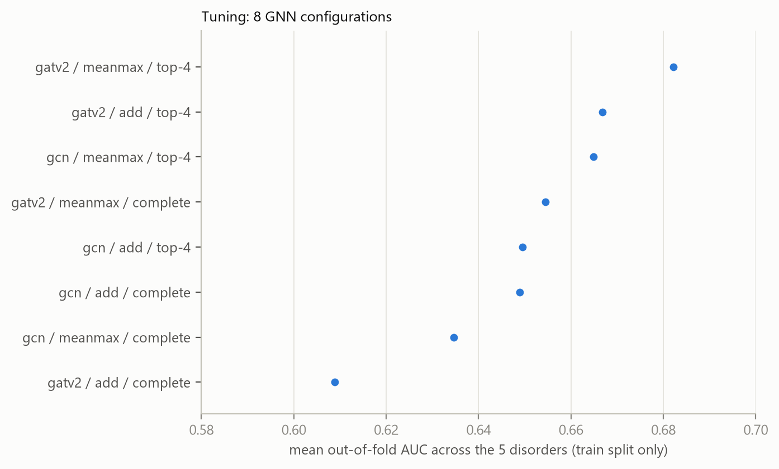
Figure 5. Tuning results (train split only). Point estimates on a zoomed axis: gaps of ~0.02 are within cross-validation noise; the consistent signal is that sparse (top-4) graphs fill the top three places.
conv | pooling | graph | schizophrenia | mood | addictive | trauma | anxiety | mean
gatv2 | meanmax | top-4 | 0.658 | 0.726 | 0.685 | 0.742 | 0.600 | 0.682
gatv2 | add | top-4 | 0.633 | 0.713 | 0.659 | 0.710 | 0.618 | 0.667
gcn | meanmax | top-4 | 0.626 | 0.697 | 0.668 | 0.703 | 0.631 | 0.665
gatv2 | meanmax | complete | 0.624 | 0.701 | 0.668 | 0.689 | 0.589 | 0.654
gcn | add | top-4 | 0.563 | 0.712 | 0.659 | 0.698 | 0.615 | 0.649
gcn | add | complete | 0.600 | 0.697 | 0.663 | 0.671 | 0.614 | 0.649
gcn | meanmax | complete | 0.611 | 0.654 | 0.674 | 0.633 | 0.602 | 0.635
gatv2 | add | complete | 0.590 | 0.633 | 0.619 | 0.600 | 0.601 | 0.609
Pooled out-of-fold AUC per disorder. Mean excludes OCD.

model | train cases / controls | test cases / controls
schizophrenia | 94 / 76 | 23 / 19
mood | 213 / 76 | 53 / 19
addictive | 149 / 76 | 37 / 19
trauma | 102 / 76 | 26 / 19
anxiety | 85 / 76 | 22 / 19
The healthy controls are shared by all five models (95 in the whole corpus).

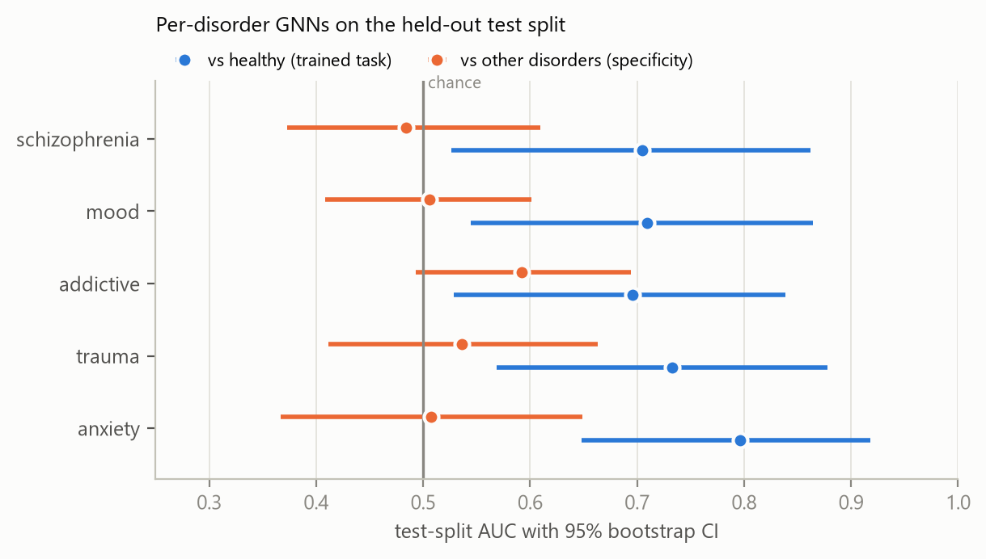
Figure 6. Blue: each model on its trained task. Orange: the same model asked to tell its disorder apart from the other disorders.
model | AUC vs healthy [95% CI] | acc | bal. acc | AUC vs other disorders [95% CI] | Brier raw -> cal.
schizophrenia | 0.705 [0.53, 0.86] | 0.548 | 0.564 | 0.484 [0.37, 0.61] | 0.285 -> 0.230
mood | 0.709 [0.54, 0.86] | 0.750 | 0.644 | 0.506 [0.41, 0.60] | 0.200 -> 0.174
addictive | 0.696 [0.53, 0.84] | 0.625 | 0.614 | 0.592 [0.49, 0.69] | 0.267 -> 0.217
trauma | 0.733 [0.57, 0.88] | 0.667 | 0.655 | 0.536 [0.41, 0.66] | 0.282 -> 0.212
anxiety | 0.797 [0.65, 0.92] | 0.634 | 0.645 | 0.508 [0.37, 0.65] | 0.257 -> 0.203
Held-out test split, 180 subjects. Threshold 0.5 on calibrated probabilities.

model | calibration slope | intercept | OOF AUC | OOF saturated
schizophrenia | 0.165 | -0.209 | 0.667 | 24%
mood | 0.184 | -0.142 | 0.748 | 44%
addictive | 0.103 | -0.159 | 0.690 | 46%
trauma | 0.204 | -0.314 | 0.732 | 36%
anxiety | 0.114 | -0.011 | 0.625 | 6%
Slopes of 0.10-0.20 mean the raw models were 5-10x overconfident. Share of test probabilities above 0.99 or below 0.01: raw 44%, calibrated 0%.

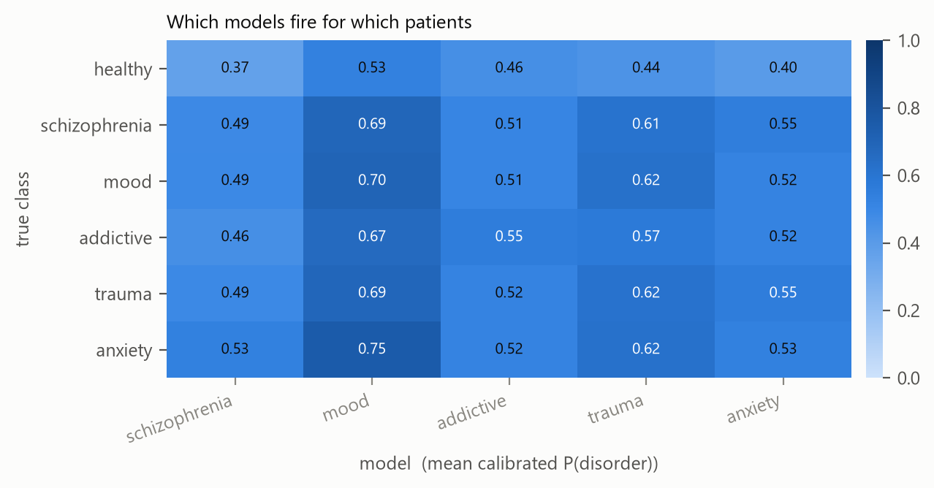
Figure 7. A disorder-specific model would light up only its own row; instead every model fires for all patients.
true class | schizophrenia | mood | addictive | trauma | anxiety
healthy | 0.37 | 0.53 | 0.46 | 0.44 | 0.40
schizophrenia | 0.49 | 0.69 | 0.51 | 0.61 | 0.55
mood | 0.49 | 0.70 | 0.51 | 0.62 | 0.52
addictive | 0.46 | 0.67 | 0.55 | 0.57 | 0.52
trauma | 0.49 | 0.69 | 0.52 | 0.62 | 0.55
anxiety | 0.53 | 0.75 | 0.52 | 0.62 | 0.53

true \ predicted | healthy | schizophrenia | mood | addictive | trauma | anxiety
healthy | 7 | 2 | 7 | 0 | 2 | 1
schizophrenia | 0 | 1 | 15 | 1 | 4 | 2
mood | 4 | 2 | 34 | 2 | 11 | 0
addictive | 6 | 3 | 21 | 3 | 4 | 0
trauma | 2 | 1 | 15 | 2 | 6 | 0
anxiety | 1 | 0 | 17 | 0 | 3 | 1
Ensemble confusion matrix. Accuracy 0.289, balanced accuracy 0.235 [0.18, 0.29], majority-class rate 0.294, chance 0.167.

Outside the healthy range: combining the five models
Because every model detects illness but none names it, the display headline is a single score: the mean of the five calibrated probabilities, flagged at 0.5. This rule was fixed before the test split was scored for it; the maximum is reported only as a secondary check, so the test split was not used to choose between rules.
score | AUC any patient vs healthy [95% CI] | sensitivity at 0.5 | specificity at 0.5
combined, mean | 0.738 [0.59, 0.85] | 0.70 | 0.58
combined, max (secondary) | 0.696 [0.52, 0.84] | 0.92 | 0.37
single schizophrenia model | 0.697 [0.53, 0.83] | - | -
single mood model | 0.702 [0.53, 0.85] | - | -
single addictive model | 0.631 [0.48, 0.77] | - | -
single trauma model | 0.719 [0.57, 0.84] | - | -
single anxiety model | 0.792 [0.67, 0.89] | - | -
Combining did not measurably help: the mean (0.738) sits inside the range of the single models, and the anxiety model alone scored higher. With 19 healthy controls none of these differences is resolvable, and switching the headline to the best single model after seeing these numbers would be test-set selection. At 0.5 the flag catches 70% of patients and wrongly flags 42% of healthy controls.

5.4 Raw EEG across hospitals
Each external dataset contributes its own healthy controls, because site effects in EEG exceed disease effects; patients from one hospital with controls from another would train a site detector. The GNN configuration is the one tuned on Park, so nothing here is selected on these data. Evaluation is subject-level, with subjects never split across folds.
ASEEG ships unlabelled channel columns. The order was recovered from the data (infer_channel_order.py): the electrode correlation fingerprint was matched against labelled Mumtaz recordings, and posterior alpha plus frontal delta resolved the front/back mirror that geometry alone cannot. Output:
marker check on labelled Mumtaz controls: alpha top-5 ['O2', 'O1', 'T6', 'T5', 'P4'] (5/5 posterior), delta top-5 ['FP1', 'FP2', 'F8', 'F7', 'T4'] (4/5 frontal)
candidate orders (column j of ASEEG = candidate[j]):
10-20 row order fingerprint r=0.869 alpha ['O2', 'O1', 'T6', 'T5', 'P4'] (5/5 post) delta ['FP2', 'FP1', 'F8', 'F7', 'F4'] (5/5 front)
left/right pairs, midline last fingerprint r=-0.018 alpha ['PZ', 'CZ', 'FZ', 'T3', 'T6'] (2/5 post) delta ['FP2', 'FP1', 'P3', 'F3', 'C4'] (3/5 front)
left chain, midline, right chain fingerprint r=0.214 alpha ['PZ', 'CZ', 'T6', 'P4', 'T4'] (3/5 post) delta ['F3', 'FP1', 'T3', 'C3', 'F7'] (3/5 front)
alphabetical fingerprint r=0.254 alpha ['T6', 'T5', 'T4', 'P3', 'T3'] (3/5 post) delta ['C4', 'C3', 'F8', 'CZ', 'F7'] (2/5 front)
unconstrained search best fingerprint r=0.898
inferred column order: ['O1', 'O2', 'T5', 'P3', 'PZ', 'P4', 'T6', 'T3', 'C3', 'CZ', 'C4', 'T4', 'F7', 'F3', 'FZ', 'F4', 'F8', 'FP2', 'FP1']
its physiology: alpha ['FP1', 'FP2', 'F8', 'F7', 'F4'] (0/5 post), delta ['O2', 'O1', 'T6', 'T5', 'P4'] (0/5 front)
best candidate: 10-20 row order r=0.869 (next candidate r=0.254, unconstrained r=0.898)
fingerprint clearly separates candidates and is near the optimum: True
physiology (alpha posterior AND delta frontal): True
unconstrained optimum rejected as a front/back mirror: True
VERDICT: ACCEPT '10-20 row order': ['FP1', 'FP2', 'F7', 'F3', 'FZ', 'F4', 'F8', 'T3', 'C3', 'CZ', 'C4', 'T4', 'T5', 'P3', 'PZ', 'P4', 'T6', 'O1', 'O2']
residual assumption: left/right (e.g. FP1 vs FP2) is not identifiable from resting EEG; taken from this standard export order.
dataset | group | subjects | windows kept | rejected
aseeg | controls | 50 | 1480 | 1.3%
aseeg | patients | 51 | 1459 | 4.3%
warsaw | controls | 14 | 420 | 4.1%
warsaw | patients | 14 | 420 | 4.8%
mumtaz | controls | 28 | 828 | 1.2%
mumtaz | patients | 30 | 805 | 7.8%
Windows with any channel peak-to-peak above 300 uV or flat are rejected; at most 30 clean 10 s windows per subject. Mumtaz patients lose more windows (recording differences between groups are a possible confound).

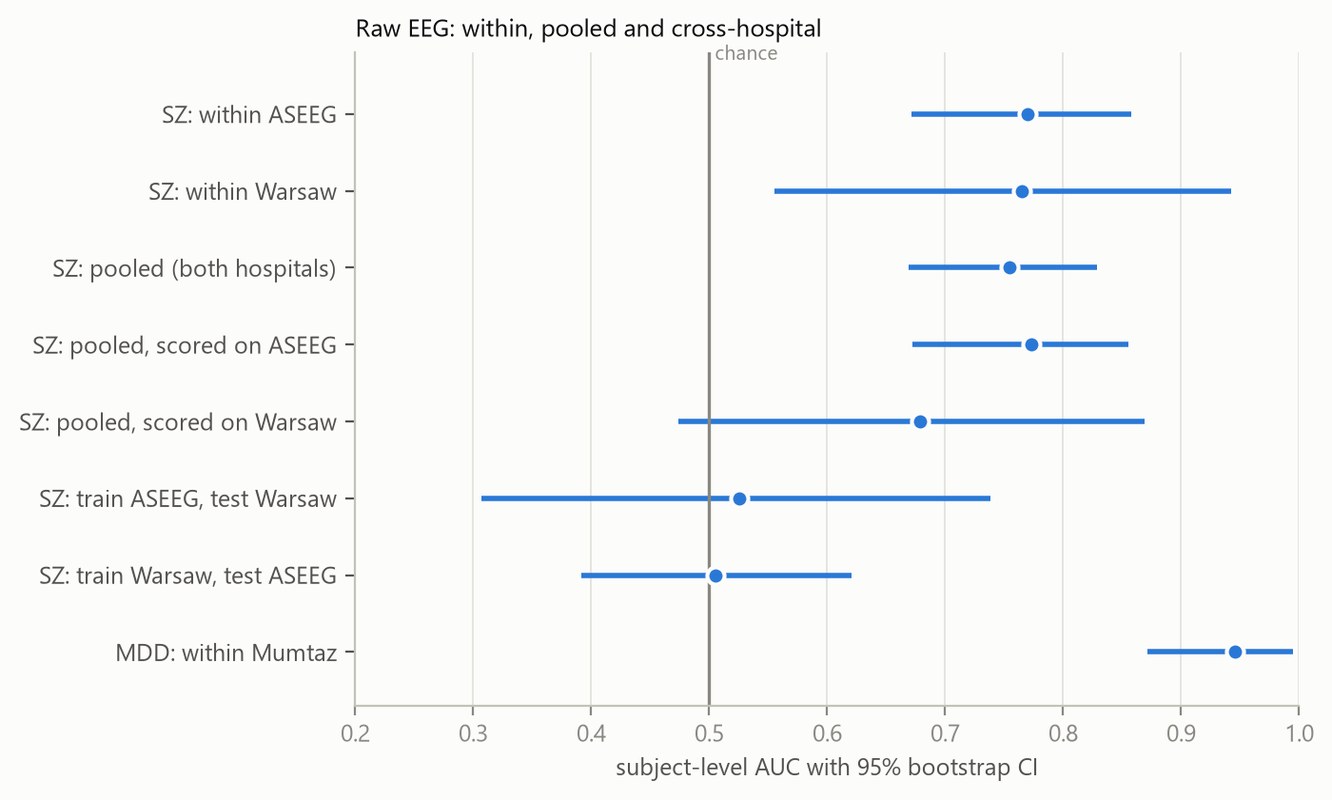
Figure 8. Raw-EEG results. Transfer = train on one hospital, test on the other, never seen.
evaluation | AUC [95% CI] | patients | controls
SZ: within ASEEG | 0.769 [0.67, 0.86] | 51 | 50
SZ: within Warsaw | 0.765 [0.56, 0.94] | 14 | 14
SZ: pooled (both hospitals) | 0.754 [0.67, 0.83] | 65 | 64
SZ: pooled, scored on ASEEG | 0.773 [0.67, 0.85] | 51 | 50
SZ: pooled, scored on Warsaw | 0.679 [0.47, 0.87] | 14 | 14
SZ: train ASEEG, test Warsaw | 0.526 [0.31, 0.74] | 14 | 14
SZ: train Warsaw, test ASEEG | 0.505 [0.39, 0.62] | 51 | 50
MDD: within Mumtaz | 0.945 [0.87, 1.00] | 30 | 28

6. Problems found and fixed
- PyG checkpoint layout changed since 2020: GCN weights moved into a Linear submodule with transposed shape, so porting needs a transpose, not a rename.
- Positive class: the baseline corpus is 87% diseased, so precision/recall against 'healthy' looked nothing like the paper while AUC and balanced accuracy (symmetric) matched.
- Park stores coherence as a percentage (0-100). Fed raw into an unnormalised GCN over a complete 19-node graph, activations grew ~4e8 and accuracy fell below chance.
- float32 softmax saturated to exactly 1.0 for ~44% of test probabilities, erasing ranking and blocking calibration; scoring now uses the float64 logit margin.
- Subject-score aggregation indexed a subset of windows against the full probability array; caught when the first two-dataset run crashed, fixed and covered by a test.
- f-strings containing backslashes parsed only on Python 3.12+; a normalisation test compared two randomly initialised models and was flaky.

7. Limitations
- Small test sets: with 19-23 healthy controls in most comparisons, AUC confidence intervals are roughly +/-0.15. Differences smaller than that are not interpretable.
- One feature row per subject in Park (no raw EEG), so no windowing or augmentation is possible there.
- Depression has only one open raw dataset with controls, so its within-dataset result has no cross-hospital check. Addictive, trauma and anxiety have no open raw dataset with controls.
- ASEEG left/right channel assignment is not identifiable from resting EEG and follows the standard 10-20 export order.
- Per-disorder and raw-EEG results were computed on a laptop CPU (Blackwell node unreachable on 2026-09-13); the baseline and the Park graph study ran on the Blackwell node.

8. Reproduce
python train.py --eval-ckpt # EEG-GCNN reproduction
python per_disorder.py tune | train | calibrate | evaluate
python per_disorder.py predict --ids <subject no.> # per-disorder probabilities
python infer_channel_order.py # ASEEG channel order
python raw_eeg.py features
python raw_eeg.py run --disease schizophrenia | mood
python make_report.py # this document

