**FUNDAMENTAL OF PROGRAMMING**

**ASSIGNMENT 1**

**SUBMITTED BY ABDUL MANAN**

**QALAM ID 462449**

**1 Write a C++ program to display factors of a number using for loops**

#include <iostream>

using namespace std;

int main(){

int num;

cout << "PLEASE ENTER THE NUMBER ";

cin>>num;

cout<<"THE FACTOR OF "<<num<<" : " ;

for (int i = 1; i <= num; i++) {

if (num%i==0) {

cout<<i<<"\n";

}

}

return 0;

}

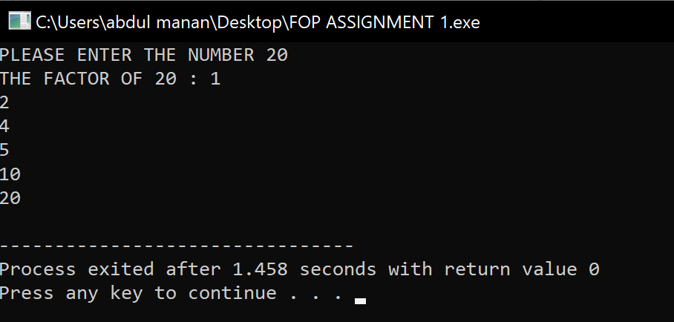

**2 Write output to the following code.**

#include <iostream>

int main() {

int x = 5;

int y = 10;

if (x == 5)

if (y == 10)

std::cout << "x is 5 and y is 10" << std::endl;

else

std::cout << "x is not 5" << std::endl;

return 0;

}

Ans) x is 5 and y is 10

**3 Write a C++ program, take an integer value from user and check if it’s greater than 10 and less than equal to 20. Print 1 if yes and print 0 if no. Use appropriate datatype for output**

#include <iostream>

using namespace std;

int main() {

int num;

cout<<"PLEASE ENTER THE NUMBER: ";

cin>>num;

if (num > 10 && num <=20) {

cout<<"1";

}

else {

cout<<"0";

}

return 0;

}

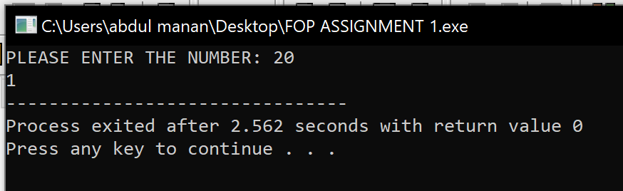

v

**4 Write a C++ program that uses a while loop to find the largest prime number less than a given positive integer N. Your program should take the value of N as input from the user and then find the largest prime number less than or equal to N. You are not allowed to use any library or pre-existing functions to check for prime numbers**

#include <iostream>

using namespace std;

int main() {

int n, i, factor, j ;

cout<<"PLEASE ENTER YOUR NUMBER: ";

cin>>n;

i = n;

while (i >= 2) {

factor = 0;

j = 1;

while (j <= i) {

if (i%j==0) {

factor++; }

j++; }

if (factor==2) {

cout<<"THE HIGHEST PRIME NUMBER LOWER THAN N : "<<i;

break; }

i--; }

return 0;

}

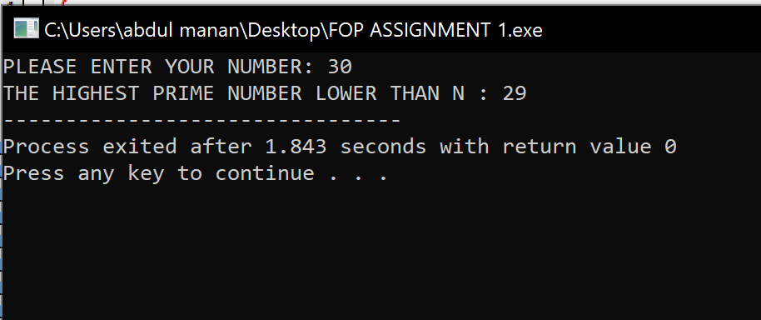

**5 Write a C++ program, take two string as input from user and check if both strings are equal or not. If they are equal make them unequal by rotating string. e.g., Hello is turned into olleH etc**

#include <iostream>

#include <string>

using namespace std;

int main()

{

string stng1, stng2, rotated;

rotated= "";

cout<<"ENTER YOUR FIRST STRING "<<endl;

cin>>stng1;

cout<<"ENTER YOUR SECOND STRING: "<<endl;

cin>>stng2;

if (stng1==stng2) {

for (int i=0; i < stng1.length(); i++) {

rotated = stng1[i] + rotated;

}

cout<<"BOTH STRINGS ARE EQUAL THEREFORE ROTATED STRING IS "<<endl;

cout<<rotated;

}

else {

cout<<"BOTH STRINGS ARE UNEQUAL";

}

return 0;}

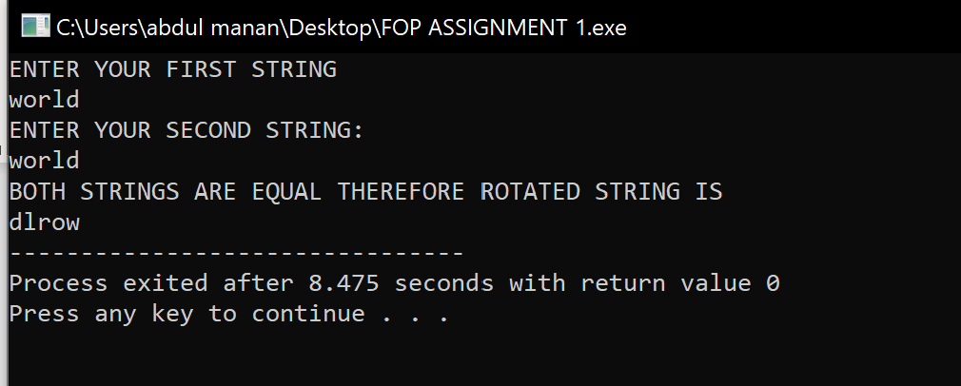

**6 Perform division in C++ without / using for loops. You can use / only to display the final results. Your dividend must be greater than divisor.**

#include <iostream>

using namespace std;

int main() {

int dividend, divisor, remainder, quotient;

cout<<"MAKE SURE THAT DIVIDEND IS GREATER THAN THE DIVISOR"<<endl;

cout<<"ENTER THE DIVIDEND "<<endl;

cin>>dividend;

cout<<"ENTER THE DIVISOR "<<endl;

cin>>divisor;

if (dividend < divisor) {

cout<<"PLEASE ENTER DIVIDEND AGAIN AND MAKE SURE IT IS GREATER THAN DIVISOR"; }

remainder = dividend;

for (int i = 1; i <= dividend; i++) {

remainder -= divisor;

if (remainder < divisor) {

quotient = i;

break; }

}

cout<< dividend <<"/"<<divisor<<"="<<quotient<<endl;

return 0;

}

**7 Write a C++program for a string which may contain lowercase and uppercase characters. The task is to remove all duplicate characters from the string and find the resultant string**

#include <iostream>

#include <string>

using namespace std;

int main() {

string stng, result;

bool found;

cout<<"Enter String: ";

cin>>stng;

result = "";

for (int i = 0; i < stng.length(); i++) {

found = false;

for (int j = 0; j < result.length(); j++) {

if ( stng[i] == result[j] ) {

found = true; }

}

if (found == false) {

result += stng[i];

}

}

cout<<"RESULT "<<result;

return 0;

}

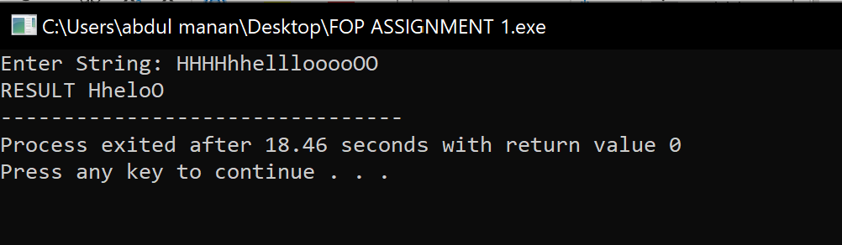

**8 Suppose an integer array a[5] = {1,2,3,4,5}. Add more elements to it and display them in C++**

#include <iostream>

using namespace std;

int main(){

int x,new_array[5+x], array[5] = {1,2,3,4,5} ;

cout<<"ARRAY {";

for (int i = 0; i<5; i++) {

cout<<array[i];

cout<<" , ";

}

cout<<"}"<<endl;

cout<<"ENTER HOW MANY ELEMENTS YOU WANT TO ADD TO THE ARRAY"<<endl;

cin>>x;

for (int i = 0;i<5;i++) {

new_array[i] = array[i];

}

cout<<"ENTER THE " << x << " NEW INTEGERS NEEDED TO BE ADDED TO ARRAY "<<endl;

for (int i =5;i<5+x;i++)

cin>>new_array[i];

cout<<"NEW ARRAY WITH THE THE ADDITIONAL ELEMENTS"<<endl;

cout<<"NEW ARRAY = {";

for (int i = 0; i<5+x; i++) {

cout<<new_array[i]<<" ";

cout<<" , ";

}

cout<<"}"<<endl;

return 0;

}

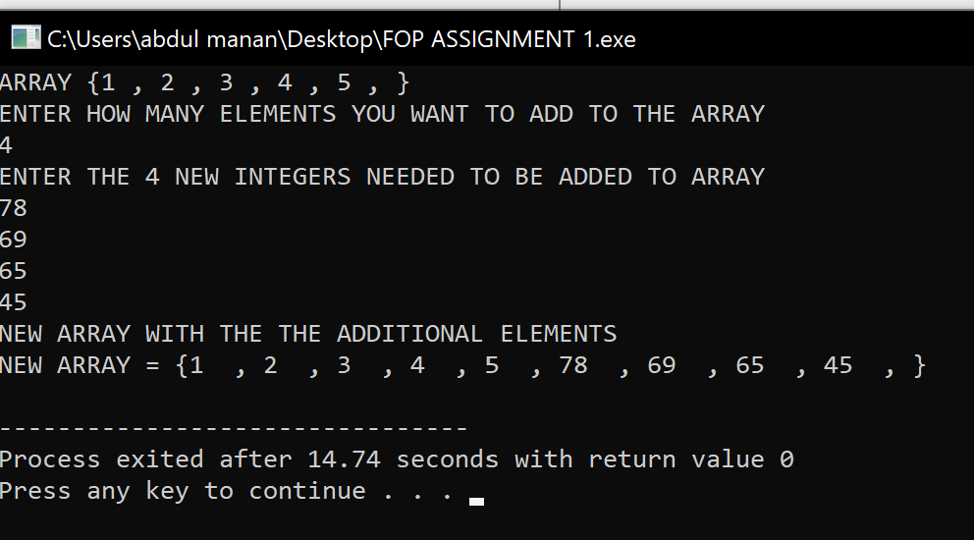

**9 Given an integer array and an integer X. Find if there’s a triplet in the array which sums up to the given integer X**

#include <iostream>

using namespace std;

int main() {

int array[6],X,sum,a,b,c;

cout<<"PLEASE ENTER THE ELEMENTS OF ARRAY "<<endl;

for (a=0; a<8; a++) {

cin>>array[a]; }

bool result = false;

cout<<"PLEASE ENTER THE INTEGER X "<<endl;

cin>>X;

cout<<"TRIPLET GIVING SUM EQUAL TO INTEGER X ARE "<<endl;

for (a=0; a<8; a++) {

for (b=0; b<8; b++) {

if (a==b)

continue;

for (c=0; c<8; c++) {

if (c== a || c == b)

continue;

sum = array[a] + array[b] + array[c];

if (sum == X) {

cout<<" ("<<array[a]<<", "<<array[b]<<", "<<array[c]<<")";

result = true; } } } }

if (result == false) {

cout<<"\n";

cout<<"\n";

cout<<"!!! SORRY NO SUCH TRIPLETS ARE PRESENT IN THE ARRAY !!!"<<endl; }

return 0;

}

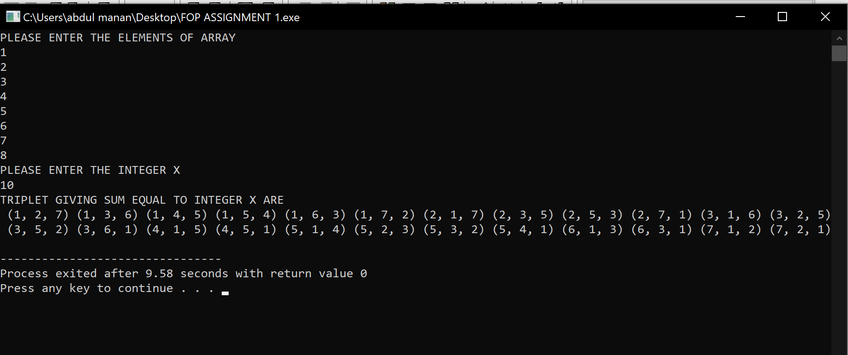

**10 Implement Bubble Sort on an array of 6 integers.**

#include <iostream>

using namespace std;

int main() {

#define num 6

int a[num], x,y,z;

cout<<"ENTER THE ELEMENTS OF ARRAY "<<endl;

for(x=0;x<num;x++)

{

cin>>a[x];}

for(x =0;x<num-1;x++) {

for(y = 0; y < num-1-x; y++) {

if(a[y] > a[y+1]) {

z = a[y];

a[y] = a[y+1];

a[y+1] = z;}

} }

cout<<"SORTED ARRAY = ";

cout<<"{";

for(x = 0; x < num; x++) {

cout << a[x] << " ";

}

cout<<"}";

}

