TASK 1

**#include <iostream>**

**using namespace std;**

**int main(){**

**int sum, a,b;**

**while(b<=10) {**

**cout<<"Enter the numbers you want sum of"<<endl;**

**cin>>a;**

**sum+=a;**

**b++;**

**}**

**cout<<"the sum of first 10 first natural numbers "<< sum<<endl;**

**return 0 ; }**

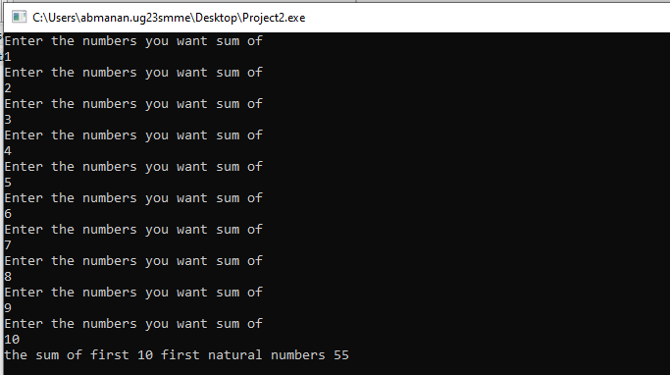

**TASK 2**

**#include <iostream>**

**using namespace std;**

**int main(){**

**int i=1,A,B;**

**cout<<"please write the number for which you want the table of"<<endl;**

**cin>>A;**

**while(i<=10){**

**cout<< A << " * "<< i<<" = "<< A*i<<endl;**

**i++;**

**}**

**return 0;**

**}**

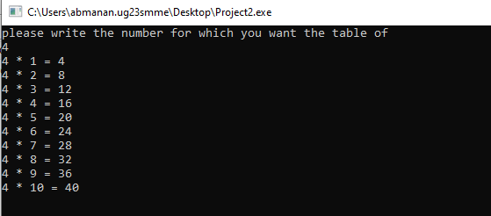**\**

**TASK 3**

**#include <iostream>**

**using namespace std;**

**int main()**

**{**

**int f=1,n,i;**

**cout<<"Please write the number for which you need factorial of "<<endl;**

**cin>>n;**

**for(i=1;i<=n;i++){**

**f=f*i;**

**}**

**cout<<"the facorial of "<< n<<" is "<< f <<endl;**

**return 0;**

**}**

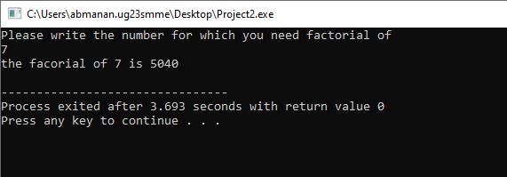

**TASK 4**

**#include <iostream>**

**using namespace std;**

**int main() {**

**int num1,num2,t,a;**

**cout<<"ENTER THE FIRST TERM OF THE SEQUENCE"<<endl;**

**cin>>num1;**

**cout<<"ENTER THE SECOND TERM OF THE SEQUENCE"<<endl;**

**cin>>num2;**

**cout<<"ENTER HOW MANY TOTAL TERMS TO BE PRESENTED"<<endl;**

**cin>>t;**

**cout<<num1<<endl<<num2<<endl;**

**for(int i=1;i<t-2;i++)**

**{**

**a=num1+num2;**

**num1=num2;**

**num2=a;**

**cout<<a<<endl;**

**}**

**}**

