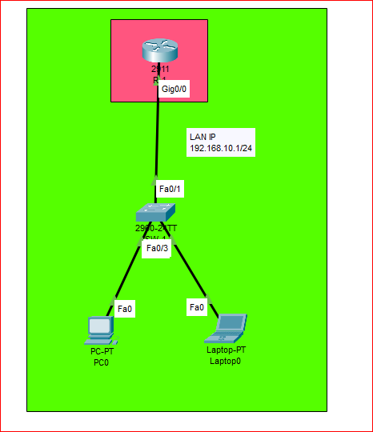

1. Requirements
- Devices Needed:
  - Cisco Router 2811
  - Cisco Switch 2960
  - 1 Laptop
  - 1 PC
- Software:
  - Cisco Packet Tracer
- Objective:
  - Connect Router, Switch, Laptop, and PC.
  - Configure basic IP addressing.
  - Configure DHCP

2. Network Topology
- Router 2811 connected to Switch 2960 Gigabit 0/0.
- Laptop connected to Switch 2960 via FastEthernet port.
- PC connected to Switch 2960 via FastEthernet port.
_________________

3. Configuration Steps
A. Router Configuration
Router> enable
Router# configure terminal
Router(config)# hostname R1
R-1 (config)# interface gig0/0
R-1 (config-if)# ip address 192.168.10.1 255.255.255.0
R-1 (config-if)# no shutdown
R-1 (config-if)# exit
R-1 (config)# banner motd !Welcome To Net_Tech #Warning! Authorized users only! DHCP_Configuration!
R-1 (config)# exit
R-1# write
R-1(config)# username DHCP password DHCP
R-1(config)# line Console
R-1(config-line)# login local
R-1(config-line)#exit
R-1(config)# do write

4. DHCP Configuration on Router
Step 1: Enable DHCP and define pool
R1> enable
R1# configure terminal
R1(config)# ip dhcp pool LAN-Network
R1(dhcp-config)# network 192.168.10.0 255.255.255.0
R1(dhcp-config)# default-router 192.168.10.1
R1(dhcp-config)# dns-server 8.8.8.8
R1(dhcp-config)# exit
Exclude Router IP from DHCP
R1(config)# ip dhcp excluded-address 192.168.10.1 192.168.10.10

6. Laptop and PC Configuration for DHCP
- Set IP configuration to Obtain IP Address Automatically (DHCP).
- After connecting to switch, the devices will get:
  - Laptop: e.g., 192.168.10.11
  - PC: e.g., 192.168.10.12
  - Gateway: 192.168.10.1
  - DNS: 8.8.8.8

