**AUTOMATED NO DUES CLEARNCE SYSTEM**



A thesis submitted by

1. **Naimat U llah Nohari (Group Leader) 14CS42**

2. Abdul Maroof Yousfani 14CS08

3. Zuhaib Shaikh 14CS14

4. Naresh Kumar 14CS56

5. Dawood Pathan 14-13CS184

Supervised by

**A.Prof. Liaquat Ali Thebo**

Department of Computer Systems Engineering

Mehran University of Engineering and Technology, Jamshoro

Submitted in partial fulfillment of the requirement for the degree

Of Bachelor of Computer Systems Engineering

Octomber, 2017

*Dedicated to our parents and teachers for their endless love, support and encourage.*



Certificate

This is to certify that the work presented in this thesis titled as “AUTOMATED NO DUES CLEARANCE SYSTEM” is entirely written by the following students themselves as a partial fulfillment of requirement for degree of Bachelor of Computer Systems Engineering.

|  |  |
| --- | --- |
| **Name of Student** | **Roll no.** |

1. Naimat U llah Nohari (G.L) 14CS42

2. Abdul Maroof Yousfani 14CS08

3. Zuhaib Shaikh 14CS14

4. Naresh Kumar 14CS56

5. Dawood Pathan 14-13CS184

|  |  |
| --- | --- |
| ____________________________  **Project/Thesis Supervisor** | **____________________________**  **External Examiner** |
| _____________________________________  **Chairman  Department of Computer System Engineering** | |

Date: _____________________

**Acknowledgment**

First of all we are very much thankful to the Almighty Allah for giving us strength and capability to develop this application.

Our heartful gratitude goes to our project supervisor ***A.Prof. Liaquat Ali Thebo,*** for his significant guidance, encouragement, appreciation and inspiration. In particular, we are very much thankful for the greatest counseling, the ideas he gave and the precious time he devoted for the supervision of our project.

Our greatest thanks go to **Prof*. Dr. Sheeraz Memon****,* Chairman Computer Systems Engineering and Director Institute of Information and Communication Technology, Mehran University of Engineering and Technology, Jamshoro, who has always been cooperative and supportive. His encouragement and appreciation made us able to work effectively and efficiently.

Last, but not the least, we are grateful to our family and friends for their co-operation and help in all respects during study period which enabled us to progress expeditiously.

**ABSTRACT**

It is noticed that when a student graduates from a university he has to clear a no dues clearance form from each department before getting degree. Each Student has to go to every particular department to get their no dues form signed from respective authorities of the department so that if there are any dues then it must be cleared. Current system is manually process that is time consuming.

Therefore we are focusing on developing an automated no dues system which will generate computerized no dues form showing the dues status.

Automated No Dues clearance system is an internet base research work that will help build an effective information management for universities. It is aimed at developing an automated system that replaces the manual method of clearance for graduating students. The designed software will serve as a more reliable and effective means of undertaking students clearance, remove all forms of delay and stress as well as enable you to understand the procedure involved, as well as how to do your clearance online. This project work makes use of raw data and the software is developed to effectively achieve the aim of the project. In this project the implementation is carried out with PHP, MYSQL as the database. In conclusion it will meet all the objectives and it will be recommended for all the departments in a university.

Objective of the existing system is to unable student to clear all their dues before leaving the university. The clearance system is designed to help student pay/clear all their dues and obtain a clearance certificate.

Table of Contents

DESCRIPTION PAGE

ACKNOWLEDGEMENTS IV

ABSTRACT V

LIST OF FIGURES IX

CHAPTER: 01- INTRODUCTION ………………....……..…………………....01

1.1. INTRODUCTION……………………………………………………………**01**

1.2. BACKGROUND OF STUDY…………………………………………….....02

1.3. PURPOSE…………………………………………………………………....02

1.4. PROBLEM…………………………………………………………………...02

1.5. STATEMENT OF PROBLE………………………………………………...03

1.6. PROPOSED SOLUTION…………………………………………………....03

1.7. OBJECTIVES OF THE STUDY…………………………………………….04

1.8. SIGNIFICANT OF THE STUDY…………………………………………...04

1.9. SCOPE OF STUDY…………………………………………………………05

1.10.LIMITATIONS……………………………………………………………..05

1.10.1.TIME CONSTRAINTS…………………………………………………05

1.10.2. FINANCIAL CONSTRAINTS………………………………………...05

1.11. DEFINITION OF TERMS………………………………………………....06

1.12. STRUCTURE OF THESIS………………………………………………...07

CHAPTER: 02- LITERATURE REVIEW ………………..………………....…..08

2.1.ROLE OF INFORMATION TECHNOLOGY IN ACADMIC SYSTEM ….08

2.2. DATA AND INFORMATION……………………………………………....09

2.3.TECHN0LOGY ENHANCE SOFTWARE BASED SYSTEM……………..10

2.4. COMPUTER BASED ONLINE INFORMATION SYSTEM……………....12

2.5. DATA BASES……………………………………………………………….13

2.6.COMMUNICATION TECHNOLOGY USED IN CLEARANCE SYSTEM.15

**CHAPTER: 03- METHODOLGY**…………………………………………..…….**16**

3.1. GENERAL ANALYSIS OF EXISTING SYSTEM…………………………16

3.2.METHOD OF DATA COLLECTION ………………………………………16

3.2.1. PRIMARY SOURCE………………………………………………...….16

3.2.2. SECONDARY SOURCE………………………………………………..17

3.3. ORAL INTERVIEW…………………………………………………………17

3.3.1. STUDT OF MANUAL…………………………………………………..17

3.3.2. EVOLUATION OF FORUM…………………………………………....17

3.4. PROBLEM OF THE CURRENT SYSTEM…………………………………17

3.5. JUSTIFICATION FOR NEW SYSTEM……………………………………18

3.6. METHODOLOGY…………………………………………………………...19

3.7. FLOW OF THE SYSTEM…………………………………………………...20

3.8. ROLES OF USERS…………………………………………………………..21

3.8.1. ADMIN ROLE…………………………………………………………..21

3.8.2. STUDENT ROLE…………………………………………………….....21

3.8.3. TEACHER ROLE……………………………………………………….21

CHAPTER: 04 - TOOLS AND TECHNOLOGIES …………………...…….....23

4.1. WAMP INTRODUCTION………………………………………………….23

4.1.1 Apache Introduction……………………………………………………...24

4.1.2 MariaDB Introduction……………………………………………………24

4.1.3 PHP Introduction…………………………………………………………25

4.2. SUBLIME TEXT…………………………………………………………….26

4.3. VISUAL PARADIGM……………………………………………………….27

4.4 HTML5………………………………………………………………………..28

4.5 CSS3…………………………………………………………………………..29

4.6 BOOTSTRAP…………………………………………………………………30

4.7 JAVASCRIPT…...……………………………………………………………30

4.8 JQUERY………………………………………………………………………31

4.9. AJAX…………………………………………………………………………32

4.10. PERL………………………………………………………………………..33

4.10.1 PERL FEATURES……………………………………………………...34

4.11. OOP…………………………………………………………………………35

CHAPTER: 05 – IMPLEMENTATION AND TESTING ……...…..……….....36

5.1. UI DESIGN………………………………………………………………….36

5.2. IMPLEMENTED DESIGN TEMPLATE…………………………………...36

5.3. THE INDEX PAGE………………………………………………………….36

5.4. IMPLEMENTATION………………………………………………………..37

5.4.1. THE SIGN-IN PAGE 37

5.4.2. CLEARANCE PAGE 38

5.4.3. TEACHER’S CLEARANCE VIEW 39

5.4.4. DEAPARTEMENT CLEARANCE PAGE 40

5.4.4.1 STATUS OF STUDENTS BEFORE TEACHER’S CLEAREANCE 40

5.4.4.2. APPLY FOR DEPARTEMNET CLEARANCE 40

5.4.4.3. STATUS OF STUDENTS AFTER TEACHER’S CLEARANCE 40

5.4.5. LIBRARY CLEARANCE PAGE 40

5.4.5.1. THE BBAUTIFUL USER INTERFACE TO APPLY 41

5.4.5.2. AFTER LIBRARY CLEARANCE 41

5.4.6. SEMINAR CLEARANCE PAGE 41

5.4.6.1. INTERFACE TO APPLY FOR CLEARNCE 41

5.4.6.2. AFTER CLEARNCE 41

5.4.7. SPORTS CLEARANCE PAGE 42

5.4.7.1. INTERFACE TO APPLY FOR CLEARNCE 42

5.4.7.2. ATER CLEARNCE 42

5.4.8. EXAMINATION CLEARANCE PAGE 42

5.4.8.1. INTERFACE TO APPLY FOR CLEARNCE 42

5.4.8.2.AFTER CLEARANCE 42

5.4.9. HOSTEL CLEARANCE PAGE 43

5.4.9.1. INTERFACE TO APPLY FOR CLEARNCE 43

5.4.9.2.AFTER CLEARANCE 43

5.4.10. ACCOUNTS CLEARANCE PAGE 43

5.4.10.1. INTERFACE TO APPLY FOR CLEARNCE 43

5.4.10.2.AFTER CLEARANCE 43

5.5. UI INTERFACE FOR ADMIN PANEL……………………………………..44

5.5.1. LOGIN PAGE 44

5.5.2. THE ADMIN PANEL 44

5.5.3. THE USER MANAGEMANT PAGE IN ADMIN PANEL 45

5.5.4. ADD USER PAGE IN ADMIN PANEL 46

5.5.5. CLEARANCE PAGE 47

5.5.6. HOD PAGE 48

5.5.7. ALL DEPARTMENTS PAGE 48

5.5.8. ADDING DEPARTMENT PAGE 48

5.6. TESTING THE WEB APPLICATION 49

5.6.1. FUNCTIONAL REQIREMENT TESTING 49

5.6.2. TEST CASE 1- SIGNUP 49

5.6.3. USER IN VALID 50

5.6.4. TEST CASE 2- TEACHERS CLEARANCE 50

5.6.4.1. TEACHERS APPROVALS 50

5.6.5. TEST CASE 3- PRINTING DOCUMENTS 51

5.6.5.1.STUDENT DUES CLEARANCE FROM ALL DIRECTORATES 51

5.6.5.2.PRINTING THE CLEARANCE FORM 52

CHAPTER: 06 – CONCLUSION AND FUTURE WORK……………………...53

6.1. CONCLUSION………………………………………………………………..53

6.2. FUTURE WORK……………………………………………………………...53

**REFERENCES**…………………………………………………………………...54

**LIST OF FIGURES**

Figure 3.1: Methodology 20

Figure 3.2: Flow chart 22

Figure 4.1: WAMP multitier architecture diagram. 23

Figure 4.2: Apache server architecture diagram 24

Figure 4.3: Logo of Maria-Db database. 25

Figure 4.4: Logo of Php Language 26

Figure 4.5: Sublime Text IDE 27

Figure 4.6: IDE for Visual Paradigm 28

Figure 4.7: Logo of HTML5 28

Figure 4.8: Logo of CSS3 29

Figure 4.9: Logo of Bootstrap 30

Figure 4.10: Logo of JavaScript. 31

Figure 4.11: Logo of jQuery 32

Figure 4.12: Logo of Ajax Programming 33

Figure 4.13: Logo of Perl Programming 34

Figure 4.14: Logo of object oriented programming 35

Figure 5.1: Index page 37

Figure 5.2: Login interface 37

Figure 5.3: Apply page 38

Figure 5.4: Pending page 39

Figure 5.5: Clearance view 39

Figure 5.6: Apply1. 40

Figure 5.7: Apply2. 41

Figure 5.8: Apply3. 41

Figure 5.9: Apply4. 42

Figure 5.10: Apply5. 42

Figure 5.11: Apply6. 43

Figure 5.12: Apply7. 44

Figure 5.13: Sign-in page. 44

Figure 5.14: Admin Panel. 45

Figure 5.15: Management page. 45

Figure 5.16: Admin interfaces. 46

Figure 5.17: Add user page. 47

Figure 5.18: Clearance page. 47

Figure 5.19: HOD view. 48

Figure 5.20: Deparments view. 48

Figure 5.21: Add departement view. 48

Figure 5.22: Log-in View 49

Figure 5.23: User in valid view 50

Figure 5.24: Approvlas view 50

Figure 5.25: Apply8 51

Figure 5.26: Printing form view 51

Figure 5.27: Printed form view 52

# CHAPTER:-01

# INTRODUCTION

## 1.1 INTRODUCTION

A clearance is a certificate giving permission to disengage from an institution. Final year students who have satisfied the academic requirements to graduate must undergo a clearance process before they disengage from the university. The process of clearing involves the Student’s academic department, Faculty, Library, Hostel, Sports department, Examination department, Accounts office, Gymnasium and ELDC.A student is allowed to collect his/her graduation certificate only after he/she has been cleared for something to be done.

Automated No Dues Clearance System is software developed for students to clear their No dues clearance form in universities. If facilitates to access the no dues clearance signed of a particular student through him/her login ID in a particular department. The information is sorted by the operators, which will be provided by the employee for a particular working day. This system will also help to clear no dues computerized in compare to manually. Students are supposed to get their no dues cleared from each department at the end of the degree or at any point of time they want to leave the university which is very tedious and pain staking job. Each Student has to go to every particular department to get their no dues form signed from respective authorities of the department so that if there are any dues then it must be cleared. Therefore we are focusing on developing a no dues clearance system which will generate computerized no dues form showing the dues status. When a student is about to graduate, he/she will take his/her degree exam after which he obtains a clearance letter from various departments and unions. The Registrar's Office carefully reviews each degree candidate's academic record and certifies to the faculty that the candidate has completed requirements for the degree. Also the bursary has to certify that the student has completed all payments. The current clearance system of the university is a manual one. This makes the system so tedious and time consuming. Here, students have to visit all the clearance offices with a form for them to sign. Once these forms are signed, it proves that the student has been cleared. This process takes some months to be completed and posses a lot of stress to both staff and students involved. In the manual system, the clearance forms are documented in a file cabinet. Each time the clearance form is needed, a search operation is conducted on the file cabinets to locate a particular student’s clearance form.

## 1.2 BACKROUND OF STUDY

Mehran UET is a public research university in Jamshoro, Sindh, Pakistan focused on STEM education. Mehran UET established in July 1976, as a campus of the University of Sindh, and a year later was charted as an independent university. Mehran UET aims to promote technological change and sustainable development through higher education, research and outreach. Towards this end, it will provide a rewarding and challenging environment for faculty, staff and students. In university like Mehran UET, Clearance form is important to clear before getting a degree. when a student is about to graduate he has to clear no dues form and there process is manual process which is time consuming, therefore there is need for automated method of clearing dues computerized, more so a greater needs for an Automated no dues clearance system. This would a long way in alleviating the various problems and stress involved in the manual method of clearance. Moreover, the issue of delayed for students as well as for employees as a result of mobility to complete the tedious manual process of clearance would be curtailed.

## 1.3 PURPOSE

The purpose of developing Automated no dues system is to computerized the tradition way of clearing no dues form. Another purpose for developing this software is to generate the report automatically at the end of the session or in the between of the session.

## 1.4 PROBLEM

The process of clearing students of a named institution Mehran UET after graduation requires that the students must be cleared in their various departments and information units. Among which are:

* Departmental Dues
* Library Dues
* Hostel Dues
* Gymnasium Dues
* Transport Dues
* Examination department dues
* Accounts office dues

Furthermore, for a graduating student to carry out his/her clearance from all these departments it normally takes a lot of time and a lot of processes and delay in clearing the student for youth service as well as collection of statement of results. Hence, it became imperative for computer software based automated clearance system to eliminate the shortcoming of the manual system in place.

* Due to the manual means being used by the University, in keeping information about student’s clearance, a lot of problems are encountered which includes:
* Delay in processing clearance form.
* Unavailability of some key staff while processing clearance form, which leads to students repeatedly visiting a particular office in other to sign his/her clearance form.
* Loss of vital documents as the filing system manual.
* Damage of documents due to fire incident.
* Illegal removal of forms by fraudulent staff leading to insecurity.
* Takes a lot of time to retrieve a particular clearance form.

**1.5 STAMENT OF PROBLEM**

*“To develop an Automated Clearance system which will generate computerized no dues form showing the dues status”.*

**1.6 PROPESED SOLUTION**

After analyzing the above mentioned manually process that is time consuming, we decided to go with the solution that uses the automated clearance system which is more effective than manually process and process will be done within limited time.

Our project proposes the ability to create an automated clearance system that functions using online no dues clearance but efficiently. With the help of automated clearance system we can sign/approve clearance form through digital signatures from every particular department or a teacher online through IDs.

## 1.7 OBJECTIVES OF THE STUDY

The main objective of this Automated no dues clearance system is to reduce the consumption of time usually taken during maintaining the records of the dues management. Separate divisions are developed to maintain the records of authority, students, and dues details.

* Effective and efficient way for student’s clearance.
* To provide a reliable and transparent system devoid of personal inclinations and interest.
* To alleviate the problems and stress of travelling and queuing up of students during
* To design the environment for automation.
* To enter data in MySQL database.
* Protection of data/provide software’s security.
* Testing of possible solution on a selected structure.
* Student’s information will be gathered for creating database.
* To provide borderless access.
* To ensure prompt clearance.

## 1.8 SIGNIFICANT OF THE STUDY

The project work will help in a good number of ways to ease the queuing system in the university as the automated clearance system will help student to achieve whatever they want to achieve without coming to the various offices for clearance. Clear advantages of automated information processing over those of traditional manual system are higher yields. Automated clearance system allows the users to check their clearance status as whether they are in any way indebted to the school, fill and submit their clearance form, and obtain their clearance letter. There are many other advantages of online clearance system and some of them are listed below:-

* It saves a lot of time.
* It is very convenient to use it right from the bedroom, office or anywhere in the world.
* Information processing is very fast and delays can be avoided.
* It is inexpensive to student and school management.
* It is also help the school in reducing cost such as labor and stationary.

## 1.9 SCOPE OF THE STUDY

Need of system to develop an automated clearance system for documenting, fast and better record keeping in an institution.

This project work is to develop computer software based automated Clearance system for doing clearance for graduating students of an institution.

## 1.10 LIMITATIONS

This project covers some of the aspect of a computer software based automated clearance system using CSE MUET as case study. However the following are the constraints:

**1.10.1 TIME CONSTRAINTS**: Due to time constrain the web-page covers only clearance for various departments by the graduating student.

**1.10.2 FINANCIAL CONSTRAINTS:** Due financial constraints people cannot afford this kind of process online especially towards the cost of accessing the internet. Therefore, it would cost a lot to develop a full web-based clearance system. Some documents were considered confidential and were not made available.

**1.11 DEFINITION OF TERMS**

**Computer Network:** Computer network is a system that connects two or more computers together using a communication link.

**World Wide Web:** World Wide Web simply called “www” is the most important tool of the internet, it was created in the late 1980’s in Europe and was limitedly use in academics cycle.

**Clearances:** official certification of blamelessness trust worthiness or suitability for graduation and issue of certificate in degree course.

**File Transfer:** Any kind of computer file can be sent via the internet from one internet user to another. Table of account in a spreadsheet, design by a graphic artist, music and sound files etc can all be exchanged in this way.

**Web Browser:** this is special kind of software that processes hypertext mark-up language (HTML) document. In other words, a web browser is a computer program that interprets HTML command to collect, arranged and display the parts of a web page.

**Web Site:** A web site is a collection of many interconnected web page organized by a specific college, organization company etc, containing web page (goods and commodities) on the internet. Web site is stored on web servers. There are many web sites and thousand of HTML pages on each web site. A web is a treasure of information and entertainment.

**Hyperlinks:** Hyperlinks are highlighted words and phrase you find on a web document that you can click on as to jump to some other document or internet services.

**Online:** connected via a computer attached to or available via a central computer network.

**Offline:** Disconnected from computer network, describe a computer terminal or peripheral devices disconnected from a computer network.

**System:** Set of computer components that is, an assembling of hardware, software and peripheral functioning together.

## 1.12 STRUCTURE OF THE THESIS

The complete thesis is organized into six chapters. Chapter 01 provided the introduction to the research and its background study. It also presented the motivations of the research. Further, it described the problem statement and presented the research goals.

Chapter 02 presents the literature review of the research. All the experimental study conducted, related to the research is concluded. The weaknesses of the previous methods are also summarized and concluded.

Chapter 03 discusses all the methodologies, experimental settings, tools and solutions to address the research questions. The chapter describes the methodology of this system. In the end, the project development life cycle is discussed in detail.

Chapter 4 introduces the detailed related tools and technologies which used to accomplish web application, such as: PHP, CSS and JavaScript.

Chapter 05 presents and discusses all the results of the experiments presented in the previous chapter. Finally, the performance of the classifiers is compared on the basis of the experimental results.

Chapter 06 discusses conclusion of the study. It presents the concluding statements on the basis of the experimental results. It describes the shortcomings of the study and future recommendations to the researchers and finally concludes the whole study.

**CHAPTER:-02**

**LITERATURE REVIEW**

## ROLE OF INFORMATION TECHNOLOGY IN ACADEMIC

## SYSTEM

## The introduction of computer into information technology has massively improved the information need of organization; the success of this machine is dependent on the knowledge base. Therefore, one can be prompted to ask aloud “what is a computer” Funk (1980) defined a computer as an electronic device that can perform automatically at a high speed of a sequence of logical operations according to instructions giving to it inform of pre-arranged program.

Anigbogu (2000) define a computer as an electronic device capable of accepting data and instruction; process the data base on the instruction to generate result or output in such a manner that is yet to be equaled by any other known machine to mankind.

Chimezie (1990) define computer by saying that computers are looked upon as obedient servants who are ever ready to free man from tedious procedures and produce result as compared with human computing time.

Obilikwu (1995) define a computer as a machine that is capable of accepting input data, store and process the data base on the instructions giving by the computer users and in this way produce expected result, generally called output.

World net describes an information system (I.S) as systems consisting of all communication channels used within an organization and include software and hardware. It may also be define as a system that collect and process data (information) and provide it to manager of all levels that use it for decision making, planning, program implementation and control. The aim of information system to admission, registration, result processing and clearance in universities using computer software based online clearance system is to improve the quality and accuracy of information provided to all involved as well as assisting universities in compiling and reporting information, making work lesser for the management. Information technology has been an integral part of academic system since almost four decades. According to Hewlet (1993) the world is entering an era in which technology will literally transform every aspect of business, every aspect of life and every aspect of society. Since the arrival of internet technology, school system has taken a new shape style with a blend of convenience and satisfaction. Taylor (1980) says that computer base education includes both computer-assisted instruction programs that interact with students in a dialogue and a broader array of educational computer applications such as simulations or instructions in computer programming. Learning from a student bedroom, office or anywhere in the world has made its way into university system with the advent of internet technology. Information technology has always helped the university system to educate student in better way.

Student online clearance is a method where the student obtains his/her clearance letter without carrying files around. This is safe, fast and has no hazels. Filling out the documents and comparing options and writing for approval is a time consuming process. Through the internet, this process is made much easier and sometimes the approval is made within minutes. This explains an efficient way of obtaining clearance and saves time and money for students.

* 1. **DATA AND INFORMATION**

The concept of data and information are very important in understanding issues that go with development and implementation of a computer software based online clearance system. The term “data” and “information” are used interchangeably every day conversation as meaning the same thing Too many manager and information specialist. However, these terms have distinct meaning. According to O’Leary (1996) data simply consist of raw unprocessed facts while information is a data that have been processed by the computer. Horde ski (1986) gives the following definition of data; A graphic or textual representation of facts concepts, numbers, letters, symbols or instructions suitable for communication, interpretation or processing. Data is the basic element of information that is use to described objects, ideas, conditions or situations.

Lucy (1991) defines data and information as Data is fact events, transactions and so on, which have been recorded. They are the raw materials from which information is produced. Information is data that has been produced in such a way as to be useful to the recipient. Data are fact obtained by observation, counting, measuring, weighing etc, which are often records of day-to-day transactions of the organization. For example, the date, amount, and other details of an invoice or cheque, payroll details of payment, the number of a student living in a particular hostel and so on.

Enwerem (1992) argue that concept of information in an organization sense is more complex and difficult than the frequent use of this common word would suggest. Oketunji (2002) emphasized that information is data that have been processed, transmitted by the recipient, interpreted and understood by the recipient. Here it should be noted that the user, not just the sender is involved in the transformation of data into information. There is a process of though and understanding involved and if follows that a given message can have different meaning to different people. Based on this, one can conclude that data which has been analyzed summarized or processed in some other fashion to produce a message or report which is conveniently deemed “management information” only becomes information if it is understood by the recipient. Therefore it is user who determines whether a report contains information or just processed data.

* 1. **TECHNOLOGY ENHANCE SOFTWARE BASED ONLINE SYSTEM**

According to Jeremy v Ernest, a comparison of traditional and hybrid online system in communication technology Online system has become a central element of the discourse on higher education (Cox 2005). There seems to be an overall derive towards online system given the mountain need for flexibility in scheduling and the daily emergency of communication technology and capabilities (Hill stock 2005). Online system is presented as a means of conveying instruction to an extensive learning community any place at any time Cox (2005). Indicate that adequate designate online learning as the driving force and model for transformation in teaching, learning and formal schooling online course has the potential to provide learner individualized attention by the instructor, otherwise impossible in a large classroom environment (environmental education and training partnership 2006). With the continued development of online system applications, many colleges and universities has began to offer online courses as an alternative to traditional face-to-face instructions. 67% of colleges and universities agreed that online education is the most logical long term strategies for their institutions (Hill stock 2005). However, there is considerable hesitation rising predominantly related quality and student respectively to online system, (Yong and Conellus 2004). Just as their advantages there are also disadvantages to the online system instruction delivery method. There is evidence through previous research that student fill isolated or disconnected when not engaged in traditional face-to-face instruction (Guhu 2001, Graham 2001), while other report indicate large success (Hoff man 2002, Kaczynski and Kelly 2004: Mayer 2002). There remains a lack of clarity whether online courses are as affective as traditional courses (Peirier and Feldman 2004).While there has been vast amount of research conducted on the advantages and the disadvantages of online system institution, little is known on how assessment is used in online classroom to monitor performance and progress (Liang and Jeremy v Ernest Jeremy Ernest @NCSU.edu) is an assistant professor in the department of mathematics science and technology education at North Carolina state university Ralugh Journal of technology education volume 19 No.2 spring 2008 (Creasy 2004). Hew, Liu, Martinez. Bonk, and Lee (2004) describe the evaluation of current online education system at three levels; the macro level, the meso level and micro level. The macro level is an online evaluation that access an entire online program, the meso level evaluation access individual online courses, and the micro level access the learning of the online student. Online clearance system presents educational experience very different from standard face-to-face environment (Hew, Liu, Martinez, Bonk and Lee 2004). When conducting a micro level courses evaluation, interest commonly lies in learner perception of the course experience pertaining to the level of comfort, ability to communicate with class mate and the instructor, as well as comparison to traditional face-to-face lecture. Many times the only means of evaluating learner perception is in the form of a questionnaire or survey. Although perception of online system can be extremely useful information, it is usually not sufficient to conclude the evaluation without expanding to learners understanding.

* 1. **COMPUTER-BASED ONLINE INFORMATION SYSTEM**

An information specialist Lucey (1991) define computer based management information system as: the combination of human and computer based resource that result in the collection, storage, retrieval, communication and use of data for the purpose of efficient management of operations and for business planning. Computer based information system is a feature of all large organization nowadays. The literature identifies four kinds of computer based information: Transaction processing system (TPS), management information system (MIS), decision support system (DSS) and executive support system (ESS). Some system record routine activities: Employees hired, material purchased or produced and the like. Such recorded events are called transactions. Other system uses this recorded event to help managerial planning and control. The systems form a pyramid each primarily supporting one another level of management.

**a. Transaction processing system (TPS):** these system record day-to-day transactions such as customer order, bills, inventory levels and production output. The TPS helps supervisors by generating data base that act as foundation for other information system.

**b. Management information system (MIS).** These summarize the detailed data of the transaction processing system standard report for middle level managers. Such report might include production schedules and budget summarizes.

**c. Decision support system (DSS);** The DSS provide the flexible tools for analyzes. The DSS help middle level managers and other in the organization analyze a wide range of problem, such as effect of event and trend outside the organization. Like the MIS, the DSS draws on the detailed data of transaction processing system.

**d. Executive support system (ESS):** The ESS is easy-to-use systems that present information in a very highly summarized form. It helps top level management to oversee the company operation and develop strategic plans. The ESS combines internal data from TPS and MIS with external data.

* 1. **DATA BASES**

In the early days of computerization, it was normal to maintain specific files for individual application. Data where processes centrally in batches and there was little or no online interrogation of data. This approach is wholly inefficient for most of today’s data processing systems. Supporting this vossen (1991) enumerated the problems that result from organizing the data using the file system.

a. There exist high redundancies between files which result from the fact that the information is replicated in different places, and that these replications are not controlled by a central monitor

b. Inconsistencies might result from the possibilities that a program makes changes on the files it uses without these changes being made (at the same time) by all other programs that uses the files.

c. There exist in flexibility against changes in the application: if new actions or event arise in the cause of time, these can be realize at a substantial expense of time.

d. The work of many programmers involved is characterize by low productivity, seems program maintenance is expensive: if the structure of an existing file has to be modify during it life time, then all application program has to be modify correspondently

e. Finally, there is the problem of adopting and maintaining standard (with respect to coding data format etc), which is important for exchanging data or for migration to new operating system released, or even to a new computer system.

To overcome these problems, data bases where developed. It is now common for large organization to organize their operational data using the data base technology. The subject of data is adequately covered in many works in data base technology. Clifton (1983) briefly define data base as a collection of data supporting the operation of an organization. Quoting CIMA, Lucey (1991) provide a more detailed definition. A data base is a file of data structured in such a way that it may serve a number of application without it structure being dictated by any one of those application, the concept being that programs are written round the data base rather than files being structure to meet the need of particular programs. Russel M. (1987) dealt extensively on the need for the use of on such data base system like computerized clearance system. In the world of Dimorji (2003), “At the center of any information system is a data base, which is any collection of related information grouped together as a simple item. The term can also apply to the ways in which information is catalogued, analyzed, stored and used manually”. Rossell (2005) was also of the view that without computer, effective handling of candidate record cannot be achieved effectively in a data base, all the data is defined together rather than each file being define separately. In fact, all the literature consulted seems to support the fact that a data base is a collection of structured data with the structure of data being independent of any particular application. Specify the need for data base, O’Leary (1996) listed the following advantages:

a. Sharing: in an organization, information from one department can be readily shared with others.

b. Security: users are giving password or access only to the kind information they need to know. Thus, the payroll department may have access to employees pay rate but they would not.

c. Fewer files: with several departments having access to one files, there are fewer files therefore, excess storage or what is called redundancy is reduced.

d. Data Integrity: older filing system many times did not have integrity i.e. a change made in the file in one department might not be made in the file in another department. As one might expect, these can cause serious problems and conflict when data is used for important decision affecting but department.

**Advantages**

a. Standard/access protocols can be enforced.

b. Currency of data can be maintained.

c. Data/program independent can be maintained.

d. Conflicting requirement can be balanced among users.

In these days of integrated networks, the database appeared as the most logical method for organizing the operational data of large organizations. One may as well say that these advantages give the database the attraction over the traditional file processing method.

**2.6 COMMUNICATION TECHNOLOGY USED IN ONLINE CLEARANCE SYSTEM**

Several communicational tools are at the disposal of students and staffs to support their activities during the clearance. The partner universities offer two virtual communication tools with different capabilities (marratech and central). It is also available online and the communication management systems (OCMS) and in dependent discussion forum.

**Marratech**

Marratech is a virtual online tool that allows holding meeting and video conferencing on the web, face-to-face, whenever you want to talk, see each other and share application and document without being in the same room, the same building, or even the same country. This platform is used in several systems like in the energy online master program for online lectures, project meetings and project presentation.

**Central**

Central enables group to work faster and more effectively by automating critical clearance system and training initiatives online through virtual classroom, online meeting and web conferences. Central has a broad array of features that make live, group-oriented system effective on the web. Interactive white board, yes/no feedback, had-raising, multi-point conferencing, advanced application shearing and text and fool-duplex chart examples, in the energy online master program for online lectures, project meetings and project presentation. Communication management tools are available at each university and also in an online clearance system homepage.

**CHAPTER:-03**

**METHODOLOGY**

**3.1 GENERAL ANALYSIS OF EXISTING SYSTEM**

When a student is about to graduate, he/she will take his/her degree exam after which candidate has to obtain clearance letter from various departments and unions to be signed. The registrar office carefully reviews academic records of each candidate and reviews their certificate to faculty that the candidate has completed his requirement for the degree. The bursary has to certify that the student has completed all payment. The current clearance system of the university is a manual one. These make the system tedious and time consuming for administration, staff and also for the candidates. Here, student has to visit all the clearance offices with a form for them to sign, once the forms are signed, it has been proved that the candidate is cleared, the process take a lot of time to be completed and processes a lot of stress to both staffs and the student involved. In the manual system, the clearance forms are documented in a file cabinet. Each time the clearance form is needed, a search operation is conducted on the file cabinet to locate a particular student clearance form. In this manual system candidate face many problems to get their clearance form signedand being the eligible for his/her degree.

**3.2 METHOD OF DATA COLLECTION**

During this project research work named automated no dues clearance system, data was needed to gather from the various sources. In gathering and collecting necessary data and information needed for the system analyses, two major fact-finding techniques were used in this work and there are:

**3.2.1 PRIMARY SOURCE**

This refers to the source of collecting original data in which we made use of empirical approach such as personal interview and a set of printed or written questions with a choice of answers, devised for the purposes of a survey or statistical study.

**3.2.2 SECONDARY SOURCE**

The secondary data we obtained from magazine, journal, newspaper, library source and internet downloads. The data collected from this means have been covered in literature review in the chapter two.

**3.3 ORAL INTERVIEW**

This was done between us and the staff of the computer systems Engineering MUET JAMSHORO. Also various departmental heads were interviewed reliable facts were got based on the questions posed to the staffs by us.

**3.3.1 STUDY OF MANUAL**

Manuals and report based on clearance were studied and a lot of information concerning the system in question was obtained. The clearance forms were gathered and information relating to clearance fee and other requirement were also obtained. The appearance of final form is resembled to the form of current manual system.

**3.3.2 EVALUATION OF FORUM.**

Some forums that are necessary and available were accessed. These included clearance form, fee receipt, registration forms, login form, profile data form etc. these forms help us in the designing of the new automated clearance system replacing manual system.

**3.4 PROBLEM OF THE CURRENT SYSTEM.**

Due to the manual means been used by the university, keeping information about student clearance, a lot problems are encountered which includes:

a. Delay in processing clearance form

b. Unavailability of some key staffs while processing clearance form, which leads student repeatedly visiting a particular office in other to sign his/her clearance form. Due to this process student face many problems.

c. Lose of vital documents including birth certificate, mark sheets, domicile etc. as the filing system is manual.

d. Damage of document due to fire or rain incident then the data of candidate cannot be retrieved.

e. Illegal removal of forms by fraudulent staff leading to insecurity.

f. Take a lot of time to retrieve a particular clearance form.

**3.5 JUSTIFICATION FOR THE NEW SYSTEM**

The new system is designed to solve problem affecting the manual system in use. It is design to be used online thereby relieving both student and staff from much stress as experienced from the manual system. This will do the analyzing and storing of information either automatically or interactively, it will make use of online access to internet. The proposed system will also have some other features like.

* Fast rate of operation and excellent response time.
* Accuracy in handling of data.
* Flexibility (i.e.) it can be accessed at any time
* Easy way of back up or duplicating data in diskette in case of data loss.
* Better storage and faster retrieval system.
* Accessibility from any part of the world.
* Secure than the manual system.

**3.6 METHODOLOGY**

There are four steps in methodology of this system.

**1-FRONT-END DESIGN**

Front-end development is the practice of producing HTML, CSS and JavaScript for a website or web application so that a user can see and interact with them directly. The challenge associated with front-end development is that tools and techniques used to create the front end of a website change constantly and so developer needs to constantly be aware of how the field is developing.

In this method, designing of this system is done.

**2-DATABASE CREATION**

Database design is the process of producing a detailed data model of database. This data model contains all needed logical and physical design choices and physical storage parameters needed to generate a design in a data definition language, which can then be used to create database.

In this method, data and records are created of all users which are used in this system.

**3-API IMPLEMENTATION**

The API describes and prescribes the expected behavior (a specification) while the library is an actual implementation of this set of rules. A single API can have multiple implementation (or none, being abstract) in the form of different libraries that share the same programming interface.

**4-BACKEND DEVELOPMENT**

Most of the code that is required to make an application work will be done on the backend. Backend code is run on the server, as opposed to the client. This means that backend developers not only need to understand programming languages and databases, but they must have an understanding of server architecture as well.

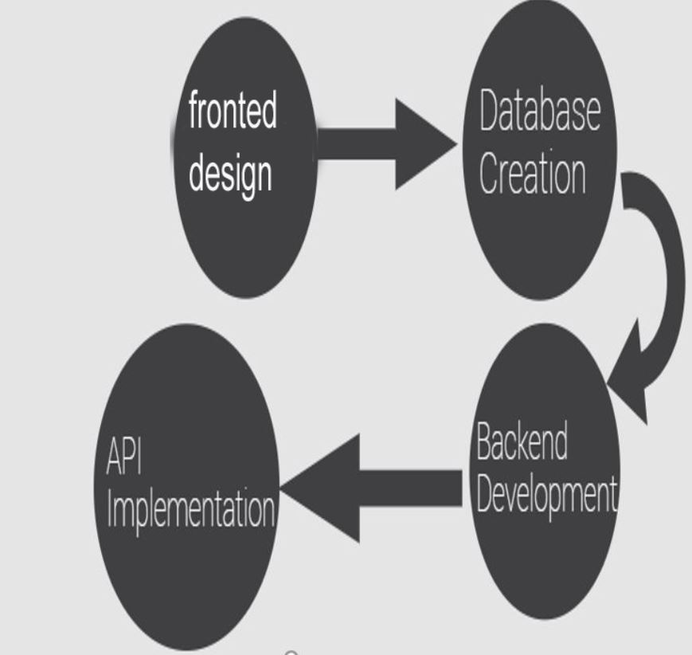

Figure 3.1: Methodology

**5.7 FLOW OF THE SYSTEM.**

**STEP.1**

In very first step the admin login from the login panel, Admin creates the user’s accounts like student account, teacher account, Library admin account etc.

**STEP.2**

User login the account which is created by the admin and apply for the respective dues clearance.

**STEP.3**

When candidate applied for dues, the process is same for the teachers, they just login respective accounts and check notification of the student, if any then respond to the request.

**STEP.4**

Each admin user login their respective account and clear the due status accordingly, if any dues are remaining, admin just decline that candidate.

**STEP.5**

Each user will be familiar to his/her dues status either, they are cleared or not. Each candidate can see where the request is in pending and from where he/she is cleared.

**5.8. ROLES OF USERS**

Every user has his/her role, which is mandatory for them. The roles enlisted below.

* + 1. **ADMIN ROLE**

1. Add user.

2. Delete user.

3. Reject user.

4. Block user.

5. Add post.

6. Set head of department.

7. Set seminar library admin.

8. Check feedback.

9. Add department.

10. Check Clearance.

* + 1. **STUDENT ROLE**

1. Add Feedback.

2. See posts

3. Apply for dues clearance.

4. Check for the dues status.

* + 1. **TEACHER ROLE**

1. View pending requests.

2. Accept request accordingly.

3. Reject requests.

# CHAPTER:-04

# TOOLS AND TECHNOLOGIES

The architecture of a web system normally consists of three layers: UI layer, Business logic layer and Database layer.

The following is several related technologies.

## 4.1. WAMP INTRODUCTION

The WAMP Platform is a multi-tier enterprise applications (see Figure 4.1), the web server tier, PHP programming tier, database server tier and business logic tier. Windows + Apache + Mysql + Python, a group softwares often used to build dynamic Web site or server[15], itself are separate programs, but because often used together with the increasing of compatibility, constitute a powerful Web application platform.

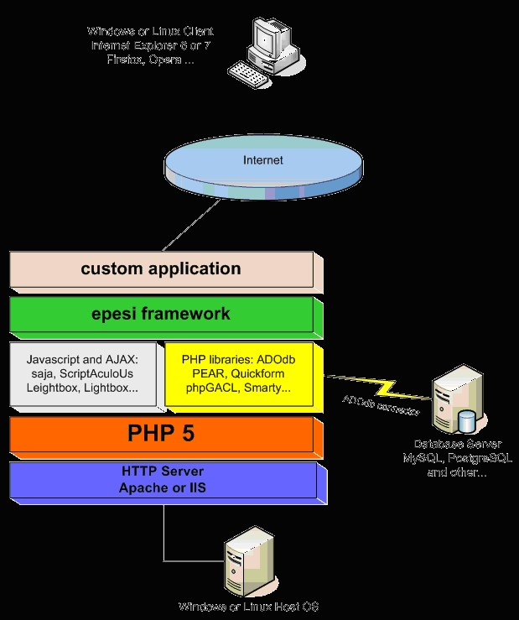

Figure 4.1 WAMP multitier architecture diagram

### 4.1.1 APACHE INTRODUCTION

Apache Web Server is a very stable and robust web server for the Linux, Unix, Windows and other related operating systems that existed today. Apache is a process-based structure, the process consumes more system costs than the thread does, so it is not suitable for multi-processor environment [16], therefore, when an Apache Web site needs to expand, usually to increase or expand a server cluster rather than increase processors. The layout below (see Figure 4.2) shows the general setup flow to follow, when setting up a Web Server or HTTP server as follows:

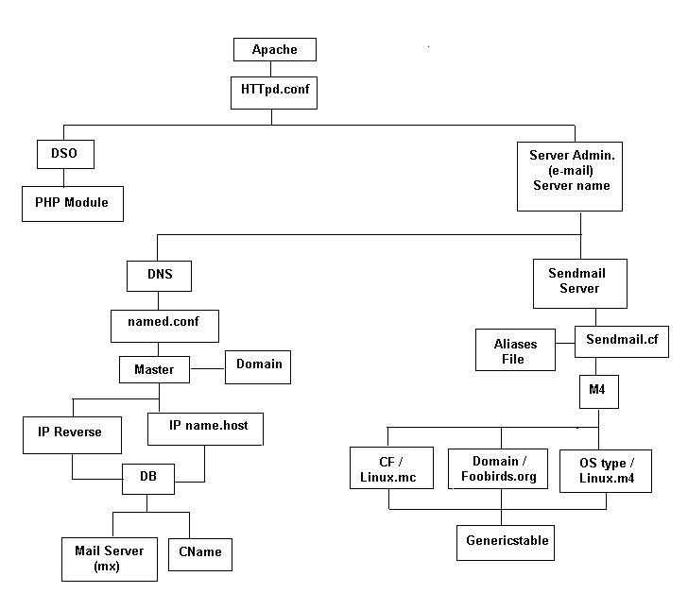

Figure 4.2: Apache server architecture diagram

**4.1.2 MARIA-DB (DATABASE)**

Maria-Db is a community-developed fork of the MySQL relational database management system intended to remain free under the GNU GPL. Development is led by some of the original developers of MySQL, who forked it due to concerns over its acquisition by Oracle Corporation. It started by core members of the original MySQL team. Maria-Db actively works with outside developers to deliver the most featureful, stable, and sanely licensed open SQL server in the industry.

Maria-Db turns data into structured information in a wide array of applications, ranging from banking to websites. It is an enhanced, drop-in replacement for MySQL. Maria-Db is used because it is fast, scalable and robust, with a rich ecosystem of storage engines, plug-in and many other tools make it very versatile for a wide variety of use cases.

Maria-Db is developed as open source software and as a relational database it provides an SQL interface for accessing data. The latest versions of Maria-Db also include GIS and JSON features.



Figure 4.3: Logo of Maria-Db database

### 4.1.3 PHP INTRODUCTION

PHP: Hypertext Preprocessor is a webpage programming language that was designed to produce dynamic web pages. For this purpose, PHP code is embedded into the html source file with PHP tags and interpreted by a web server. PHP is a server scripting language, and a powerful tool for making dynamic and interactive Web pages. PHP is a widely-used, free, and efficient alternative to competitors such as Microsoft's ASP [18]. PHP codes are executed on the server, and the result is returned to the browser as plain HTML. PHP files have extension ".php". It can generate dynamic page content, can create, open, read, write, delete, and close files on the server. PHP can collect form data. It can also send and receive cookies. It runs on various platforms (Windows, Linux, Unix, Mac OS X, etc.) and is compatible with almost all servers used today (Apache, IIS, etc.).It supports a wide range of databases. PHP is free to download and is easy to learn and runs efficiently on the server side. Figure 4.4 is logo for PHP.



Figure 4.4: Logo of PHP Language

## 4.2 SUBLIME TEXT

Sublime Text is a sophisticated text editor for code, markup and prose. Its slick user interface, extraordinary features and amazing performance is an attractive choice for programmers. Sublime Text 2 in its simplest form is a lightweight text editor. Everything about it was built for speed, which makes sublime one of the quickest and easiest text editors to use. Along with this speed sublime text 2 has 1000s of additional open source plug-in, with a massive community of developers contributing to new plug-in. Sublime Text 2 can be used for multiple languages from web development to software development [19].

Project management in sublime is also very easy, you can add folders to new projects and sublime will generate a project file automatically to help manage the project. This is perfect if you’re used to working on different projects at the same time.

Another great feature of Sublime is that you can customize everything about it.

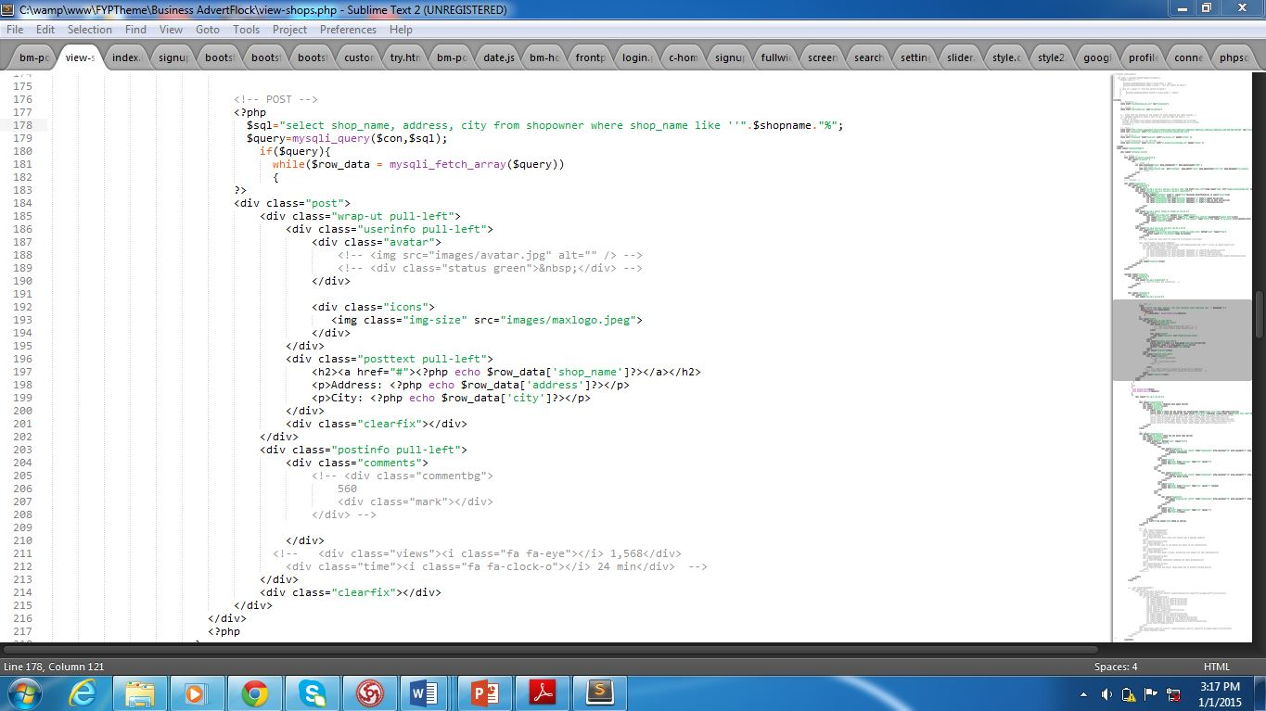

Figure 4.5: Sublime Text IDE

## 4.3 VISUAL PARADIGM

Visual Paradigm for UML (Visual Paradigm, 2010) is a CASE tool with several options for modeling with UML2 diagrams and also supports SysML requirements diagrams and ER diagrams [20]. The tool has a good working environment, which facilitates viewing and manipulation of the modeling project. It is a business tool and also supports specific changes to source code of some programming languages such as C++ and Java.In addition to modeling support, it provides report generation and code engineering capabilities including code generation. It can reverse engineer diagrams from code, and provide round-trip engineering for various programming languages.

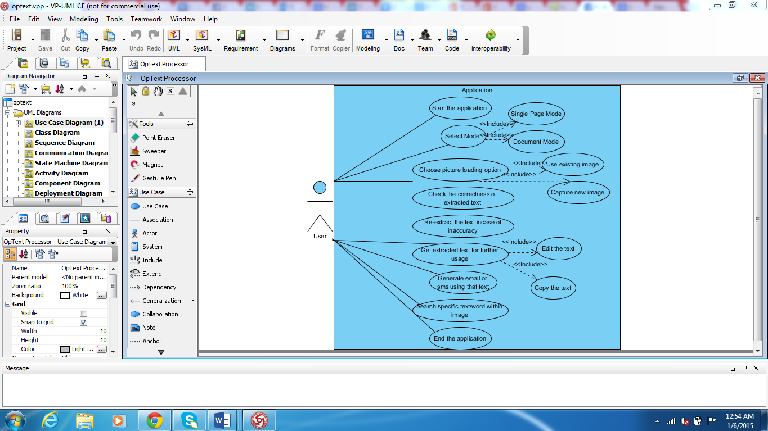

Figure 4.6: IDE for Visual Paradigm

## 4.4 HTML5

HTML5 is the latest evolution of the standard that defines HTML. The term represents two different concepts. It is a new version of the language HTML, with new elements, attributes, and behaviors, **and** a larger set of technologies that allows the building of more diverse and powerful Web sites and applications.



Figure 4.7: Logo of HTML5

**4.5 CSS3**

Cascading Style Sheets (CSS) is a style sheet language used for describing the look and formatting of a document written in a markup language.CSS3 is a latest standard of CSS earlier versions (CSS2).The main difference between css2 and css3 is follows

* Media Queries
* Namespaces
* Selectors Level 3
* Color

CSS3 modules

CSS3 is collaboration of CSS2 specifications and new specifications, we can called this collaboration is module. Some of the modules are shown below

* Selectors
* Box Model
* Backgrounds
* Image Values and Replaced Content
* Text Effects
* 2D Transformations
* 3D Transformations
* Animations
* Multiple Column Layout
* User Interface



Figure 4.8: Logo of CSS3

**4.6 BOOTSRAP**

Bootstrap is a free and open-source front-end web framework for designing websites and web applications. It contains HTML- and CSS-based design templates for typography, forms, buttons, navigation and other interface components, as well as optional JavaScript extensions. Unlike many web frameworks, it concerns itself with front-end development only.



Figure 4.9: Logo of Bootstrap

**4.7 JAVASCRIPT**

JavaScript is an object oriented web page programming language used by web application programmer.

Based on the html, using JavaScript can develop dynamic interactive Web pages[21]. The emergence of JavaScript enables web pages and users to achieve a real-time, dynamic, interactive relationship, so that pages contain more active elements and more exciting content. Nowadays almost all web pages contain JavaScript, a scripting programming language that runs on visitor's web browser. It makes web pages functional for specific purposes and if disabled for some reason, the content or the functionality of the web page can be limited or unavailable. JavaScript is mainly used for Client-Side validation to validate the data, it decreases the server overhead of validation user inputs. It ensures that data is not passed to server without validating and imposes different kind of validation checks. Figure 4.8 is logo of JavaScript



Figure 4.10: Logo of JavaScript.

**4.8 JQUERY**

JQuery is a cross-platform JavaScript library designed to simplify the client-side scripting of HTML. It is free, open-source software using the permissive MIT License. Web analysis indicates that it is the most widely deployed JavaScript library by a large margin.

JQuery’s syntax is designed to make it easier to navigate a document, select DOM elements, create animations, handle events, and develop Ajax applications. JQuery also provides capabilities for developers to create plug-ins on top of the JavaScript library. This enables developers to create abstractions for low-level interaction and animation, advanced effects and high-level, theme able widgets. The modular approach to the jQuery library allows the creation of powerful dynamic web pages and Web applications.



Figure 4.11: Logo of jQuery

**4.9 AJAX**

AJAX stands for Asynchronous JavaScript and XML. In a nutshell, it is the use of the XML Http Request object to communicate with servers. It can send and receive information in various formats, including JSON, XML, HTML, and text files.

Ajax is a client-side script that communicates to and from a server/database without the need for a post back or a complete page refresh. The best definition for Ajax is “the method of exchanging data with a server, and updating parts of a web page – without reloading the entire page.”



Figure 4.12: Logo of Ajax Programming

**4.10 PERL**

Perl is a general-purpose programming language originally developed for text manipulation and now used for a wide range of tasks including system administration, web development, network programming, GUI development, and more.

* Perl is a stable, cross platform programming language.
* Though Perl is not officially an acronym but few people used it as Practical Extraction and Report Language.
* It is used for mission critical projects in the public and private sectors.
* Perl is Open Source software, licensed under its Artistic License, or the GNU General Public License (GPL).
* Perl was created by Larry Wall.
* Perl 1.0 was released to Usenet’s alt.comp.sources in 1987.
* At the time of writing this tutorial, the latest version of Perl was 5.16.2.
* Perl is listed in the Oxford English Dictionary.

PC Magazine announced Perl as the finalist for its 1998 Technical Excellence Award in the Development Tool category.

**4.10.1 PERL FEATURES**

* Perl takes the best features from other languages, such as C, awk, sed, sh, and BASIC, among others.
* Perls database integration interface DBI supports third-party databases including Oracle, Sybase, Postgres, MySQL and others.
* Perl works with HTML, XML, and other mark-up languages.
* Perl supports Unicode.
* Perl is Y2K compliant.
* Perl supports both procedural and object-oriented programming.
* Perl interfaces with external C/C++ libraries through XS or SWIG.
* Perl is extensible. There are over 20,000 third party modules available from the Comprehensive Perl Archive Network ([CPAN](http://cpan.perl.org/)).
* The Perl interpreter can be embedded into other systems.

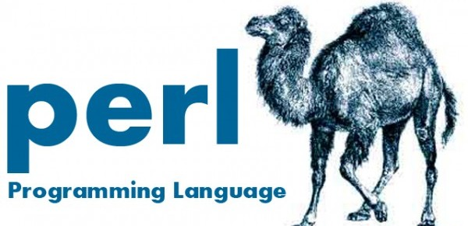

Figure 4.13: Logo of Perl Programming

**4.11 OOP**

Object-oriented programming (OOP) is a programming language model organized around objects rather than “action” and data rather than logic. Historically, a program has been viewed as a logical procedure that takes input data, processes it, and produces output data.

Object oriented programming is a programming style that is associated with the concept of Class, Objects and various other concepts revolving around these two, like Inheritance, Polymorphism, Abstraction, Encapsulation etc

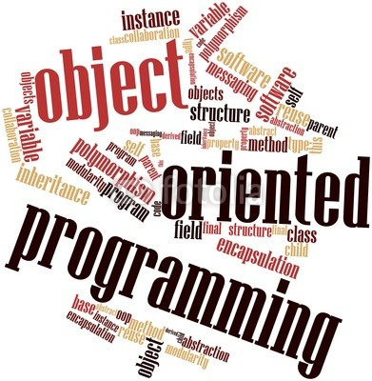

Figure 4.24: Logo of object oriented programming

# CHAPTER:-05

# IMPLEMENTATION AND TESTING

**5.1 UI DESIGN**

Implementation phase of the project begin with discussion of UI. The UI is the User Interface to easily interact the user with its Application.

### 5.2 IMPLEMENTED DESIGN TEMPLATE

The Automated No dues Clearance System is just like a management System which includes a beautiful User interface developed using Html5, Css3, JavaScript, Bootstrap, PHP and MySQL. Each web page has a beautiful User Interface which reflect the identity of a webpage with its functionality

This section discusses the final implemented design of the web application and discusses the functionality of each web page.

**5.3 THE INDEX PAGE**

The index page is the default page or home page of any website or web application, whenever any Website is loaded, the first webpage which displays on the screen is the index page.

The Home Page contains a Sign In Page, a navigation to navigate through different functions of Web App, the Home page is always found to be quite simple contains main User layout Structure, such as Header Containing Logo, Navigation menu defining functionality of Web Application, Section area, sidebar

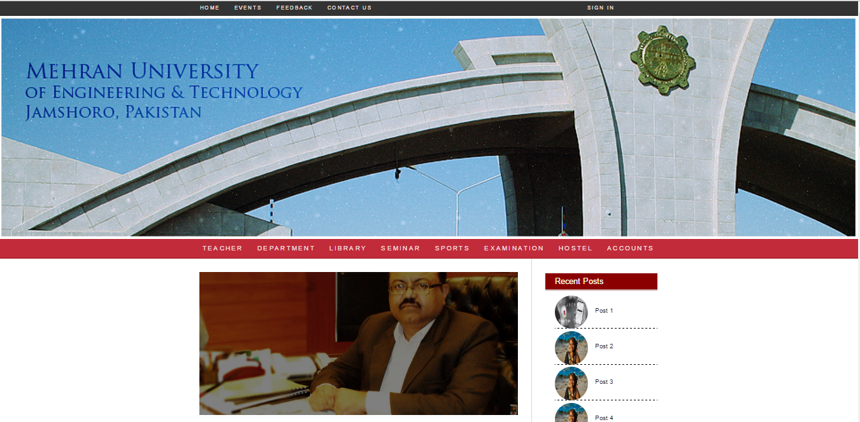

Figure 5.1: Index page

**5.4 IMPLEMENTATION**

**5.4.1 THE SIGN IN PAGE**

The sign in or the log in page lets the authorized user to access the Web applications, there are two field given in this web app user have to enter valid username and password provided by the Faculty

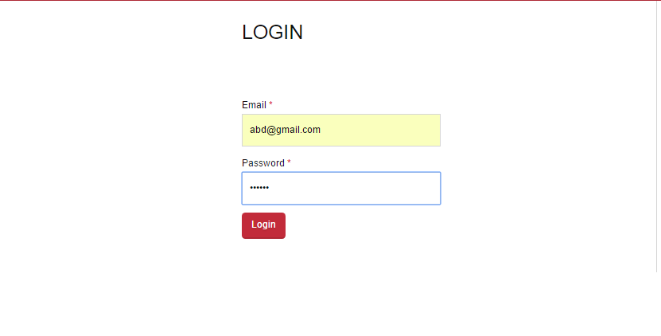

Figure 5.2: Login interface

**5.4.2 CLEARANCE PAGE**

The main Section of the Project which aims was to provide and automated system where teachers can clear the dues of student, students are required to have clearance of teachers of their corresponding Department , which is so much difficult for the students, the major issue is unavailability of teachers, this page is beautifully designed and fulfill the aims of providing an automated system, students are required to sign in using Sign in page, after logging into their accounts, in the navigation there is a teacher’s section within the navigation Menu, after reaching to the teacher’s page there would be number of teacher’s available to apply for clearance, student just have to apply for the clearance and corresponding teacher will approve the request, which saves student’s time.

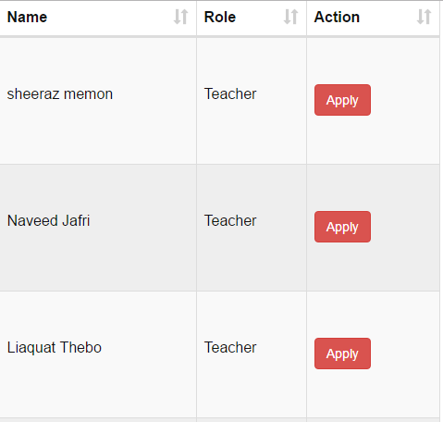

Figure 5.3: Apply page

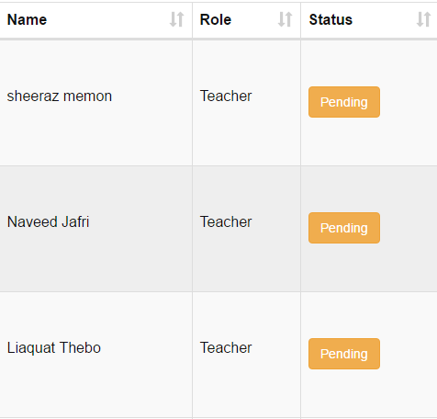

Figure 5.4: Pending page

**5.4.3 TEACHER’S CLEARANCE VIEW**

This is the Part of “**Student’s Department teacher Clearance Page**”, The teacher will log in the web application, their he will find a Pending Section, in Pending Page, there would be number of students in the list who have applied for the particular teacher who has currently logged in, The teacher Just have to approve the dues.



Figure 5.5: Clearance view

**5.4.4 DEPARTMENT CLEARANCE PAGE**

Student visits this page for their departmental clearance, for that they are required to first clear the dues of the teachers in their respective departments, once teacher clears the dues, student can apply for the clearance at departmental level, The HOD or Chairman of the Department will approve the dues

**5.4.4.1 STATUS OF STUDENTS BEFORE THE TEACHER’S CLEARANCE**



First Clear Dues from Teacher

**5.4.4.2 TEACHER DUES ARE CLEARED NOW APPLY FOR DEPARTEMNET CLEARANCE**

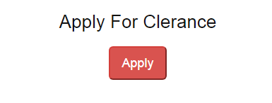

Figure 5.6: Apply1

**5.4.4.3 STATUS OF STUDENTS AFTER TEACHERS CLEARANCE**

**5.4.5 LIBRARY CLEARANCE PAGE:**

Likewise the department clearance it is necessary for students to clear the dues of library as well, the dues may include as issued book not returned, the book been misplaced and extra.

**5.4.5.1 THE BEAUTIFUL USER INTERFACE TO APPLY**



Figure 5.7: Apply2

**5.4.5.2 AFTER LIBRARY CLEARANCE**



**5.4.6 SEMINAR CLEARANCE PAGE:**

Likewise the department clearance it is necessary for students to clear the dues of Seminar Library as well

**5.4.6.1 INTERFACE TO APPLY FOR CLEARANCE**



Figure 5.8: Apply3

**5.4.6.2 AFTER CLEARANCE**



**5.4.7 SPORTS CLEARANCE PAGE**

Likewise the department clearance it is necessary for students to clear the dues of Sports Directorate.

**5.4.7.1 INTERFACE TO APPLY FOR CLEARANCE**



Figure 5.9: Apply4

**5.4.7.2 AFTER CLEARANCE**



**5.4.8 EXAMINATION CLEARANCE PAGE**

Likewise the department clearance it is necessary for students to clear the dues of Examination Directorate

**5.4.8.1 INTERFACE TO APPLY FOR CLEARANCE**



Figure 5.10: Apply5

**5.4.8.2 AFTER CLEARANCE**



**5.4.9 HOSTEL CLEARANCE PAGE**

Likewise the department clearance it is necessary for students to clear the dues of Hostel Directorate

**5.4.9.1 INTERFACE TO APPLY FOR CLEARANCE**



Figure 5.11: Apply6

**5.4.9.2 AFTER CLEARANCE**



**5.4.10 ACCOUNTS CLEARNCE PAGE**

Likewise the department clearance it is necessary for students to clear the dues of Accounts Directorate.

**5.4.10.1 INTERFACE TO APPLY FOR CLEARANCE**



Figure 5.12: Apply7

**5.4.10.2 AFTER CLEARANCE**



**5.5 UI INTERFACE FOR THE ADMIN PANEL**

**5.5.1 THE LOGIN PAGE**

The login page has same function as in login page of main application, it lets authenticate admin to enter the Admin Panel

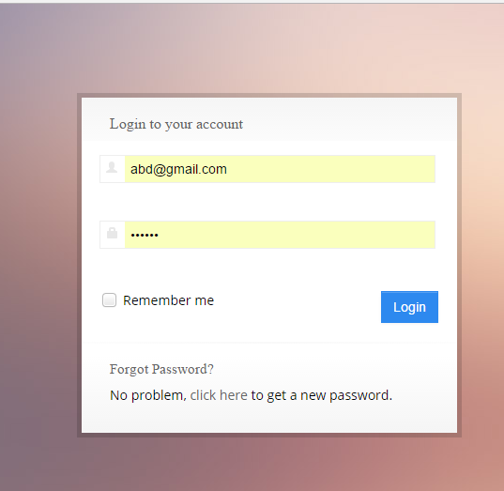

Figure 5.13: Sign-in page

**5.5.2 THE ADMIN PANEL**

The Admin Panel has a beautiful design, the user Interface is simple, engaging and attractive which results easy to understand and flexible to user for the admin here is the dashboard of the admin Panel.

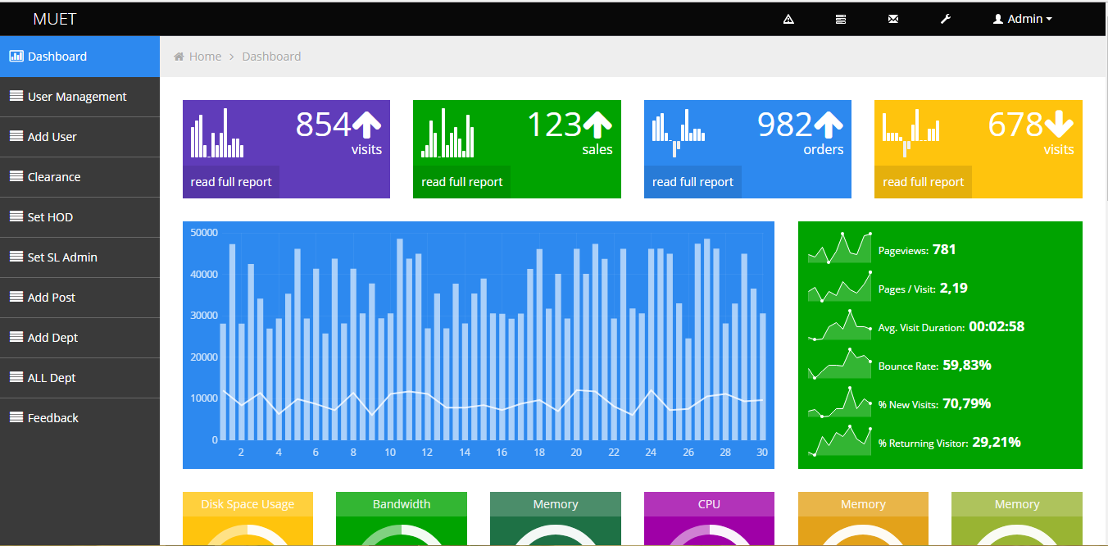

Figure 5.14: Admin Panel

**5.5.3 THE USER MANAGEMENT PAGE IN ADMIN PANEL**

The user management contains four basic options, it displays total number of users, has privilege to block students, reject students and all such options are for the admin only

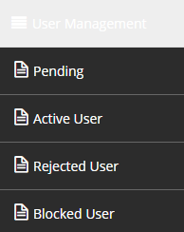

Figure 5.15: Management Page



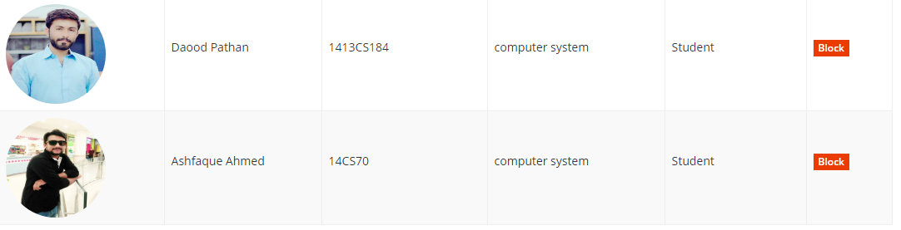

Figure 5.16: Admin interfaces

**5.5.4 ADD USER PAGE IN ADMIN PANEL**

Students are directly added by the admin in Automated No dues Clearance System, the record of each student is gathered at the start, password will be given to each student comparing to their unique ids.

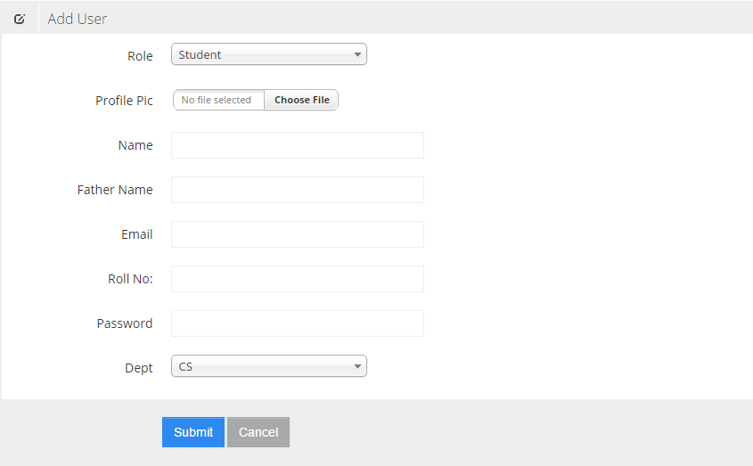

Figure 5.17: Add user page

**5.5.5 CLEARANCE PAGE**

This page Display the no of users with their clearance from teachers of student’s department with the clearance from all directorates

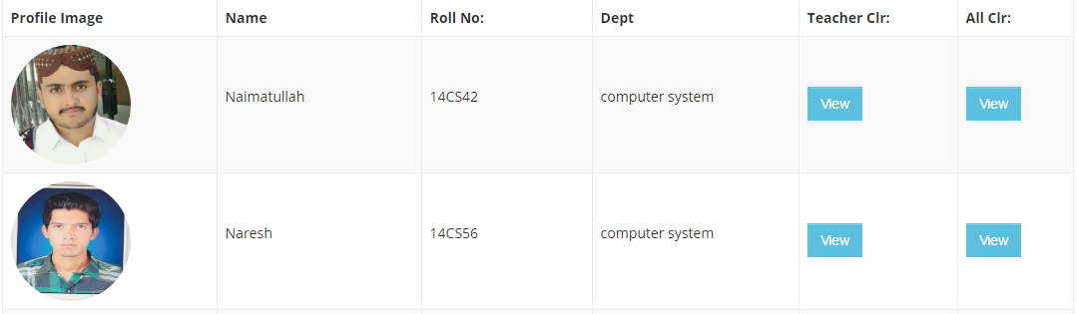

Figure 5.18: Clearance page

**5.5.6 SET HOD PAGE**

This Page Displays the Number of Teacher’s and as per rule selects the head of department

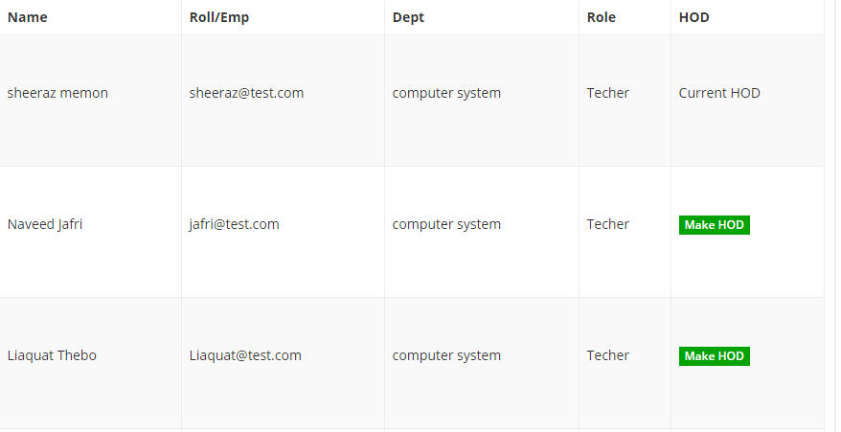

Figure 5.19: HOD page

**5.5.7 ALL DEPARTMENTS PAGE**

Displays all departments of University

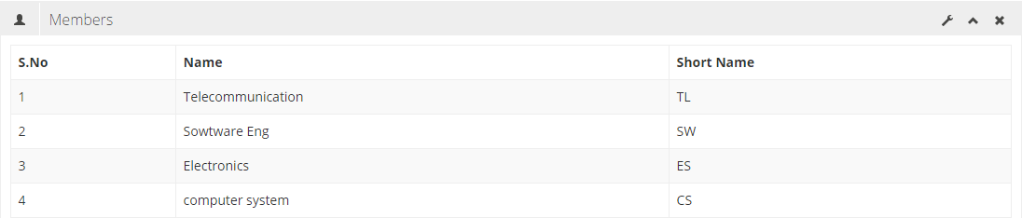

Figure 5.20: Departments view

**5.5.8 ADDING DEPARTMENT PAGE**

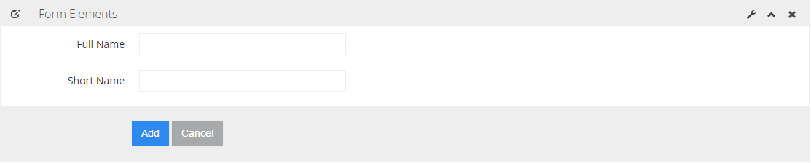

Figure 5.21: Add department view

**5.6 TESTING THE WEB APPLICATION**

The important section of the Project, to check evaluation and working of the project if it is working up to the requirements

Following will get you to the Proofs of what were promised to be an automated system

**5.6.1 FUNCTIONAL REQUIREMENT TESTING**

To make sure, the project is tested and working fine the following features have checked, although table of required and passing target with their screen shots are been printed.

**5.6.2 TEST CASE 1 – SIGNUP**

|  |  |
| --- | --- |
| Test Content | To check whether the student is authenticate, the process will check the Email and Password from the User |
| Input | All fields are required to enter |
| Passing Criteria | Input is Accepted data is stored |

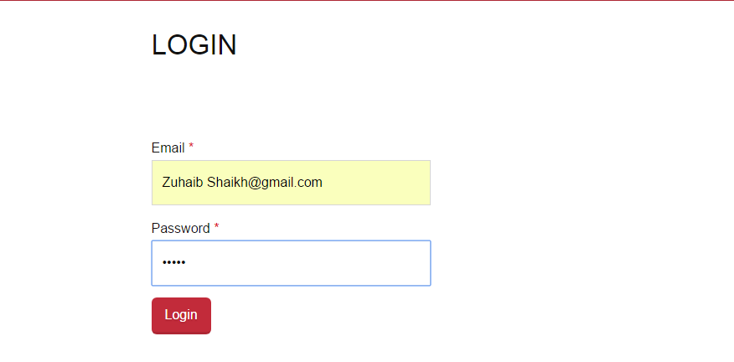

Figure 5.22: Log-in view

**5.6.3 USER IS VALID**



Figure 5.23: User in valid view

**5.6.4 TEST CASE 2 –TEACHERS CLEARANCE**

|  |  |
| --- | --- |
| Test Content | To check if all teachers have approved student, the student will be able to apply for departmental level |
| Input | Apply each teacher in the list of students |
| Passing criteria | All teachers have approved, now student can apply for Departmental clearance |

**5.6.4.1 TEACHER’S APPROVALS**

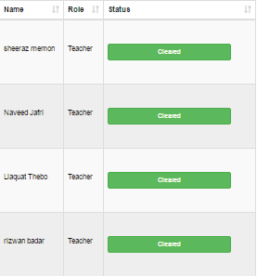

Figure 5.24: Approvals view

Now Student can apply For Department No dues



Figure 5.25: Apply8

**5.6.5 TEST CASE 3 –PRINTING DOCUMENT**

|  |  |
| --- | --- |
| Test Content | To check if it is printing the document |
| Input | All dues have been cleared |
| Passing Criteria | On Printed, the flow is displayed in a Pdf form with student’s clearance of dues |

**5.6.5.1 STUDENT’S NO DUES CLEARANCE FORM ALL DIRECTORATES**

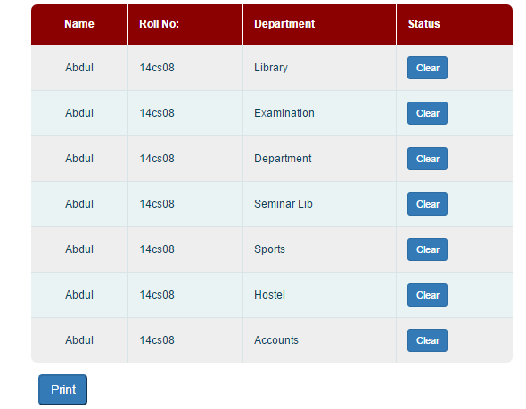

Figure 5.26: Printing form view

**5.6.5.2 PRINTING THE CLEARANCE FORM**

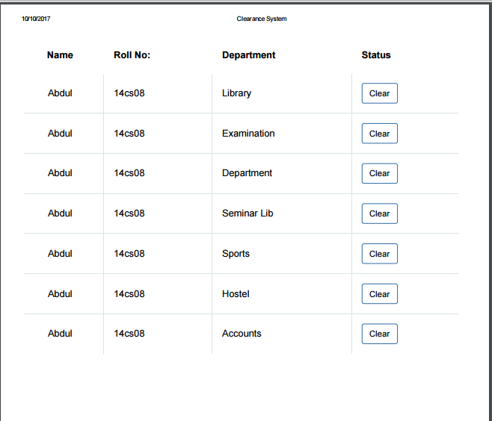

Figure 5.27: Printed form view

**CHAPTER NO:-06**

**CONCLUSION, FUTURE WORK AND REFERENCES**

**6.1 CONCLUSION:**

Our project is designed and tested successfully to maintain accuracy and quality.

This web project provides facility to candidates; they can request online and can get their Dues online. Automated No Dues clearance system saves the time of administration and reduces the efforts of institutes. It provides accuracy and transparency. It reduces paper work for the employers.

This project is very useful for any institution where clearance is important when a student is about to graduate. By implementing this system employees will get rid from extra work. In our system admin can manage whole record through admin panel easily and Institutes can keep their whole record for many years.

In this online project, we have especially concentrated on user familiar interface. This is very easy to use for students, teachers as well as other employees who will use this system. The project was designed and tested successfully to maintain accuracy and quality. Our system is providing easy and convenience way to get students their Dues signed.

**6.2 FUTURE WORK:**

Our Future work is to make another project for our Institution that can be helpful for the Students. We want to serve for our society and want to make changes in our University too.

We want to save time of our students by working on beneficial project like this. This project will definitely save their time and energy and money, so they can give their best at their study without wasting their time.

**6.3 REFERENCES:**

[1] <https://www.google.com/>

[2] <https://www.wikipedia.com/>

[3] <https://www.slideshare.net/HritikaRaj/no-dues-management-system-prepared-by-hritika-raj-shivalik-college-of-enggdehradun>

[4] <http://getreport.in/idea/application-of-automatic-no-dues-control-system>

[5] <http://projects-seminars.net/q/project-report-on-no-dues-clearance-system>

[6]<http://projects-seminars.net/Thread-online-clearance-system-for-graduating-students-ppt>