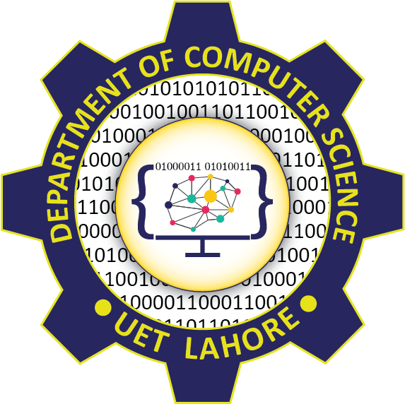

Session: 2021 – 2025

Submitted by:

Abdul Mateen 2021-CS-190

Supervised to:

Dr. Abqa Javeed

Department of Computer Science

University of Engineering and Technology

Lahore Pakistan

# Worst:

# Code

# 

## Output

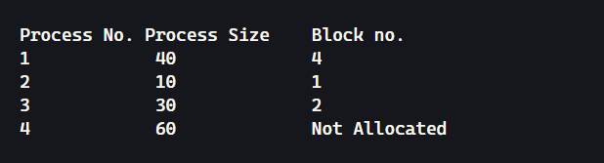

# Best:

## Code

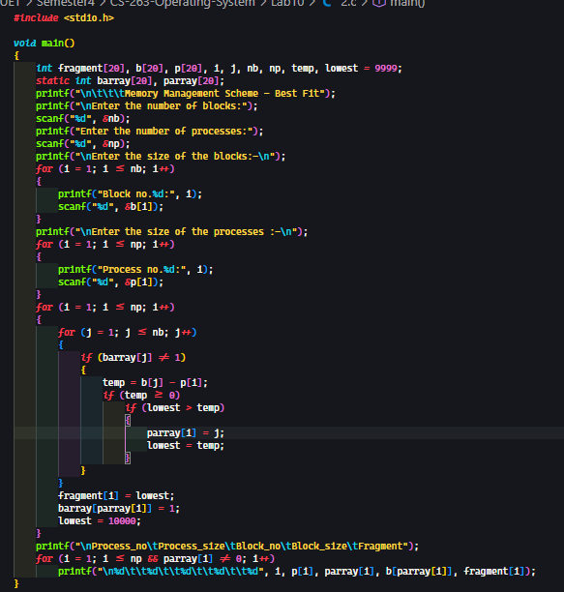

## Output

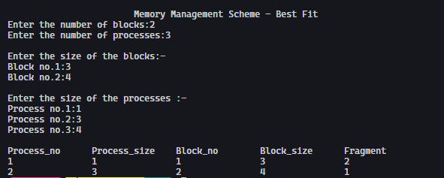

# Task3:

## Code

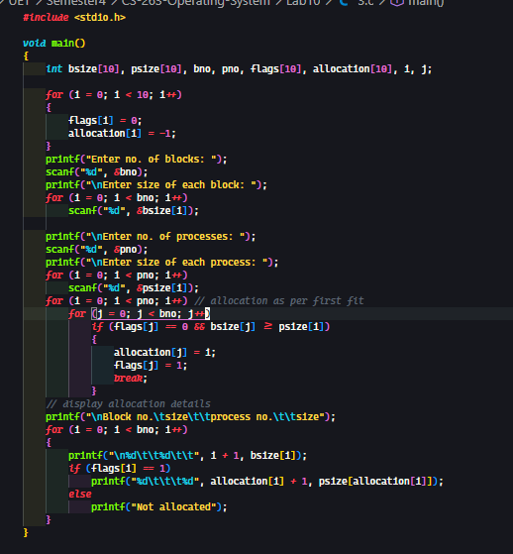

## Output

