
Session: 2021 – 2025
Submitted by:
Abdul Mateen 2021-CS-190

Supervised to:
Mam Abqa Javed

Department of Computer Science
University of Engineering and Technology
Lahore Pakistan

1) In first command I created a file named 19f-XXXX.txt

In second line I edited the file using vi.

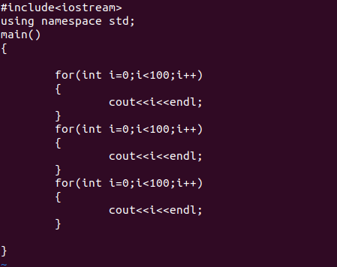

2) After that I created file named Abdul_Mateen.txt and wrote 10 lines in it.
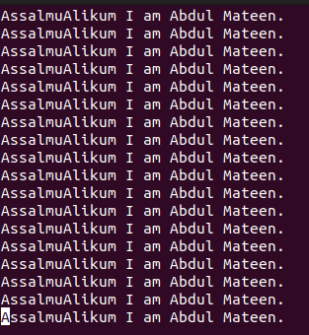

3) View content of file with cat command

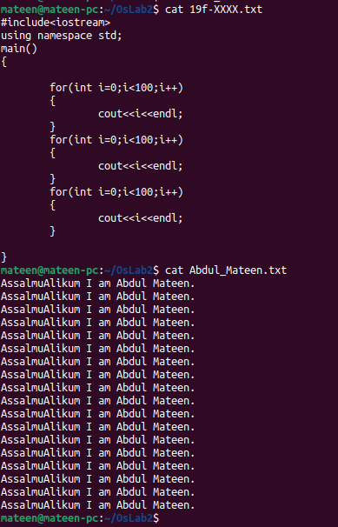

4) Merge file 1 and file 2 to a new file merge.txt

5) Saved the merged data in merge.txt

6) Displays first 2 lines of first file
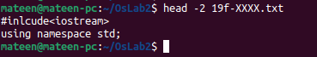

7) Displays last 2 lines of second file.
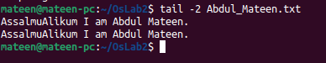

8) Search using Grep command
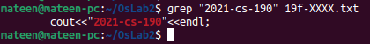

9) Granting execute permission to group

10) changing permession

11) Current working directory is shown by pwd command

12) All files in the Desktop are shown by

13) The folder named roll# is made

