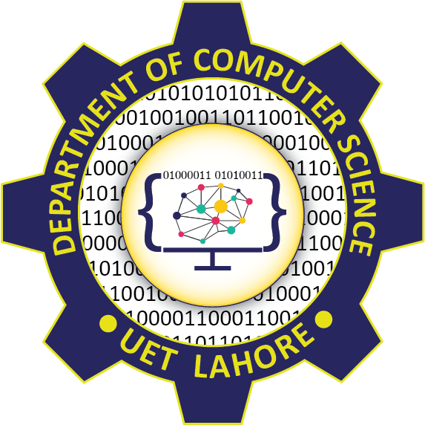

Session: 2021 – 2025

**Submitted by:**

Abdul Mateen 2021-CS-190

Khadim Hussain 2021-CS-204

**Supervised to:**

Dr. Maida Shahid

Department of Computer Science

**University of Engineering and Technology**, **Lahore Pakistan**

Contents

Introduction 2

Project Features 2

Use Cases 2

Class Diagram 2

Wire Frames 3

Technology and Resources 3

# Introduction

# Project Features

# Use Cases

# Class Diagram

# Wire Frames

# Technology and Resources