

NETWORKS AND SYSTEMS ADMINISTRATION

Module Title | NETWORKS AND SYSTEMS ADMINISTRATION
Module Code | B9IS121
Module Instructor | Kingsley Ibomo
Assignment Title | Automated Container deployment and  Administration in the cloud
Student Name | Abdul Mateen
Student ID | 20093908
Course | MSc Information Systems and Computing
Deliverables | PDF, GitHub Links, Recording Links
Summary Word Count  Main Text Word Count  Total Word Count | 165  2764  2699
GitHub Link  Recording Link | https://github.com/AbdulMateenzwl/Networking-CA  https://youtu.be/UPfZ_297IkA

Summary 3
Introduction 3
Content 4
Infrastructure Setup (Part 1) 4
Tools and Approach 4
Resources Used 4
Challenges and Workaround 5
Deliverables 5
Configuration Management (Part 2) 5
Tools and Approach 5
Configuration Applied 6
Outcome 6
Deliverables 7
Docker Container Deployment (Part 3) 7
Tools and Approach 7
Ansible Playbook 8
Application and Container Setup 8
Outcomes 9
Deliverables 9
CI/CD Pipeline Integration 9
Tools and Approach 9
Pipeline Structure 9
Outcomes 10
Deliverables 10
Conclusion 10
Appendices 12
Appendix A 12
Appendix B 12
Appendix C 13
Appendix D 14
References 17

Summary
The Goal of this project was to automate the process of deployment of Web Application on a public cloud. The tools used in this project are Terraform, Ansible, Docker and Github Actions. These tools handle different stages of the pipeline. Azure Student Subscription was used so there were some region and resource limits. Azure Virtual Machine with configuration was set up with terraform running Ubuntu 24.04 version in Norway East Region. With Ansible the machine was configured to update and install required packages which were necessary for the deployment and testing of the app. Docker was configured to autostart on boot. The HTML web app is containerised using Docker and Nginx and is served on port 8080. Server Inbound rule is set so that we can access it on port 8080. GitHub Actions pipeline is configured to autowatch code pushes and redeploy automatically, no manual deploy required. All the industry standard tools were used with Industry wide practices to achieve the best results possible.

Introduction
Cloud Computing has changed the way software is built, maintained and deployed. Before Cloud Computing deployments were manual, slow and had a lot of chances to get errors. With Devops Practices this problem is solved from infrastructure to deployment everything has been automated.
This project implements a real DevOps pipeline on Azure using four tools. Terraform handles the infrastructure, Ansible for server configuration, Docker for containerization and Github Actions for deployments. Each tool is chosen because of Industry standards and is in use by enterprise organizations which manage millions of requests per second.
The report is divided into four sections, which are four parts of the assignment. Each section covers one tool and its role in the pipeline moving from infrastructure to live deployment. The problems faced during each part of the section are explained in their own section rather than separately. The technical items such as code files and screenshots are kept in Appendices so that the main content remains focused on explanation and not on code listing. All the references used in the report are from official documentation of HarshiCorp, Docker, Ansible and Github and some are from Blogs which explains certain issues during this project.

Content

Infrastructure Setup (Part 1)

Tools and Approach
The tools used for Infrastructure setup is Terraform. It is an open source Infrastructure as code developed by HashiCorp (HashiCorp, n.d.). Rather than defining all the configurations for cloud infrastructure, you can just define them in code and run it to create the same infrastructure every single time without any mistakes. Terraform using HCL (HashiCorp Configuration Language) to describe the resources (HashiCorp, 2024a). These configurations can be used multiple times, can easily be version controlled and shared via github, so that teams can work on development of infrastructure at the same time. It allows the creation and destruction of infrastructure with just some commands which reduces human error which can occur due to manual clicking through the portal. The advantage of Infrastructure as code is that it gives you a clear understanding of how the code is deployed and how services interact with each other (Morris, 2016). Terraform is used because it is an industry standard and is in use by Enterprise Organizations like Netflix, Uber, Slack, JP Morgan Chase to name a few (HashiCorp, 2024b).

Resources Used
The Cloud resources created for deployment are listed below:
- Resource Group: Keeps all the related resources together
- Virtual Network: To isolate the private network with address space 10.0.0.0/16 (Microsoft, 2024a)
- Subnet: subdevides the VNet, address range 10.0.1.0/24, VM is in here
- Network Security Group: Firewall that controls inbound and outbound traffic (Microsoft, 2024b)
- NSG inbound rules configured: port 22 for SSH, port 80 for http, port 8080 for application
- Public IP Address: Static IP assigned to VM, so that it can be accessible from internet
- Network Interface: Connects the VM to the subnet and public IP
- Linux Virtual Machine: Ubuntu 24.04 LTS, Standard B1s, located in Norway East region (Microsoft, 2024c)
How They Connect:
- VM attached to NIC → NIC attached to Subnet → Subnet inside VNet → NSG applied to Subnet → Public IP attached to NIC
- This chain means traffic from internet hits Public IP → passes NSG rules → reaches VM

Challenges and Workaround
The challenges faced during creation of the infrastructure is that we were getting the ‘403 Forbidden’ error while applying the terraform apply command. After doing some research it turned out that I was on an Azure student subscription and it does not allow creation of certain resources in some regions (Microsoft, 2024d). There were no specific regions mentioned anywhere with this subscription where I can work without any issues. After the hit and trial I was able to create the infrastructure in the Norway East Region.

Deliverables
- Terraform Scripts (Appendix A)
- Diagram of Deployed Resources (Appendix A)

Configuration Management (Part 2)

Tools and Approach
The tool used for the configuration of the server is Ansible. It is an open source configuration and management tool by Red Hat (Red Hat, 2024a). It uses YAML files to define the list of tasks to run on a remote server. These YAML files are called playbooks. This approach does not require you manually SSH into the VM and set it up and does not require any software to be installed to the VM. It connects with SSH and sets it up with the instructions you have provided for all the VMs provided in the Hosts file. It connects directly from a local machine or GitHub Actions Runner to VM over SSH (Red Hat, 2024a).
Ansible has become an industry standard for configuration management. Although there are tools like Chef, Puppet but Ansible makes it much simpler with YAML files which are easy to read and understand (Red Hat, 2024b). Ansible works perfectly with Azure as it only needs SSH and we have already configured that in Infrastructure setup.
Below is how Ansible is structured in this project.
- ansible.cfg: global settings file, points to inventory, disables host key checking
- inventory/hosts.ini: contains VM IP address and SSH connection details
- setup.yml: main playbook, entry point that calls the configuration role
- roles/configuration/tasks/main.yml: all installation steps defined here
- roles/configuration/handlers/main.yml: restarts Docker service only when a change is made

Configuration Applied
The server package repository is first updated with the latest version available. This is a crucial setup, If this is missed we can lead to a hell of old installed packages and broken dependencies. Then required packages like curl, git, ca-certificates, gnugp, lsb-release are installed, as we need docker these are required dependencies for it. Docker official GPG key was added to the VM, it verifies that packages are downloaded from the official sources (Docker, 2024a). Docker's official apt repository was added to the VM package sources. Docker engine is installed. Docker service starts immediately after installation. Then docker service enabled so that it auto start on VM reboot, no manual start required (Docker, 2024b). Then ‘mateen’ is added to the docker group so that this user can run docker commands without sudo privileges (Docker, 2024b). Application directory /opt/app is created with ownership to ‘mateen’ (user). This directory serves as a location where app files are copied during deployment. After the install some steps were performed to ensure that setup was successful and there were no issues. Check for the docker version and its status if it is running.

Outcome
The outcome of Step 2 was to ensure the server is properly configured with requirements which are necessary for project deployment. What we achieved is that docker is installed. It is enabled to autorun on reboot. Our user (‘mateen’) can run docker commands without elevated privileges. Application directory is ready for Part 3. This entire configuration is repeatable with this Ansible playbook setup.yml (Red Hat, 2024a).
To verify these configurations, we can SSH into the VM and check if the configuration is successful. Below are the commands to check them:
- docker --version should return the docker version installed.
- Run sudo systemctl status docker, it shows active (running).
- Run sudo systemctl is-enabled docker, it should return enabled
- Run getent group docker, should return ‘mateen’ part of the group.
- Run docker run hello-world, should pull and run a test container.
Ansible replaces these 25 plus manual commands with simple script. This script can be used to configure multiple servers without any errors. The advantage of Ansible is that it gives you configuration in text form which makes it easy to version control in GitHub where developers can see what actually changes in deployment and what exactly is the issue with new configurations (Red Hat, 2024b).

Deliverables
- Ansible Scripts (Appendix B)
- Readme file (Appendix B)
- Ansible Configuration Diagram (Appendix B)

Docker Container Deployment (Part 3)

Tools and Approach
Docker is an open source containerisation that packages applications and its dependencies into isolated units called containers (Docker, 2024a). Containers are light weight, portable and run consistently across any environment and any operating system. The main advantage of Docker is that it removes the “works on my machine” problem, when a project runs on one machine using docker, there is a 100% guarantee that it will run the same on another person's laptop, mac or cloud server (Docker, 2024a). For containerization I choose docker because it is considered industry standard and used by Enterprise companies like Google, Amazon, Netflix etc (Docker, 2024b).
For serving webpages Nginx is used. It is a high performance open source webserver. It is the most common and widely used web server. It is light weight and fast and perfect for serving static webpages (Nginx, 2024). I used base Image of Nginx instead of Apache because it is smaller in size and gives better performance for static content (Nginx, 2024).
Below is how Ansible is used to automate the deployment of docker containers.
- inventory/hosts.ini: contains VM IP address and SSH connection details
- roles/deploy/tasks/main.yml: all installation steps defined here
- roles/deploy/defaults/main.yml: variables like app directory path
- deploy.yaml: this playbook is entry point to do deploy the app after the server is configured with setup.yaml

Ansible Playbook
The deploy pipeline first creates a folder /opt/app if it does not exist and gives user (‘mateen’) permission to read, write and modify while other users can only read. The entire app folder is then copied from the local machine to the VM over SSH which includes Dockerfile, docker-compose.yml, nginx.conf and index.html (Red Hat, 2024a)..
Before building the image and running it. We first remove all running containers and the image if it exists. So that it does not cause any conflict with the new build. The app runs with docker compose command and builds a fresh image from the dockerfile everytime. Build:always ensures no cached content is used (Docker, 2024c). The container then runs in detach mode and the output from the compose is captured and printed. Before checking if the container is up and running a five second pause ensures that the container is fully initialized. At last the app response from browser is checked if it returns a 200 status code on our app port 8080

Application and Container Setup
The web app contains only a single HTML file. It shows some basic HTML so that users can have at least one page to view. It is served on port 80 inside the container of Nginx which is then mapped to external port 8080.
The base Image of Nginx alpine is used because of its minimal size of 23MB compared to 140MB for full Nginx Image (Nginx, 2024). The default page inside the directory used to host the page is removed and replaced with our custom HTML page. Our custom nginx.conf is copied inside the folder, it tells nginx how to serve the files. About the nginx configuration, it listens on port 80, serves files from /usr/share/nginx/html, default is set to index.html, 404 errors are redirected back to index.html (Nginx, 2024).
Docker-compose.yml defines the container name as webapp. It maps the port 8080 of the VM to port 80 inside the container. The restart: always makes sure the container auto restarts if VM reboot or container crashes (Docker, 2024c).
The app is accessible on http://vm_public_ip:8080. Azure NSG allows inbound traffic on port 8080 which was configured in part 1 (Microsoft, 2024b). Docker maps that 8080 port to port 80 to nginx container which then serves the index.html page.

Outcomes
The outcomes generated from part 3 is that the docker image is built successfully from Dockerfile using nginx:alpine. The container running on the Azure VM is accessible via public IP on the port 8080. When it is accessed on the browser it is served with an index.html page. The container is configured with restart:always, so it survives VM reboot and no manual intervention is needed (Docker, 2024c).
For verification of the container deployment we can SSH to the VM and run command docker ps it shows that the container is running and the port mapping. In case of issues we can view the longs with docker logs webapp.

Deliverables
- Dockerfile (Appendix C)
- Automation script (Appendix C)
- Sample app Repository (Appendix C)

CI/CD Pipeline Integration

Tools and Approach
GitHub Actions is a CI/CD Platform built directory inside Github (GitHub, 2024a). There is no need for a separate tool to handle CI/CD. For this project GitHub Actions are used because it is already there for GitHub repos and free to use. GitHub auto detects the changes and runs the workflows. Workflows can be triggered through UI apart from pushes or merges (GitHub, 2024a). Each pipeline runs separately on a fresh GitHub based Ubuntu machine called runner.
CI/CD has been in use for more than a decade and has become a standard for deployments (Humble and Farley, 2010). Without CI/CD we have to manually SSH to the server, copy the files, build it over there and then run the container. This would be very inefficient as there is a high probability of human error. A single wrong step and the entire production goes down (Humble and Farley, 2010).

Pipeline Structure
The pipeline is structured to run only on a single GitHub trigger whenever the new commit is pushed to the repository on the main branch. The workflow_dispath is added so that users can trigger from Github UI.
The flow of pipeline is like this:
- Repository checked out to runner, it gives it access to both Ansible/ and app/ folders (GitHub, 2024b).
- Ansible is installed on the server with apt-get since it is a fresh Ubuntu machine.
- SSH private key written from VM_SSH_KEY secret to ~/.ssh/id_rsa, permissions set to 600 (Red Hat, 2024a).
- ssh-keyscan adds VM fingerprint to known hosts, this would prevent SSH from asking for confirmation by manual input (GitHub, 2024c).
- hosts.ini generated dynamically with values from GitHub secrets, values should not be directly hardcoded inside the code (GitHub, 2024c).
- ansible-playbooks Ansible/deploy.yml runs the Ansible connects to VM over SSH and handles all the deployment (Red Hat, 2024a).
All the logic for deployment lives inside the Ansible/deploy.yml, thus it does not repeat inside the GitHub workflow. The pipeline itself handles only that thing which is not handled by Ansible, to install the Ansible on the runner and setting up SSH credentials (Humble and Farley, 2010).

Outcomes
The outcome of Step 4 is a fully end-to-end automated pipeline which works on every code and deploys it on the server in less than 2 minutes. With each push on the main branch it rebuilds the project and redeploys the container on the Azure VM. No manual step is required after the GitHub is configured with secrets required for workflow to run (GitHub, 2024a). The logs of the workflow are visible to the github and errors can be easily viewed from there.

Deliverables
- Pipeline Yaml File (Appendix D)
- Demo of pipeline in action (Appendix D)

Conclusion
This project successfully demonstrates a complete end-to-end DevOps pipeline on Microsoft Azure. All the four parts are completed and integrated into a continuous automated workflow. The start of the pipeline is a code change on a local computer and the end result is those changes reflected on to the deployed server. There is no manual intervention required after initial setup, the whole process automated from push to deployment.
Each tool handled a specific stage of the deployment. Terraform defined the infrastructure, Ansible configured the server, Docker containerized the application, GitHub automated the deployment. The tools were not used in isolation, Output from each stage is input for the next part. The Ansible playbook written in part 3 is used again in part 4 for deployment, hence no duplication. This reflects the real world DevOps principle of single source of truth.
Azure student subscription has some restrictions showing that real cloud environments have constraints that require adaptation. We had to configure the infrastructure in a different region. The default http port is being used by my other application, So i have to use a different one 8080 and it is accessible on the browser.
This project reflects DevOps industry standards practices used by engineering teams daily. Infrastructure as code, configuration management, containerisation and CI/CD are four pillars of modern DevOps. The skills and tools used are Terraform, Ansible, Docker, GitHub Actions which are most demanded in cloud and DevOps roles today.

Appendices

Appendix A
All the files to setup infrastructure setup using Terraform and its explanation in readme file is here at Github:
https://github.com/AbdulMateenzwl/Networking-CA/tree/main/Terraform
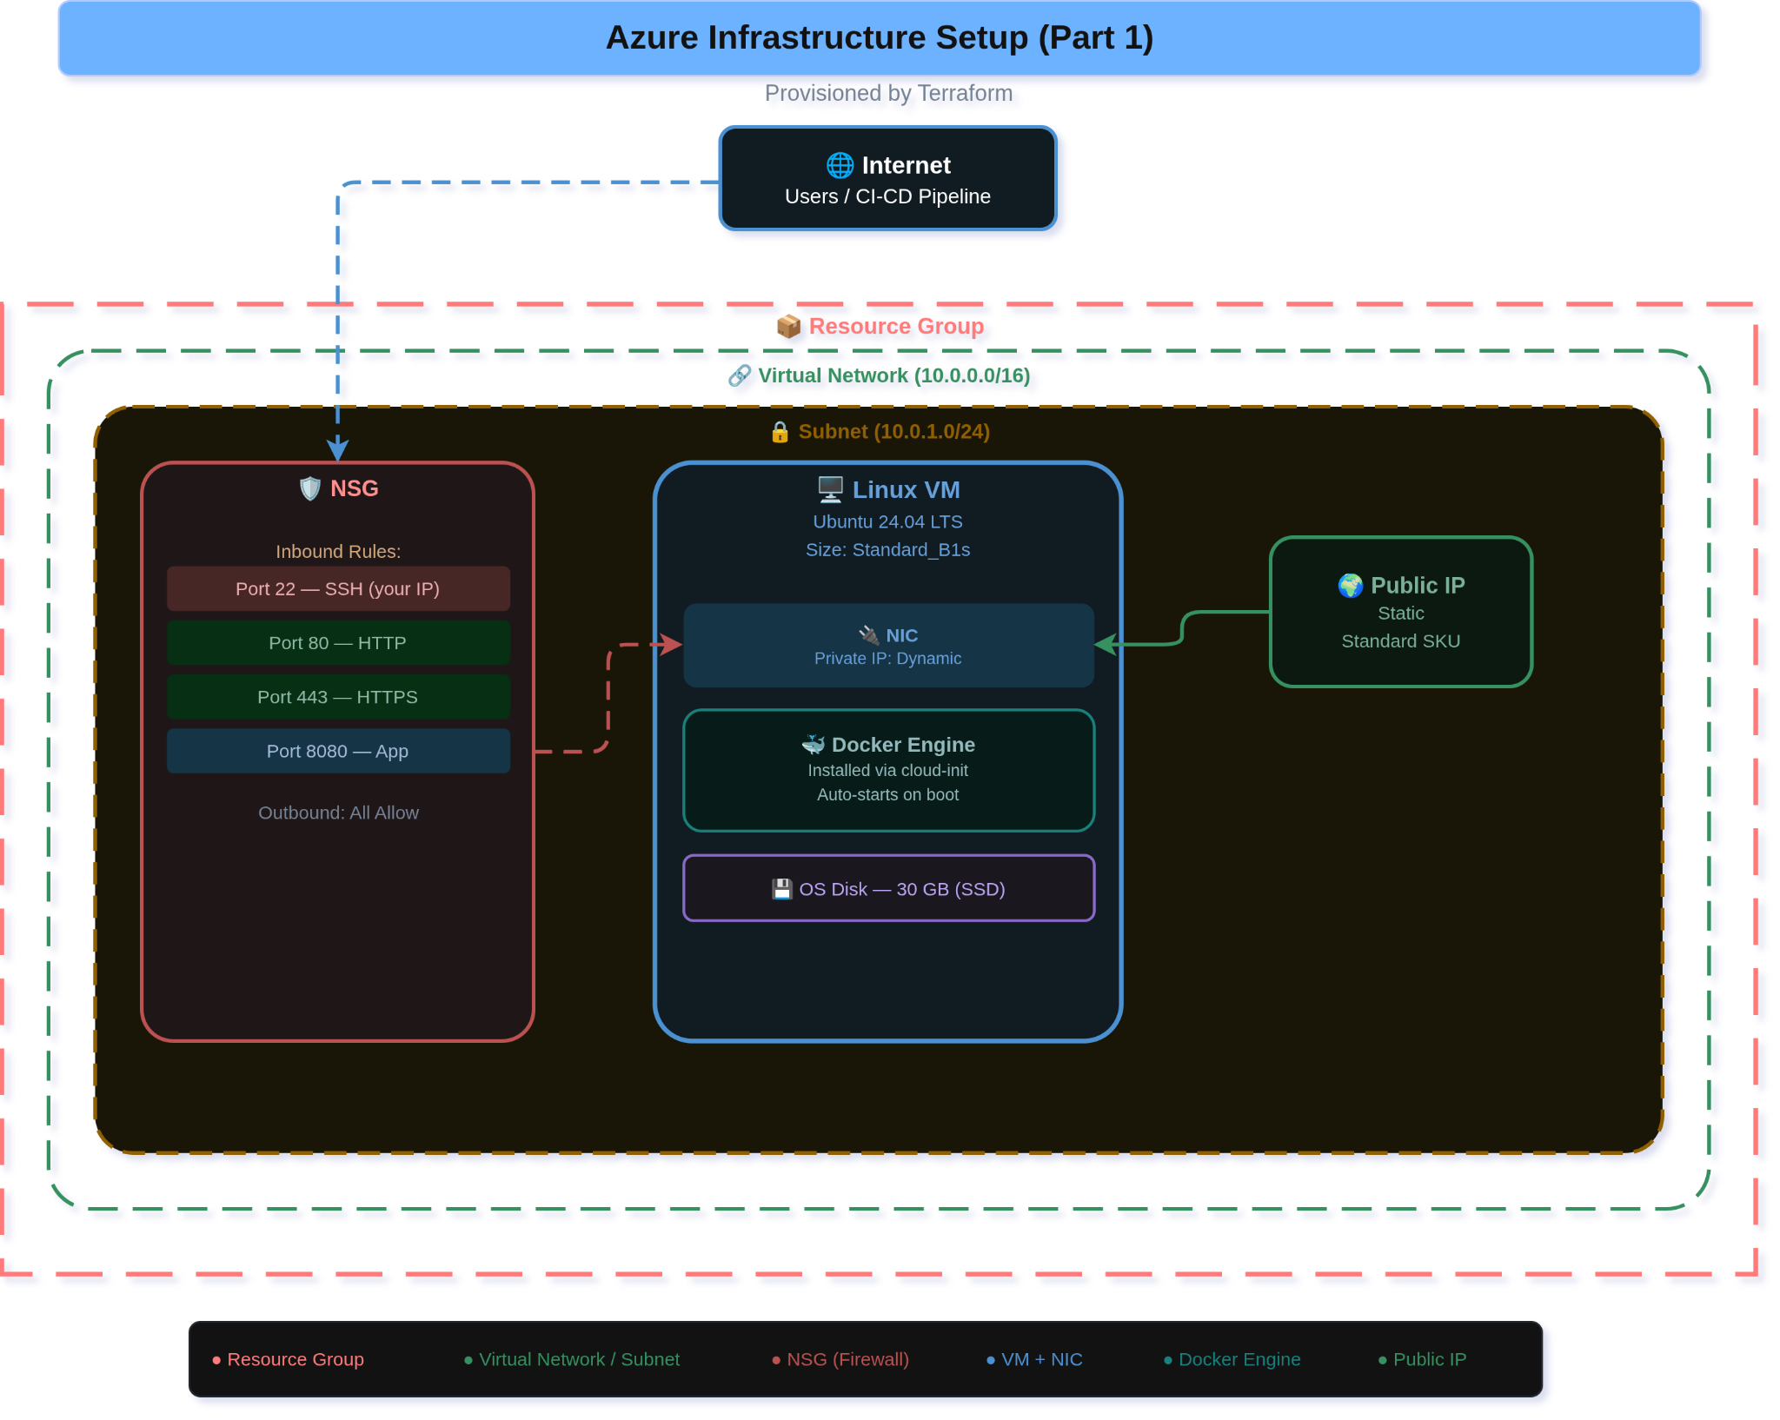

Appendix B
All the scripts for server configuration and readme to explain the configuration is available on the following GitHub repository:
https://github.com/AbdulMateenzwl/Networking-CA/tree/main/Ansible
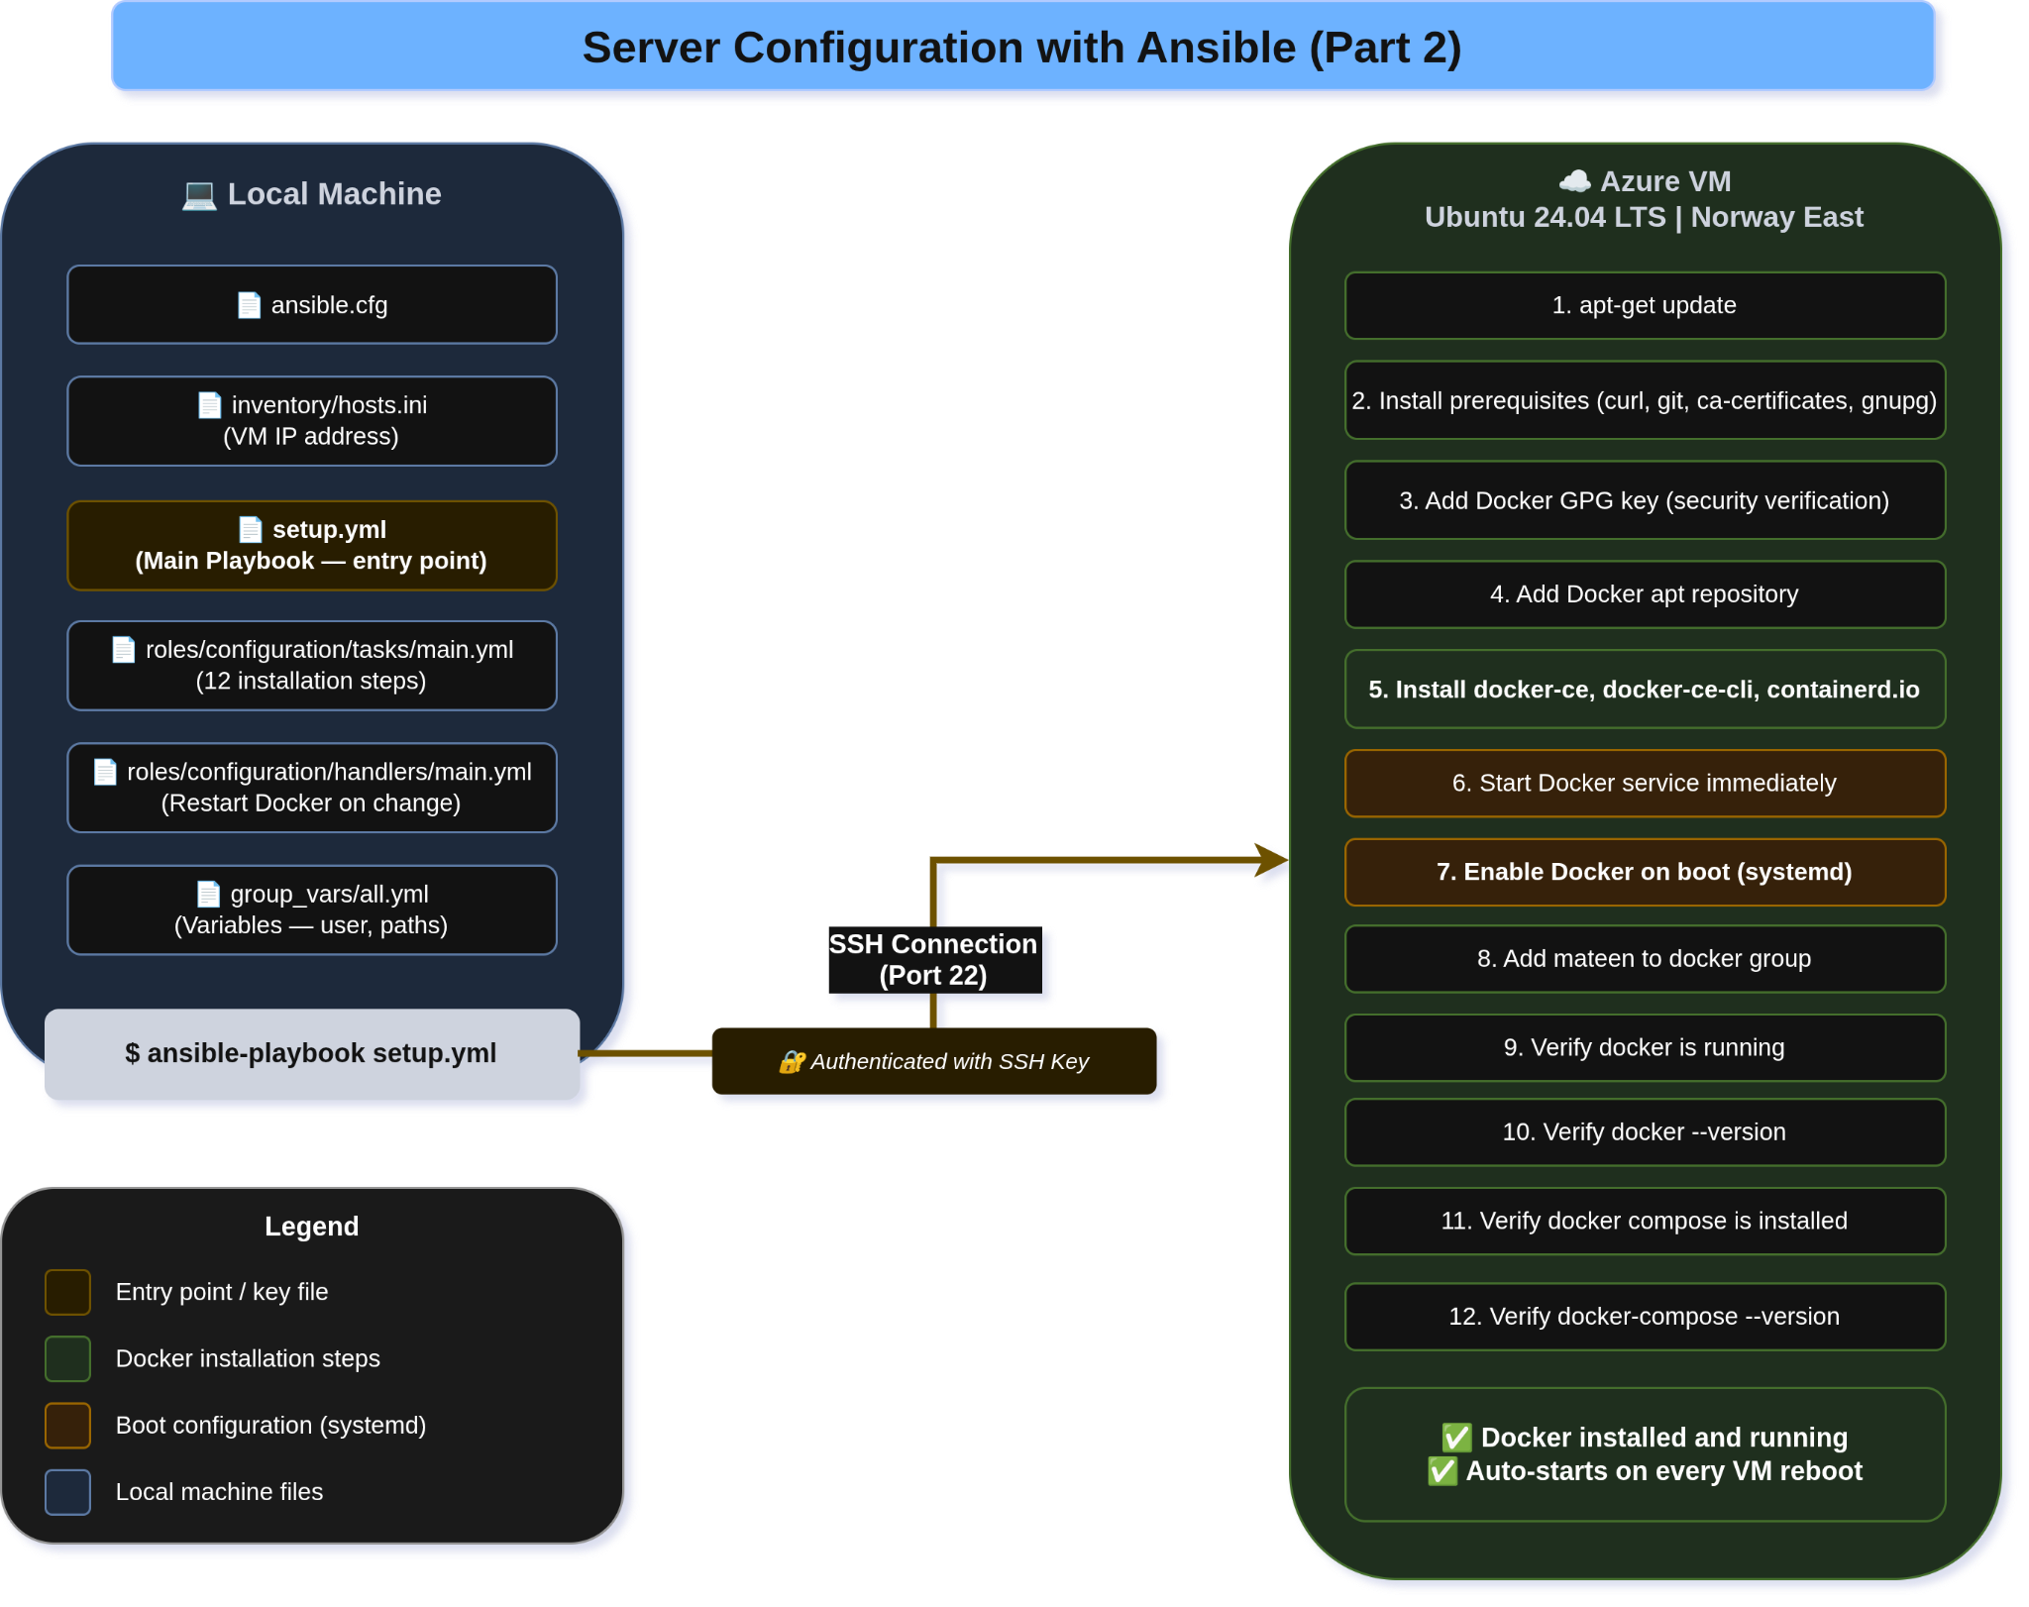

Appendix C
The link for github repo is below:
https://github.com/AbdulMateenzwl/Networking-CA/tree/main/app
The link for github repo is below:
https://github.com/AbdulMateenzwl/Networking-CA/blob/main/app/Dockerfile
Automation Script:
https://github.com/AbdulMateenzwl/Networking-CA/blob/main/Ansible/deploy.yml
https://github.com/AbdulMateenzwl/Networking-CA/blob/main/Ansible/roles/deploy/tasks/main.yml
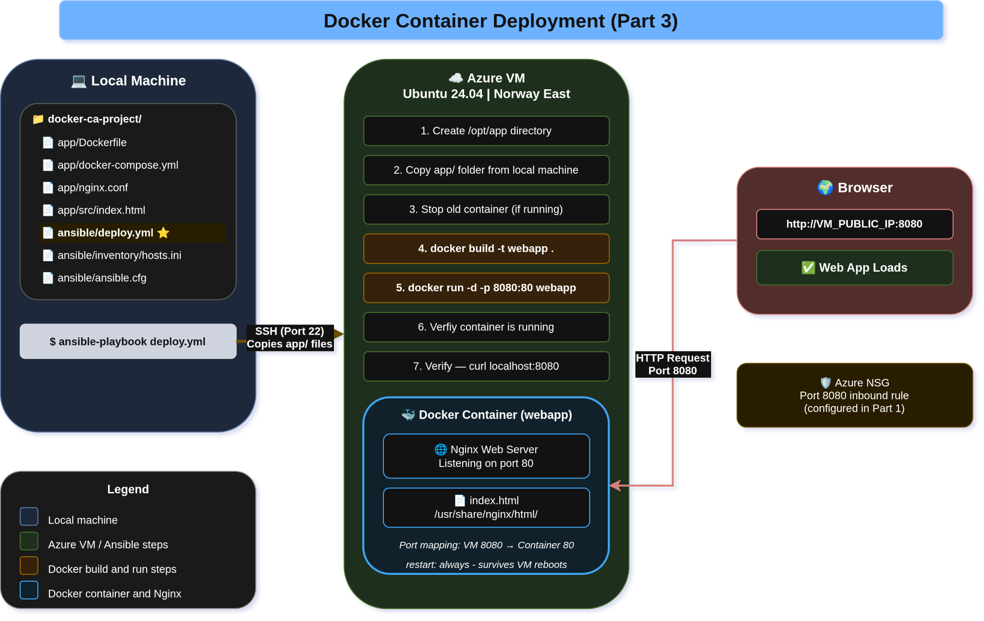

Appendix D
The link for GitHub workflow is below:
https://github.com/AbdulMateenzwl/Networking-CA/blob/main/.github/workflows/deploy.yml
The link of video showing demo of Pipeline in Action
https://youtu.be/zodyFSn06eA

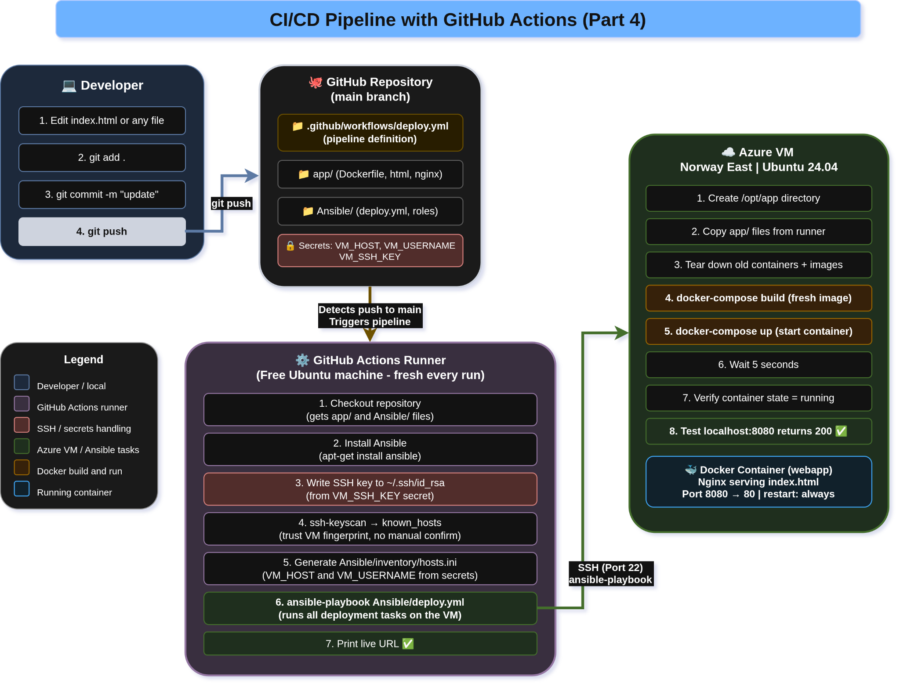

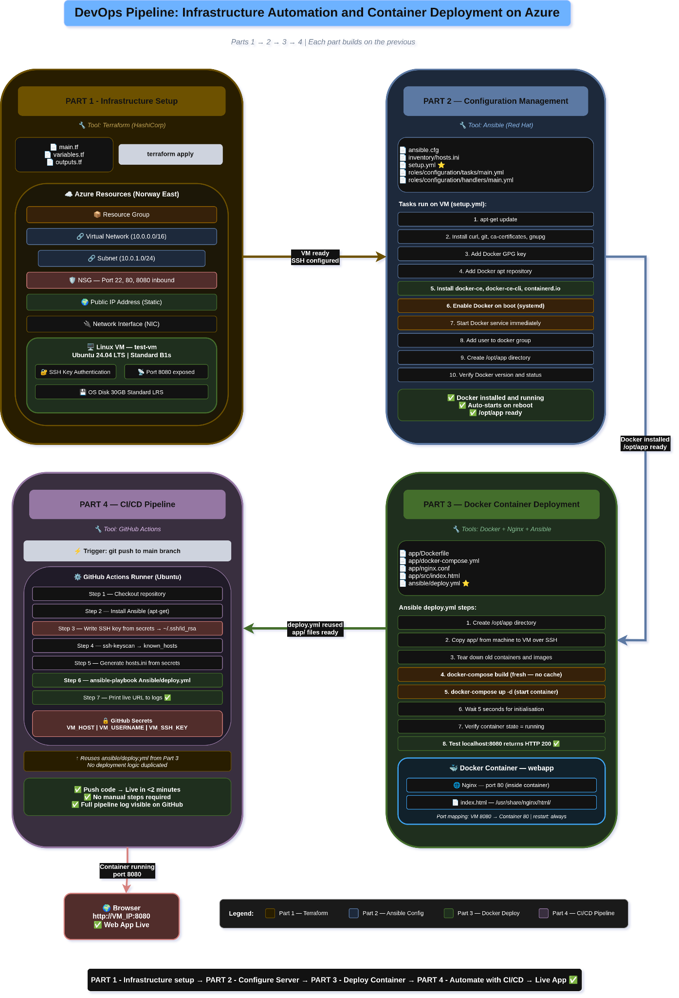

References
- Docker, (2024a). Docker Overview. [online] Available at: https://docs.docker.com/get-started/docker-overview [Accessed 25 February 2026].
- Docker, (2024b). Install Docker Engine on Ubuntu. [online] Available at: https://docs.docker.com/engine/install/ubuntu [Accessed 25 February 2026].
- Docker, (2024c). Configure Docker to Start on Boot with systemd. [online] Available at: https://docs.docker.com/engine/install/linux-postinstall [Accessed 25 February 2026].
- Docker, (2024d). Docker Compose Documentation. [online] Available at: https://docs.docker.com/compose [Accessed 25 February 2026].
- Docker, (2024e). Docker Case Studies. [online] Available at: https://www.docker.com/customers [Accessed 25 February 2026].
- GitHub, (2024a). GitHub Actions Documentation. [online] Available at: https://docs.github.com/en/actions [Accessed 25 February 2026].
- GitHub, (2024b). Triggering a Workflow — GitHub Actions. [online] Available at: https://docs.github.com/en/actions/writing-workflows/choosing-when-your-workflow-runs/triggering-a-workflow [Accessed 25 February 2026].
- GitHub, (2024c). Using Secrets in GitHub Actions. [online] Available at: https://docs.github.com/en/actions/security-for-github-actions/security-guides/using-secrets-in-github-actions [Accessed 25 February 2026].
- HashiCorp, (2024a). Terraform AzureRM Provider Documentation. [online] Available at: https://registry.terraform.io/providers/hashicorp/azurerm/latest/docs [Accessed 22 February 2026].
- HashiCorp, (2024b). Terraform Introduction — Who Uses Terraform. [online] Available at: https://developer.hashicorp.com/terraform/intro [Accessed 23 February 2026].
- Humble, J. and Farley, D. (2010). Continuous Delivery: Reliable Software Releases through Build, Test, and Deployment Automation. Boston: Addison-Wesley.
- Microsoft, (2024a). Azure Virtual Network Overview. [online] Available at: https://learn.microsoft.com/en-us/azure/virtual-network/virtual-networks-overview [Accessed 22 February 2026].
- Microsoft, (2024b). Network Security Groups Overview. [online] Available at: https://learn.microsoft.com/en-us/azure/virtual-network/network-security-groups-overview [Accessed 22 February 2026].
- Microsoft, (2024c). Quickstart: Create a Linux Virtual Machine using Terraform. [online] Available at: https://learn.microsoft.com/en-us/azure/virtual-machines/linux/quick-create-terraform [Accessed 22 February 2026].
- Microsoft, (2024d). Azure for Students Subscription Overview. [online] Available at: https://azure.microsoft.com/en-us/free/students [Accessed 22 February 2026].
- Morris, K. (2016). Infrastructure as Code: Managing Servers in the Cloud. Sebastopol: O'Reilly Media.
- Nginx, (2024). Nginx Documentation. [online] Available at: https://nginx.org/en/docs [Accessed 23 February 2026].
- Red Hat, (2024a). Ansible Documentation — Getting Started. [online] Available at: https://docs.ansible.com/ansible/latest/getting_started/index.html [Accessed 23 February 2026].
- Red Hat, (2024b). How Ansible Works. [online] Available at: https://www.ansible.com/overview/how-ansible-works [Accessed 23 February 2026].

