Contents
Bus Transport Management System - Report 2
1. Introduction 2
2. Purpose of the System 2
3. Features of the System 2
4. Module Descriptions + code 2
A. Bus Module 2
Bus Module code 2
B. Route Module 5
Route Module Code 5
C. Driver Module 7
Driver Module Code 7
D. Student Module 9
Student Module Code 9
5. Fare Function 13
Fare Function Code 13
6. Discount Function 13
Discount Function code 13
7. TAX Function 14
Tax Function code 14
8. Main Menu 15
Code 15
What we have used in this program? 16
Outputs Module Wise: 17
Menu: 17
Student Module: 17
Bus Module 18
Route Module: 19
Driver Module: 20

Bus Transport Management System - Report

1. Introduction
The Bus Transport Management System is a console-based Java application designed to manage transportation-related information. It includes Bus, Route, Driver, and Student modules. Each module stores data inside arrays and uses functions, loops, and conditions to manage and display records.

2. Purpose of the System
The system was created to digitally organize transport-related information, reduce manual errors, practice array-based storage, modular programming, and develop a menu-driven system for structured record management.

3. Features of the System
• Bus Module: Stores bus information.
• Route Module: Stores route information.
• Driver Module: Stores driver information and applies tax function.
• Student Module: Stores student information and applies fare & discount functions.
• Fare Function based on distance.
• Discount Function based on advance fee status.
• Tax Function applying 5% tax above salary threshold.
• Menu.

4. Module Descriptions + code

A. Bus Module
Fields used: Bus ID, Bus Number, Bus Type, Bus Capacity, Last Maintenance Date.
This module stores multiple bus records, displays them, and supports searching by Bus ID.

Bus Module code
//bus function
public static void bus() {
Scanner s = new Scanner(System.in);
System.out.println("enter numbers of records you want to store");
int b=s.nextInt();
int[] bid = new int[b];
int[] bc = new int[b];
String[] bt = new String[b];
String[] md = new String[b];
String[] bn = new String[b];

System.out.println("BUS MODULE");
System.out.println("_________________________________________________________________________________________________________");
for (int i = 0; i < bt.length; i++) {
System.out.println("enter bus ID" + (i + 1));
bid[i] = s.nextInt();
s.nextLine();
System.out.println("Enter bus number" + (i + 1));
bn[i] = s.nextLine();
System.out.println("enter bus type" + (i + 1));
bt[i] = s.nextLine();

System.out.println("enter bus capacity" + (i + 1));
bc[i] = s.nextInt();
s.nextLine();
System.out.println("enter last maintenance date" + (i + 1));
md[i] = s.nextLine();
}
System.out.println("Bus ID: Bus Number: Bus Type: Bus Capacity: Last Maintenance:");

for (int i = 0; i < bt.length; i++) {
System.out.printf("%-20d %-20s %-20s %-20d %-20s\n", bid[i], bn[i], bt[i], bc[i], md[i]);

}

System.out.println("if you want to see any individual record press S");
char c = s.next().charAt(0);

while (c == 's' || c == 'S') {
System.out.println("if you want to see any individual record enter bus id");
int sbid = s.nextInt();

for (int i = 0; i < bt.length; i++) {

if (bid[i] == sbid) {
System.out.println("Bus ID: Bus Number: Bus Type: Bus Capacity: Last Maintenance:");
System.out.printf("%-20d %-20s %-20s %-20d %-20s\n", bid[i], bn[i], bt[i], bc[i], md[i]);
}
}
System.out.println("if you want to see any other record press 's' again");
c = s.next().charAt(0);

}
}

B. Route Module
Fields used: Route ID, Start Point, End Point, Number of Stops, Distance.
Stores route details and supports searching by Route ID.

Route Module Code
//route function
public static void route() {
Scanner s = new Scanner(System.in);
System.out.println("enter numbers of records you want to store");
int b=s.nextInt();
int[] rid = new int[b];
String[] sp = new String[b];
String[] ep = new String[b];
int[] ns = new int[b];
float[] d = new float[b];

System.out.println("ROUTE MODULE");
System.out.println("_________________________________________________________________________________________________________");
for (int i = 0; i < sp.length; i++) {
System.out.println("ENTER ROUTE ID");
rid[i] = s.nextInt();
s.nextLine();
System.out.println("START POINT LOCATION NAME" + (i + 1));
sp[i] = s.nextLine();
System.out.println("ENDING POINT LOCATION NAME" + (i + 1));
ep[i] = s.nextLine();
System.out.println("ENTER TOTAL NUMBER OF STOPS" + (i + 1));
ns[i] = s.nextInt();
System.out.println("ENTER DISTANCE IN KMS" + (i + 1));
d[i] = s.nextFloat();
}

System.out.println("ROUTE ID: START POINT: END POINT LOCATION: NUMBER OF STOPS: TOTAL DISTANCE:");
for (int i = 0; i < sp.length; i++) {

System.out.printf("%-20d %-20s %-20s %-20d %-20f\n", rid[i], sp[i], ep[i], ns[i],d[i]);
}

System.out.println("if you want to see any individual record press S");
char c = s.next().charAt(0);

while (c == 's' || c == 'S') {
System.out.println("if you want to see any individual record enter route id");
int srid = s.nextInt();

for (int i = 0; i < sp.length; i++) {

if (rid[i] == srid) {
System.out.println("ROUTE ID: START POINT: END POINT LOCATION: NUMBER OF STOPS: TOTAL DISTANCE:");
System.out.printf("%-20d %-20s %-20s %-20d %-20.2f\n", rid[i], sp[i], ep[i], ns[i],d[i]);
}}
System.out.println("if you want to see any other record press 's' again");
c = s.next().charAt(0);

}

}

C. Driver Module
Fields used: Driver Name, ID, License Number, Contact, Salary, Salary After Tax.
Uses tax function to calculate salary after deductions.

Driver Module Code
//driver function
public static void driver() {
Scanner s = new Scanner(System.in);
System.out.println("enter numbers of records you want to store");
int b=s.nextInt();
int[] did = new int[b];
String[] dn = new String[b];
String[] dln = new String[b];
int[] dc = new int[b];
int[] ds = new int[b];
double[] st = new double[b];
System.out.println("DRIVER MODULE");
System.out.println("_________________________________________________________________________________________________________");
s.nextLine();
for (int i = 0; i < st.length; i++) {

System.out.println("Enter driver name: " + (i + 1));
dn[i] = s.nextLine();

System.out.println("Enter driver id" + (i + 1));
did[i] = s.nextInt();
s.nextLine();
System.out.println("Enter License Number: " + (i + 1));
dln[i] = s.nextLine();
System.out.println("Enter driver contact:" + (i + 1));
dc[i] = s.nextInt();
System.out.println("Enter driver salary:" + (i + 1));

ds[i] = s.nextInt();
st[i] = tax(ds[i]);
}
System.out.println("_________________________________________________________________________________________________________");

System.out.println("Name: license no: id: contact: salary: salary after tax");
for (int x = 0; x < st.length; x++) {
System.out.printf("%-20s %-20s %-20d %-20d %-20d %-20f \n", dn[x], dln[x], did[x], dc[x], ds[x], st[x]);
}
System.out.println("if you want to see any individual record press S");
char c = s.next().charAt(0);
while (c == 's' || c == 'S') {
System.out.println("if you want to see any individual record enter driver id");
int sdid = s.nextInt();
for (int y = 0; y < st.length; y++) {

if (did[y] == sdid) {
System.out.println("Name: license no: id: contact: salary: salary after tax");
System.out.printf("%-20s %-20s %-20d %-20d %-20d %-20f \n", dn[y], dln[y], did[y], dc[y], ds[y], st[y]);
}
}
System.out.println("if you want to see any other record press 's' again");
c = s.next().charAt(0);

}

}

D. Student Module
Fields used: Student Name, Age, ID, Gender, Location, Contact, Distance, Fare, Status, Discounted Fare.
Uses fare function and discount function.

Student Module Code
public static void student() {
Scanner s = new Scanner(System.in);
System.out.println("enter numbers of records you want to store");
int b=s.nextInt();
{

int[] sid = new int[b];
int[] sa = new int[b];
String[] sn = new String[b];
String[] sg = new String[b];
String[] shl = new String[b];
int[] sc = new int[b];
int[] sd = new int[b];
int[] f = new int[b];
int[] df = new int[b];

int[] status = new int[b];
//starting

System.out.println("STUDENT MODULE");
System.out.println("_________________________________________________________________________________________________________");
s.nextLine();
for (int i = 0; i < sc.length; i++) {

System.out.println("Enter student name:" + (i + 1));
sn[i] = s.nextLine();

System.out.println("Enter student id:" + (i + 1));
sid[i] = s.nextInt();
System.out.println("Enter student age:" + (i + 1));
sa[i] = s.nextInt();
s.nextLine();
System.out.println("Enter student Gender:" + (i + 1));
sg[i] = s.nextLine();

System.out.println("student home location name:" + (i + 1));
shl[i] = s.nextLine();
System.out.println("Enter student contact:" + (i + 1));
sc[i] = s.nextInt();
System.out.println("enter total distance in kms:" + (i + 1));
sd[i] = s.nextInt();
s.nextLine();
f[i] = fare(sd[i]);
df[i] = discount(f[i]);
if (df[i] == f[i]) {
status[i] = 0;

} else {
status[i] = 1;

}

}

System.out.println("_________________________________________________________________________________________________________");
System.out.println("Name: age: id: Gender: location: Contact: Distance: Fare: status of advance fee: Discounted fare:");
for (int i = 0; i < sc.length; i++) {
System.out.printf("%-15s %-15d %-15d %-15s %-15s %-15d %-15d %-25d %-25d %-25d\n", sn[i], sa[i], sid[i], sg[i], shl[i], sc[i], sd[i], f[i], status[i], df[i]);
}

System.out.println("if you want to see any individual record press S");
char c = s.next().charAt(0);
while (c == 's' || c == 'S') {
System.out.println("if you want to see any individual record enter student id");
int ssid = s.nextInt();
for (int i = 0; i < sc.length; i++) {

if (sid[i] == ssid) {
System.out.println("Name: age: id: Gender: location: Contact: Distance: Fare: status of advance fee: Discounted fare:");
System.out.printf("%-15s %-15d %-15d %-15s %-15s %-15d %-15d %-25d %-25d %-25d\n", sn[i], sa[i], sid[i], sg[i], shl[i], sc[i], sd[i], f[i], status[i], df[i]);
}

}
System.out.println("if you want to see any other record press 's' again");
c = s.next().charAt(0);

}
}
}

5. Fare Function
This function calculates fare of student on the basis of number of kilometers. This function is called in Student Module.

Fare Function Code
//fare function

public static int fare(int sd) {
int f;
if (sd <= 30) {
f = 100 * sd;
return f;
} else {
f = 140 * sd;
return f;
}
}

6. Discount Function
This function gives a discount of 500 from actual fare calculated if student has paid an advance fee.

Discount Function code
//discount function
public static int discount(int f) {
Scanner s = new Scanner(System.in);
int df;
System.out.println("student has paid advance fee press 'y' if not press 'n'");
char dc = s.next().charAt(0);

if (dc == 'y' || dc == 'Y') {

df = f - 500;
return df;
} else {
df = f;
}
return df;

}

7. TAX Function
This function deducts 5% tax from the salary of bus drivers if their salary exceeds 50000.

Tax Function code
//tax function

public static double tax(double s) {
double st;

if (s > 50000) {
st = (s - s * 0.05);
return st;
} else {
st = s;
return st;
}

}

8. Main Menu
It shows menu and repeatedly until user himself wants to exit program.

Code
System.out.println("enter y to see the menu ");
char c = s.next().charAt(0);
while (c == 'y' || c == 'Y') {
System.out.println("ENTER NUMBER BETWEEEN 1 AND 4 ACCORDING TO MENU WHRE YOU WANT TO STORE DATA");
System.out.println("...ENTER 1 FOR BUS MODULE...");
System.out.println("...2 FOR ROUTE MODULE...");
System.out.println("...3 FOR DRIVER MODULE...");
System.out.println("...4 FOR STUDENT MODULE...");
System.out.println("enter number...");
int number = s.nextInt();
switch (number) {
case 1:
System.out.println("if you want to add a record press 'A'");
char bch = s.next().charAt(0);
if (bch == 'a' || bch == 'A') { bus(); }
else { System.out.println("invalid choice"); }
break;
case 2:
System.out.println("if you want to add a record press 'A'");
char rch = s.next().charAt(0);
if (rch == 'a' || rch == 'A') { route(); }
else { System.out.println("invalid choice"); }
break;
case 3:
System.out.println("if you want to add a record press 'A'");
char dch = s.next().charAt(0);
if (dch == 'a' || dch == 'A') { driver(); }
else { System.out.println("invalid choice"); }
break;
case 4:
System.out.println("if you want to add a record press 'A'");
char sch = s.next().charAt(0);
if (sch == 'a' || sch == 'A') { student(); }
else { System.out.println("invalid choice"); }
break;
default:
System.out.println("you have made invalid choice");
}
System.out.println("enter y to see the menu again or any other button to exit program");
c = s.next().charAt(0);
}
System.out.println("program has ended! YOU DIDN'T SELECTED Y TO SEE THE MENU AGAIN");

What we have used in this program?
- Scanner
- Arrays
- Methods
- Loops
- Decision structures like switch if , if-else.

Outputs Module Wise:

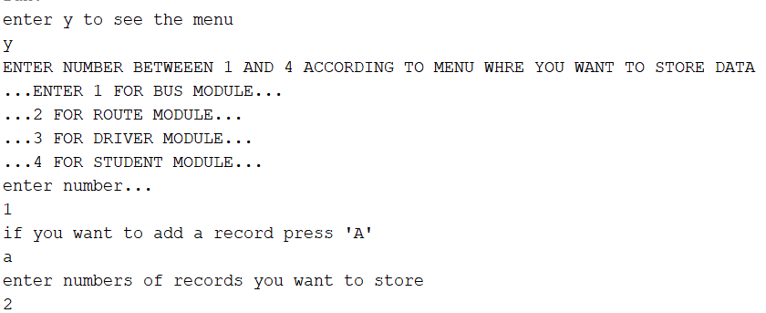
Menu:

Student Module:
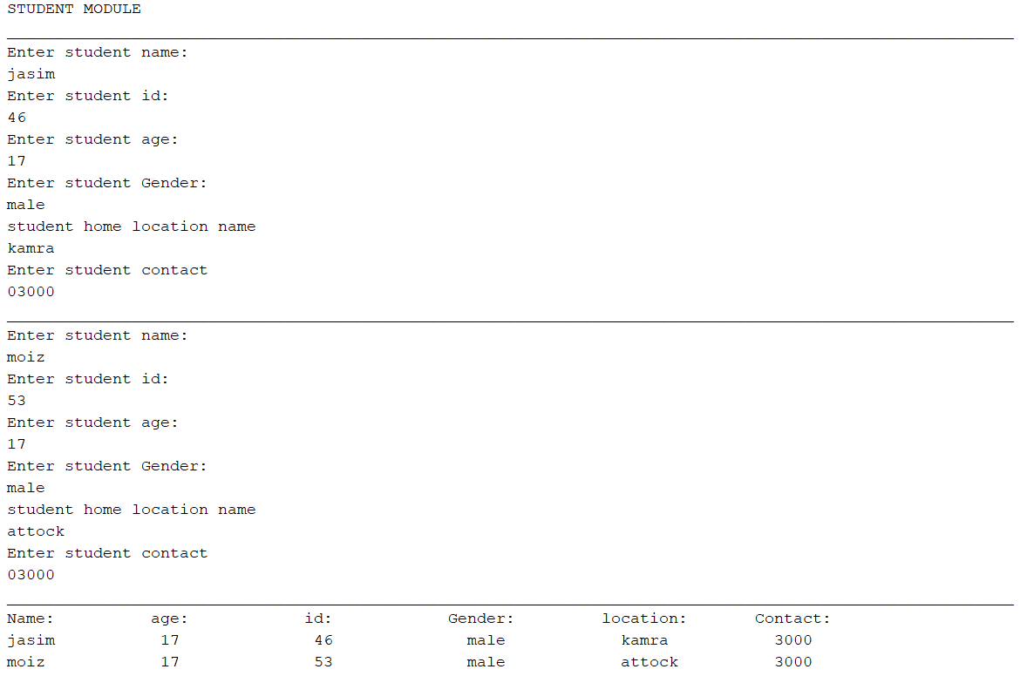

Bus Module

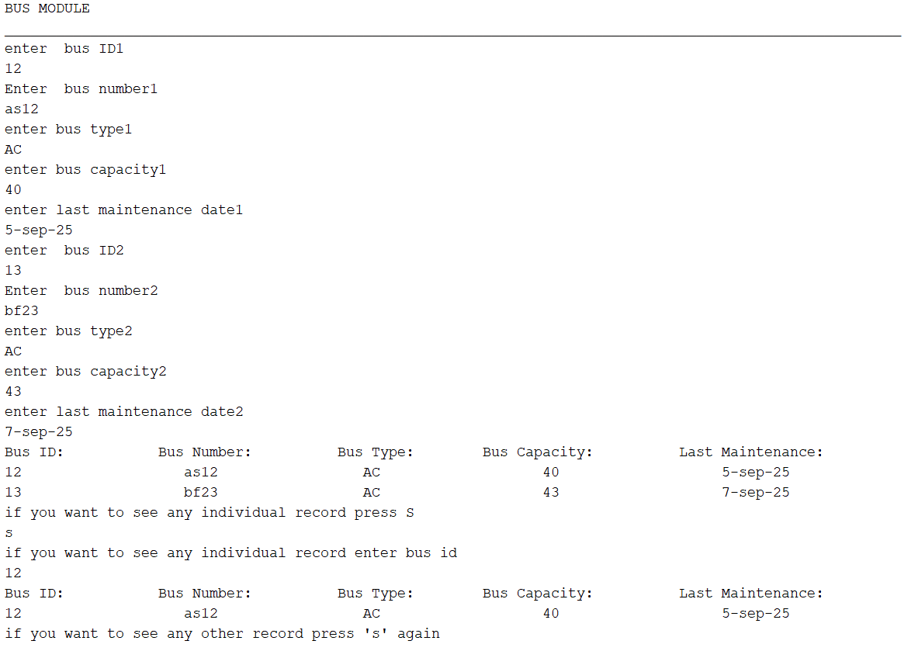

Route Module:

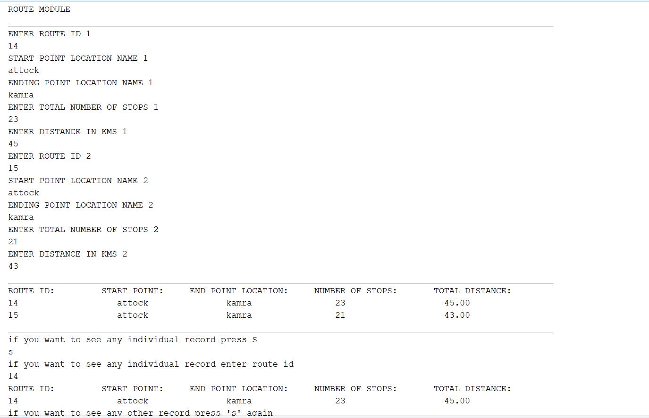

Driver Module:
