Lab 1 - Getting Started with RISC-V (Assembly Language) in VS Code

Name: Abdul Moiz Ahmed | Student ID: aa08811

Task 3:

Code:
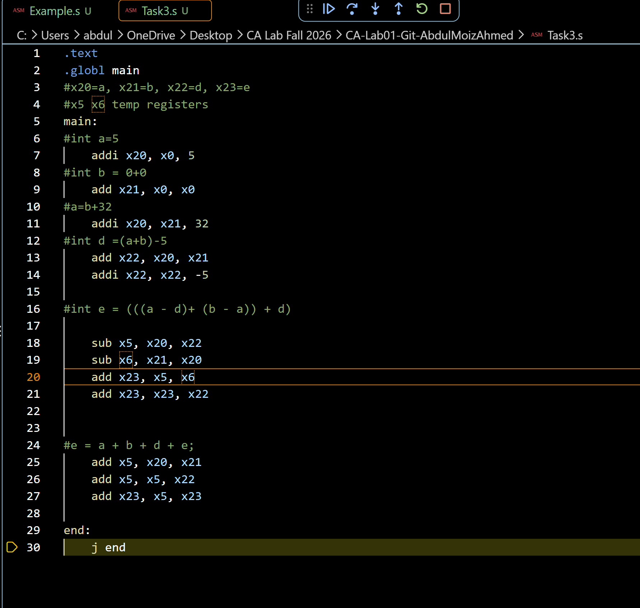

Results:
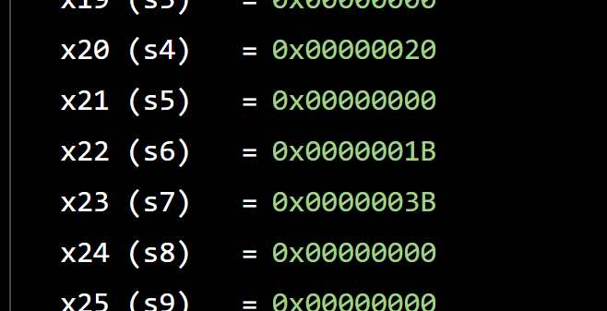

a=32, b=0, d=27, e=59

We converted the given statements into RISC V assembly instructions. The registers were used to store the variables and temp results while doing the calculations. The final register values matched the results from the original statements

Task 4a:
- Store x10 as unsigned integer at address 0x100.
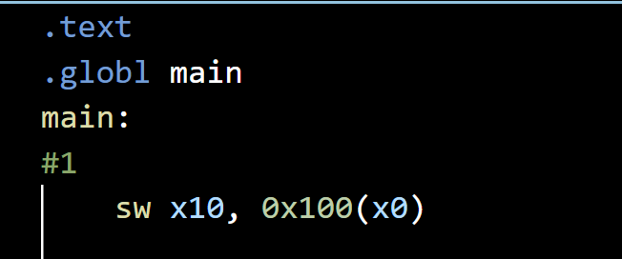

- Store x11 as unsigned integer at address 0x1F0.
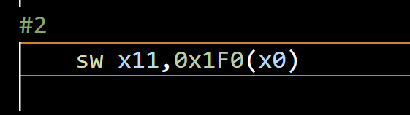

- Load an unsigned short integer (two bytes) from address 0x100 in x12.
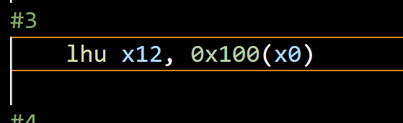

- Load a short integer from address 0x1F0 in register x13.
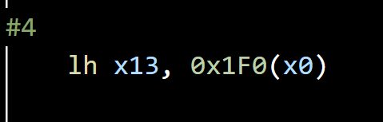

- Load a singed character from address 0x1F0 in register x14.
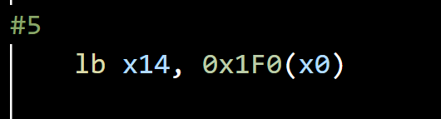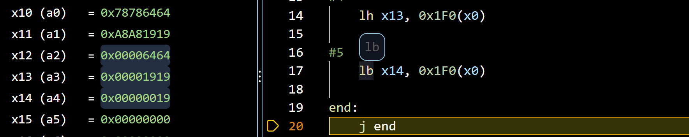

we used RISC V load and store instructionsin order to move data between the registers and the memory. Words, halfwords, and bytes all used different instructions depending on their size. The results we got showed that the correct values were stored and loaded from the addresses

Task 4b:

Code:
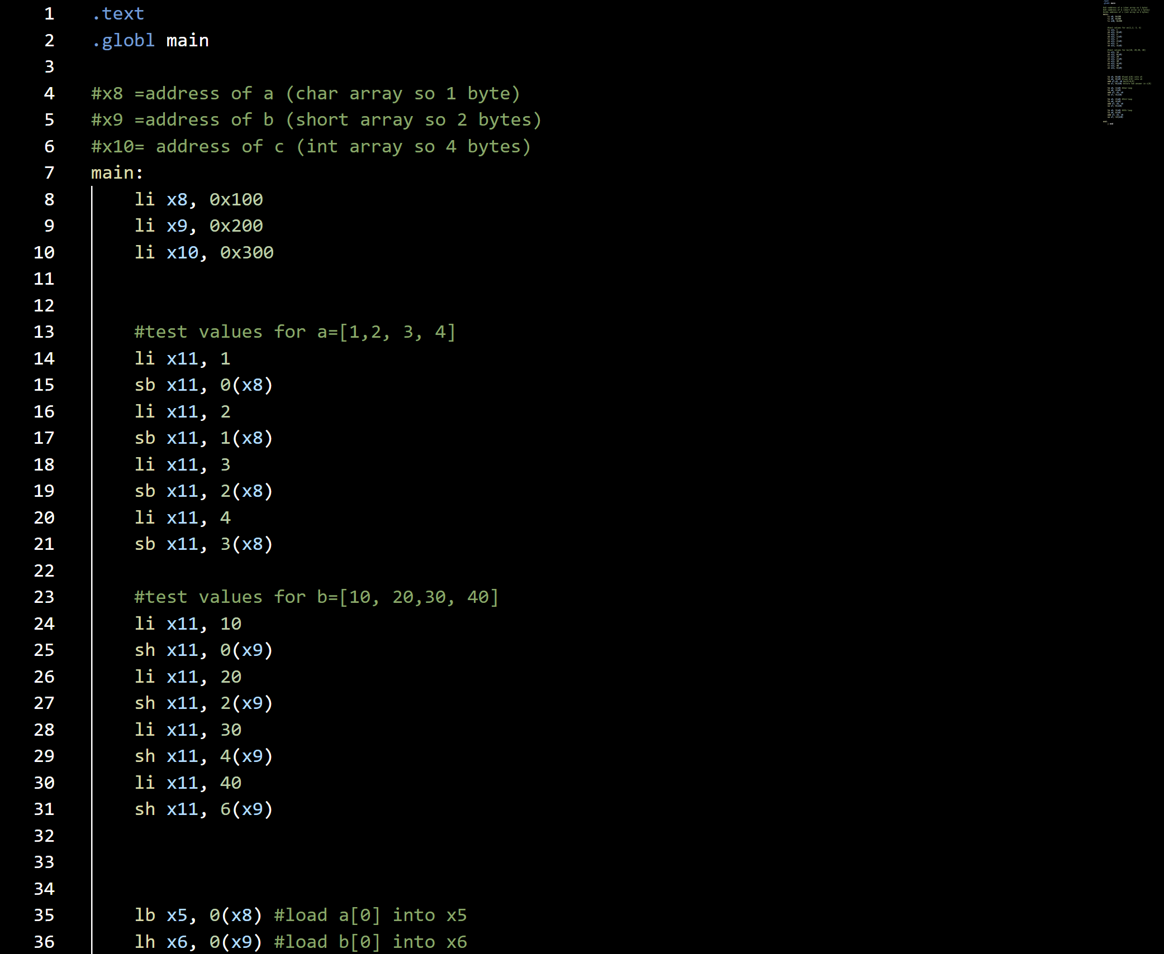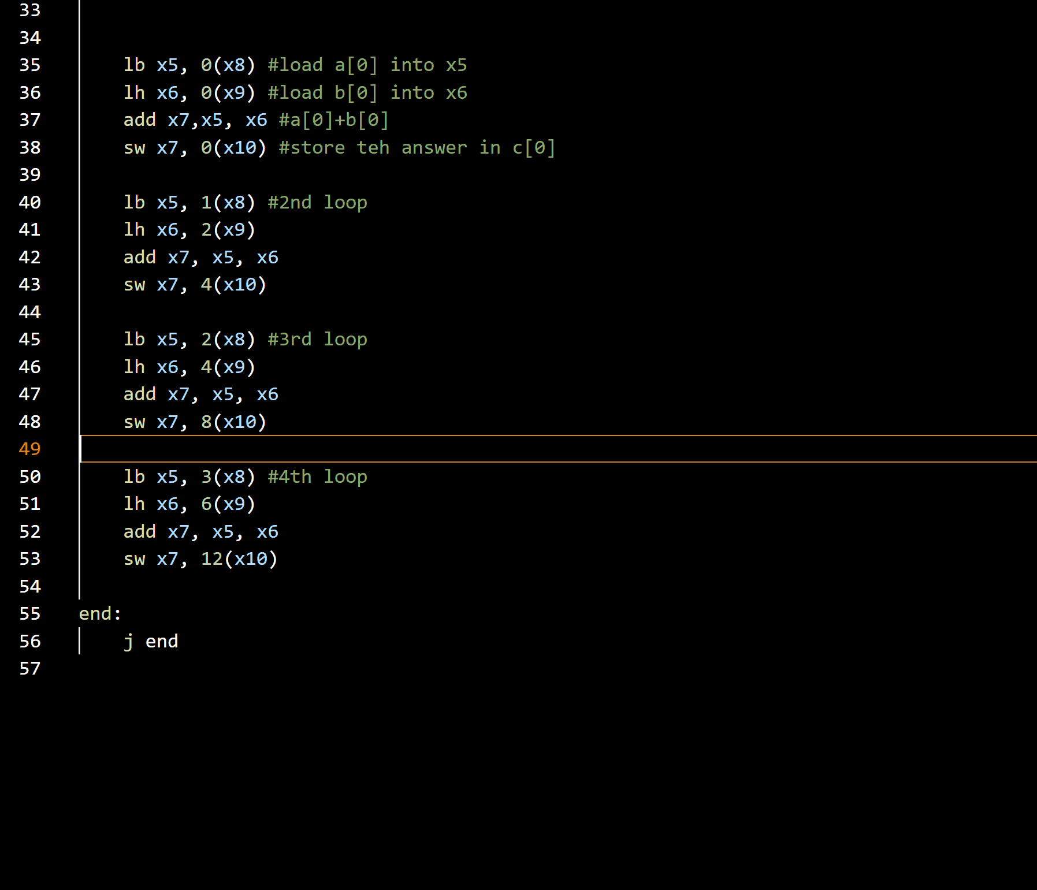

Results:
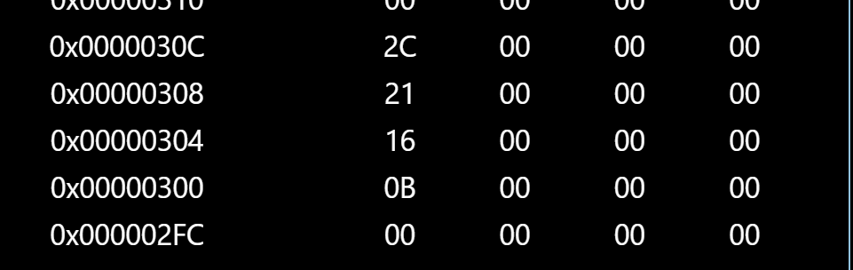
We showed the four iteration loop that was given without using any actual loop instruction. The iterations were written separately and we used different offsets for the char, short, and integer arrays. The final values were stored in array c which confirmed that each element of arrays a andb was correct
TASK 1:
git --version
git config --global user.name "Abdul Moiz Ahmed"
git config --global user.email "your-email"

git clone https://github.com/AbdulMoizAhmd/CA-Lab01-Git-AbdulMoizAhmed.git

touch hello.txt
nano bye.txt

git status
git add bye.txt
git commit -m "Added bye.txt"
git push origin main

In Task 1 we used Git and GitHub where we made agithub repository for the lab and committed a file to it using the above code and the changes were also pushed to the repository

TASK 2:

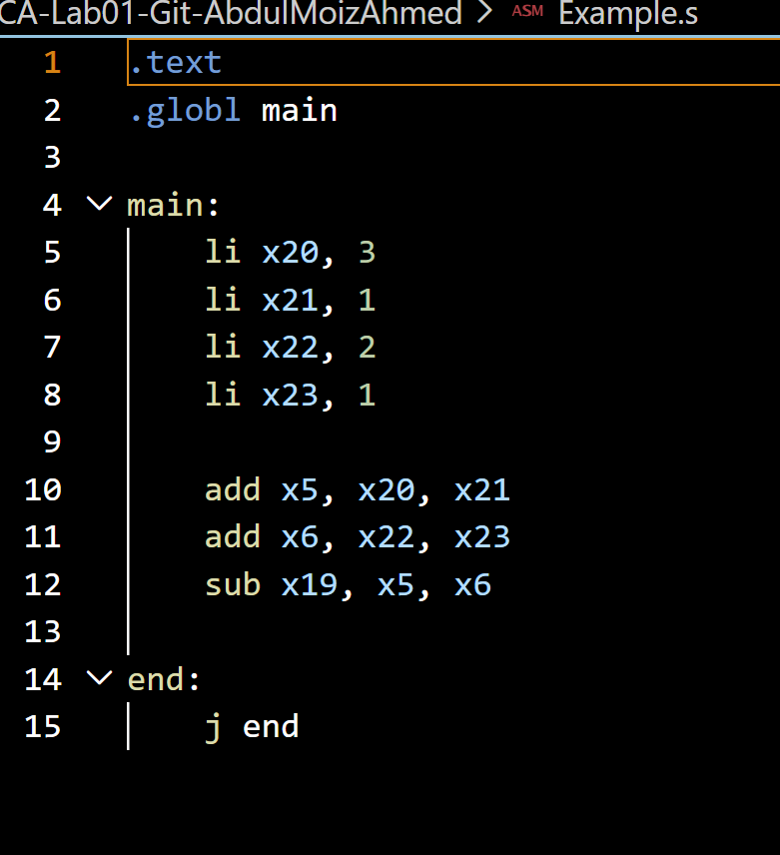

For task 2 we set up RISC V simulation inside of VS Code using Venus simulator and executed a simple program to test and the register values were checked using the debugger. The Venus Memory Viewer was opened so that we could observe how memory is represented there

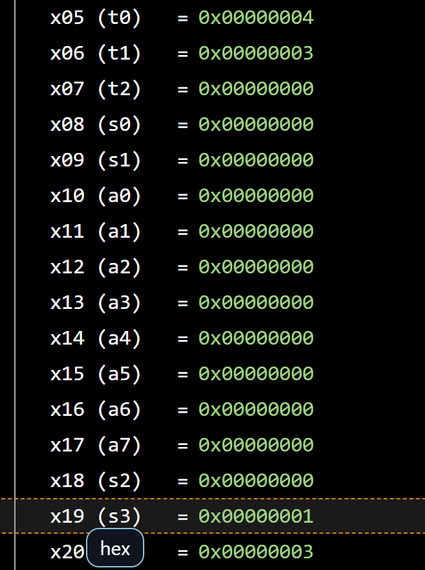

Assessment Rubric
Lab 1: Getting Started with RISC-V (Assembly Language) n VS Code

Name | Student ID: | Section:

Points Distribution:

 | Task No. | LR 2 (Code) | LR 5 (Results)
In-Lab | Task 1 | - | /15
In-Lab | Task 2 | - | /15
In-Lab | Task 3 | /10 | /5
In-Lab | Task 4a | /10 | /5
In-Lab | Task 4b | /10 | /10
Total Points: 100 |  | /30 | /50
CLO Mapped |  | CLO 2

Affective Domain Rubric |  | Points | CLO Mapped
AR7 | Report Submission & Git Upload | /10 & /10 | CLO 2

CLO | Total Points | Points Obtained
2 | 100
Total | 100

