Lab 2 - Implementing Decision Instructions in RISC V Assembly Language

Name: Abdul Moiz Ahmed | Student ID: aa08811

Task 1:

Code:
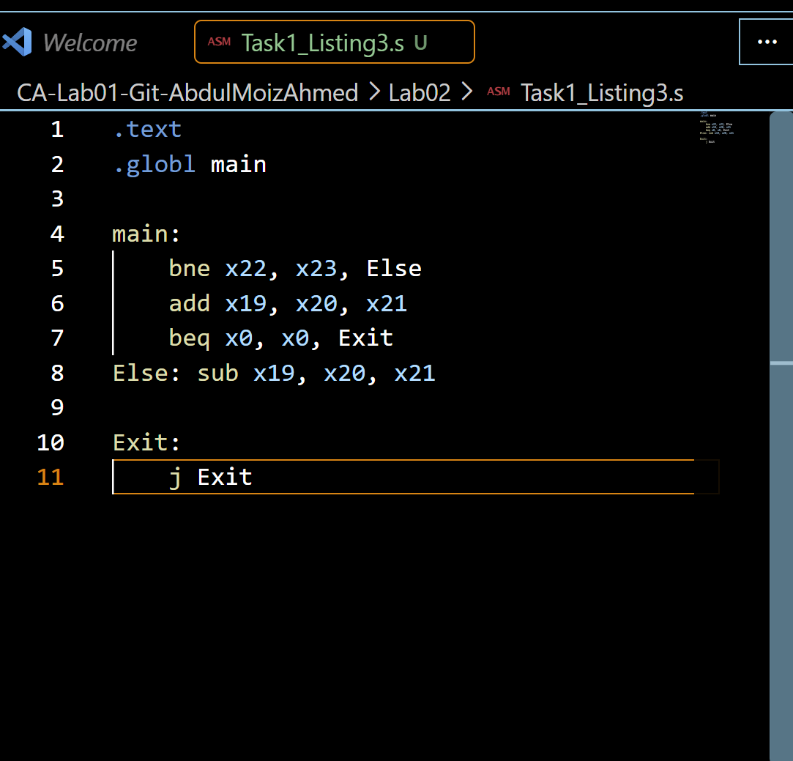
Listing 3 code
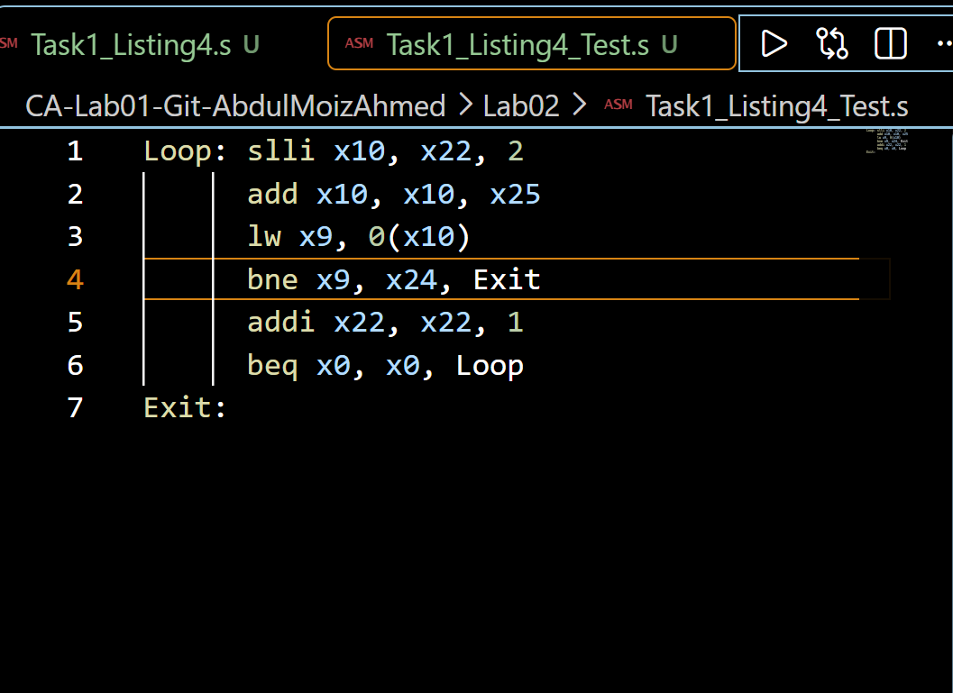
Listing 4 code

Results:
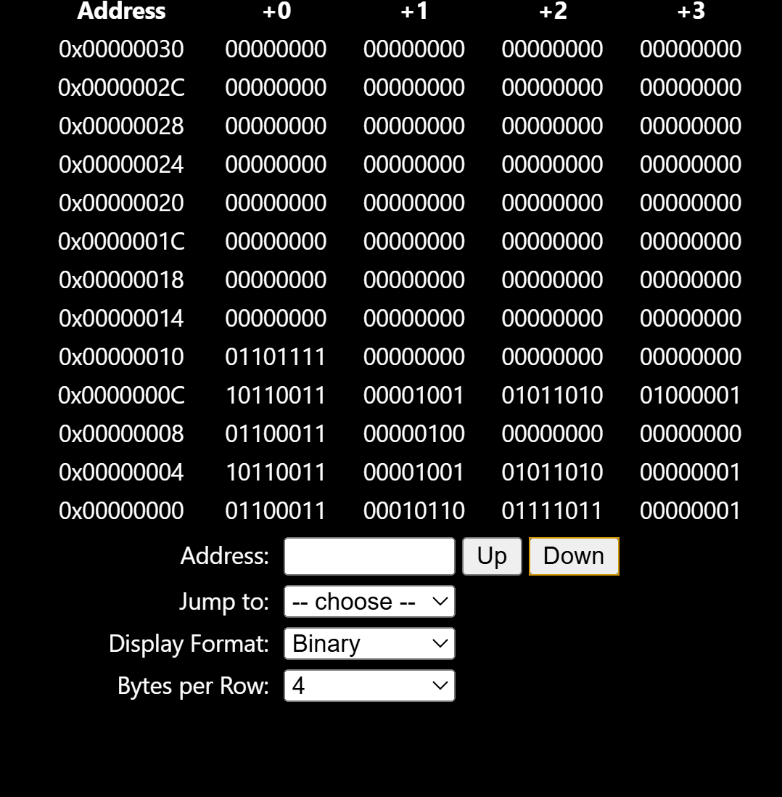
Wrote the code for listing 3 and executed in Venus and the results show the binary encoding of the branch instructions. The bne and beq instructions were checked in binary form. The branch address is stored as an offset from the current instruction instead of storing the full address and a PC offset from the current instruction.
bne x22, x23, Else:
Hex: 0x017B1663 and Binary: 00000001011110110001011001100011
beq x0, x0, Exit: Hex: 0x00000463 and Binary: 00000000000000000000010001100011

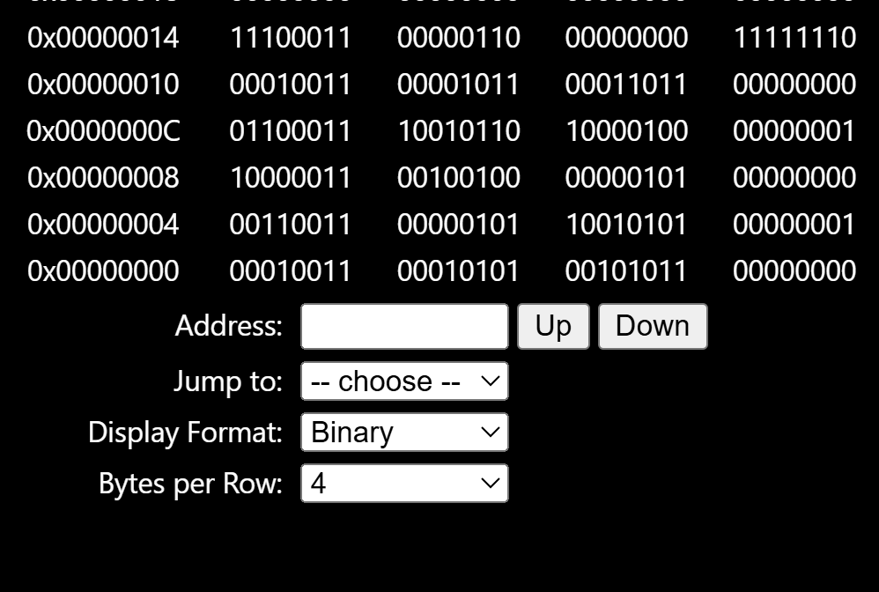
The bne instruction checks when to exit the loop and the beq instruction jumps back to the start of the loop. Both use an offset for the branch address

bne x22, x23, Else: opcode = 1100011, funct3 = 001, rs1 = x22, rs2 = x23, and the immediate stores the PC offset to Else
beq x0, x0, Exit: opcode = 1100011, funct3 = 000, rs1 = x0, rs2 = x0, and the immediate stores the PC offset to Exit

Task 2:

Code:

# thevalues for b and c
addi x22, x0, 10
addi x23, x0, 5

#x valeu
addi x20, x0, 5
#case 1 check
addi x5, x0, 1
beq x20, x5, Case1

#case 2
addi x5, x0, 2
beq x20, x5, Case2
#case 3
addi x5, x0, 3
beq x20, x5, Case3

#case 4
addi x5, x0, 4
beq x20, x5, Case4

#default
addi x21, x0, 0
beq x0, x0, Exit

Case1:
add x21, x22, x23
beq x0, x0, Exit

Case2:
sub x21, x22, x23
beq x0, x0, Exit

Case3:
slli x21, x22, 1
beq x0, x0, Exit
Case4:
addi x21, x0, 0
addi x6, x22, 0

Divide:
addi x5, x0, 2
blt x6, x5, Exit
addi x6, x6, -2
addi x21, x21, 1
beq x0, x0, Divide
Exit:

Results:
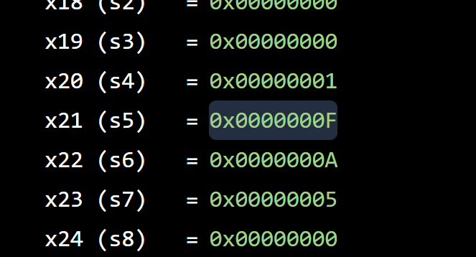
Case 1: For x=1 the program adds values fo b and c and the result is 15 which is stored in x21
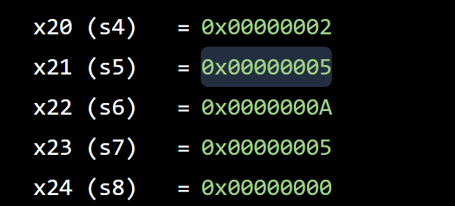
For case 2, x=2 and the code subtracts c from b which equals 5 and its stored in x21

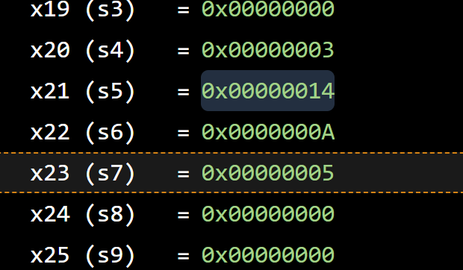
Case 3: for x=3, we multiply b by 2 which gives 20 and the result is stored in x21

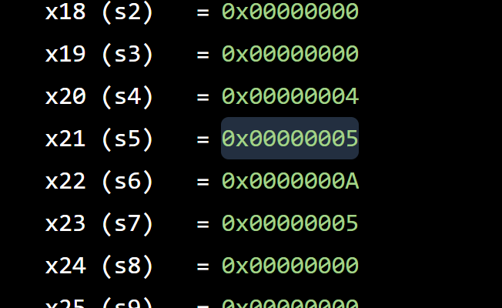
For case 4: x=4 and the code divides b by 2 which gives 5 and the result is stored in x21
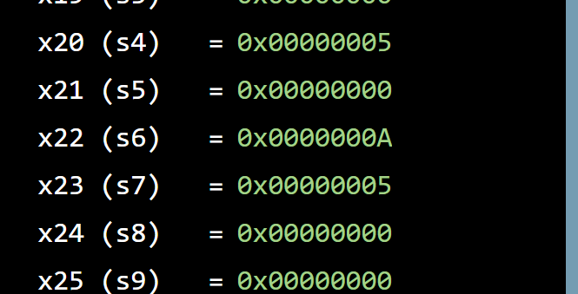
For the default case, x=5 and since none of the cases match it sets a=0

For testing the value of x in x20 was changed from 1 to 5 to check each case and the default case
Task 3:

Code:
addi x25, x0, 0x200
addi x5, x0, 10
addi x22, x0, 0
Loop1:
slli x10, x22, 2
add x10, x10, x25
sw x22, 0(x10)
addi x22, x22, 1
blt x22, x5, Loop1
addi x22, x0, 0
Loop2:
slli x10, x22, 2
add x10, x10, x25
lw x9, 0(x10)
add x23, x23, x9
addi x22, x22, 1
blt x22, x5, Loop2

Results:
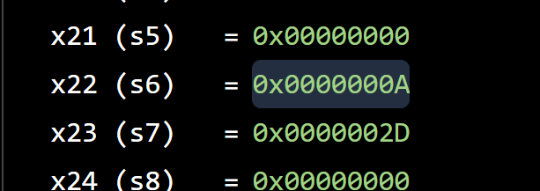
The loop here runs until i=10 and the values from 0 ot 9 are added together which gives a result of 45 stroed in x23

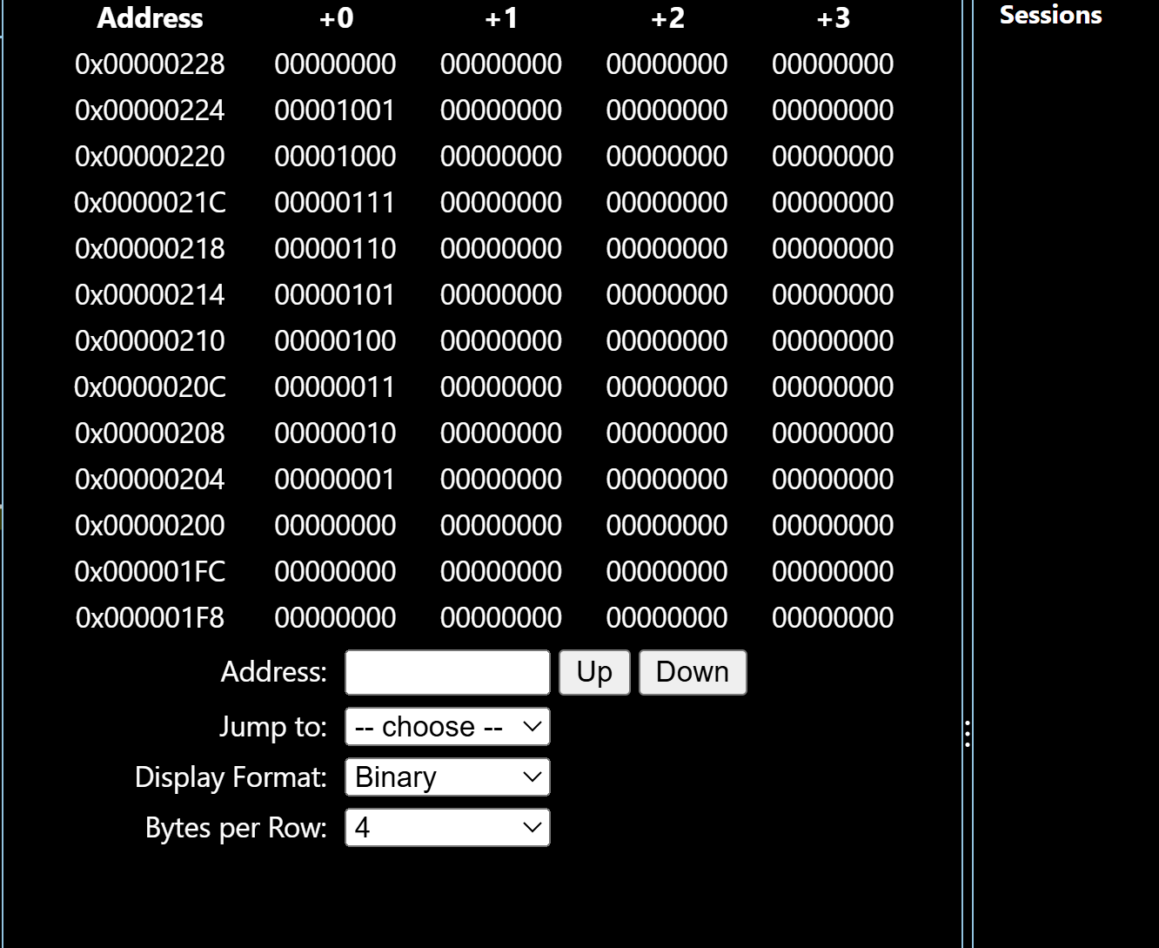

Task 4:

Code:
addi x7, x0, 0

Loop1:
addi x29, x0, 0
Loop2:
slli x9, x29, 4
add x9, x9, x10
add x28, x7, x29
sw x28, 0(x9)
addi x29, x29, 1
blt x29, x6, Loop2
addi x7, x7, 1
blt x7, x5, Loop1

Results:
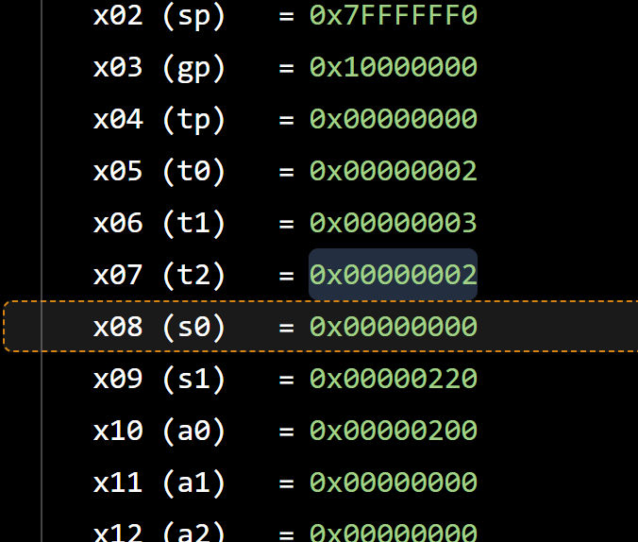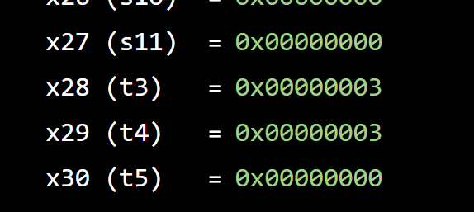
The nested loops in the code ended with i=2and j=3 and the base address of array D is 0x200 and the final value calculated was 3
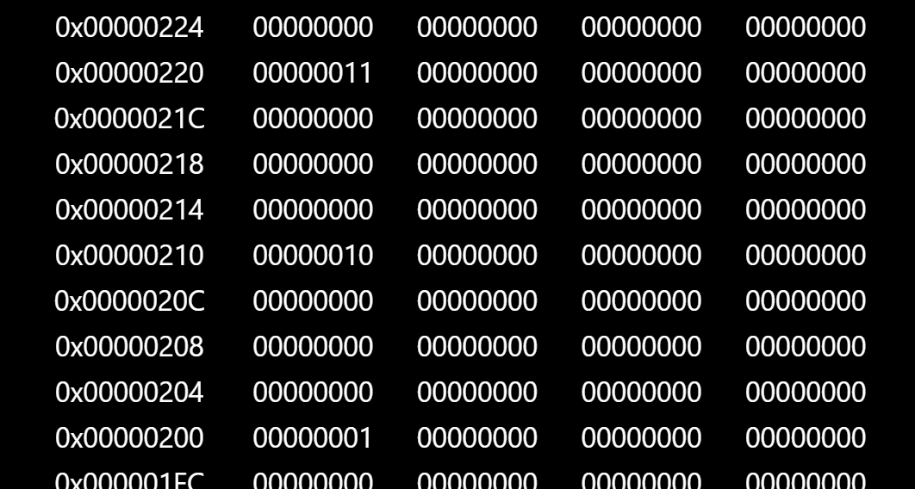
The values stored in array D are 1, 2, and 3 at addresses 0x200, 0x210, and 0x220 which shows that the nested loops worked correctly
For testing, a = 2, b = 3, and the base address of D was set to 0x200

Assessment Rubric
Lab 2 - Implementing Decision Instructions in RISC V Assembly Language

Name | Student ID: | Section:

Points Distribution:

 | Task No. | LR 2 (Code) | LR 5 (Results)
In-Lab | Task 1 | - | /5
In-Lab | Task 2 | /10 | /10
In-Lab | Task 3 | /15 | /10
In-Lab | Task 4 | /20 | /10
Total Points: 100 |  | /45 | /35
CLO Mapped |  | CLO 2

Affective Domain Rubric |  | Points | CLO Mapped
AR7 | Report Submission & Git Upload | /10 & /10 | CLO 2

CLO | Total Points | Points Obtained
2 | 100
Total | 100

