**Sir Syed University of Engineering & Technology**

ANSWER SCRIPT

|  |  |
| --- | --- |
| Date: | 12th June 9, 2021 |
| Roll Number: | SE-20F-022 |
| Section: | A |
| Name: | Abdul Moiz Chishti |
| Course Name: | Introduction to Software Engineering |
| Degree Program: | Software Engineering |
| Total number of pages being submitted: |  |

**QUES 1:**

**Part (a):**

The major limitations of the Waterfall Model are as follows −

1. No working software is produced until late during the life cycle.

2. High amounts of risk and uncertainty.

3. Not a good model for complex and object-oriented projects.

4. Poor model for long and ongoing projects.

5. Not suitable for the projects where requirements are at a moderate to high risk of changing. So, risk and uncertainty is high with this process model.

6. It is difficult to measure progress within stages.

7. Cannot accommodate changing requirements.

8. Adjusting scope during the life cycle can end a project.

**Part (b):**

Q #1) What is the difference between Quality Assurance, Quality Control, and Testing?

Answer: Quality Assurance is the process of planning and defining the way of monitoring and implementing the quality(test) processes within a team and organization. This method defines and sets the quality standards of the projects.

Quality Control is the process of finding defects and providing suggestions to improve the quality of the software. The methods used by Quality Control are usually established by quality assurance. It is the primary responsibility of the testing team to implement quality control.

Testing is the process of finding defects/bugs. It validates whether the software built by the development team meets the requirements set by the user and the standards set by the organization.

Here, the main focus is on finding bugs and the testing teams work as a quality gatekeeper.

Q #2) When do you think QA activities should start?

Answer: QA activity should start at the beginning of the project. The more early it starts the more beneficial it is to set the standard for achieving the quality.

The cost, time and efforts are very challenging in case the QA activities get delayed.

Q #3) What is the difference between the Test Plan and Test Strategy?

Answer: Test Strategy is at a higher level, mostly created by the Project Manager which demonstrates the overall approach of the testing for the entire project, whereas the Test plan depicts how the testing should be performed for a particular application, falling under a project.

Q #4) Can you explain the Software Testing Life Cycle?

Answer: Software Testing Life Cycle refers to a testing process that has specific steps to be executed in a definite sequence to ensure that the quality goals have been met.

**Part (c):**

Bottom-up testing is a type of incremental integration testing, method validation, which is performed by the mainstream, or to connect two or more of the modules, by moving the top and bottom of the flow through the architecture of the control of the body. In the first test, the low-level modules, and, at a high level. This is the type of the test method is also known as inductive reasoning, and, in many cases, are synonymous with the synthesis. The Bottom-up test-this is an easy test that will lead to an increase in the total volume of the programme. In this test, results in a high response rate of profit in the long run.

Usage :

The next step is to perform during the 'processing' means :

Teams are formed through a merger, or to combine the low-level modules, or components. These groups are also well-known that the installation, which is responsible for the processing, define the center or the extra features of the software.

It is important that the type of controls and test of the software. The I-control software, which is also known as the driver or a high-level modules. It is simply the coordinates of the input and the output of the case, the tests are performed.

The test is carried out for all your installation, or clusters, that have a low-level modules.

Finally, the executing program, or a device driver, or a high-level modules to be removed from the integration of the group, and moving up and down in the program structure, and with the help of the control of the flow rate.

**Part (d):**

**Software Technical Manager:**

As a software technical manager who is the point person for any issues that arise within the

team and is responsible for making key decisions for technical issues related to the company

after considering everything from cost to quality of software. Considering quality features

The Dynamic System Development Method will be suitable for software development.

Dynamic System Development Method (DSDM):

DSDM is an agile software development methodology. It is an iterative, incremental

approach.The method provides a four-phase framework consisting of:

* Feasibility and business study
* Functional model / prototype iteration
* Design and build iteration
* Implementation
* Within each phase, DSDM relies on several different activities and techniques based on these

principles:

* Projects evolve best through direct and co-located collaboration between the developers and

the users.

* Self-managed and empowered teams must have the authority to make time sensitive and

critical project-level decisions.

* Design and development is incremental and evolutionary in nature and is largely driven by

regular, iterative user feedback.

* Working software deliverables are defined as systems that address the critical, current

business needs versus systems that address less critical future needs.

* Frequent and incremental delivery of working software is valued over infrequent delivery of

perfectly working software.

* All changes introduced during development must be reversible.
* Continuous integration and quality assurance testing is conducted in-line, throughout the

project lifecycle.

* Visibility and transparency is encouraged through regular communication and collaboration

amongst all project stakeholders

**QUES 2:**

**Part (a):**

CNIC:42101-8106300-7

DATA:

LOC=63007

AP=421018

LBR=60,000$

SOLUTION:

Cost per line = LBR/Average Productivity

=60,000/421018

=0.143$/LOC

Total estimation project cost= cost per line*estimated line of code

=63007*0.143

=9010.001$

Estimated line of code = Total estimation project cost/ labor rate

= 9010.001/ 60,000

= 0.150

DATA:

FB=63007

AP= 421018

LBR=60,000$

SOLUTION:

Cost per FB= LBR/Average Productivity

=60,000/421018

=0.143

Total estimation project cost= cost per line*estimated line of code

=63007*0.143

=9010.001$

Estimated line of code = Total estimation project cost/ labor rate

= 9010.001/ 60,000

= 0.150

**Part (b):**

CNIC:42101-8106300-7

DATA:

Risk probability = 16% = 16/100 = 0.160

Risk impact = 50% * 8000/100 = 4000

=8000-4000

= 4000

Avg component = 250 loc

Cost of each line of code = 2201 Saudi riyal

Total cost = 2201 * 250 * 4000

Total cost= 2201000,000 Saudi riyal

CNIC= 42010-8106300-7

DATA:

Risk probability = 07% = 07/100 = 0.07

Risk impact = 50% * 8000/100 = 4000

=8000-4000

= 4000

Avg component = 250 loc

Cost of each line of code = 2101 Saudi riyal

Total cost = 2101 * 250 * 4000

Total cost= 2101000000 Saudi riyal

SOLUTION

Risk exposure = p*c

Risk exposure = 0.07 *2101000000 Saudi riyal

Risk exposure = 147070000 Saudi riyal

**QUES 3:**

**Class diagram:**

**Use Case Diagram:**

**QUES 4:**

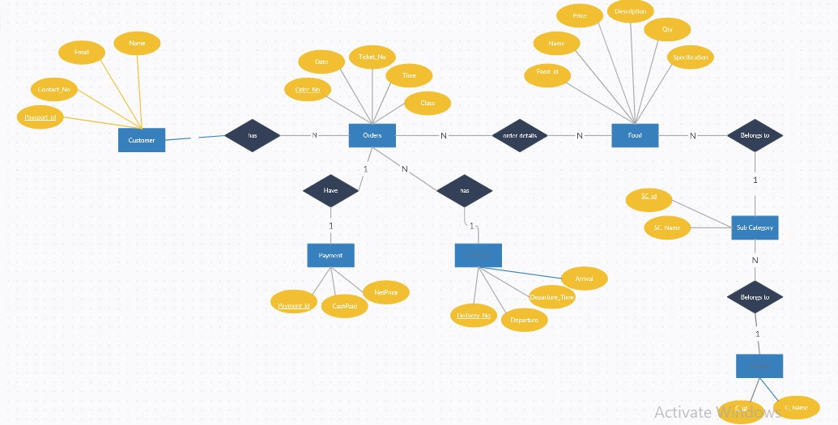

**content object structure diagram (Data Flow Diagram)**

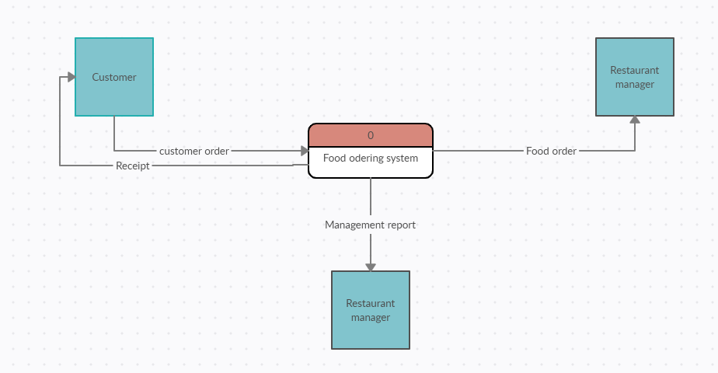

**Data flow Diagram Entity relationship diagram**

|  |  |  |
| --- | --- | --- |
| 1. | It stands for Data Flow Diagram. | It stands for Entity Relationship Diagram or Model. |
| 2. | Main objective is to represent the processes and data flow between them. | Main objective is to represent the data object or entity and relationship between them. |
| 3. | It explains the flow and process of data input, data output, and storing data. | It explains and represent the relationship between entities stored in a database. |

|  |  |  |
| --- | --- | --- |
| 4. | Symbols used in DFD are: rectangles (represent the data entity), circles (represent the process), arrows (represent the flow of data), ovals or parallel lines (represent data storing). | Symbols used in ERD are: rectangles (represent the entity), diamond boxes (represent relationship), lines and standard notations (represent cardinality). |
| 5. | Rule followed by DFD is that at least one data flow should be there entering into and leaving the process or store. | Rule followed by ERD is that all entities must represent the set of similar things. |
| 6. | It models the flow of data through a system. | It model entities like people, objects, places and events for which data is stored in a system. |

**Drawbacks of ERD:**

No industry standard for notation: There is no industry standard notation for developing an E-R diagram. Popular for high-level design: The E-R data model is especially popular for high level.

**Drawbacks of DFD:**

It make the programmers little confusing concerning the system. The biggest drawback of the DFD is that it simply takes a long time to create, so long that the analyst may not receive support from management to complete it. Physical considerations are left out.