COMSATS Connect
Project Report
A real-time, role-based campus messaging system built with Node.js and Socket.IO
Field | Detail
Developer | Abdul Moiz Israr
Background | BS Computer Science student, COMSATS University Islamabad
Project type | Full-stack real-time web application
Technology | Node.js, Express, Socket.IO, HTML/CSS/JavaScript
Status | Working prototype with automated tests
Date | October 2026

1. Project overview
Most chat applications are open rooms where anyone can talk to anyone. A university is different. Official notices must be read-only for students, a course group belongs to one department and one instructor, and a new student should not be able to message every faculty member on campus.
COMSATS Connect is a real-time messaging platform that models these rules. Administrators add users, authorised staff create groups, and every group and direct message is governed by a clear rulebook: who can join, who can post, and who can message whom. The browser never decides what is allowed. Every Socket.IO event is checked on the server.
This is an unofficial student project. It is not affiliated with or endorsed by COMSATS University Islamabad; the name is used because the scenarios are modelled on campus communication.

2. Goals and key features
The goal was to build a messaging platform that behaves like the communication needs of a real campus rather than an open chat room, using Socket.IO for all real-time traffic. The main features are:
- Users can be added: only the admin office (Registrar) can create new users with a role and department.
- Groups can be created: admin, Heads of Department (HoD) and faculty can create groups, each within limits set by their role.
- Communication boundaries: every group has a list of roles allowed to join, a list of roles allowed to post, and an optional department limit. Direct messages follow separate rules.
- Realistic COMSATS scenarios: official notices, department notices, course groups, faculty rooms, a Heads-of-Departments group, transport updates, an IT helpdesk and a student society.
- Real-time: all messaging, presence and typing indicators run over Socket.IO WebSockets.

3. Realistic requirements analysis
Before coding, the communication patterns of a university like COMSATS were analysed. The following roles and channels were identified.

3.1 User roles
Role | Example at COMSATS | What they need to do
Admin | Registrar Office | Add users, create any group, post official notices, message anyone.
HoD | Head of the CS or EE department | Create groups inside own department, manage members, post department notices.
Faculty | Course instructors | Create course and discussion groups for own department, post lectures and announcements.
Student | BCS, BEE and BSE students | Read notices, ask questions in course groups, chat with classmates.
Staff | Transport Office, IT Helpdesk | Broadcast service updates and answer student queries.

3.2 Group types and seed data
The following groups are created when the server starts. The group owner and the admin can always post in addition to the roles listed.
Group | Type | Dept | Who can join | Who can post
COMSATS Official Notices | announcement | All | All roles | Admin only
Transport Updates | announcement | All | All roles | Admin, Staff
IT Helpdesk Support | discussion | All | All roles | All roles
Heads of Departments | faculty | All | HoD | HoD
CS Department Notices | announcement | CS | HoD, Faculty, Student | HoD
CS Faculty Room | faculty | CS | HoD, Faculty | HoD, Faculty
CS Students Hub | discussion | CS | Student | Student
CSC101 Programming Fundamentals (BCS-1A) | course | CS | Faculty, Student | Faculty, Student
CSC210 Data Structures (BCS-3B) | course | CS | Faculty, Student | Faculty only
EE Department Notices | announcement | EE | HoD, Faculty, Student | HoD
Software Engineering Society | society | All | Student, Faculty | Student, Faculty

4. System design

4.1 Architecture
COMSATS Connect is a Node.js application. Express serves the single-page client, and Socket.IO carries all real-time traffic. The browser never decides what is allowed: it only displays what the server sends. Every Socket.IO event is checked on the server against the rules in one policy file before anything happens.
File | Responsibility
server.js | Express and Socket.IO server, login check, rooms, all event handlers, presence, typing indicator, flood control.
policies.js | All communication boundaries in one place: canBeMember, canPost, canManage, canDM, validateCreate.
data.js | In-memory users, groups and message history, plus the COMSATS seed data.
public/index.html | Client UI: login, group and people lists, chat window, create-group and add-user dialogs, group manager.
package.json | Dependencies (express, socket.io) and the start script.

4.2 Data model
- User: id (registration or employee number), name, role, department, password.
- Group: id, name, type, department, ownerId, allowedRoles, postRoles, members, muted members.
- Message: id, room, sender (id, name, role), text, timestamp.

4.3 Authentication
Login uses the Socket.IO handshake. The client connects with its ID and password in the auth field, and a server middleware rejects the connection if they do not match a known user. An unknown ID, such as one a person invents, cannot connect. This is why the admin must add a user before that person can sign in.

5. Communication boundaries
This is the core of the system. The rules below are enforced on the server in policies.js.
Boundary | Rule
Who can join a group | The user role must be in the group allowedRoles list. If the group has a department, the user must belong to that department (admin is exempt).
Who can read a group | Only members (and admin). Non-members cannot load history or receive messages. Socket.IO rooms are re-synchronised after every membership change.
Who can post in a group | Roles in postRoles, plus the group owner and admin. Everyone else sees a read-only banner. A moderator can also mute a single member.
Who can create groups | Admin: any group. HoD: any type, forced into own department. Faculty: only course or discussion groups, forced into own department and limited to faculty and students. Students and staff: none.
Who can manage a group | Admin, the group owner, or the HoD of the group department. They can add, remove and mute members and delete the group.
Who can add users | Admin only.
Direct messages | Admin can message everyone. Student to student: same department only. Student to faculty, HoD or staff: only if they share a course, society or discussion group. Faculty, HoD and staff can message each other freely.

Broadcast channels (announcements) and university-wide groups are deliberately not counted as a shared group for direct messages. Otherwise every student would share a group with every teacher, and the rule would never block anything.

5.1 Key code
Membership and posting rules:
function canBeMember(user, group) {
if (!group.allowedRoles.includes(user.role)) return false;
if (group.dept && user.dept !== group.dept && !isAdmin(user)) return false;
return true;
}

function canPost(user, g) {
if (!hasAccess(user, g)) return false;
if (g.muted.has(user.id)) return false;
return isAdmin(user) || g.ownerId === user.id || g.postRoles.includes(user.role);
}

Direct-message rule:
function canDM(a, b) {
if (a.id === b.id) return false;
if (isAdmin(a) || isAdmin(b)) return true;
if (a.role === 'student' && b.role === 'student') return a.dept === b.dept;
if (a.role === 'student' || b.role === 'student') return sharesGroup(a, b);
return true;
}

6. Socket.IO events
Event | Direction | Purpose
connection (auth) | Client to server | Login with ID and password during the handshake. Invalid credentials are rejected.
state | Server to client | Sends the user profile, the groups they may see, the people they may message, and the directory (non-students).
presence | Server to client | List of users currently online, shown as green dots.
group:history | Client to server | Load older messages. Allowed for members only.
group:message | Client to server | Post in a group. Checked with canPost and flood control.
dm:history / dm:message | Client to server | Load and send direct messages. Checked with canDM.
message | Server to client | Delivers a new group or direct message to the right Socket.IO room only.
typing | Both | Shows the "is typing" indicator in the open chat.
user:create | Client to server | Admin adds a new user.
group:create | Client to server | Create a group, checked with validateCreate. Ineligible initial members are skipped and reported.
group:addMember / removeMember | Client to server | Manage membership. Adding is checked with canBeMember.
group:toggleMute / group:delete | Client to server | Moderation by the owner, HoD or admin.

7. How to run the project
- Install Node.js, open the project folder in a terminal.
- Run npm install to download express and socket.io.
- Run npm start. The terminal prints: COMSATS Connect running on http://localhost:3000.
- Open http://localhost:3000 in one or more browsers. Sign in with a demo account (password 123) or with a user the admin has added.

7.1 Demo accounts
ID | Role | Name
ADM-001 | Admin | Registrar Office
EMP-100 | HoD (CS) | Dr. Ahmed Raza
EMP-110 | HoD (EE) | Dr. Nadia Khan
EMP-201 | Faculty (CS) | Dr. Sana Malik
EMP-202 | Faculty (CS) | Mr. Usman Tariq
EMP-301 | Faculty (EE) | Dr. Bilal Hussain
FA23-BCS-001 / 002 / 003 | Student (CS) | Ali Hassan, Fatima Noor, Hamza Yousaf
FA23-BEE-001 | Student (EE) | Zainab Iqbal
SP24-BSE-001 | Student (SE) | Omar Farooq
STF-01 / STF-02 | Staff | Transport Office, IT Helpdesk

8. Implementation and testing screenshots
The screenshots below were taken while running and testing the system. Each one is explained and linked to the feature it demonstrates. The system was also opened in two different browsers at the same time to confirm that real-time chat works between separate users.

8.1 Project setup and server
Figure 9: Project structure and server start in VS Code
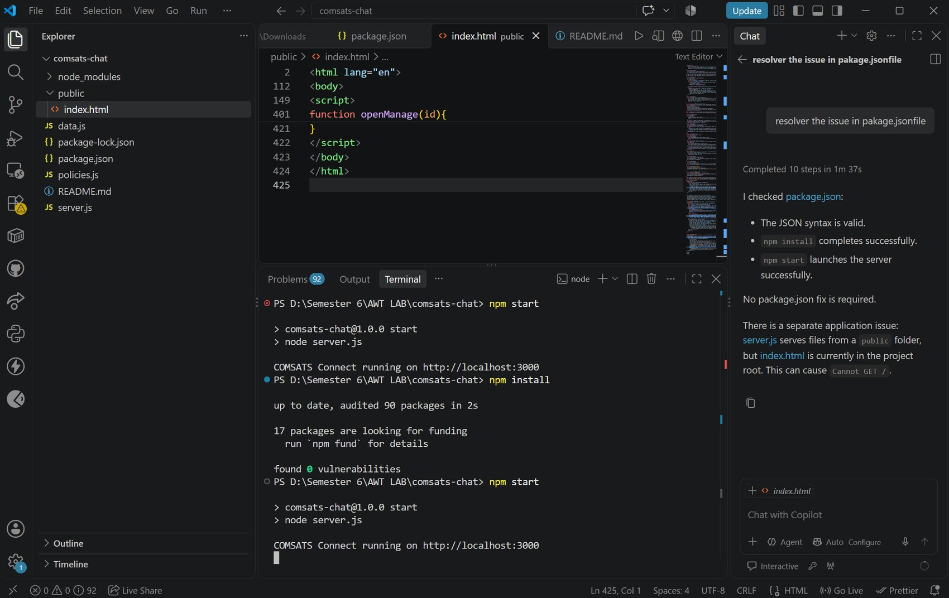
The project folder comsats-chat in Visual Studio Code. It contains server.js, policies.js, data.js, package.json and the public folder with index.html. The terminal shows npm install finishing with 0 vulnerabilities, followed by npm start printing that COMSATS Connect is running on http://localhost:3000.
- Shows the Node.js and Socket.IO server running locally.
- Shows the code is separated into server logic, policies, data and client.
Figure 10: Communication boundary code (policies.js)
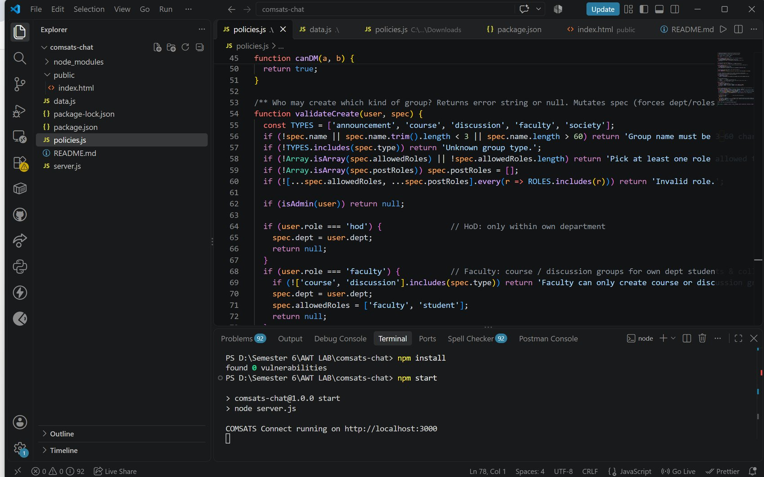
The policies.js file open in the editor, showing the canDM function and validateCreate function, which decides which role may create which kind of group. This file holds every communication boundary in one place, and the server calls it before acting on any event.
- Demonstrates the communication boundaries in code.
- validateCreate forces HoD and faculty groups into their own department and limits faculty to course and discussion groups.

8.2 Login
Figure 1: Sign-in page
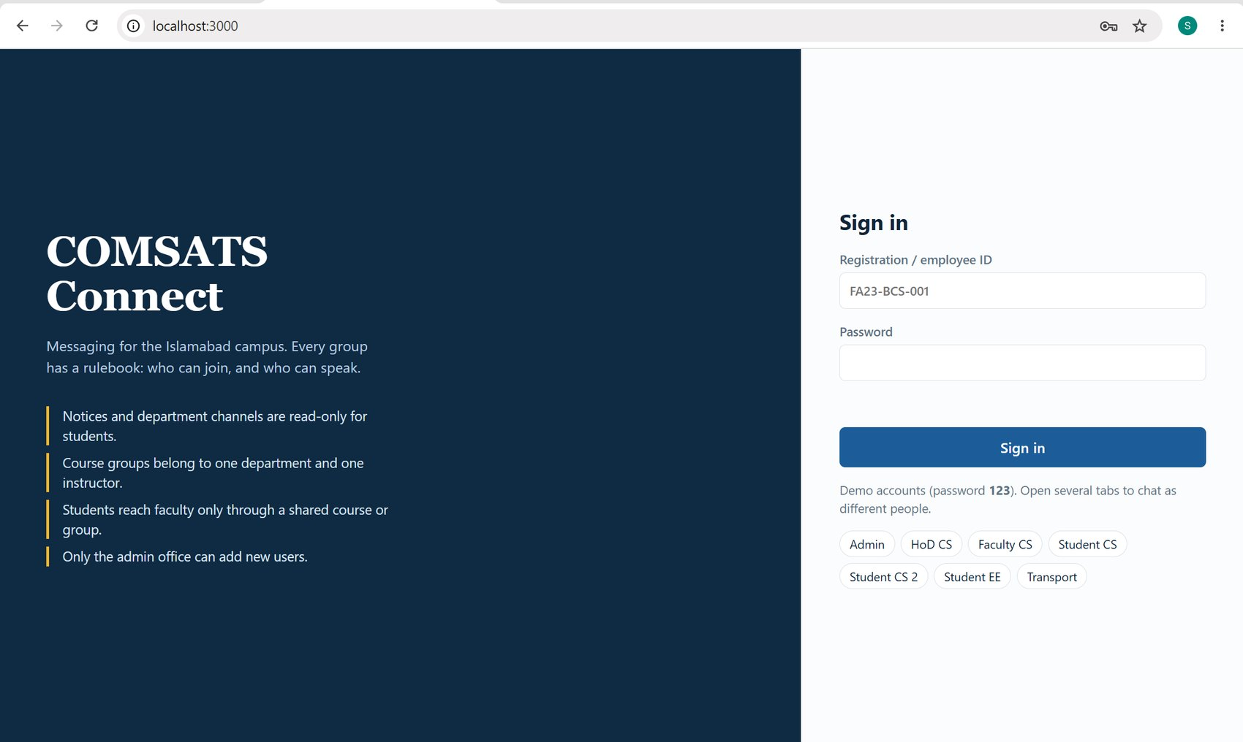
The COMSATS Connect login page. The left side summarises the four main rules of the system. The right side takes a registration or employee ID and a password, with one-click demo buttons for the Admin, HoD, Faculty, Students and Transport accounts.
- Only users that exist in the system can sign in.
Figure 3: Signing in as a newly added user
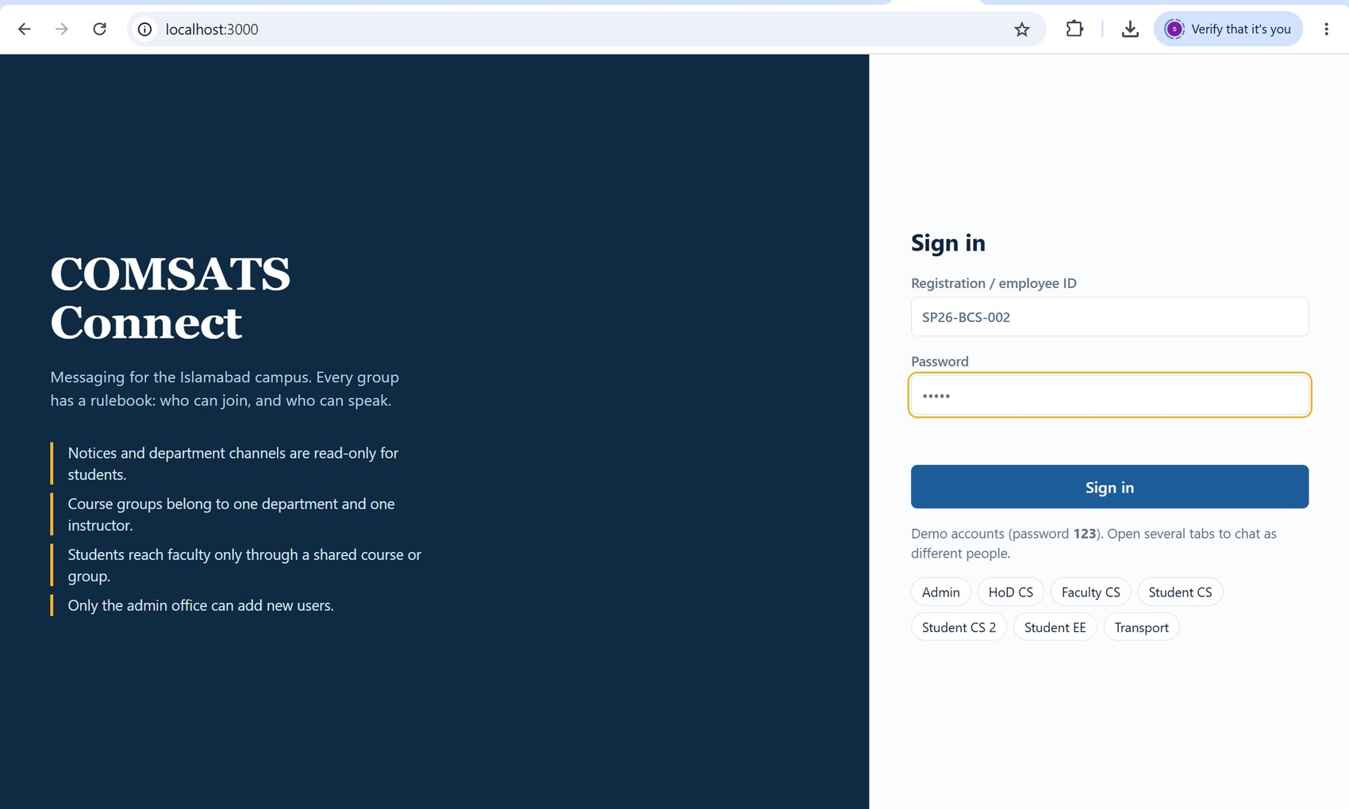
The sign-in page with the ID and password of the user that the admin created in Figure 8. This confirms that a user added by the admin can log in, and that nobody else can log in with an ID that was never added.

8.3 Admin: adding users and creating groups
Figure 2: Admin dashboard (Registrar Office)
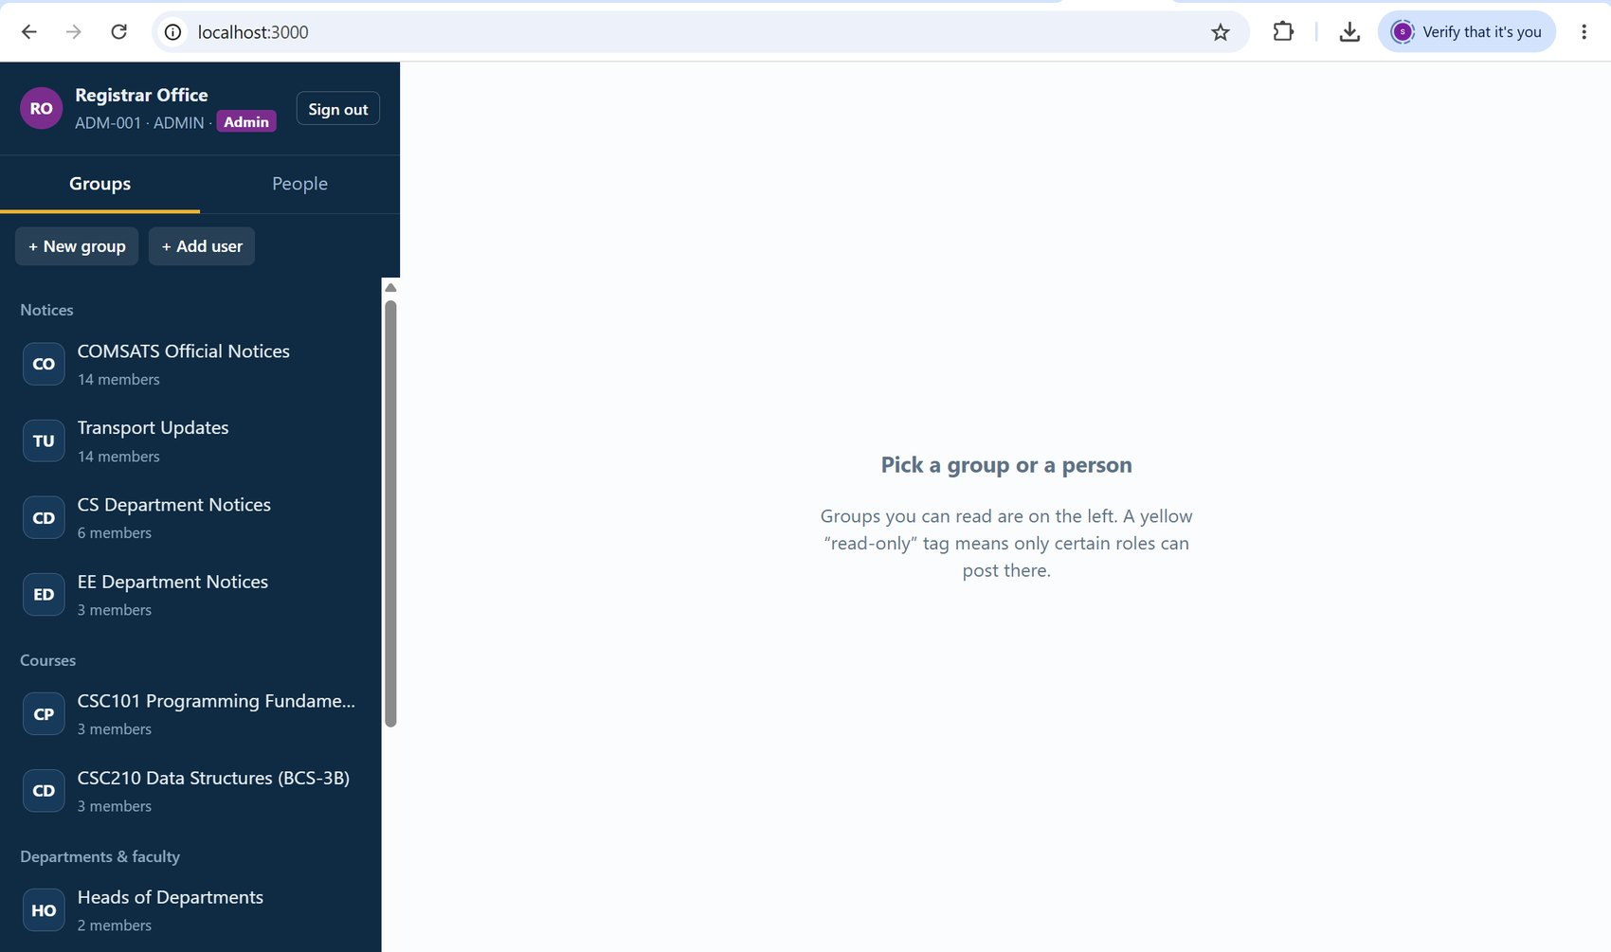
The Admin view. Only the admin sees both the "+ New group" and "+ Add user" buttons. The sidebar lists every group, grouped by Notices, Courses and Departments & faculty, with member counts. For example, COMSATS Official Notices has 14 members, CS Department Notices has 6 and EE Department Notices has 3. The admin can see all groups, including those of every department.
- Feature: users can be added by the admin (the Add user button).
- Feature: groups can be created (the New group button).
Figure 8: Add a user form (admin only)
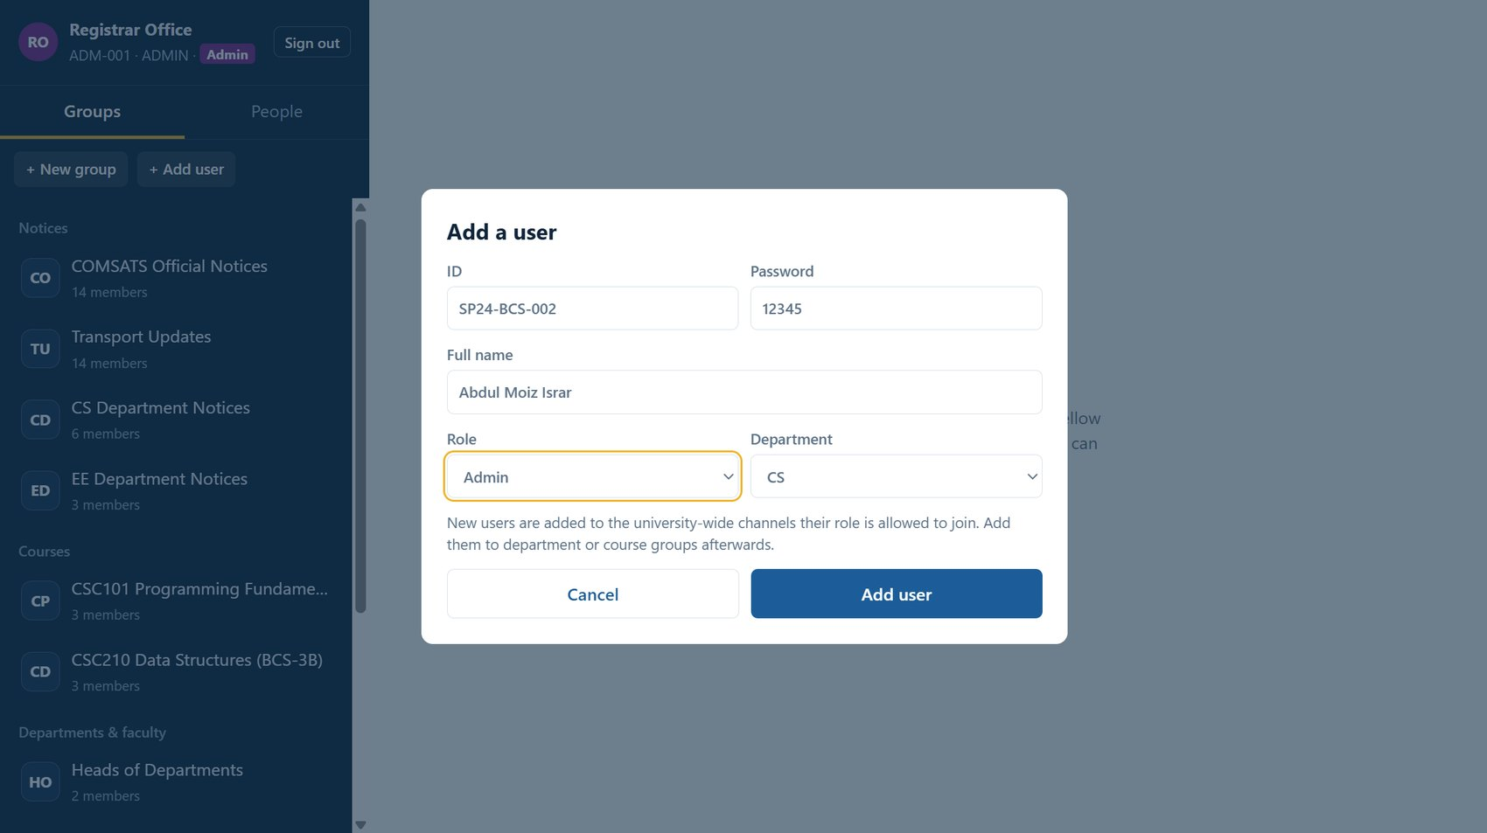
The dialog the admin uses to add a user. It asks for the ID, a password, the full name, a role (Admin, HoD, Faculty, Student or Staff) and a department. The note below the form explains that new users are placed in the university-wide channels their role may join, and must be added to department or course groups afterwards.
- The server rejects this action for any role other than admin.
Figure 5: Create a group form
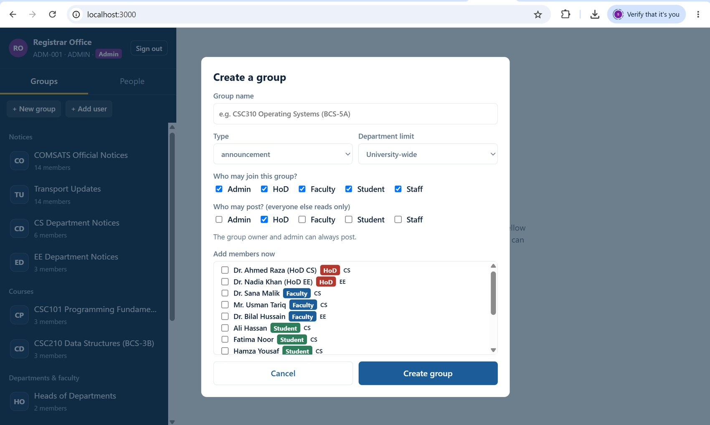
The group creation dialog. The creator enters a group name, chooses a type (announcement, course, discussion, faculty or society) and an optional department limit. Two checkbox rows define the boundary: "Who may join this group?" and "Who may post?" (everyone else reads only). The member list below only shows people who satisfy the chosen roles and department.
- This is where the communication boundary of each group is defined.
- Choosing the type pre-fills sensible role defaults, for example announcements allow only a HoD to post.

8.4 Group chat and read-only enforcement
Figure 4: Student view with limited groups
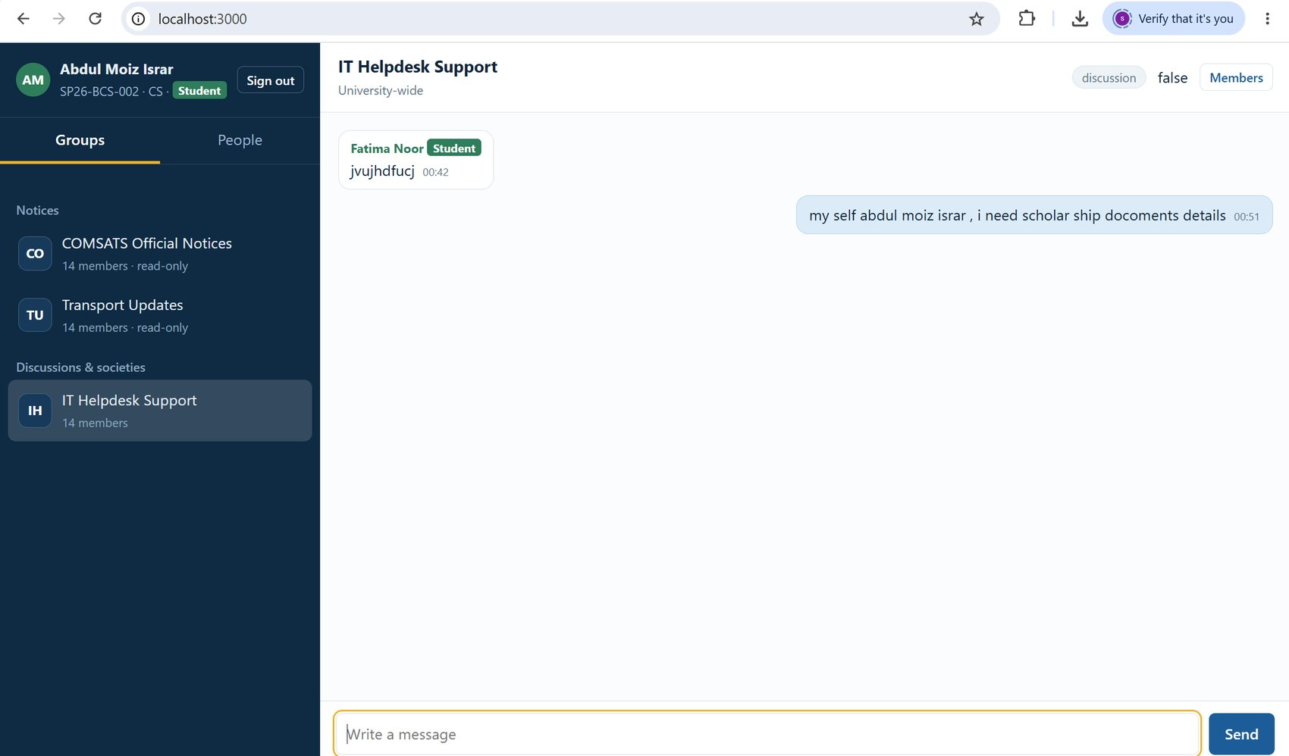
A student signed in as the newly added user. The sidebar shows the Notices COMSATS Official Notices and Transport Updates marked "read-only", and only one discussion group, IT Helpdesk Support. This student has not yet been added to any department or course group, so those groups are not visible at all. In IT Helpdesk Support the message box is available because students are allowed to post there.
- Shows that a student only sees groups they belong to.
- Shows the read-only label on notice channels.
Figure 7: Another student receives the message in real time
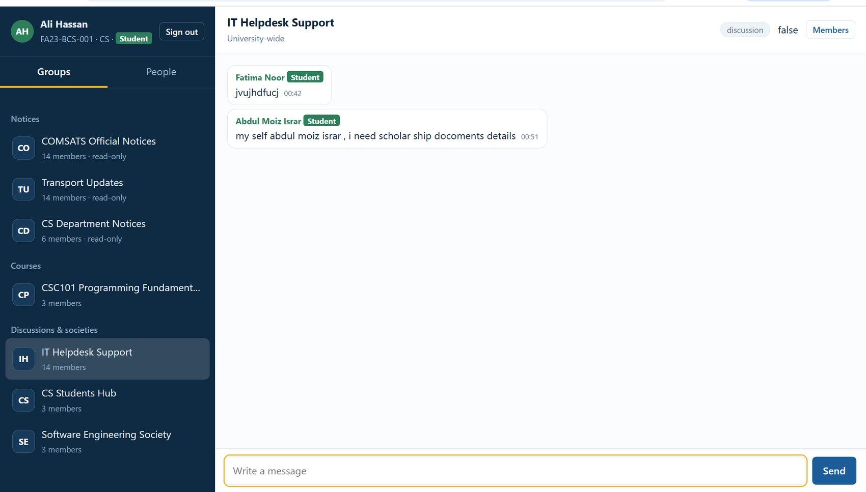
A second student (Ali Hassan) in the same IT Helpdesk Support group. The message sent by the newly added student in Figure 4 appears here, along with the earlier message from Fatima Noor. Ali has more groups than the new student: CS Department Notices (read-only), the CSC101 course group, CS Students Hub and Software Engineering Society, because he was added to them.
- Demonstrates real-time delivery of group messages over Socket.IO.
- Shows that different users see different groups according to their membership.

8.5 Direct-message boundaries
Figure 6: People tab: who a student may message
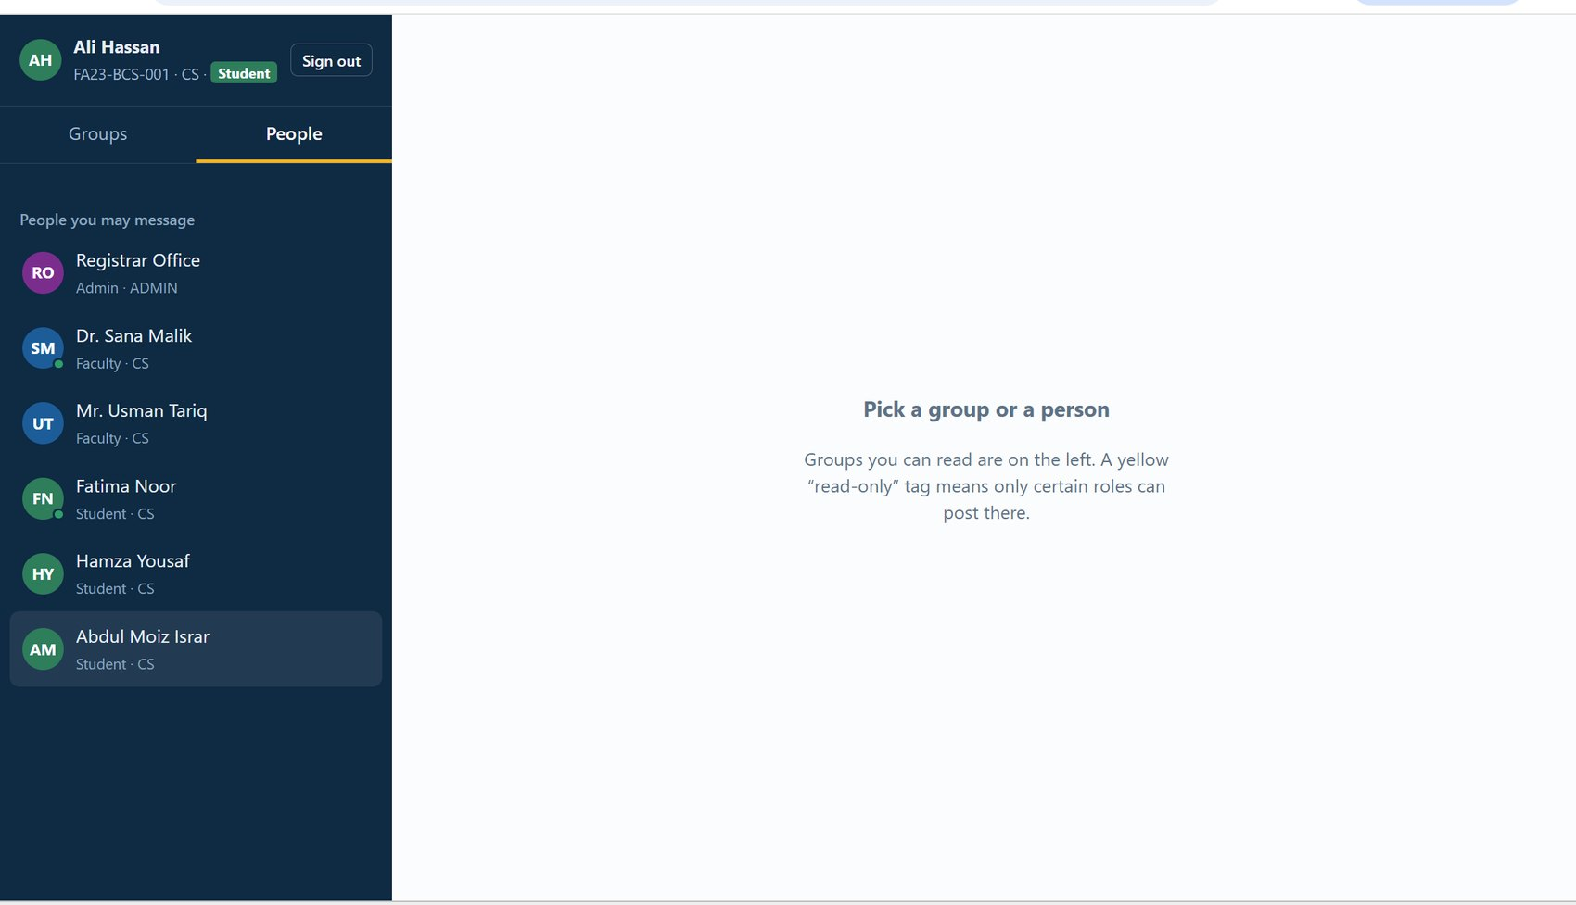
The People tab for the student Ali Hassan (CS). He can message the Registrar Office, his CS teachers (Dr. Sana Malik and Mr. Usman Tariq), and the other CS students (Fatima Noor, Hamza Yousaf and the newly added student). Green dots show who is online. The list does not include EE students, the EE faculty, the HoDs, or the Transport and IT staff.
- Student to student messaging is limited to the same department.
- Student to faculty messaging is allowed only through a shared course, society or discussion group.
- The admin is always reachable.
Figure 11: Real-time direct messages between two users in two browsers
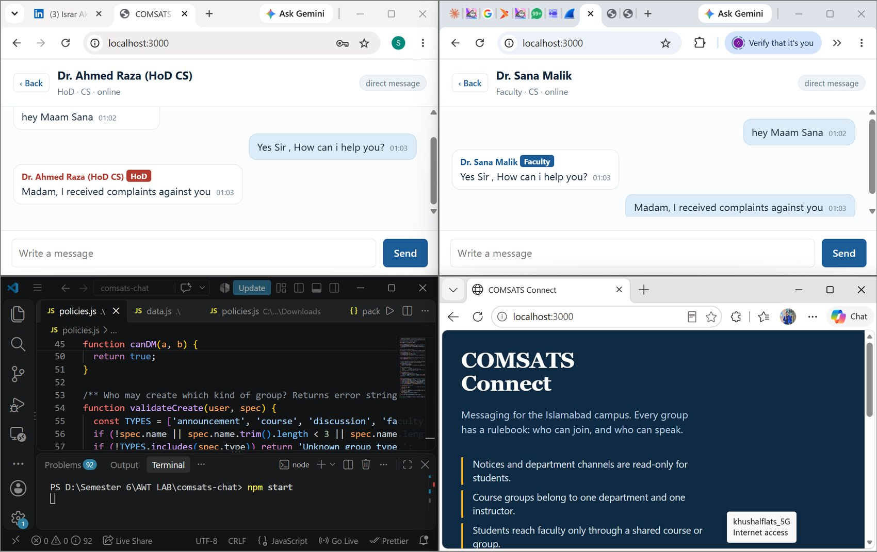
Two different browsers open at the same time, with the VS Code terminal and the login page also visible. In one window Dr. Ahmed Raza (HoD CS) and Dr. Sana Malik (Faculty CS) exchange direct messages. Each message sent in one window appears immediately in the other window with the correct sender name and role label, and both users show as online.
- Confirms the system works across separate browsers and users at the same time.
- Faculty and HoD can message each other freely.

9. Automated boundary testing
In addition to manual testing, a script connected several Socket.IO clients (students, faculty, HoD and admin) to the running server and checked 20 rules. All of them passed in the final run. One test failed on the first run and exposed a real flaw: university-wide channels were counted as a shared group, which let any student message any teacher. The shared-group check was then changed to ignore announcement and university-wide groups, and the test passed.
No. | Test case | Result
1 | Wrong password is rejected at connection | Pass
2 | Student cannot see the CS Faculty Room | Pass
3 | Student cannot see another department's notices (EE) | Pass
4 | Student cannot post in read-only department notices | Pass
5 | Student can post in a course group | Pass
6 | Student cannot read faculty-room history | Pass
7 | Group message is delivered to another member | Pass
8 | Student to student direct message in the same department is allowed | Pass
9 | Student to student direct message across departments is blocked | Pass
10 | Student to own course teacher direct message is allowed | Pass
11 | Student to EE teacher with no shared group is blocked | Pass
12 | Student cannot create users | Pass
13 | Student cannot create groups | Pass
14 | Faculty can create a course group; department is forced to own and an EE student is skipped | Pass
15 | Faculty cannot create a faculty-type group | Pass
16 | HoD cannot add a faculty member to a students-only group | Pass
17 | HoD cannot add an EE student to a CS group | Pass
18 | A muted student cannot post | Pass
19 | Admin can add a user | Pass
20 | New user is auto-enrolled in the official notices group | Pass

10. Feature checklist
Feature | How it works | Evidence
Real-time with Socket.IO | All login, messaging, presence and typing run over Socket.IO events. | Figures 9, 11
User management | Admin-only Add user form and user:create event with validation. | Figures 3, 8
Group creation | Create group dialog with type, department and role settings. | Figures 2, 5
Communication boundaries | Join, post, read, create, manage and direct-message rules enforced by the server. | Figures 4, 6, 10
Realistic campus scenarios | Roles, notices, department and course groups, faculty room, HoD group, transport, IT helpdesk, society. | Figures 2, 4, 7
Real-time chat between users | Tested in two browsers at once. | Figures 7, 11

11. Limitations and future work
- Data is stored in memory and resets when the server restarts. A database such as MongoDB or MySQL would make users, groups and history permanent.
- Passwords are stored as plain text for this demo. A real system should hash them (for example with bcrypt) and use tokens or sessions.
- Possible extensions: file attachments, student society presidents who can create societies, message search, read receipts and push notifications.

12. Conclusion
COMSATS Connect delivers a working, rule-driven messaging platform. Users can be added by the admin, groups can be created by authorised roles, and every group and direct message is governed by clear boundaries that reflect real communication at COMSATS: official notices are read-only for students, course groups belong to one department and instructor, and students reach faculty only through a shared course or group. The server enforces all rules, and both manual and automated testing confirmed that the system behaves as designed, including real-time chat between users in separate browsers.

