**PRACTICAL ASSESSMENT**

**Marks : 20**

**Duration: 45 minutes**

**Instructions:**

1. Create a text file with the name “**Git_answers_yourname**” and do post the answers in the file
2. Push the answers file to the github repository which you are going to create in the Q1.

**Q1. Do the following [ 10 marks]**

a. Create a new private GitHub repository named **fresher-git-task** [ 1 mark]

b. Clone the repository to your local machine [1 mark]

c. Inside the repository, create one file: [1 mark]

answers.txt (add all 3 Question answers)

Commit and Push these files to the **main** branch

d. Create a new branch called **feature/login-page** from **main** [1 mark]

e. On the **feature/login-page** branch, create a file named **login.html** (add any text

    content inside it). Commit and push this branch to GitHub. [ 2 marks]

f. Open a Pull Request (PR) on GitHub to merge feature/login-page into main.

Add a meaningful PR title and description

Provide a screenshot of your PR [2 marks]

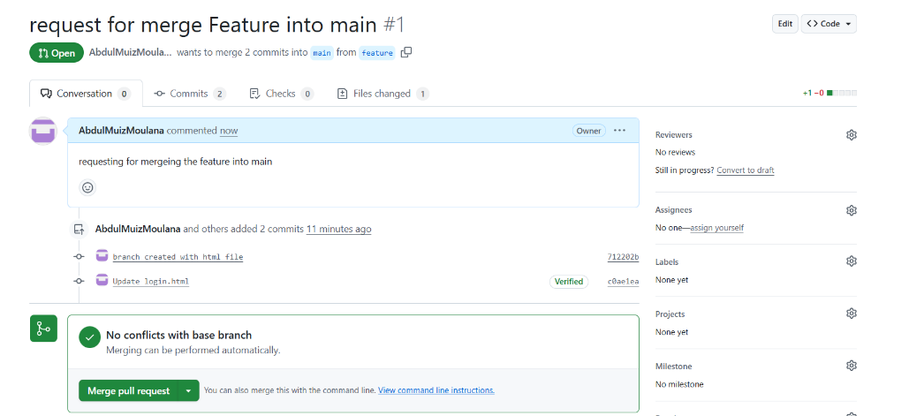

g. Invite another GitHub user (**mallikarjuna.hs@tibilsolutions.com**) as a collaborator

     with Write access to your private repository.

Provide a screenshot showing the collaborator added. [2 marks]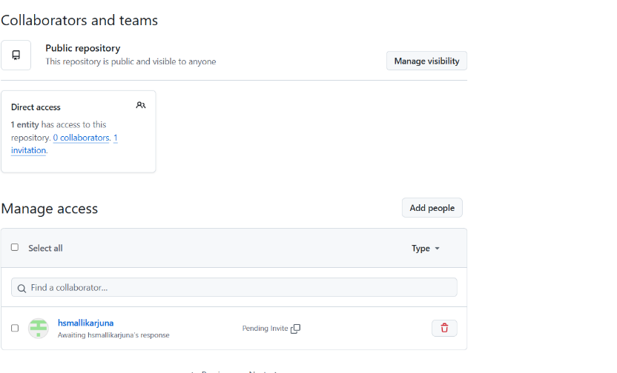

**Q2. Network Information Task [ 5 marks ]**

Perform the following tasks on your laptop and provide the answers:

1. Find and provide your laptop’s private IP address (local IP)         [1 mark]

192.168.248.124

2. Find and provide your laptop’s public IP address (external IP)    [1 mark]

3. Find and provide your laptop’s MAC (hardware) address. [1.5 marks]

E0-2E-0B-AE-10-A5

4. Write the command(s) or tool(s) you used to find this information.  [1.5 marks]

Ipconfig

curl ipconfig .me

getmac

**Q3. Internet Connectivity Check [ 5 Marks ]**

Answer the following using simple terminal commands:

1. How can you check if your laptop has internet access? Provide one simple command.

Hint : You can try to ping a well-known website             [1 mark]

ping google.com

1. How can you check if a website (ex: [www.google.com](http://www.google.com) ) is reachable from your laptop?

Provide one simple command               [1 mark]

Hint: Think of a basic command that shows replies if reachable

Ping www.google.com

1. Write one command that shows your current network configuration (IP address etc)

Hint : Command like *ipconfig* (Windows) or *ifconfig/ip addr* (Linux/Mac)  [ 1 mark ]

ipConfig

1. How can you test your public IP using terminal or browser? Mention any one method

                                                        curl ipconfig.me                                                                   [1 mark]

1. Which command can you use to send continuous pings until you stop it manually ping -t google.com [ 1 mark]

**\*\*\***