Single SPA framework

Evaluate Single SPA framework capability to load/mount multiple (more than 5) micro apps

simultaneously inside main app.

Micro frontend the way we would like to utilize Single SPA framework is as follows:

I have created few images to help me explain it better.

In the below example we are using multiple apps developed in angular 4 for simplification.

Scenario 1:

Different angular apps mounted in Main app

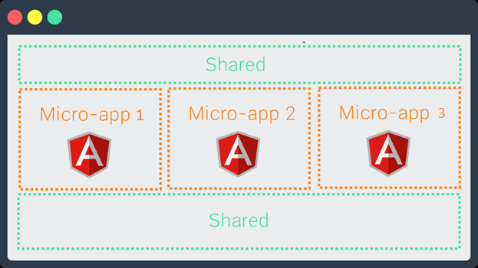

Scenario 2:

Different angular apps mounted in Main app, note app 1 is mounted twice.

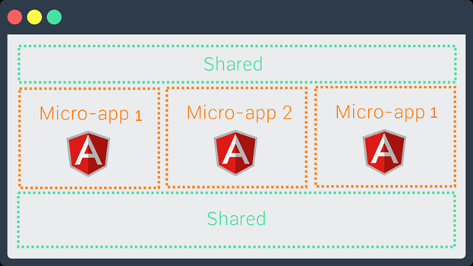

Scenario 3:

Different angular apps mounted in Main app using tabs to switch between apps

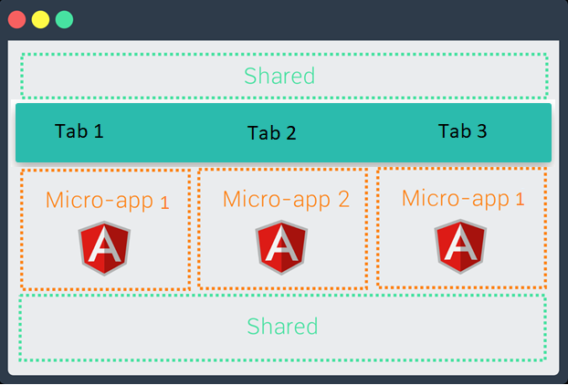

The active tab micro app would be visible, as per below example App 2 is visible

App1 in Tab 1 and Tab 3 is hidden though app 1 is mounted

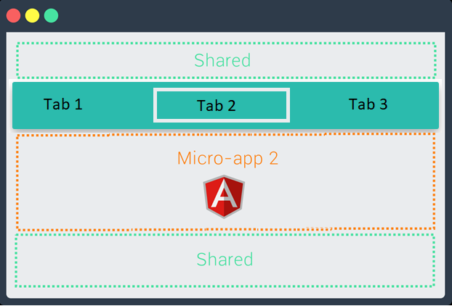

Hope I’m able to explain what we are trying to achieve here using single SPA framework.

To evaluate above scenario’s, I tried modifying the “simple-single-spa-webpack-example” example

given at URL: <https://github.com/joeldenning/simple-single-spa-webpack-example>

I modified root- application.js:

singleSpa.registerApplication('app-1', () =>

import ('../app1/app1.js'), () => ture);

singleSpa.registerApplication('app-2', () =>

import ('../app2/app2.js'), () => ture);

It throws below error:

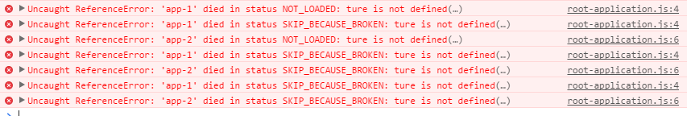

Could you please suggest on this requirement, can Single SPA framework be used to address above mentioned scenarios