**App: Jetpack Joyride**

Jetpack Joyride is a 2011 side-scrolling endless runner action video game created by Halfbrick Studios. It was released for iOS devices on the App Store on September 1, 2011, and has been ported to other systems.

1. Create a table that stores data.

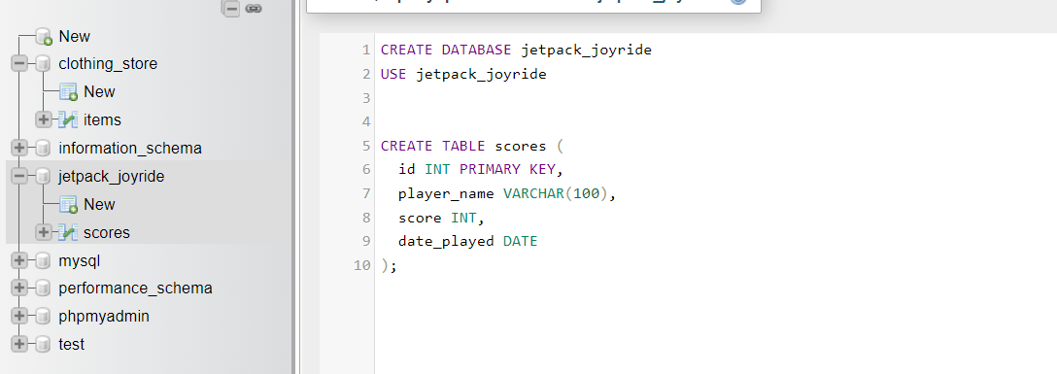

1. Insert a few examples rows in the table.

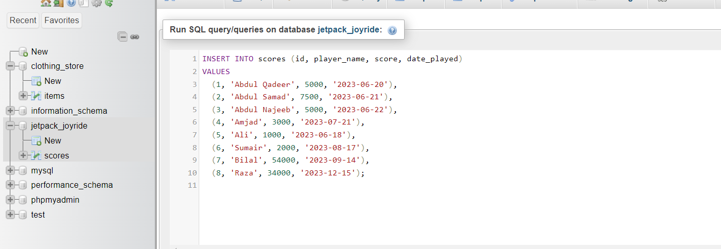

1. Use an **update** to emulate what happens when you edit data in the app.

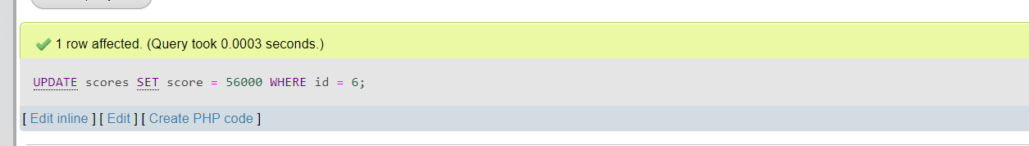

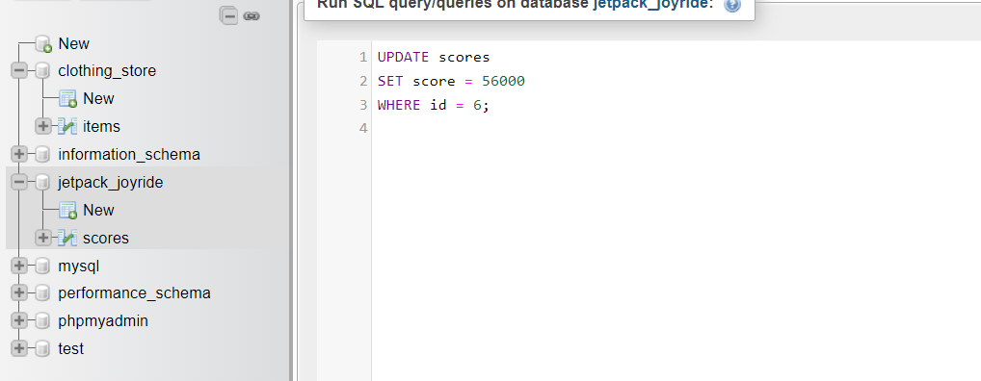

1. Use a **delete** to emulate what happens when you edit data in the app.



