**TOPIC 2 Telling time**

Telling Time

|  |  |
| --- | --- |
| time | *akhjein / naji* |
| clock/watch | *naji* |
| minute | *mi.ni’* |
| half past (30 minutes)  now | *khwe:*  *akhu.* |
| What’s the time now? | *Akhu be akhjein le: / be naji le:* |
| It’s 2 o’ clock. | *nhi’naji* |
| It’s 4:20pm. | *nja. nei lei: na ji nhi’ hse mi. ni’* |
| morning. | *ma ne’* |
| afternoon | *nei. le,* |
| evening | *nja. nei* |
| night | *nja.* |
| early  late  faster  wake up | *so:*  *nau’ kja.*  *mjanmjan*  *aei’ jahta.* |
| wait | *saun.* |
| for a while | *khana. lei:* |
| Wait for a while. | *khana. lei: saun. ba (kjei: zu: pju. pji:/pi:)* |

**Hours of the day**

In Myanmar,a day is broken into four parts,as follows:

* + ma ne’ –morning from 4am to 11:59am
  + nei. le –afternoon 12 to 2:59pm
  + nja. nei – evening 3 to 6:59pm
  + nja. – night between 7pm and before 3:59am

Examples: More for hours of the Day

|  |  |
| --- | --- |
| ***3 o’ clock in the evening*** | ***- in the evening 3 o’ clock -*** nja. nei thoun: na ji |
| 5 am | - ma ne’ nga: naji |
| 8:30 pm | - nja.shi’ najikhwe: (30mn/half past) |
| 8:40 am | - ma ne’ shi’ na ji lei: hse |
| 12:00 noon | - nei. le (ta)hse. nhi’ na ji |
| 11:00 am | - ma ne’hse. ti’ na ji |
| 9:30 pm | - nja. kou: naji khwe: |
| 4:20 pm | - nja. nei lei; na ji nhi’ hse mini’ |
| 5:15 pm | - nja. nei nga; na ji hse. nga: mi ni’ |
| 3 am | - ma ne’ thoun: na ji |
| 7:45pm | - nja.khoun nhi’ na ji lei: hse. nga: mi. ni’ |

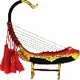Practice 1

Tell the time in Myanmar.You have to add morning, afternoon, evening or night after the time.

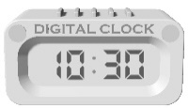

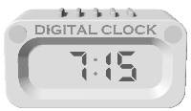

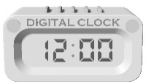

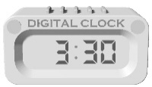

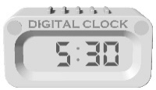

Grammar Points

**Sentence Construction1**

Here is simple Sentence Construction “verb + verb particle”

I eat- kja no sa: +de

I ate- kja no sa: +khe.+ de

I am eating- kja no sa: +nei +de

I will eat- kja no sa: +~~de~~+me

I have eaten- kja no sa: +~~de~~+pji: pji

***Question words “la: and le:”***

Do you eat? - sa:+la: - sa: de/ ma sa: bu:

What do you eat? - ba sa: le: - nasi lemak sa: de

***Negative Sentence construction***

I do not eat- kja no ma sa: bu:/ kja no ma sa: ba

**Sentence Construction 2 (Writing, Reading and translation)**

Sub + obj + verb + verb particle

Time factor- after sub preposition follows obj

Neg: polite sen: - sa:+ba kaun: ba bi

kjei; zu; tin ba de

Translate the following sentences to Myanmar.

1. I came to Myanmar class in the morning.
2. I am happy (not happy) to learn Myanmar language.

3. I meet my friends and teacher in the class. (friends-thu nge khjin: mja:)

4. Learning Myanmar is a lot of fun *I* boring. (fun - pjo saja/ boring - pjin: sa ja )

5. Myanmar Language is interesting. (Interesting-sei’ win sa: sa ja)

6. It is came from ancient Indian writing(shei: India a jei:)

7. I hope to visit Myanmar next year (2). (next year -shei' nhi')

8. We will go by plane. (Plane- lei jin ne.)

9. We all will buy things*.* (thing-pji' si:,all (a: loun:)

10. We planned already. (si sin)

11. We are saving money now. (Money- pai' hsan) (save - su.)

12. The trip is Myanmar study tour*.* (trip- kha ji:, Myanmar study tour -Myanmar sa

pei lei. la jei: kh ji:)